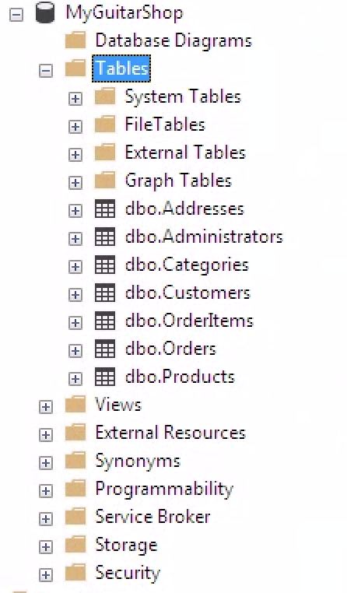

The most difficult part of this week’s exercise was correctly opening Microsoft SQL Server correctly on the Aloft VM, but once I opened the instructions I did not have any issues. Creating the database and inputting the SQL queries was simple.