Part A:

Question 1 Screen Shot: 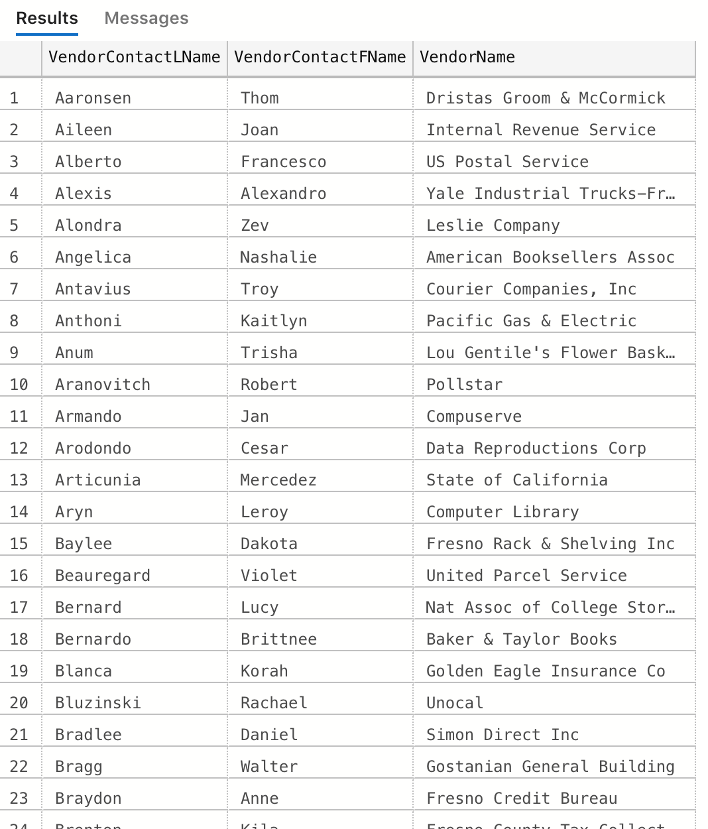

Question 7 Screen Shot: (no results)

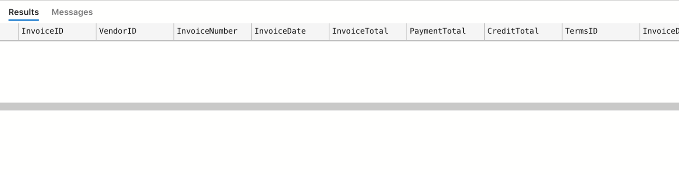

Part B:

1. Each table’s primary key is made up of a unique number. However, the OrderLineItems table has a composite primary key that is made up of both the OrderSequence and the OrderID.

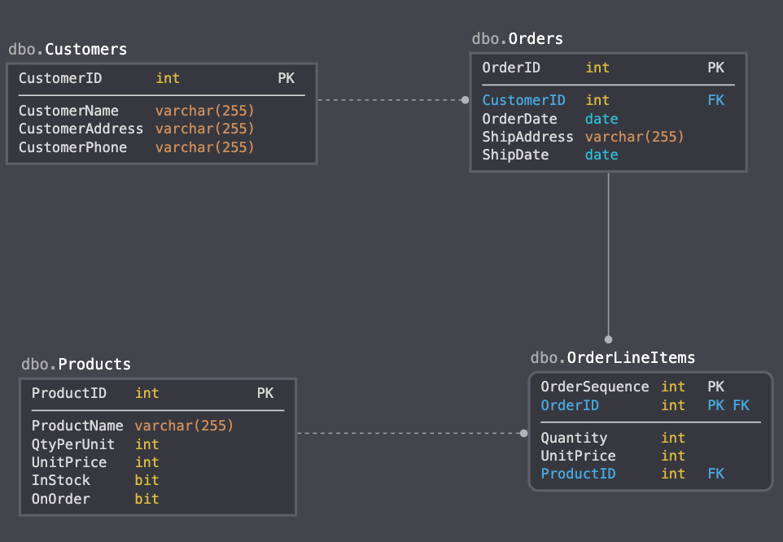

1. The Shippers, Employees, and Address table have been added to the initial database design. The Address table has been added to better track the different occurrences of addresses stored in the various tables. I also added a column for email to the Employees table.

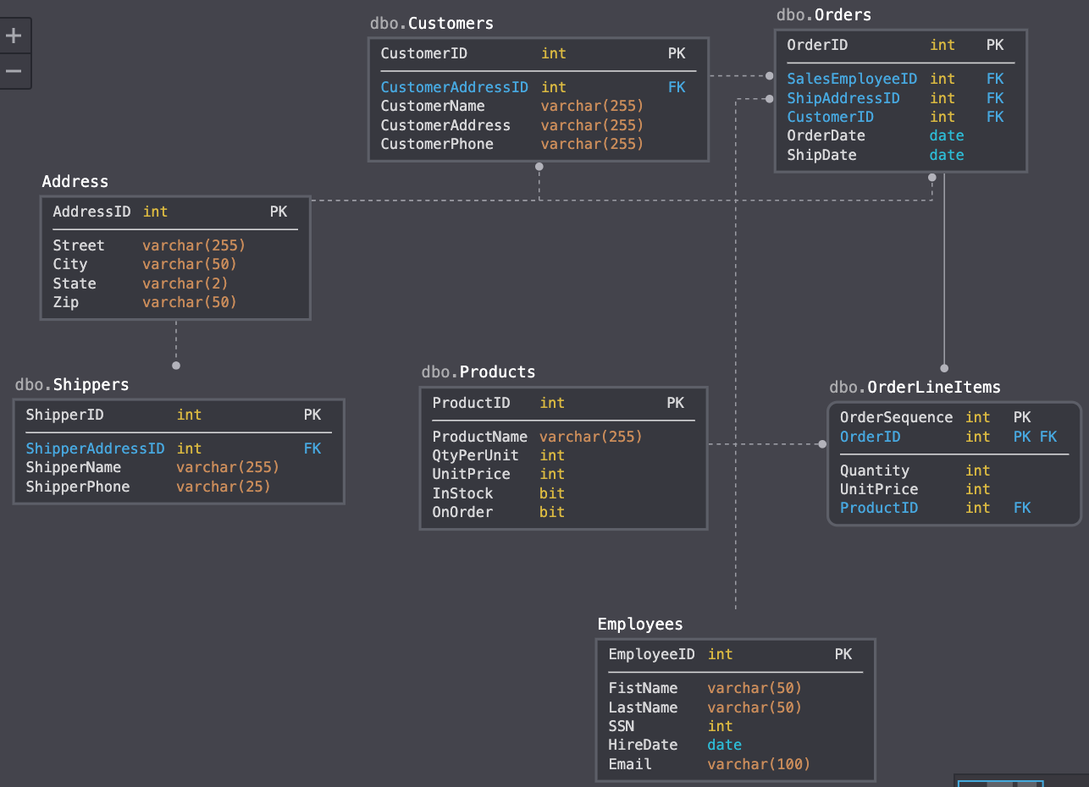

1. Each table would be indexed on the primary key. In addition to the primary key index, the following additional indexes would be added:
   1. Customers table: CustomerName
   2. Products table: ProductName
   3. Employees table: LastName, SSN

The reason for these additional indexes is because each of the three tables use and ID as their primary key which might not be known/easily found. The additional indexes will allow the database user to search these tables without knowing the ID while still getting the performance benefit of using an index.

1. In order to get the many-to-many relationship described in the requirements, I included a linking table in the initial database design.

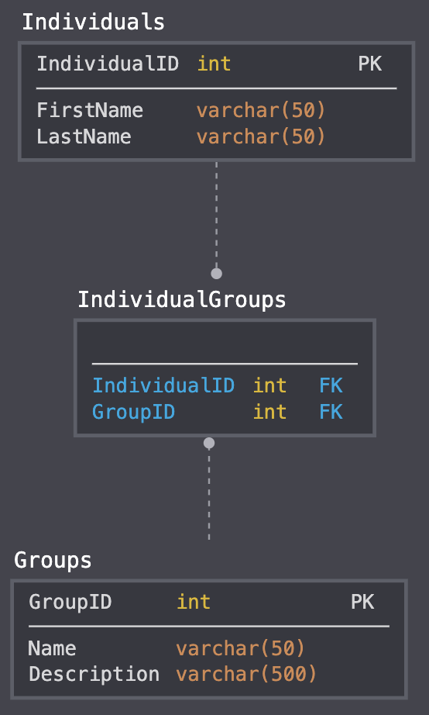

1. Based on the new DB requirements, additional role (i.e. ‘President’, ‘VicePresident’, etc.) columns cannot be added to the Group table, because each group has a ‘unique set of roles’ to fill. Instead, I added a fourth table, GroupIndividualRoles, that will keep track of the individual, the group, and the role that individual has within that group.

