**Part A**

Exercise 1 Screen Shot:

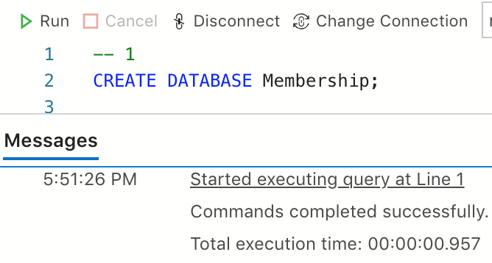

Exercise 2 Screen Shot:

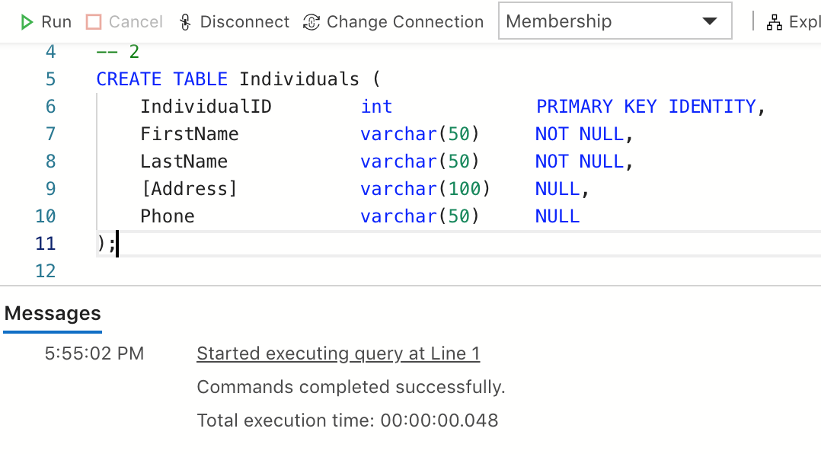

Exercise 5 Screen Shot:

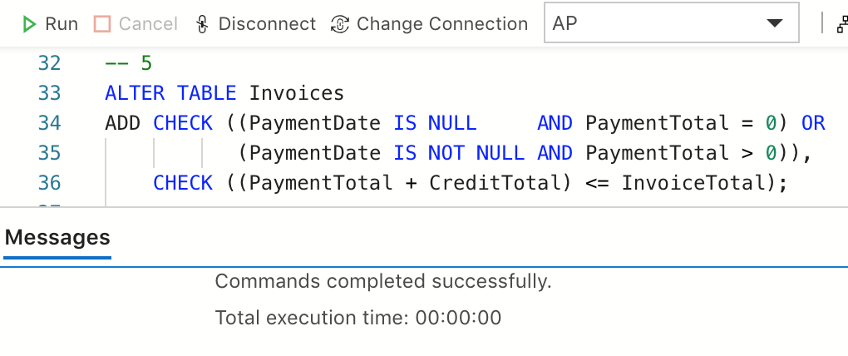

**Part B**

1. Use the Management Studio to create a new database called Membership2 using the default settings. (If the database already exists, use the Management Studio to delete it and then recreate it.)

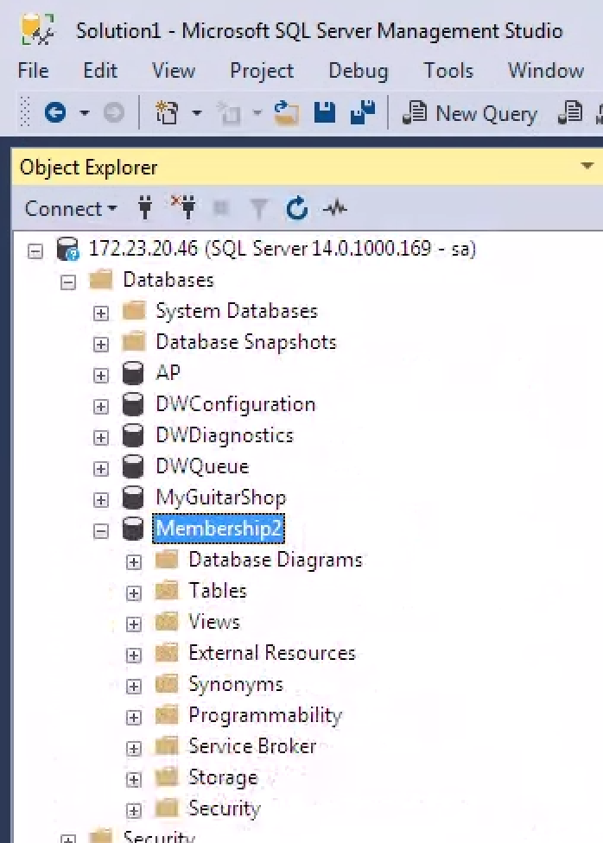

2.

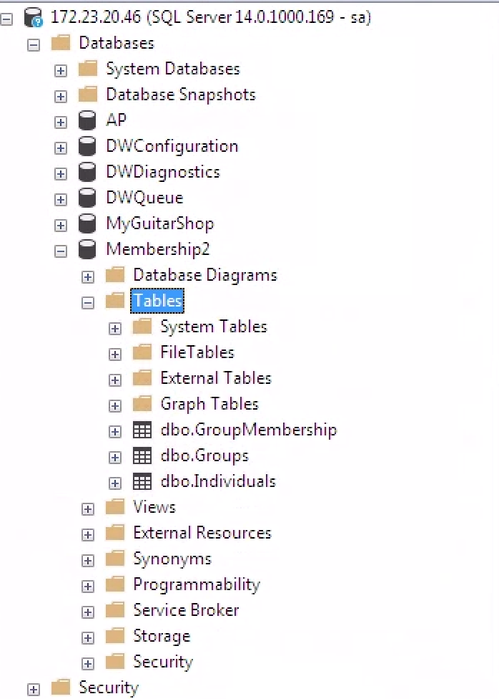

3.

