Part A:

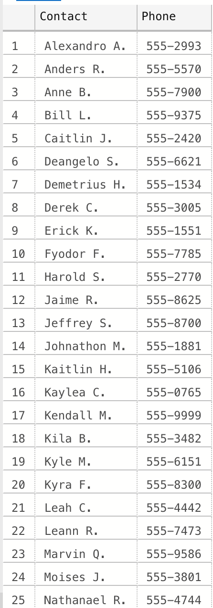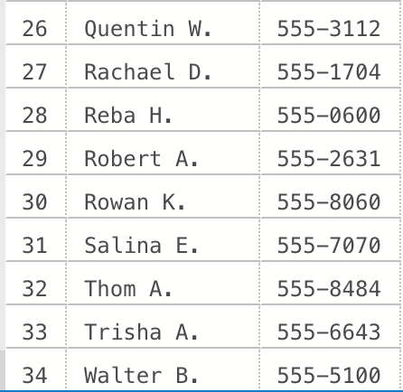

1. (This is what the script returned that was in the downloaded folder, but I think it is incorrect. The questions states: ‘less than 30 days from today.’; unless I just misunderstood the question, this should not return anything since these show an InvoiceDueDate in 2012.)

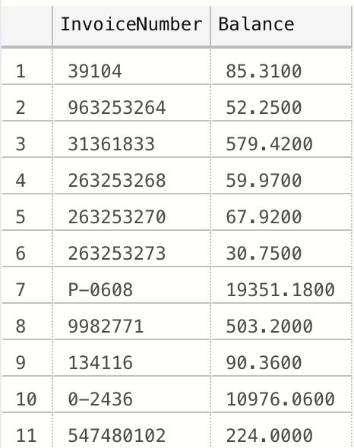

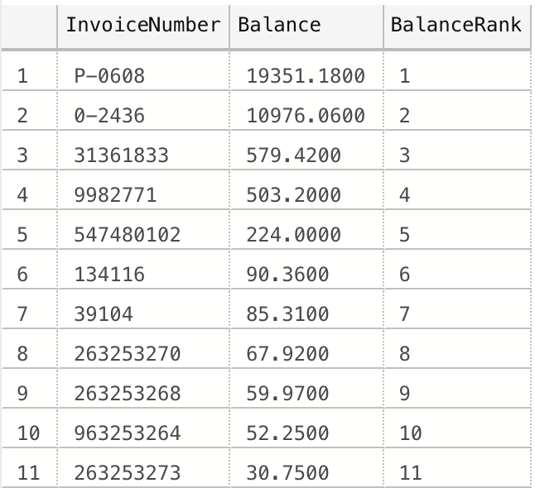

Part B:

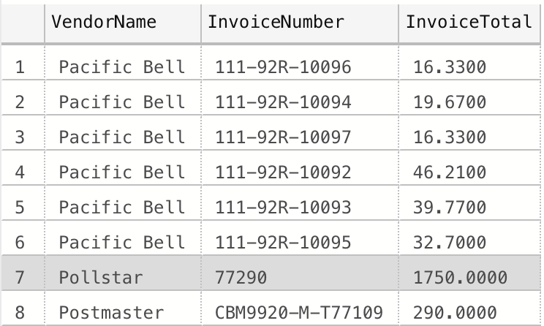

4.

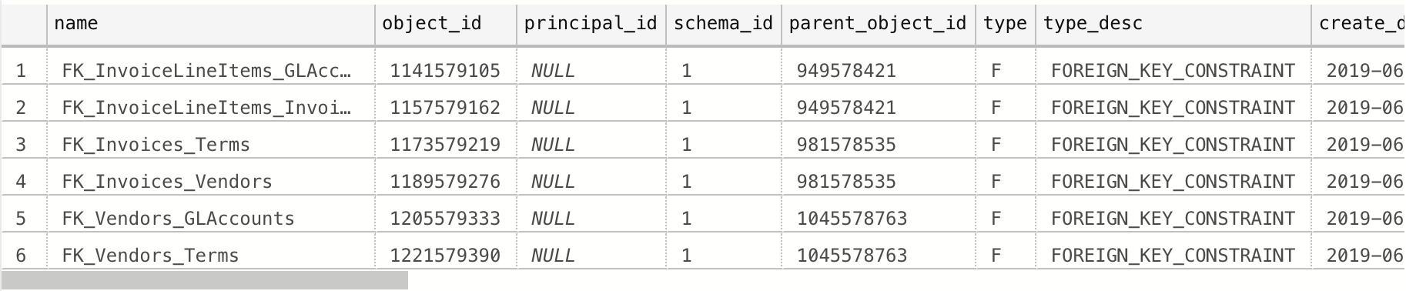

5.

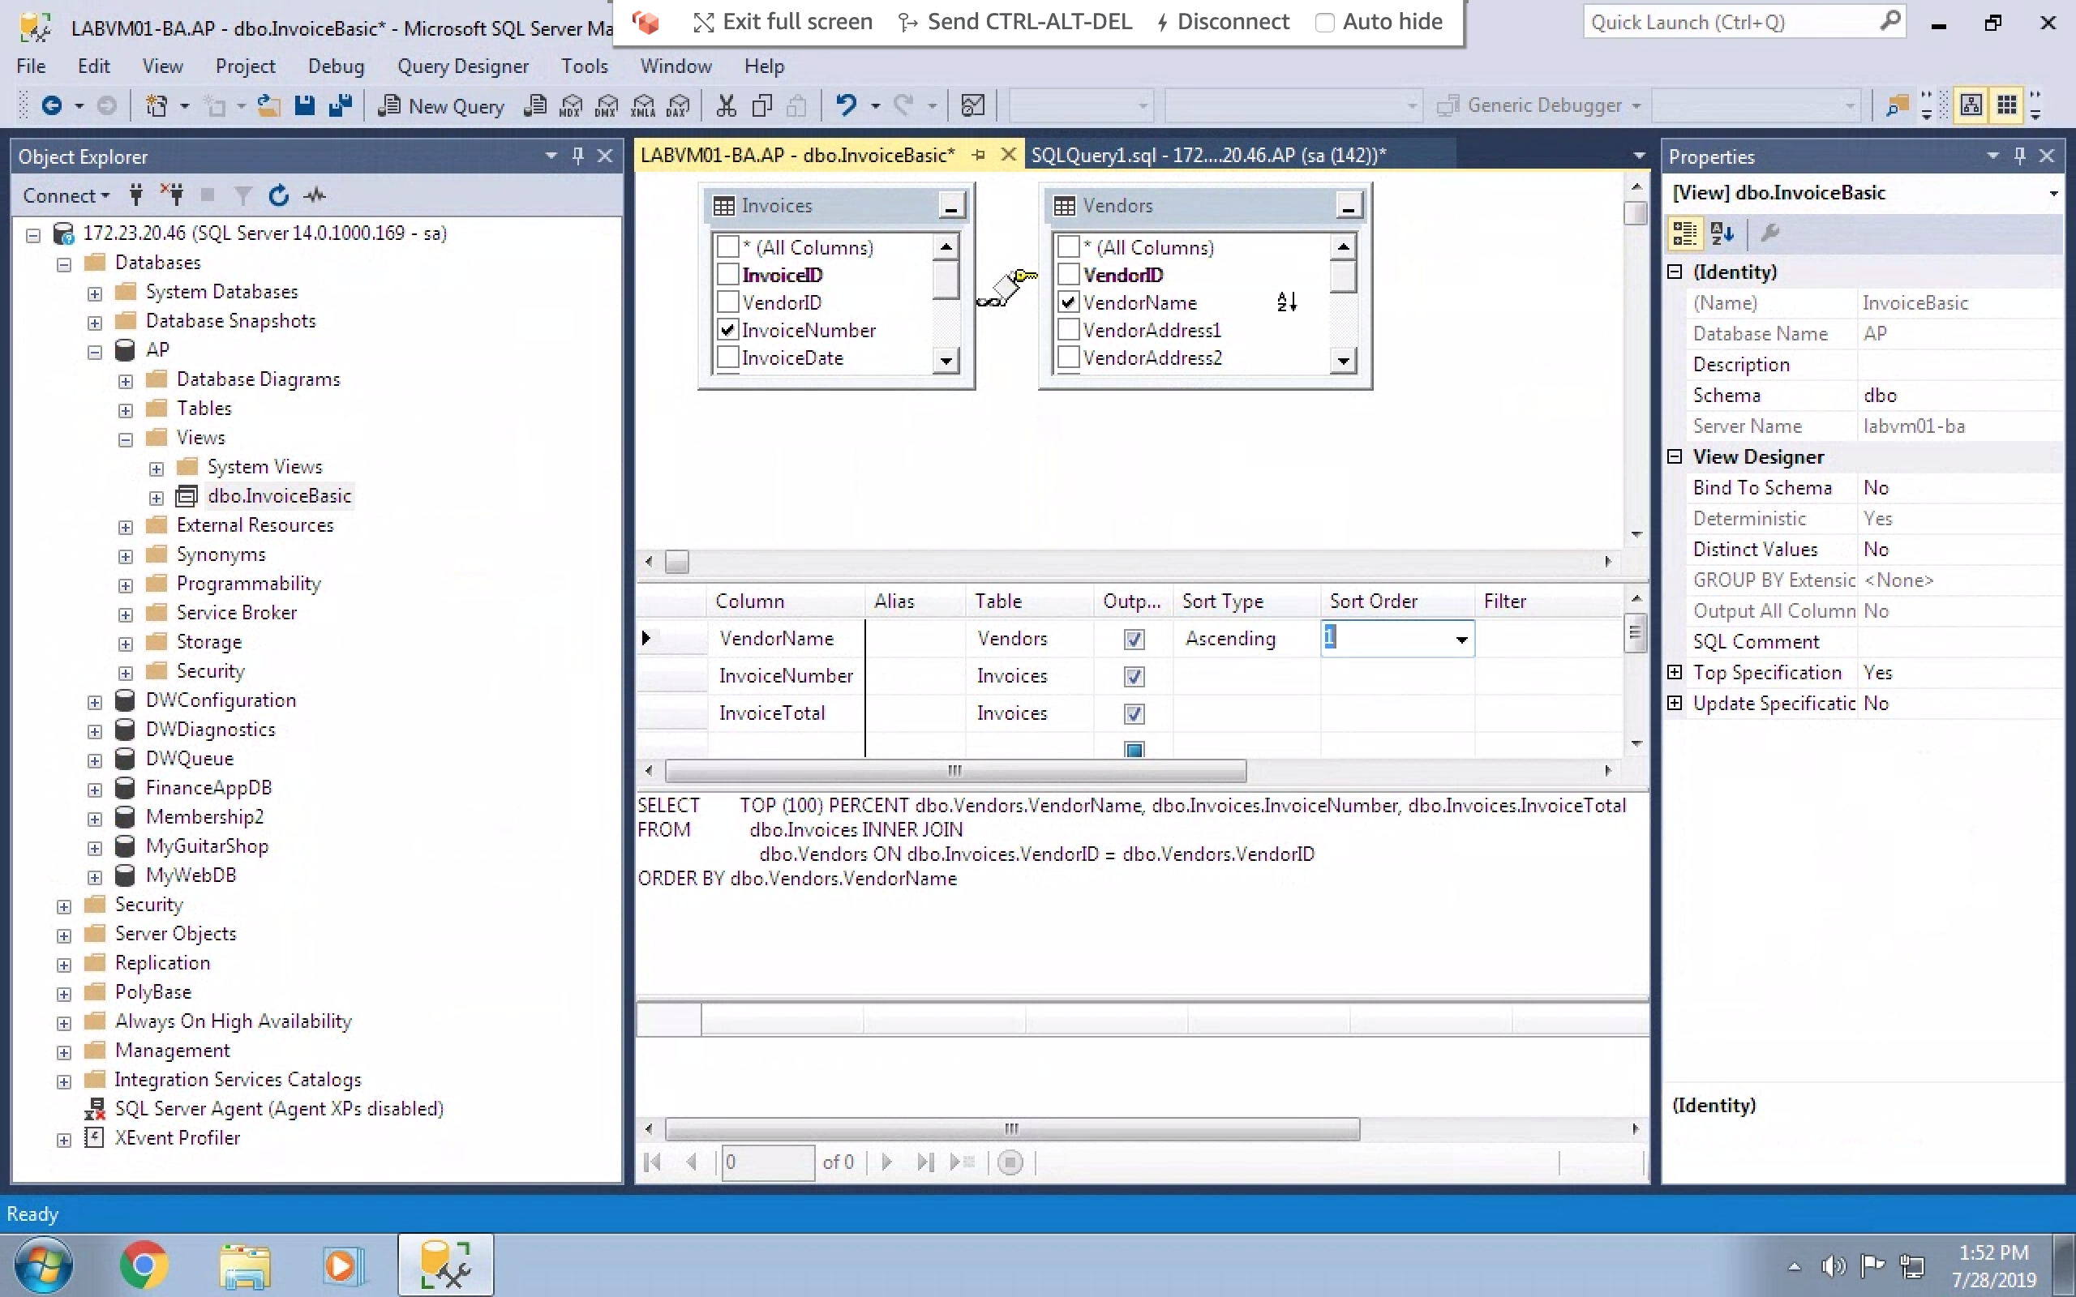

Part C:

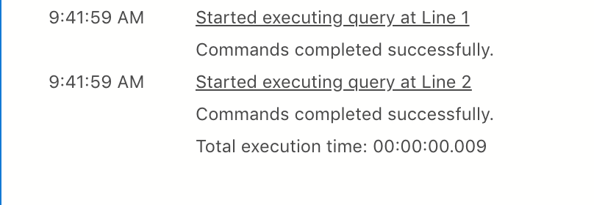

1. The script from the download (pictured first) did not include the VendorName. I added to that script to include the VendorName in the second image.

