BurgerDisk/DominoDisk Smartport Hard Disk for Apple II

User manual

Version 2.5
April 2026

colin@colino.net – https://www.colino.net/
Table of Contents
Index of Figures ii
Index of Tables ii
Introduction 3
BurgerDisk storage configuration 4
Presenting disk images to the computer 4
Debugging and options 5
BurgerDisk installation 6
Booting the computer 6
Troubleshooting 7
Serial debug output 7
Blinking LED, no image mounted 7
Compatibility 7

Index of Figures
Figure 1: Inserting the MicroSD card 5
Figure 2: Example daisy-chain 6

Index of Tables
Table 1: Example config.txt 4

Introduction
BurgerDisk and DominoDisk are Smartport hard disks, with storage backed on a microSD card, for the Apple II line of computers running ProDOS.
Both devices share the same firmware and the same features, so this user manual applies equally to both devices.
It is compatible with the Smartport-enabled Apple II models:
- The Apple //c (apart from the ROM255 version, which can be upgraded)
- The Apple IIgs
- Slotted Apple II computers with a DiskII controller and a SoftSP card.

It is daisy-chainable, which lets you use other storage devices with it.

BurgerDisk storage configuration

Presenting disk images to the computer
Different image formats are supported:
- .po (in ProDOS-ordered format)
- .2mg (in ProDOS-ordered format)
- .dsk (in ProDOS or DOS3.3-ordered format, but of ProDOS volumes)
- .hdv
These images can be either 140KB, 400KB, 800KB, or an arbitrary number of blocks up to 32MB (65535 blocks).
The BurgerDisk does not support .woz, .nib, .edf, .do images.
BurgerDisk uses these disk images to present to ProDOS. They are stored as files on the MicroSD card, formatted as FAT.
By default, the firmware will search for four files: PART1.po, PART2.po, PART3.po, PART4.po, and present them if they exist.
You can also put images with arbitrary names, and reference at most four of them in the config.txt file at the root of the MicroSD’s filesystem.
Table 1: Example config.txt
A2DeskTop-1.5-en_800k.2mg
Total Replay v5.2.hdv
Documents.po

Your Apple II can boot from any slot, but only from the first device in any slot. For the BurgerDisk, this means you can boot from the first partition if the device is first in the daisy-chain. Booting from another partition requires modifying their order in config.txt.
Afterwards, you can insert the MicroSD card in its slot (face up, connector down), connect your device to your Apple II, and boot it.
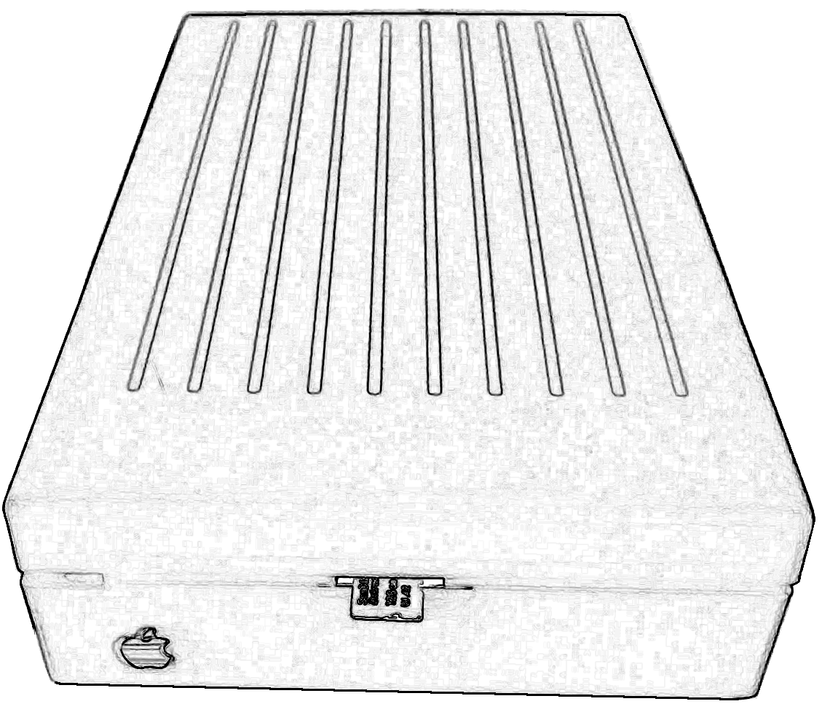Figure 1: Inserting the MicroSD card

Push the card until it clicks in place. Push it again to remove it.

Debugging and options
debug (default 0): If you would like to work on the BurgerDisk firmware, enabling debug messages on its serial port will be useful. You can do that by adding debug=1 in an options.txt file at the root of the SD card.
force_next_smartport (default 1): By default, BurgerDisk lies to the controller, telling it there are more Smartport devices after it. This makes chaining an SPIISD (or other devices that do not correctly advertise themselves as Smartport devices) possible. It has no adverse effects, but this can be disabled using force_next_smartport=0 in the options.txt file.

BurgerDisk installation
To connect the BurgerDisk to your Apple II, you can either plug it directly to the computer, or to another device, in what is called a Daisy Chain. This allows you to have multiple storage devices connected to your computer. Daisy chains have rules about devices ordering:
- First “dumb” 3.5” floppy drives, like the Apple 3.5 Drive (A9M0106)
- then Smartport devices, like the Unidisk 3.5 (A2M2053) or the BurgerDisk
- followed by 5.25” floppy drives (except on Liron cards, which do not handle 5.25” drives at all)
In this example, the Apple II will be able to boot from the Unidisk 3.5”. To boot from the BurgerDisk’s first partition, invert the Unidisk 3.5” and BurgerDisk, so that the BurgerDisk is connected to the computer, the Unidisk connected to the BurgerDisk, and the Disk //c connected to the Unidisk.
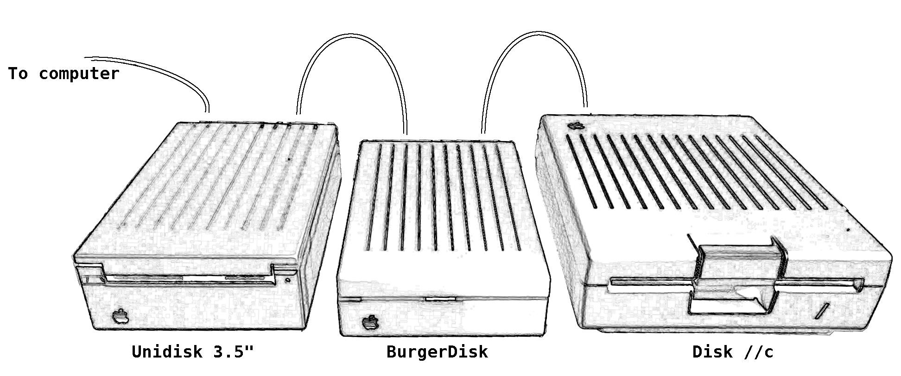Figure 2: Example daisy-chain

Booting the computer
The Apple II can boot from the first device in a given slot. Smartport devices are usually in slot #5, and 5.25” drives in slot #6.
If you want to boot your Apple II from the BurgerDisk, use a bootable image, like A2Desktop, as first image; and connect the BurgerDisk first to the computer.
Note: this means that you cannot directly boot from the BurgerDisk if an Apple 3.5” drive (A9M0106) is present in your chain, even if no floppy is inserted into it; because the A9M0106 drive has to be connected first.

Troubleshooting

Serial debug output
If you are investigating a problem or experimenting with your own modifications of the firmware, you might want to enable debug output on the Arduino’s serial port.
This can be enabled with a debug=1 line in options.txt.
Afterwards, you can open the enclosure, locate the UART port, and connect an UART to USB adapter to it. Connect the UART’s GND to the adapter’s GND, and the UART’s TX to the adapter’s RX.

Blinking LED, no image mounted
If after booting the Apple II, a small delay happens, followed by the BurgerDisk’s LED blinking 4 times per second, and none of its volumes are visible by ProDOS, this means that the MicroSD card initialization failed, or that zero valid images were found on the card. Verify its presence and contents.

Compatibility
So far, the BurgerDisk has been tested on:
- Apple //c ROM3, model A2S4000
- Apple //c ROM4x, model A2S4100
- Apple IIgs, ROM01
- Apple IIe, Liron card
- Apple IIe, DiskII controller + SoftSP card
Various daisy chaining configurations have been tested:
- only the BurgerDisk on the Smartport bus
- Unidisk 3.5”, then BurgerDisk
- BurgerDisk, then Disk //c
- Unidisk 3.5”, then BurgerDisk, then Disk //c
- Unidisk 3.5”, then BurgerDisk, then another BurgerDisk, then Disk //c
- BurgerDisk, then Unidisk 3.5”, then Disk //c
In case of problems in a daisy chain, verify that your chain respect Apple’s rules, and that the chained devices are actually able to be chained.

Liron card notes: the Liron card is not able to drive a 5.25” drive.
SoftSP card notes: the SoftSP card is not able to drive a Unidisk 3.5” drive. It has annoying, but non-blocking issues with 5.25” drives.

Compatibility with the SPIISD, Fujinet, or other Smartport-based devices has not yet been tested.

