BurgerDisk Smartport Hard Disk for Apple II

Quickstart

Thank you for getting a BurgerDisk! I hope you will like it.

Quick pointers to start using it:
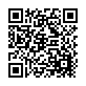 | The User Manual is available at https://www.colino.net/wordpress/wp-content/burgerdisk-user-manual.pdf
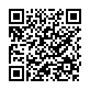 | Assembly instructions are available at https://github.com/colinleroy/BurgerDisk/tree/main/build_instructions

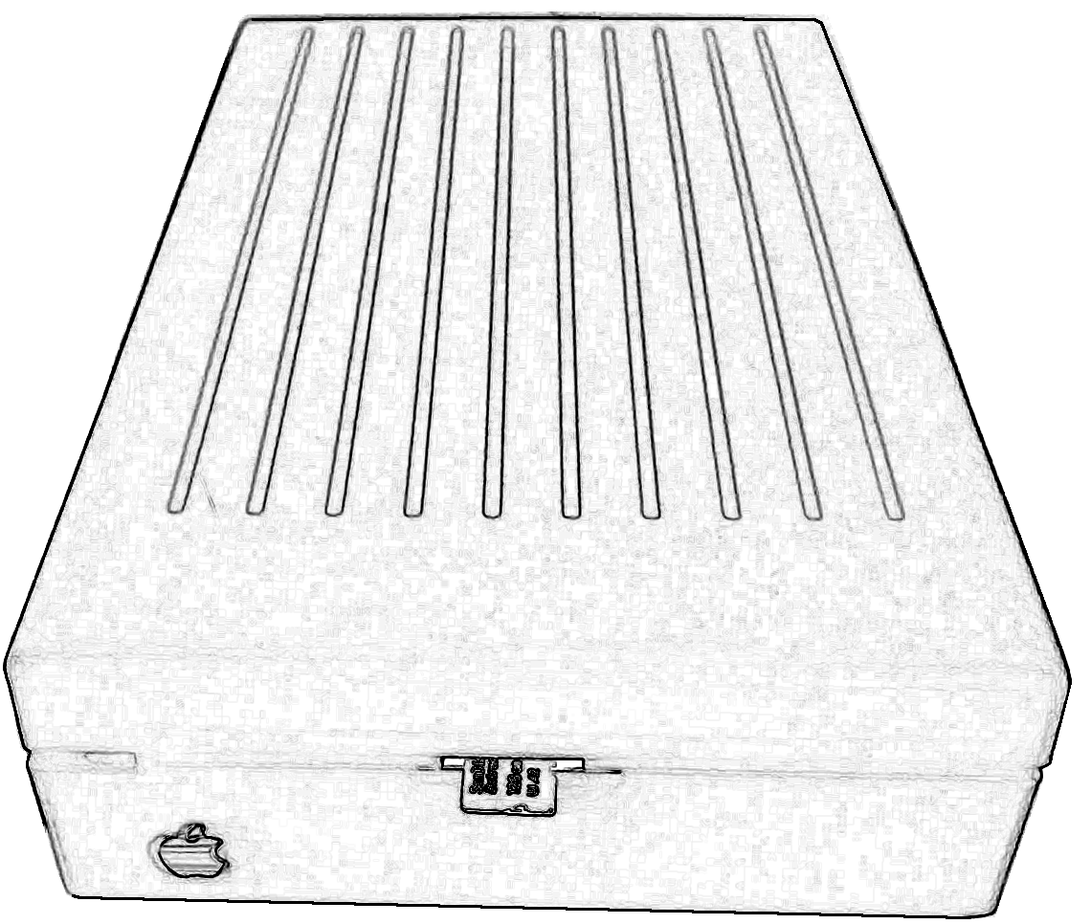
Your enclosure comes with a 3D-printed Apple logo taped to it. You can either glue it, or remove it and glue a real vintage Apple logo if you have one available.
Have fun!

Kit contents
Small components taped here
R2  150Ω | R1  330Ω | D1  removed | D2 1N4448 | D3  1N5818 | R4  10kΩ | R5  1kΩ | R3  470Ω
Errata: D1 was an issue with SoftSP
cards.Solder a leg from another
component instead.

In the box, for the PCB
- One BurgerDisk PCB
- One adapter PCB
- One Arduino Nano
- One MicroSD module
- One pair of DB19 connectors
- One pair of IDC20 connectors
- One pair of 15-pin sockets
- One LED
- One PC817 optocoupler
- Two 2-pin headers
- One 6-pin header
- One 6-pin cable
- One 2-pin cable
- One IDC20 cable
- 2 M2x8mm screws

In the box, for the enclosure
- The enclosure itself
- The adapter’s enclosure
- One LED diffuser
- One white Apple logo
- Two M2x12mm screws
- Four M3x20mm screws

