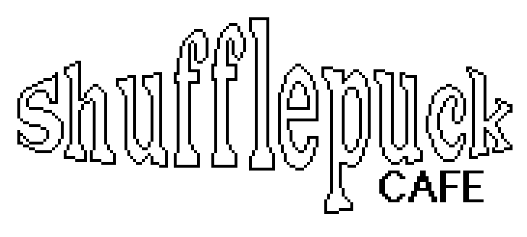
for the Apple II
Game manual
Version 23.1.0
June 2025

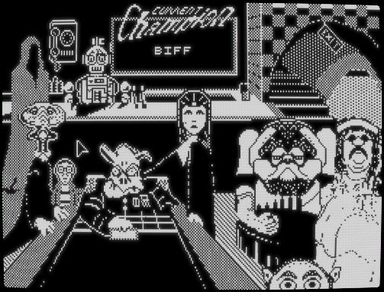

colin@colino.net – https://www.colino.net/
Table of Contents
Requirements 3
Welcome to the Shufflepuck Cafe 4
Meet the Gang 5
The tournament 7
A word about the Apple II port 8
Thanks and acknowledgments 9

Requirements

This game requires an Apple ][+ or more recent (IIe, //c, //c+, IIgs...) with:
- 64kB of RAM or more
- a 6502 CPU
- a mouse (and Mouse Card)

It is more pleasant to play Shufflepuck Cafe on a monochrome monitor. A color monitor will work as well, but there will be color artifacts on composite output (with an RGB card, the graphics should be monochrome).

The two players mode require, of course, a serial card in both computers.

Welcome to the Shufflepuck Cafe

You are the galaxy’s most adventurous spaceman. On the way back home for an overdue bowl of Chocolate Frosted Sugar Bombs, your trusty but old spaceship suffers a Turbo-Hyper Thrust Drive malfunction and you find yourself stranded on planet Plootarg. You end up on the wrong side of town. Now all you need to do is find a phone, and a rescue team composed of a stuffed tiger and your mom will be on its way.

The only signs of life seem to be coming from a shoddy structure three doors down and across the street.

Opening the door, you make your way down a flight of debris-covered stairs.
You stumble into the room and suddenly it’s as silent as the depths of space. Several pairs of hostile eyes, and one set of three, challenge you to enter. The only thing that stands between you and the telephone is eight galactic misfits, an obsolete droid bartender, and a few “friendly” games of Shufflepuck. Relax: if you lose, you’ll earn their contempt. Win, and you’ll earn their resentment.

But as you and them get to know each other, you may start enjoying each other’s company and build community with these outliers.

Meet the Gang

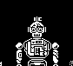
DC3-ALSO is a standard training robot developed by Tons-O-Fun industries. He doubles as a bartender in the cafe, but can take time out of his job to play with you. Adjust his knobs using the Space key during a game to train according to your abilities. His Maximum Movement Speed knob makes him better at catching the puck, while his Hit Force makes him more or less aggressive sending it back to you.

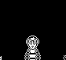
Skip Feeney is a novice player. Skip likes to think of himself as a badass and this is why he hangs in there, but he’s a really bad player and the others mostly accept him because he is a nice person, and maybe also because it is fun to beat him 15-0. Maybe one day he’ll get good at the game!


Visine Orb is a native of Squalor III. He’s a bit shy and has a hard time judging the puck’s movement due to his lack of height, but he can surprise you from time to time. He also does not try to hide his feelings, which is refreshing.

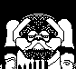
Vinnie the Dweeb is a grad student, attending the University of Xytpl. A physics major, he is very good at puck’s ballistics and you will need to have him make an effort in order to score points.

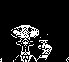
Lexan Smythe-Worthington is from one of the richest families on Saurus VIII. Rejected by his family for who is he, he receives 2500 credits a month as long as he stays five light-years away from his home planet. An extremely good player, he could be a champion if he did not have the bad habit of celebrating most of the points he scores.

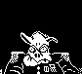
The General, also known as Eneg Doowtrop, is an intergalactic revolutionary who sadly thinks replacing the existing oppressors with oppressors he agrees with would be a good thing. While a very good player, he somehow manages to lose a tiny bit of his concentration after a few exchanges. This is your chance.

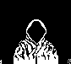
Nerual Ttoille. A mysterious hooded figure, no one really knows from where they are from, or what their story is. They like to play in their opponent’s style, so you’ll get what you send them. Better be sure of you before trying to score!

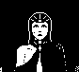
Princess Bejin is one of the most respected players in the Cafe. She can trounce any of the other patrons, except Biff. She has unique mental powers, akin to a magician, that she will use against you. Some may call that cheating, but nothing in the rules of Shufflepuck says that one actually has to touch the puck. Be mindful and connected to all your senses when she serves or you’re toast.

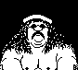
Biff Raunch is the reigning Cafe champion. He supposes he hates to lose. That never happened, but he hates the thought of it. He can be very mean during a game as he takes Shufflepuck very seriously, but is a lighthearted, kind dude otherwise. He won’t give you any point, so you’ll have to be as mean as he is to stand a chance.

To begin playing, just click on your opponent. You control your paddle with the mouse. The button has no purpose in this version of the game. Your paddle has some very evolved technology that prevents it from sending the puck towards your end of the table, no matter how hard you try.

To return to the Cafe during an actual game, you can exit using the Escape key. During a game, the Space key will pause the game.

When you are ready to leave the Cafe and go home, victorious or not, simply click the staircase’s EXIT sign or press Escape.

The tournament

Once you got to know your comrades and think you stand a chance to actually win against everybody, click on the Champion sign in the Cafe, then select TOURNAMENT. Once you win against Skip, Visine will try to beat you, and all the others will in turn try to stop you from proudly writing your name on the Roster of Champions. If you, or anybody else, somehow managed to beat everyone, you will be able to fondly remember those memories by clicking the Champion sign and selecting VIEW ROSTER.

DC3 will not participate in the tournament, as he insists on playing with both knobs turned to 11, which nobody agrees to, because everybody considers that would be cheating.

Good luck!

Two players mode
Hook up two Apple II computers together using a null-modem serial cable, make a copy of the game floppy, and play Shufflepuck against friends or family.
Click on the telephone behind DC3 in the bar. On the next screen, select your serial card slot (on the Apple IIgs, select the Modem or Printer port).
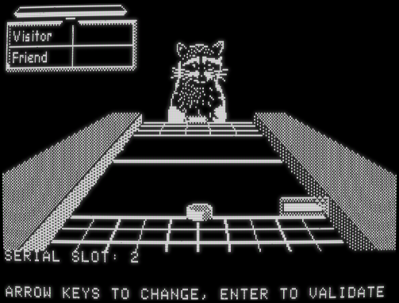
You can then select your avatar and press Enter. Once your opponent will have done the same, the game starts. The first player to serve is determined randomly.

In two players mode, your paddle hits the puck less hard than against the computer. The puck’s maximum speed is in fact divided by two. This choice has been made after beta-testing with my sons and partner, and agreeing that we humans, in fact, have Skip-level reflexes!

A word about the Apple II port

Back in 1990, at the age of 10, I had the privilege of having access to an Apple //c in my (and my sister’s) bedroom. It came from my father’s workplace when they upgraded their computers, and it came with a mouse, a few utilities floppies, AppleWorks and Mousepaint, one (1) game floppy – Space Invaders - and two manuals: the ProDOS manual, and the AppleSoft BASIC manual.

Despite my very limited access to resources – most of my friends had either a Nintendo console, a 286 with a color monitor, or no computer at all, I still fell in love with that computer and with the thought that given enough effort, one could do anything with these machines (and it is what made me choose IT as a career).

On some week-ends, we went to visit my grandparents, where my uncle Xavier had a remote work station set up in the attic – in 1990!

There was a Sun workstation with an optical mouse, which I didn’t dare to touch, a modem, and a Macintosh SE/30. I would spend afternoons playing the games he had on the SE/30: Beyond Dark Castle, Crystal Quest, Glider, and Shufflepuck Cafe. I loved this game so much that I tried, multiple times, to clone it at home, on the //c, in BASIC. Needless to say I badly failed each time.

Well, now I succeeded.

This port is meant as a tribute to the original game, and I hope that if Christopher Gross, Gene Portwood and Lauren Elliott hear of it, they will not mind that my version is so heavily inspired by their work.

I hope you will enjoy playing the game as much as I enjoyed developing it.

Thanks and acknowledgments

As usual, I want to start by thanking my partner Abi, who again has been very tolerant of the long evening hours I spent coding this game, combing through 6502 traces and “coming in five minutes”; and even afterwards, actually listening to my infodumps about segments, cycles, hertz, vertical blanking and so on. Thanks Abi, I love you.

I would also like to thank my kids, all three of them, because their initial response to my Glider port has been really unexpectedly enthusiastic for people born in the 2010s. That made me think I was possibly doing something right, and that I could, maybe, finally tackle Shufflepuck and be proud of the result. They actually ask me if they can play Shufflepuck on the Apple //c, while they have Minecraft, Forza Horizon, DOOM Eternal and such games at their disposal, which really means something to me.

Thanks also to LeJun for doing the Vinnie, Eneg, Nerual, Biff and DC3 sprites for me, and thanks to Awot83 for Lexan’s sprite.

Thanks to Antoine Vignau, Blake Patterson, Jarrod K., and Steve Yuhasz for their bug reporting and testing.

Serial cable wiring
It’s up to you to wire your serial cable depending on the computers you want to use. Three pins are required: TX, RX, and ground. TX on one side goes to RX on the other, and vice-versa. Here are the pinouts for the different Apple II serial connectors:

Apple IIc, with DIN-5 connectors

1 5 2: RX (Seen from front of male plug)
2 4 3: Ground
3 4: TX

Apple IIe, with DB-25 connectors

1 2 3 4...11 12 13 2: TX (Seen from front of male plug)
14 15 ... 24 25 3: RX
7: Ground

Apple IIgs, with Mini-DIN-8 connectors

6 7 8 3: RX (Seen from front of male plug)
3 4 5 4: Ground
1 2 5: TX

Example
To connect an Apple //c to a IIe:
DIN-5 | DB-25
2 (RX) | 2 (TX)
3 (Ground) | 7 (Ground)
4 (TX) | 3 (RX)

With 64kB of memory available, there will be more floppy disk access; with 128kB or more, /RAM will be used as a cache for most assets.
I am not an artist, so by “heavily inspired”, I mean that I used the original sound effects and redrew the art, with four times less pixels, using theirs as a model. Yes, I ripped all of it off. But I realized while doing it that I actually like doing pixel art.

