Wozamp for Apple II

User guide

Version 23.1.0
June 2025

colin@colino.net – https://www.colino.net/
Table of Contents
Index of Figures ii
Index of Tables ii
Introduction 4
Startup and initial configuration 5
Requirements 5
Serial communications setup 5
Other side of the communications setup 5
The welcome screen 7
Choosing the source server 7
Connection error 8
Browsing webradios 9
Supported medias 10
Playing videos 10
Controlling what to play 11
Controlling playback 12
Audio 12
Video 13
Volume control (for audio and video) 14
Browsing an FTP server 15
Recursive play mode 16
The configuration screen 17
Links and resources 18
Thanks and acknowledgments 19

Index of Figures
Figure 1: The welcome screen 6
Figure 2: The search results 8
Figure 3: Playing an audio file 11
Figure 4: Playing a video file (Prodigy's Breathe) 12
Figure 5: Browsing a NAS FTP server 14
Figure 6: The configuration screen 17

Index of Tables
Table 1: Serial ports by Apple II type 4
Table 2: Navigation controls 10
Table 3: General keyboard shortcuts 10
Table 4: Audio playback controls 11
Table 5: Video playback controls 12

Introduction
Wozamp for Apple II is a project I wanted to tackle since long. As my other Apple II projects, it’s doesn’t have any practical value beyond being fun and very interesting to do.
It is a network multimedia player. It can receive audio and video data over the Apple II serial port(s), and play them to the best of the 6502 CPU and ACIA 6551 serial chip abilities: the sound uses an 11.52kHz sample rate, with 5 bits precision. The video is either about 140x90 pixels resolution (which, technically, is 13K pixels, so it’s not as bad as it sounds once marketing tricks do their magic), or fullscreen with a (much) lower framerate.
Along this core feature are a few bells and whistles: an UI to navigate the contents of your FTP media server, basic playback control (rewind, fast-forward, pause and stop). You will also be able to play a whole directory, view your music files’ metadata (Artist, Album, Title and Track number). When available, Wozamp will display the current song’s album cover art.
Wozamp is also able to let you search for webradios, and stream them. Last but not least, a VU meter will be displayed at the bottom of the screen.

Startup and initial configuration

Requirements

This software requires an Apple ][+, //c, //c+, IIe or IIgs with:
- a language card, providing 64kB of RAM or more
- a serial card, optionally two for video playback
Video playback is not available on the IIgs.

Serial communications setup

By default, the serial port Wozamp uses is the modem port. On a Apple IIe, this translates to slot 2. If you want to use a different slot, you can configure it at startup after the initial connection fails.

Apple II type | Serial ports
Apple //c and //c+ | Slot 1: Printer port  Slot 2: Modem port (default)
Apple IIe | Physical installation slot of the Super Serial Card (default: 2)
Apple IIgs | Channel A: Printer  Channel B: Modem (default)
Table 1: Serial ports by Apple II type
The serial cable to use is a standard Apple II serial cable, the same you would use with ADTPro.

Other side of the communications setup
The proxy server installation is out of scope of this document, and documented at https://www.colino.net/wordpress/surl-server-a-serial-proxy-for-8bit-computers/.
If you plan on watching videos with Wozamp, though, as that requires a dual-serial cable setup, a few words about dual-serial setup. On the hardware side, you will need a second Apple II serial – to – DB-9 cable, and a second USB serial adapter. Plug the first serial cable in the Apple II’s modem port (or slot 2) and the proxy; it should appear on the proxy as /dev/ttyUSB0, and will be the main link (referenced as the ‘tty:’ parameter of the proxy’s configuration file). Plug the second cable in the Apple II’s printer port (or slot 1) and the proxy. It should appear as /dev/ttyUSB1, and is referenced as ‘aux_tty:’ in the proxy configuration file.
The problem with ttyUSBx is that the number depends on the order of which adapter is plugged first. You can work around this, on the proxy, by using the /dev/serial/by-id/ directory: identify which USB adapter is plugged in the Apple II’s modem port (slot 2), and on the proxy, do the following to get their ID:
root@surl-server:~# ls -l /dev/serial/by-id/
total 0
lrwxrwxrwx 1 root root 13 11 avril 03:17 usb-FTDI_FT232R_USB_UART_AB0PXCGI-if00-port0 -> ../../ttyUSB1
lrwxrwxrwx 1 root root 13 11 avril 03:17 usb-Prolific_Technology_Inc._USB-Serial_Controller-if00-port0 -> ../../ttyUSB0
You can now use the following in /etc/a2tools/tty.conf and be sure they won’t switch at the next proxy reboot:
root@surl-server:~# cat /etc/a2tools/tty.conf
tty: /dev/serial/by-id/usb-FTDI_FT232R_USB_UART_AB0PXCGI-if00-port0
baudrate: 115200
hw_handshake: on
aux_tty: /dev/serial/by-id/usb-Prolific_Technology_Inc._USB-Serial_Controller-if00-port0

The welcome screen

Choosing the source server
When starting Wozamp, you will be greeted with a server selection screen, where you will be able to load an URL. By default, the last used URL will be suggested.
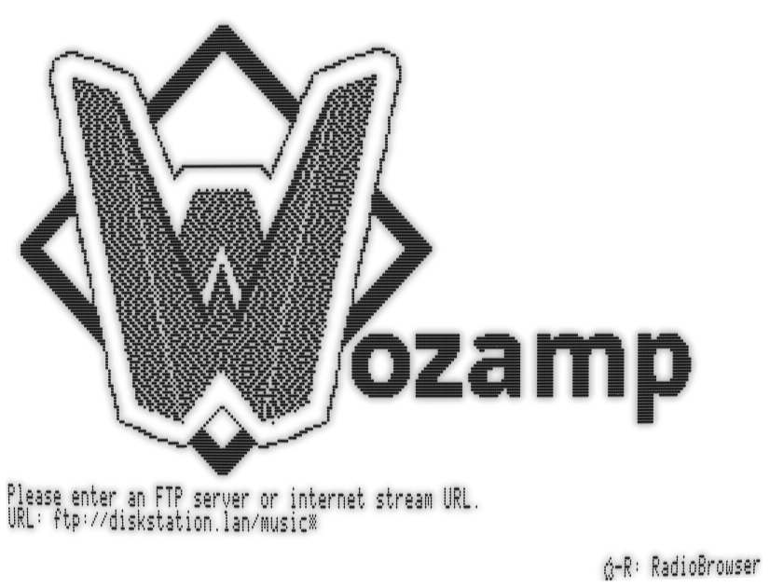Figure 1: The welcome screen
You can use two kinds of URLs in Wozamp:
- A direct URL to a file or stream, for example ‘http://8bit.fm:8000/live’, ‘https://example.com/filename.mp3’, ‘smb://NAS/Videos/movie.mp4’, etc.
- An URL to an FTP server, for example ‘ftp://nas.local/music/’.
In the first case, Wozamp will play the file, and return to the server selection screen at the end of the playback.
In the second case, Wozamp will load the contents of the FTP server, and allow you to browse into subdirectories and select file(s) to play.
In order to help you find a webradio’s URL, you can use Open-Apple-R to start the Radio Browser interface.
It is not possible to use a Youtube, Peertube, Dailymotion etc URL. This functionality is available in WozTubes for Apple II.
From the Radio Browser and the FTP listing, you will be able to change the current server using Open-Apple-S.

Connection error
If you get a connection error (Timeout), you will be able to use the ‘C’ key to configure your serial port. Please check the serial cable is in the slot you intended to use, and try again. Wozamp requires the serial port speed to be set to 115.200bps.

Browsing webradios
The Radio Browser interface greets you with a search query. You can type the name, or part of the name, of the radio you want to listen to. Hit enter to see a list of matches; navigate through the results using left and right arrows, and hit Enter to stream the radio.
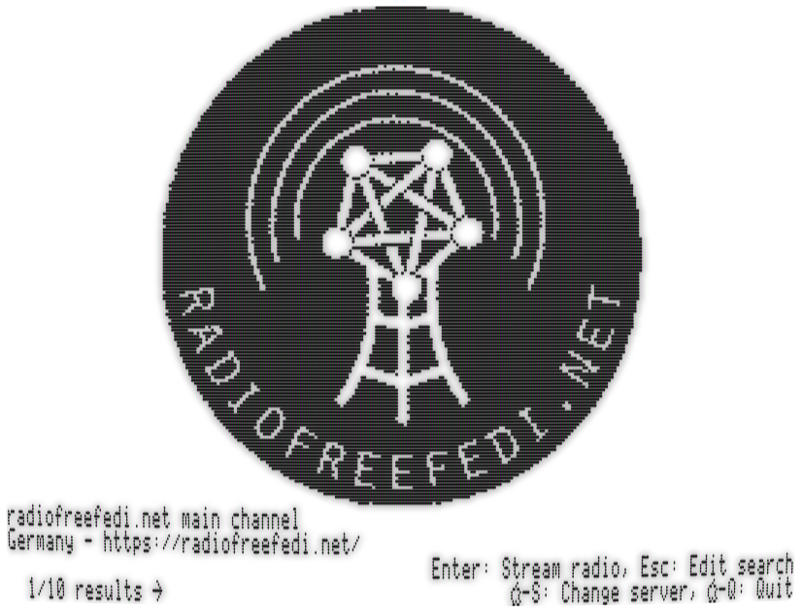Figure 2: The search results
When you exit a webradio stream with the Esc key, Wozamp will take you back to the RadioBrowser interface.

Supported medias
Wozamp can play audio files, video files and images. The specifics (codecs, containers, formats) depend on the libraries on which the surl-server proxy relies. These libraries are ffmpeg and SDLImage, so the supported formats are: a lot.

Playing videos
Wozamp can play video files in two manners. The first one is audio+video; the second one is audio only. If your Apple II computer has two serial ports, and video playback is enabled in the configuration screen, Wozamp will start Video Wozamp when you connect to a direct URL to a video, or when you browse and choose a video file to play.
If your computer has a single serial port, you should disable video playback in the configuration screen, in order to avoid writing to another extension card’s RAM space.
Note: When playing a video file with Video Wozamp, the sound quality is less than when playing only its soundtrack. This limitation is due to the very constrained power of the 65(c)02 CPU: when playing audio only, each sample is played twice to emulate a 22kHz sample rate, which makes the carrier signal less audible. When playing video, the CPU cycles of that second sample are dedicated to video data, and the carriers drops to 15kHz, which is more audible.
When starting to play a video, Video Winamp’s loading screen may stay longer than expected; this depends on the quality and weight of the video, which the proxy has to start decoding enough to make sure it can feed data to the Apple II. An estimation of the time remaining will appear after a few seconds if this is the case.

Controlling what to play
When the server you connected to is an FTP server, Wozamp will present you with a list-based browser, with the files and directories present on your FTP server. The current selection will be highlighted by a ‘>’ symbol at the left of the line. To navigate in the server, you can use the following keys:
Table 2: Navigation controls
Key | Action
Up/Down | Move in the list
Enter | Enter the selected subdirectory / play the selected file
Escape | Exit to the parent directory
A | Play all files in the directory, sequentially and recursively, starting from the selected line
R | Play all files in the directory, randomly and recursively
/ | Search for a string
N | Search for the next occurrence of searched string

In addition to that, from the navigation list, you will be able to use the following shortcuts:
Table 3: General keyboard shortcuts
Key | Action
Open-Apple+C | Configure Wozamp (see The configuration screen)
Open-Apple+S | Change server (see Choosing the source server)
Open-Apple+Q | Quit Wozamp to Bitsy Bye

Controlling playback

Audio
While an audio file is playing, the following controls are available:
Table 4: Audio playback controls
Key | Action
Space | Pause/resume the playback
Left/down | Rewind 10 seconds / 1 minute
Right/up | Fast forward 10 seconds / 1 minute (not on webradios streams)
N | Skip the current song, play next on list
Escape | Stop the playback, go back to list
- | Decrease amplification
= | Set amplification to normal
+ | Increase amplification

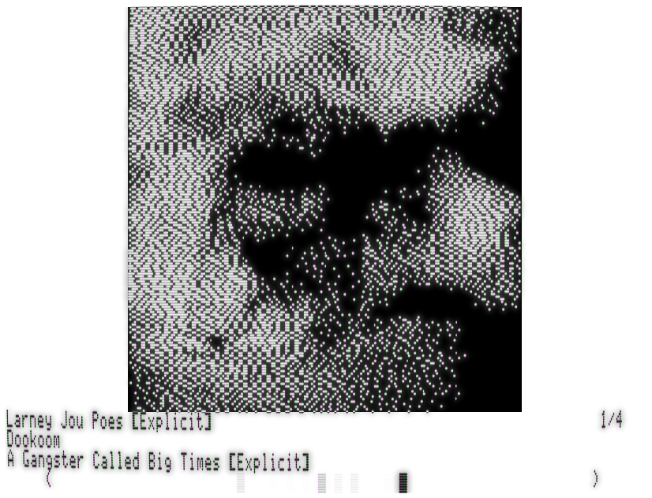Figure 3: Playing an audio file

Video
While a video file is playing, the following control is available:
Table 5: Video playback controls
Key | Action
Space | Pause/resume the playback
Left/Down | Rewind 10 seconds / 1 minute
Right/Up | Fast forward 10 seconds / 1 minute (if enough of the stream is decoded on the proxy)
Escape | Stop the playback
Tab | Toggle subtitles on/off, if enabled in configuration
-/=/+ | Decrease amplification, set to normal, increase amplification
S | Toggle speed/quality

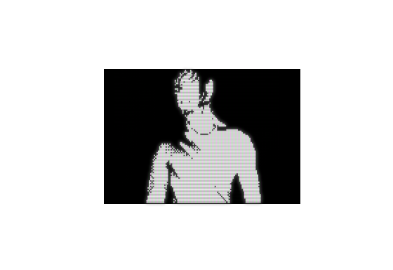Figure 4: Playing a video file (Prodigy's Breathe)
Subtitles generation must be enabled (in the Configuration screen) for the Tab key to have an effect.
The proxy loads subtitles from two possible sources: first subtitle stream embedded in the video file if one exists, or from an SRT file named the same as the video file and stored alongside the video file.
The speed/quality toggle controls which lines of the video are rendered. In faster mode, only one every second line is displayed. This doubles framerate at the expense of precision, in a way that the human eye tolerates surprisingly well. This is most useful if you chose the large video player.

Volume control (for audio and video)
As soon as the proxy finishes decoding the audio stream, it will adapt the amplification level so that over the whole file, the sound signal will use the whole dynamic range.
This automatic gain control is not applied to webradio streaming, as these streams never end.
You can increase the gain with the ‘+’ key, but the loudest parts of the audio stream will be distorted. You can decrease it with ‘-’, but the quietest parts will be less audible. Using ‘=’ resets the gain to the best compromise.

Browsing an FTP server
You can navigate around the contents of the FTP server using:
- Enter: open a subdirectory, or play the selected file
- Escape: go back to the parent directory
- Up and down: move the selection (U and J on a non-enhanced Apple II)
- Open-Apple + Up/Down: move the selection a whole screen (enhanced Apple II only)
- /: Search in the current directory
- N: Search for the next match in the current directory
- A: Recursively play all files, starting from the current selected line
- R: Randomly play all files in the current directory and subdirectories
- Open-Apple + C: Open the configuration screen
- Open-Apple + S: Change the current server URL
- Open-Apple + Q: Quit to ProDOS’s BitsyBye
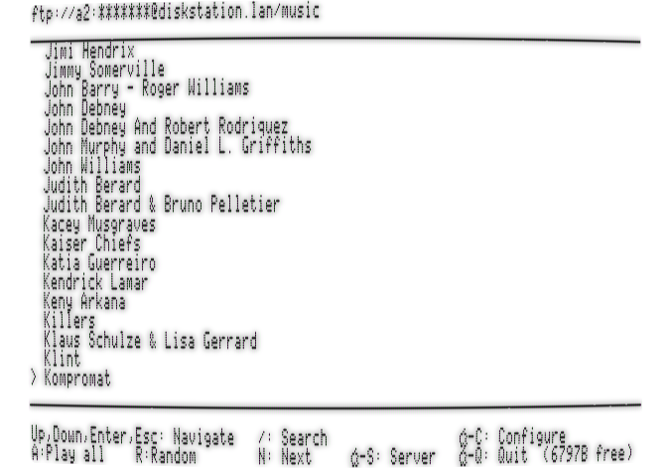Figure 5: Browsing a NAS FTP server

Recursive play mode
When using “Play All” or “Random” play modes, Video Wozamp will not be used if one of the files is a video file, even if enabled; instead, only the soundtrack of the video will be played.
If one or more image files are encountered, they will be shown during 10 seconds. This can let you use Wozamp as a slideshow application.
In both “Play all” and “Random” modes, you can press Escape during playback to completely stop playing, or N to skip the current file and continue playing.

The configuration screen
On the configuration screen, you will be able to specify which kind of keyboard your Apple II has, if applicable. This allows Wozamp to select the appropriate character set and transcode UTF-8 filenames, and metadata, to the Apple II’s native character set. This setting does not appear on non-enhanced Apple II computers, which only support the US-ASCII charset.
You will then be able to specify whether you have a monochrome or color screen. This setting will be used for displaying cover art. It will not, however, be used for Video Wozamp. Video Wozamp’s streaming protocol makes it impossible to use color for the video stream; this means that on a color screen, videos will have green and purple artefacts where some pixels should be white.
The third setting, “Enable video playback”, controls whether you want to play the video on video files. If disabled, only the video’s soundtrack will be played, but at a better quality. This setting does not appear on non-enhanced Apple II computers.
“Video size” controls how large the video will be rendered. Choose “Small” for a higher framerate. In this case, the video will be a maximum of 12800 pixels, centered on the screen.
Choose “Large” for a full-height video (192px if subtitles are disabled, 160px otherwise). In Large mode, the framerate is very low on the majority of videos, but can be increased while watching it by toggling Speed/Quality to Speed.
“Enable subtitles” controls proxy-side generation of subtitles for video. If disabled, using Tab while watching a video will have no effect.
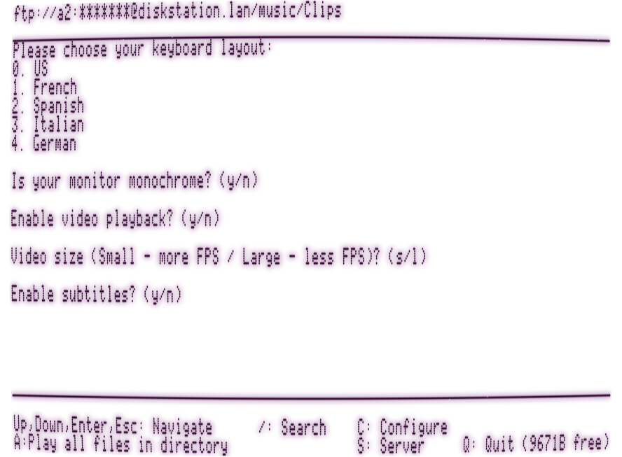Figure 6: The configuration screen

Links and resources
The project code lives at https://github.com/colinleroy/a2tools/
Its homepage is at https://www.colino.net/wordpress/en/wozamp-an-apple-ii-music-and-video-player/
It is built using cc65, https://github.com/cc65/cc65/
Understanding PWM sound generation: https://www.youtube.com/watch?v=UhDgV0sv37o

Thanks and acknowledgments
Many thanks again to Oliver Schmidt (https://github.com/oliverschmidt/), long-time cc65 contributor and Apple II hacker, for his Kansasfest presentation on his A2Stream project, explaining the basics of PWM generation wery well (video linked on the previous chapter).
Thanks to Bits&Terminal Jeff, for finding the coolest name for this project, and by the way, thanks to Steve Wozniak for building my childhood’s computer, and the Winamp folks of the twentieth century for providing the soundtrack to my studies.
Thanks to LeJun for giving me a beautiful SVG basis for the logo – the W is their work!
Thanks to Alex Segler for the nice RadioBrowser API.
Heartfelt thanks, as always, to my soulmate Abigail for her encouragments, her incredible patience and tolerance to my deep-focus mode.

https://www.colino.net/wordpress/en/woztubes-an-apple-ii-invidious-and-peertube-client/

