QuickTake for Apple II

User guide

Version 26.1.1
August 2026

colin@colino.net – https://www.colino.net/
Table of Contents
Index of Figures ii
Index of Tables iii
Introduction 4
Startup and initial configuration 5
Requirements 5
Supported cameras 5
Serial communications setup 5
The Quicktake 100 or 150 connection to an 8-bits Apple II (IIe, //c, //c+) 5
Connecting the Quicktake 100 or 150 with the Connector Box 6
Super Serial Cards configuration on the Apple IIe 7
ImageWriter configuration 7
The Quicktake 200 connection 7
The Kodak DC50 Zoom connection 7
Verifying the connection 8
The main menu 9
Get one picture 9
Preview pictures 11
Delete all pictures 11
Snap a picture 11
Set camera name 12
Set camera time 12
Set quality to... 12
Set flash to... 12
Editing a picture 13
Brightness/contrast settings 13
Dithering 14
Rotation and reframing 14
Saving the result 15
Viewing DHGR pictures 16
Printing a picture 16
Links and resources 17
Thanks and acknowledgments 18
Serial cables reference, per camera and computer 19
Quicktake 100 or 150 cable 19
Quicktake 200 cable 21
Kodak DC50 Zoom cable 22

Index of Figures
Figure 1: Connecting using the Connector Box 6
Figure 2: The serial configuration screen 8
Figure 3: Quicktake for Apple II's main menu 9
Figure 4: Selecting the destination directory 10
Figure 5: Filling in the image name 10
Figure 6: Decompression of a picture 11
Figure 7: The picture edition screen 13
Figure 8: The reframing UI 14

Index of Tables
Table 1: Serial ports by Apple II type 5
Table 2: Custom Quicktake 1x0 cable for Apple //c 19
Table 3: Custom Quicktake 1x0 cable for Apple IIe 19
Table 4: Custom Quicktake 1x0 cable for Apple //c+ 20
Table 5: Custom Quicktake 1x0 cable for Apple IIgs 20
Table 6: Custom Quicktake 200 cable for Apple //c 21
Table 7: Custom Quicktake 200 cable for Apple IIe 21
Table 8: Custom Quicktake 200 cable for Apple //c+ or IIgs 21
Table 9: Custom Kodak DC50 cable for Apple //c 22
Table 10: Custom Kodak DC50 cable for Apple IIe 22
Table 11: Custom Kodak DC50 cable for Apple //c+ or IIgs 23

Introduction
The QuickTake for Apple II project started once Mastodon for Apple II neared completion. It seemed to be a continuity (I could use this to post pictures online using Mastodon), while also providing new challenges – reverse-engineering of serial protocols, of image codecs, and new kinds of optimisations.
I have not been disappointed and am quite proud of the functionality that this little program provides. About all of the basic image edition things you’d do with a modern computer are doable with an Apple II, if only “a bit” slower. And if 1 to 3 minutes to decompress a picture may seem a bit long, it was 90 minutes at first!
This user guide is written to give the curious reader a sense of what can be done today with an Apple II - a machine built forty years ago! - and maybe give them the motivation to go through the initial setup and give this a real test, and marvel at the 560x192 green-and-black images that once were state of the art.

Startup and initial configuration

Requirements

This software requires an Apple //c, //c+, IIgs; or a IIe with:
- an extended 80-columns card, providing 128kB of RAM total
- two Super serial cards

Supported cameras
Despite its name, this software supports more cameras than only Apple’s Quicktakes:
- Apple Quicktake 100 and 150
- Apple Quicktake 200
- Kodak DC50 Zoom

Serial communications setup

The serial slot(s) to use differs with the camera you want to connect, and with different iterations of the Apple II computer.

Apple II type | Serial ports
Apple //c and //c+ | Slot 1: Printer port  Slot 2: Modem port
Apple IIe | Physical installation slots of the Super Serial Cards
Apple IIgs | Channel A: Printer  Channel B: Modem
Table 1: Serial ports by Apple II type

The Quicktake 100 or 150 connection to an 8-bits Apple II (IIe, //c, //c+)
The Quicktake 100 and 150 will not start talking to the computer as long as the DTR line is up. This is not a problem on an Apple IIgs, but will be on all 8-bits Apple II computers, as they use an ACIA-based Super Serial Card: as soon as DTR is deasserted, the ACIA serial chip completely stops communicating. This is a problem that has to be worked around in a hardware fashion. There are two ways to solve this: either using the Apple II Quicktake Connector Box, or building a custom cable.
Using the Apple II Quicktake Connector Box has the advantage of letting you keep the printer connected to the computer, instead of having to switch the printer port cable for printing.

Connecting the Quicktake 100 or 150 with the Connector Box
Connect the two DIN-5 cables to the Modem Port and Printer Port connectors on the Connector Box. Connect the other ends of these cables to your computer, using the necessary adapters if needed (for IIe and //c+).
Connect the Quicktake to the Quicktake port of the Connector Box using a standard AppleTalk cable.
If you have one, connect your printer to the ImageWriter port of the Connector Box, using a standard AppleTalk cable (plus adapter for the ImageWriter I).
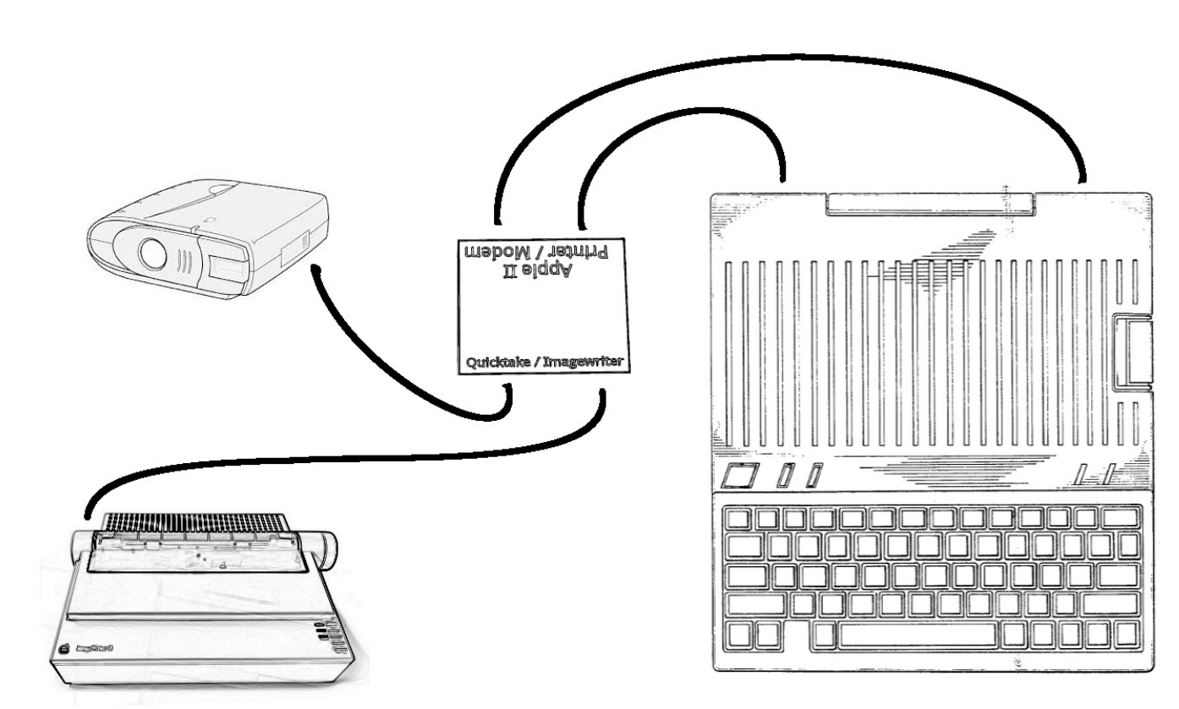Figure 1: Connecting using the Connector Box

Super Serial Cards configuration on the Apple IIe
By default, Quicktake for Apple II will use the card in slot 2 as Modem port, and the card in slot 1 as Printer port. Both cards should be configured as follows:
- The jumper block should point towards MODEM
- Modem mode: SW1-5 and SW1-6 should be ON (closed)
- Interrupts: SW2-6 should be ON (closed)
- RS232C signals: SW1-7 should be ON (closed) and SW2-7 OFF (open)
See the Super Serial Card user manual for more information.

ImageWriter configuration
The ImageWriter should be configured for 9600bps, software flow control (XON/XOFF):
- 9600 bps: SW2-1 and SW2-2 ON (closed)
- XON/XOFF: SW2-3 ON (closed)
These settings are the same for both the ImageWriter I and II.
On the ImageWriter I, also set SW1-5 OFF (open).
See their user manuals for more information.

The Quicktake 200 connection
The Quicktake 200 is provided with a mini-jack to female DB-9 null-modem cable, so you will just need a male DIN-5 (for //c), DB-25 (for IIe) or Mini-DIN-8 (for IIgs) to male DB-9 straight cable.

The Kodak DC50 Zoom connection
The DC50 uses a simple null-modem serial cable, with a Mini-DIN-8 on the camera side, and whatever you need on the computer side. You can also connect your DC50 to the Quicktake port of the Connector Box if you want to avoid making your own cable.

Verifying the connection
At startup, the software will try to connect to a camera. If one is plugged in and turned on, the connection will be made and you will arrive on the main menu. Otherwise, you will be asked whether to configure the serial ports, or try again at a slower speed, 9600 bps.
In the serial configuration screen, the Data slot is where you plug the QuickTake data lines, and the Printer slot is where you plug the DTR line, if applicable.
The Printer slot is also used for printing images when a printer is connected.

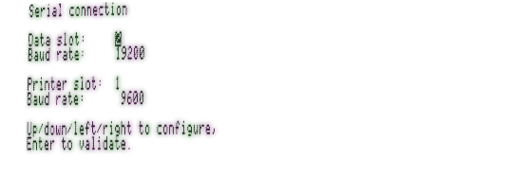Figure 2: The serial configuration screen
If you want to access image edition and viewing features without connecting your camera, you can wait for the timeout and use the N key to stop trying to connect.

The main menu
The main menu header will contain information about your camera, and present you with a list of actions.
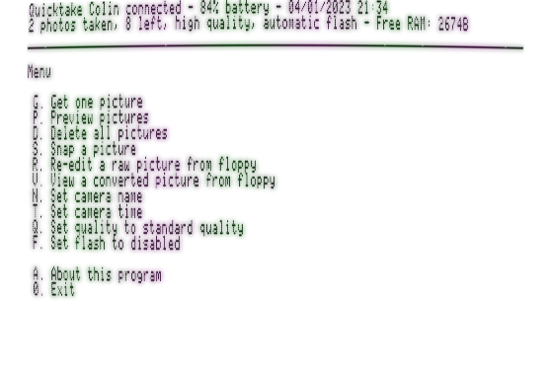Figure 3: Quicktake for Apple II's main menu
Some choices exist only for certains cameras. These are:
- Delete all pictures
- Snap a picture
- Set camera name
- Set camera time
- Set quality mode
- Set flash mode

Get one picture
When you select “Get one picture”, the software will ask you for the number of the picture you want to download and edit. It will then ask you for the destination directory (using a file selector). Navigate to the desired directory using the directional keys and validate with Enter.
Then, complete the path with the desired image name and press Enter.
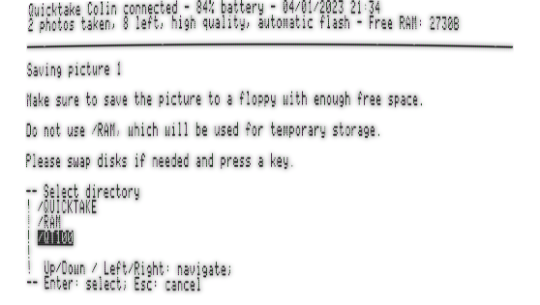Figure 4: Selecting the destination directory
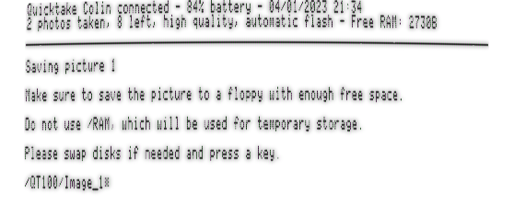Figure 5: Filling in the image name
You can cancel the process and return to the main menu using the Escape key.
The software will now download the picture to disk, and start converting it.

Performance tip: If you are using a Quicktake 100, you might want to shoot in Standard Quality mode. The pictures being four times smaller means they are downloaded four times faster, and decoded twice as fast. The resulting quality loss is barely visible in DHGR.
Once the process is finished, you will be able to edit the picture.
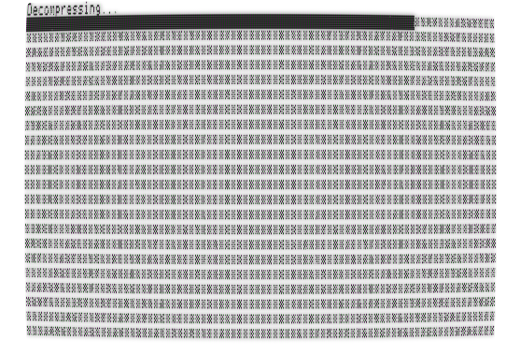Figure 6: Decompression of a picture

Preview pictures
When you select “Preview pictures”, you will be shown the thumbnail for the first picture in your camera, along with the picture’s date and time, the quality mode used to shoot it, and whether the flash was active. You can decide to download the picture (G key), return to the menu (Escape key), or proceed to the next thumbnail (any other key).
The software will remember the last viewed thumbnail during the session, and start again at the next one if you re-use the Preview pictures function.
The thumbnails can be hard to parse as they are very low resolution.

Delete all pictures
Use this function to empty your camera memory.

Snap a picture
Use this function to trigger the camera to take a picture. This is useful in a “studio” setting with the camera mounted to a tripod, for example.

Set camera name
Use this function to change your camera’s name.

Set camera time
Use this function to set your camera’s clock.

Set quality to...
Use this function to change the selected quality mode of your camera.

Set flash to...
Use this function to change the selected flash mode of your camera.

Editing a picture
You can open the picture edition screen in two ways. It is automatically opened after a raw picture is downloaded from the Quicktake camera, and a raw picture stored on disk can be re-edited using the main menu’s “Re-edit a raw picture from floppy” item.
In this screen, you will be able to tweak a few settings to make the best out of the picture. The help at the bottom of the screen will remind you of the available commands; it is hidden by default (in order to see the bottom of the picture), but you can show it by pressing Space.
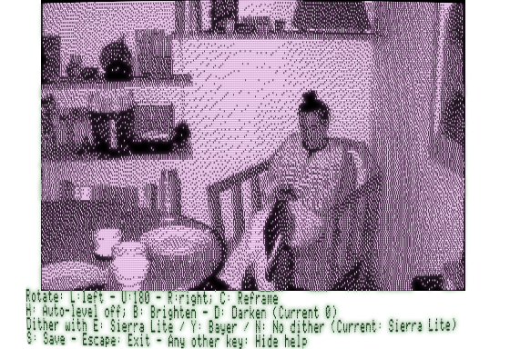Figure 7: The picture edition screen

Brightness/contrast settings
You can disable or enable auto-leveling. This feature finds the darkest and clearest parts of the picture, and re-equalizes the histogram so that the darkest is black, and the clearest is white. This often gives better results, but not always.
You can also manually brighten or darken the picture. If the most interesting parts of a picture are washed-out white, for example, try darkening it a bit.

Dithering
Dithering is the process of reducing the palette. Different algorithms are available: Sierra Lite dithering is the default one, using error diffusion and often giving the best results. Bayer dithering is also available, using ordered dithering instead of error diffusion, and giving quite a different look to the picture. No dithering is also an option, although its use is dubious.

Rotation and reframing
If your picture was shot in landscape mode, it will be 256x192 pixels. If it was shot in portrait mode, you will be able to rotate it left or right. By default, the picture will be rescaled so that all of it fits on-screen, resulting in a 144x192 pixels picture. If you prefer to zoom into the middle part of the picture, you can choose Crop instead of Fit; the picture will then be 192x192 pixels.
When the picture is not rotated, you will be able to reframe it: zoom in a part of a picture.
The levels of zoom available depend on the resolution of the raw picture. A Quicktake 100 raw standard-resolution picture is 320x240 pixels, and you will be able to zoom into a 256x192 region of it. Quicktake 100 high-resolution pictures are 640x480, and you will be able to zoom into regions of either 512x384 pixels, 320x240 pixels or 256x192 pixels.
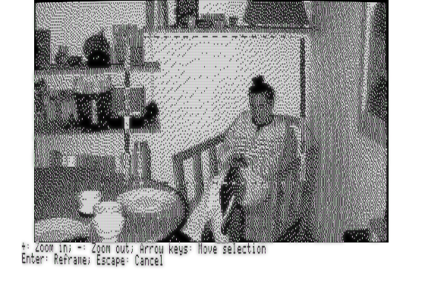Figure 8: The reframing UI
The Quicktake 150 and 200 pictures, while being 640x480, are decompressed to 320x240 and you will only be able to zoom into a 256x192 region of them.
Validating the reframing triggers a new decompression in order to achieve a good quality result.
Even though the Quicktake for Apple II decoders downscale pictures to 256x192 – in order to keep memory requirements low enough -, the dithering process dithers to DHGR, so the resulting pictures are 512x192 pixels. The resulting smoothing of the error diffusion gives notably better results.

Saving the result
Once you are happy with the results, you can save the picture in DHGR format. This is the format that will allow you to quickly re-view converted pictures, print them, or if you feel like it, send them using Mastodon for Apple II!
By default, the DHGR picture name will be saved with the same name as the raw picture, with a .DHGR extension.

Viewing DHGR pictures
You can view your DHGR pictures with the software of your choice, and Quicktake for Apple II comes with a basic image viewer.
Choose “View a converted picture from floppy” to launch it, then select the picture you want to view using the file selector.
The controls of the image viewer are rather simple:
- The Space key allows you to open the next picture in the same directory (and loops over all pictures of this directory).
- The Escape key quits the viewer.
- The P key allows you to print the picture to an ImageWriter II
- Any other key toggles the inline help.

Printing a picture
Before you print a picture, you will be asked for the print scale. You can choose between 72dpi, where one pixel on screen equals one matrix dot and the resulting image will be approximately 9 x 6,7 centimeters; or 36 dpi, where one pixel on screen equals four matrix dots and the resulting image will be 18 x 13 centimeters.
Before starting to print, the software will remind you of the expected printer settings and let you, if necessary, unplug the Quicktake 100/150’s DTR line and plug the printer instead.
Note: only XON/XOFF flow control is supported. This is set on the ImageWriter II by toggling DIP switch 2-3 to off.

Links and resources
The project code lives at https://github.com/colinleroy/a2tools/
Its homepage is at https://www.colino.net/wordpress/en/quicktake-for-apple-ii/
It is built using cc65, https://github.com/cc65/cc65/
The Quicktake Connector Box is available at https://www.colino.net/shop/

Thanks and acknowledgments
Thanks to the #RetroComputing community, full of awesome people. They push me towards doing more and better. Special thanks to @FozzTexx@fozztexx.com on Mastodon, for all his help on testing this software on a wide range of Apple II machines.
Many thanks again to Oliver Schmidt (https://github.com/oliverschmidt/), long-time cc65 contributor and Apple II hacker, for his patience and guidance when I need help to learn things, from linker configurations to 6502 assembly to acceptable-pull-request coding-style.
Thanks to Pierre Dandumont for lending me a Quicktake 150 and 200, so that I could extend my program to also support those.
Thanks to Jonathan Adar for testing, reporting bugs, suggesting good ideas, and his general enthusiasm.
Thanks to Philippe Fernandez for gifting me an extra Super Serial Card and an ImageWriter.
Heartfelt thanks to my soulmate Abigail for their encouragments, their incredible patience and tolerance to my deep-focus mode, the mode in which I can spend full week-ends doing nothing else and basically don’t live here (or anywhere) anymore. Thank you for gifting me an ImageWriter II, knowing full well that meant more hacking time, with awful noises as a bonus! I love you.

Serial cables reference, per camera and computer

Quicktake 100 or 150 cable
Your custom serial cable will plug into the Quicktake on one end, and into two SSCs on the other ends. The cable will be Y shaped. Data will be handled by the modem port, and DTR will be handled by the printer port.
Table 2: Custom Quicktake 1x0 cable for Apple //c
Mini-DIN-8 to QT | DIN-5 modem port | DIN-5 printer port
6 7 8  3 4 5  1 2 | 1 5  2 4  3 | 1 5  2 4  3 | Pin numbering, seen from front of male plug
2+7 |  | 1 | DTR
3 | 4 |  | RX
4 | 3 |  | GND
5 | 2 |  | TX
Table 3: Custom Quicktake 1x0 cable for Apple IIe
Mini-DIN-8 to QT | DB-25 modem port | DB-25 printer port
6 7 8  3 4 5  1 2 | 1 2 3 4...11 12 13  14 15 ... 24 25 | 1 2 3 4...11 12 13  14 15 ... 24 25 | Pin numbering, seen from front of male plug
2+7 |  | 20 | DTR
3 | 3 |  | RX
4 | 7 |  | GND
5 | 2 |  | TX

Table 4: Custom Quicktake 1x0 cable for Apple //c+
Mini-DIN-8 to QT | M-D-8 modem port | M-D-8 printer port
6 7 8  3 4 5  1 2 | 6 7 8  3 4 5  1 2 | 6 7 8  3 4 5  1 2 | Pin numbering, seen from front of male plug
2+7 |  | 20 | DTR
3 | 5 |  | RX
4 | 4 |  | GND
5 | 3 |  | TX
Table 5: Custom Quicktake 1x0 cable for Apple IIgs
Mini-DIN-8 to QT | M-D-8 modem port
6 7 8  3 4 5  1 2 | 6 7 8  3 4 5  1 2 | Pin numbering, seen from front of male plug
1 | 2 | DTR
2 | 1
3 | 5 | RX
4 | 4 | GND
5 | 3 | TX
6 | 8
7 | 7
8 | 6
Note: this is the same cable as the standard Macintosh printer/Appletalk cable

Quicktake 200 cable
Table 6: Custom Quicktake 200 cable for Apple //c
Jack 2.5mm to QT | DIN-5 modem port
BASE|MID|TIP> | 1 5  2 4  3 | Pin numbering, seen from front of male plug
TIP | 4 | RX
BASE | 3 | GND
MID | 2 | TX

Table 7: Custom Quicktake 200 cable for Apple IIe
Jack 2.5mm to QT | DB-25 modem port
BASE|MID|TIP> | 1 2 3 4...11 12 13  14 15 ... 24 25 | Pin numbering, seen from front of male plug
TIP | 3 | RX
BASE | 7 | GND
MID | 2 | TX
Table 8: Custom Quicktake 200 cable for Apple //c+ or IIgs
Jack 2.5mm to QT | M-D-8 modem port
BASE|MID|TIP> | 6 7 8  3 4 5  1 2 | Pin numbering, seen from front of male plug
TIP | 5 | RX
BASE | 4 | GND
MID | 3 | TX

Kodak DC50 Zoom cable
Table 9: Custom Kodak DC50 cable for Apple //c
Mini-DIN-8 to DC50 | DIN-5 modem port
6 7 8  3 4 5  1 2 | 1 5  2 4  3 | Pin numbering, seen from front of male plug
2+7 together |  | DTR
 | 1+5 together | DTR
3 | 4 | RX
4 | 3 | GND
5 | 2 | TX

Table 10: Custom Kodak DC50 cable for Apple IIe
Mini-DIN-8 to DC50 | DB-25 modem port
6 7 8  3 4 5  1 2 | 1 2 3 4...11 12 13  14 15 ... 24 25 | Pin numbering, seen from front of male plug
2+7 together |  | DTR
 | 20+6 together | DTR
3 | 3 | RX
4 | 7 | GND
5 | 2 | TX

Table 11: Custom Kodak DC50 cable for Apple //c+ or IIgs
Mini-DIN-8 to DC50 | M-D-8 modem port
6 7 8  3 4 5  1 2 | 6 7 8  3 4 5  1 2 | Pin numbering, seen from front of male plug
1 | 2 | DTR
2 | 1
3 | 5 | RX
4 | 4 | GND
5 | 3 | TX
6 | 8
7 | 7
8 | 6
Note: this is the same cable as the standard Macintosh printer/Appletalk cable

https://mirrors.apple2.org.za/ftp.apple.asimov.net/documentation/hardware/io/%0Asuper_serial_card/Apple II Super Serial Card User's Manual.pdf
ImageWriter I: https://documents.cdn.ifixit.com/kc5NFFCZCGGyMYxw.pdf ImageWriter II: https://apple2online.com/wp-content/uploads/ImageWriter-II-Owners-Manual.pdf

