surl-server Raspberry Pi 4/5 serial hat for Apple II

Quickstart

Kit assembly is done in a few steps:
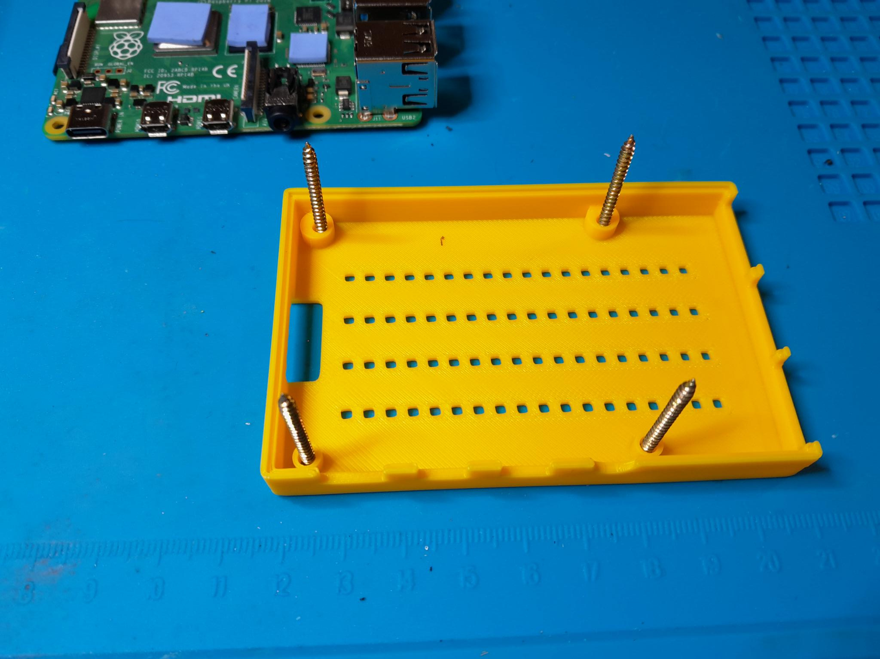  1. Insert four screws at the bottom of the case | 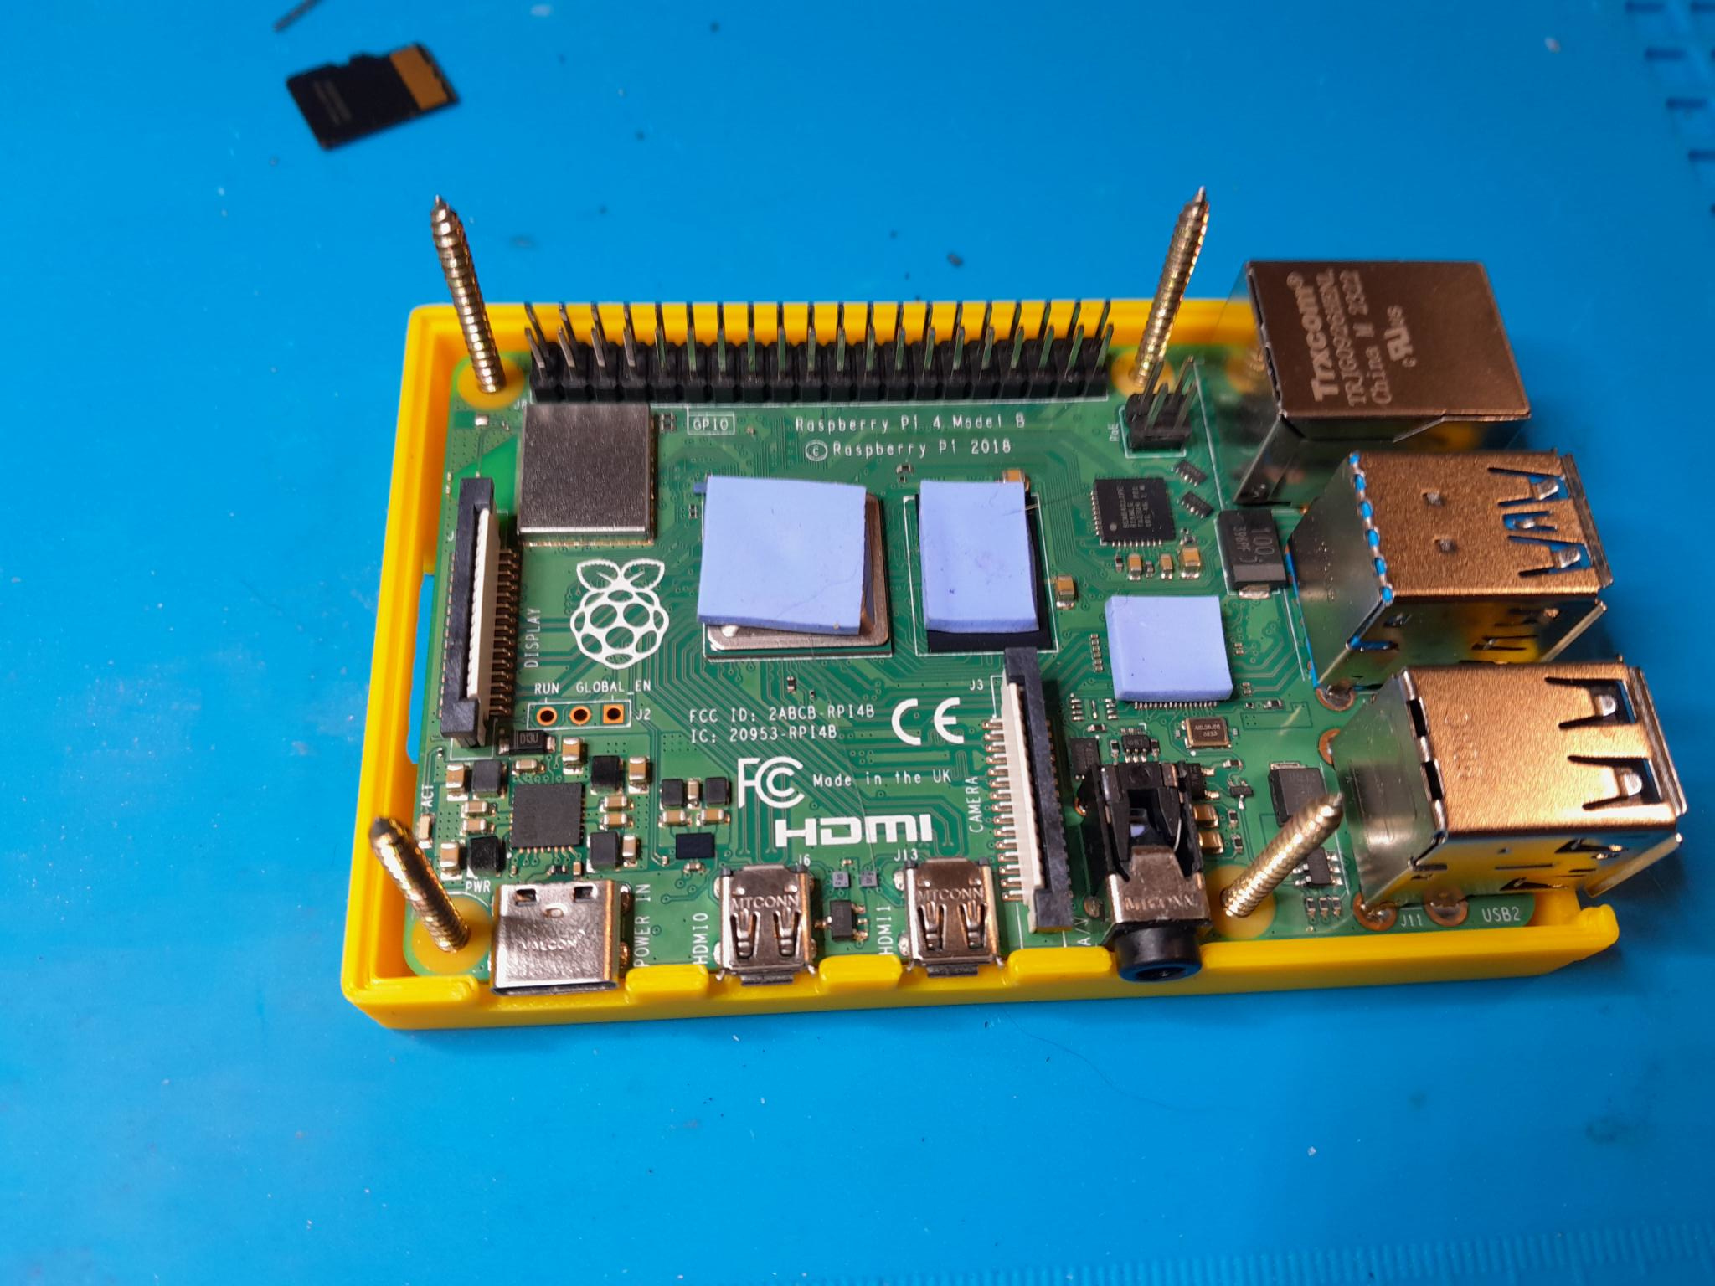  2. Position the Pi in the case
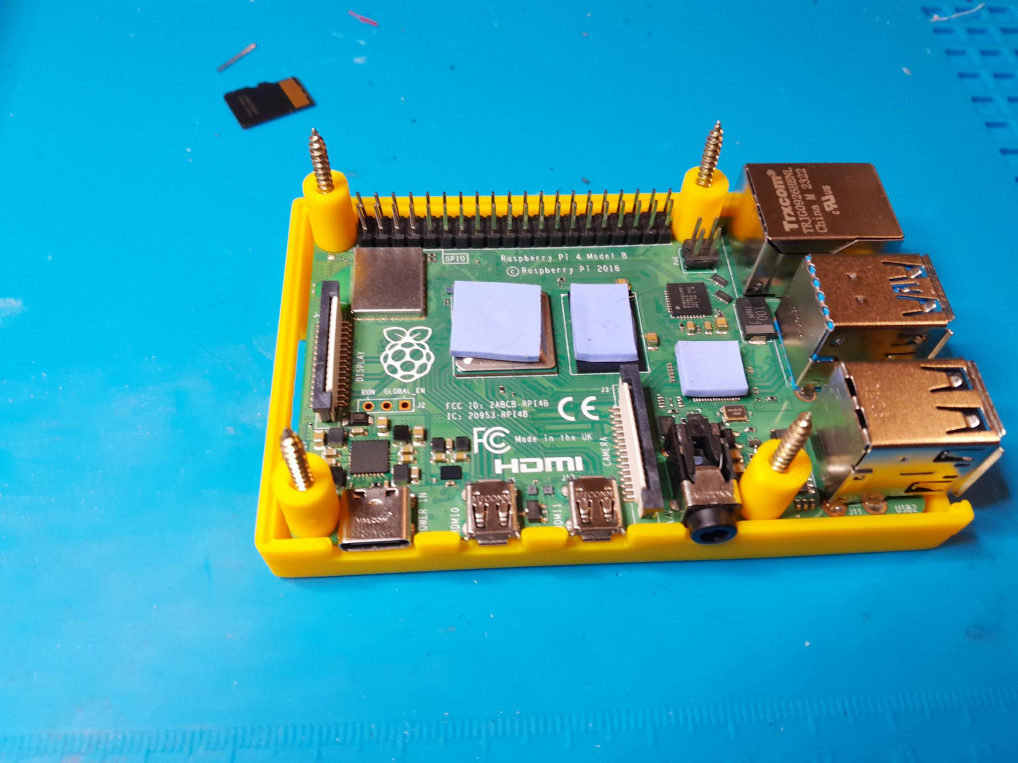  3. Insert spacers on the screws* | 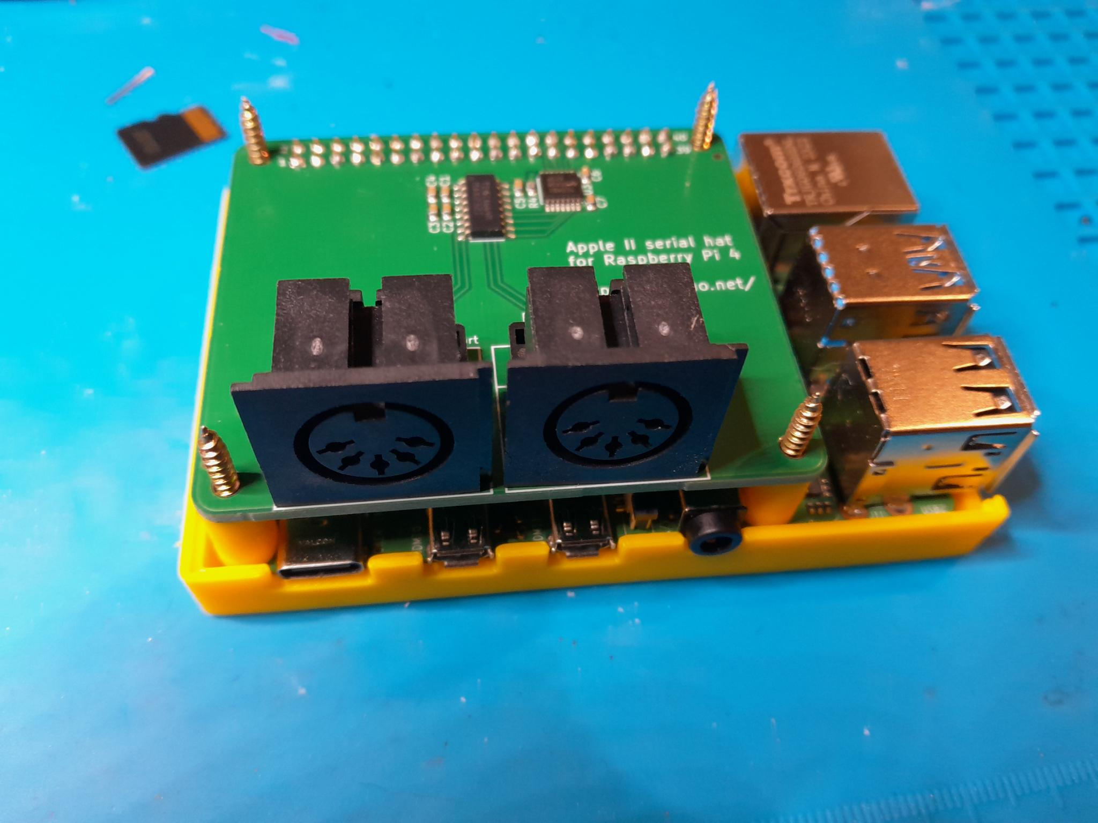  4. Plug the serial hat on the Pi
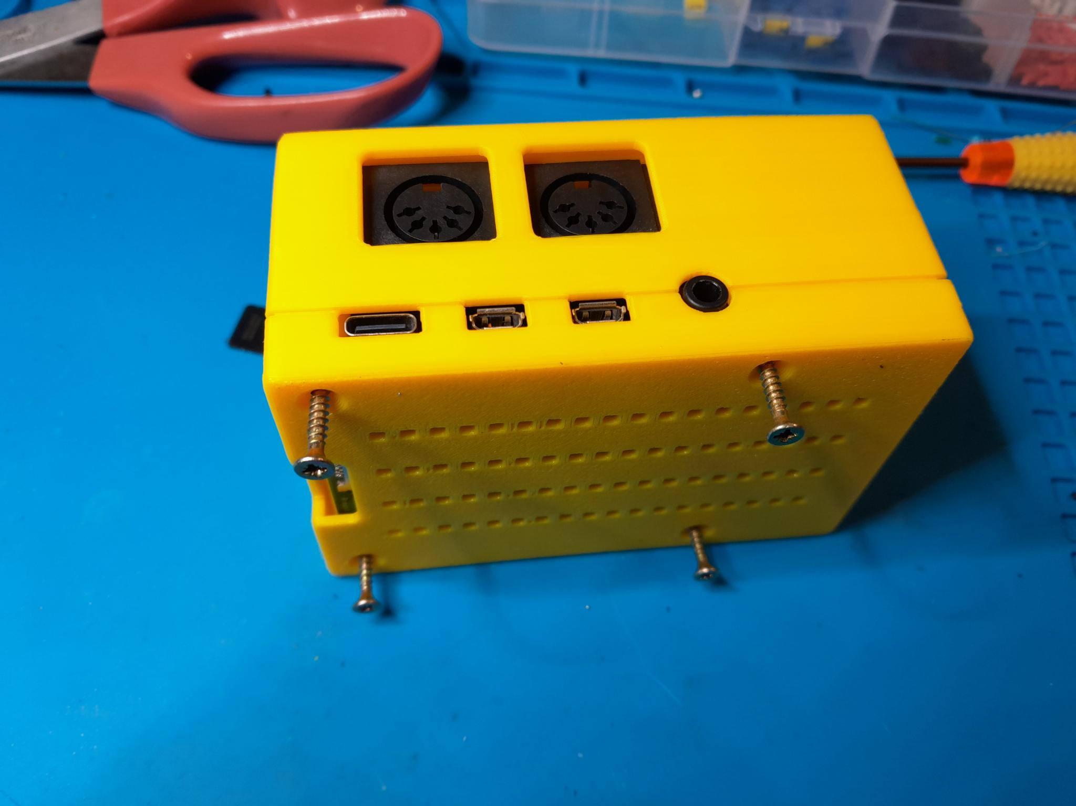  5. Rotate 90°, minding that the screws stay in place enough to hold the spacers | 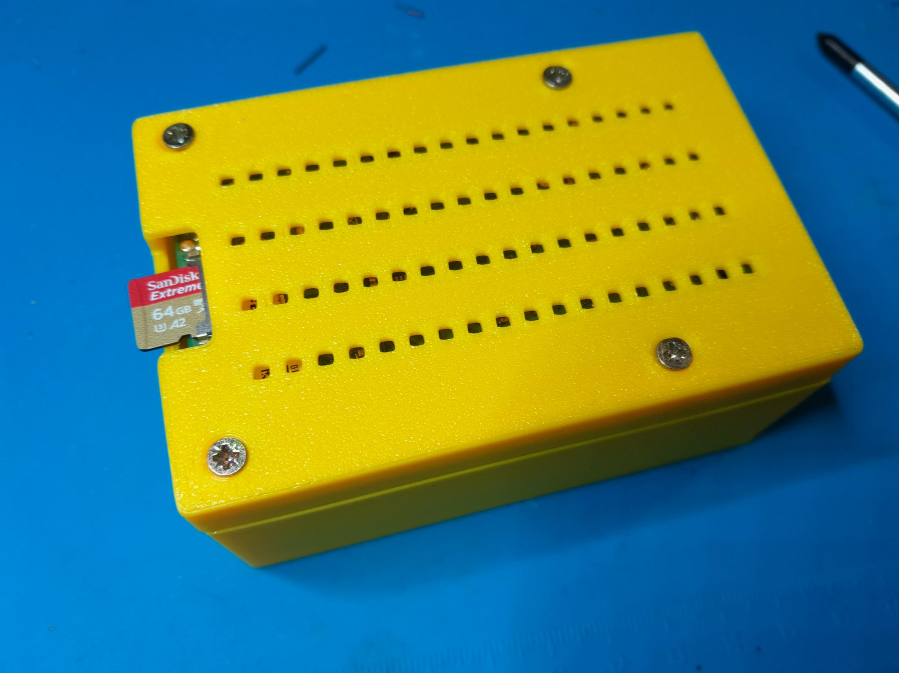  6. Screw shut and insert the microSD card
*2mm spacers with Geekworm P165-A heatsink, 11mm otherwise

Software installation
If you start from scratch, get the latest surl-server image from https://github.com/colinleroy/a2tools/releases and dump it on a microSD card.
From a Linux computer, the procedure is something like:
gunzip surl-server-RELEASE-YYYY-MM-DD-lite.img.gz
sudo dd if=surl-server-RELEASE-YYYY-MM-DD-lite.img of=/dev/mmcblk0
sync && sudo eject /dev/mmcblk0

More details are available at https://www.colino.net/wordpress/surl-server-a-serial-proxy-for-8bit-computers/.

If you already are a surl-server user, update surl-server to the latest version:
sudo apt update && sudo apt install surl-server

Enable the relevant UARTs in /boot/firmware/config.txt:
[pi4]
enable_uart=1
dtoverlay=uart2
dtoverlay=uart3
[pi5]
enable_uart=1
dtoverlay=uart1-pi5
dtoverlay=uart2-pi5

Delete the existing surl-server configuration file:
rm /etc/a2tools/tty.conf
And finally, reboot:
sudo reboot
The serial hat’s serial connectors should be used by surl-server after the reboot. If needed, look at the logs using:
journalctl -u surl-server.service --lines 50 -f

I am available for support at colin@colino.net.
Have fun!
Colin

Note for the Super Serial Cards setup on the Apple IIe
By default, the serial hat needs both cards setup in Modem mode, with interrupts on:
- Jumper block pointing towards Modem
- Modem mode: SW1-5 and SW1-6 should be ON (closed)
- Interrupts: SW2-6 should be ON (closed)
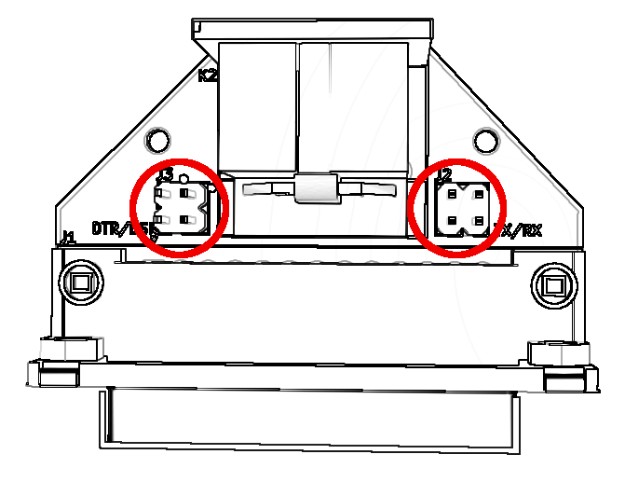
- RS232C signals: SW1-7 should be ON (closed) and SW2-7 OFF (open)
If your Super Serial Card in set to printer mode (Jumper block pointing towards Terminal, SW1-5 OFF, SW1-6 ON), you can open the DIN-5 to DB-25 adapter enclosures, and turn both jumper blocks (pictured right) 90°.

