Quicktake Connector Box for Apple II

Quickstart

Thank you for getting the Quicktake Connector box ! I hope you will like it.
 | The Quicktake for Apple II User Manual is available at https://www.colino.net/wordpress/wp-content/quicktake-user-guide.pdf
Here are the most relevant parts concerning setup:

Installation
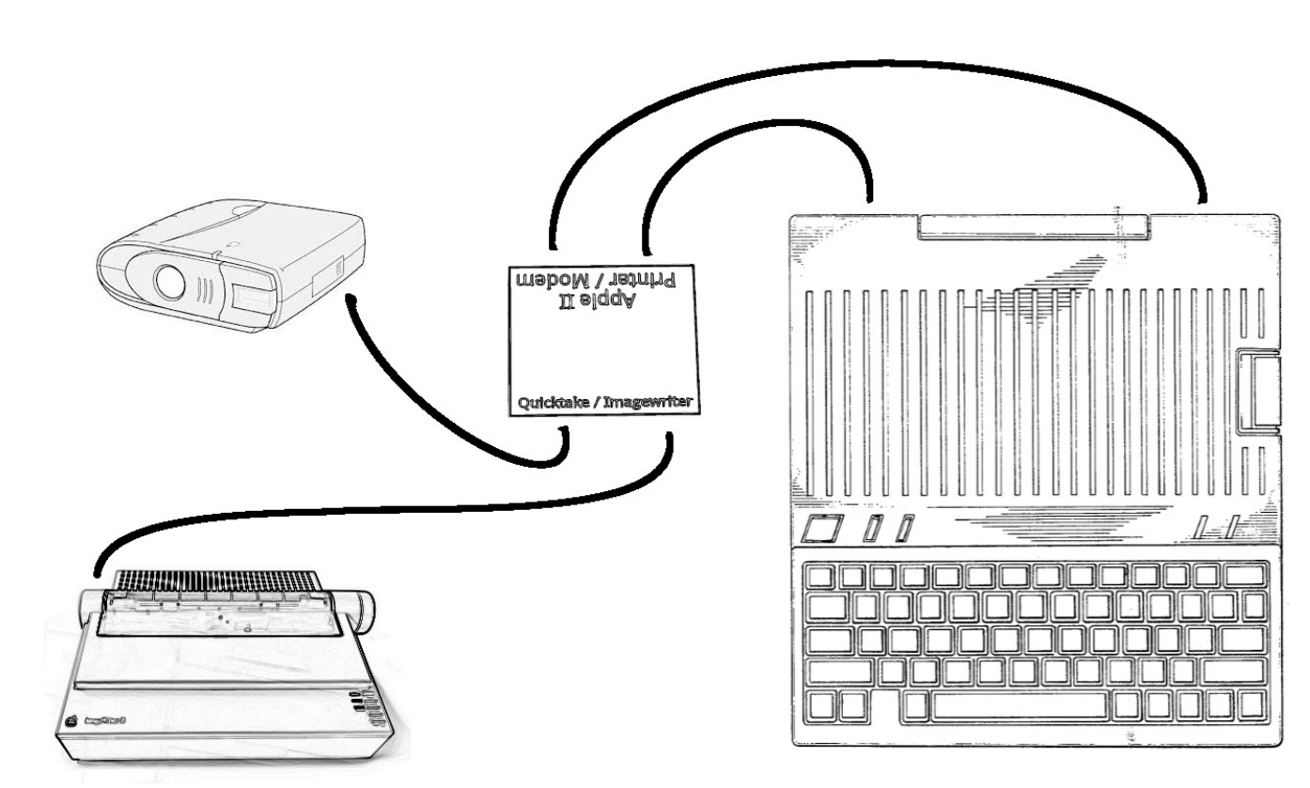
- Connect the Apple II Printer Port DIN-5 cable from the box to your //c+ Printer port, using one of the DIN-5 to Mini-DIN-8 adapters
- Connect the Apple II Modem Port DIN-5 cable from the box to your //c+ Modem port, using one of the DIN-5 to Mini-DIN-8 adapters
- Connect the Quicktake to the Quicktake connector on the Box using one of the Mini-DIN-8 cables
- Connect your ImageWriter to the ImageWriter connector on the Box, using the other Mini-DIN-8 cable and Mini-DIN-8 to DB-25 adapter.

Usage
Turn your Quicktake camera on by opening the lens cover. It should make a little noise, and the LCD should show a rotating rectangle.
Start the Quicktake for Apple II program on your computer. It should detect the Quicktake at start.
You can now get pictures from the camera to your computer using the ‘G’ key, and after they are decompressed and displayed on screen, you can save and print them.

Note for the Super Serial Cards setup on the Apple IIe
By default, the Quicktake program and connector box need both cards setup in Modem mode, with interrupts on:
- Jumper block pointing towards Modem
- Modem mode: SW1-5 and SW1-6 should be ON (closed)
- Interrupts: SW2-6 should be ON (closed)
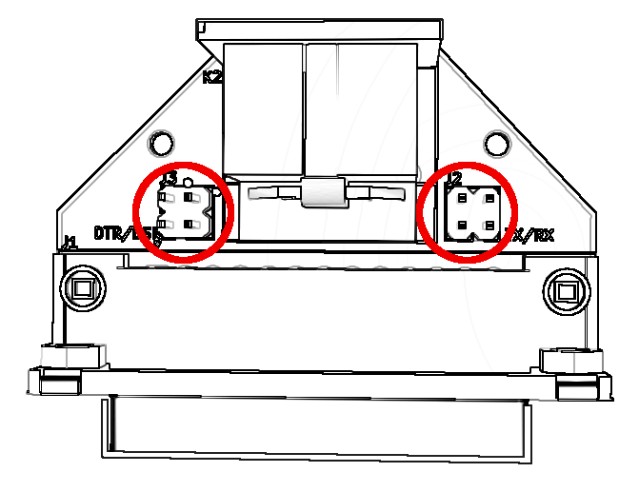
- RS232C signals: SW1-7 should be ON (closed) and SW2-7 OFF (open)
If your Super Serial Card in slot 1 is set to printer mode (Jumper block pointing towards Terminal, SW1-5 OFF, SW1-6 ON), you can open the Printer port’s DIN-5 to DB-25 adapter enclosure, and turn both jumper blocks (pictured right) 90°.

Note for the ImageWriter configuration
The ImageWriter should be configured for 9600bps, software flow control (XON/XOFF):
- 9600 bps: SW2-1 and SW2-2 ON (closed)
- XON/XOFF: SW2-3 ON (closed)
On the ImageWriter I, also set SW1-5 OFF (open).

Support
I’m available at colin@colino.net for support if needed. Have fun! :-)

