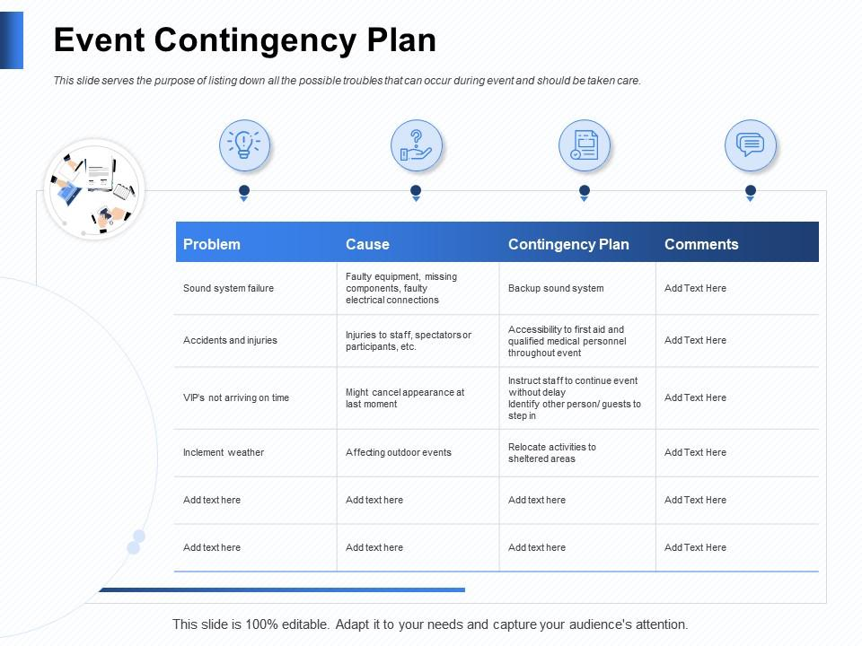
EVENT CONTINGENCY PLAN

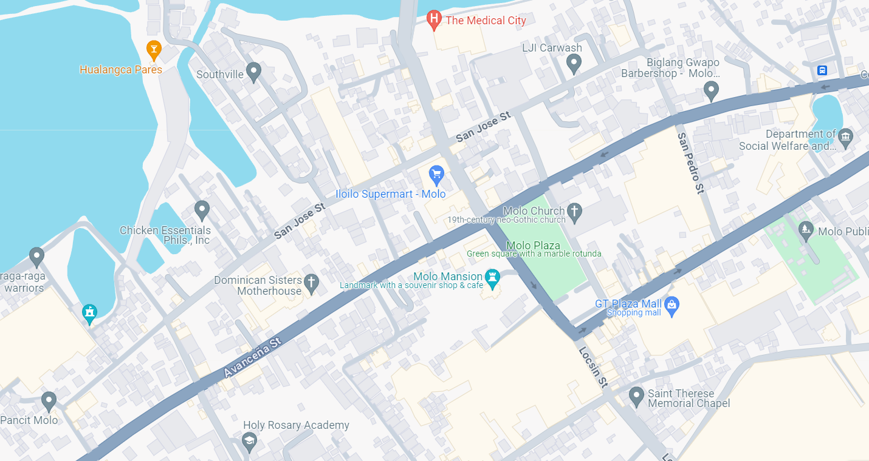

EVENT AREA “ROAD CLOSURE”

