If you are on windows, you will need python installed on your computer. If you don’t already have python, you can quickly download it [here](https://www.python.org/downloads/). If you are on mac, you can ignore this part.

It doesn’t matter where you download python to on your computer.

Go to the onedrive link and download the zip folder

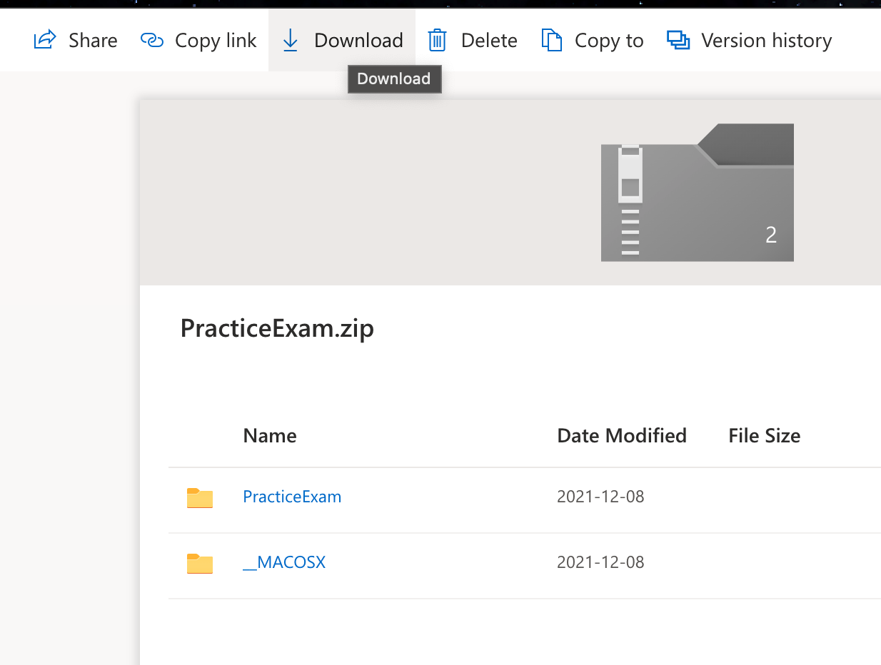

Next, you need to extract the contents, if it doesn’t happen automatically. Then, drag the folder onto your desktop. This program will only work if the folder is on your desktop.

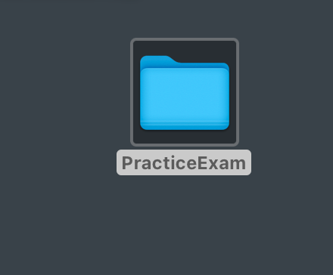

Do not change the names of any of the folders or files or this program won’t work.

If you are on mac, double click “generator_mac” and the program will start.

If you are on windows, double click “generator_windows.py” and the code will open in python. Then, once the code is opened up, hit F5 to run it.

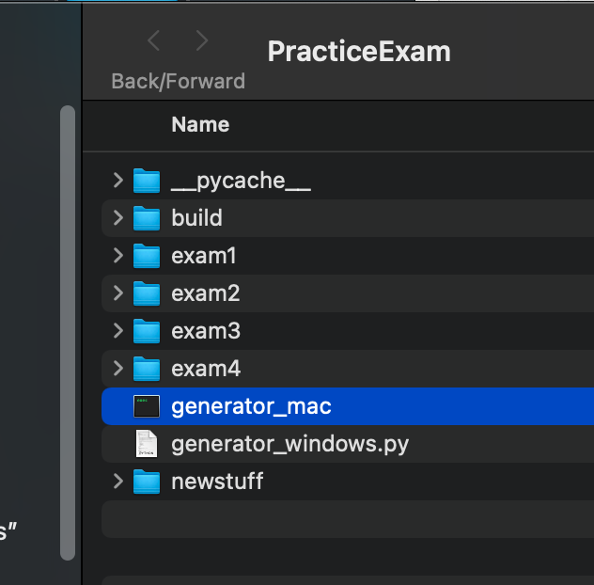

If mac osx blocks it from running because it’s from an “unknown developer” just go to your system preferences and hit “open anyway” like shown below.

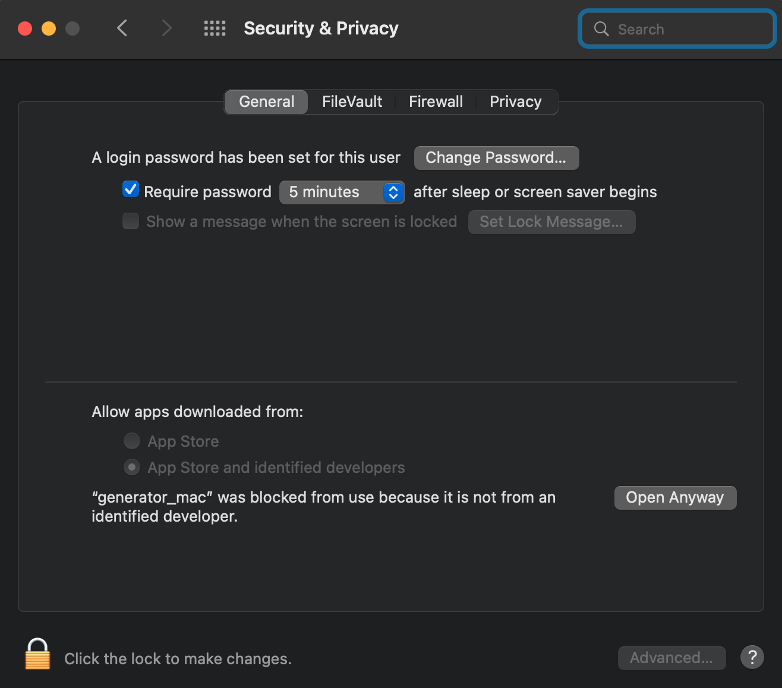

The program will ask you what material you want to see. Just type “y” or “n” then hit enter

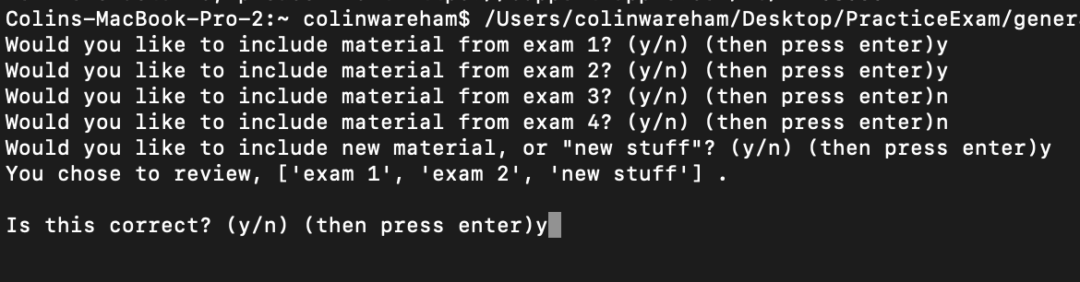

The program will open a picture of the question in preview on mac and in ms paint on windows. Hit enter to see the solution, then hit enter again to see the next problem, etc.

Make sure to exit out of the windows as you move on with the review so you don’t have a bunch of windows open.

When you are done with the review, hit “q” when the prompt comes up or just hit the x or red circle.

