

FT-100 Stock Screening and ML forecasting Software

Final project submission for Code Labs Academy Data Science and AI Bootcamp
Author: Colin Moughton
Date: Dec 24
Rev. 1

1.0 Introduction
The project goal was to create a predictive model capable of identifying trading opportunities. The model operates on historical daily stock price data that has the data features ‘open’, ‘high’, ‘low’, ‘close’ and ‘volume’ (OHLCV) for stocks within the FT-100 index. This financial index is made up of the largest 100 public companies trading on the London Stock Exchange.
The machine learning (ML) software developed to achieve this goal is called ‘Ginger’. It runs as a FastAPI web application. This report aims to describe what Ginger is and how it works. The software is available on GitHub.

2.0 Working principle
Ginger operates on a static set of data of 100 stocks. Each stock has approximately 1700 daily OHLCV records. Currently Ginger does not have a ‘real-time’ predictive capability, however, this functionality could easily be added.
The main focus of this work was to understand whether ML models could provide a stock picking advantage using a known historical dataset.
The Ginger workflow is currently made up of three stages.
- Stock screening
- ML model selection and training
- Back testing and results evaluation

2.1 Stock screening
The first stage of the Ginger workflow involves a stock screening process. This is a simple algorithm and does not involve machine learning, it is primarily to help understand the data. In this process the user inputs several parameters that define a successful single trading event. Ginger optimistically assumes long-trades; this is when stock is bought at a price, the stock then rises and is sold for a profit. The parameters input to the screener are:
- Trade Size – the amount of money being risked (e.g. £10,000)
- Target Trade Profit – if successful, the return achieved (e.g. £500)
- Trade Loss Limit – a stop-loss (sell) would trigger if loss greater than this (e.g. 150)
- Test End Date – this is the last day of testing – governed by the available data.
- Max Trade Duration – the forward time window in which the trade must happen (days).
- Training Duration – the number of days of data the ML model will be trained on (days).
- Test Duration – the number of days the ML model will be tested on (days).
Using these input parameters each of the 100 stocks in the database are evaluated to establish how many successful trading events occur over the entire history considered. (training + test duration).
Each daily OHLCV record of each stock is considered and labeled with a ‘1’ if a successful trade event occurs within the forward window specified, and ‘0’ if not. This classification step only uses the forward ‘high’ and ‘low’ price data to discern whether that day is ‘1’ or ‘0’.
This method of course has knowledge of the future that would not be available in real life, however, the aim of the screener is only to evaluate historic data to identify whether many positive trading events occur and how spread out they are. The screener output enables the user to pick a good stock with many known positive events on which to run machine learning models.
The screener therefore provides information to help identify good stocks to consider further.
Figures 1 & 2 below describe how the screener discerns whether the current day is classified as a ‘1’ or a ‘0’.
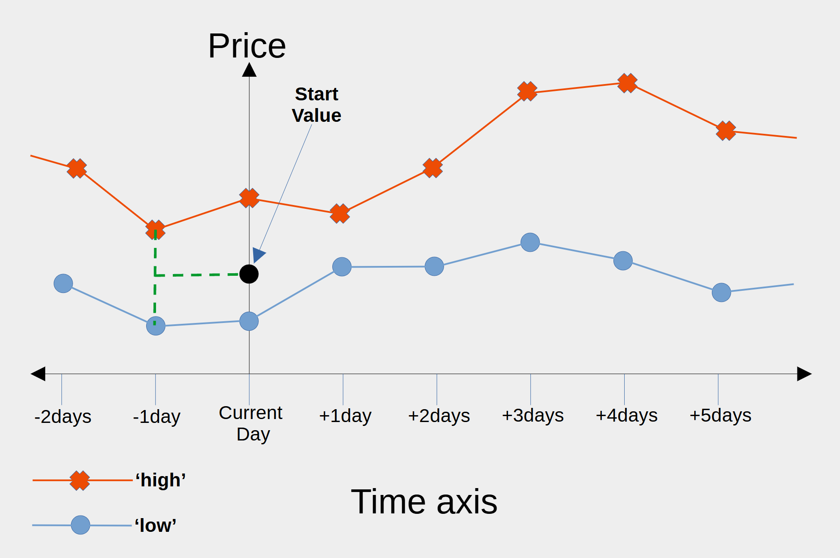
Figure 1: The first step in the screener algorithm is to calculate the mean of the previous day’s high & low. This is used as the start value for the current day.
In this first part of the screener algorithm a ‘0’ label could result, either if the ‘current day’ high is below the ‘start value’ or if the ‘current day’ low is low is above the ‘start value’. In either of these cases the buy order would not fill if placed at the start value, at the start of the current day.
The user input values are used to define three key parameters:
- High threshold
- Low threshold
- Max Trade Duration
these are shown in figure 2 below. The High & Low thresholds are calculated using the Start Value, Trade Size, Target Trade Profit and Trade Loss Limit.
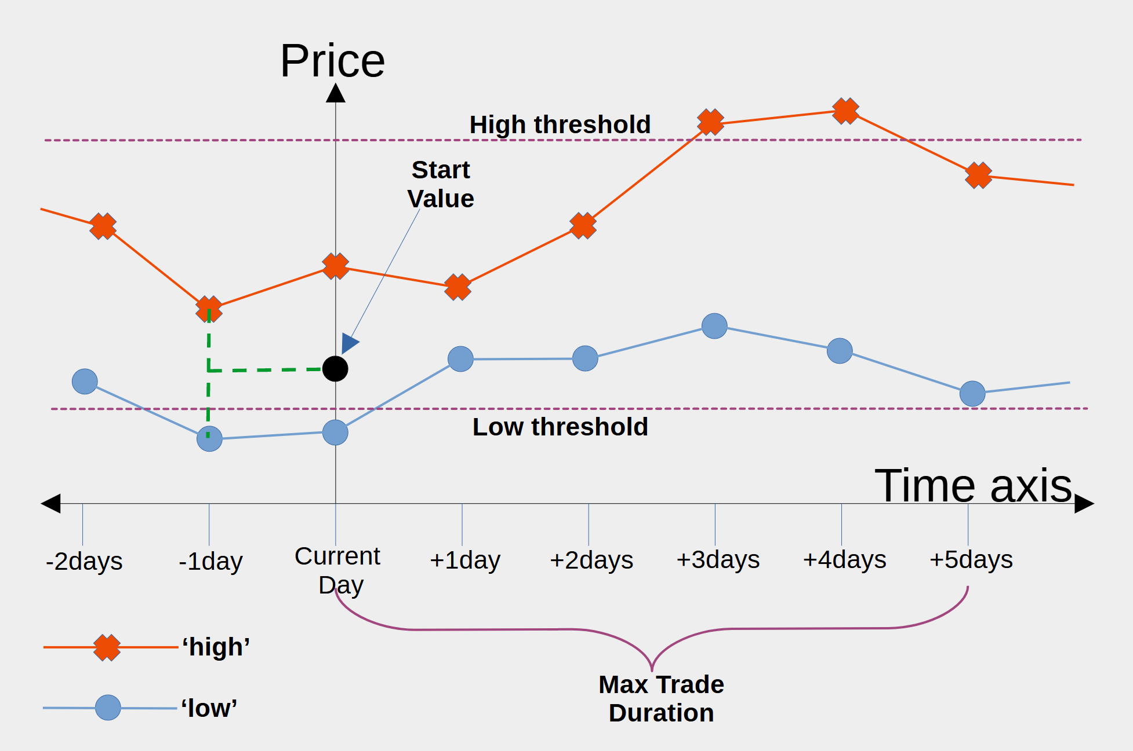
Figure 2: The screener algorithm computes a High & Low threshold and checks whether the high breaks the High threshold within the Max Trade Duration before the Low breaks the Low threshold. Only the first day onward are considered. If this happens (as in this case) a label value of ‘1’ is assigned to the current day. If not, a ‘0’.
In this way the screener works through all of the days in all of the stocks and then presents a league table of stocks showing the following results for each stock:
- Total Records – the number of days considered.
- Occurrence – how many times a positive event ‘1’ label occurs.
- Occurrence Interval – the averaged time between ‘1’ labels.
- Trade Duration – the average time it took to reach the High threshold.
- Four Sigma – distribution, smaller is better, 95% of trade duration fall within.
The output league table of stocks is presented in order of Occurrence. The more ‘1’ occurrences the better.
To summarize, the screener classifies each day of each stock as a ‘1’ or a ‘0’. A ‘1’ means if money was invested on this day, it would hit the profit target and not stop out. The stock with the highest number of events (‘1’s) represents the biggest opportunity if the distribution is not abnormal. So, for the given input parameters, the screener returns a league table of stocks ranked by profit opportunity. This helps the user select a good stock to model with ML.

2.2 Machine learning models
The stock screener provided a classification method for each daily record. This classification method required daily ‘high’ and ‘low’ prices from each record as inputs. Initially the ML problem was approached as a classification model. This approach ran into difficulties, the classification ML model types and approaches are described in a later section.
The approach that was found to work best was to use a Recurrent Neural Network (RNN) to predict actual forward price values of the stocks, rather than predict whether each day was a ‘1’ or a ‘0’. To enable performance measurement, the classification stage was then achieved by post processing the predicted price values.
The best results were achieved using a Gated Recurrent Unit (GRU) model, see figure 3 below, but modified to include attention. Long Short Term Memory (LSTM) models were also explored, however, they appeared to offered no improvement over the GRU model in terms of predictive performance and were slower to run.

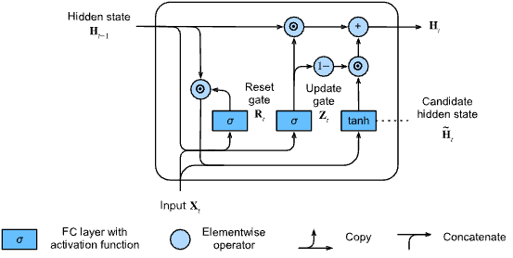
Figure 3: Gated Recurrent Unit (GRU) architecture (https://d2l.ai/chapter_recurrent-modern/gru.html)
Initially the GRU model was used to predict the ‘high’ price time series. It was realized at this point that both the ‘high’ and ‘low’ price series would require predicting if the screener post-processing classification was to be replicated, (as shown in figure 1 & 2), using the predicted values. This approach was named the ‘high-low’ ML model. This the ‘high-low’ ML model has not been implemented in this software revision but will be included in the next revision.
Instead of the using the ‘high-low’ ML method, a simplified approach was developed. This new approach was called the ‘high-low-mean’ ML method. The intention was to evaluate whether a simplified approach could deliver a faster solution.
The ‘high-low-mean’ ML method would pre-process the ‘high’ and ‘low’ price time series data to give the ‘mean price’ time series. This simplification would require only one ML model to be trained, rather than two. However, it did mean that the post-processing classification method would require modification. This modification is covered in the next section (Back testing & results evaluation).
The benefit of the ‘high-low-mean’ model was that a single average price time series curve could be modeled and predicted, then evaluated for accuracy and loss performance.
The ‘high-low-mean’ GRU ML model was fed daily incremented windows of data, the best performance was obtained using window length values of 25 days of daily time series data. Each window of data used to predict the next days price value. So in this training and test stage, the ability of the model to predict the next was assessed by comparing the graphs of the actual test time series data for average price and the predicted test data time series curves.

The metrics chosen were assess the training results were:
- An overlaid plot of actual vs predicted average prices – looking at visual fit.
- R2 score – to assess this numerically over the epochs.
- Training and validation loss graph to understand model convergence.

The training results data are shown below for the stock AAF:
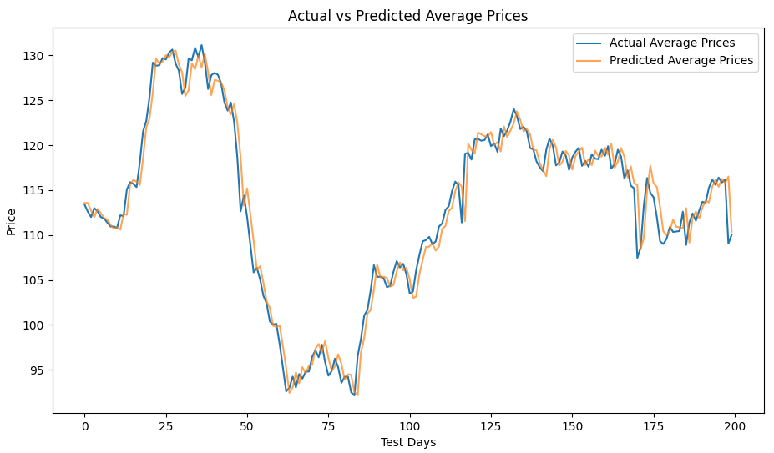
Figure 4: Overlaid plot of actual vs predicted average prices for a given stock

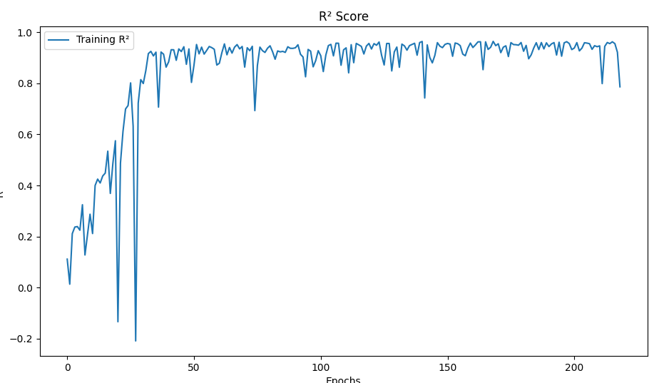
Figure 5: The R2 score of the actual verses predicted curves

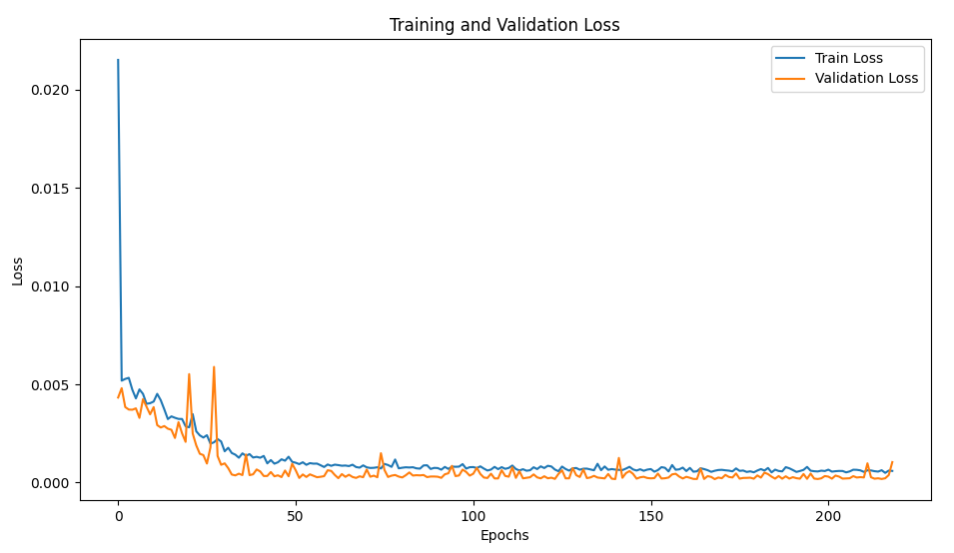
Figure 6: The training and validation loss curves.

2.2.1Hyper parameter tuning
As mentioned above, the sliding data window found to work best was 25 days. A number of other hyper parameters were also tuned. Different numbers GRU layers and GRU units per layer were experimented with. Four GRU layers each with 50 GRU units and a 0.2 dropout layer were found to work well. In the experiment these values were tried doubled and halved to understand the impact on the training results.
The learning rate was also adjusted understand if this would improve performance. The learning rate was reduced to 0.001. This was found to deliver better performance on the stocks tested.
The final dropout layer was fed into an attention layer, this layer was added to provide attention over different periods of the time series history.
The attention layer was fed into a Global pooling layer and finally into a dense layer with one node to give the predicted price output for the given day.
All of the training day data was used for training, and the test days data used for both validation and test. The number of epochs was set to 500 with an early stopping callback. A further callback was used to pull out the R2 values during the run.
Several different optimizers listed in the Keras documentation were tried but none performed noticeably better than adam.
A wider sensitivity study would be useful to dial the hyper parameters in further.
The model attention-GRU model definition is shown in the listing below:

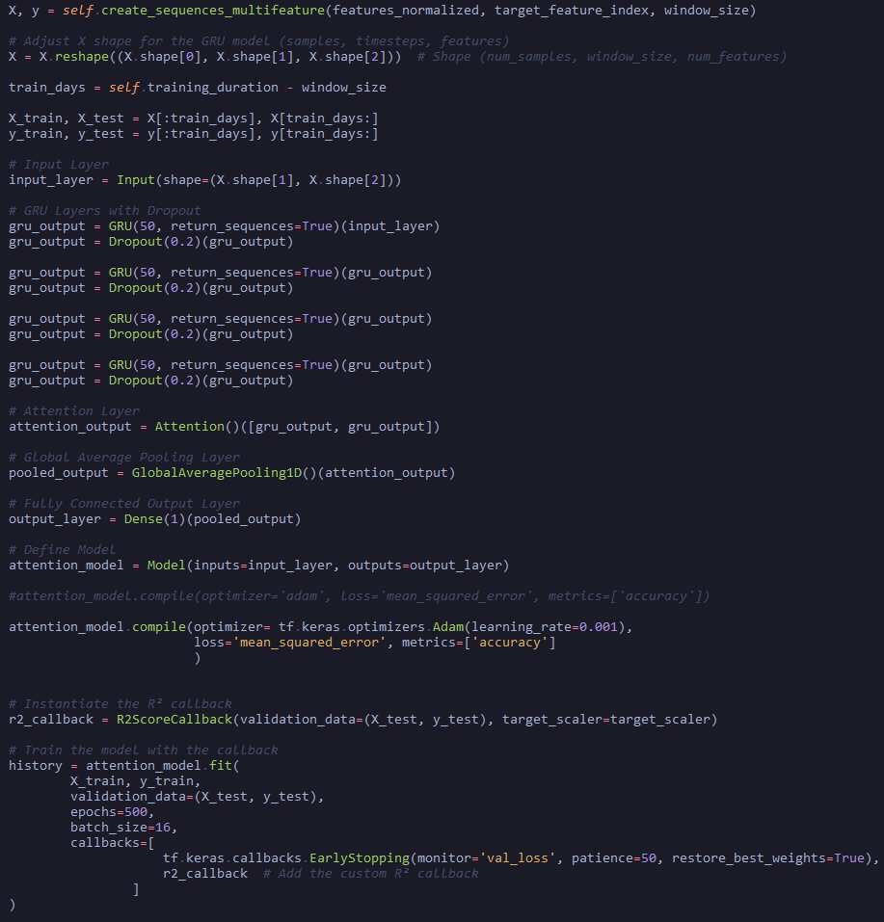
Figure 7: Attention-GRU model code listing.

2.2.2 Data analysis and feature engineering
The daily ohlcv data was initially sourced from a python module called y-Finance. This program offered free downloads of the data needed for all of the stocks in the FT-100 index. The data was graphed and evaluated. Unfortunately, a number of anomalies were found when spot checks were carried out using data from the exchange website.
Another source of data was found called Alpha Vantage. To obtain data from this source the user is asked to create and identity and get an api key. This key could then be used to query their database and obtain the desired data.
This ohlcv data was also spot checked against data available on the stock exchange website. It was found to match and so was accepted. Further checks for missing values were carried out.
The ohlcv data used on Ginger does not include the impact of stocks and dividends. The rational for this is that the trades are short and it thought best to train the models on actual exchange data that was live, rather than post processed data.
During the development journey of Ginger the initial intention was to first try using a dense neutral network to predict the screener classified labels. To achieve this each row of data would need to have all the information it needed about past price movements. An initial feature correlation matrix showed that even with the addition of some moving averages and calculated features from the screener there was very little variation that a machine learning model could make use of.
The initial feature correlation matrix is shown below in figure 8. A number of features were developed top provide the neural network with more context. Figure 9 shows a more developed feature correlation matrix.
Interestingly, the dense neutral network was poor at predicting the labels, even after adding attention and a rich set of data features. .
When testing on the GRU and LSTM models it was found that adding many data features did little to improve performance, likely because they are all derived from the same data. After much experimentation the best input features for the attention-GRU model were found to be the average price time series (also the target) and a feature showing the percent change in that value from the previous day.
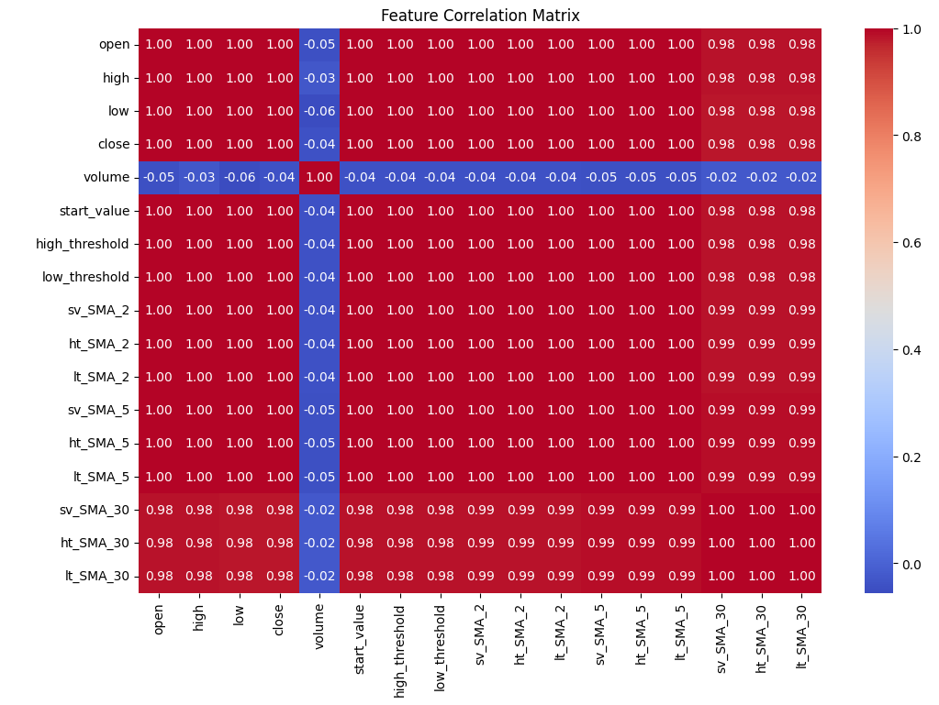
Figure 8: Initial feature correlation matrix.
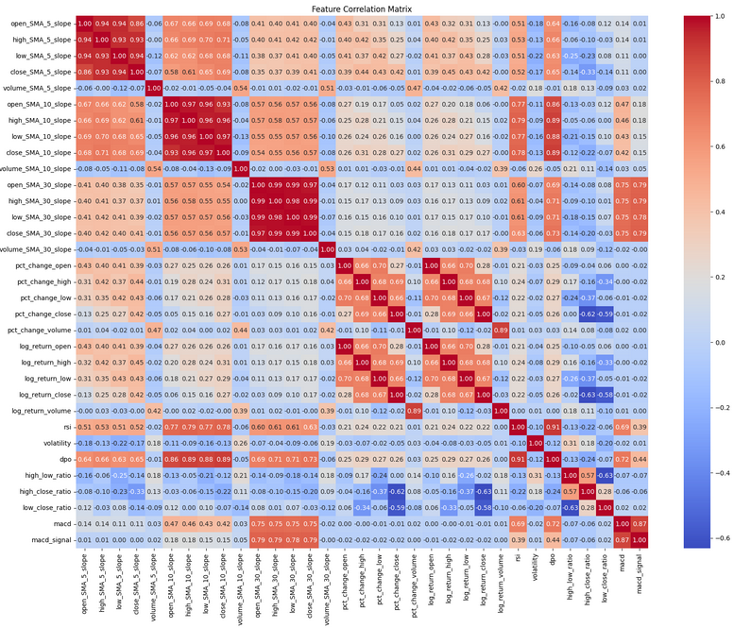
Figure 9: Developed feature correlation matrix.

2.3 Back testing and results evaluation
The wights from the attention-GRU ML model and those of the scalers were saved at the end of the training phase. The next stage of the modeling was to develop a back tester.

2.3.1 Back testing
The aim of the back testing within Ginger is to predict for each day whether that day should be classified as a ‘1’ or a ‘0’. This is carried out for all of the test days. Only with knowledge of the past, no knowledge of the future is used in this testing. The testing is done in two stages.
- Average time series price prediction using the attention-GRU model for the forward time window (Max Trade Duration).
- The screener classification algorithm applied to the predicted price data to discern whether the day is predicted as a ‘0’ or ‘1’.
In the second stage a key issue with the simplified ‘high-low-mean’ ML model is that the high and low values of the time series had been averaged for the prediction. This meant that the screener classification algorithm also required simplification. The implications of simplifying the screener classification algorithm from ‘high-low’, to ‘average’ had to be considered before using any predicted ‘averaged’ price values for classification.

Simplified High-Low-Mean screener classification algorithm
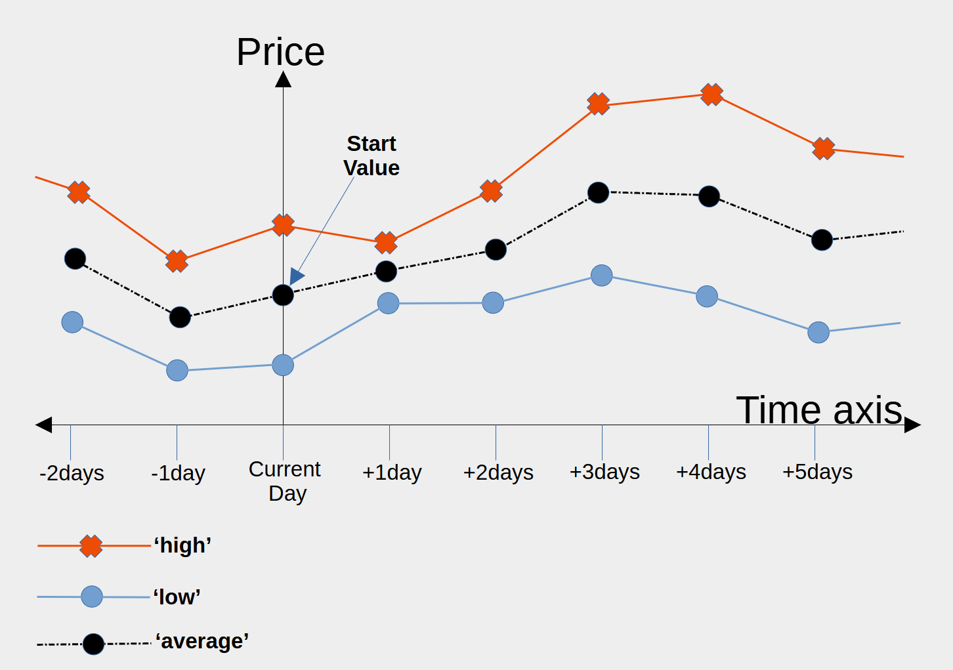
Figure 10: Price chart showing the average of high and low prices

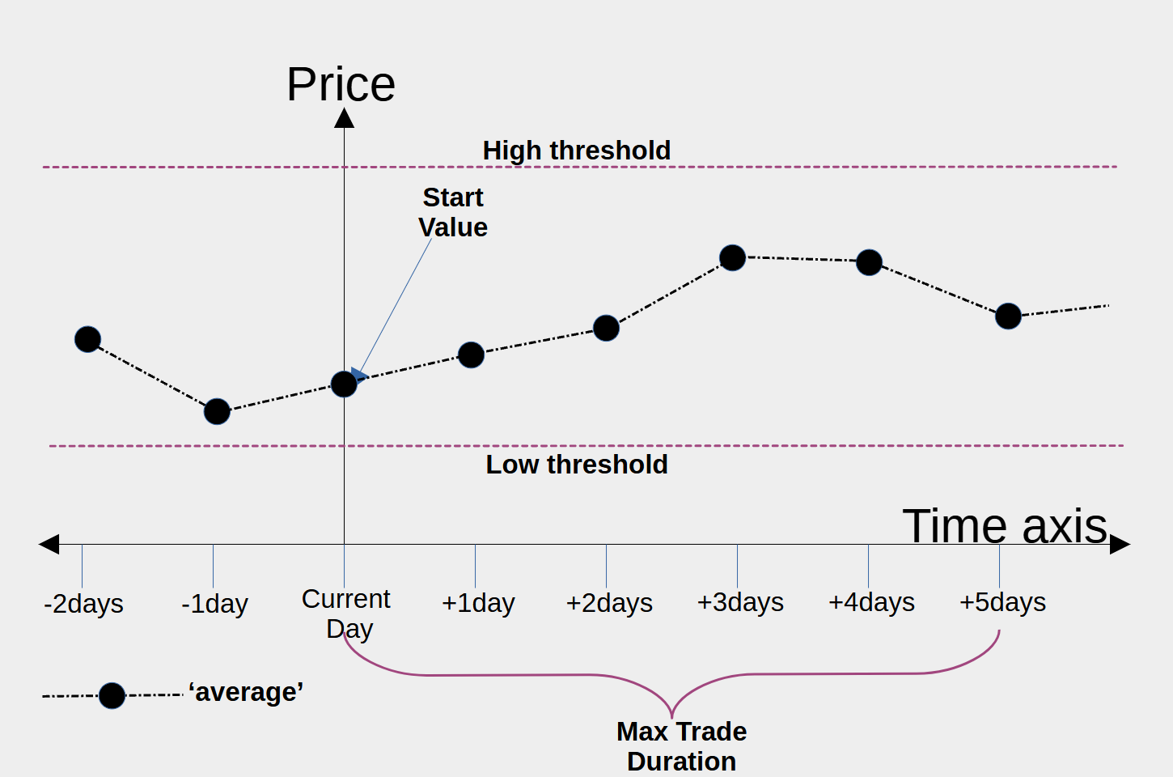
Figure 11: Price chart showing the thresholds generated from the input data and the duration using the simplified screener classification algorithm. With ‘high-low’ this would have been a ‘1’ ,now with ‘high-low-avarage’ this is a ‘0’.

It is clear from figure 10 and 11 that the ‘high-low’, and the ‘high-low-average’ were likely to give different predictions of ‘1’s and ‘0’s.
To address this simplification Ginger shows two back testing graphs. The first graph shows how the averaged ‘high-low-average’ screener algorithm compares against the original screener algorithm that uses ‘high’ and ‘low’ time series curves independently to calculate labels.
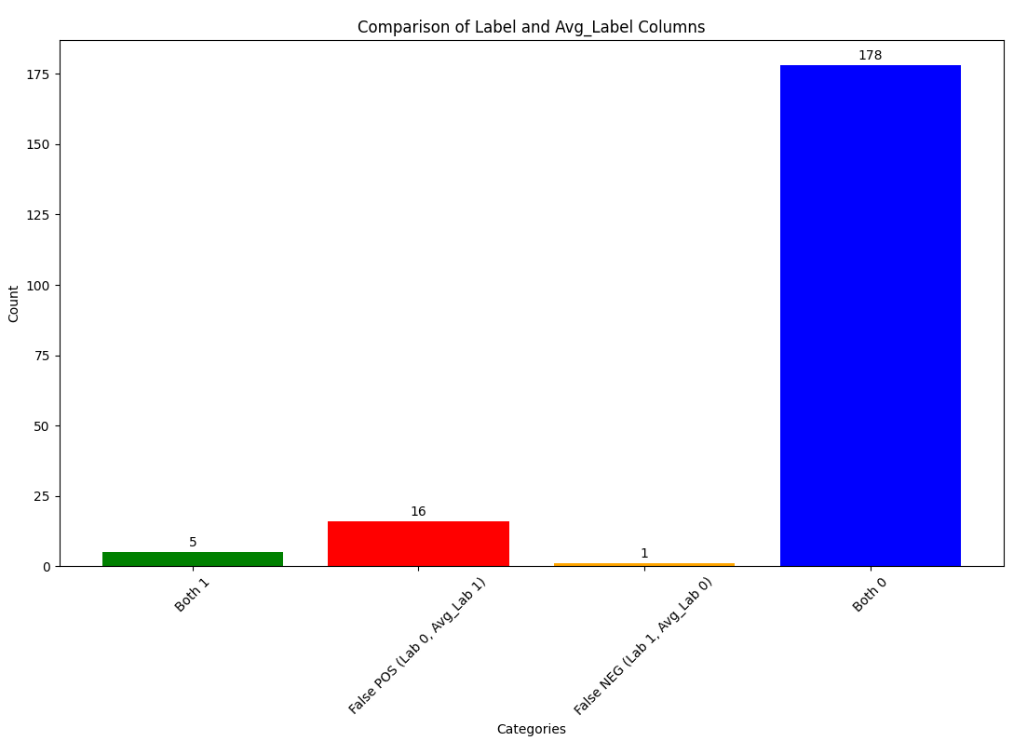
Figure 12: Shows the effect of simplification on the classification algorithm
It can be seen from figure 12 that the simplified ‘Avg_label’ screener classification algorithm impacts the labeling. It correctly captures 5 out of 6 of the ‘1’ labels. However, it also generates 16 false positives. False positives are the worst results because each of them represents a loosing trade. The real outcome is ‘0’ but the simplified high-low-mean’ algorithm thinks it is a ‘1’. This is an important graph because it shows that the averaging simplification has introduced significant degradation in performance even before any predictive modeling is carried out.
The simplified average time series price screener algorithm basically has full knowledge of all of the data, but incorrectly identifies many false positives compared to the ‘high-low’ screener classification algorithm because of the averaging.
This graph is presented in the back test results for each stock within Ginger that uses the high-low average simplified ML algorithm workflow. The reason it is presented is to give context when the predictive ‘high’-low-mean’ results are presented.

The simplified screener classification methodology has been presented here first here because its assumptions have such a profound effect in terms of false positives.

As mentioned above, the first stage of the back testing is the average time series price prediction using the attention-GRU model for the forward time window (Max Trade Duration). In this first stage the model accepts the previous 25 daily historic records and then predicts the next days average price value. The attention-GRU model is used with the scaling and model weights from the training to achieve this. Then the predicted value of average price is used to calculate the daily percentage change (the other input feature) for that day. The new predicted values of average price and daily percent change are added to the front of the 25 day sliding window with the last values dropped. This updated 25 day window is then used to calculate the next day, and so on until predictions are created for the whole ‘Max Trade Duration’ as specified in the input parameters.
These predicted values for the days in the ‘Max Trade Duration’ are then fed into the simplified screener classifier algorithm (figures 10 & 11) to establish whether each day is a predicted ‘1’ or ‘0’. These results are then presented in the same format as the simplified screener results as below.
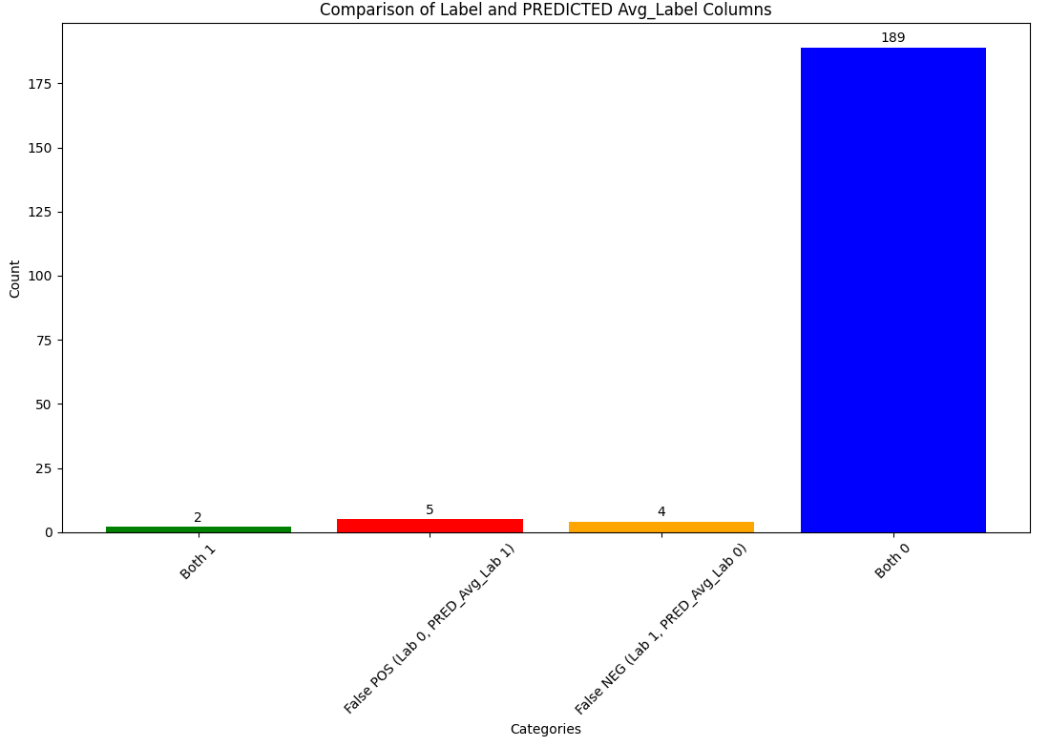
Figure 13: Comparison of original label and ‘high-low-mean’ ML model results.
The predicted results in figure 13 above show that the ‘high-low-mean’ ML model was able to predict 2 of the 6 positive trade events ‘1’s. It had considerably fewer false positives than the screener alone (5 compared to 16).
If this algorithm was followed it would have yielded a profit. The ratio of wins to losses was 1:2.5. The input parameters were a profit of £700 and a stop loss of £150. So without including trading costs the trades would be +£325 in profit.
However, it would be wise to implement the ‘high-low’ algorithm prior to trading this model because there is obviously a significant impact due to the averaging.
It would also be sensible to paper trade the model for a significant period to get confidence in its predictive ability before live trading.
Also the fit of the model varies between stocks. Further tuning would be sensible.

3.0 Ginger workflow

4.0 Further workflow
- Implement the high-low ML model.
- A more in-depth sensitivity study on the hyper parameters do identify optimal values.
- Add indicators to the predicted events to screen out as many false positives as possible.
- Implement the real time data updating and prediction.
- Paper trade the updated model.

