ECED3901: Group Project 1

**Date: Jan 15, 2025**

**Due: Feb 3, 2025**

## Learning Outcomes:

The purpose of this assignment is to have you create an PCB design. To do this you’ll learn about the typical resistance of a PCB trace, and make decisions on what parts to use.

## Deliverables:

1. Answer the questions below.
2. Include a KiCad design (zip file with submission)
3. Include Gerber files suitable for ordering, this would be equivalent to the zip-file you upload to JLCPCB for example.

NOTE: These boards will not be ordered, but if you wish to use them please talk to the technicians.

NOT all topics in this assignment were covered in class, it is expected that you will find external resources to understand the requirements. I’ve tried to include links to suitable resources, please consult them before asking questions!

## Design Requirements

**Overview:**

You are designing a driver for a moderate-power electromagnet (inductive load). The parameters of this are:

1. Must be able to drive 1A at 12V without failing.
2. Must have over-current protection for a current above 5A.
3. Will be driven by a 3.3V logic-level input signal.
4. When operating at 40°C, the PCB trace temperature is at maximum 65°C during any operation.

The basic design is shown below, here we use a MOSFET as a switching element:

You need to modify this design to add any required features, including a suitable over-current protection (such as a fuse) and a freewheeling diode.

*NOTE: The inductor L1 is NOT included in your PCB so you may leave this off the schematic. I’ve included it here to show you where the electromagnet (inductor) is attached.*

In this example schematic, screw terminal J2 is the input power. Pin 2 is positive input, and Pin 1 is negative. You may wish to add a diode that prevents reverse-polarity to this positive power rail. You will also need to add a fuse in series to the positive power rail.

The electromagnet (inductor) is attached to screw terminal J1.

Finally, your input logic level signal is connected to terminal J3. You’ll notice there is a resistor (R1) that pulls down the MOSFET gate when there is no signal connected. Because MOSFETs do not have any noticeable gate current, we need this inductor to prevent stray charge from turning on our MOSFET if no lead is attached.

**Question 1: PCB Trace Width [4 pts]**

As covered in lecture, we need to find out the suitable PCB width for our current carrying traces. From the specifications we know that we have a maximum of a 25C temperature rise allowed.

If you go to <https://www.protoexpress.com/tools/trace-width-and-current-capacity-calculator> and press the “Input your Specs to Get Started” Button:

You should be presented with the calculator itself:

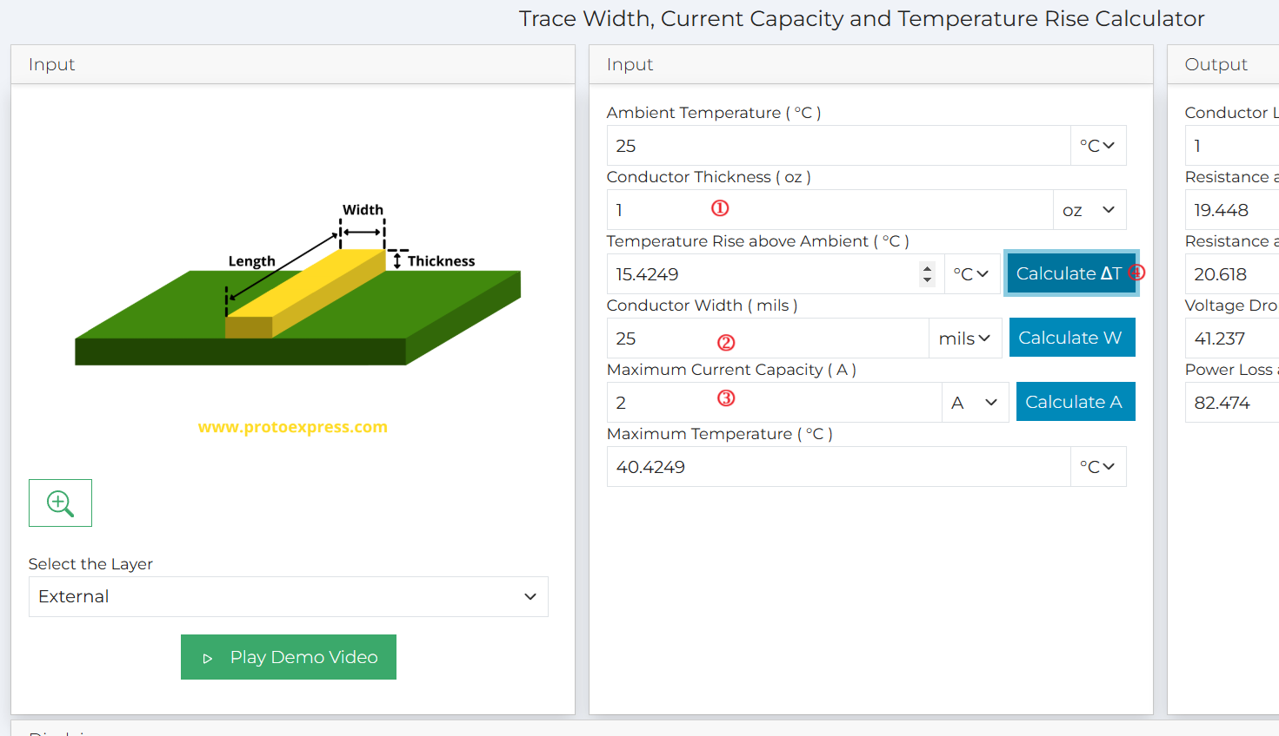

To use this:

1. Put “1 oz” conductor thickness (our normal copper thickness).
2. Enter a conductor width (here I have 25 mils).
3. Enter a current capacity (here I have 2A).
4. Press “Calculate Delta-T” button to see the resulting temperature rise.

[4 pts] Use this (or another similar tool) to fill in this table:

|  |  |  |
| --- | --- | --- |
| **Conductor Width** | **Current** | **Temperature Rise** |
| 10 mil | 1A |  |
| 10 mil | 5A |  |
| 50 mil | 5A |  |
|  | 5A | 45°C |

Based on this table, what conductor width do you need to guarantee your operating condition? Be sure to use this width for any current-carrying traces!

**Question 2: MOSFET Selection [4 pts]**

Go to digikey.ca & search for “MOSFET”. Select “Single FETs, MOSFETS” in the resulting search:

Then start filtering based on what we need to switch:

FET Type:

N-Channel

Drain to Source Voltage (Vdss):

20V to 200V (hold down shift)

Current – Continuous Drain (Id) @ 24C:

10A or higher (hold down shift, select say 10A to 100A)

Drive Voltage (Max Rds On, Min Rds On):

We need to turn the MOSFET on & off with 3.3V. So we want to ensure we turn on below 3.3V. Select the values below that limit, for example:

1.5V, 4.5V

1.8V, 4.5V

2.5V, 10V

2.5V, 4.5V

2.5V, 8V

2.8V, 10V

From the MOSFETs that you find, select one. There are many you could use, but before selecting one think about soldering the board together. You may find it easier to use a common package such as DPAK, D2PAK or SOIC8.

You may also want to place a MOSFET in KiCad & see what versions are available, but if doing this check the KiCad parts are actually available to purchase (they may be old or unavailable). Also confirm the MOSFET is a “logic-level” MOSFET!

Once you select a MOSFET, answer the following questions about your MOSFET selected:

* What is the part number of your MOSFET?
* What is the package type?
* What is the pinout (include a screenshot of the datasheet)?
* What is the maximum voltage rating of Vdss?

**Question 3: Driving Inductive Loads, Fuses, and Terminal Blocks [6 pts]**

A)

Driving inductive loads have an issue with inductive spikes, which requires a *flyback diode* (also called *freewheeling diode*) or *snubber*.

Find a resource to learn about this (e.g., a simple YouTube video such as <https://www.youtube.com/watch?v=6YOctFtOuwY> or any other online resource).

Select a suitable diode or other circuitry to properly deal with this.

*Summarize your part choice(s) [2 pt]*

B)

You also need a *current limiting device*, such as a fuse or other part. If you go to digikey.ca & search *Fuses* . You can then search for the suitable current limit (5A).

There are many choices – you can choose to mount a fuse holder, OR to solder a fuse in the board.

You may wish to look in KiCad at what available footprints there are, by placing a footprint in the PCB editor or opening the footprint browser, and look at the fuses:

You will see some fuse holders, some solder-down fuses, etc.

*Summarize your part choice(s) [2 pt]*

C) Finally we need a way to connect our electromagnet. We might like to use *terminal blocks*:

Search Digikey.ca for “Terminal Block”, and select “Wire to Board” category:

In the filtering, select:

Number of Levels:

1

Positions Per Level:

2

This will give us 2-pin terminal blocks. From here you can choose the *pitch* (3.5mm, 5mm, and 5.08mm are common for example).

Again, you may wish to see what footprints you have in KiCad already. If you search “terminal block” you will see some options for 2-pin terminal blocks. You may want to check if the KiCad footprints already have part numbers you can use.

*Summarize your part choice [2 pt]*

**Question 4: Schematic Design [10 pts]**

Based on the requirements and your selected parts, update the schematic. Be especially careful about:

* When placing the MOSFET, check how the pins on the schematic map to the PCB. You’ll need to ensure you have selected a compatible footprint if you are not using one of the built-in parts.
* You’ll need to add a fuse to the positive power input.
* You’ll need to add a freewheeling diode.
* You will have to select a package and part for the gate pull-down resistor.
* You *may* want to add other parts such as an LED to indicate the status, additional filter, etc. This is up to you but not required.

This will be marked by opening your KiCad project/PCB. Marks given for:

|  |  |  |  |  |
| --- | --- | --- | --- | --- |
| **Subject** | **Needs Improvement** | **Acceptable** | **Good** | **Great** |
| **Visual Appearance [3 pts]** | 0 = Incomplete | 1 = Messy but connections present | 2 = Reasonably clean schematic, some part numbers or details missing | 3 = Clean schematic + title block, all details present. |
| **Design**  **[7 pts]** | 0 = Incomplete | 1-3 = Missing some features needed, but should at least turn the inductor on & off (e.g., basically same schematic as given in the assignment handout). | 4-6 = Most features present, may be borderline on some requirements but generally should work. | 7 = Design exceeds specifications, likely to be highly reliable. Includes additional features for the user. |

**PCB Design [10 pts]**

This will be marked by opening your KiCad project/PCB. Marks given for:

|  |  |  |  |  |
| --- | --- | --- | --- | --- |
| **Subject** | **Needs Improvement** | **Acceptable** | **Good** | **Great** |
| **Silkscreen [3 pts]** | 0 = Silkscreen not cleaned up (designators overlapping parts fully) | 1 = Minimal effort, designators moved | 2 = Clean silkscreen, additional info present such as team & ratings | 3 = Also visually appealing design |
| **Routing [3 pts]** | 0 = Routing will not work | 1 = functional, some traces thin and messy, may have heat issues | 2 = Traces suitable and reasonable routes | 3 = Good routing, use of ground pours where possible, clean design |
| **Placement/Footprints [3 pts]** | 0 = footprints do not match or missing | 1 = footprints match, but placement will be difficult | 2 = footprints look correct & placement is reasonable | 3 = good design, additional features such as mounting holes included |
| **DRC [1 pt]** | 0 = DRC does not pass |  |  | 1 = DRC passes (no warnings/errors) |

While not marked, it is highly recommended to include a short description of any design choices or how you intend for the design to be used. This will help the marker understand any design choices you have made.

You are free to decide on the size of the board and other requirements.

**Gerber Files [4 pts]**

* Files are included suitable for ordering
  + Use a preview such as on JLCPCB and upload your zip-file to check it renders correctly.
* A README file is present showing the expected files.