Table 1
 | Northern North Sea | Southern North Sea | VIa (west of Scotland)
Northern North Sea | - | 0.0009 | 0.003
Southern North Sea | 0.00003 | - | 0.0207
VIa (west of Scotland) | 0.0041 | 0.0039 | -

Table 2
 | Northern North Sea | Southern North Sea | VIa (west of Scotland)
Northern North Sea | - | 0.0079 | 0.0015
Southern North Sea | 0.0235 | - | 0.0039
VIa (west of Scotland) | 0.0003 | 0.0064 | -

Figure 1

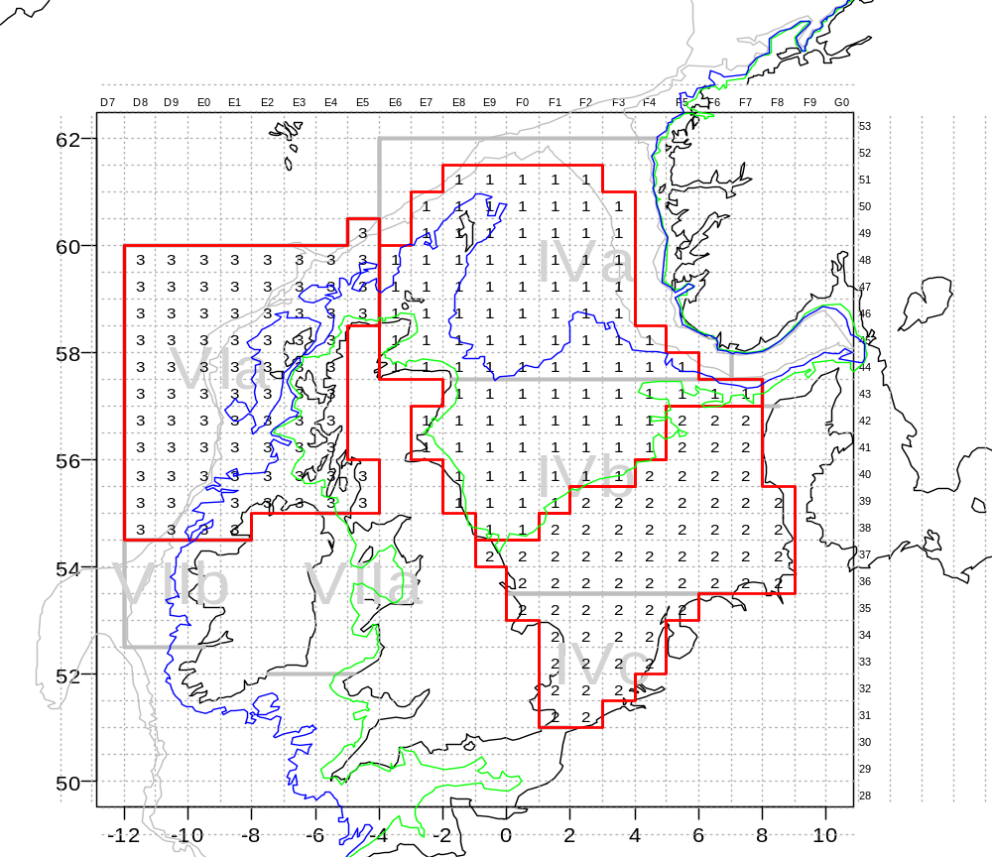

Figure 2

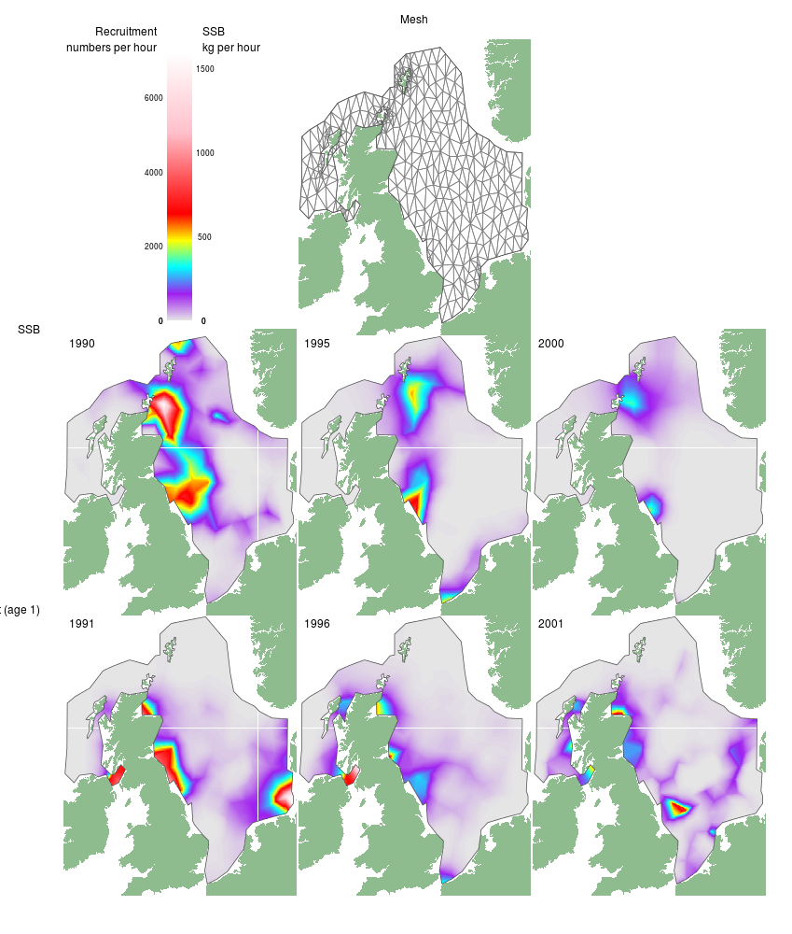

Figure 3

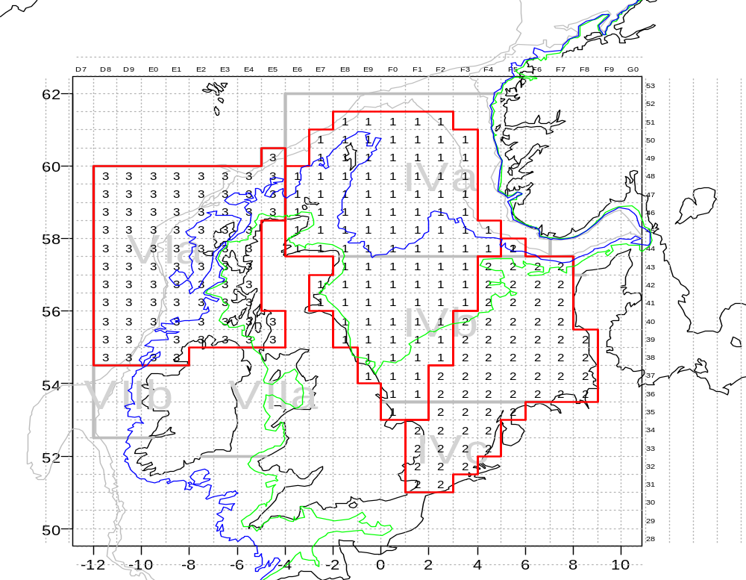

Figure 4

a)  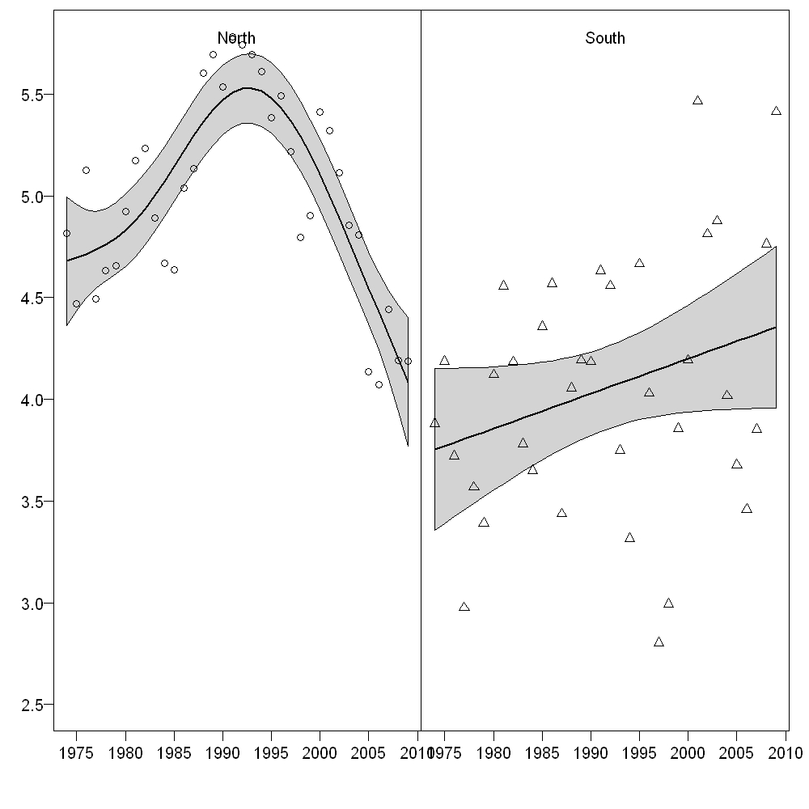 | b)  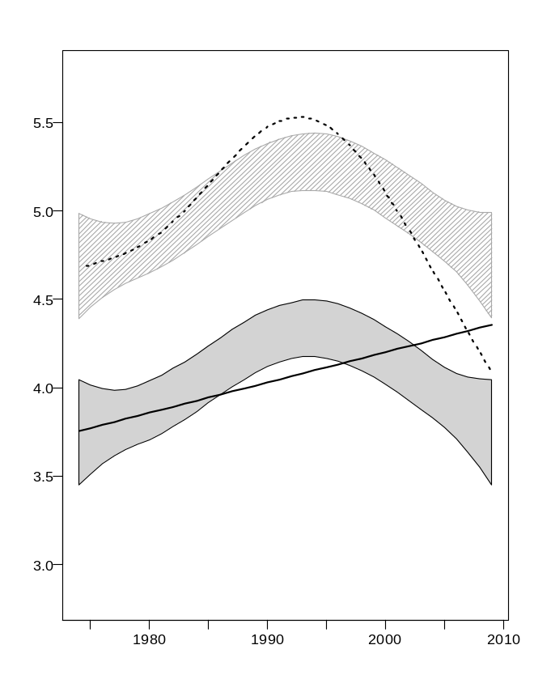

Figure 5
a)  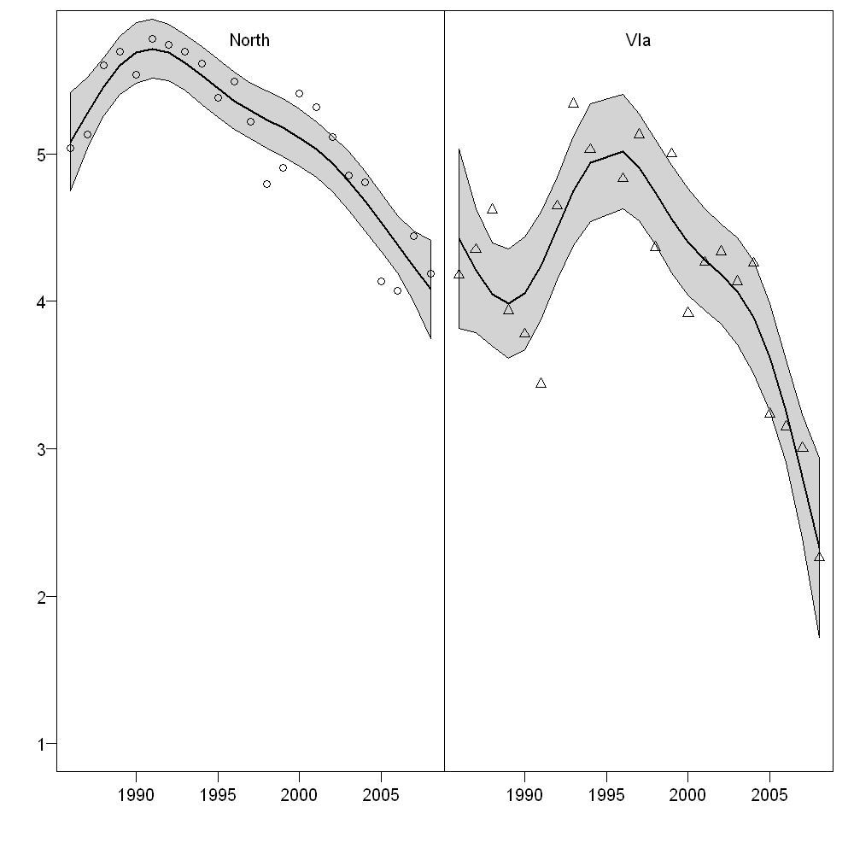 | b)  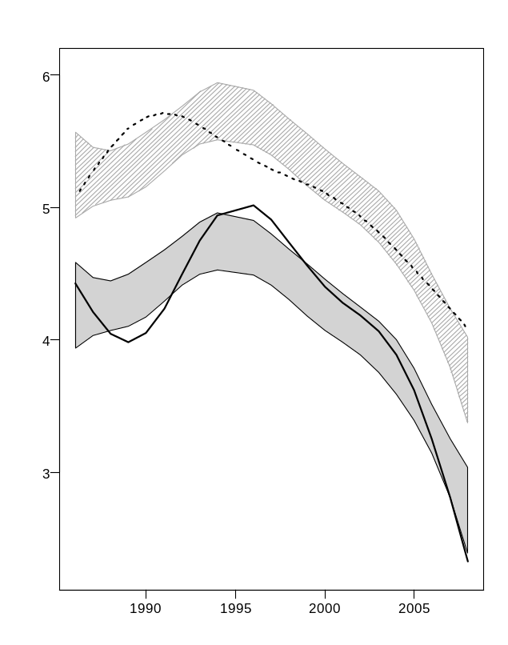

Figure 6
a)  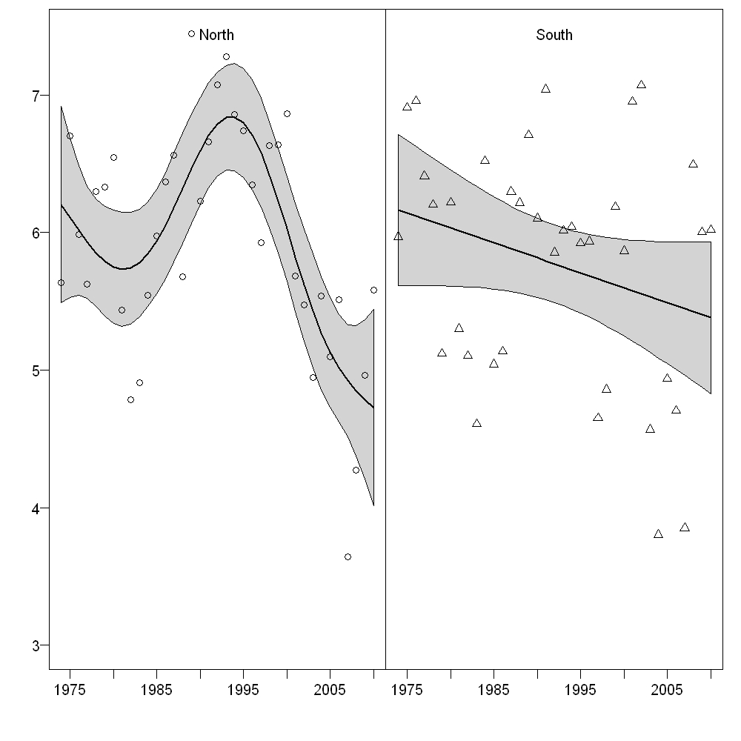 | b)  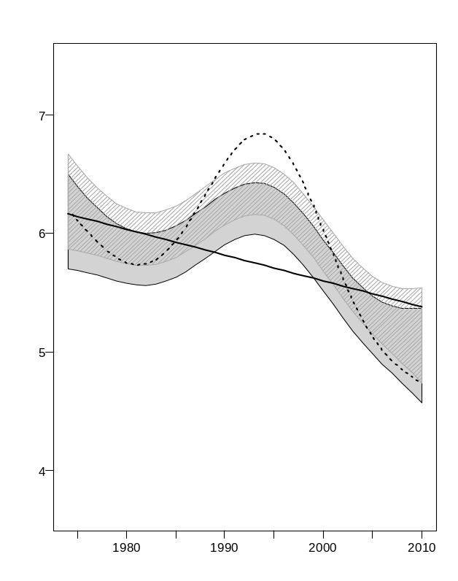

Figure 7
a)  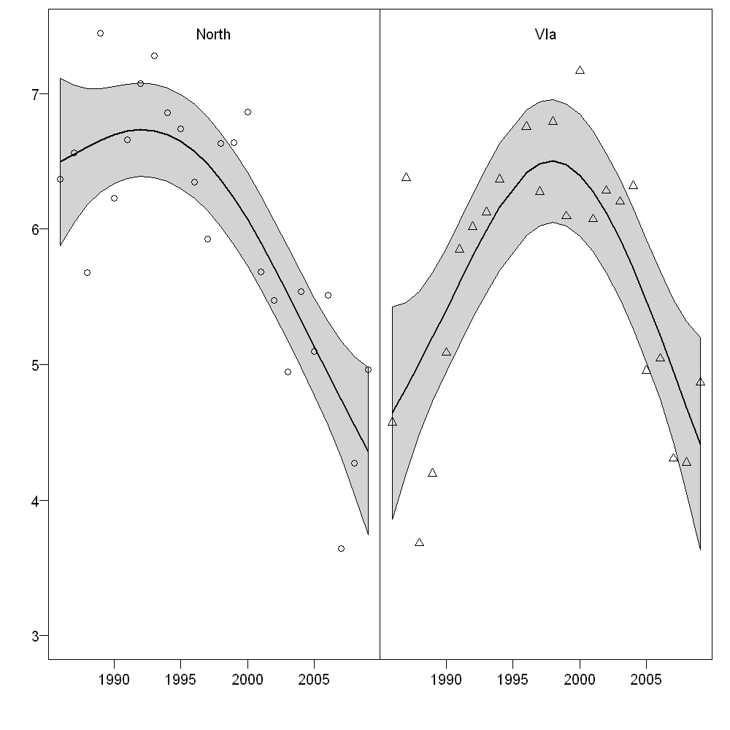 | b)  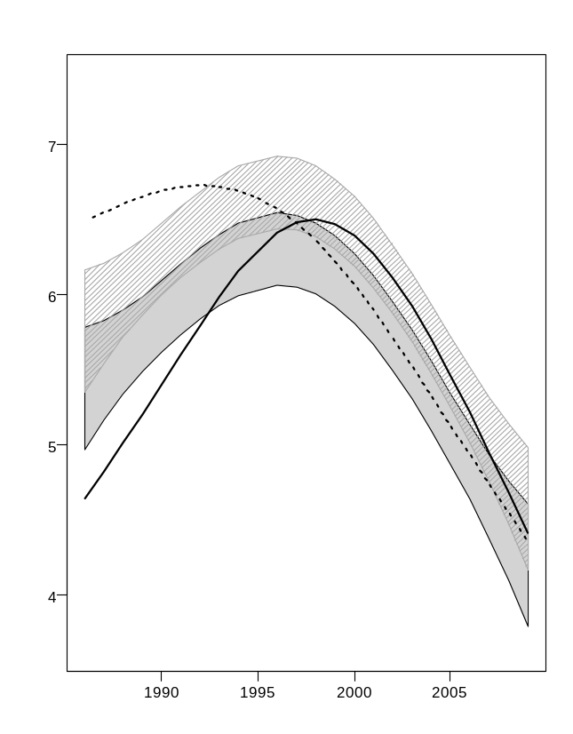

Figure 8
a)  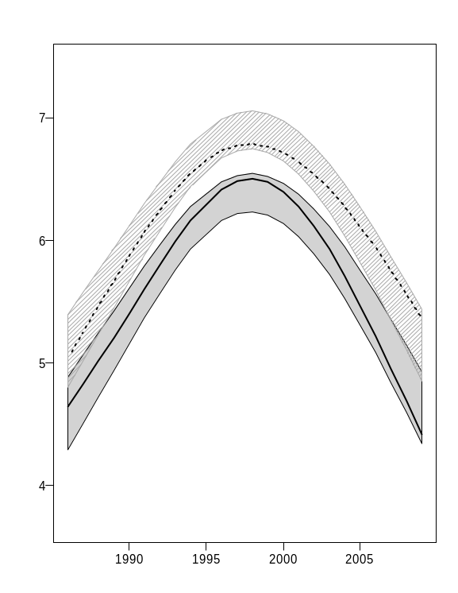 | b)  