1.1 Estimation of reference points

Introduction
Reference points (biomass and exploitation rates) were estimated for two stocks: The stock assessment of Sardine in GSA 17 and Anchovy in GSA 17 are included in section X.X).

Estimation of reference points was done based on the methodology described in Simmonds et al., (2011) which originated as a working document to the 2010 WKFRAME meeting (Anon., 2010). The framework uses computer intensive methods to estimate MSY (Maximum Sustainable Yield) reference points and calculates for a given value of B_{lim} corresponding F_{lim} reference points. These reference points have a probabilistic interpretation, for example two of the F_{lim} reference points calculated are the F that gives a 5% probability of SSB (spawning stock biomass) falling below B_{lim} (denoted F_{lim5}) and the F that gives a 10% probability of SSB falling below B_{lim}. Other F reference points are F_{msy}: the median of the Fs that give the maximum sustainable yield, F_{msy catch}: the F that gives the maximum average yield, F_{crash5}: the F that has a 5% chance of crashing the stock, and F_{crash50}: the F that has a 50% chance of crashing the stock. The method also attempts to estimate a B_{lim} by using the location of the breakpoint in a fit of the hockey-stick stock recruitment (SR) function.

Methodology
The methodology follows that in Simmonds et al. (2011), there were some refinements of the model averaging methodology largely of a technical nature.
The approach follows that of a typical medium term projection but it includes the uncertainty in the choice of the stock recruitment model. Three models were investigated: the Ricker, the Beverton and Holt and the Hockey-stick models. Bayesian model averaging was used to combine the models giving appropriate weight to the best fitting models. The result is an algorithm which simulates recruitment given an SSB estimate while incorporating error not just in the fit of the individual model parameters (parameter uncertainty) but also incorporating error in the choice of model (model uncertainty). The method in Simmonds et al. (2011) uses an estimate of the posterior model probability from Gammerman 1997, then samples independently from the parameter distribution in each model, selecting which model to sample based on the estimate of the posterior model probability. This was changed and the approach taken here is to sample from the joint distribution of models and parameters (as in Madigan and York, 1995 and discussed in Hoeting et al., 1999), which is more appropriate.

The inputs to the medium term projection were mean weight at age in the catch, mean weight at age in the stock, selectivity at age, maturity and natural mortality. For each year in the projection, sets of these values from 2009 to 2011 were chosen at random by selecting a year and using the same compliment of selectivity and weights at age and other parameters to maintain any within year correlation while also adding some noise that reflects current variations in these quantities. The simulations were initiated with a recruitment equal to the mean geometric mean of the series, and other inputs such as proportion of F before spawning and proportion of M before spawning were fixed based on a three year average (though these quantities do not change).

The projection was run for 200 years and reference point calculations were based on the last 50 years (i.e. it is assumed that equilibrium is reached before 150 years). A range of F_{bar} values (40 in total) were simulated between 0 and 1 and for each F_{bar} value 5000 simulations were conducted. Bpa was defined as 1.4 x Blim.

A paragraph on how the reference point estimates were calculated...

Results
      - Sardine in GSA 17
        - The data

The stock recruitment data are plotted in Figure 1. It shows an approximately linear relationship between SSB and recruitment. The data presented on this plot are from the final SGMED assessment (see section XX).
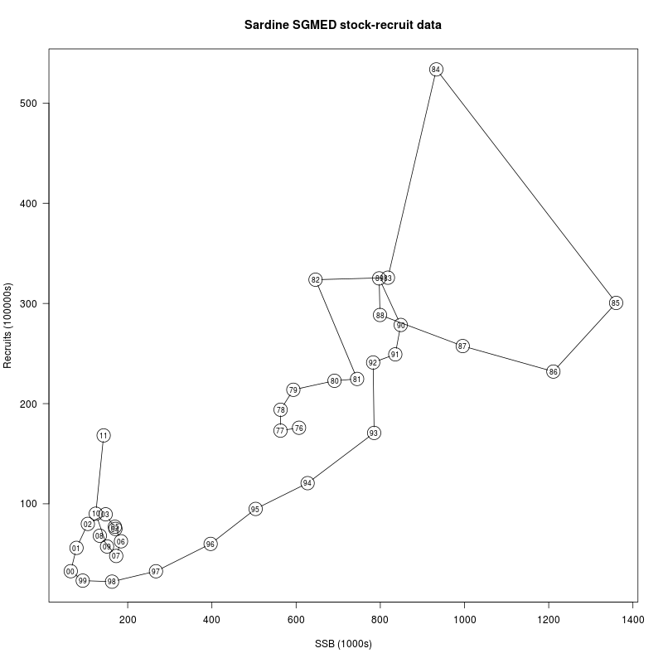
Figure S1. Stock and recruitment data for sardine in GSA 17. Consecutive years are joined by lines. The year in which the recruitment takes place is given inside the point (years run from 1975 to 2011).

        - Scenario 1: SGMED assessment stock-recruit data

The data used in these simulations is shown in figure S1. The fits of the individual stock recruitment models are shown in figure S1.1 along with a figure showing 500,000 simulations of recruitment after accounting for model and parameter uncertainty. Looking at Figure S1.2 and S1.2 d) in particular it can be seen that, although the 1984 recruitment is high, it is not as much of an outlier as the low 1997 recruitment. This is a consequence of the constant CV assumption and is not obvious prior to looking at figure S1.1. The overall fits look good, apart from the period of lower than expected recruitments between 1993 and 1998.

The results of the simulations are given in figures S1.1 and S1.2 and the reference points estimated are shown in table S1. It was not possible to use the estimate of Blim from the hockey stick recruitment model break point since it was not well defined. A pragmatic alternative is to use 30% of the maximum predicted historical SSB taking this to be a proxy for 30% of virgin biomass and this is the value used to estimate Flim and Bpa.

Table S1 Estimated reference points. F_{lim5}, F_{lim10} and F_{lim50} are the F values that give a 5%, 10% and 50% probability of SSB falling below B_{lim}. F_{MSY} is the median F that gives maximum sustainable yield and F_{max catch} maximises average catch. F_{crash5} and F_{crash50} are the F values that give 5% and 10% probability of crashing the stock. B_{lim} was defined as 30% of maximum observed SSB
B_{lim} | B_{pa} | F_{lim5} | F_{lim10} | F_{lim50} | F_{MSY} | F_{max Catch} | F_{crash5} | F_{crash50}
408,032 | 571,245 | 0.13 | 0.17 | 0.36 | 0.36 | 0.23 | 0.13 | 0.33

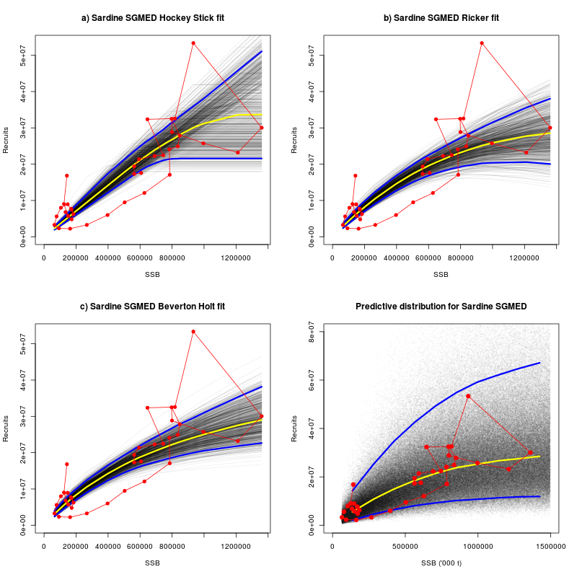
Figure S1.1. Stock-recruitment model fits showing the data (red), the median (yellow) and the 5th and 95th percentiles. Panels a) – c) show SR model fits (Hockey-stick, Ricker and Beverton and Holt) along with 5000 simulated recruitment relationships showing the parameter uncertainty. Panel d) shows predicted recruitments at different level of SSB accounting for both parameter and model uncertainty.

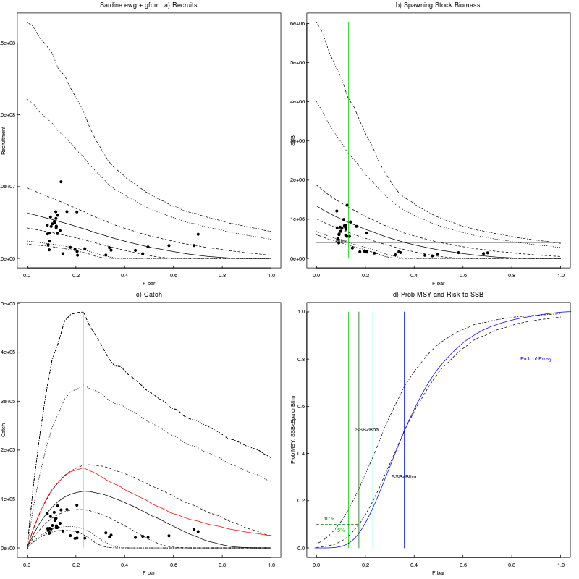
Figure S1.2. A summary of the state of the equilibrium stock under different fishing mortalities. The points show the recent state of the stock. Panel a) shows the distribution of recruitment against F_{bar}, the solid line is the median, with the remaining dotted lines showing the 25th and 75th, 5th and 95th, and 2.5th and 97.5th quantiles. The vertical green bar shows the position of F_{lim5}. Panel b) show the same for SSB against F with a solid horizontal line representing B_{lim} highlighting the definition of F_{lim5}. Panel c) shows catch against F_{bar}, here a red line shows average equilibrium catch, which is maximised at F_{max catch} indicated by a vertical light blue line. In the final panel (d) three distributions are shown: the probability of achieving MSY in blue and the probability of SSB falling below B_{lim} and B_{pa}. F_{MSY} (blue), F_{max catch} (light blue), F_{lim5} (green) and F_{lim10} (dark green) are shown as vertical lines.

        - Scenario 2: SGMED assessment stock-recruit data with high recruitment removed

The results of the simulations are given in figures S2.1 and S2.2 and the reference points estimated are shown in table S2. It was not possible to use the estimate of Blim from the hockey stick break point since it was not well defined. A pragmatic alternative is to use 30% of the maximum predicted historical SSB taking this to be a proxy for 30% of virgin biomass and this is the value used to estimate Flim and Bpa.

Table S2 Estimated reference points. F_{lim5}, F_{lim10} and F_{lim50} are the F values that give a 5%, 10% and 50% probability of SSB falling below B_{lim}. F_{MSY} is the median F that gives maximum sustainable yield and F_{max catch} maximises average catch. F_{crash5} and F_{crash50} are the F values that give 5% and 10% probability of crashing the stock. B_{lim} was defined as 30% of maximum observed SSB.
B_{lim} | B_{pa} | F_{lim5} | F_{lim10} | F_{lim50} | F_{MSY} | F_{max Catch} | F_{crash5} | F_{crash50}
408,032 | 571,245 | 0.11 | 0.15 | 0.34 | 0.38 | 0.23 | 0.13 | 0.38

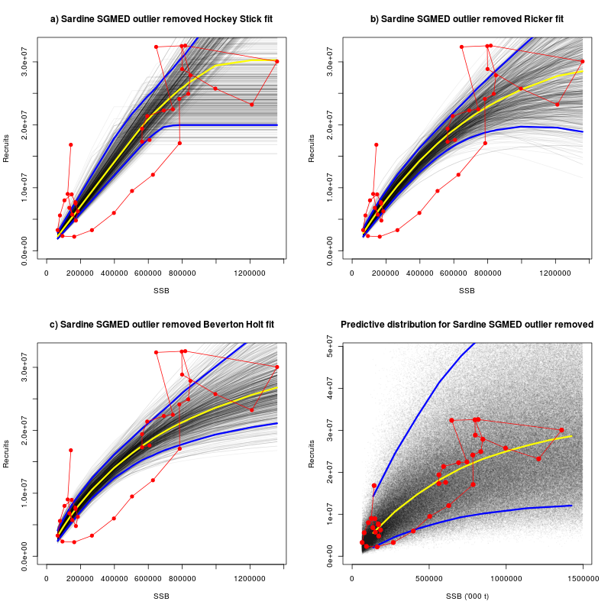Figure S2.1. Stock-recruitment model fits showing the data (red), the median (yellow) and the 5th and 95th percentiles. Panels a) – c) show model fits (Hockey-stick, Ricker and Beverton and Holt) along with 5000 simulated recruitment relationships showing the parameter uncertainty. Panel d) shows predicted recruitments given different values of SSB accounting for both parameter and model uncertainty.

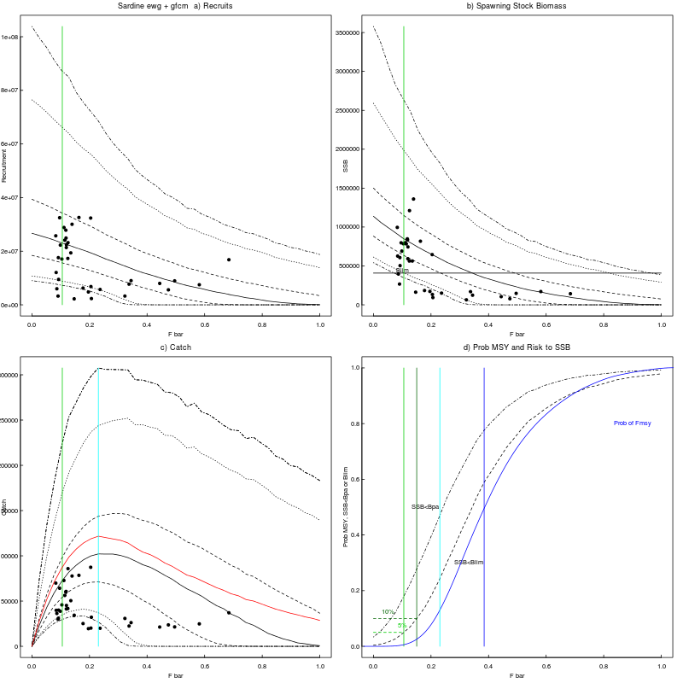
Figure S2.2. A summary of the state of the equilibrium stock under different fishing mortalities. The points show the recent state of the stock. Panel a) shows the distribution of recruitment against F_{bar}, the solid line is the median, with the remaining dotted lines showing the 25th and 75th, 5th and 95th, and 2.5th and 97.5th quantiles. The vertical green bar shows the position of F_{lim5}. Panel b) show the same for SSB against F with a solid horizontal line representing B_{lim} highlighting the definition of F_{lim5}. Panel c) shows catch against F_{bar}, here a red line shows average equilibrium catch, which is maximised at F_{max catch} indicated by a vertical light blue line. In the final panel (d) three distributions are shown: the probability of achieving MSY in blue and the probability of SSB falling below B_{lim} and B_{pa}. F_{MSY} (blue), F_{max catch} (light blue), F_{lim5} (green) and F_{lim10} (dark green) are shown as vertical lines.

        - Scenario 3: stock-recruit data from ICA fit to the full series using 2010 settings

The results of the simulations are given in figures S3.1 and S3.2 and the reference points estimated are shown in table S3. It was not possible to use the estimate of Blim from the hockey stick break point since it was not well defined. A pragmatic alternative is to use 30% of the maximum predicted historical SSB taking this to be a proxy for 30% of virgin biomass and this is the value used to estimate Flim and Bpa.

Table S3 Estimated reference points. F_{lim5}, F_{lim10} and F_{lim50} are the F values that give a 5%, 10% and 50% probability of SSB falling below B_{lim}. F_{MSY} is the median F that gives maximum sustainable yield and F_{max catch} maximises average catch. F_{crash5} and F_{crash50} are the F values that give 5% and 10% probability of crashing the stock. B_{lim} was defined as 30% of maximum observed SSB.
B_{lim} | B_{pa} | F_{lim5} | F_{lim10} | F_{lim50} | F_{MSY} | F_{max Catch} | F_{crash5} | F_{crash50}
408,032 | 571,245 | 0.13 | 0.17 | 0.38 | 0.41 | 0.26 | 0.15 | 0.38

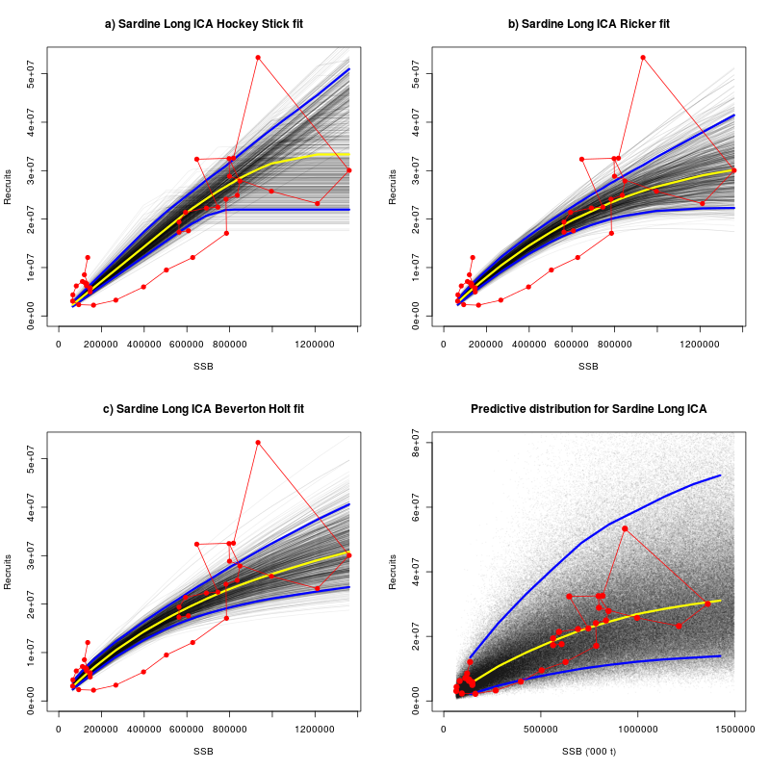
Figure S3.1. Stock-recruit model fits showing the data (red), the median (yellow) and the 5th and 95th percentiles. Panels a) – c) show model fits (Hockey-stick, Ricker and Beverton and Holt) along with 5000 simulated recruitment relationships showing the parameter uncertainty. Panel d) shows predicted recruitments given different values of SSB accounting for both parameter and model uncertainty.

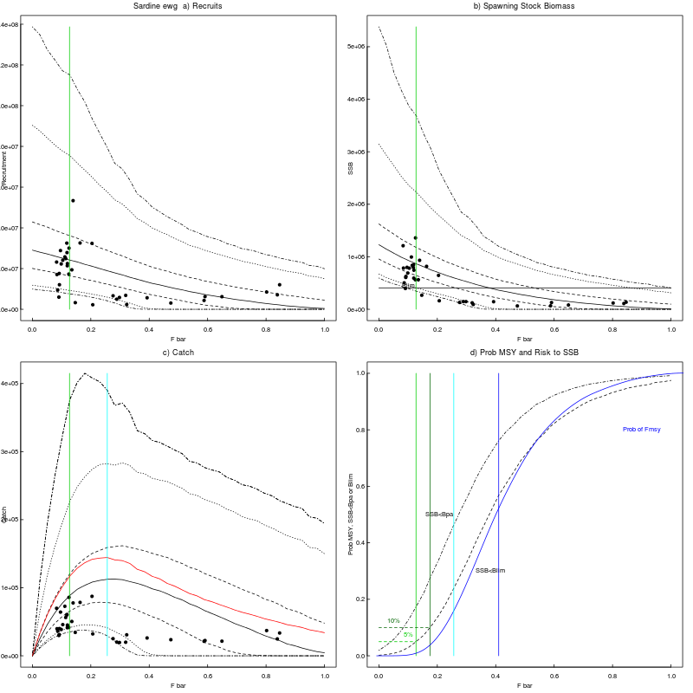
Figure S3.2. A summary of the state of the equilibrium stock under different fishing mortalities. The points show the recent state of the stock. Panel a) shows the distribution of recruitment against F_{bar}, the solid line is the median, with the remaining dotted lines showing the 25th and 75th, 5th and 95th, and 2.5th and 97.5th quantiles. The vertical green bar shows the position of F_{lim5}. Panel b) show the same for SSB against F with a solid horizontal line representing B_{lim} highlighting the definition of F_{lim5}. Panel c) shows catch against F_{bar}, here a red line shows average equilibrium catch, which is maximised at F_{max catch} indicated by a vertical light blue line. In the final panel (d) three distributions are shown: the probability of achieving MSY in blue and the probability of SSB falling below B_{lim} and B_{pa}. F_{MSY} (blue), F_{max catch} (light blue), F_{lim5} (green) and F_{lim10} (dark green) are shown as vertical lines.

        - Scenario 4: GFCM 2011 assessment stock-recruit data

The results of the simulations are given in figures S4.1 and S4.2 and the reference points estimated are shown in table S4. It was not possible to use the estimate of Blim from the hockey stick break point since it was not well defined. A pragmatic alternative is to use 30% of the maximum predicted historical SSB taking this to be a proxy for 30% of virgin biomass and this is the value used to estimate Flim and Bpa.

Table S4 Estimated reference points. F_{lim5}, F_{lim10} and F_{lim50} are the F values that give a 5%, 10% and 50% probability of SSB falling below B_{lim}. F_{MSY} is the median F that gives maximum sustainable yield and F_{max catch} maximises average catch. F_{crash5} and F_{crash50} are the F values that give 5% and 10% probability of crashing the stock. B_{lim} was defined as 30% of maximum observed SSB.
B_{lim} | B_{pa} | F_{lim5} | F_{lim10} | F_{lim50} | F_{MSY} | F_{max Catch} | F_{crash5} | F_{crash50}
55,217 | 77,304 | - | - | - | - | - | - | -

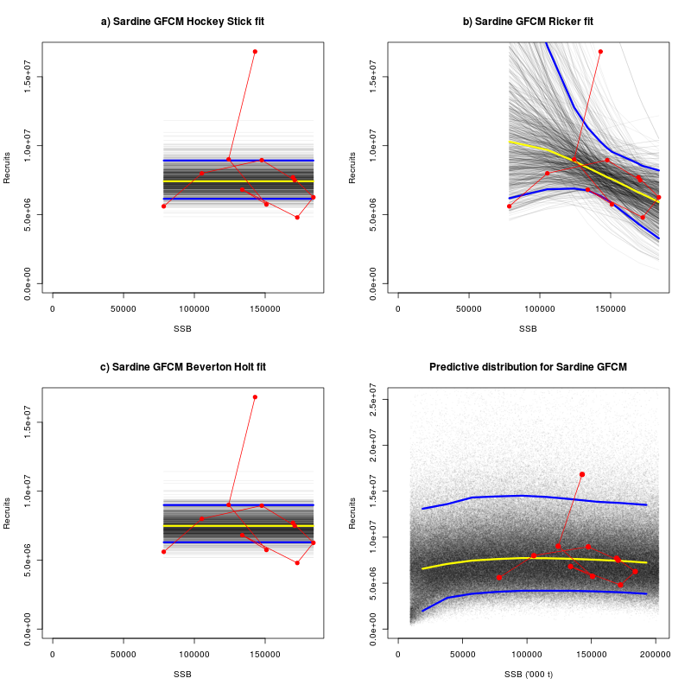
Figure S4.1. Stock-recruit model fits showing the data (red), the median (yellow) and the 5th and 95th percentiles. Panels a) – c) show model fits (Hockey-stick, Ricker and Beverton and Holt) along with 5000 simulated recruitment relationships showing the parameter uncertainty. Panel d) shows predicted recruitments at different values of SSB accounting for both parameter and model uncertainty.

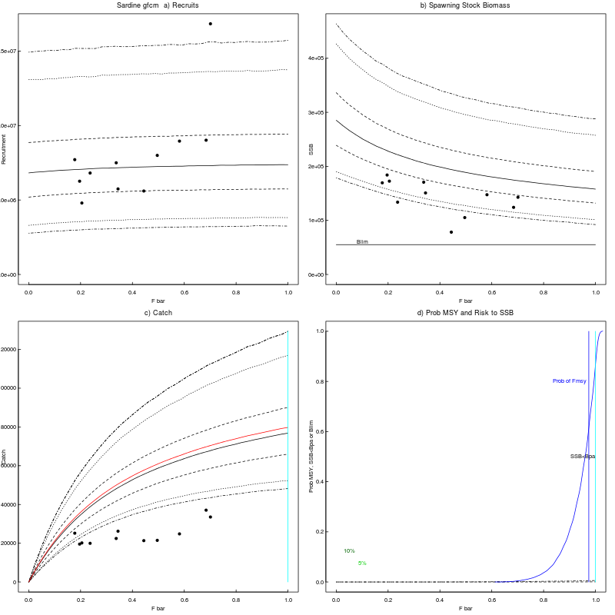
Figure S4.2. A summary of the state of the equilibrium stock under different fishing mortalities. The points show the recent state of the stock. Panel a) shows the distribution of recruitment against F_{bar}, the solid line is the median, with the remaining dotted lines showing the 25th and 75th, 5th and 95th, and 2.5th and 97.5th quantiles. The vertical green bar shows the position of F_{lim5}. Panel b) show the same for SSB against F with a solid horizontal line representing B_{lim} highlighting the definition of F_{lim5}. Panel c) shows catch against F_{bar}, here a red line shows average equilibrium catch, which is maximised at F_{max catch} indicated by a vertical light blue line. In the final panel (d) three distributions are shown: the probability of achieving MSY in blue and the probability of SSB falling below B_{lim} and B_{pa}. F_{MSY} (blue), F_{max catch} (light blue), F_{lim5} (green) and F_{lim10} (dark green) are shown as vertical lines.

        - Summary and recommendations

There was a suitable stock-recruitment relations in long time series scenarios to estimate reference points. The short time series (scenario 4) did not have sufficient contrast to estimate anything but a straight line (ie recruitment independent of stock size).

A summary of estimated reference points is shown in table S5. Scenarios 1 to 3 vary a little in there estimates of F reference point estimates but we may be seeing some error due to the simulations themselves (so called monte-carlo error). FMSY is estimated to be around 0.38, however the F the give a 50/50 chance of crashing the stock is around this value (0.33 – 0.38). The F that maximises average catch is estimated to be around 0.24 which may give around a 10% chance of crashing the stock (Fcrash5 is around 0.14). Setting Blim at 30% max observed SSB results in Flim values that pose a small risk to crashing the stock.

Table S5 Summary of reference point estimates from all four scenarios.
Scenario | B_{lim} | B_{pa} | F_{lim5} | F_{lim10} | F_{lim50} | F_{MSY} | F_{max Catch} | F_{crash5} | F_{crash50}
1 | 408,032 | 571,245 | 0.13 | 0.17 | 0.36 | 0.36 | 0.23 | 0.13 | 0.33
2 | 408,032 | 571,245 | 0.11 | 0.15 | 0.34 | 0.38 | 0.23 | 0.13 | 0.38
3 | 408,032 | 571,245 | 0.13 | 0.17 | 0.38 | 0.41 | 0.26 | 0.15 | 0.38
4 | 55,217 | 77,304 | - | - | - | - | - | - | -

      - Anchovy in GSA 17
        - The data

The stock recruitment data are plotted in Figure A1. It shows an approximately linear relationship between SSB and recruitment. The data presented on this plot are from the final STECF assessment (see section XX).
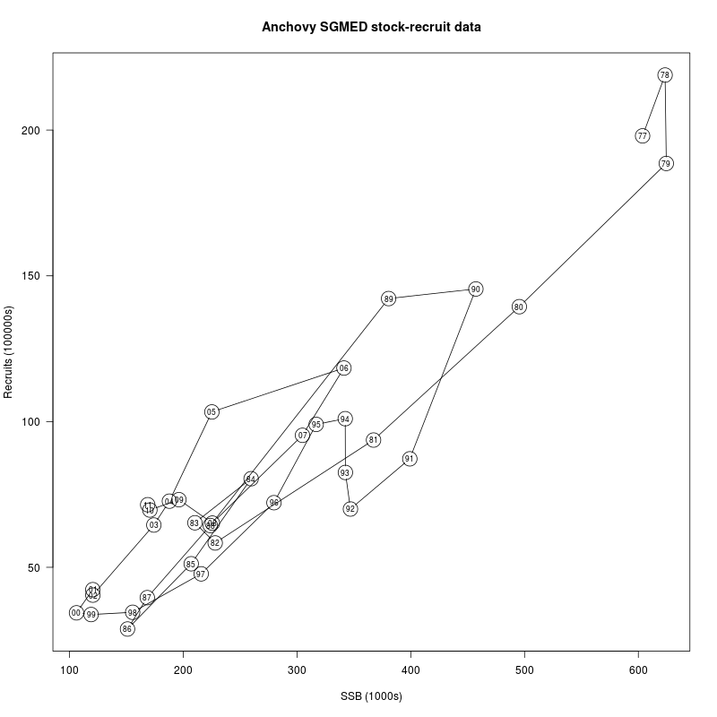
Figure A1. Stock and recruitment data for anchovy in GSA 17. Consecutive years are joined by lines and the year. The year in which the recruitment takes place is given inside the point (years run from 1977 to 2011).

        - Scenario 1: SGMED assessment stock-recruit data

The results of the simulations are given in figures A1.1 and A1.2 and the reference points estimated are shown in table A1. It was not possible to use the estimate of Blim from the hockey stick break point since it was not well defined. A pragmatic alternative is to use 30% of the maximum predicted historical SSB taking this to be a proxy for 30% of virgin biomass and this is the value used to estimate Flim and Bpa.

Table A1 Estimated reference points. F_{lim5}, F_{lim10} and F_{lim50} are the F values that give a 5%, 10% and 50% probability of SSB falling below B_{lim}. F_{MSY} is the median F that gives maximum sustainable yield and F_{max catch} maximises average catch. F_{crash5} and F_{crash50} are the F values that give 5% and 10% probability of crashing the stock. B_{lim} was defined as 30% of maximum observed SSB.
B_{lim} | B_{pa} | F_{lim5} | F_{lim10} | F_{lim50} | F_{MSY} | F_{max Catch} | F_{crash5} | F_{crash50}
187,377 | 262,327 | - | - | - | - | - | - | -

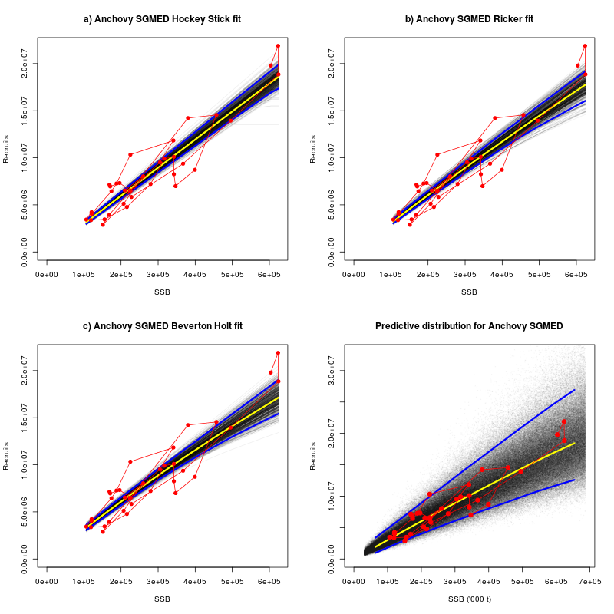
Figure A1.1. Stock-recruit model fits showing the data (red), the median (yellow) and the 5th and 95th percentiles. Panels a) – c) show model fits (Hockey-stick, Ricker and Beverton and Holt) along with 5000 simulated recruitment relationships showing the parameter uncertainty. Panel d) shows predicted recruitments at different values of SSB accounting for both parameter and model uncertainty.

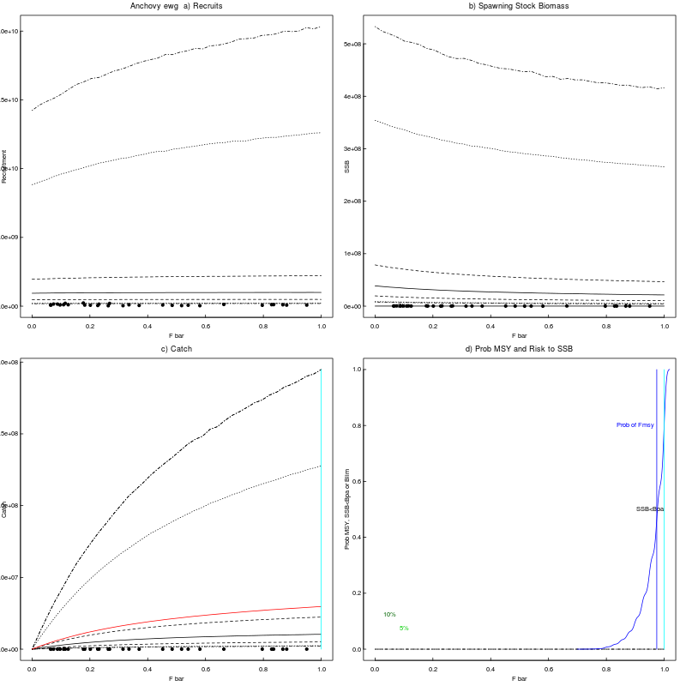
Figure A1.2. A summary of the state of the equilibrium stock under different fishing mortalities. The points show the recent state of the stock. Panel a) shows the distribution of recruitment against F_{bar}, the solid line is the median, with the remaining dotted lines showing the 25th and 75th, 5th and 95th, and 2.5th and 97.5th quantiles. The vertical green bar shows the position of F_{lim5}. Panel b) show the same for SSB against F with a solid horizontal line representing B_{lim} highlighting the definition of F_{lim5}. Panel c) shows catch against F_{bar}, here a red line shows average equilibrium catch, which is maximised at F_{max catch} indicated by a vertical light blue line. In the final panel (d) three distributions are shown: the probability of achieving MSY in blue and the probability of SSB falling below B_{lim} and B_{pa}. F_{MSY} (blue), F_{max catch} (light blue), F_{lim5} (green) and F_{lim10} (dark green) are shown as vertical lines.

        - Scenario 2: SGMED assessment stock-recruit data with high SSBs removed

The results of the simulations are given in figures A2.1 and A2.2 and the reference points estimated are shown in table A2. It was not possible to use the estimate of Blim from the hockey stick break point since it was not well defined. A pragmatic alternative is to use 30% of the maximum predicted historical SSB taking this to be a proxy for 30% of virgin biomass and this is the value used to estimate Flim and Bpa.

Table A2 Estimated reference points. F_{lim5}, F_{lim10} and F_{lim50} are the F values that give a 5%, 10% and 50% probability of SSB falling below B_{lim}. F_{MSY} is the median F that gives maximum sustainable yield and F_{max catch} maximises average catch. F_{crash5} and F_{crash50} are the F values that give 5% and 10% probability of crashing the stock. B_{lim} was defined as 30% of maximum observed SSB.
B_{lim} | B_{pa} | F_{lim5} | F_{lim10} | F_{lim50} | F_{MSY} | F_{max Catch} | F_{crash5} | F_{crash50}
148,623 | 208,073 | - | - | - | - | - | - | -

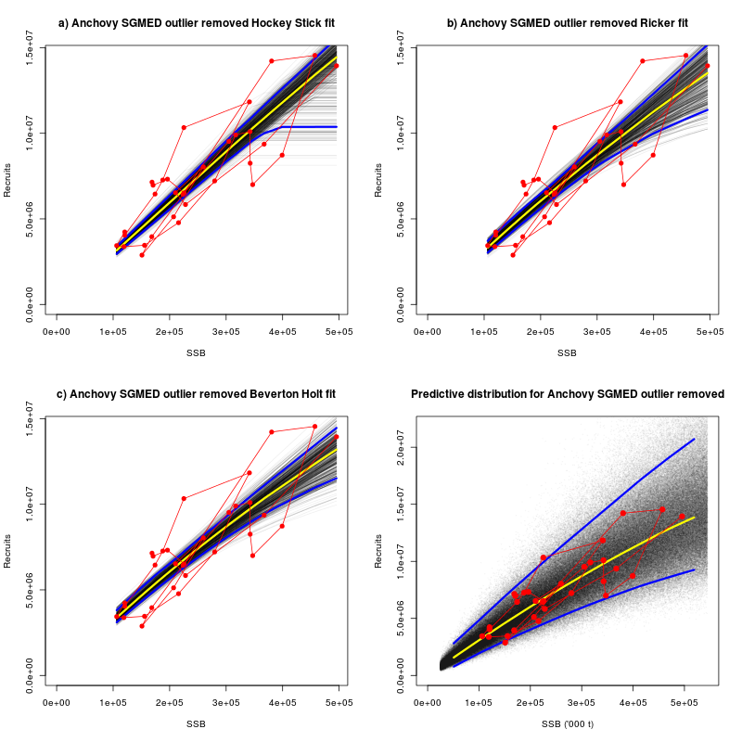
Figure A2.1. Stock-recruit model fits showing the data (red), the median (yellow) and the 5th and 95th percentiles. Panels a) – c) show model fits (Hockey-stick, Ricker and Beverton and Holt) along with 5000 simulated recruitment relationships showing the parameter uncertainty. Panel d) shows predicted recruitments given SSB accounting for both parameter and model uncertainty.

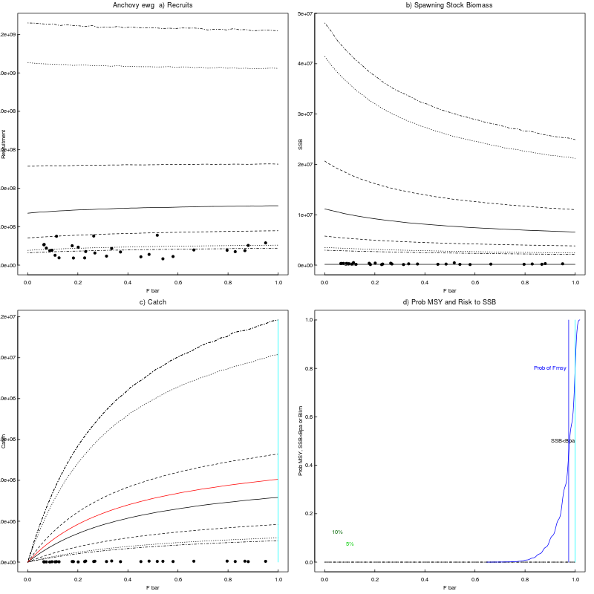
Figure A2.2. A summary of the state of the equilibrium stock under different fishing mortalities. The points show the recent state of the stock. Panel a) shows the distribution of recruitment against F_{bar}, the solid line is the median, with the remaining dotted lines showing the 25th and 75th, 5th and 95th, and 2.5th and 97.5th quantiles. The vertical green bar shows the position of F_{lim5}. Panel b) show the same for SSB against F with a solid horizontal line representing B_{lim} highlighting the definition of F_{lim5}. Panel c) shows catch against F_{bar}, here a red line shows average equilibrium catch, which is maximised at F_{max catch} indicated by a vertical light blue line. In the final panel (d) three distributions are shown: the probability of achieving MSY in blue and the probability of SSB falling below B_{lim} and B_{pa}. F_{MSY} (blue), F_{max catch} (light blue), F_{lim5} (green) and F_{lim10} (dark green) are shown as vertical lines.

        - Scenario 3: SGMED assessment stock-recruit data with age zero removed

Note age zero was also removed from the SSB calculation.
The results of the simulations are given in figures A3.1 and A3.2 and the reference points estimated are shown in table A3. It was not possible to use the estimate of Blim from the hockey stick break point since it was not well defined. A pragmatic alternative is to use 30% of the maximum predicted historical SSB taking this to be a proxy for 30% of virgin biomass and this is the value used to estimate Flim and Bpa.

Table A3 Estimated reference points. F_{lim5}, F_{lim10} and F_{lim50} are the F values that give a 5%, 10% and 50% probability of SSB falling below B_{lim}. F_{MSY} is the median F that gives maximum sustainable yield and F_{max catch} maximises average catch. F_{crash5} and F_{crash50} are the F values that give 5% and 10% probability of crashing the stock. B_{lim} was defined as 30% of maximum observed SSB.
B_{lim} | B_{pa} | F_{lim5} | F_{lim10} | F_{lim50} | F_{MSY} | F_{max Catch} | F_{crash5} | F_{crash50}
62,611 | 87,655 | - | - | - | - | - | - | -

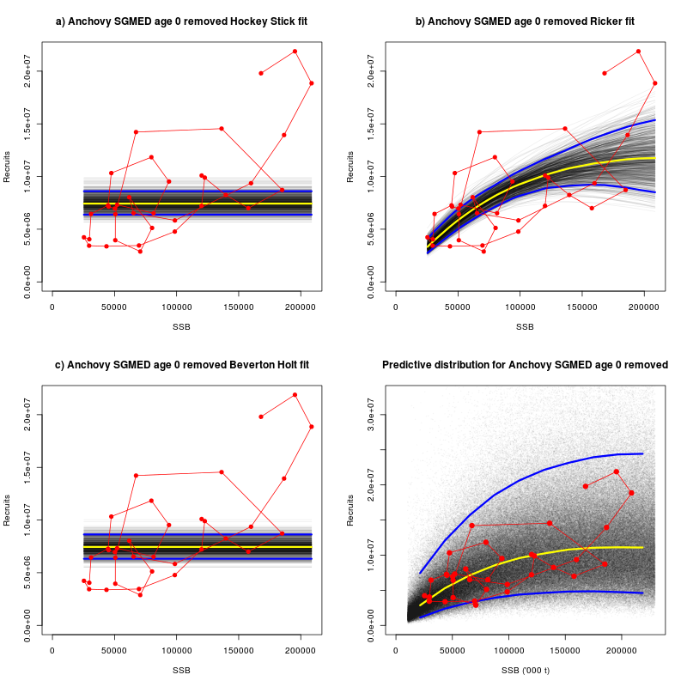
Figure A3.1. Stock-recruit model fits showing the data (red), the median (yellow) and the 5th and 95th percentiles. Panels a) – c) show model fits (Hockey-stick, Ricker and Beverton and Holt) along with 5000 simulated recruitment relationships showing the parameter uncertainty. Panel d) shows predicted recruitments given SSB accounting for both parameter and model uncertainty.

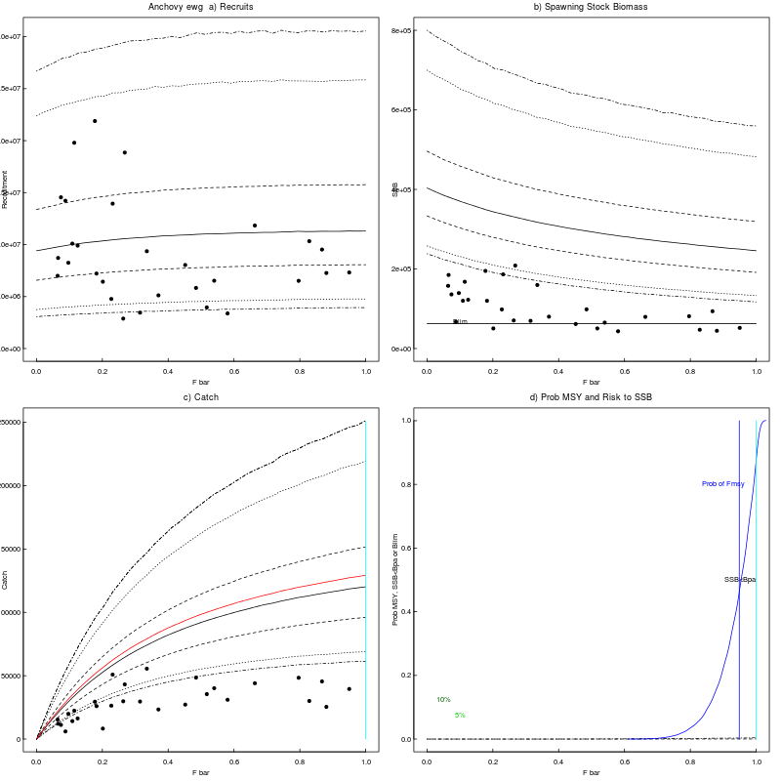
Figure A3.2. A summary of the state of the equilibrium stock under different fishing mortalities. The points show the recent state of the stock. Panel a) shows the distribution of recruitment against F_{bar}, the solid line is the median, with the remaining dotted lines showing the 25th and 75th, 5th and 95th, and 2.5th and 97.5th quantiles. The vertical green bar shows the position of F_{lim5}. Panel b) show the same for SSB against F with a solid horizontal line representing B_{lim} highlighting the definition of F_{lim5}. Panel c) shows catch against F_{bar}, here a red line shows average equilibrium catch, which is maximised at F_{max catch} indicated by a vertical light blue line. In the final panel (d) three distributions are shown: the probability of achieving MSY in blue and the probability of SSB falling below B_{lim} and B_{pa}. F_{MSY} (blue), F_{max catch} (light blue), F_{lim5} (green) and F_{lim10} (dark green) are shown as vertical lines.

Summary and recommendations

Due to the strong linearity and lack of curvature in the stock-recruitment relationship in anchovy none of the simulations were able to estimate reference points. For completeness a summary of estimated reference points is shown in table A4.

Table A4 Summary of reference point estimates from all four scenarios.
Scenario | B_{lim} | B_{pa} | F_{lim5} | F_{lim10} | F_{lim50} | F_{MSY} | F_{max Catch} | F_{crash5} | F_{crash50}
1 | 408,032 | 571,245 | 0.13 | 0.17 | 0.36 | 0.36 | 0.23 | 0.13 | 0.33
2 | 408,032 | 571,245 | 0.11 | 0.15 | 0.34 | 0.38 | 0.23 | 0.13 | 0.38
3 | 408,032 | 571,245 | 0.13 | 0.17 | 0.38 | 0.41 | 0.26 | 0.15 | 0.38

References

Anon., 2010. Report of the Workshop on Implementing the
ICES FMSY framework. ICES CM 2010/ACOM:54

Gammerman, D. 1997. Markov Chain Monte Carlo: Stochastic simulation for Bayesian Inference. Chapman and Hall, London.
Hoeting, J.A., Madigan, D., Raferty, A.E., and Volinsky, C.T. 1999. Bayesian model averaging: a tutorial. Statistical Science, 14(4): 382-417.
Madigan, D. and York, J. 1995. Bayesian graphical models for discrete data. International Statistical Review, 93(2): 215-232.

Simmonds, E.J., Campbell, A., Skagen, D., Roel, B.A., and Kelly, C. 2011. Development of a stock-recruit model for simulating stock dynamics for uncertain situations: the example of Northeast Atlantic mackerel (Scomber scombrus). ICES Journal of Marine Science, 68: 848-859

