GESC 151: Our Digital Earth

Colin Robertson

2020-08-25

# Preface

This is a document in support of the GESC 151 Our Digital Earth course.

## Course Goal and Learning Outcomes

The goal of this course is to develop an understanding of how the earth is represented in digital systems and how these representations can be used to address environmental issues of societal relevance. In completing this course, students will be able to:

1. Describe how information about the earth is captured and represented in digital systems
2. Explain how a geographic perspective on the world can contribute to understanding both natural and anthropogenic processes
3. Learn how to access and analyze geospatial data
4. Utilize freely available geospatial technologies to map spatial distributions of geographic features and processes
5. To assess the accuracy and limitations of digital systems and geospatial data

## Case studies used in this course

As DE tools and technologies can be used in so many different types of applications, we have selected a handful of sample problems which we will use to illustrate key concepts and tools in the course. The case studies as follows

1. Crime and policing in the City of Toronto/Waterloo Region
2. Mapping the weather
3. COVID-19; mapping and modelling
4. Mapping temperature extremes
5. Personal and community geographic knowledge
6. Tracking the Sahara Desert cloud
7. Global freshwater ecosystems

These case studies cover mapping, satellite imaging, big data and surveillance, climate change, among many other topical issues that intersect with the environment and its digital representation. As we move through the course, we encourage to pause often to think about connections between the case studies, and how their digital representation effects how we come to understand and manage these important issues.

## Course readings

There is not a required textbook for this course.

Weekly readings and related materials will be posted to MyLS.

# Introduction to the Digital Earth

The world is rapidly changing. When we consider how we have used maps and mapping in the past to record locations, routes, forest boundaries, roads, etc. we tended to depend on static versions of the world; singular snapshots in time captured on a paper map, or later, on digital version of a paper map. However this situation has changed dramatically. Almost every aspects of our lives are mediated through some digital technologies, and often, these are encoded with some geographic details about the **location** where things occur. Images and videos are increasingly obtained from drones, satellites, and mobile phones.

Consider a typical day for a university student in Canada, and the digital representation of this day.

Table 1:

| Activity | Digital |
| --- | --- |
| Wake up | Phone records first time you check your messages, has location reference connected wit Wifi router at home |
| Catch the bus to school | Swiping bus pass records your ID and bus stop location and time you board |
| Attend classes | Using student card and payment card records time and location of various activities throughout the day, connecting to different wifi spots as you move about campus records location |
| Meet friends for coffee | Using bank card for purchase records time and location |
| Go to volleyball practice | Cell phone pings of towers recording approximate location as you move around the city |
| Go home | Netflix connection records device ID and time you log on |
| All day long | Satellite imaging of locations you are at various resolutions, CCTV cameras capturing images and video, other people capturing you in photos and video |

Figures and tables with captions will be placed in figure and table environments, respectively.

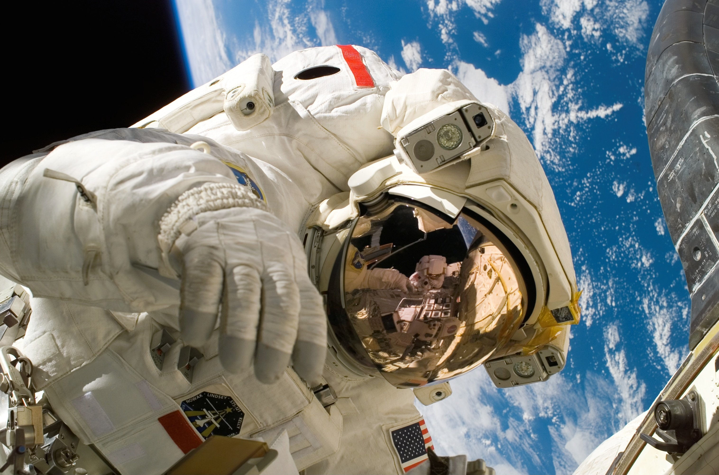

Figure 1: Here is a nice figure!

Reference a figure by its code chunk label with the fig: prefix, e.g., see Figure ??. Similarly, you can reference tables generated from knitr::kable(), e.g., see Table 2.

knitr::kable(  
 head(iris, 20), caption = 'Here is a nice table!',  
 booktabs = TRUE  
)

Table 2: Here is a nice table!

|  |  |  |  |  |
| --- | --- | --- | --- | --- |
| Sepal.Length | Sepal.Width | Petal.Length | Petal.Width | Species |
| 5.1 | 3.5 | 1.4 | 0.2 | setosa |
| 4.9 | 3.0 | 1.4 | 0.2 | setosa |
| 4.7 | 3.2 | 1.3 | 0.2 | setosa |
| 4.6 | 3.1 | 1.5 | 0.2 | setosa |
| 5.0 | 3.6 | 1.4 | 0.2 | setosa |
| 5.4 | 3.9 | 1.7 | 0.4 | setosa |
| 4.6 | 3.4 | 1.4 | 0.3 | setosa |
| 5.0 | 3.4 | 1.5 | 0.2 | setosa |
| 4.4 | 2.9 | 1.4 | 0.2 | setosa |
| 4.9 | 3.1 | 1.5 | 0.1 | setosa |
| 5.4 | 3.7 | 1.5 | 0.2 | setosa |
| 4.8 | 3.4 | 1.6 | 0.2 | setosa |
| 4.8 | 3.0 | 1.4 | 0.1 | setosa |
| 4.3 | 3.0 | 1.1 | 0.1 | setosa |
| 5.8 | 4.0 | 1.2 | 0.2 | setosa |
| 5.7 | 4.4 | 1.5 | 0.4 | setosa |
| 5.4 | 3.9 | 1.3 | 0.4 | setosa |
| 5.1 | 3.5 | 1.4 | 0.3 | setosa |
| 5.7 | 3.8 | 1.7 | 0.3 | setosa |
| 5.1 | 3.8 | 1.5 | 0.3 | setosa |

You can write citations, too. For example, we are using the **bookdown** package (Xie 2020) in this sample book, which was built on top of R Markdown and **knitr** (Xie 2015).

# The Digital Earth in Action

Here is a review of existing methods.

par(mar = c(4, 4, .1, .1))  
plot(pressure, type = 'b', pch = 19)

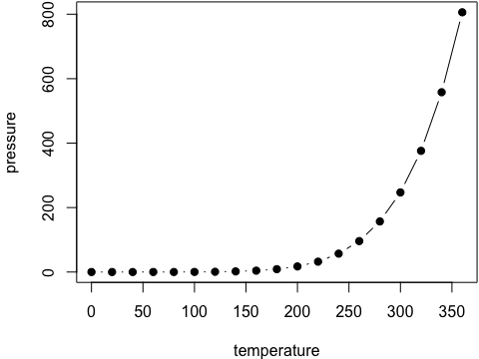

Figure 2: Here is a nice figure alos!

Reference a figure by its code chunk label with the fig: prefix, e.g., see Figure ??. Similarly, you can reference tables generated from knitr::kable(), e.g., see Table 2.

# The View from Above: Satellite Imagery for Earth Observation

We describe our methods in this chapter.

# The View from the Ground: Citizen Science and Community Mapping

Some *significant* applications are demonstrated in this chapter.

## Example one

## Example two

# GPS and Wayfinding

We have finished a nice book.

# UAS and Automated Earth Observations

We have finished a nice book.

# GIS and Big Data

We have finished a nice book.

# 3D Visualization and Story Maps

We have finished a nice book.

# Term Project and Digital Earth Project Management

We have finished a nice book.

# The Digital Earth Town Hall

During the week of December 9th 2020, we will convene a Digital Earth Town Hall with guest speakers, a discussion panel, and a map contest.

Xie, Yihui. 2015. *Dynamic Documents with R and Knitr*. 2nd ed. Boca Raton, Florida: Chapman; Hall/CRC. <http://yihui.name/knitr/>.

———. 2020. *Bookdown: Authoring Books and Technical Documents with R Markdown*. <https://CRAN.R-project.org/package=bookdown>.