Src > App.js:
Component (stateless functional / class component) is in the src directory
Building blocks of UI to make complete application are placed here
NOTE: Remember to export the app to be imported into public > Index.html
NOTE: Usually a component is returning some form of HTML!

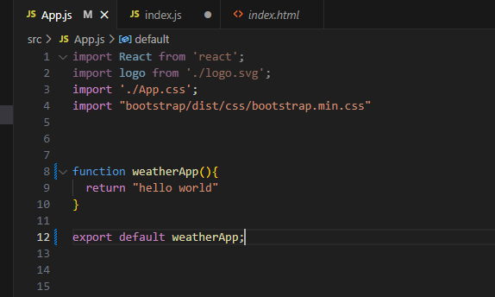

src > Index.js
Renders application from src > App.js NOTE: import exported application from src > App.js

public > Index.html
This file contains standard HTML template that contains divs / main/ sections responsible for containing the component to be rendered from src > Index.js file by React.

Think: Index.js renders to Index.html
