https://www.youtube.com/watch?v=y9wFFD2bXQM

C - Conceptualize the data (What story can be told w/ this data) ~ 2:30

> 5 Ws of data: Who, What, When, Where, Why, How?

Ex:

Who – User 2c06175e
What – Puchased Nintendo Switch
When – 12/24/2020 that shipped on 12/13/20 (NOTE ship date earlier than purchase date (DOES NOT MAKE SENSE))
Where - User 2c06175e is in United States
How – via website via affiliate marketing
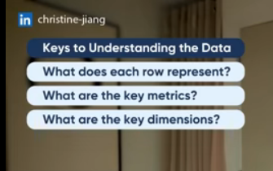

If possible – knowing what questions the business needs answered is VERY helpful in shaping focus on which data / dimensions are most important


For gamezone dataset:
each row = 1 order
Key Metric(s): Purchase price
Key Dimensions:
Purchase date / ship date (time to ship = ship date – order date)
Country from which purchased
Most likely all other fields are dimensions

L – Locate resolvable issues

E – Evaluate non resolvable issues

A – Augment dataset / make dataset more robust

N- Note / document findings

