1. Load data

**Data Source:**

* **1.United States COVID-19 Cases and Deaths by State over Time**
  + Link : <https://data.cdc.gov/Case-Surveillance/United-States-COVID-19-Cases-and-Deaths-by-State-o/9mfq-cb36>
  + API Endpoint : <https://data.cdc.gov/resource/9mfq-cb36.json>
    - * <https://data.cdc.gov/resource/9mfq-cb36.csv>

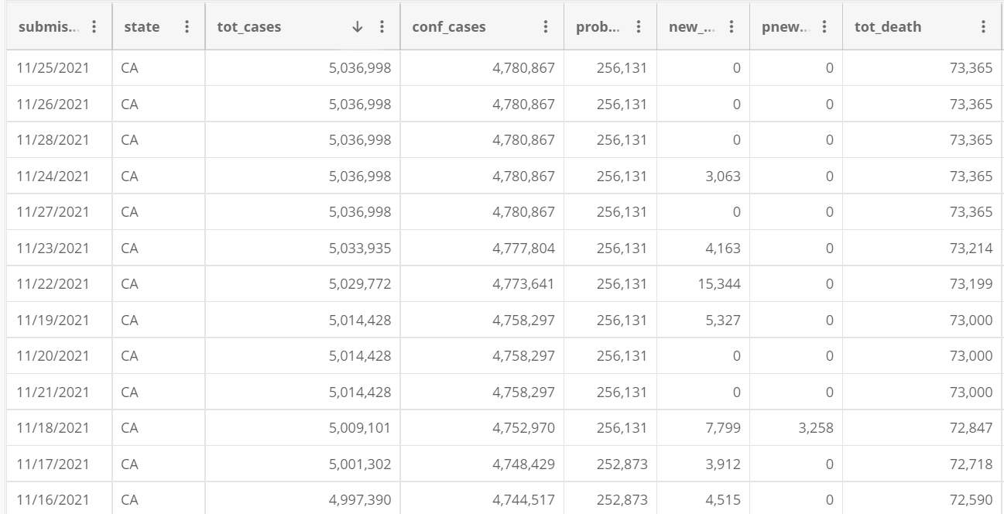

* Load data into Covid Case data frame
* **Trips by Distance :**

Link: <https://data.bts.gov/Research-and-Statistics/Trips-by-Distance/w96p-f2qv>

API Endpoint : <https://data.bts.gov/resource/w96p-f2qv.json>

<https://data.bts.gov/resource/w96p-f2qv.csv>

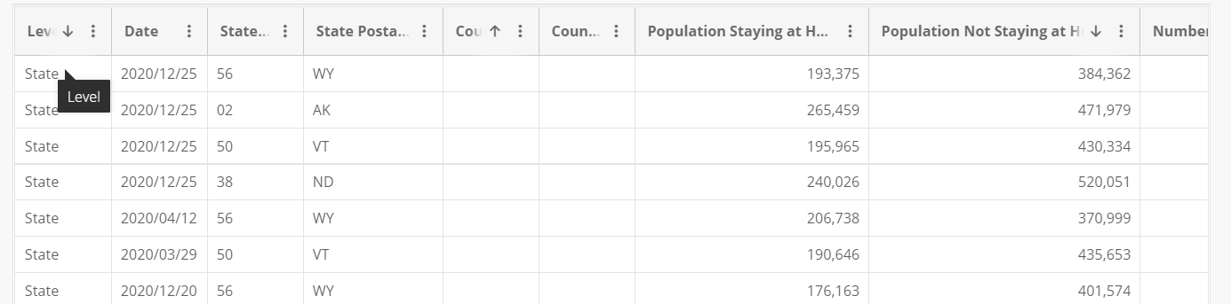

* Load data into travel data frame
* Remove data for all other levels except state
* Merge Covid Case data frame with Travel data frame based on State and Dates (inner join)
* Plot correlation between cases and travel patterns (total travel, type of trips)
* Plot correlation between death and travel patterns (total travel, type of trips)
* Plot line trends of cases and travel patterns (total travel, type of trips) for given time series
* Plot line trends of deaths and travel patterns (total travel, type of trips) for given time series
* Provide case and travel pattern comparison between states
* Identify highest and lowest impacted states of travel impacts for Covid pandemic
* Use Google heatmap to show impacts by state using intensity numbers of impacts per million

(we can add more)

We can also enhance our scope of work with

1.State wise Vaccination data and Travel data

2.Covid data and unemployment data