This part of the project aim to answer two specific questions in regards to the changes in travel pattern.

1. How long does it take for travel pattern to be affected after new cases or new deaths are reported.
2. If the new cases or new death reported has the same effect on every state or if each state react differently.

In order to look at the travel pattern, we must first determine how long it take after cases and deaths are reported before travel pattern changes. To do that we will assume that travel pattern is not affected by the reporting on the day of and that the higher number of people staying at home reflect change in travel pattern.

To determine the number of lag days to use in calculation, a series of lags for number people staying at home are created (1,3,5,7,9,11&13). From the lag data Pearson-R value are calculated for both **“New Case vs Population Staying at Home”** and **“New Death vs Population Staying at Home”**

The table below show the result of the Pearson-R Value calculation

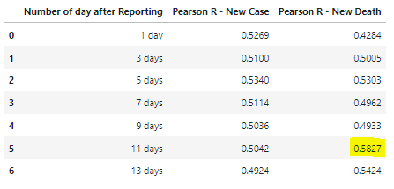

From the table, we determined that there are moderate correlations between the population travel pattern and new cases/new deaths reported. The strongest relations are between 11 days after reporting and New Death. Therefore, we will use 11 days after new death is reported for calculation for the other states.

Using the information we have, we plot a series of scatter plot with trend line to see if there is any correlation for the other states as well as calculate the Pearson R value. Note that for the initial calculation, we have selected California for the calculation. The scatter plots show a varying degree of change in travel pattern for differences states as well as in our R-value tables.

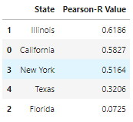

Based on the R value tables and the scatter plot, we can conclude that while there reported death affect travel pattern, not all states’ travel pattern are affected by the new death reported. The state that travel pattern is affected by new death reported are Illinois, California, and New York. While the states that travel pattern are less affected or not affected by the death reported are Texas and Florida.

