**Q1. Which States reacted most/least aggressively to COVID (largest change in travel patterns before and after COVID)? Compare individual state’s pattern with nationwide data.**

**Graphs:**

1.Time Series of COVID Cases, total death, population staying at home, population not staying at home (Overlay 2019 and 2020) in USA

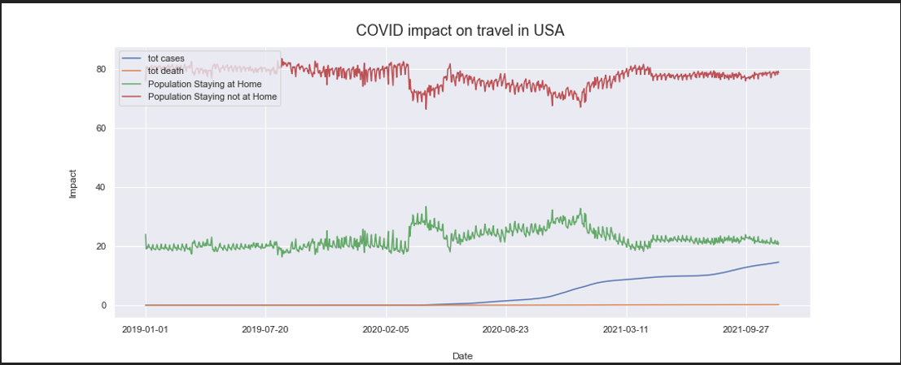

Observations :

Above graph is showing changes in number of trips one year before and one year after COVID started at national level.

* We can see a overall reduction of trips after covid.
* Specifically when COVID was picking up we can see dip in number of trips.
* After some time when COVID was stabilizing we can see increment of trips although COVID cases was happening.

1. Time Series of COVID Cases, total death ,population staying at home, population not staying at home (Overlay 2019 , 2020 and 2021) in California

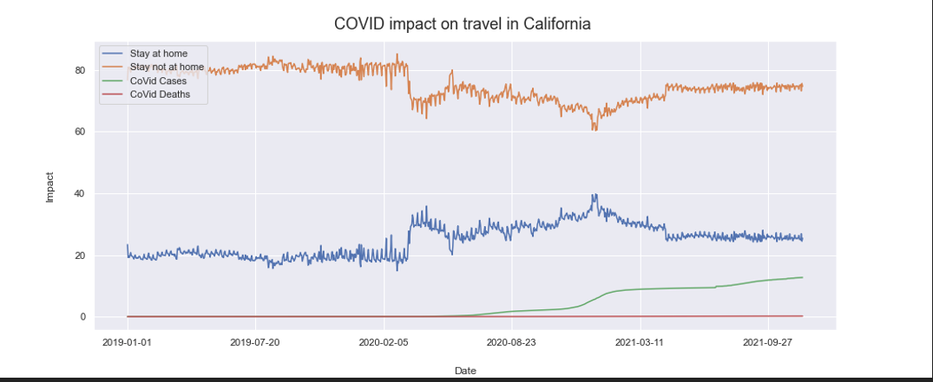

**Observation** : We picked CA as one of highly COVID impacted state ,we can see similar pattern of reducing trips as national trend .But here intensity is high.

3)Time Series of COVID Cases, total death ,population staying at home, population not staying at home (Overlay 2019 , 2020 and 2021) in Vermont

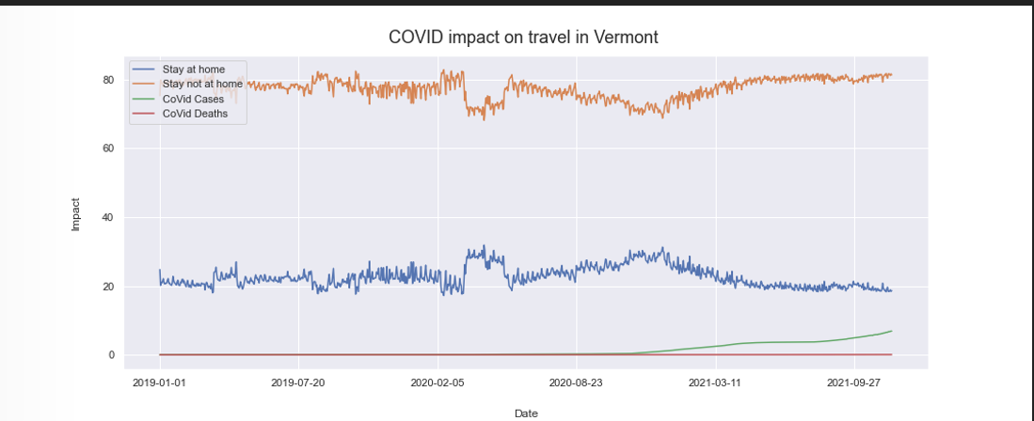

**Observation**: We picked VT as one of the lowest COVID impacted state ,we can see similar pattern of reducing trips as national trend .But here intensity is low.

4) State Specific Bar Graph showing travel before / travel after , potentially all 50 states

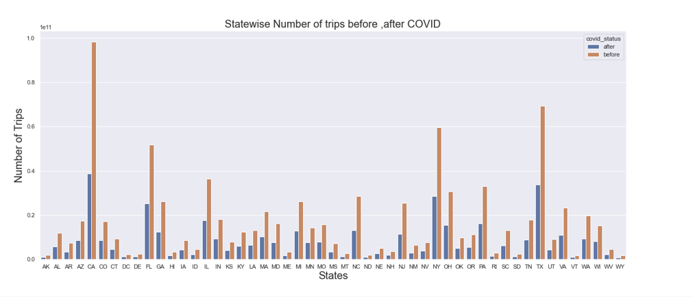

5) Change in percentage of travel after COVID-State wise

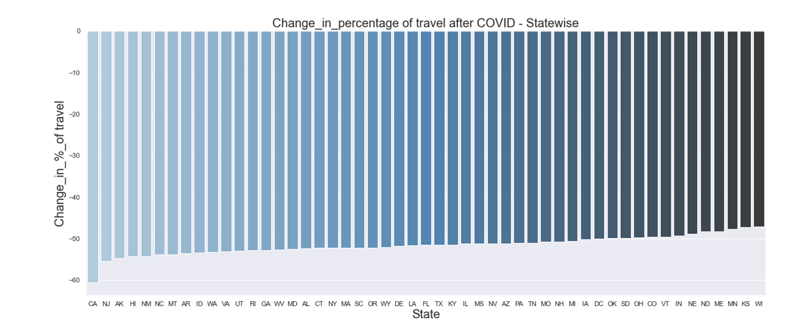

**Observations**:

We plotted absolute and percentage change in number of trips comparing before and after covid situation. The graphs clearly show CA is the highest impacted state where trips are reduced significantly after COVID. And WI is the least impacted state.

**Q2. How did COVID change the nature / length of travel?**

5) Time Series of Trip Type over Time (Nationally)

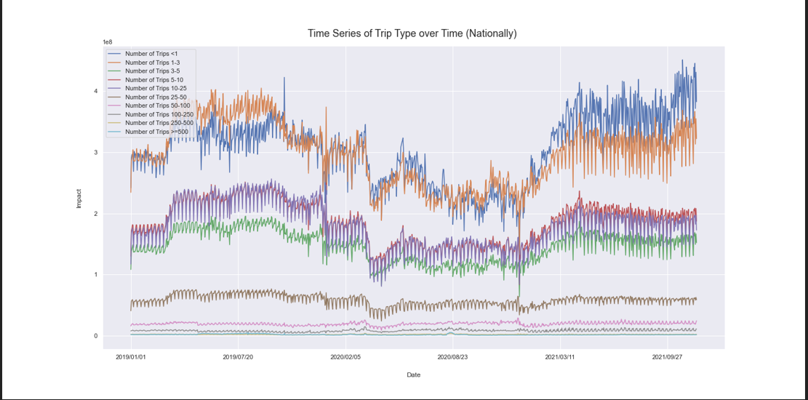

**Observations**:

From the graph We can see less impact of COVID on long range travels (>=100). There is an impact on the medium range travel (>= 100 <250) when COVID started .But we can see significant impact on short trips (<100) due to COVID.