1，
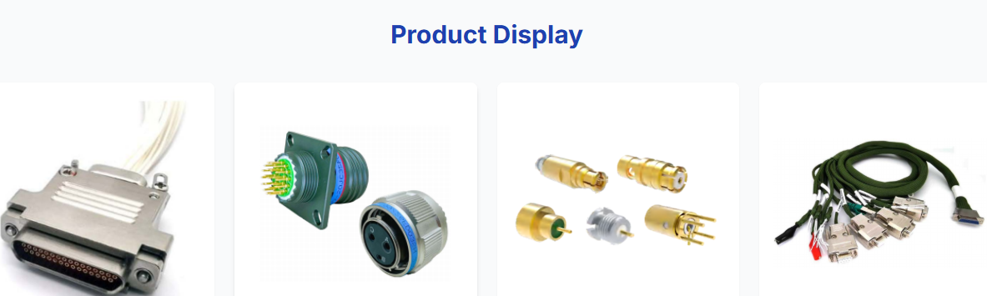
首页这里的Product Display改成PRODUCTS

2，
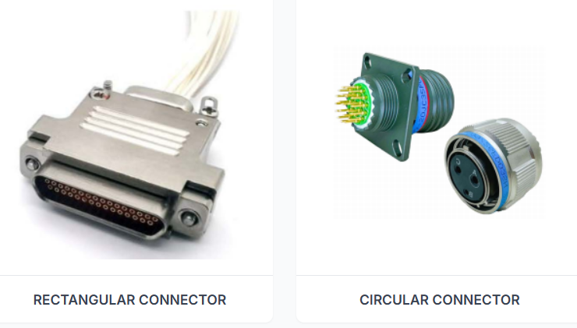
首页左边这个矩形连接器的图太大，稍微缩小点，跟右边的保持协调。

3，
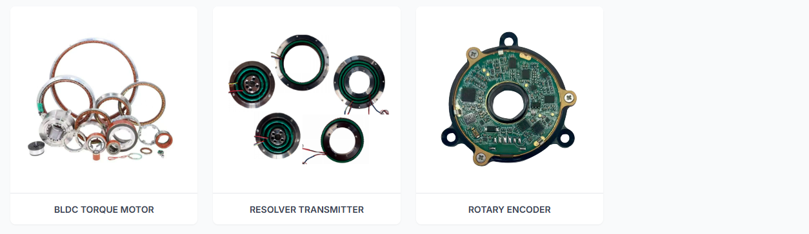
首页上面最右边的空白处增加一个下面的图片
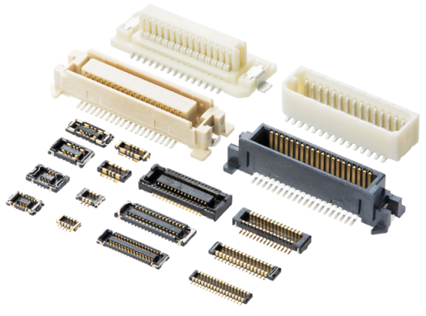 图片下面的文字为：INTERNATIONAL BRANDS

4,
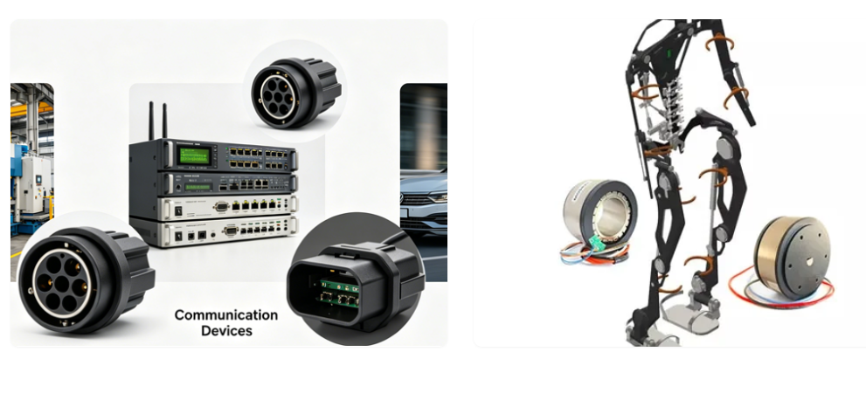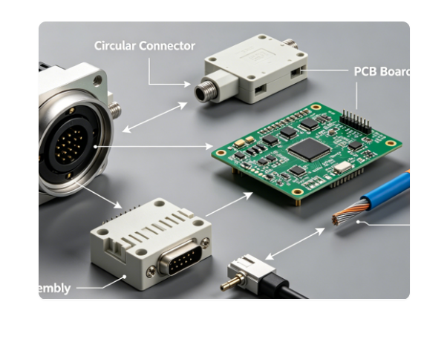

首页下面的APPLICATIONS处的这几张图的英文没显示出来，没显示完整。

5,
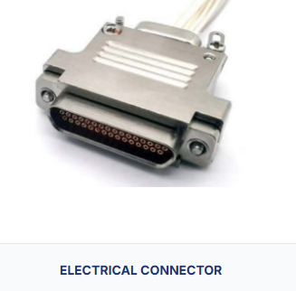
这个点击PRODUCTS后的这张图，换成下图
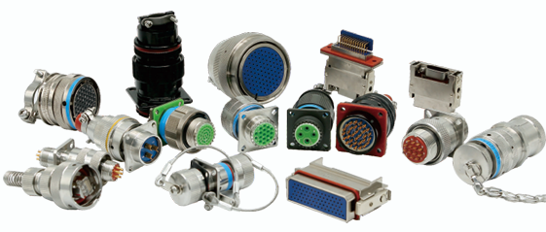

6，点击PORDUCTS里的RF CONNECTOR里面的具体内容，待提供修改文件供修改。
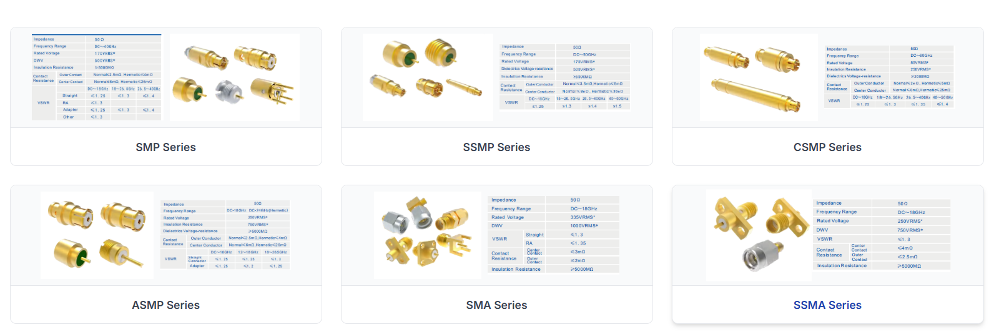

上面这种要统一成下面这种布局格式。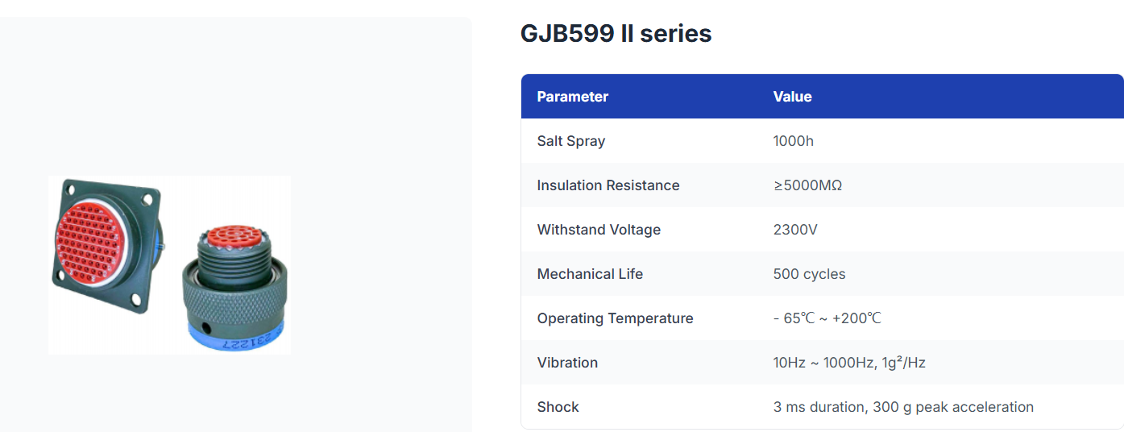

7，
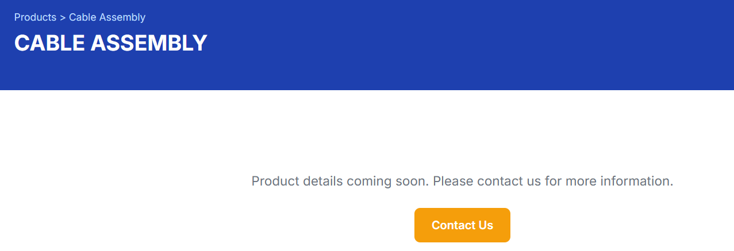
这里面增加下面的图片内容和特点文字介绍。
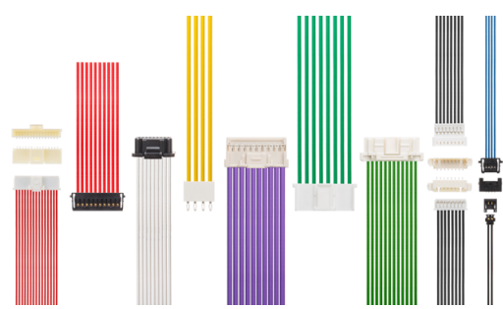

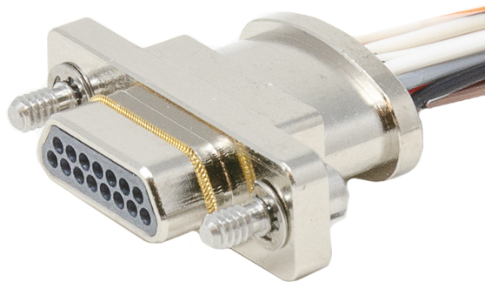

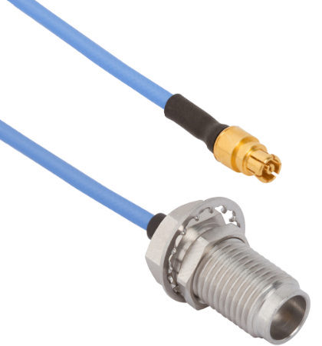

Rectangular Connector Cable Assembly
- Compact structure, space-saving design for dense installation scenarios.
- High contact density, stable signal transmission and strong shock resistance.
- Easy plug-and-play assembly, convenient for equipment wiring and maintenance.
- Good mechanical durability and reliable locking performance for industrial equipment connection.

Circular Connector Cable Assembly
- Round waterproof and dustproof design, adapt to harsh outdoor and industrial environments.
- Excellent vibration resistance and pull-out resistance, firm connection without loose contact.
- Multi-core optional, support power and signal integrated transmission.
- High sealing performance, suitable for harsh environment applications.

RF Connector Cable Assembly
- Low insertion loss and high return loss, ensure high-frequency signal stable transmission.
- Excellent electromagnetic shielding performance, effectively avoid signal interference.
- Precise impedance matching, stable performance in radio frequency and microwave systems.
- Strictly calibrated production, widely used in communication, base station and wireless equipment.

8，
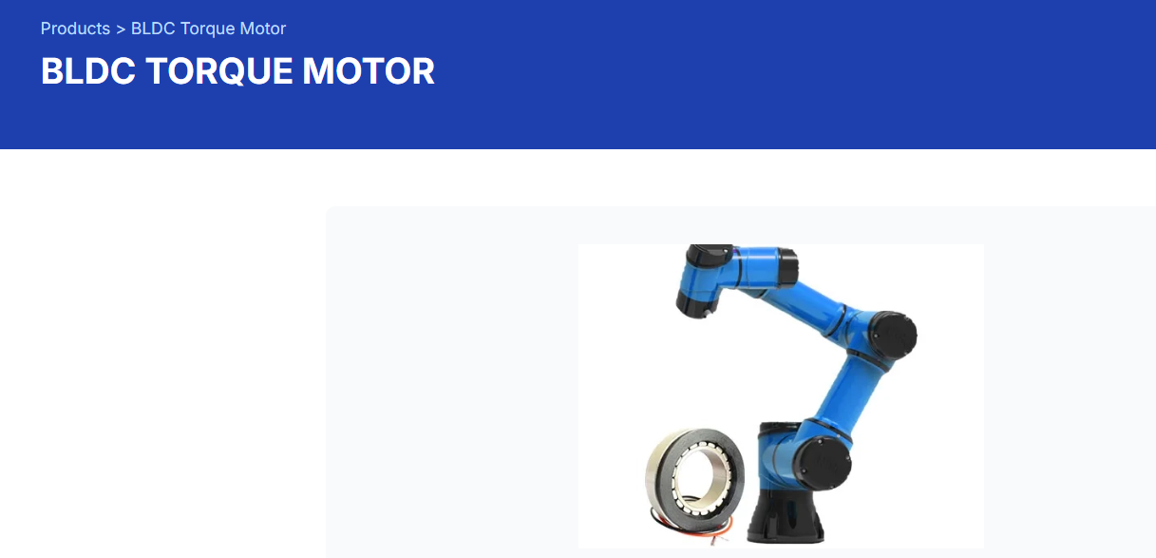
这个里面增加下面图片内容
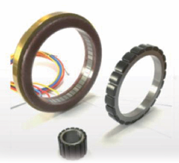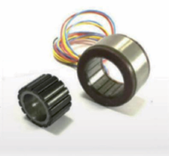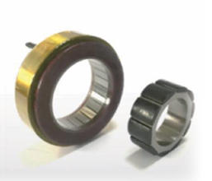

9，
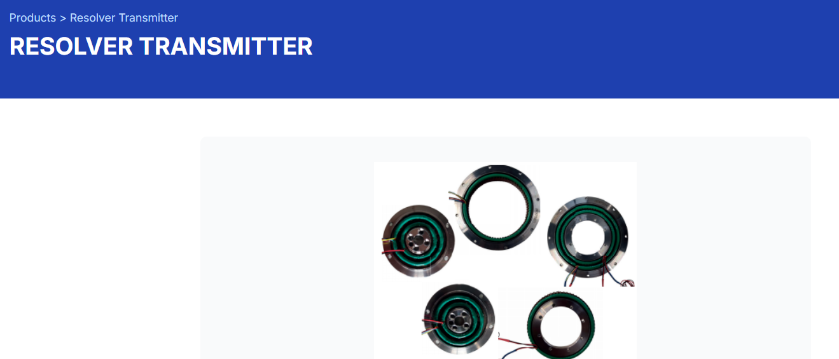
这个也需要增加下面图片。
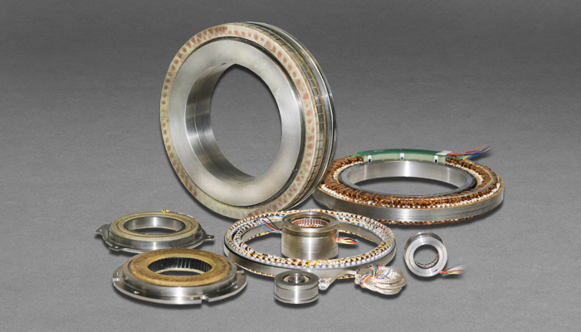

10，
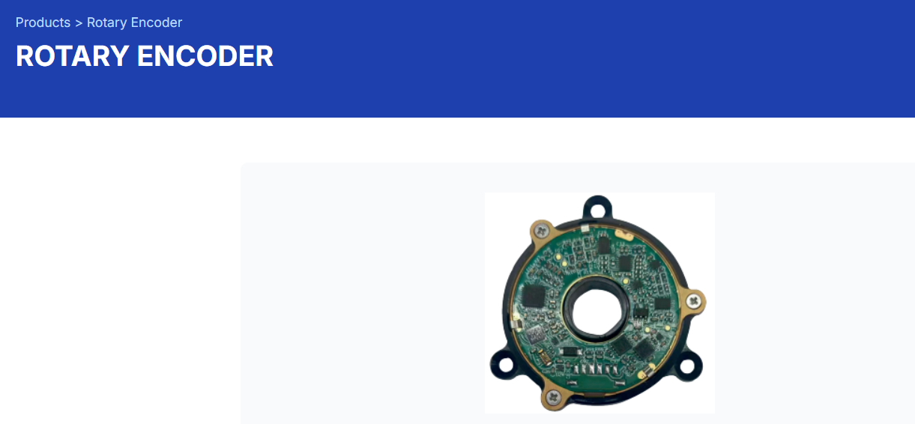
这个增加下面图片
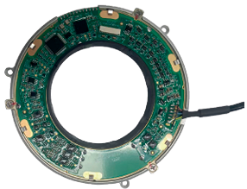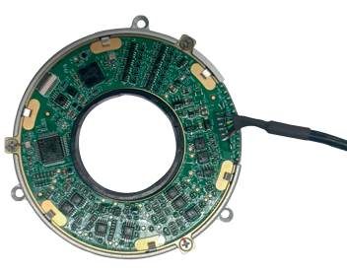
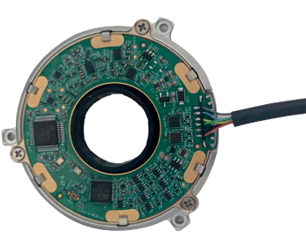
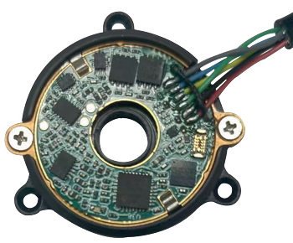
11，

点击进入这里头的内容，把文字 CONNECTORS BRANDS和PASSIVE COMPONENTS BRANDS都删除，只留LOGO图就好

12，点击首页PRODUCTS后的下面TE图
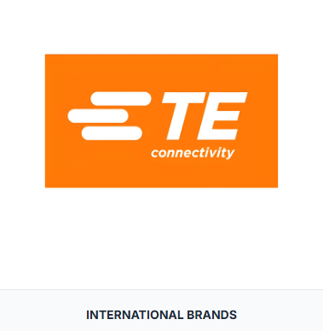更换为下面图片
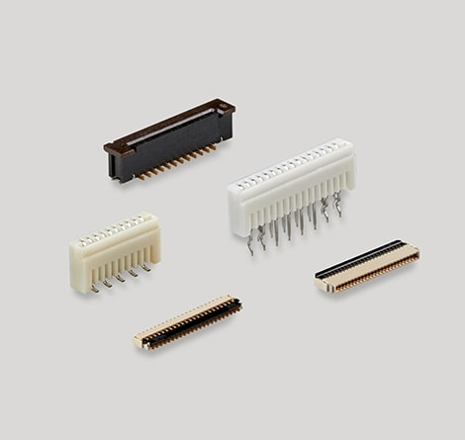

13,
点击NEWS进入的页面里面的内容删除

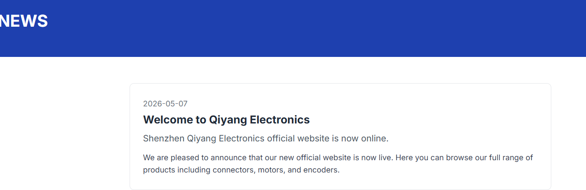

14，
首页点击PRODUCTS中的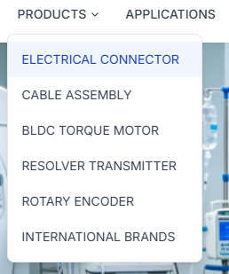应该还要有三个子目录，分别是rectangular connector, circular onnector, rf connector (英文都大写)

15，
后续还需要在首页下方添加微信和WhatsApp的二维码。

16
网站内容产品图和参数务必按我提供的EXCEL表格里的一一对应好，我今天还没来得及逐一核对。

