1，参考网页模板（仅需英文的）
https://demo.nicebox.cn/?f6bad81ce9354e14&templateid=3067&version=n9&iswxapp=1166&home=qcloud
- 首页左上角的

LOGO换成公司名改成：Shenzhen Qiyang Electronics Co., Ltd.
Email改成sales@sz-qy.com.cn
电话改成 +86 待定

首页的上面的目录
改为
HOME PRODUCTS APPLICATIONS NEWS ABOUT US CONTACT US

3,ABOUT US
点击About us进去后放入下面公司英文简介内容。
Shenzhen Qiyang Electronics Co., Ltd. is an innovative enterprise specializing in the precision interconnection and servo control industry, integrating independent R&D, intelligent manufacturing, and global sales. Our core product portfolio includes high-reliability rectangular connectors, circular connectors, RF connectors, cable assemblies, brushless torque DC motors, resolver transmitters, rotary encoders. Backed by our mature technical expertise and strictly controlled quality management system, our products are built to function steadily in harsh environments, and can fully meet diverse application demands of customers in different industries.
Adhering to technology as the core and quality as the foundation, our products and services widely cover high-end applications such as consumer electronics, industrial control, security monitoring, communication equipment, aerospace, automotive electronics, medical equipment, machine tools, automation and precision instruments, delivering reliable solutions for customers across the world.
Moving forward, we will keep pursuing technological innovation and product excellence, and strive to become a trusted long-term partner for global clients.
以下工厂图片：看怎么排版一下，或者可以弄成一张合在一起的照片，放在ABOUT US的页面内。
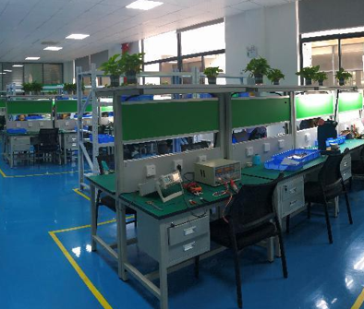
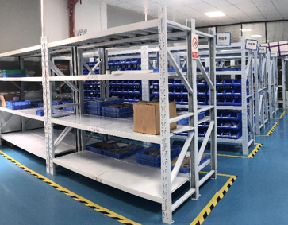

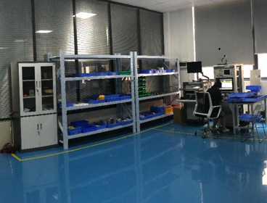

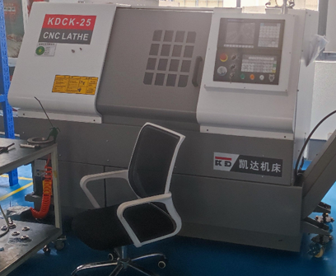
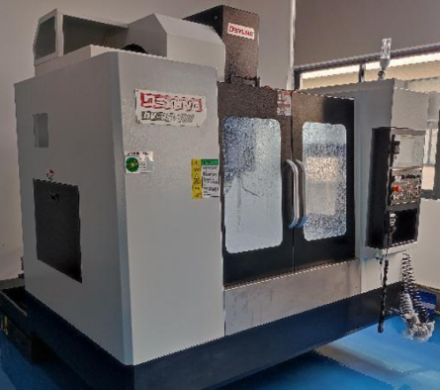
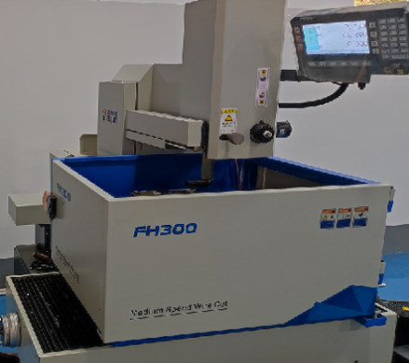

- PRODUCTS
点击PRODUCTS后显示下面6个子目录产品类别
ELECTRICAL CONNECTOR
CABLE ASSEMBLY
BLDC TORQUE MOTOR
RESOLVER TRANSMITTER
ROTARY ENCODER
INTERNATIONAL BRANDS

这上面的ELECTRICAL CONNECTOR点击后又显示下面三个子目录
RETANGULAR CONNECTOR
CIRCULAR CONNECTOR
RF CONNECTOR

点击以上这些子目录后进入的页面放入附件EXCEL（公司各类产品明细20260420）里头对应的每个子目录名称册所有产品图和参数规格。
点击INTERNATIONAL BRANDS进入的页面放入附件文件夹（国际品牌LOGO）里头的品牌LOGO图。
- 首页的Product display这里分别换成下面的刘类产品图
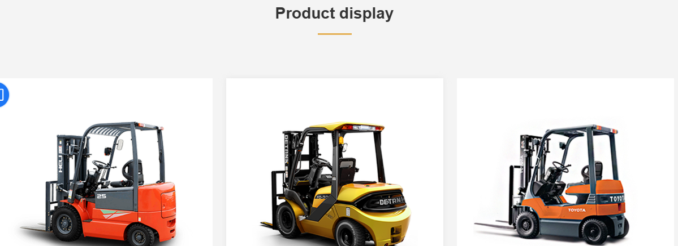
RETANGULAR CONNECTOR：
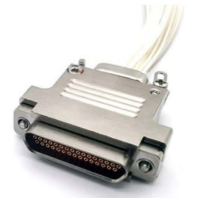
CIRCULAR CONNECTOR
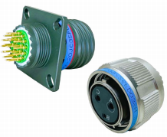
RF CONNECTOR
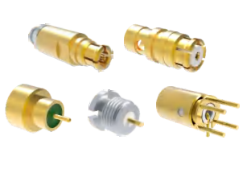

CABLE ASSEMBLY
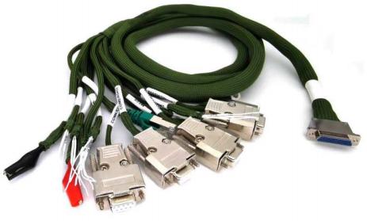
BLDC TORQUE MOTOR
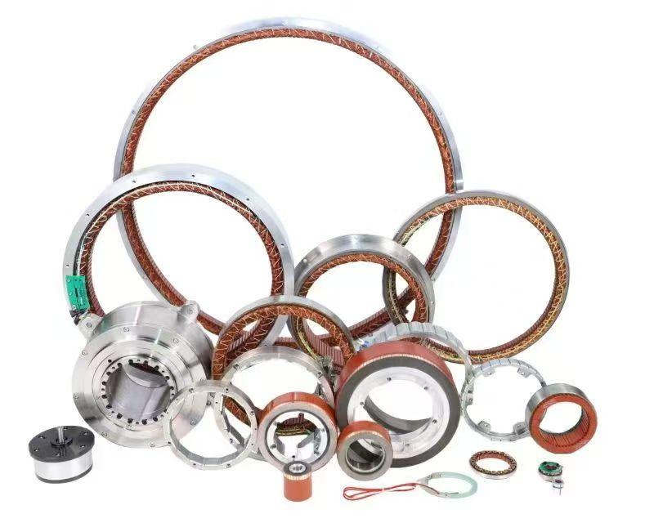
RESOLVER TRANSMITTER
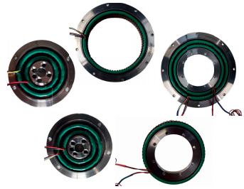

ROTARY ENCODER
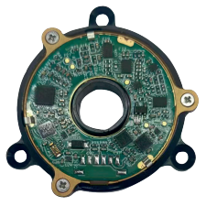

6，首页里面的Product advantage这些内容不需要，请删除
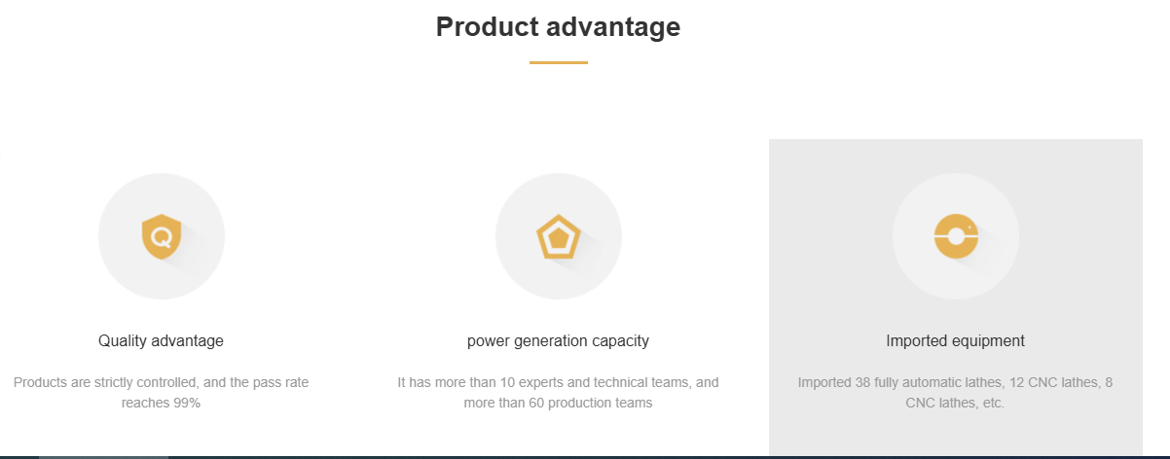
包括下面这些也删除。
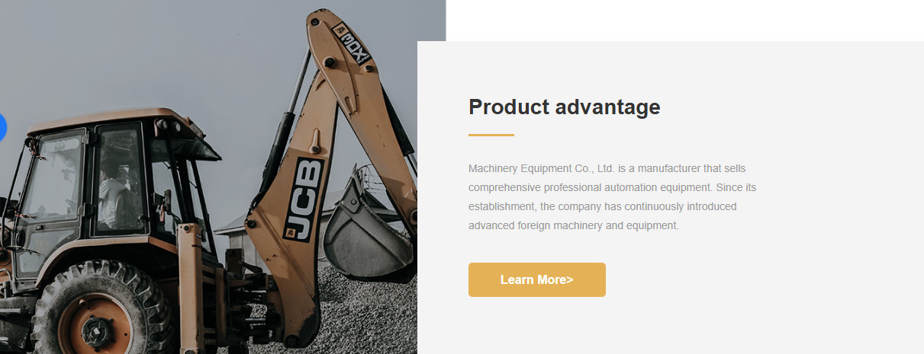

- 首页里的下面这些也不需要，请删除。
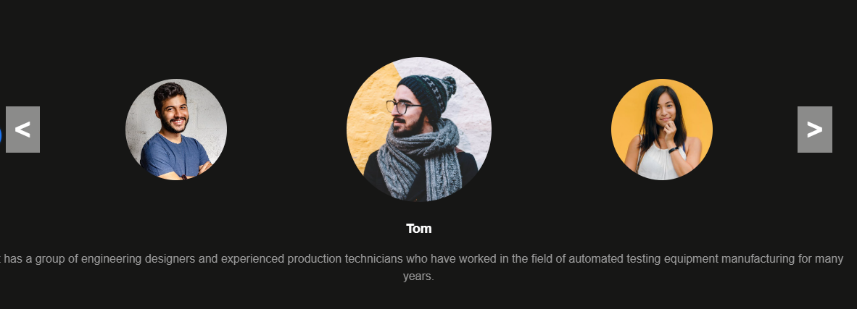

- 首页SERVICE CASE改成APPLICATIONS，并把图片更换成我下面的图片内容。
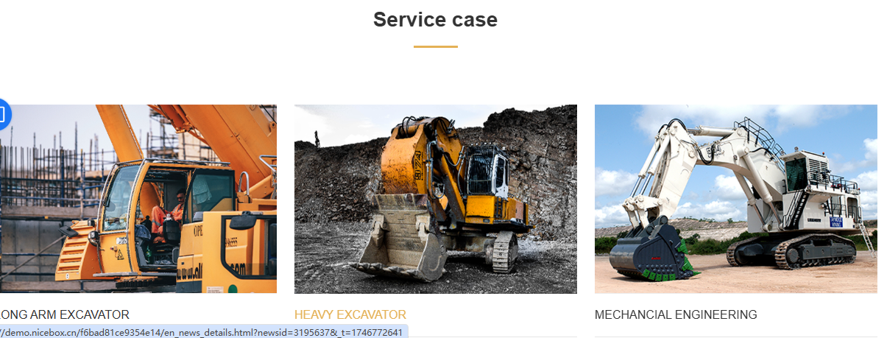
更换图片1：
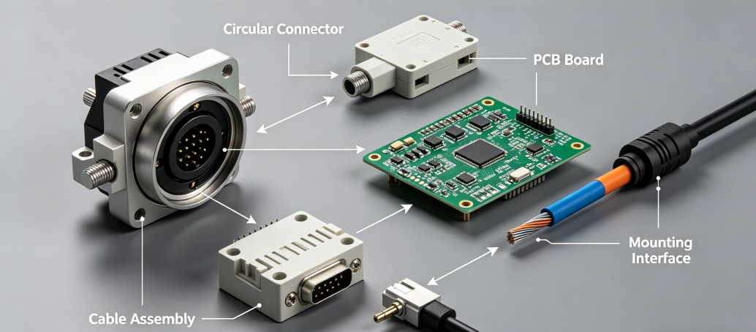
更换图2：
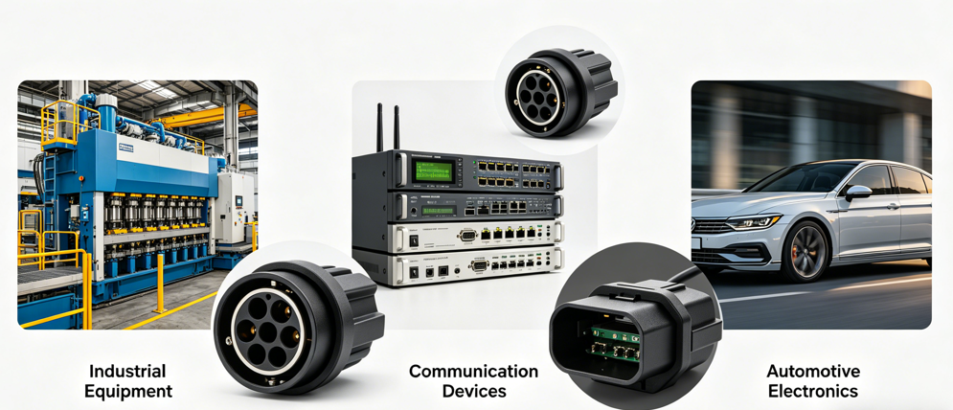

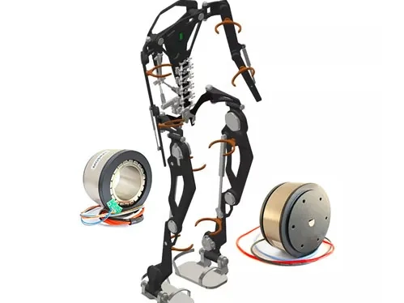
更换图3：

- CONTACT US
Shenzhen Qiyang Electronics Co., Ltd.
Address: 2nd Floor, 23rd Building of Keyuan West, No.1 of Kezhi West Road
Yuehai street, Nanshan, Shenzhen, Guangdong, China
Tel: +86 待定
Email: sales@sz-qy.com.cn
Website:www.sz-qy.com.cn

10, NEWS
点击进去里面内容先留空。
11, APPLICATIONS
点击进去是下面这些图轮播。

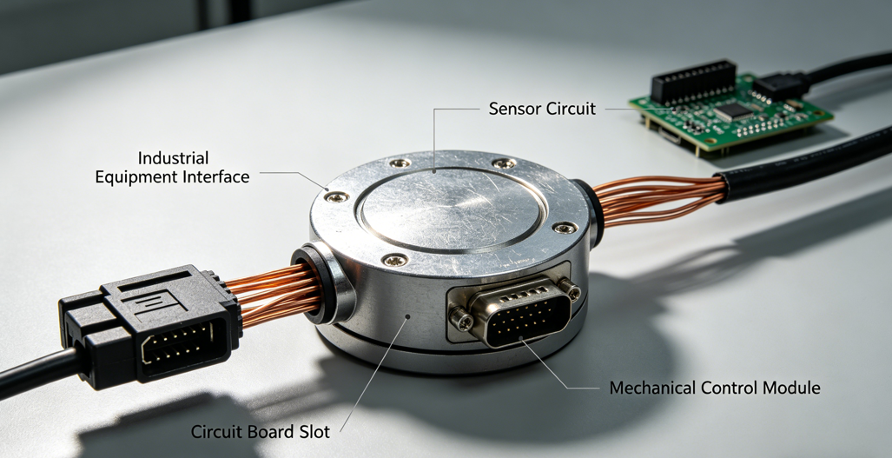
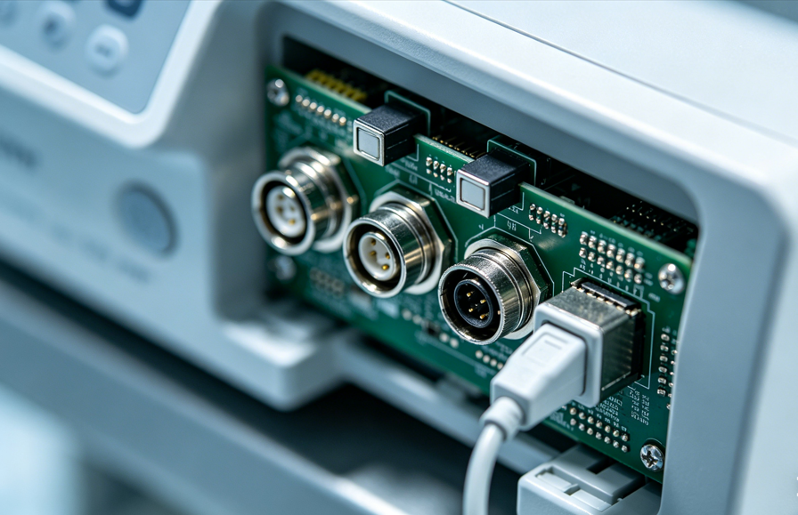
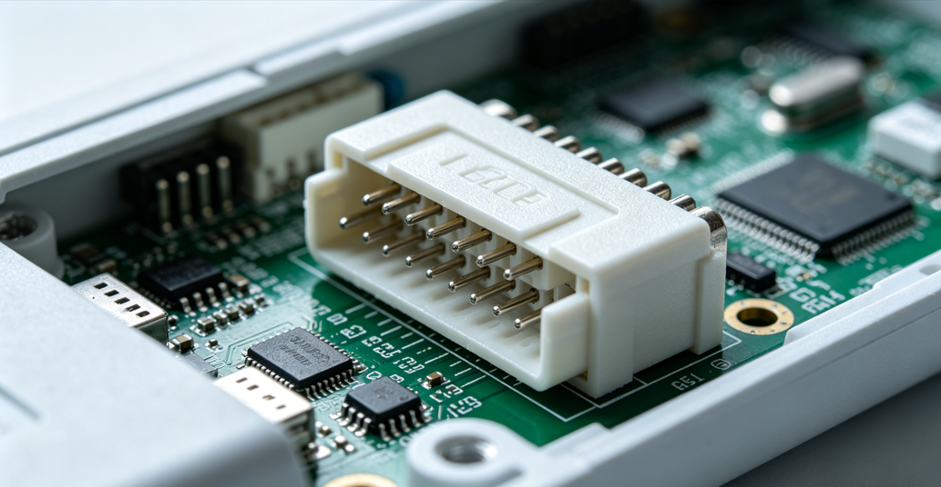
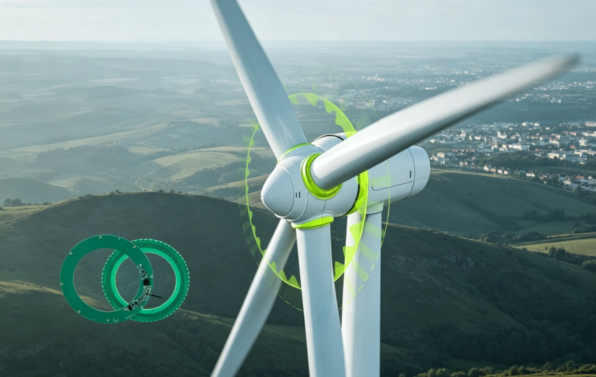



- 网站首页上方的轮播图更换成我下面的图片

更换为以下图片













13,首页下面的内容需修改。
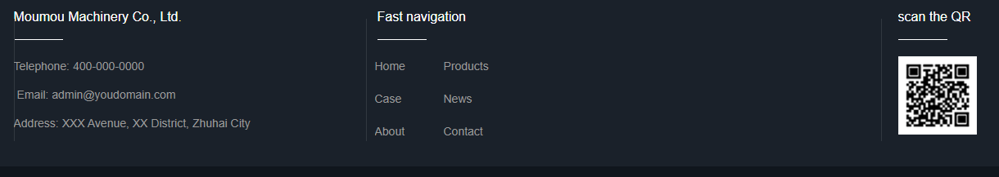
最右的二维码删除，不需要。
左边的信息修改为下面：
Shenzhen Qiyang Electronics Co., Ltd.
Address: 2nd Floor, 23rd Building of Keyuan West, No.1 of Kezhi West Road
Yuehai street, Nanshan, Shenzhen, Guangdong, China
Tel: +86 待定
Email: sales@sz-qy.com.cn
Website:www.sz-qy.com.cn

中间的Fast navigation下面内容改为：
HOME PRODUCTS APPLICATIONS NEWS ABOUT US CONTACT US

