NYC Taxi ETL Project — Documentation

Project Overview
This project builds a repeatable ETL pipeline that ingests NYC Yellow Taxi trip data, performs scalable transformations and aggregations using Apache Spark, exports aggregated CSVs for visualization. The pipeline is orchestrated by Apache Airflow.

Goals
- Ingest realistic taxi trip data (monthly Parquet files).
- Process and aggregate data at scale (category-based aggregations).
- Export cleaned/aggregated CSVs for BI tools.
- Automate generation of visualization images and save to Windows-accessible folder.
- Run end-to-end with Airflow, enabling scheduled or on-demand pipeline runs.

Dataset
Source: NYC TLC Trip Record Data (Yellow Taxi)
Official link (example used): https://d37ci6vzurychx.cloudfront.net/tripdata/yellow_tripdata_2023-01.parquet
https://www.nyc.gov/site/tlc/about/tlc-trip-record-data.page Format: Parquet (columnar)
Typical columns: tpep_pickup_datetime, tpep_dropoff_datetime, passenger_count, trip_distance, fare_amount, tip_amount, total_amount, PULocationID, DOLocationID, payment_type, congestion_surcharge, etc.
Notes: We used the Jan 2023 Yellow Taxi file as the sample dataset. Parquet is recommended for efficient Spark processing.

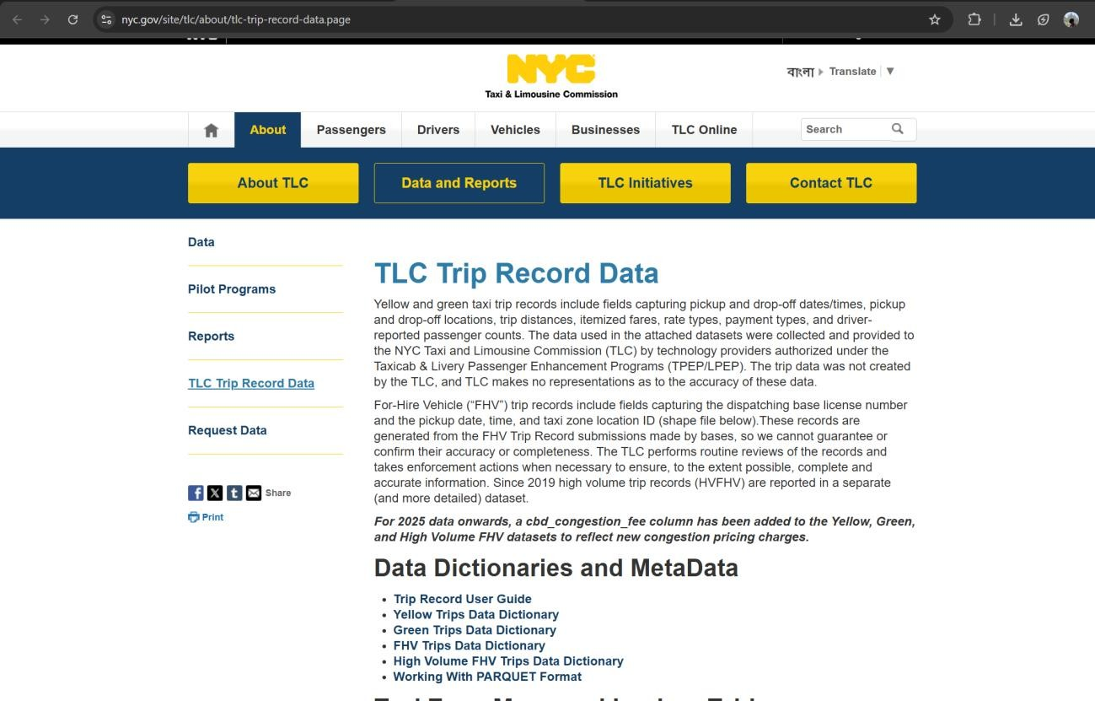
Data
set Source:

Environment & Dependencies

- OS: WSL2 (Ubuntu) on Windows.
- Python: 3.12 (used inside a virtualenv airflow_env)
- Key Python packages (recommended versions): o pandas (1.x or compatible with pyarrow) o pyarrow < 15 (recommended 14.x) o numpy < 2 (recommended 1.26.x)
  - datasets (if used) ==2.19.1 (only if using HF datasets) o requests
  - matplotlib or plotly/kaleido for advanced charts o pyspark (matching local Spark installation)
- Apache Spark (local installation, spark-submit accessible)
- Apache Airflow (local) with a working airflow_home and scheduler/webserver Install example (venv active):
pip install requests pandas pyarrow==14.0.2 numpy<2 pyspark matplotlib plotly kaleido

Airflow & PySpark Setup
Follow these steps to install and configure Apache Airflow and Apache Spark (PySpark) on your WSL Ubuntu environment so the ETL pipeline runs reliably.

1. Prerequisites
- WSL2 (Ubuntu) on Windows with enough memory (recommended 4–8 GB for local testing).

- sudo privileges in WSL.

- A Python virtual environment for project dependencies (airflow_env used throughout this documentation).

- Familiarity with editing ~/.bashrc to add environment variables.

2. Create & activate virtualenv
Run in your project root (e.g. /root/airflow_session):
python3 -m venv airflow_env source airflow_env/bin/activate pip install --upgrade pip setuptools wheel

3. Install Java (required by Spark)
Install OpenJDK 11 (recommended):
sudo apt update
sudo apt install -y openjdk-11-jdk wget unzip git build-essential java -version

4. Install Apache Spark (binary)
Download and extract a prebuilt Spark distribution (example Spark 3.4.1 with Hadoop 3):
export SPARK_VERSION=3.4.1 export HADOOP_VERSION=3
cd /opt
sudo wget https://archive.apache.org/dist/spark/spark-${SPARK_VERSION}/spark-${SPARK_V ERSION}-bin-hadoop${HADOOP_VERSION}.tgz sudo tar -xzf spark-${SPARK_VERSION}-bin-hadoop${HADOOP_VERSION}.tgz sudo mv spark-${SPARK_VERSION}-bin-hadoop${HADOOP_VERSION} spark
Alternative: pip install pyspark installs PySpark but does not provide the spark-submit binary.
Installing the Spark binary gives you spark-submit which is used in the DAG.

5. Add environment variables to ~/.bashrc
Append these lines (update <YourWindowsUser> and paths as needed):
# Project & Airflow export AIRFLOW_HOME="/root/airflow_session/airflow_home" export PROJECT_HOME="/root/airflow_session/twitter_project"

# Java & Spark export JAVA_HOME="/usr/lib/jvm/java-11-openjdk-amd64" export SPARK_HOME="/opt/spark" export PATH="$SPARK_HOME/bin:$PATH"

# Ensure PySpark uses the venv python export PYSPARK_PYTHON="$HOME/airflow_session/airflow_env/bin/python" export PYSPARK_DRIVER_PYTHON="$HOME/airflow_session/airflow_env/bin/python"

# Windows folder used by DAG to copy outputs (replace with your user) export WINDOWS_TABLEAU_DIR="/mnt/c/Users/<YourWindowsUser>/Documents/tableau_d ata" Then run:
source ~/.bashrc
Successfully Installed PySpark:
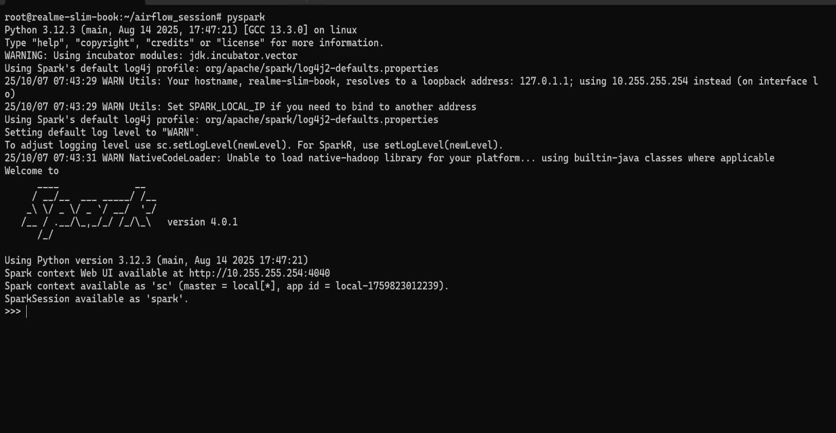

6. Install Python dependencies (requirements.txt)
Create a requirements.txt in your project root with the pinned versions:
apache-airflow==2.7.1 pandas==1.5.3 pyarrow==14.0.2 numpy<2 pyspark==3.4.1 requests matplotlib plotly kaleido
Install Airflow with constraints (inside the activated venv):
export AIRFLOW_VERSION=2.7.1 export PYTHON_VER="$(python -c 'import sys;print(f"{sys.version_info.major}.{sys.version_i nfo.minor}")')"
export CONSTRAINT_URL="https://raw.githubusercontent.com/apache/airflow/constraints-${ AIRFLOW_VERSION}/constraints-${PYTHON_VER}.txt"

pip install "apache-airflow==${AIRFLOW_VERSION}" --constraint "${CONSTRAINT_URL}"
# then install remaining packages pip install -r requirements.txt
If the constraint URL fails, follow the official Airflow install docs for the correct constraints URL for your Python minor version.

7. Initialize Airflow DB and create a user
airflow db init airflow users create --username admin --firstname Admin --lastname User --role Admin --email admin@example.com --password admin
By default Airflow uses SQLite (fine for development). For better concurrency use Postgres + LocalExecutor (see step 9).

8. Start Airflow UI & Scheduler (in separate shells)
airflow webserver -p 8080 airflow scheduler
Open http://localhost:8080 in your browser and trigger the DAG to test.

10. Test Spark + PySpark
Verify spark-submit and that PySpark can connect to the venv python:
spark-submit --version python - <<'PY'
from pyspark.sql import SparkSession
spark = SparkSession.builder.master("local[*]").appName("smoke").getOrCreate() df = spark.range(5).toDF("n") df.show() spark.stop()
PY
Airflow installed and ran successfully:
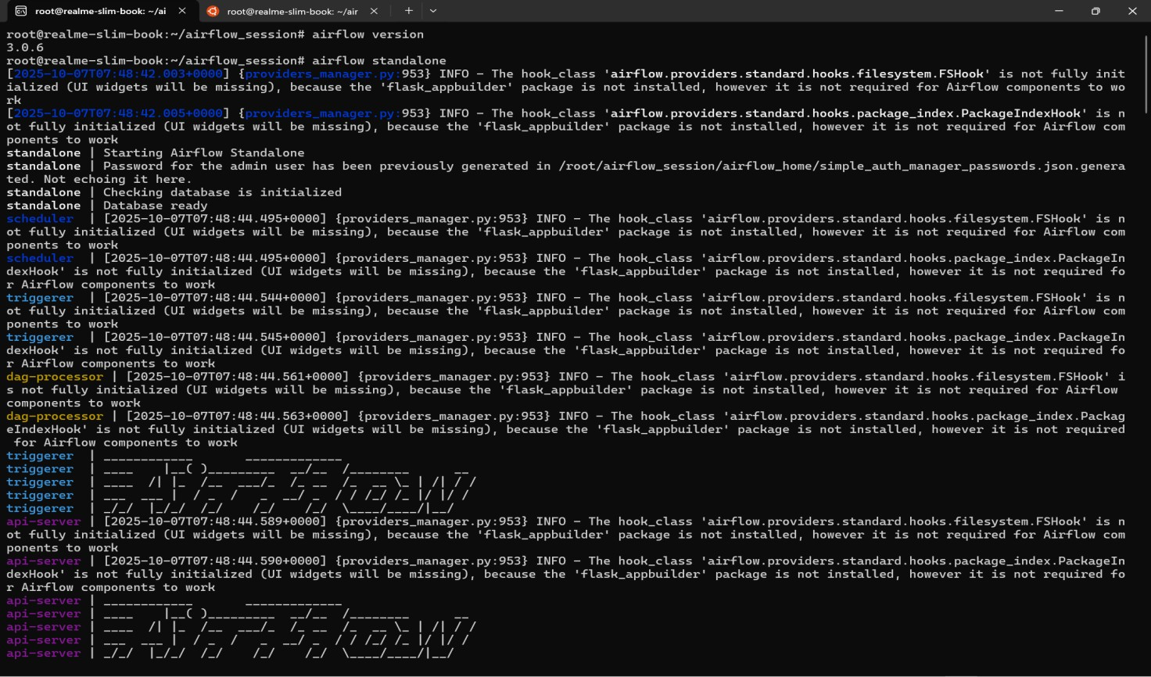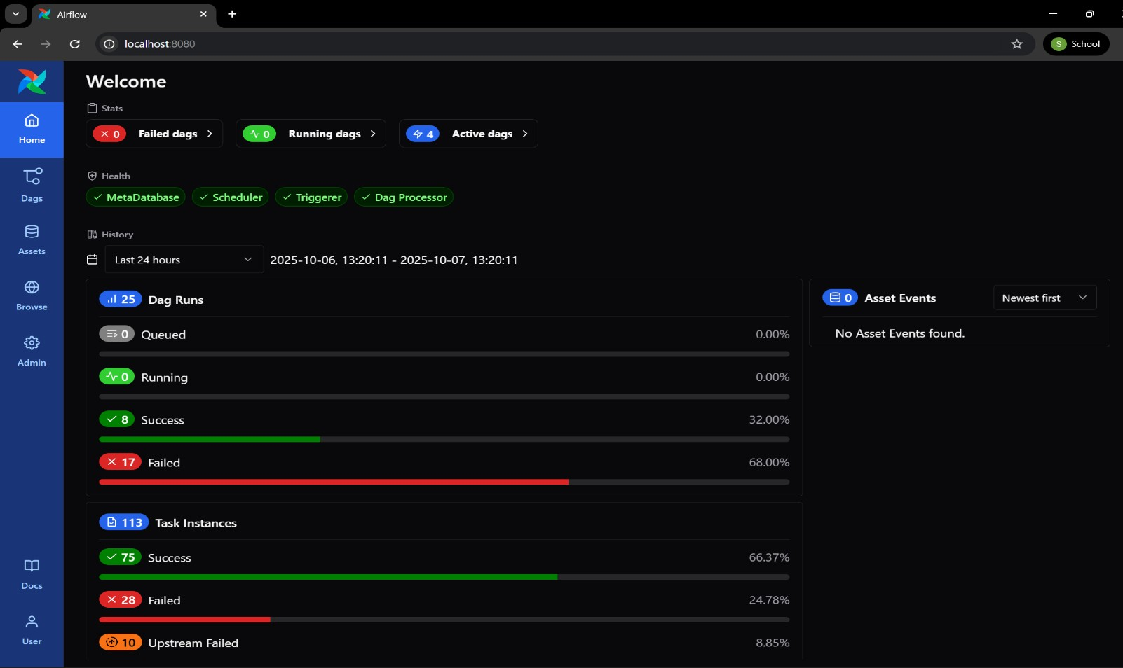

Airflow running on http://localhost:8080/
Here we can the Active and Running Dags.

Project Structure
/root/airflow_session/
├─ airflow_home/
│ └─ dags/etl_nyc_dags.py
├─ nyc_taxi_project/
│ ├─ scripts/
│ │ ├─ data_ingestion_nyc.py
│ │ ├─ spark_transformations_nyc.py
│ │ ├─ export_to_csv.py
│ │ └─ generate_visualizations.py
│ └─ data/
│ ├─ raw/nyc_taxi/
│ ├─ processed/csv_exports/
│ └─ processed/plots/

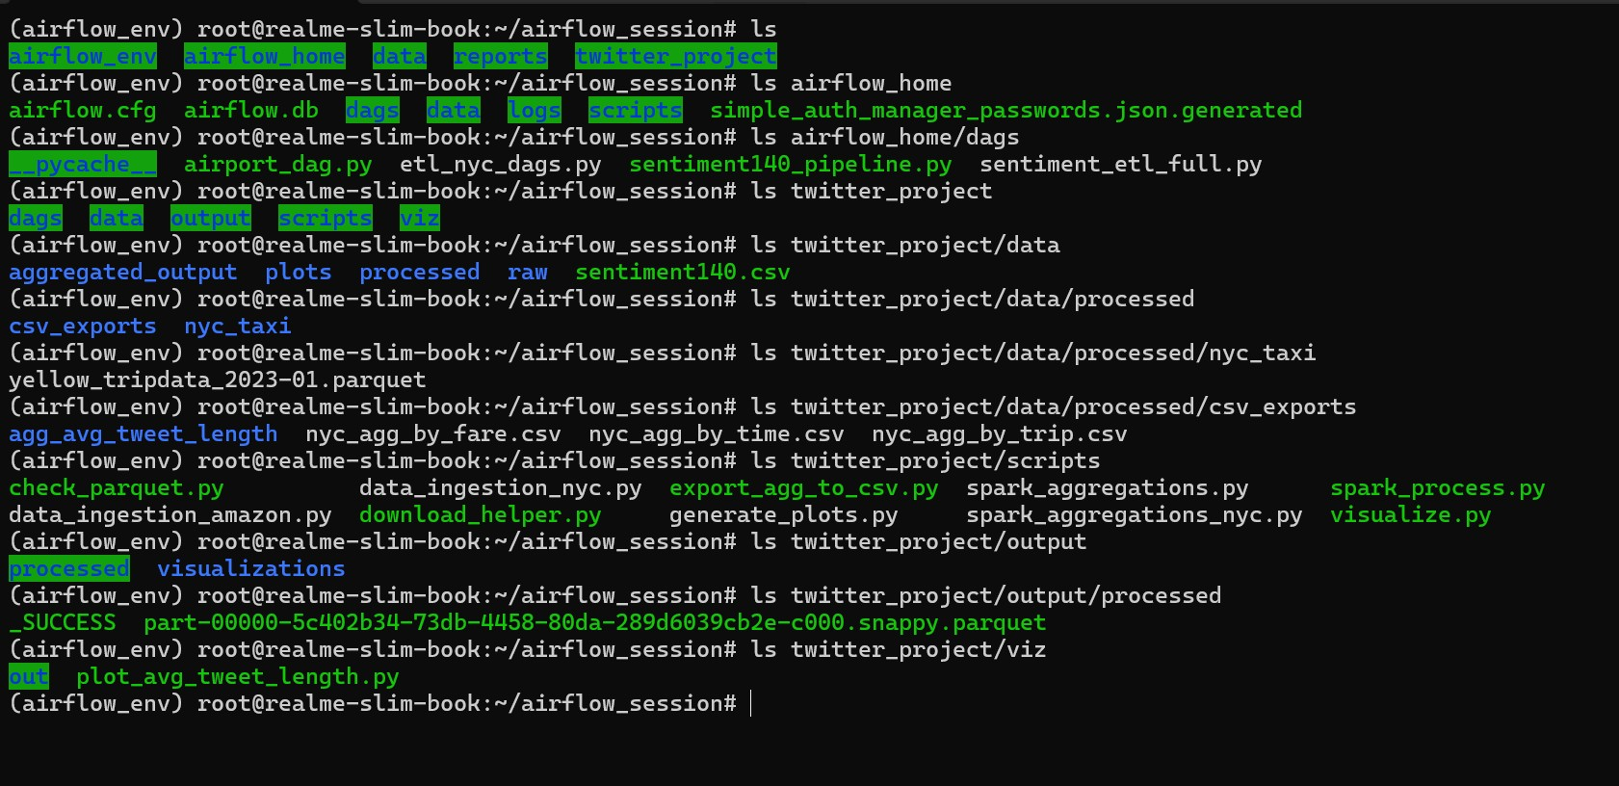

Scripts: Purpose & Key Details
data_ingestion_nyc.py
- Downloads Parquet files from the official NYC cloudfront URL(s).
- Writes the raw Parquet into twitter_project/data/raw/nyc_taxi/.
- Memory-safe variant: downloads to disk and stages to processed/ without fully loading into pandas to avoid OOM in Airflow.
Important config: edit MONTHS or URL template to add more files.
spark_transformations_nyc.py
- Uses Spark to read processed parquet files (data/processed/nyc_taxi/*.parquet).
- Normalizes column names, derives timestamp/date/hour fields if pickup datetime exists.
- Creates category columns:
  - trip_category (Short / Medium / Long based on trip_distance thresholds)
  - fare_category (Low / Medium / High based on fare_amount thresholds)
- Aggregations produced:
  - agg_by_trip — group by passenger_count, trip_category with avg distance, avg fare, counts
  - agg_by_fare — group by fare_category with counts and avg fare o agg_by_time — group by trip_date, trip_hour (if available) for time-series
- Writes outputs to twitter_project/data/aggregated_output/nyc_taxi/ in both Parquet (partitioned) and coalesced CSV summaries for BI tools.

export_to_csv.py (or export_agg_to_csv.py)
- Flattens the CSV part-*.csv files generated by Spark into single CSV files in twitter_project/data/processed/csv_exports/.
- Ensures predictable filenames used by Tableau and generate_visualizations.py.
_{generate_visualizations.py} ( Optional )
- Reads the final CSV(s) from data/processed/csv_exports/.
- Produces PNGs (and optionally interactive HTML) for one or more charts:
avg_fare_by_category.png, avg_distance_by_category.png, total_revenue_by_category.png, nyc_trips_by_time.html.
- Saves images to Windows path: e.g.,
/mnt/c/Users/<WindowsUser>/Documents/tableau_data/visualizations/ to make them directly available in Tableau Desktop. Update <WindowsUser> before running.
- Optionally includes timestamps in filenames for historical versions.

Airflow DAG: etl_nyc_dags.py
- Tasks (order):
  - data_ingestion — runs data_ingestion_nyc.py (BashOperator)
  - spark_transformations — runs spark_transformations_nyc.py via spark-submit or Python (BashOperator)
  - export_agg_to_csv — runs export_to_csv.py
  - copy_to_windows (optional) — copies CSV(s) to
C:\Users\<WindowsUser>\Documents\tableau_data\ via /mnt/c/...
  - generate_plots — runs generate_visualizations.py to create PNGs in the Windows folder
- DAG default args: schedule (@daily or None), retries, start_date, etc.

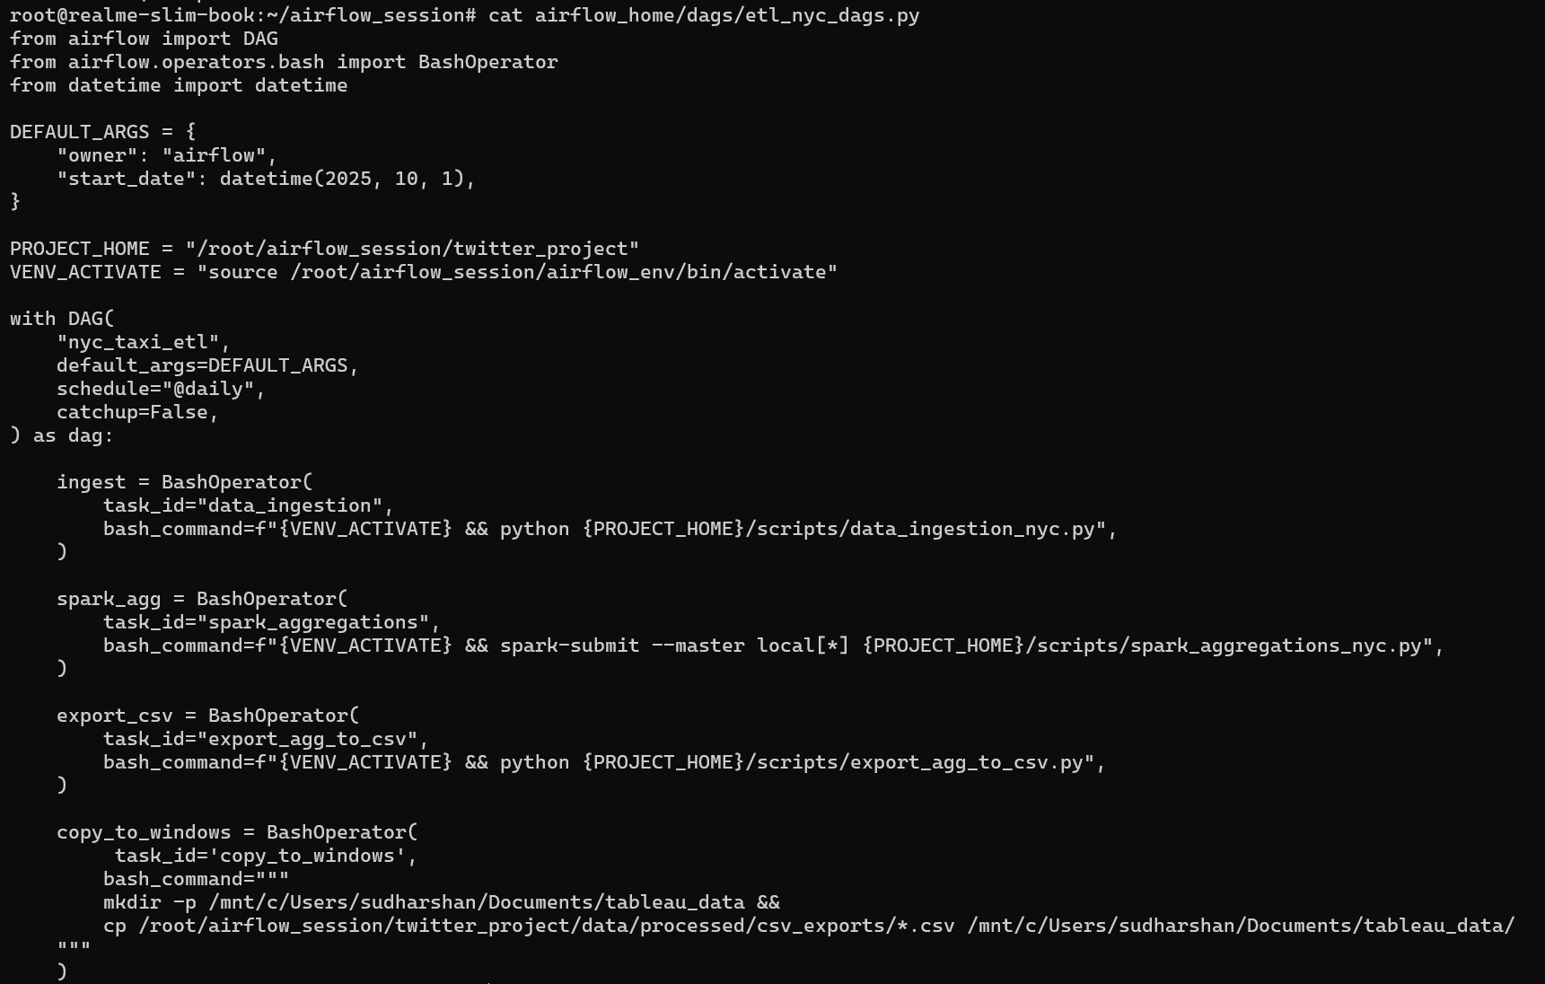
Dag Script:

How to Run Locally (manual steps)
- Activate venv: source /root/airflow_session/airflow_env/bin/activate
- Run ingestion manually (to test):
python twitter_project/scripts/data_ingestion_nyc.py
- Run Spark aggregations:
spark-submit --master local[*] twitter_project/scripts/spark_transformations_nyc.py
- Export CSVs:
python twitter_project/scripts/export_to_csv.py
- Generate plots (writes directly to Windows folder):
python twitter_project/scripts/generate_visualizations.py
- Start Airflow (if using DAG scheduling):
airflow db init airflow webserver -p 8080 airflow scheduler
Then trigger the nyc_taxi_etl DAG from the UI.

The Dag for our dataset has been ran successfully and we have built the ETL pipeline for our Project using Airflow and PySpark
Screenshots:
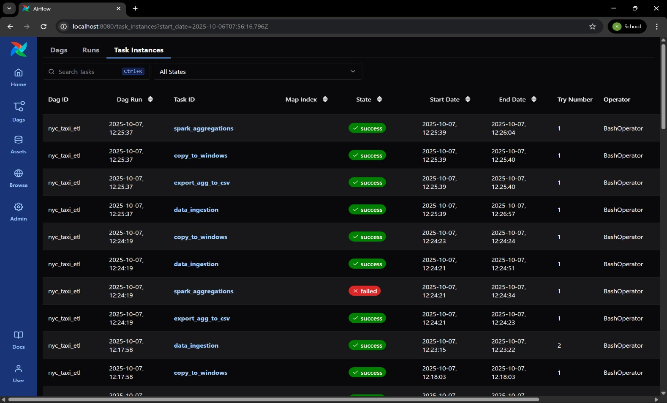

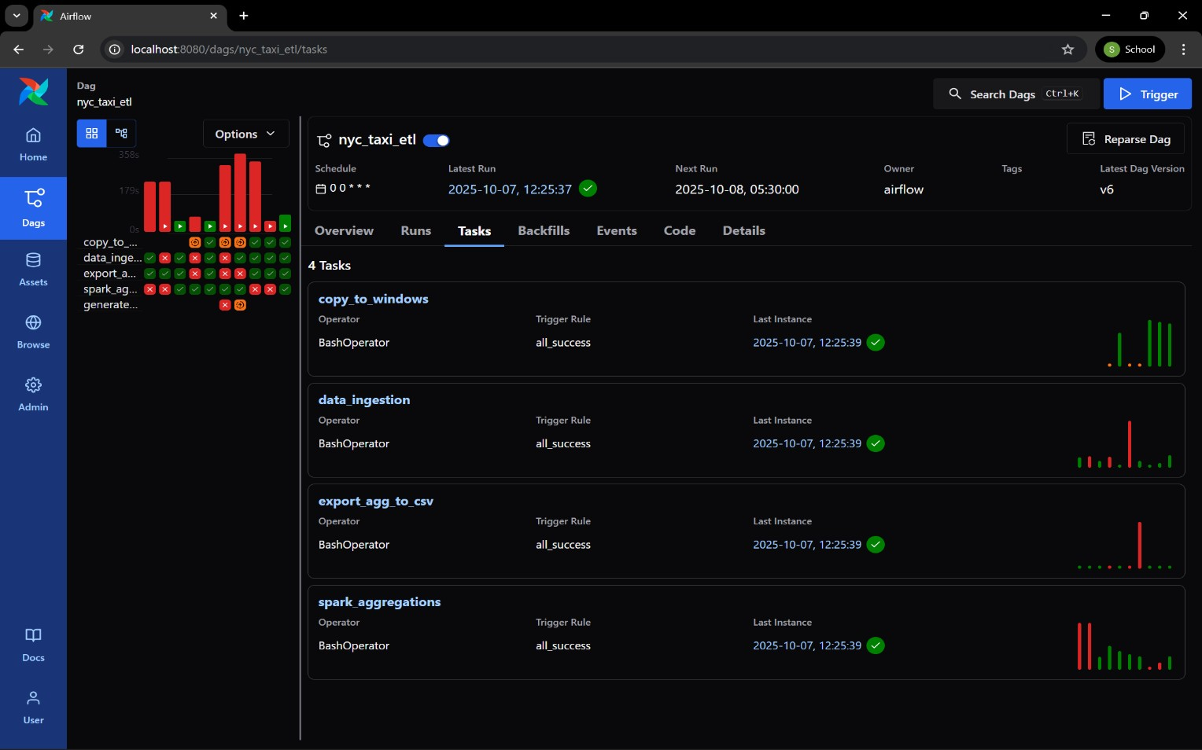

Outputs:
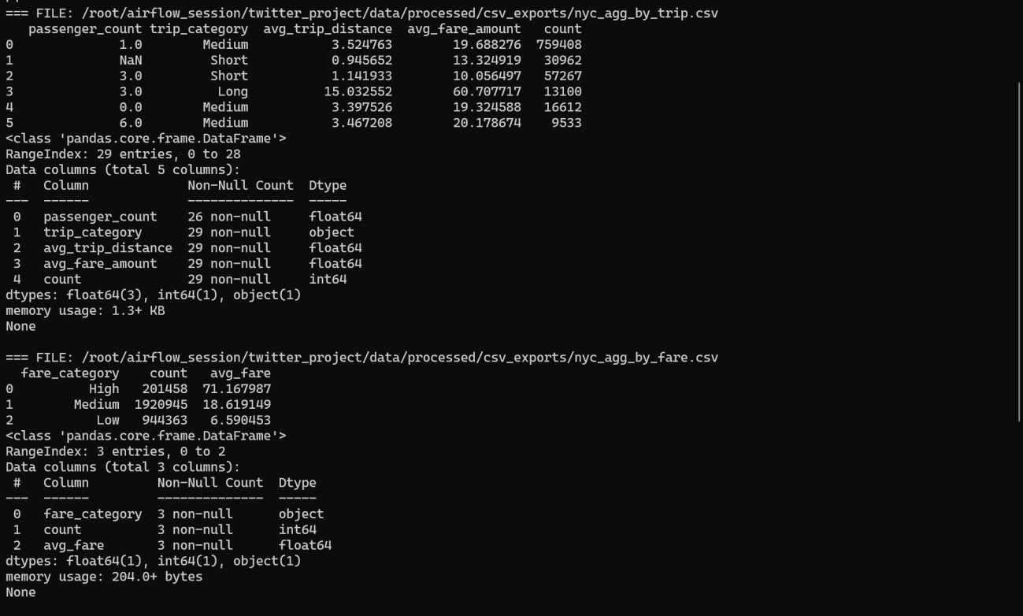
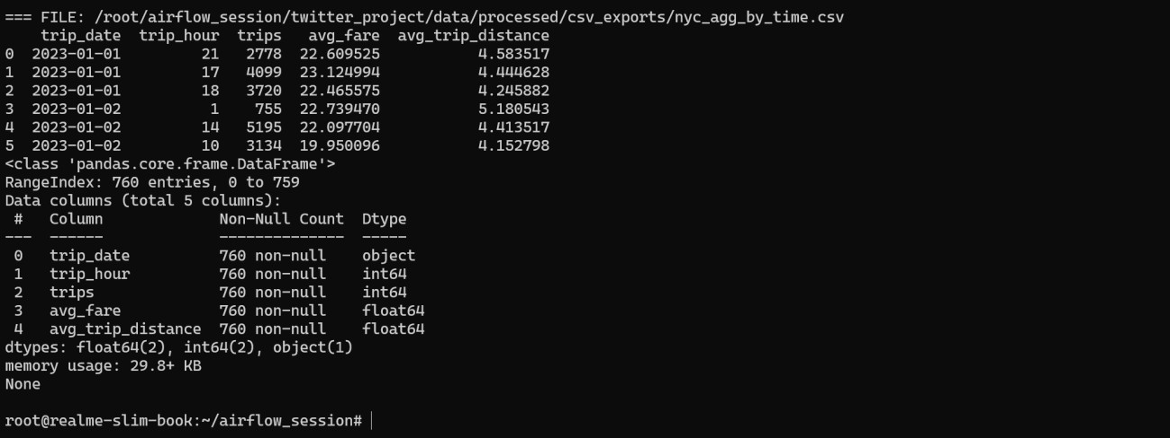

How to Connect to Tableau Desktop
- Ensure CSVs are copied to: C:\Users\<WindowsUser>\Documents\tableau_data\ (Airflow DAG does this).
- Open Tableau Desktop → Connect → Text file → choose the CSV.
- Build sheets/dashboards: bar charts, heatmaps, time-series, filters.
- Save workbook as .twbx in C:\Users\<WindowsUser>\Documents\tableau_dashboards\.
Automation tip: Use Windows Task Scheduler to open the workbook after DAG completes (no server required). Or rely on the plot PNGs generated automatically
Visulaization Using Tableau:
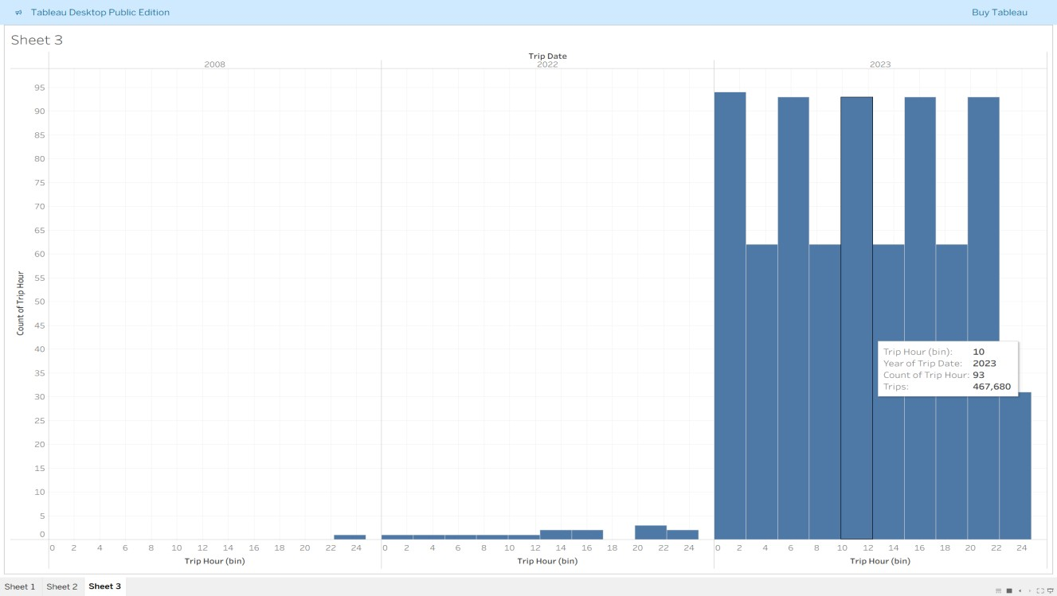

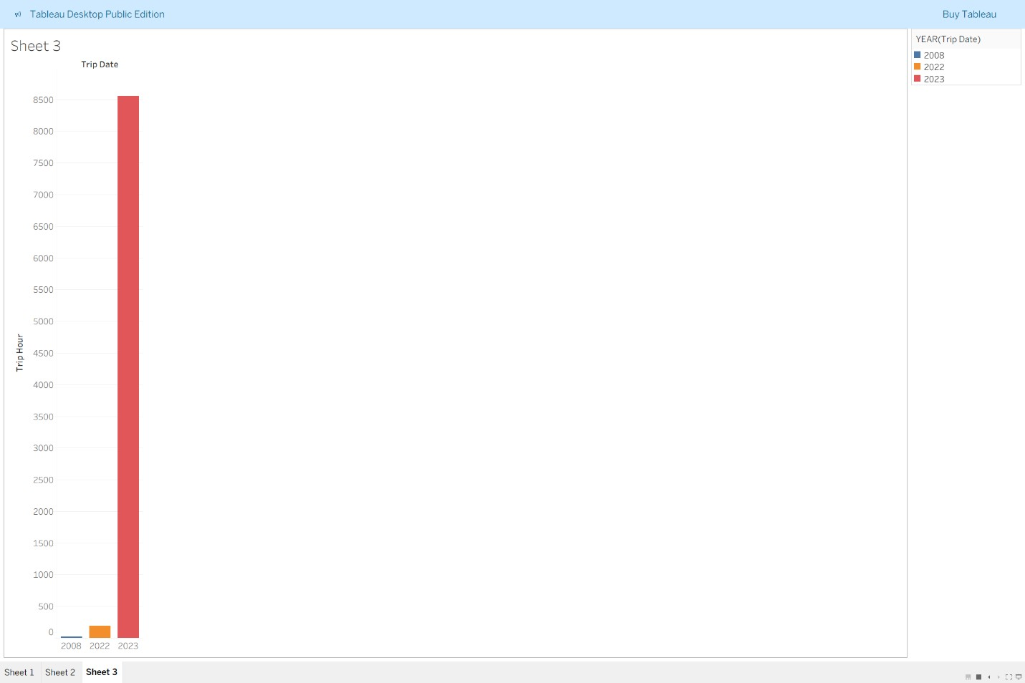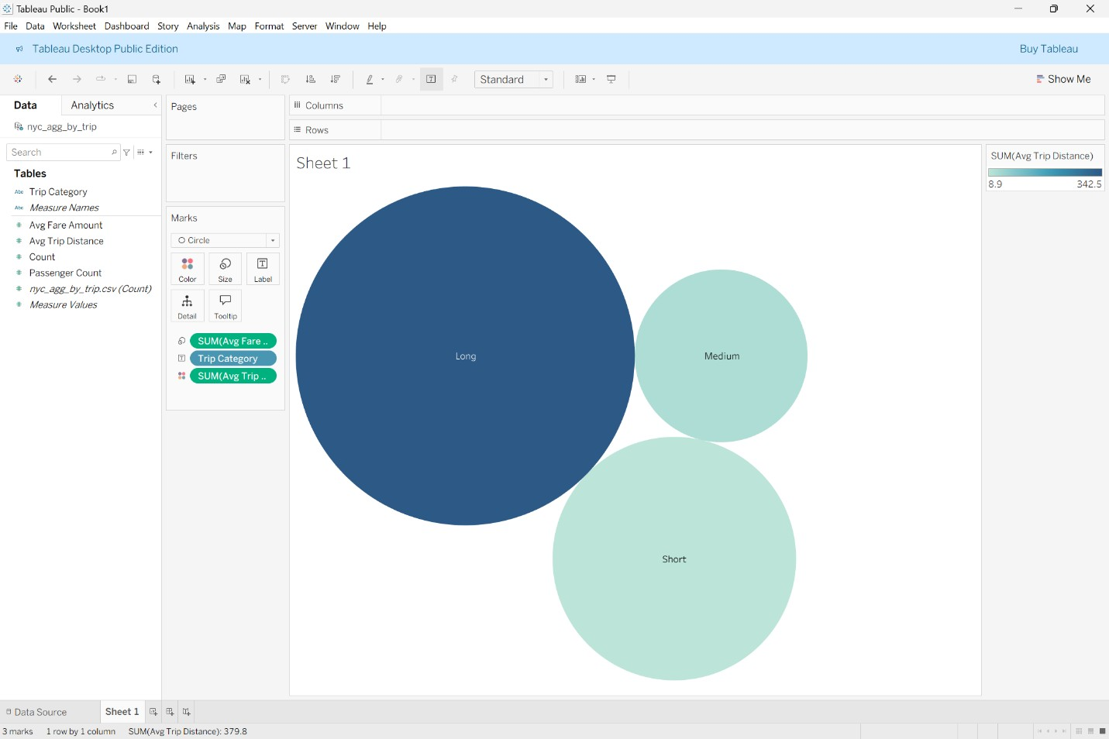

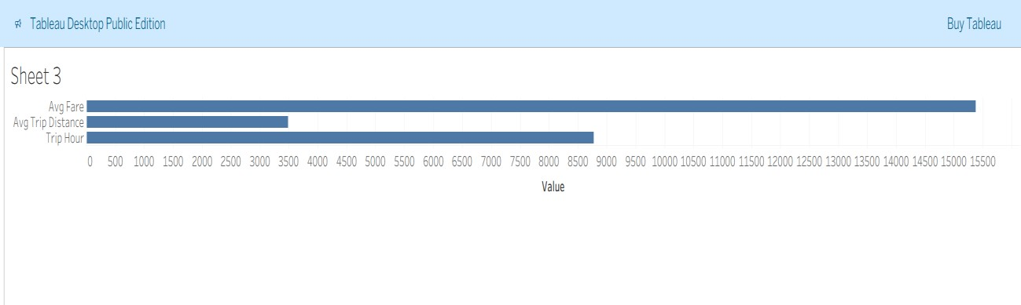
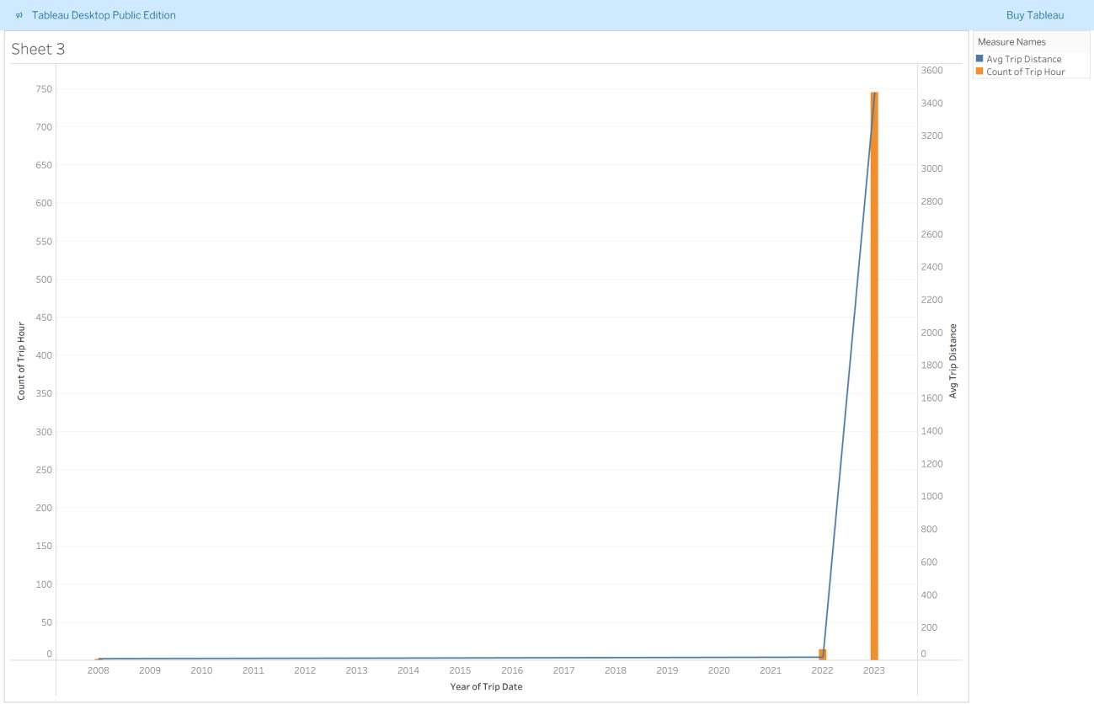

Row-count & Monitoring
- Use Spark to count rows safely (example):
spark.read.parquet("/path/to/parquet").count()
- Add print() logging in scripts to emit counts into Airflow task logs (these appear in Airflow UI).
- Add a row_count_log.csv file append step if you want a running history of processed rows per DAG run.

Enhancements & Next Steps
- Partition aggregated Parquet by date for faster incremental queries and dashboarding.
- Save daily/hourly pre-aggregations to speed Tableau queries.
- Add metadata logging (row counts, run duration) to a small SQLite DB or CSV for monitoring.
- If you acquire Tableau Server/Online, implement automatic publishing + extract refresh using Tableau REST API or tabcmd.
- Add unit tests for scripts and a small CI check that runs pipeline on a very small sample.

Change Log (high level)
- Built ingestion to use official NYC CloudFront Parquet URIs.
- Switched to memory-safe staging for Airflow tasks.
- Implemented Spark-based category aggregation with multiple outputs (parquet + CSV).
- Automated visualization generation and saving to Windows folder for Tableau Desktop.

Contact / Where to find the files
All scripts live under: /root/airflow_session/twitter_project/scripts/
Data lives (raw/processed/aggregated) under: /root/airflow_session/twitter_project/data/
DAG lives: /root/airflow_session/airflow_home/dags/etl_nyc_dags.py

