KREDIT
Tokenizing Welfare Into Real-World Value

CS-220 Database Systems — Final Project Report

Name | Roll Number
M. Talha Asif | 576751
M. Shazel Rizwan | 550820
Rao Ahmed Shehrayar Aleem | 542830
M. Abdul Qayyum Khan | 558351

Repository: github.com/collab15/Kredit

1. Project Overview
Kredit is a full-stack PERN (PostgreSQL, Express.js, React, Node.js) web application that functions as a community welfare ledger. It tokenizes welfare and community work into a digital currency called kreds, which users earn by performing favours for one another, receive as rewards from welfare agencies, and spend at partnered businesses.
The project demonstrates every topic covered in CS-220 Database Systems — from ER modeling and normalization through DDL, DML, joins, subqueries, and trigger-based automation — implemented in a production-quality PostgreSQL schema with a full React frontend and Express.js REST API.

1.1 Core Concept
The Kredit ecosystem has three actor types:
- Users — register accounts, earn kred balances by completing favours, request favours from other users, and spend kreds at partnered organizations.
- Agencies — welfare organizations that authenticate via an API key and issue kred rewards to users in recognition of community work.
- Partners — businesses that accept kred payments from users, giving real-world economic value to welfare contributions.

2. Requirements and Scope

2.1 Functional Requirements
The system must support the following operations:
Requirement | Description
User Management | Register users, authenticate with username/password (bcrypt), update profile, view balance, delete accounts (admin only).
Favour System | Users request favours from other users; the system enforces no self-favour constraints; favours transition through Created → Pending → Completed states via database triggers. The requestor marks a favour complete; the requestee may ignore (remove) a pending request.
Peer Transfers | Users transfer kreds to other users; balance is debited/credited atomically by a trigger; overdrafts are prevented by a CHECK constraint.
Agency Rewards | Agencies issue kred rewards to users; balance is credited automatically by a trigger.
Org Payments | Users spend kreds at partnered organizations; the system validates the target is a partnered (not agency) org before allowing the transaction.
Admin Operations | Admins can view all users, organizations, favours, and transactions; no row-level scoping applied to admin queries.
Audit Logging | Every balance change is logged automatically in balance_audit with old balance, new balance, delta, and timestamp.
Role-Scoped Access | Users see only their own records; orgs see only their org's records; admins see all.

2.2 Non-Functional Requirements
- All business logic enforced at the database level via triggers and CHECK constraints — not just the application layer.
- ACID transactions for every balance-altering operation.
- Row-level locking (SELECT ... FOR UPDATE) on user rows during debit operations to prevent race conditions.
- Parameterized queries throughout — no string interpolation in SQL to prevent injection.
- Passwords hashed with bcryptjs before storage; never stored or returned as plaintext.
- JWT-based stateless authentication; tokens carry role (user/org/admin) for middleware enforcement.

2.3 Scope
In Scope:
- Full PostgreSQL schema with 15 tables, 7 triggers, 3 database roles, and 11 covering indexes.
- Express.js REST API with endpoints for all CRUD operations on users, organizations, favours, and transactions.
- React SPA frontend with separate dashboards for users, agencies, and partnered organizations.
- Admin panel for system-wide visibility.
Out of Scope:
- Real payment gateway integration.
- Mobile native applications.
- Email/SMS notification systems.

Conceptual Model
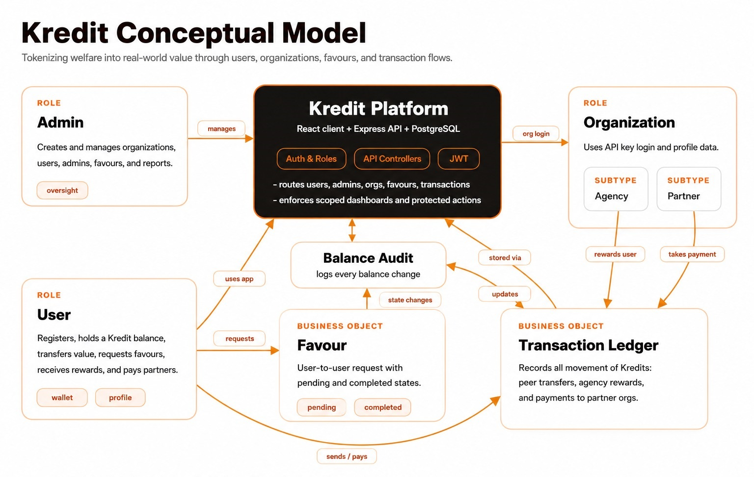

Use Case Diagram
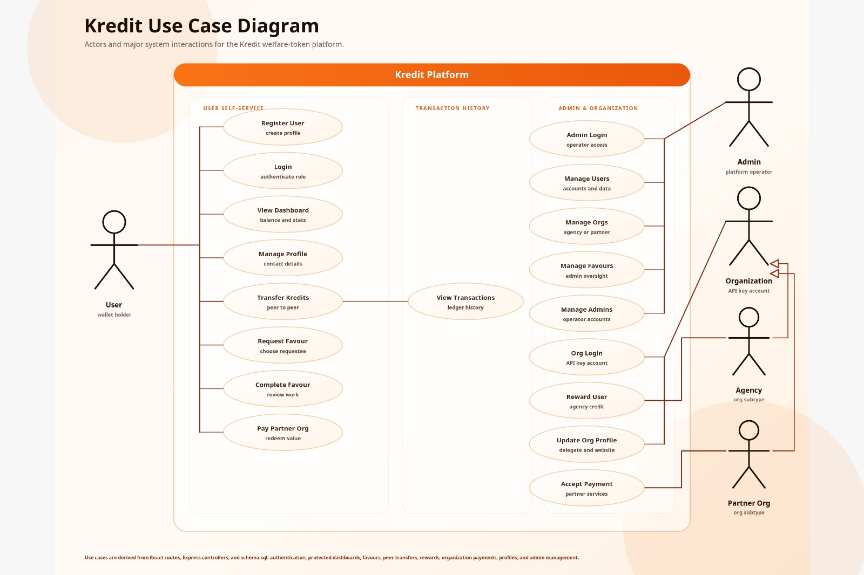

3. CS-220 Curriculum Alignment
Every topic in the CS-220 Database Systems lesson plan is demonstrated by the Kredit implementation. The table below maps each week's topic to the specific feature or design decision in the project.
Week | Topic | Kredit Implementation
Week 1 | File Systems vs. Databases | Kredit uses PostgreSQL over flat files — ACID transactions, referential integrity, concurrent access, and trigger automation are impossible with file-based storage.
Wks 2–3 | Database Concepts & Relational Algebra | Schema uses relations (tables), tuples (rows), and attributes with domains. SELECT, PROJECT, JOIN, and UNION operations map directly to every API query.
Week 4 | Data Manipulation Language (DML) | Every API endpoint maps to INSERT (create user/tx), SELECT (read data), UPDATE (complete favour / balance via trigger), DELETE (admin operations with CASCADE).
Week 5 | Joins | Multi-table INNER JOINs for transaction feeds (transactions ⋈ peer_transactions ⋈ users). LEFT JOIN ON FALSE used structurally in UNION ALL to match column counts.
Week 6 | Subqueries | Correlated subquery checks org subtype before org_payment (SELECT 1 FROM partnered WHERE org_id=$1). Row-locking subquery: SELECT balance FROM users WHERE user_id=$1 FOR UPDATE.
Week 7 | Data Definition Language (DDL) | CREATE TABLE with UUID PKs, NUMERIC(12,2), TEXT, BOOLEAN, TIMESTAMP. CHECK constraints, FK CASCADE, UNIQUE, DEFAULT. 11 covering indexes. Trigger function definitions in DDL.
Week 8 | Entity-Relationship Modeling (ERM/EERM) | ERD designed first. Generalization/specialization for ORGS → agencies / partnered. Total disjoint specialization. Shared INFO entity reused across users and orgs.
Week 10 | ER Model to Relational Schema | Each entity mapped to its own table. Each specialization uses table-per-type pattern (child table shares parent PK as its own PK and FK). Relationships → FK columns.
Wks 11–12 | Database Anomalies & Normalization (3NF) | All tables verified in 3NF. Shared info table eliminates transitive dependency. balance_audit is append-only — no update anomaly. No partial dependencies (single-column UUID PKs).

4. Database Schema

ERD: Lucid chart link


4.1 Entity-Relationship Design
The database was designed entity-first using an Extended ER Model (EERM) before writing DDL.
Main entities and their relationships:
- USERS (1:N) FAVOURS — as requestor and requestee
- USERS (1:N) TRANSACTIONS — as sender, receiver, payer, or rewardee
- ORGS (1:N) REWARDS — agencies issue rewards to users
- ORGS (1:N) ORG_PAYMENTS — partnered orgs receive payments from users
EERM specializations (disjoint, total):
- ORGS specializes into AGENCIES (scope) and PARTNERED (services) — an org is one or the other, never both.
- TRANSACTIONS specializes into PEER_TRANSACTIONS, REWARDS, and ORG_PAYMENTS.
- USERS extends via INFO (contact), USER_INFO (personal), and BALANCE_AUDIT (history).

4.2 Table Groups
Users & Info: users, info, user_info, admins, balance_audit
Organizations: orgs, org_info, agencies, partnered
Favours: favours, pending_favours, completed_favours
Transactions: transactions, peer_transactions, rewards, org_payments

4.3 Normalization
All tables satisfy Third Normal Form (3NF). The design decisions that enforce normalization:
- 1NF: Every column holds a single atomic value. No arrays or comma-separated lists — each relationship has its own table.
- 2NF: All tables use single-column UUID primary keys, making partial dependencies structurally impossible.
- 3NF: Contact info (phone, email, address) that would create a transitive dependency in both users and orgs is factored into a shared info table.
- No update anomaly: balance_audit is append-only — one row per balance change, never updated.
- No insertion anomaly: creating a transaction requires only FKs; no redundant user data is duplicated.
- No deletion anomaly: each entity is independent; deleting a favour does not affect the users table.

4.4 Step-by-Step Conversion

Following is the step by step procedure used for the rigorous conversion process:
Step 1: Mapping of Regular Entity Types Every strong entity becomes a relation with its primary key.
- INFO = INFO(Info_ID PK, Phone, Email, Address)
- TRANSACTIONS = TRANSACTIONS(Transaction_ID PK, Amount, Description, Time_Stamp)
- FAVOURS = FAVOURS(Favour_ID PK, Description, Compensation, Requestor_ID, Requestee_ID)
- USERS = USERS(User_ID PK, Username, Password, Balance, Joining_Date)
- ORGS = ORGS(Org_ID PK, API_Key)
- ADMINS = ADMINS(Admin_ID PK, Username, Password, Joining_Date)

Step 2: Mapping of Weak Entity Types
- USER_INFO
- ORG_INFO
These are weak entities as they cannot exist without USERS and ORGS respectively. We add the owner's primary key as a foreign key in them.
- USER_INFO(Info_ID PK/FK, User_ID FK, First_Name, Last_Name, Gender, Age)
- ORG_INFO(Info_ID PK/FK, Org_ID FK, Name, Delegate, Website)

Step 3: Mapping of Binary 1:1 Relationships
- USERS and USER_INFO
- ORGS and ORG_INFO
These are 1:1 relations. Handled by adding the primary keys of USERS and ORGS as foreign keys in USER_INFO and ORG_INFO respectively. Already done during the mapping of weak entities.

Step 4: Mapping of Binary 1:N Relationships
Users → Favours One user can request multiple favours, and one user can be the requestee of multiple favours. Mapped as: FAVOURS(Favour_ID PK, Description, Requestor_ID FK, Requestee_ID FK) Requestor_ID and Requestee_ID are foreign keys referencing USERS.
Users → Balance_Audit One user can have multiple balance change records over time. Mapped as: BALANCE_AUDIT(Audit_ID PK, User_ID FK, Old_Balance, New_Balance, Delta, Changed_At) User_ID is a foreign key referencing USERS.
Transactions → Peer_Transactions A transaction involves a sender and a receiver. Mapped as: PEER_TRANSACTIONS(Transaction_ID PK/FK, Sender_ID FK, Receiver_ID FK) Sender_ID and Receiver_ID are foreign keys referencing USERS.
Orgs → Rewards One organization can give multiple rewards to users. Mapped as: REWARDS(Transaction_ID PK/FK, Rewardee_ID FK, Org_ID FK) Rewardee_ID and Org_ID are foreign keys referencing USERS and ORGS.
Users/Orgs → Org_Payments A user can make multiple payments to organizations. Mapped as: ORG_PAYMENTS(Transaction_ID PK/FK, Payer_ID FK, Org_ID FK) Payer_ID is a foreign key referencing USERS, Org_ID is a foreign key referencing ORGS.

Step 5: Mapping of Binary M:N Relationships
Users ↔ Transactions Instead of direct mapping, intermediate relations are used:
- PEER_TRANSACTIONS resolves the M:N relationship between users as senders and receivers.
- ORG_PAYMENTS resolves the M:N relationship between users and organizations for payments.

Step 6: Mapping of Multivalued Attributes No multivalued attributes in the ERD (e.g., no repeating attribute like multiple phone numbers). Step skipped.

Step 7: Mapping of N-ary Relationships
Ternary relationship — Organisation gives reward to User via Transaction: Embedded into: REWARDS(Transaction_ID PK/FK, Org_ID FK, Rewardee_ID FK)
Ternary relationship — User pays Organisation via Transaction: Embedded into: ORG_PAYMENTS(Transaction_ID PK/FK, Payer_ID FK, Org_ID FK)

Step 8: Mapping of Generalisation / Specialisation
1. ORGS specialisation ORGS specializes to: PARTNERED, AGENCIES Relations used:
- PARTNERED(Org_ID PK/FK, Services)
- AGENCIES(Org_ID PK/FK, Scope)
2. TRANSACTIONS specialisation TRANSACTIONS specializes to: REWARDS, PEER_TRANSACTIONS, ORG_PAYMENTS Implemented via subtype tables referencing Transaction_ID:
- REWARDS(Transaction_ID PK/FK, Rewardee_ID FK, Org_ID FK)
- PEER_TRANSACTIONS(Transaction_ID PK/FK, Sender_ID FK, Receiver_ID FK)
- ORG_PAYMENTS(Transaction_ID PK/FK, Payer_ID FK, Org_ID FK)
3. FAVOURS specialisation (state-based) FAVOURS specializes to: PENDING_FAVOURS, COMPLETED_FAVOURS Mapped as:
- PENDING_FAVOURS(Favour_ID PK/FK, Acception_Status)
- COMPLETED_FAVOURS(Favour_ID PK/FK, Done_At, Review)
4. INFO specialisation INFO specializes to: USER_INFO, ORG_INFO Mapped as:
- USER_INFO(Info_ID PK/FK, User_ID FK, First_Name, Last_Name, Gender, Age)
- ORG_INFO(Info_ID PK/FK, Org_ID FK, Name, Delegate, Website)

6. Implemented Schema DDL
Schema: Lucid Chart Link

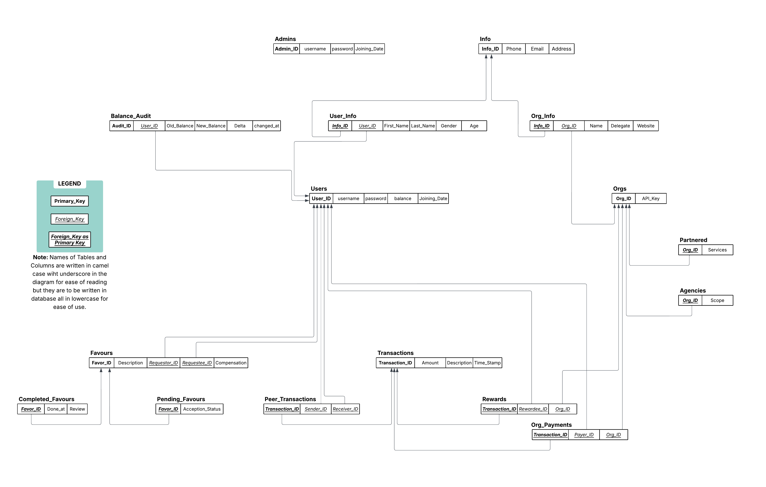

The full PostgreSQL DDL for all 15 tables is provided below. All primary keys use UUID generated by gen_random_uuid(). Financial amounts use NUMERIC(12,2). All foreign keys specify ON DELETE CASCADE.

5.1 info
CREATE TABLE info (
info_id UUID PRIMARY KEY DEFAULT gen_random_uuid(),
phone TEXT,
email TEXT,
address TEXT
);

5.2 users
CREATE TABLE users (
user_id UUID PRIMARY KEY DEFAULT gen_random_uuid(),
username TEXT NOT NULL UNIQUE,
password TEXT NOT NULL,
balance NUMERIC(12,2) NOT NULL DEFAULT 0
CHECK (balance >= 0),
created_at TIMESTAMP DEFAULT now()
);
CREATE INDEX idx_users_username ON users(username);

5.3 user_info
CREATE TABLE user_info (
user_info_id UUID PRIMARY KEY DEFAULT gen_random_uuid(),
user_id UUID NOT NULL REFERENCES users(user_id) ON DELETE CASCADE,
info_id UUID NOT NULL REFERENCES info(info_id) ON DELETE CASCADE,
first_name TEXT,
last_name TEXT,
gender TEXT,
age INTEGER,
national_id TEXT UNIQUE
);
CREATE INDEX idx_user_info_user_id ON user_info(user_id);

5.4 admins
CREATE TABLE admins (
admin_id UUID PRIMARY KEY DEFAULT gen_random_uuid(),
username TEXT NOT NULL UNIQUE,
password TEXT NOT NULL
);

5.5 balance_audit
CREATE TABLE balance_audit (
audit_id UUID PRIMARY KEY DEFAULT gen_random_uuid(),
user_id UUID NOT NULL REFERENCES users(user_id) ON DELETE CASCADE,
old_balance NUMERIC(12,2) NOT NULL,
new_balance NUMERIC(12,2) NOT NULL,
delta NUMERIC(12,2) NOT NULL,
changed_at TIMESTAMP DEFAULT now()
);
CREATE INDEX idx_balance_audit_user_id ON balance_audit(user_id);
CREATE INDEX idx_balance_audit_changed_at ON balance_audit(changed_at DESC);

5.6 orgs
CREATE TABLE orgs (
org_id UUID PRIMARY KEY DEFAULT gen_random_uuid(),
api_key TEXT NOT NULL UNIQUE,
password TEXT NOT NULL,
created_at TIMESTAMP DEFAULT now()
);
CREATE INDEX idx_orgs_api_key ON orgs(api_key);

5.7 org_info
CREATE TABLE org_info (
org_info_id UUID PRIMARY KEY DEFAULT gen_random_uuid(),
org_id UUID NOT NULL REFERENCES orgs(org_id) ON DELETE CASCADE,
info_id UUID NOT NULL REFERENCES info(info_id) ON DELETE CASCADE,
name TEXT NOT NULL,
delegate TEXT,
website TEXT
);
CREATE INDEX idx_org_info_org_id ON org_info(org_id);

5.8 agencies
CREATE TABLE agencies (
agency_id UUID PRIMARY KEY DEFAULT gen_random_uuid(),
org_id UUID NOT NULL REFERENCES orgs(org_id) ON DELETE CASCADE,
scope TEXT
);
CREATE INDEX idx_agencies_org_id ON agencies(org_id);

5.9 partnered
CREATE TABLE partnered (
partner_id UUID PRIMARY KEY DEFAULT gen_random_uuid(),
org_id UUID NOT NULL REFERENCES orgs(org_id) ON DELETE CASCADE,
services TEXT
);
CREATE INDEX idx_partnered_org_id ON partnered(org_id);

5.10 favours
CREATE TABLE favours (
favour_id UUID PRIMARY KEY DEFAULT gen_random_uuid(),
requestor_id UUID NOT NULL REFERENCES users(user_id) ON DELETE CASCADE,
requestee_id UUID NOT NULL REFERENCES users(user_id) ON DELETE CASCADE,
description TEXT,
compensation NUMERIC(14,2) NOT NULL DEFAULT 0,
created_at TIMESTAMP DEFAULT now(),
CONSTRAINT chk_compensation_non_neg CHECK (compensation >= 0),
CONSTRAINT chk_no_self_favour CHECK (requestor_id <> requestee_id)
);
CREATE INDEX idx_favours_requestor ON favours(requestor_id);
CREATE INDEX idx_favours_requestee ON favours(requestee_id);

5.11 pending_favours
CREATE TABLE pending_favours (
pending_id UUID PRIMARY KEY DEFAULT gen_random_uuid(),
favour_id UUID NOT NULL REFERENCES favours(favour_id) ON DELETE CASCADE,
activation_status BOOLEAN NOT NULL DEFAULT FALSE
);
CREATE INDEX idx_pending_favours_favour_id ON pending_favours(favour_id);

5.12 completed_favours
CREATE TABLE completed_favours (
completed_id UUID PRIMARY KEY DEFAULT gen_random_uuid(),
favour_id UUID NOT NULL REFERENCES favours(favour_id) ON DELETE CASCADE,
done_at TIMESTAMP DEFAULT now(),
review TEXT
);
CREATE INDEX idx_completed_favours_favour_id ON completed_favours(favour_id);
CREATE INDEX idx_completed_favours_done_at ON completed_favours(done_at DESC);

5.13 transactions
CREATE TABLE transactions (
tx_id UUID PRIMARY KEY DEFAULT gen_random_uuid(),
amount NUMERIC(12,2) NOT NULL CHECK (amount > 0),
description TEXT,
time_stamp TIMESTAMP DEFAULT now()
);
CREATE INDEX idx_transactions_time_stamp ON transactions(time_stamp DESC);

5.14 peer_transactions
CREATE TABLE peer_transactions (
peer_tx_id UUID PRIMARY KEY DEFAULT gen_random_uuid(),
tx_id UUID NOT NULL REFERENCES transactions(tx_id) ON DELETE CASCADE,
sender_id UUID NOT NULL REFERENCES users(user_id) ON DELETE CASCADE,
receiver_id UUID NOT NULL REFERENCES users(user_id) ON DELETE CASCADE,
CONSTRAINT chk_no_self_transfer CHECK (sender_id <> receiver_id)
);
CREATE INDEX idx_peer_tx_sender ON peer_transactions(sender_id);
CREATE INDEX idx_peer_tx_receiver ON peer_transactions(receiver_id);

5.15 rewards
CREATE TABLE rewards (
reward_id UUID PRIMARY KEY DEFAULT gen_random_uuid(),
tx_id UUID NOT NULL REFERENCES transactions(tx_id) ON DELETE CASCADE,
rewardee_id UUID NOT NULL REFERENCES users(user_id) ON DELETE CASCADE,
org_id UUID NOT NULL REFERENCES orgs(org_id) ON DELETE CASCADE
);
CREATE INDEX idx_rewards_rewardee ON rewards(rewardee_id);
CREATE INDEX idx_rewards_org_id ON rewards(org_id);

5.16 org_payments
CREATE TABLE org_payments (
payment_id UUID PRIMARY KEY DEFAULT gen_random_uuid(),
tx_id UUID NOT NULL REFERENCES transactions(tx_id) ON DELETE CASCADE,
payer_id UUID NOT NULL REFERENCES users(user_id) ON DELETE CASCADE,
org_id UUID NOT NULL REFERENCES orgs(org_id) ON DELETE CASCADE
);
CREATE INDEX idx_org_payments_payer ON org_payments(payer_id);
CREATE INDEX idx_org_payments_org_id ON org_payments(org_id);

6. Database Triggers
Seven trigger functions enforce all business logic at the database layer. No balance updates are ever issued directly by the application — triggers handle all state transitions and balance arithmetic.

T1 — trg_prevent_self_favour
Timing: BEFORE INSERT on favours
Raises an exception if requestor_id = requestee_id. Redundant with the CHECK constraint but provides a clear error message at the trigger level.
CREATE OR REPLACE FUNCTION fn_prevent_self_favour()
RETURNS TRIGGER AS $$
BEGIN
IF NEW.requestor_id = NEW.requestee_id THEN
RAISE EXCEPTION 'A user cannot request a favour from themselves.';
END IF;
RETURN NEW;
END;
$$ LANGUAGE plpgsql;
CREATE TRIGGER trg_prevent_self_favour
BEFORE INSERT ON favours
FOR EACH ROW EXECUTE FUNCTION fn_prevent_self_favour();

T2 — trg_auto_pending_favour
Timing: AFTER INSERT on favours
Automatically inserts the new favour into pending_favours with activation_status = FALSE. The application never calls INSERT on pending_favours directly.
CREATE OR REPLACE FUNCTION fn_auto_pending_favour()
RETURNS TRIGGER AS $$
BEGIN
INSERT INTO pending_favours (favour_id, activation_status)
VALUES (NEW.favour_id, FALSE);
RETURN NEW;
END;
$$ LANGUAGE plpgsql;
CREATE TRIGGER trg_auto_pending_favour
AFTER INSERT ON favours
FOR EACH ROW EXECUTE FUNCTION fn_auto_pending_favour();

T3 — trg_complete_favour
Timing: AFTER UPDATE on pending_favours
Fires when activation_status is set to TRUE. Inserts a row into completed_favours, deletes the row from pending_favours completing the state machine, and credits the compensation amount to the requestee's balance if compensation > 0.
CREATE OR REPLACE FUNCTION fn_complete_favour()
RETURNS TRIGGER AS $$
DECLARE
v_compensation NUMERIC(14,2);
v_requestee_id UUID;
BEGIN
IF NEW.activation_status = TRUE AND OLD.activation_status = FALSE THEN
INSERT INTO completed_favours (favour_id, done_at)
VALUES (NEW.favour_id, now());
DELETE FROM pending_favours WHERE favour_id = NEW.favour_id;
SELECT compensation, requestee_id INTO v_compensation, v_requestee_id
FROM favours WHERE favour_id = NEW.favour_id;
IF v_compensation > 0 THEN
UPDATE users SET balance = balance + v_compensation WHERE user_id = v_requestee_id;
END IF;
END IF;
RETURN NULL;
END;
$$ LANGUAGE plpgsql;
CREATE TRIGGER trg_complete_favour
AFTER UPDATE OF activation_status ON pending_favours
FOR EACH ROW
EXECUTE FUNCTION fn_complete_favour();

T4 — trg_peer_transfer_balances
Timing: AFTER INSERT on peer_transactions
Debits the sender's balance and credits the receiver's balance. Raises an exception if the sender has insufficient funds.
CREATE OR REPLACE FUNCTION fn_peer_transfer_balances()
RETURNS TRIGGER AS $$
DECLARE
sender_bal NUMERIC(12,2);
tx_amount NUMERIC(12,2);
BEGIN
SELECT amount INTO tx_amount FROM transactions WHERE tx_id = NEW.tx_id;
SELECT balance INTO sender_bal FROM users
WHERE user_id = NEW.sender_id FOR UPDATE;
IF sender_bal < tx_amount THEN
RAISE EXCEPTION 'Insufficient balance.';
END IF;
UPDATE users SET balance = balance - tx_amount WHERE user_id = NEW.sender_id;
UPDATE users SET balance = balance + tx_amount WHERE user_id = NEW.receiver_id;
RETURN NEW;
END;
$$ LANGUAGE plpgsql;
CREATE TRIGGER trg_peer_transfer_balances
AFTER INSERT ON peer_transactions
FOR EACH ROW EXECUTE FUNCTION fn_peer_transfer_balances();

T5 — trg_reward_credit_balance
Timing: AFTER INSERT on rewards
Credits the rewardee's balance with the transaction amount when an agency issues a reward.
CREATE OR REPLACE FUNCTION fn_reward_credit_balance()
RETURNS TRIGGER AS $$
DECLARE tx_amount NUMERIC(12,2);
BEGIN
SELECT amount INTO tx_amount FROM transactions WHERE tx_id = NEW.tx_id;
UPDATE users SET balance = balance + tx_amount WHERE user_id = NEW.rewardee_id;
RETURN NEW;
END;
$$ LANGUAGE plpgsql;
CREATE TRIGGER trg_reward_credit_balance
AFTER INSERT ON rewards
FOR EACH ROW EXECUTE FUNCTION fn_reward_credit_balance();

T6 — trg_org_payment_debit
Timing: AFTER INSERT on org_payments
Debits the payer's balance when they spend kreds at a partnered organization. Validates sufficient balance before debit.
CREATE OR REPLACE FUNCTION fn_org_payment_debit()
RETURNS TRIGGER AS $$
DECLARE
payer_bal NUMERIC(12,2);
tx_amount NUMERIC(12,2);
BEGIN
SELECT amount INTO tx_amount FROM transactions WHERE tx_id = NEW.tx_id;
SELECT balance INTO payer_bal FROM users
WHERE user_id = NEW.payer_id FOR UPDATE;
IF payer_bal < tx_amount THEN
RAISE EXCEPTION 'Insufficient balance for org payment.';
END IF;
UPDATE users SET balance = balance - tx_amount WHERE user_id = NEW.payer_id;
RETURN NEW;
END;
$$ LANGUAGE plpgsql;
CREATE TRIGGER trg_org_payment_debit
AFTER INSERT ON org_payments
FOR EACH ROW EXECUTE FUNCTION fn_org_payment_debit();

T7 — trg_balance_audit
Timing: AFTER UPDATE on users
Fires whenever the users.balance column is updated. Inserts a record into balance_audit with the old balance, new balance, delta, and timestamp — creating a complete, immutable audit trail.
CREATE OR REPLACE FUNCTION fn_balance_audit()
RETURNS TRIGGER AS $$
BEGIN
IF OLD.balance <> NEW.balance THEN
INSERT INTO balance_audit (user_id, old_balance, new_balance, delta)
VALUES (NEW.user_id, OLD.balance, NEW.balance, NEW.balance - OLD.balance);
END IF;
RETURN NEW;
END;
$$ LANGUAGE plpgsql;
CREATE TRIGGER trg_balance_audit
AFTER UPDATE ON users
FOR EACH ROW EXECUTE FUNCTION fn_balance_audit();

7. Backend — Express.js API

7.1 Architecture
The backend is a Node.js application using Express.js 4.x. It connects to PostgreSQL via the node-postgres (pg) library with a connection pool. All SQL queries use parameterized statements ($1, $2, ...) to prevent injection attacks.
- Entry point: server.js — creates the Express app, registers middleware, mounts routers, starts listening.
- Database: db.js — creates a pg.Pool configured from environment variables (DB_HOST, DB_PORT, DB_USER, DB_PASSWORD, DB_NAME).
- Middleware: auth.js — JWT verification middleware; extracts role and ID from token payload.
- Routers: one file per resource — users.js, orgs.js, favours.js, transactions.js, admin.js.

7.2 API Endpoints
Method | Endpoint | Description
POST | /api/users/register | Register a new user. Hashes password with bcrypt, inserts into users.
POST | /api/users/login | Authenticate user, return JWT containing user_id and role='user'.
GET | /api/users/profile | Return authenticated user's profile and balance. Requires user JWT.
GET | /api/users/transactions | Return unified transaction history (UNION ALL across three tx types). Scoped to authenticated user.
DELETE | /api/users/:id | Admin only — delete user; CASCADE removes all related rows.
POST | /api/orgs/register | Register a new organization as agency or partnered. Hashes password, inserts into orgs + org_info + subtype table.
POST | /api/orgs/login | Authenticate org via api_key, return JWT with org_id and role='org'.
POST | /api/favours | Create a new favour request. Triggers auto-insert into pending_favours.
GET | /api/favours/pending | Return all pending favours for the authenticated user (as requestee).
PATCH | /api/favours/:id/complete | Requestor only — sets activation_status=TRUE; trigger moves row to completed_favours and credits compensation to requestee.
DELETE | /api/favours/:id/ignore | Requestee only — removes the pending favour (ignore action).
POST | /api/transactions/peer | Create peer transfer. Inserts into transactions + peer_transactions; trigger debits/credits balances.
POST | /api/transactions/reward | Agency issues reward. Inserts into transactions + rewards; trigger credits user balance.
POST | /api/transactions/payment | User pays partnered org. Validates subtype, inserts into transactions + org_payments; trigger debits user.
GET | /api/admin/users | Admin only — return all users.
GET | /api/admin/orgs | Admin only — return all organizations.
GET | /api/admin/transactions | Admin only — return all transactions (all three types, no WHERE scoping).

7.3 Key Query Pattern — UNION ALL Transaction Feed
All three transaction types are returned in a single unified query using UNION ALL. Each arm of the UNION ALL joins the parent transactions table with its specific child table and uses LEFT JOIN ON FALSE to fill NULL columns that don't apply to that arm.
-- User-scoped unified transaction history
SELECT
t.tx_id, t.amount, t.description, t.time_stamp,
'peer' AS tx_type,
sn.username AS sender, rv.username AS receiver,
NULL AS org_name, NULL AS rewardee
FROM transactions t
JOIN peer_transactions pt ON pt.tx_id = t.tx_id
JOIN users sn ON sn.user_id = pt.sender_id
JOIN users rv ON rv.user_id = pt.receiver_id
WHERE pt.sender_id = $1 OR pt.receiver_id = $1
UNION ALL
SELECT
t.tx_id, t.amount, t.description, t.time_stamp,
'reward' AS tx_type,
NULL, NULL,
oi.name AS org_name,
u.username AS rewardee
FROM transactions t
JOIN rewards rw ON rw.tx_id = t.tx_id
JOIN orgs o ON o.org_id = rw.org_id
JOIN org_info oi ON oi.org_id = o.org_id
JOIN users u ON u.user_id = rw.rewardee_id
WHERE rw.rewardee_id = $1
UNION ALL
SELECT
t.tx_id, t.amount, t.description, t.time_stamp,
'payment' AS tx_type,
NULL, NULL,
oi.name AS org_name,
u.username AS payer
FROM transactions t
JOIN org_payments op ON op.tx_id = t.tx_id
JOIN orgs o ON o.org_id = op.org_id
JOIN org_info oi ON oi.org_id = o.org_id
JOIN users u ON u.user_id = op.payer_id
WHERE op.payer_id = $1
UNION ALLSELECT f.favour_id AS tx_id, f.compensation AS amount, COALESCE(f.description, 'Favour compensation') AS description, cf.done_at AS time_stamp, 'favour_compensation' AS tx_type, NULL, NULL, NULL AS org_name, u.username AS requestorFROM completed_favours cfJOIN favours f ON f.favour_id = cf.favour_idJOIN users u ON u.user_id = f.requestor_idWHERE f.requestee_id = $1 AND f.compensation > 0ORDER BY time_stamp DESC;

7.4 Authentication & Authorization
Three distinct roles are enforced:
- user — authenticated via username/password, JWT includes user_id. All queries scoped by user_id.
- org — authenticated via api_key/password, JWT includes org_id and org subtype (agency/partnered). Subtype is checked before reward or payment operations.
- admin — authenticated via admin username/password. No row-level scoping — sees all data.
JWT is verified on every protected route by the auth middleware before the controller runs.

8. Frontend — React SPA

8.1 Architecture
The frontend is a React 18 single-page application built with Vite. Tailwind CSS handles all styling. React Router v6 handles client-side navigation. Axios handles all API communication.
- src/App.jsx — root component; wraps the app in BrowserRouter, defines top-level routes.
- src/pages/ — one directory per role: UserDashboard, AgencyDashboard, PartnerDashboard, AdminDashboard, Login, Register.
- src/components/ — reusable components: TransactionCard, FavourCard, BalanceDisplay, NavBar.
- src/api/ — Axios instance with base URL and JWT interceptor (attaches Authorization header automatically).
- src/context/ — AuthContext stores decoded JWT payload and provides login/logout functions.

8.2 Views by Role
User Dashboard: Balance display, peer transfer form, favour request form, pending favours list (complete action for requestor, ignore action for requestee), full transaction history feed.
Agency Dashboard: Issue reward form (target user_id + amount + description). View all rewards issued by the agency.
Partner Dashboard: View all org_payments received by the organization.
Admin Dashboard: Full tables for all users, orgs, favours, and transactions. Delete user/org controls.
Login / Register: Shared login form (separate tabs for user, org, admin). Register form for new users and organizations.

8.3 State Management
React Context (AuthContext) stores the decoded JWT payload after login. The token is persisted in localStorage so the session survives page refreshes. Protected routes check AuthContext for an active token and role before rendering; unauthorized access redirects to /login.

9. PERN Stack — Technology Details

PostgreSQL 15
Relational database engine. Stores all 15 tables, enforces CHECK constraints and FK relationships, executes 7 trigger functions, and guarantees ACID transactions for all balance operations. Row-level locking (FOR UPDATE) prevents race conditions in concurrent balance updates.
Key features used in Kredit:
- Triggers & stored functions
- CHECK / FK constraints
- NUMERIC(12,2) for financial values
- 11 covering indexes
- gen_random_uuid() for PKs

Express.js 4
REST API framework running on Node.js. Provides structured routing, middleware pipeline (body-parser, CORS, auth), and clean separation of controllers from route definitions. All SQL is parameterized through the pg pool.
Key features used in Kredit:
- express.Router() per resource
- JWT middleware (jsonwebtoken)
- bcryptjs for password hashing
- pg connection pool
- Environment config via dotenv

React 18
Single-page application frontend. Component-based UI with hooks for state and side effects. Role-based routing prevents unauthorized view access. Axios interceptors automatically attach JWT on every API request.
Key features used in Kredit:
- Vite build tooling
- React Router v6
- Tailwind CSS 3
- Axios with JWT interceptor
- Context API for auth state

Node.js 18
JavaScript runtime for the server process. Manages the pg connection pool, runs the Express application, and handles environment variable configuration. Non-blocking I/O allows concurrent request handling without thread complexity.
Key features used in Kredit:
- pg (node-postgres) pool
- dotenv for env vars
- jsonwebtoken for JWT
- bcryptjs for hashing
- nodemon for development

10. Dependencies

10.1 Backend Dependencies (package.json)
Runtime dependencies:
Package | Version | Purpose
express | 4.x | HTTP server framework. Handles routing, middleware, and request/response lifecycle.
pg | 8.x | node-postgres — PostgreSQL client for Node.js. Used with Pool for connection management.
jsonwebtoken | 9.x | JWT signing and verification. Tokens carry user_id / org_id and role for auth middleware.
bcryptjs | 2.x | Password hashing library. All passwords are hashed with 10 salt rounds before storage.
dotenv | 16.x | Loads .env file into process.env. Used for DB credentials, JWT secret, and port config.
cors | 2.x | Cross-Origin Resource Sharing middleware. Allows the React frontend to call the API.
express-validator | 7.x | Request input validation middleware. Validates and sanitizes inputs before they reach controllers.

Development dependencies:
nodemon (3.x): Watches for file changes and automatically restarts the server during development.

10.2 Frontend Dependencies (package.json)
Package | Version | Purpose
react | 18.x | Core UI library. Component model, hooks (useState, useEffect, useContext).
react-dom | 18.x | DOM renderer for React 18.
react-router-dom | 6.x | Client-side routing. BrowserRouter, Route, Navigate for role-based redirects.
axios | 1.x | HTTP client. Configured with a base URL and request interceptor for JWT headers.
tailwindcss | 3.x | Utility-first CSS framework. All styling via class names — no custom CSS files.
vite | 5.x | Build tool and development server. Fast HMR (Hot Module Replacement) during development.
@vitejs/plugin-react | 4.x | Vite plugin for React — JSX transform and Fast Refresh.

11. Environment Setup & Configuration

11.1 Required Environment Variables
DB_HOST: PostgreSQL server hostname (e.g. localhost)
DB_PORT: PostgreSQL port (default 5432)
DB_USER: PostgreSQL username
DB_PASSWORD: PostgreSQL password
DB_NAME: Database name (e.g. kredit_db)
JWT_SECRET: Secret key for signing/verifying JWTs — must be kept private
PORT: Port for Express server (default 5000)

11.2 Running the Project
Backend:
cd server
npm install
# create .env with the variables above
npm run dev # starts with nodemon on PORT (default 5000)
Frontend:
cd client
npm install
npm run dev # starts Vite dev server, proxies /api to backend
Database setup:
psql -U postgres -c "CREATE DATABASE kredit_db;"
psql -U postgres -d kredit_db -f schema.sql # runs all DDL + trigger definitions
psql -U postgres -d kredit_db -f seed.sql # optional: seed admin account

12. Conclusion
Kredit demonstrates a complete database-driven application lifecycle — from ER modeling and normalization through DDL, trigger automation, REST API design, and role-scoped query patterns — all running on a production-quality PostgreSQL schema with a full React frontend.
Key design achievements:
- All business logic enforced at the database level. Seven triggers handle every balance change and state transition — the application never issues direct UPDATE statements on balances.
- 3NF compliance across all 15 tables. No redundant data, no update anomalies, and no insertion or deletion anomalies.
- Table-per-type inheritance for both user and organization hierarchies, directly mapping the EERM generalization/specialization to relational tables.
- Role-scoped UNION ALL queries return a unified transaction feed regardless of transaction type, with separate WHERE clauses per actor role.
- ACID-safe concurrent balance operations using row-level FOR UPDATE locking to prevent race conditions.
- Full CS-220 curriculum coverage — every topic from File Systems vs. Databases (Week 1) through Normalization (Weeks 11-12) is represented in the implementation.

