Methods and Results: Federated Proteomics, Haplographs, and Graph Learning
Chromosome 22 proof-of-concept analysis

1. Methods

Data integration and preprocessing
Three site-specific chromosome 22 proteomics matrices were read with pandas and converted from protein-by-sample to sample-by-protein format. These matrices were joined to age, sex, site, and binary case/control phenotype metadata, giving 4,000 samples and 460 measured proteins. NumPy was used for numerical transformations and missing-value handling.
Samples were divided into an 80% training set and a 20% held-out test set using a fixed random seed. Stratification used the joint site-by-phenotype label so that case/control proportions were preserved within each site. Protein filtering was learned from training samples only: proteins required at least 80% detection, median log2 intensity of at least 6, and variance of at least 0.01. For highly correlated pairs (absolute Pearson correlation >0.8), the higher-variance protein was retained.

Logistic-regression model
The reference classifier was implemented with scikit-learn. Median imputation and standardization were performed inside the model pipeline, and a class-balanced logistic-regression model used protein abundances together with age, sex, and site. Performance was measured using five-fold stratified cross-validation on the training set and final evaluation on the untouched test set. Accuracy, balanced accuracy, precision, recall, F1 score, ROC AUC, and a confusion matrix were reported.

Haplograph and knowledge graph
The annotated haplograph edge list was processed with pandas and represented with NetworkX. Haploblock co-occurrence edges retained their observed weight and lift values. Genomic overlap annotations supplied haploblock-to-protein membership edges; protein nodes were linked to gene symbols and measurement sites, and were annotated with graph degree, total edge weight, total lift, mean abundance, detection rate, and phenotype-associated abundance difference. NetworkX was also used for degree summaries, subgraph selection, and network layouts.

PyTorch Geometric comparison
A separate graph-neural-network baseline was implemented with PyTorch and PyTorch Geometric (PyG). Each patient was represented as a graph over the shared 397-protein network; node features consisted of that patient’s protein abundance plus standardized haplograph degree, weight, and lift. Protein–protein edges were projected from the annotated haploblock memberships and restricted to the 2,000 highest-weight projected edges for computational tractability. The model used two GCNConv layers, global mean pooling, and a small classifier receiving age, sex, and site covariates. The PyG model used the same stratified split and five-fold training-set cross-validation as the logistic-regression reference.

2. Results
The logistic-regression model showed strong discrimination. Five-fold cross-validation produced ROC AUC 0.930 ± 0.011, balanced accuracy 0.847 ± 0.019, and F1 score 0.819 ± 0.022. On the held-out test set, ROC AUC was 0.933, balanced accuracy was 0.848, and F1 score was 0.820; the confusion matrix contained 420 true negatives, 53 false positives, 63 false negatives, and 264 true positives.
The full annotated haplograph contained 4,344 haploblock nodes and 187,030 co-occurrence edges. The integrated graph contained 397 proteins, 391 genes, 3 sites, and 491,898 total edges after adding haploblock–protein membership, protein–gene, and site–protein measurement relationships.
The graph and predictive rankings were complementary. Among 397 matched proteins, only 2 of the top 20 proteins by haplograph degree were also among the top 20 proteins by absolute logistic coefficient (10% overlap); Spearman correlations were −0.088 for degree versus absolute coefficient and −0.087 for lift versus absolute coefficient.
The PyG GCN baseline underperformed the tabular reference model. Its held-out ROC AUC was 0.512 and five-fold cross-validation ROC AUC was 0.496 ± 0.018, compared with 0.933 and 0.930 ± 0.011 for logistic regression. This result should be interpreted as a baseline: the GCN was lightly trained and did not yet use attention, edge attributes, extensive hyperparameter tuning, or the complete projected protein network.

3. Figures
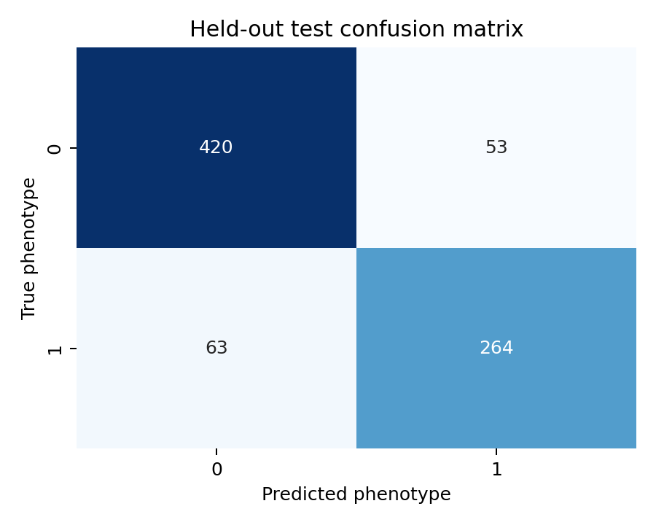
Figure 1. Held-out test confusion matrix.
Figure 1 is a confusion matrix for the held-out test samples. The horizontal axis shows the model prediction (control or case), and the vertical axis shows the true recorded phenotype; each cell contains the number of samples in that category. Darker/larger counts on the diagonal are correct predictions, while off-diagonal cells are errors: 53 controls were called cases and 63 cases were called controls. This figure is descriptive; it does not itself provide a p-value or prove statistical significance.
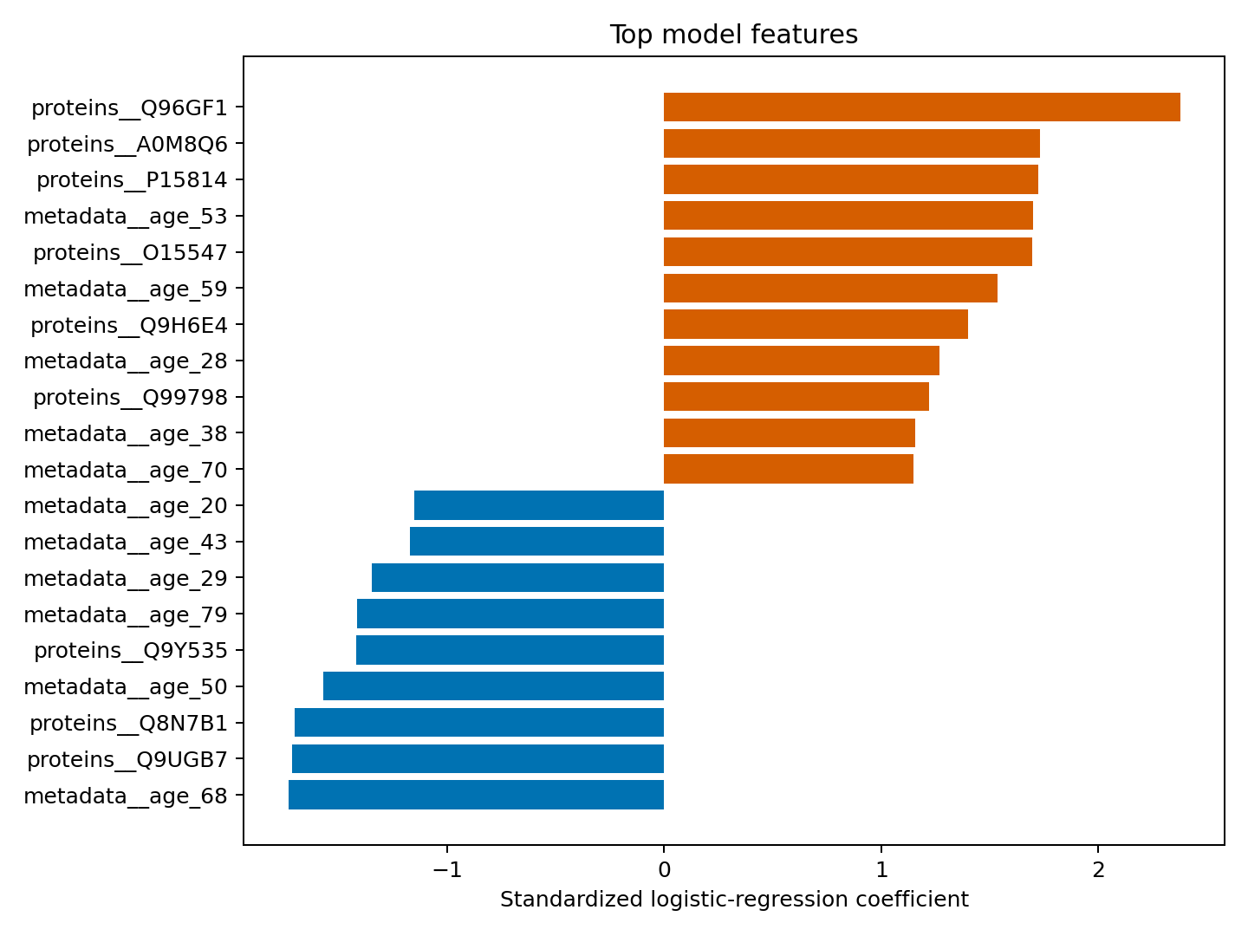
Figure 2. Largest logistic-regression feature coefficients.
Figure 2 is a horizontal bar chart of the 20 largest absolute logistic-regression coefficients. The horizontal axis is the standardized coefficient: bars to the right increase predicted case probability, while bars to the left decrease it; the vertical axis lists proteins or covariates. Longer bars indicate stronger model association after adjustment for the other features, but they are not p-values and should not be called statistically significant without confidence intervals or a formal multiple-testing procedure.
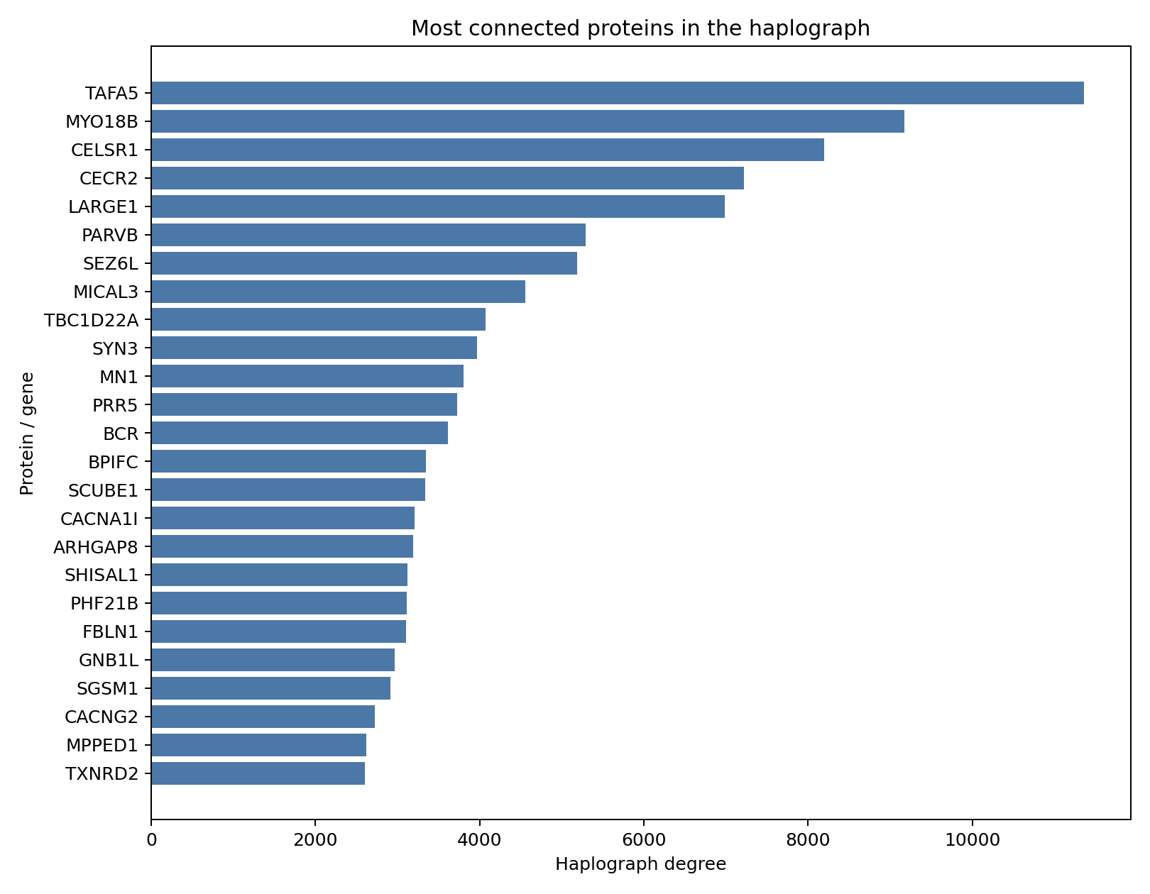
Figure 3. Most connected proteins in the haplograph.
Figure 3 is a ranked bar chart of the most connected proteins. The horizontal axis is haplograph degree, meaning the number of annotated haplograph edge records associated with each protein, and the vertical axis lists the protein or gene symbol. A longer bar means greater network connectivity; it does not mean higher expression or stronger disease prediction, and no statistical significance test is shown.
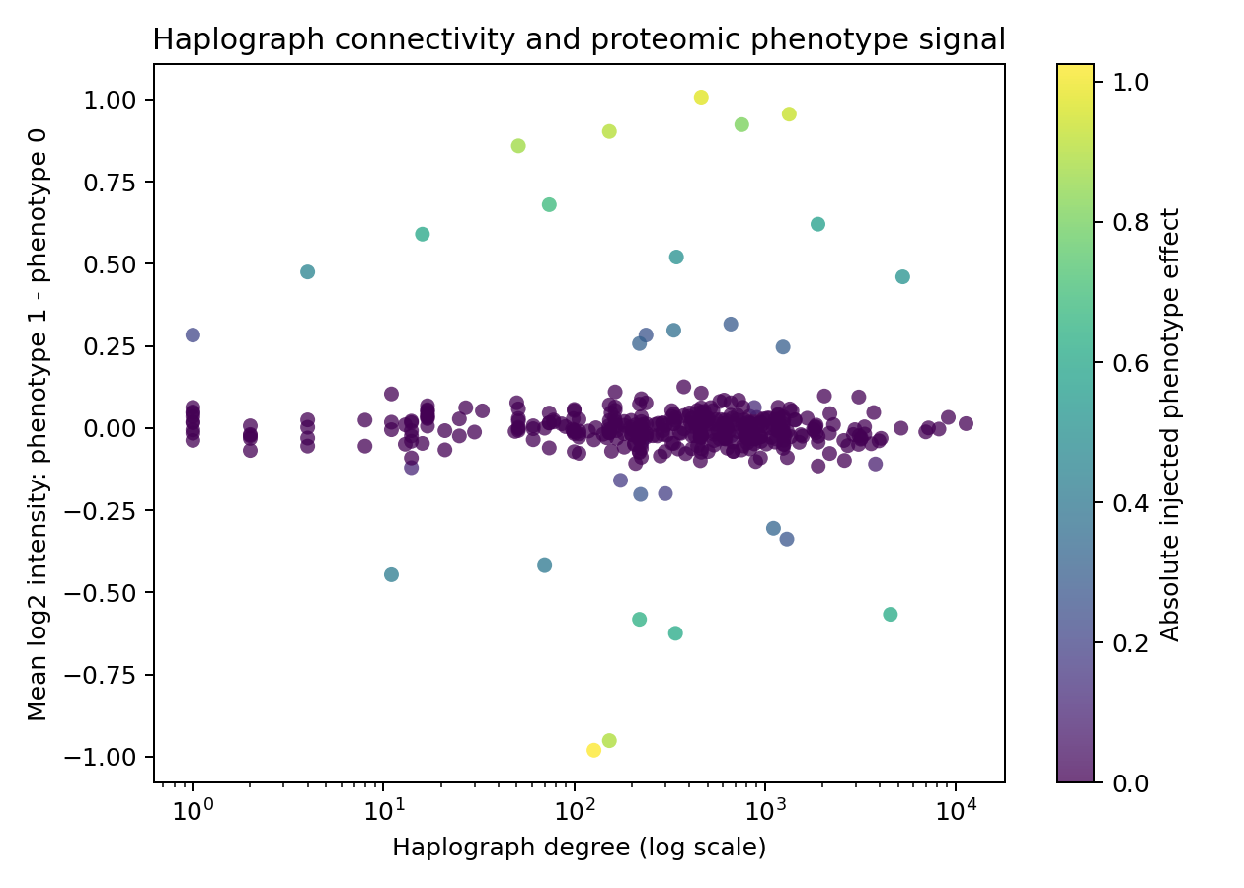
Figure 4. Haplograph connectivity versus proteomic phenotype signal.
Figure 4 is a scatter plot linking graph structure to measured proteomics. The x-axis shows haplograph degree on a logarithmic scale, so equal distances represent multiplicative rather than equal changes in degree; the y-axis shows the mean log2 expression difference between phenotype 1 and phenotype 0. Each point is one protein. Point color represents the absolute injected phenotype effect, with stronger color meaning a larger simulated effect. The plot is exploratory: the color scale is not a significance test, and the observed relationship is not interpreted as significant without a prespecified statistical test and confidence interval.
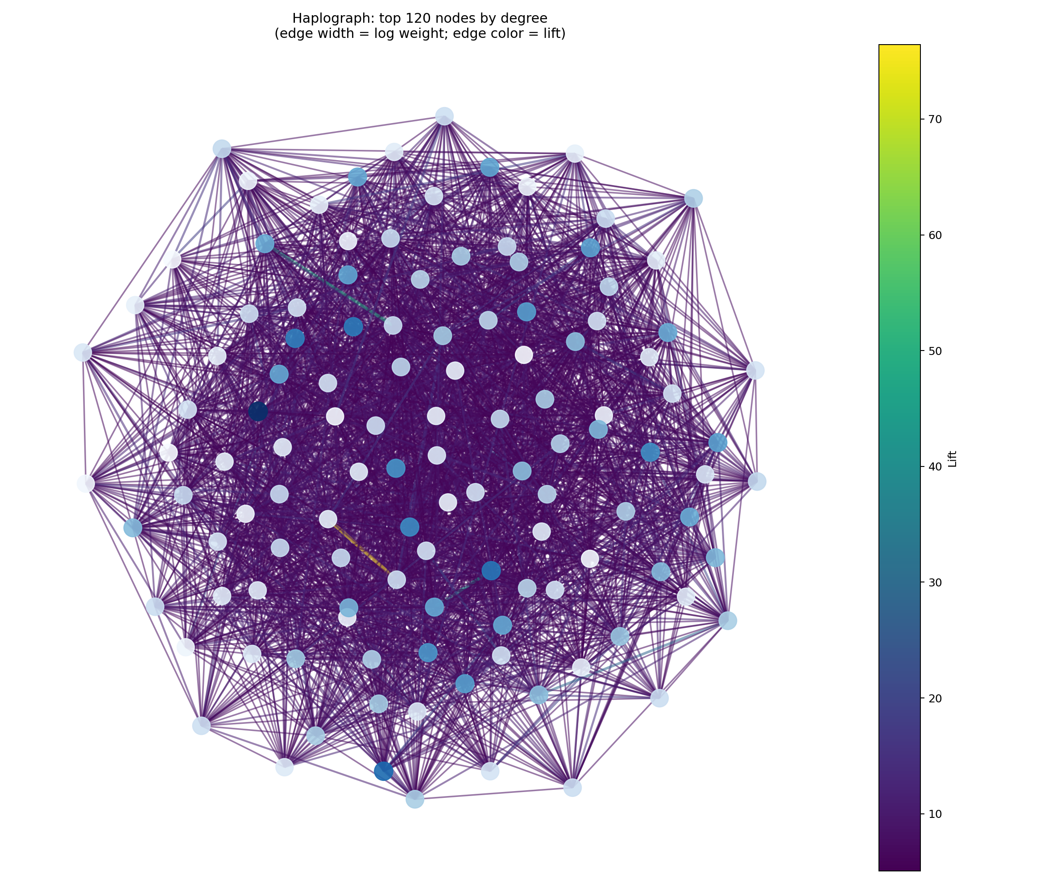
Figure 5. Haplograph-only network.
Figure 5 is a network drawing of the highest-degree haploblocks, selected to make the large graph readable. Each circle is a haploblock node; larger circles mean higher degree within the selected subgraph. Lines are co-occurrence relationships: thicker lines mean larger co-occurrence weight, and greener/yellower lines mean higher lift, or stronger enrichment above chance expectation. Lift greater than 1 indicates more co-occurrence than the independence expectation, but this figure does not display p-values or confidence intervals.
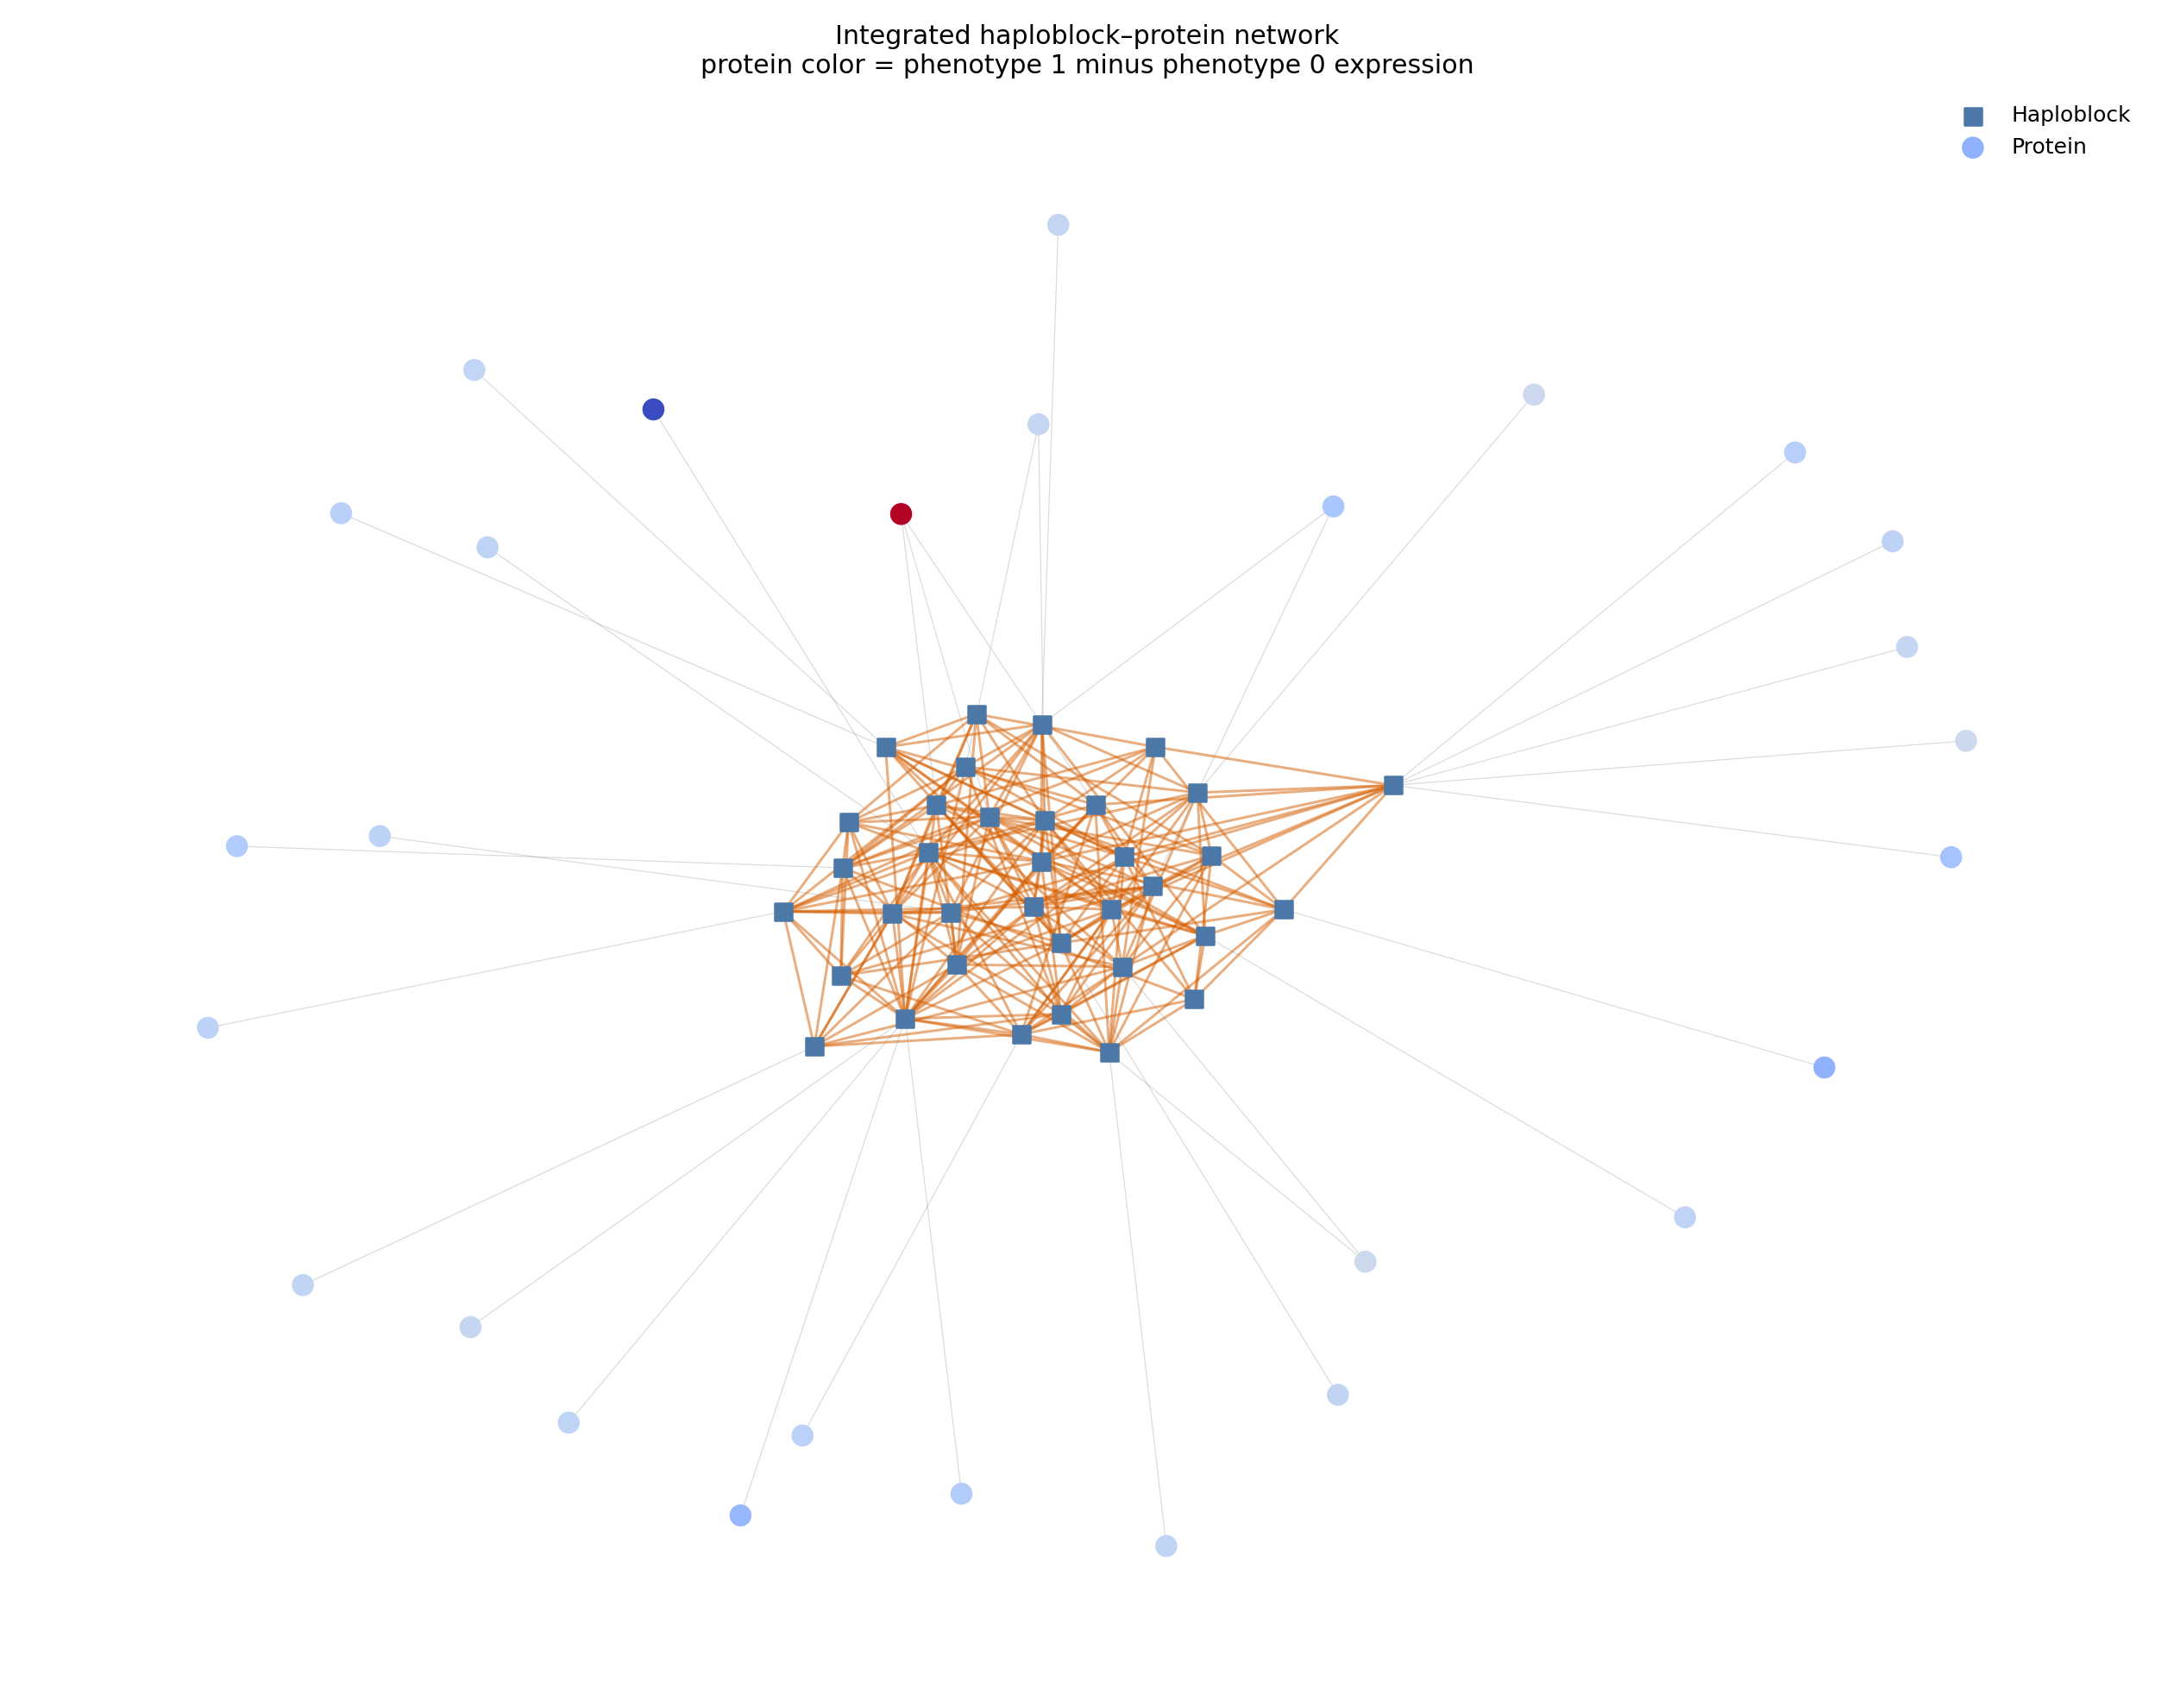
Figure 6. Integrated haploblock–proteomics network.
Figure 6 is the integrated haploblock–proteomics network. Squares are haploblocks and circles are proteins; grey lines show that a protein maps to or overlaps a haploblock, while orange lines show haploblock co-occurrence. Protein color represents the difference in mean log2 abundance between phenotype groups, with opposite colors indicating opposite directions of difference. Node colors and line widths are visual encodings, not tests of statistical significance; they show how genomic connectivity and proteomic signal can be viewed together.
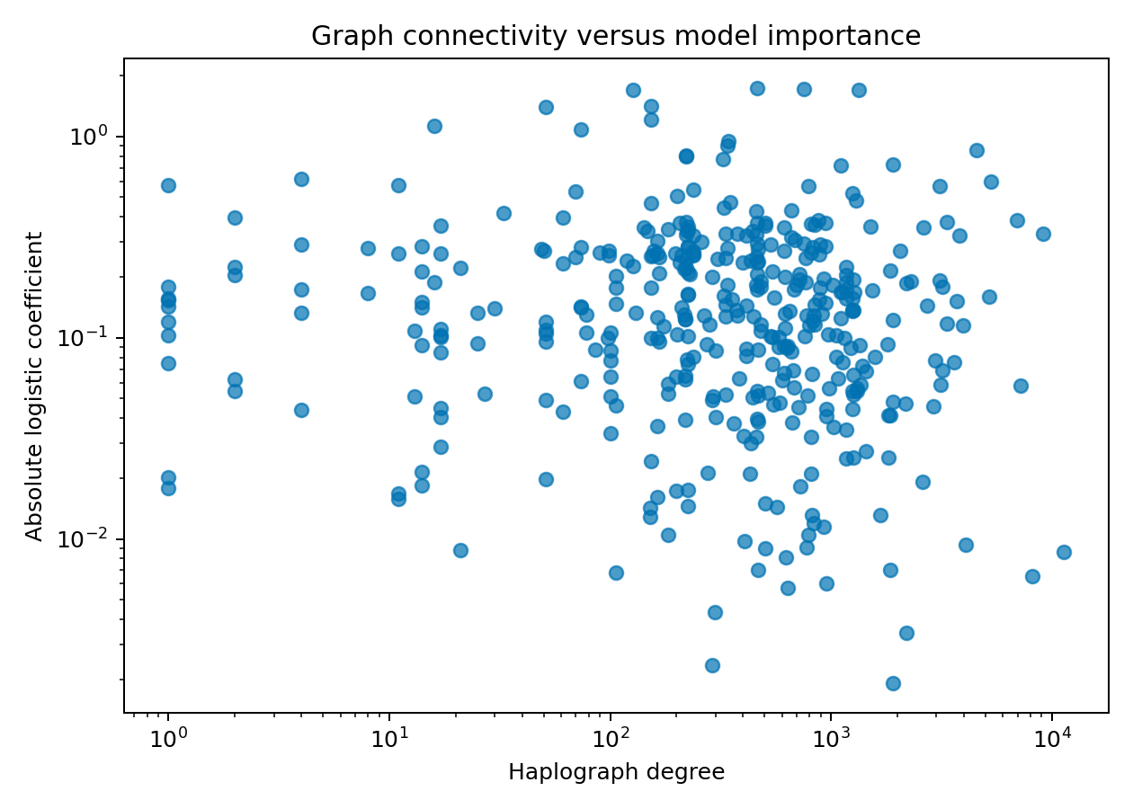
Figure 7. Graph connectivity versus logistic-regression importance.
Figure 7 compares network connectivity with predictive importance. The x-axis is haplograph degree on a logarithmic scale, and the y-axis is the absolute standardized protein coefficient from logistic regression, also shown on a logarithmic scale; each point is one matched protein. Points farther up have stronger model influence regardless of direction, while points farther right are more network-connected. The weak correlation and only 2-of-20 top-protein overlap indicate different rankings, but this plot alone does not establish statistical significance.

4. Reproducibility
The analysis scripts are scripts/analyze_proteomics.py, scripts/build_knowledge_graph.py, scripts/plot_haplograph_comparison.py, and scripts/run_pyg_comparison.py. Generated metrics, tables, figures, and the annotated haplograph input are stored under proteomics/ and haplograph/.

