Our project uses a linked list backend to keep track of website history. To run the program, you must download the .zip file on GitHub in the main repository and once downloaded you must unzip it.

Inside of the folder that is created after unzipping, there is a file called 303project. This file is a .app file and can only open on mac (and possibly Linux but unsure) operating systems.

After clicking on that file, the GUI should open and you will find buttons to add, remove, sort (A-Z), sort by date, archive and export.

To use the program, you start by adding URLs to the web history using the add button. To remove an item from the history, you select it from the list and then click the remove button. Sorting the list alphabetically is done with the sort (A-Z) button. Sorting by the date the URLs were added to the list (pulled from system time when the URLs were added) is done with the sort by date button. To archive the list, you can click archive and it will store your history in a separate linked list. Finally, the export button will write the website history into a .txt file called ExportList.txt which you will find in your documents folder.

The required functionalities were add, remove and display. The functionalities we added were the sort, archive and export functionalities.

The GUI was made with a program called QT creator (open source) where each button click corresponds to a function call from the backend linkedlist.h/linkedlist.cpp files. The linkedlist uses a website class as the data type for each node. Each website object is made of the URL (a string) and the integer values for the year, month, day, minutes and seconds.

The archive function makes a new linkedlist object and stores the current list contents inside it. The sort functions implement merge sort to sort the linkedlist and then the Qlistwidgets on the UI are cleared and refilled by adding the contents of the linkedlist to them. The export function finds the path to your documents folder and opens a file stream to write the contents of the linkedlist to a .txt file.

You can find screenshots of the working program below.

Screenshots:

GUI:

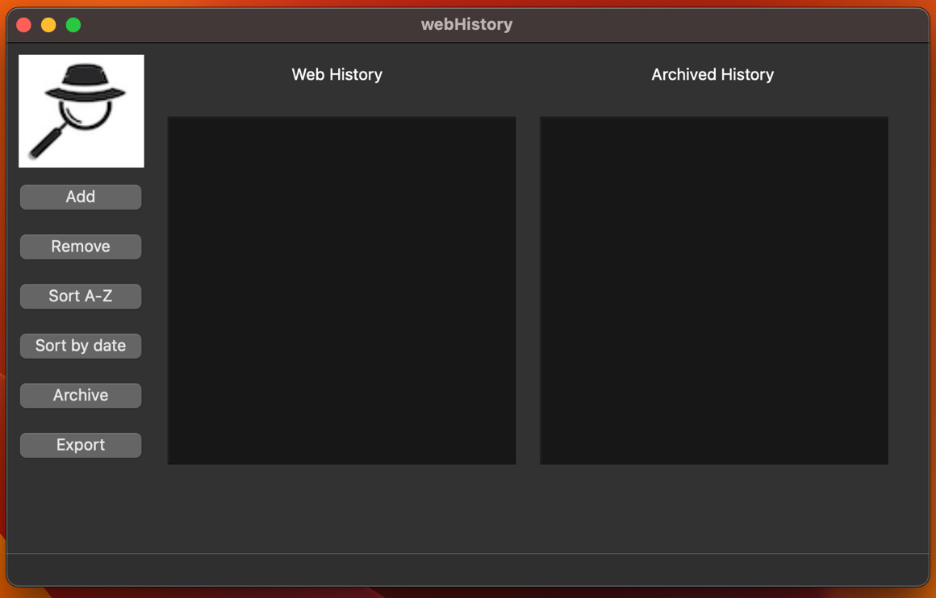

Add button clicked:

Sites added:

Selecting a site to remove (clicking remove will remove selected site):

Sorting the history (A-Z):

Archiving the history:

Exporting the history to a .txt file in documents folder:

