**INTRODUCTION**

Kickstarter is known to be one of the most popular crowdfunding service.

Crowdfunding is a way for people, businesses and charities to raise money, and it works through individuals or organizations who invest (or donate to) crowdfunding projects in return for a potential profit or reward. (Money Advice Service, UK)

Kickstarter projects start with beginning a campaign, establishing the minimum funding goal, deciding the reward criteria, and campaign deadline. Kickstarter crowdfunding service follows an all-or-nothing model; if a campaign fails to meet the funding goal, no funds are received.

**ANALYSIS**

The total funding goal and the total pledged amount for the entire project was calculated to be 295,956,469.8 USD and 46,173741.66 respectively; the pledged amount representing 15.6% of the funding goal. This could be misleading because some of the projects were cancelled, while others were still live at the deadline date of the project.

A better analysis could be done focusing on the outcomes of the projects, either successful or failed.

*Chart 1. Pivot Chart showing percentages of successful and failed project, per project category*

There were more successful projects (59%) in reference to failed projects (41%). Kickstarter indicates that, “as of November 10,2020, the success rate of fully funding a project on the crowdfunding website was 38.21 percent.” (<https://www.statista.com/statistics/235405/kickstarter-project-funding-success-rate/>). On this premise alone, the entire project could be deemed successful.

Music achieved a success percentage of 82, whiles theater, and film & Video achieved 63 percent success each, which are greater than the average success rate of all successful and failed projects.

Successful projects had on the average, more backers (123.87) than failed projects (17.71). Comparing these averages to the above percentage calculations for either outcome indicates a direct relationship between number of backers and project outcome. However, the backers count for the failed projects looks smother than for successful projects which has an outlier of 20,242, jumping from 3,355 backers. The single outlier accounted for an 18.87 increment of the average number of backers for successful projects.

*Chart 2. Scatter chart showing the Median, Mean, Maximum, Minimum, Variance and Standard Deviation values of successful and failed projects*

What else accounted for the outcomes of the projects? Could it be attributable to the project campaigners’ activities or time length for promotion?The dataset did not indicate the number of times each project was updated which would have been associated with campaigners’ activities. However, both successful and failed projects had the same average of number of days (approximately 33 days) between project launch and deadline.

Therefore, the success or failure of a project could not be attributed to timespan between launch and deadline.

A key characteristic with successful projects, as shown by chart 3 below is that, with few exceptions, the percentage per successful project decreased with increasing goal amount, whiles the percentage of failed and cancelled projects increased with increasing goal amount.

**LIMITATIONS**

The dataset was narrow as far as timespan is concerned. It will be important to analyze several crowdfunding events using the kickstarter service to understand whether different months had different impact on projects.

The sample size was not large enough to statistically produce relevant results for the categories and subcategories of projects

|  |  |  |
| --- | --- | --- |
| **Measures** | **Successful** | **Failed** |
| Median | 50 | 4 |
| Mean | 123.87 | 17.71 |
| Min | 1 | 0 |
| Max | 20242 | 1293 |
| Variance | 426811.17 | 3773.22 |
| Standard Deviation | 653.31 | 61.43 |

*Table of statistical measures*

The data contained outliers for count of backers which affected the mean and median values. The standard deviation of 653.31 for successful projects with a mean of 123.87 gives us a coefficient of variation, CV to be equal to 5.27. The CV of failed project also equals 3.47. These two CVs are all greater than 1 and this indicates a wide variation in the data points.

The interquartile range values for successful and failed projects have been calculated to be 75.00, with a median of 50.00 and 11.00 with a median of 4 respectively. The middle values for successful projects are widely spread out than those of failed projects.

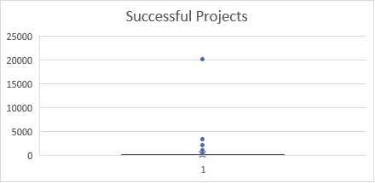

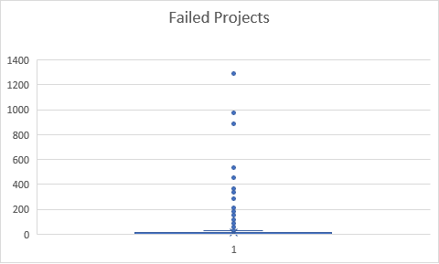

From the above, the outliers in the successful campaigns skews the mean to the right. The median in considered in relation to the interquartile better summarize the data more meaningfully.