Login to IBM Cloud (http://console.bluemix.net).

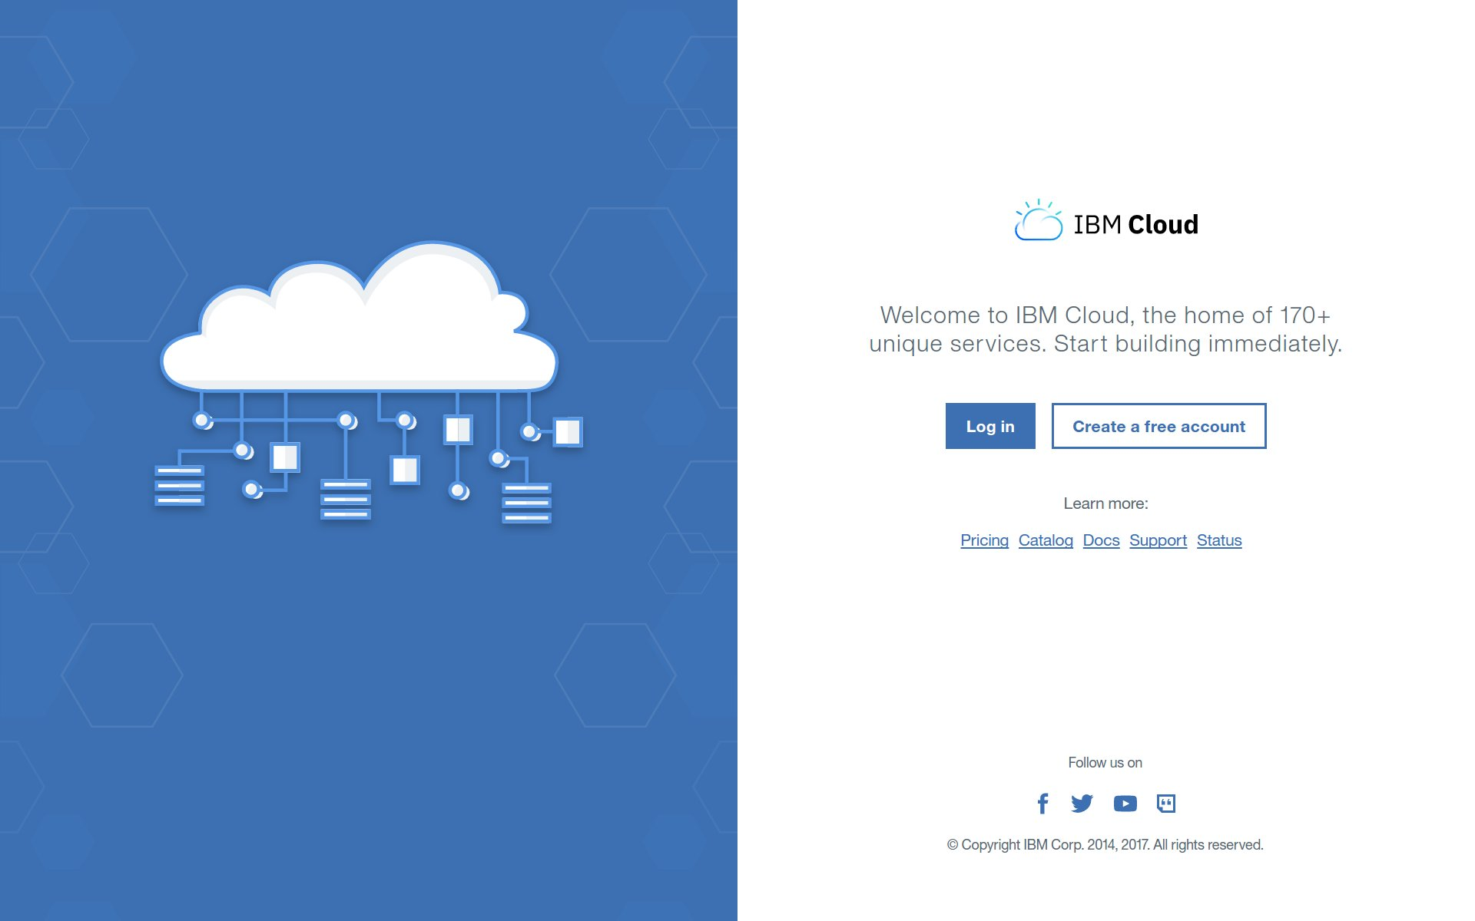

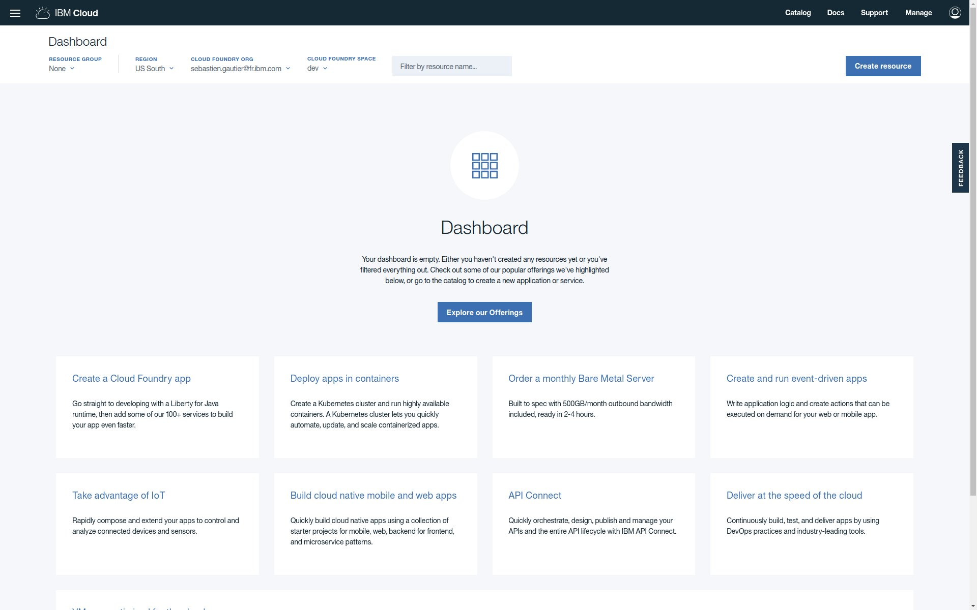

From Dashboard go to Catalog.

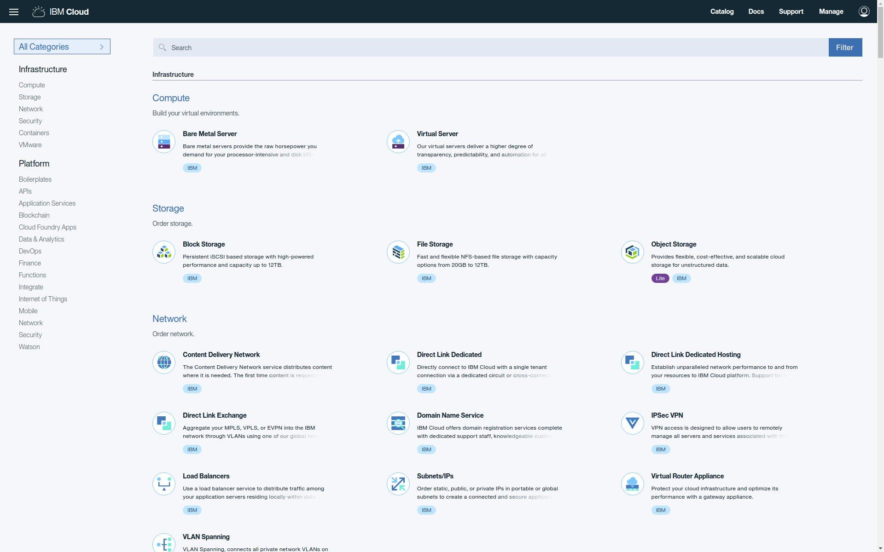

Reach Watson services.

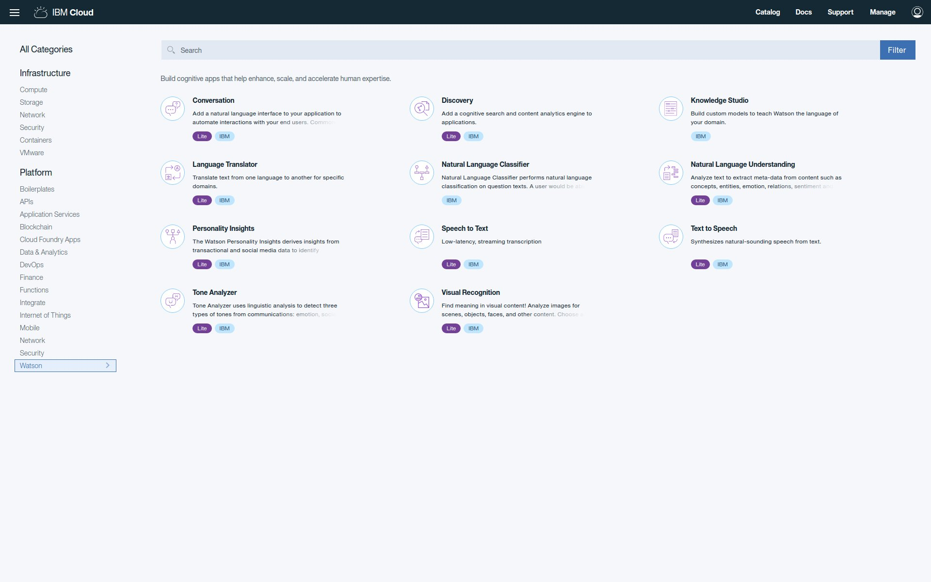

Create Tone Analyzer service ta0.

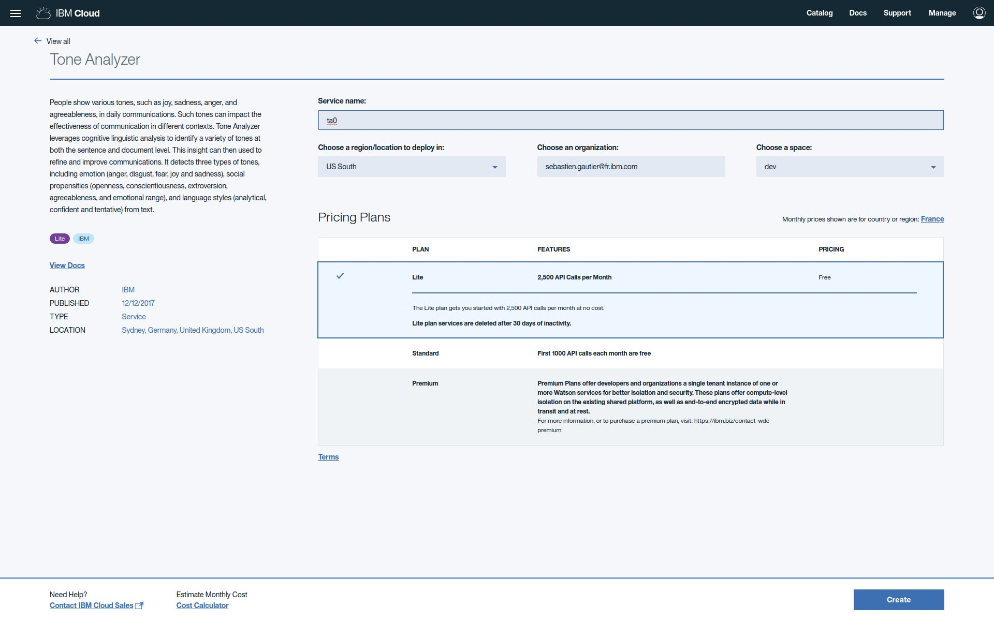

Create Tone Analyzer credential user0.

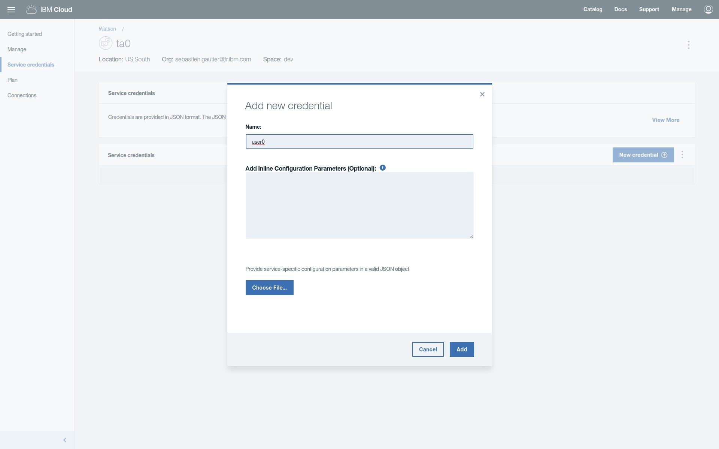

Create Natural Language Understanding service nlu0.

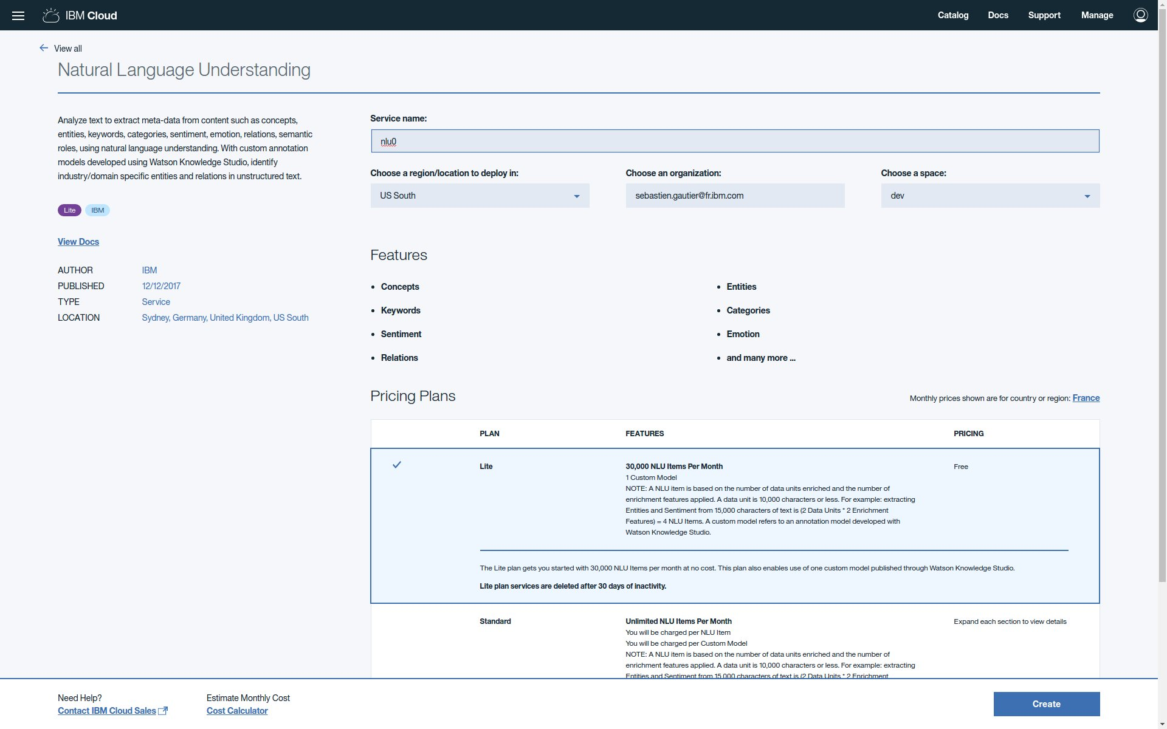

Create Natural Language Understanding credential user0.

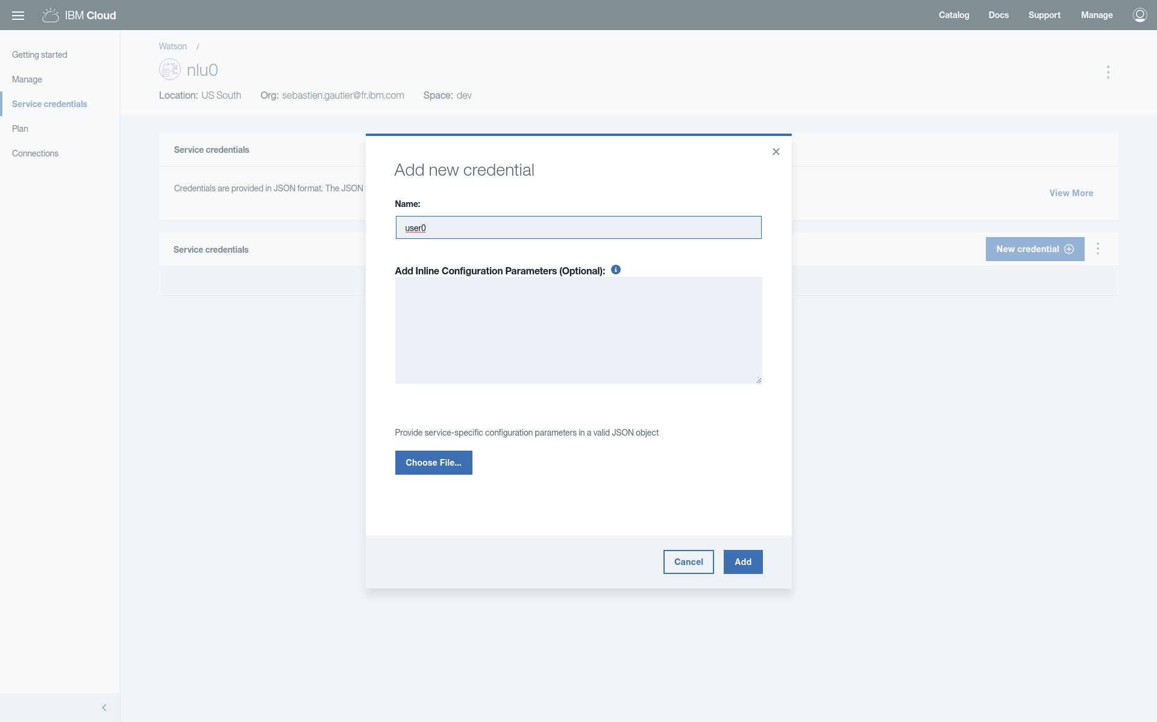

Create Discovery service dsc0.

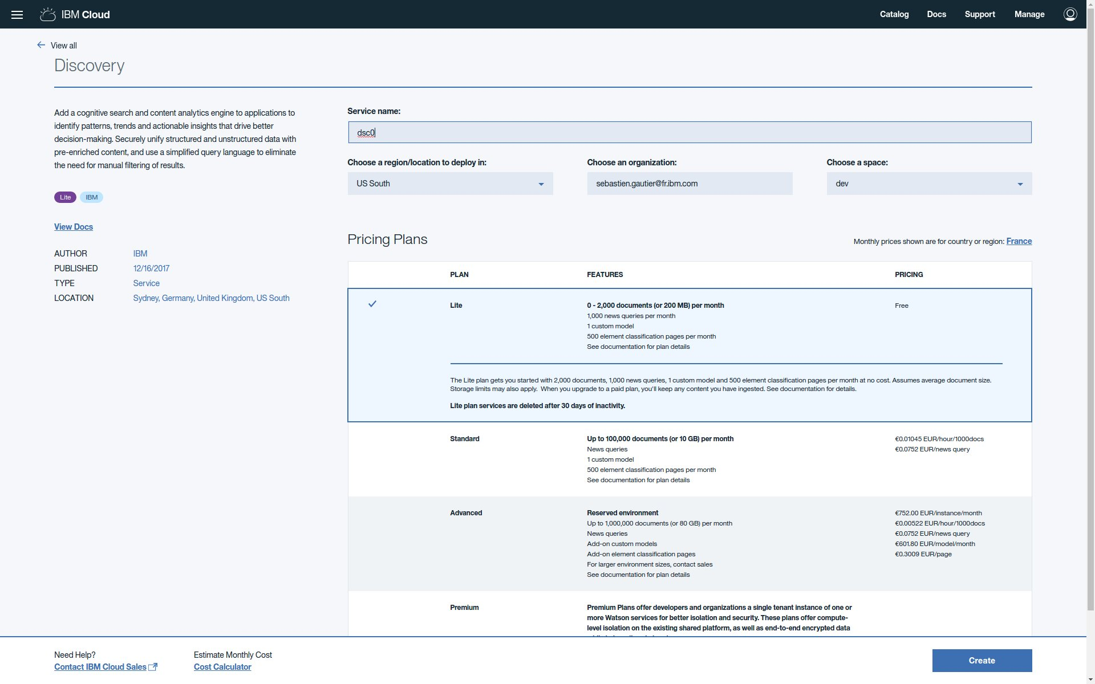

Create Discovery credential user0.

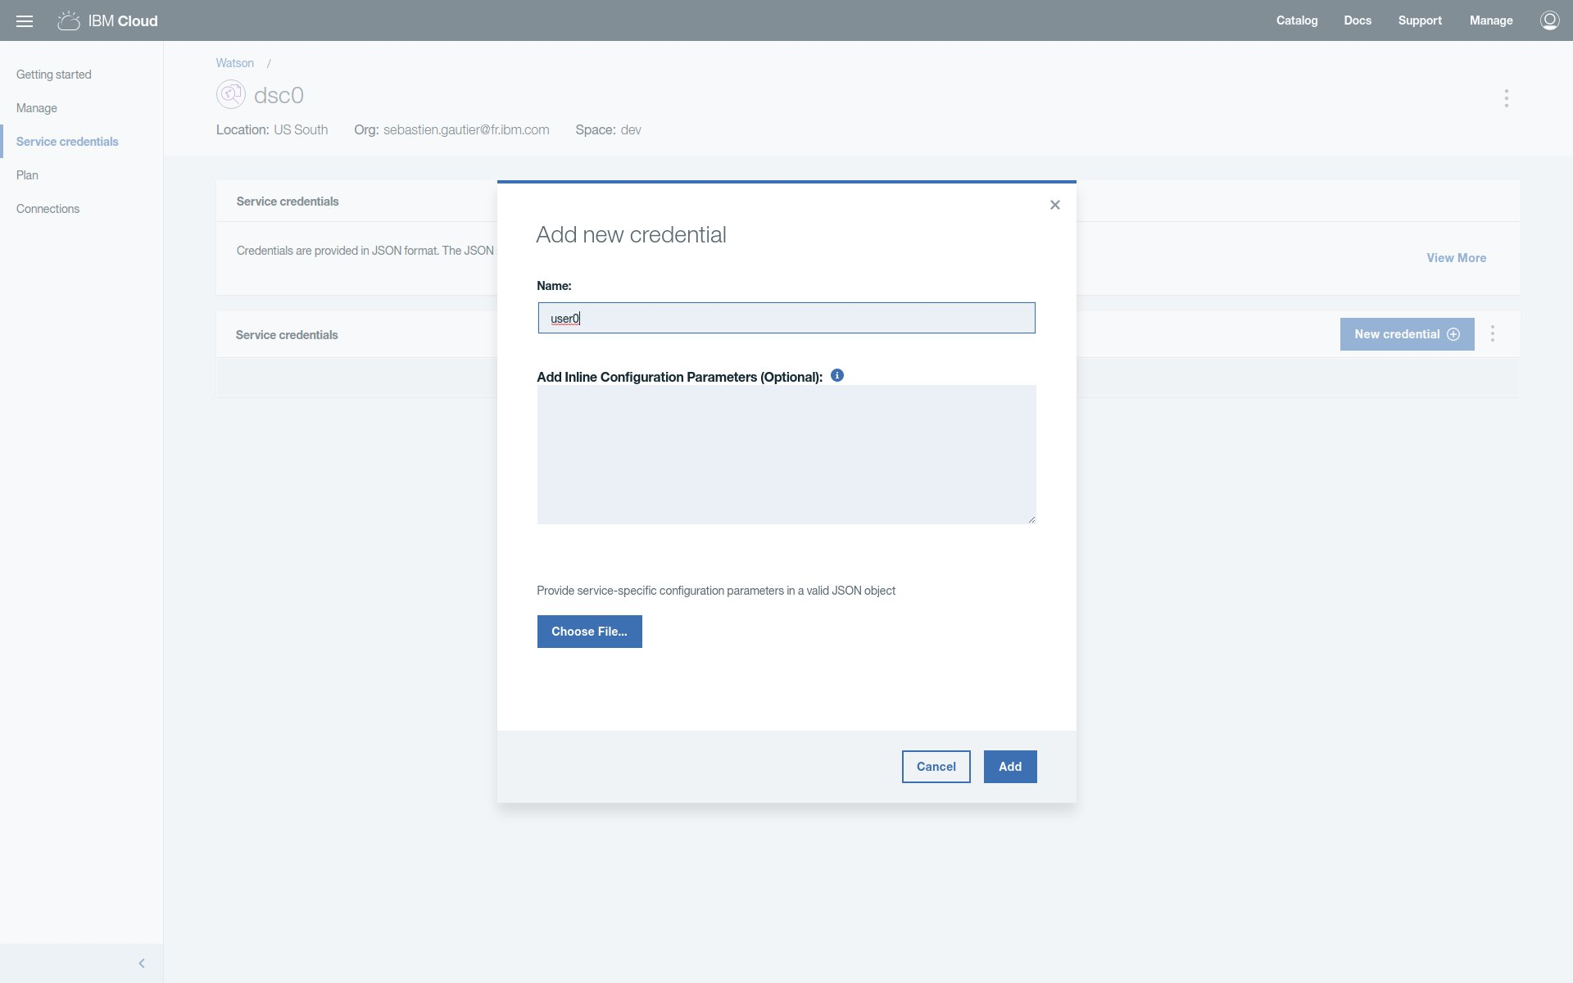

Launch Discovery Tools.

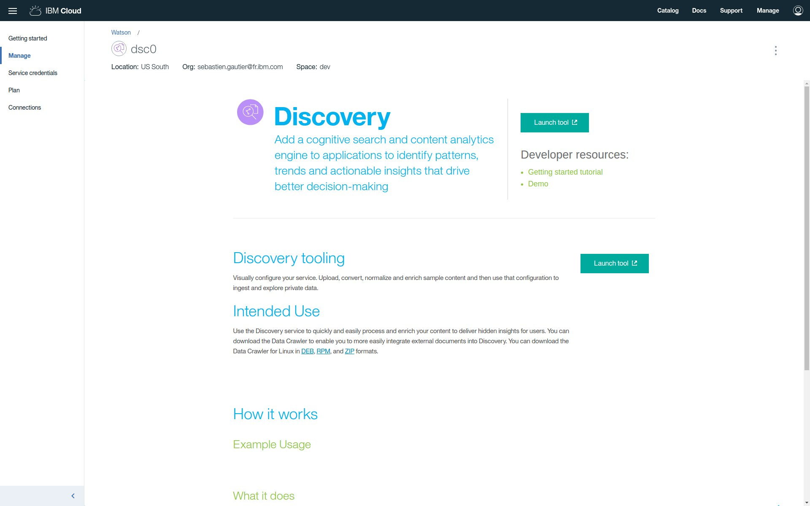

Create a Discovery collection coll0.

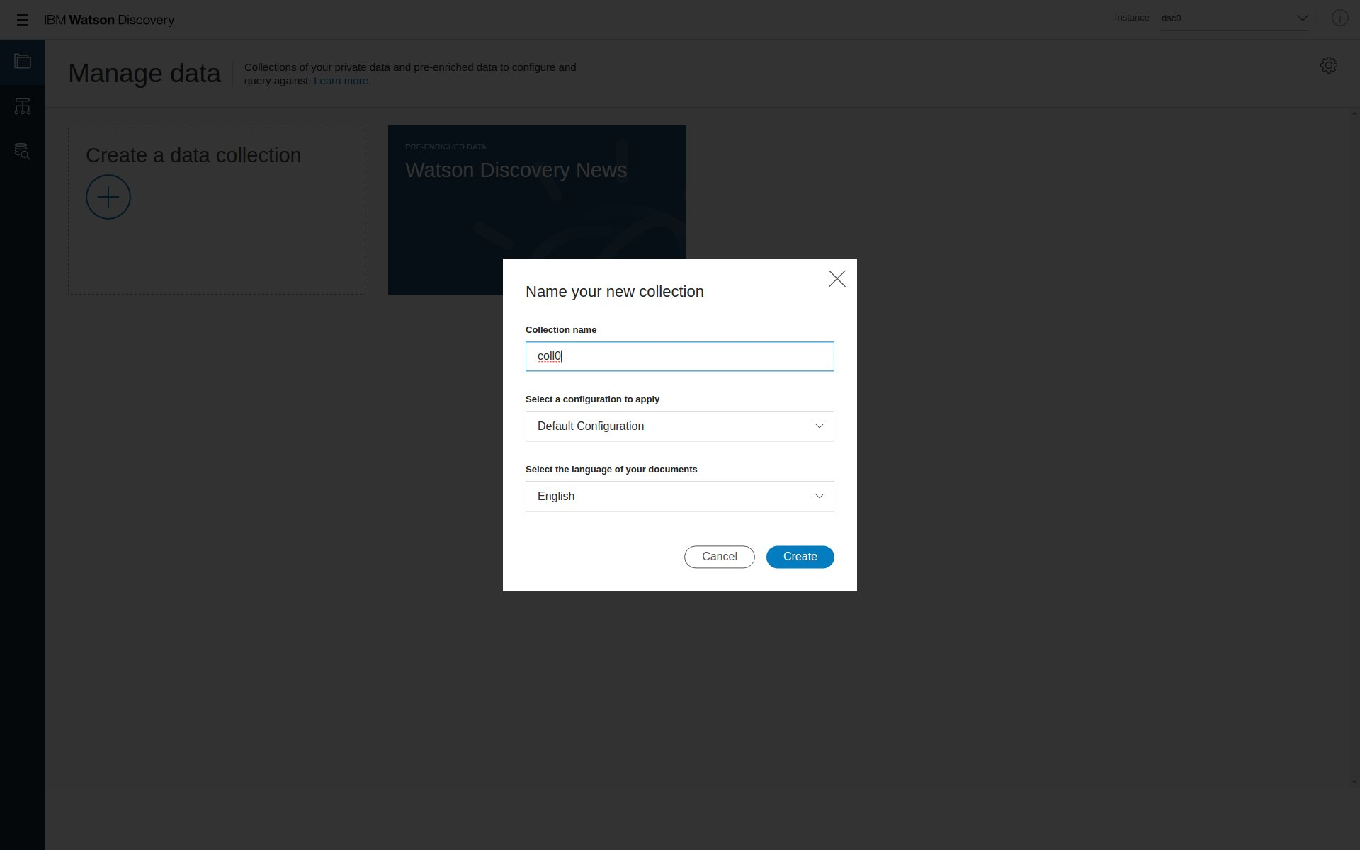

Create Visual Recognition service wvc0.

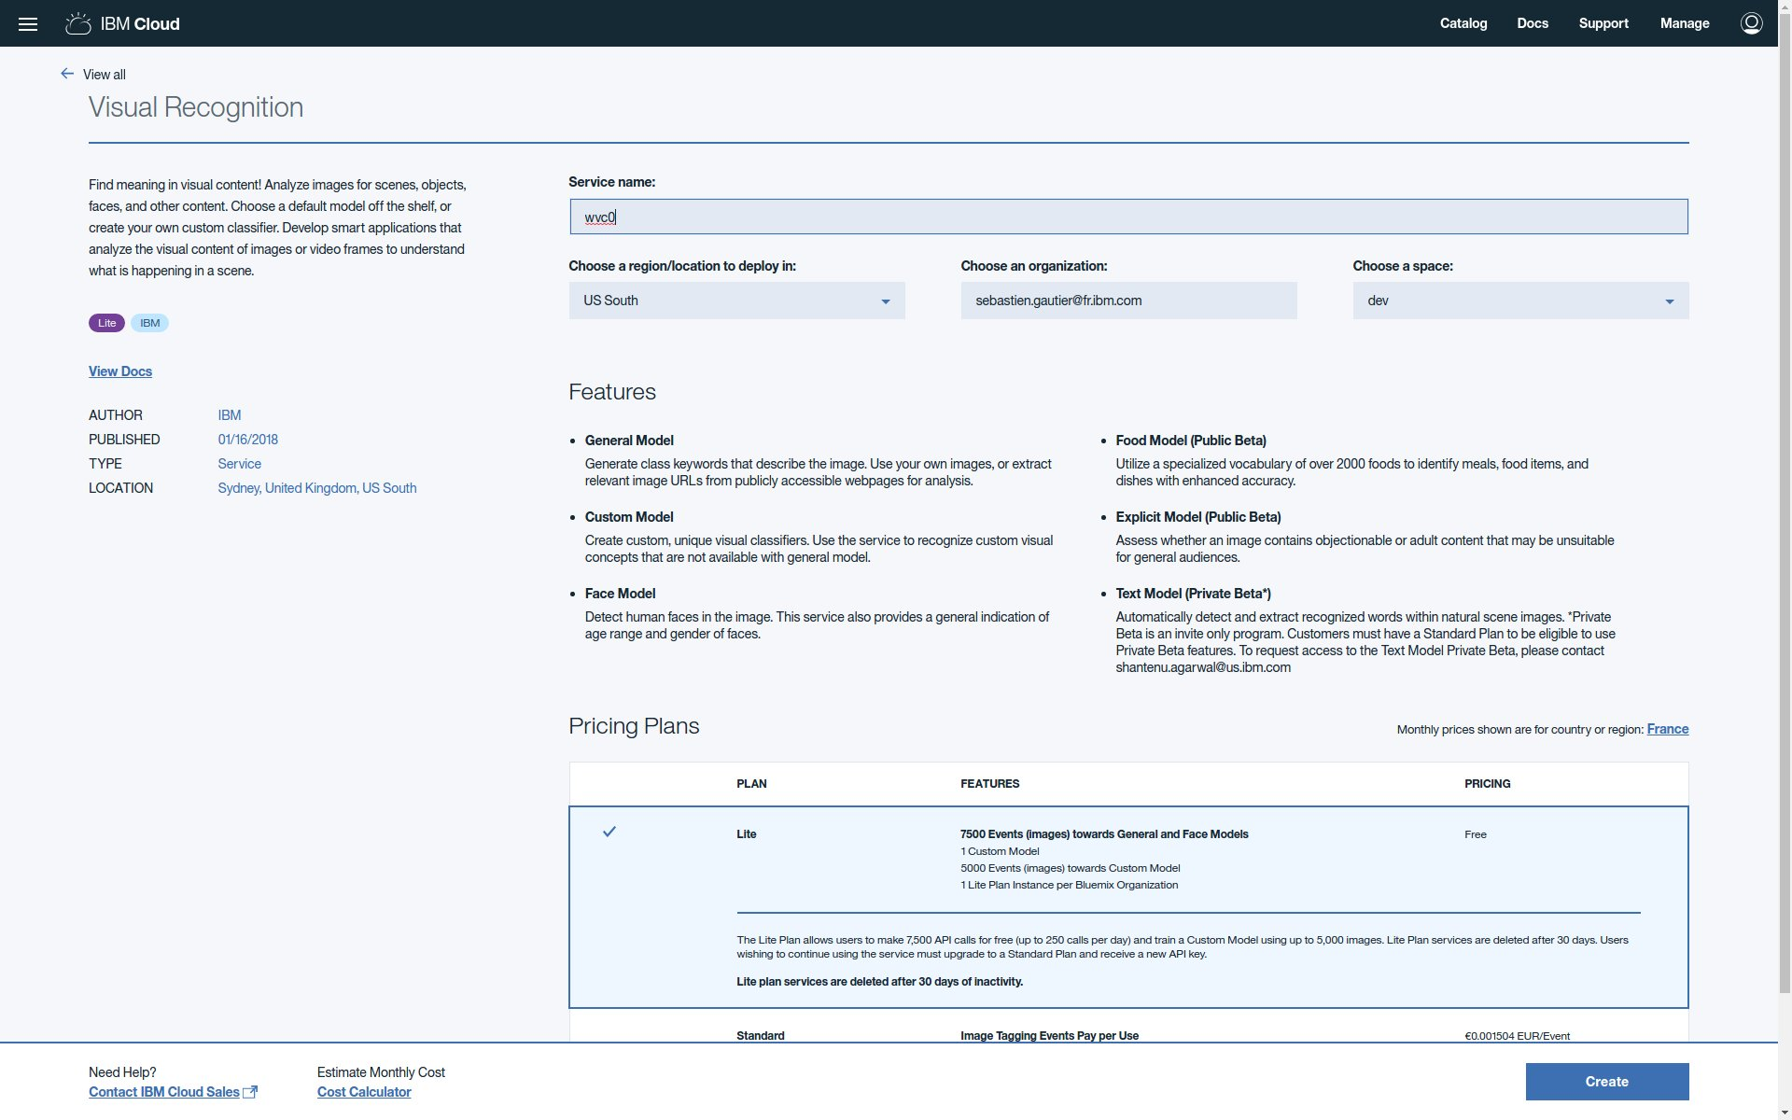

Create Visual Recognition credential user0.

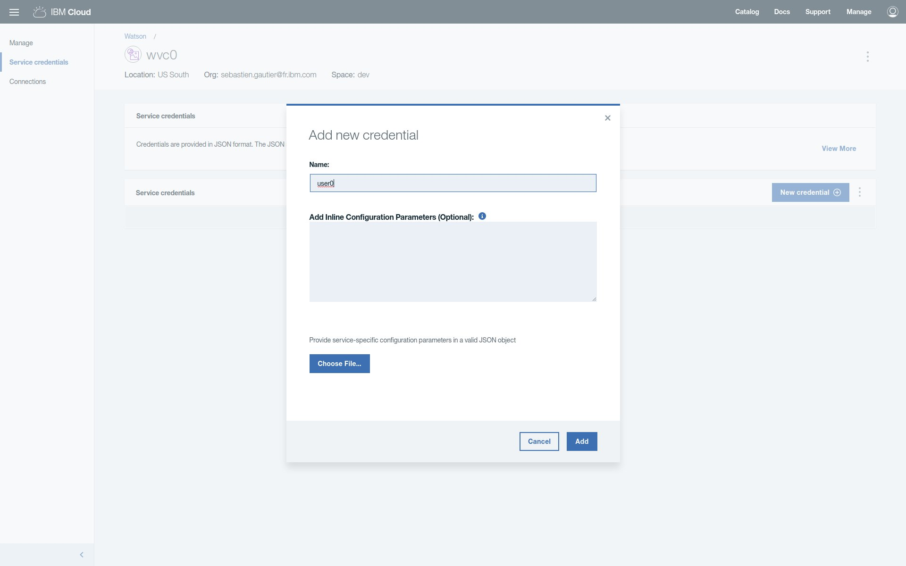

Check all services (ta0, nlu0, dsc0 and wvc0) are created in dashboard.

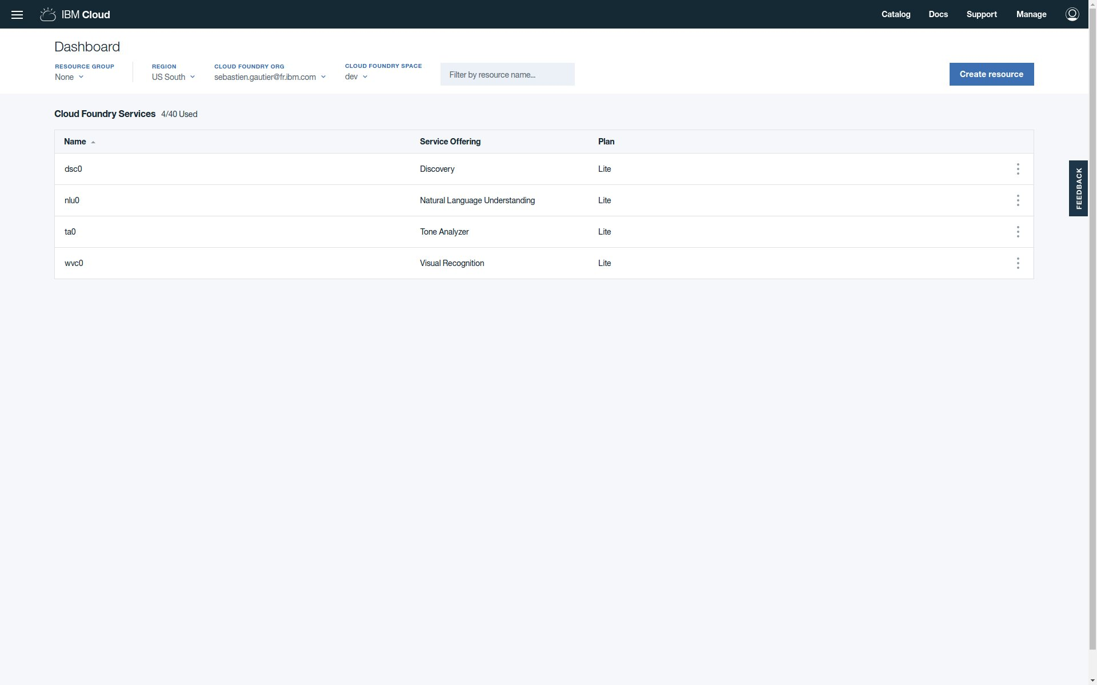

You're done with environment setup.