

collective Minds

**You,**

**The People!**

w h i t e p a p e r

A historic art collection that portrays an artificial intelligence thoughts on humanity’s sentiment.

Copyright © collective Minds 2022

Abstract

We are living at a period in history that has been dominated by the tyranny of disinformation. Never in modern times have our peoples been ruled by such totalitarianism of ideas and forced into accepting national and class ideologies, state ideocracies, personal ideomanias and ideophobias.

Our planet has been shrouded in a thick fog that obscures from our view the private and corporate interests shaping political, economic, social, administrative, pedagogical and religious principles. Those who are brave enough to search for the truth are quickly discredited, cancelled and declared enemies of state.

The truth however is out there. There can be no truer truth about the world than human sentiment: The psychological state reflecting our most deeply rooted hopes, fears, beliefs and ideas. And for being such a pure indicator of our inner selves, sentiment mining emerged as a technology that is covertly being used to measure and impose new forms of control of information.

With the objective of making sentiment data more widely available, Collective Minds have used state-of-the-art artificial intelligence to undertake the most comprehensive investigation of human sentiment ever attempted. This AI analysed the sentiment in 250 countries and territories across the world, and represented its findings in the universal language of **art**.

We are now making these artworks available for the world. In order to protect them against any form of censorship, these have been published into a blockchain in the immutable and anonymous format of Non-Fungible Tokens (NFTs) as the digital art collection that we call:

You, the People!

Contents

**Market Overview 4**

**AI Art 5**

**You, the People! 7**

**Tokenomics 8**

**Roadmap 9**

**Technology 10**

**About 11**

**References 12**

**Disclaimer 13**

Non-Fungible Tokens (NFTs) are blockchain-based digital items whose units are designed to be unique, unlike traditional cryptocurrencies whose units are meant to be interchangeable. NFTs can store data on blockchains and that data can be associated with files containing media such as images, videos, and audio, or even in some cases physical objects. NFTs typically give the holder ownership over the data, media, or object the token is associated with, and are commonly bought and sold on specialised marketplaces (Chainalysis, 2022).

By the end of 2021 the market for NFTs reached to $11 billion, a huge boost to the conventional arts market sales of $61 billion in that year. The top-tier art dealers Sotheby’s and Christie’s sold $230 million in NFTs in 2021, and in March Christie’s sold Beeple’s *Everydays: the First 5000 Days* – the first piece of purely NFT artwork to be offered by a major auction house – for $69.3 million (Art Basel & UBS Report, 2022). In December 2021, *The Merge*, a collection of over 300k NFTs by Pak, was sold-out in 48 hours for $91.8 million on the Nifty Gateway marketplace and is thus far the most expensive NFT collection ever sold.

NFTs have provided sudden and impressive income for artists who have been early adopters. This is very promising for artists that have yet to participate in this market, especially because art has always been an excellent investment for people and are often part of a diversified investment portfolio.

# Market Overview

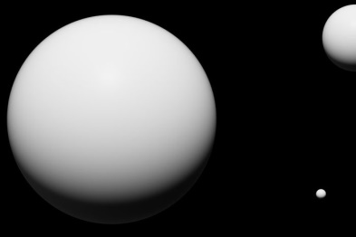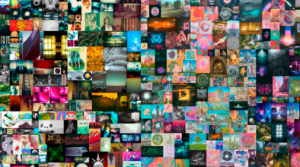

Figure 1 – *Everydays: the First 5000 Days*, by Beeple

Figure 2 – Example of NFT from *The Merge* collection*, by Pak*

# AI Art

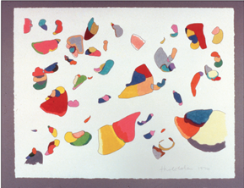

“ *I have little doubt that we will be able to produce machines and computer programs that will behave in the fashion that we speak of as intelligent. Where my doubt comes in is whether we shall be able to produce machines capable of creative thinking.* ”

— Jerome S Bruner, Harvard 1960

For 50,000 years, artistic expression has been unique to mankind. Today, this hallmark of humanity is being claimed by technology. Despite the fact that computer programs such as AARON by Harold Cohen (Figure 3) have being used since the 1970’s it was only since 2014 that AI art started to gain popularity with the appearance of GANs.

GANs – Generative Adversarial Networks – is a class of machine learning frameworks for which given a training set, it learns how to generate new data with the same characteristics as the training set. For example, a GAN trained on photographs can generate new photographs that look at least superficially authentic to human observers, having many realistic characteristics (Figure 4). Beginning in 2017, GAN technology began to make its presence felt in the fine arts arena with the appearance of a newly developed implementation which was said to have crossed the threshold of being able to generate unique and appealing abstract paintings. A GAN system was used to create the 2018 painting Edmond de Belamy, which sold for US$432,500 (Figure 5).

Figure 3 – An early drawing by AARON, 1974 - Coloured in pencil by Harold Cohen



Figure 4 – Photorealistic GAN-Generated Face (Karras, Aila, Laine, & Lehtinen, 2018)

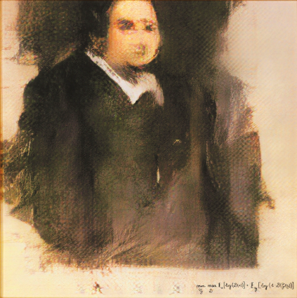

Figure 5 – *Edmond de Belamy* by arts-collective Obvious, 2018

Our project uses an architecture called VQGAN+CLIP (Crowson, et al., 2022), which is an extension of traditional GANs but connects two existing (open-source, pre-trained) neural network architectures: VQGAN and CLIP. This AI can create original, realistic images from a natural language prompt.

* VQGAN: Vector Quantized Generative Adversarial Network (Esser & Rombach, 2021)
* CLIP: for Contrastive Image-Language Pre-training (Radford, Sastry, Askell, Mishkin, & Clark, 2021)

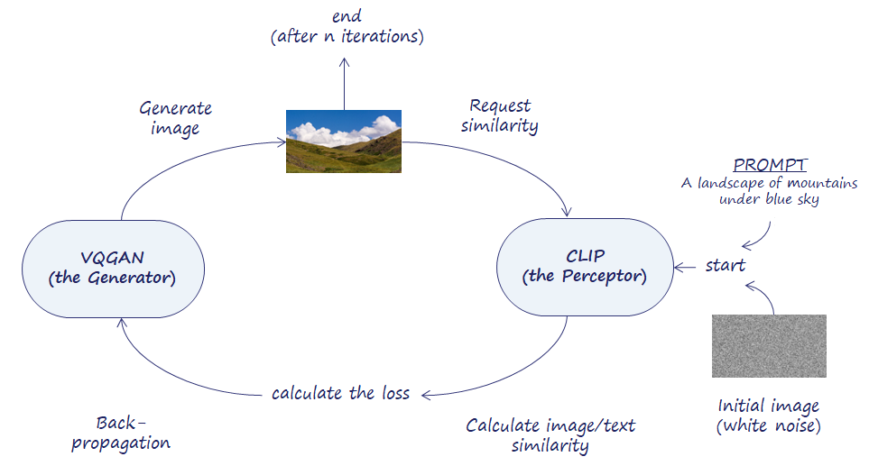VQGAN (the generator) generates the images, while CLIP (the preceptor) judges how well an image matches a text prompt. The connection of VQGAN and CLIP creates a feedback loop (Figure 6) with CLIP guiding VQGAN towards an image that is the best match to a given text. When repeated hundreds of times, this loop leads the architecture to produce accurate images.

Figure 6 - A high level overview of the VQGAN+CLIP architecture

# You, the People!

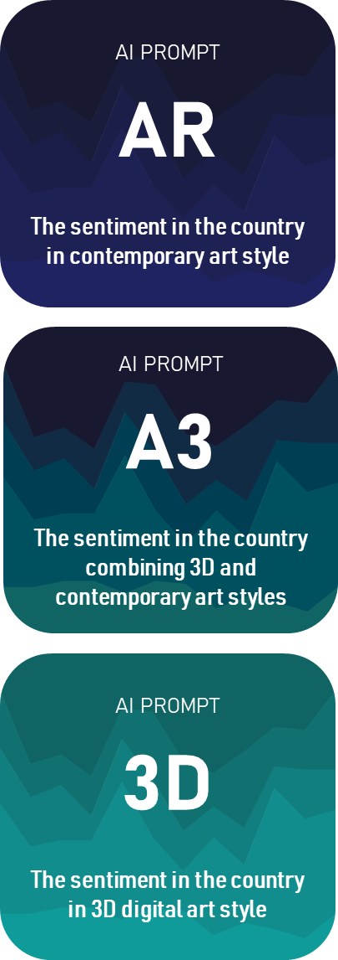

Figure 7 – AI prompts used to create the You, the People! collection

In December 2021 we asked VQGAN+CLIP to create art representing its own thoughts on humanity's sentiment. These historic images of our world are now available as the digital art collection You, the People!

The images in the collection have historical significance, as they were created right at the end of the longest period of peace in Europe, when the world was just getting back to normal after the Covid-19 pandemic and at a moment when AI had evolved just enough to represent its own insight into human condition.

VQGAN+CLIP was given three styles of prompts (Figure 7) and was asked to create one image from each of these three prompts for each of the 250 countries and territories in the world, resulting in 750 unique images.

The revolutionary innovation in this AI is that it is capable of zero-shot learning: That means that it performs exceptionally well on previously unseen datasets. And indeed the AI was able to identify with surprising accuracy a number of social and economic issues in many countries despite not being specifically trained on the subject of socio-economics.

The resulting images clearly show that many countries are being impacted by authoritarianism, climate change, pollution, wild fires and the rise of sea levels along with other events that occur frequently around the world such as over-tourism or social divide between people.

# Tokenomics

|  |  |
| --- | --- |
| **Blockchain platform** | Ethereum |
| **Token** | You, the People! |
| **Symbol** | YTP21 |
| **Standard** | ERC-721 |
| **Smart contract** | 0x6B5CCC5Eb0647B85c195d10D33C1FE0603987418 |
| **Max Supply** | 750 |

The maximum supply of YTP21 is 750. This is a fixed supply, which means that this amount cannot be reduced or increased. Tokens reserved in treasury may be distributed to marketing, advisors, ambassadors, or other project contributors. Public sale of tokens will take place at our website collectiveminds.ai.

**Token allocation**

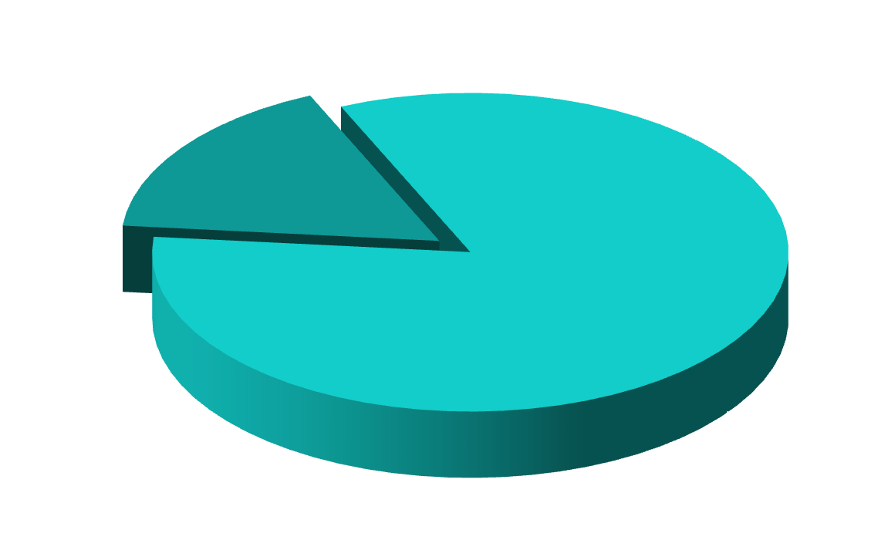

collective Minds

Figure 8 – YTP21 token allocation

# Roadmap

**Launch YTP’21**

VQGAN+CLIP images, smart contract, website, social media and Opensea



collective Minds

**Launch YTP’23**

Includes AI and traditional art galleries, with early access to patrons

**Q3 2024**

**Q2 2024**

**Q1 2024**

**Q4 2023**

**Q2 2023**

**Q3 2022**

**Launch YTP’22**

DALL.E-2 images, smart contract supports charities donations and split sales commissions

**Patrons area**

Dedicated area on website for patrons, with early access to upcoming collections

**Beyond AI art**

Launch of digital gallery for artists in the developing world to publish and sell their art

**Charity and volunteering hub**

Exciting opportunities to get involved with art and help those in need all over the world

# Technology

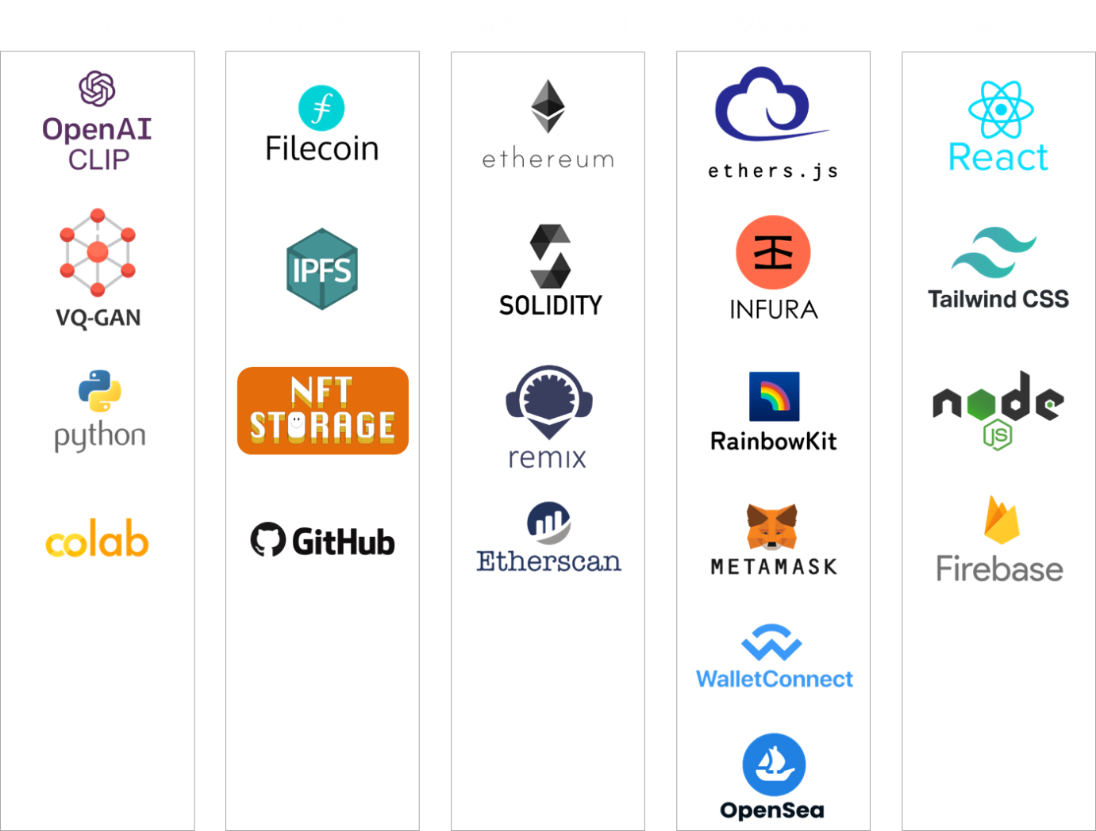

Figure 9 – Project architecture layers

collective Minds

# About



Fabio Hofer is an Oxford graduate in Software Engineering with extensive experience in software development and product management. In 2021 he founded collective Minds to create solutions for the blockchain and artificial intelligence markets. His interest in concepts of the collective unconscious by Carl Jung, the Zeitgeist from 18th Century German Philosophy and the Akashic Record by the ancient Hindu sages of the Himalayas gave origin to the NFT collection **You, The People!**

At Collective Minds we are continuously evaluating the state-of-the-art of AI and will launch new editions of "You, the People!" that will reflect the changes in technology and people's sentiment around the world.

Our objective is to understand the evolving perception that AI has of our world and to make representations of this perception widely available.

We are conscious of the danger of human bias filtering through into AI. We propose to use art as a fun way to investigate if and when this actually happens. We will publish artwork created by artists in different countries alongside AI created art, both meant to represent the ideas and beliefs of people around the world, and will provide a forum to discuss their similarities and differences.

Also, we are reaching out to communities in the development world and facilitating our patrons involvement with local artists, volunteering and charity work.

We are one.

References

Art Basel & UBS Report. (2022). *The Art Market 2022.*

Chainalysis. (2022). *The 2021 NFT Market Report.*

Crowson, K., Biderman, S. R., Kornis, D., Stander, D., Hallahan, E., Castricato, L., et al. (2022). VQGAN-CLIP: Open Domain Image Generation and Editing with Natural Language Guidance. *ArXiv*, abs/2204.08583.

Esser, P., & Rombach, R. a. (2021). Taming transformers for high-resolution image synthesis. *In Proceedings of the IEEE/CVF Conference on Computer Vision and Pattern Recognition*, 12873-12883.

Karras, T., Aila, T., Laine, S., & Lehtinen, J. (2018). Progressive Growing of GANs for Improved Quality, Stability, and Variation. *International Conference on Learning Representations.* Vancouver.

Radford, A. K., Sastry, G., Askell, A., Mishkin, P., & Clark, J. a. (2021). Learning Transferable Visual Models From Natural Language Supervision. *Proceedings of Machine Learning Research, volume 139*, 8748-8763.



collective Minds

# Disclaimer

The above information is non-binding and subject to change. It is intended only to give potential investors and partners insight into the collective Minds business model as it is currently set up. Information in this document also does not constitute a recommendation by any person to purchase tokens, currencies, or any other cryptographic assets. Collective Minds reserve the right to alter the models and information provided in this whitepaper as the business progresses and evolves. Forward-looking statements reflect the views held only as at the date of this Whitepaper.

Copyright © collective Minds 2022