

Guiders hub

B00637513



2016 - 2017

Colleen McConnell

Course: Computing Science

Mentor: Dr Fiona Browne

Table of Contents

1. **Literature Review** 1
   1. Introduction 2
      1. Project background
      2. Project Aims and objectives …………………………………………….…… 2
   2. Market Research and existing solutions **4**
      1. Interview with current guide leader
      2. Survey
      3. Current applications
      4. Requirements format
   3. Mobile web versus Native mobile applications 5

1.3.1 Mobile websites versus Native mobile applications

1.3.2 Benefits of a mobile websites

1.3.3 Benefits of an native mobile application

1.3.4 Conclusion

* 1. Technical solution 6
     1. What is a RIA? ………………………………………………
     2. RIA vs. traditional Web application …………………………
     3. Framework comparison table ……………………………….
     4. Bootstrap ………………………………………………………
     5. Languages used
     6. Client side
     7. Server Side
     8. Database
     9. Version Control
     10. Software used
     11. Internet browsers (Analysis)

### Human computer interaction

### 8 golden rules of interface design

* + 1. Another human computer interaction
  1. Software process

1.6.1 Risks

**Literature Review**

* 1. **Introduction** 
     1. *Project background*

Girl guides is a scouting organisation for girls and women. It is quite similar to the scouting organisation for males and it is a worldwide organisation, operating in 145 countries. It is the largest voluntary organisation in the world. Within the UK there are a number of different guiding organisations that are running in local communities.

There are a number of local guiding units situated throughout Northern Ireland and these units are set up for girls and women in the community. The Guiders Hub will be a web resource for one local unit situated in West Belfast. The girl guides run a number of programs and activities to help with the development of a young person. They take part in summer camps and other outdoor activities, so it is essential that the parents have all details about the activities and its location. Throughout the year they have, a number of fundraising events and ceremonies such as award nights and enrolments, where members receive their scarf’s and badges. These events take a lot of organisation and it would be beneficial to share the information with all parents and members so they can confirm attendance.

Many units are relying on social media and other communication apps to connect members and parents. Examples of these include Facebook, what’s app and text messaging. There is no central resource used for communication, which means that information sent out to parents may differ.

Facebook is used to post news and photographs of what is going on in the local guiding unit, but as we are aware not every person is a member of Facebook and only those who have an account are able to access the guides own personal profile. Therefore, members that do not check Facebook regularly or are not Facebook members will miss out on information relating to the unit. The local units Facebook page is set to private so non-members cannot gain access, as there are 1.71 billion Facebook users currently active in 2016. (Statista, 2016). Therefore, personal or sensitive information relating to the local unit will not be viewed by users who have not been given access to view the contents of the profile.

Many parents have not grown up in the era of the smart phone so many may not have access to any device or are familiar with current apps. For example, Facebook messenger and what’s app. Therefore, those who have no access to such apps are excluded from this form of communication.

Any paper based documents sent to parents and members such as news articles and weekly updates have their disadvantages. Using copious amounts of paper is harmful to the environment, which goes against the guide’s ethical contract. One of the main disadvantages with the guides using a paper-based system is the lack of storage. The area, in which they store their records and permission slips etc, is very poorly organised. Therefore, if anyone needs extra copies about events, then the leader, who is in charge of typing up the documents, has to go home and search for that particular item on their pc. The guides rely on funding and fundraising for money to keep the place running. Paper, printers and stationary can be very costly, this money could be spent elsewhere that would be more beneficial for the young people.

*1.1.2 Project Aims and objectives*

The aim of this project is to develop an online resource that will incorporate all forms of communication together for a local girl-guiding unit. In addition, to create a social hub filled with information and photos for registered members of the organisation.

Objectives

1. Undertake a literature review to establish an understanding of the project.
2. Conduct thorough research into the current systems in the market that resemble the Guiders Hub.
3. Gather a reasonable amount of functional and non-functional requirements, by using appropriate methods to gather information.
4. Research technical solutions and provide a rationale for the choices made regarding software, languages and applications.
5. Choose software development process that will help schedule tasks in a specific order.
6. Establish the possible risks associated with the project and try to develop an appropriate way to mitigate the risks.
7. Implement a fully functional rich internet application that is fully secure.
8. Implement a database to store the appropriate information.
   1. **Market Research and existing solutions**

To make the web application more appealing to the users it is advised to carry out methods to gather requirements.

* + 1. Interview with current guide leader

1.2.2 Survey

1.2.3 Current applications

**1.3 Mobile web versus Native mobile applications**

*1.3.1 Mobile websites versus Native mobile applications*

Mobile websites are responsive webpage’s that are designed to be scaled to fit the screen dimensions of smart phones and tablets as well as touch screen capabilities. Mobile webpage’s can be accessed through mobile browsers for example, IOS use Safari and Android devices typically use Google Chrome. (Angeles, 2014). Mobile applications are designed specifically for small, wireless devices such as tablets and smart phones; they are developed for use of specific devices and platforms. Mobile applications are installed on to devices, they can be found on the AppStore for IOS users and google play store for Android users.

* + 1. *Benefits of a mobile website*

The main benefit of having a mobile website is that users can access websites at any time and it will not have an impact on their experience. These websites have the same elements as the normal desktop versions such as the content, images and style, with improved readability. Although the functionality is tailored for Smartphone’s and tablets such as touch screen and screen rotations.

* + 1. *Benefits of a native mobile application*

Installed applications have more control over their presence on the device, although applications that are not currently running still run in the background and gather data about the user’s behaviour. The application can send push notifications to the user to remind them or prompt them to use the application; this cannot be achieved with on a mobile website. Mobile applications are more accessible that a mobile website, as it only requires the user to tap once on the app icon.

|  |  |  |
| --- | --- | --- |
|  | Mobile website | Native mobile applications |
| Immediacy | Instantly accessed through mobile browsers on across devices. (IOS, Android, Windows) | Apps must be downloaded and installed from app store before the content is accessible.  A significant barrier between initial engagement and action/conversion. |
| Compatibility | Mobile websites have a wide range of users from different platforms. | Separate apps must be developed for each platform. |
| Upgradability | Websites are more dynamic and updating the content can be more flexible. Updates are instant. | Updates are pushed to the users and they are required to download and installed in order to update. |
| Life cycle | Mobile websites are always available for users | Apps quickly lose their appeal. According to a study by Adobe, the lifetime usage of an app is achieved with in the first 6 months or release. (Fried, 2015) |
| Time and cost | More cost and time effective. | Requires the development of multiple apps to support different platforms. OS updates require developers to update apps frequently. |
| Maintenance | Maintaining a website over time is less costly. | Maintaining apps can be more expensive due to compatibility issues, testing and upgrades. |

* + 1. *Conclusion*

Due to time restraints, I have concluded that it would be most beneficial to create a mobile website rather than a native mobile application. There are pros and cons about both applications but the main reason for developing a mobile website is that it is available to all mobile operating systems. I will not have to build numerous native mobile applications, which will inevitably take up a lot of time.

Figure one shows the leading Smartphone OS currently in the market, from the 2009 to 2016. By the end of 2016, Android had risen to 87.8% while IOS had fallen to 11.5%. These are the main OS used today, meaning that if I were to build an android application I would be excluding the 11.5 % of IOS users and vice versa. (Statista, 2015)

Another reason for creating a mobile website is due to the lack of resources that I have. The current phone that I am using at the minute is an iphone 6, which is currently using IOS. To create an IOS application I would have to pay(Mackenzie, 2012). If I were to build an android application is would be free of cost but I don’t own an android device so I would therefore have nothing to test on.

Figure 1. (Statista, 2015)

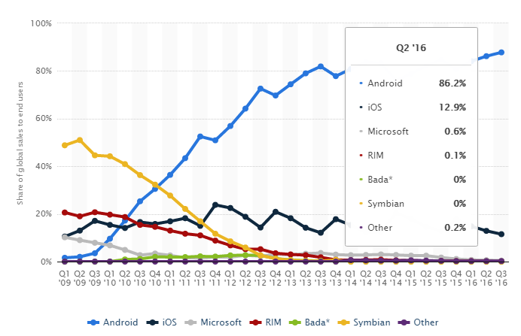

References

Angeles, S. (2014) Mobile Website vs. Mobile App: What’s the Difference? - See more at: Http://www.Businessnewsdaily.Com/6783-mobile-website-vs-mobile-app.Html#sthash.YypaJd13.Dpuf. Available at: http://www.businessnewsdaily.com/6783-mobile-website-vs-mobile-app.html (Accessed: 9 February 2017).

Statista (2015) *Smartphone OS global market share 2009-2016 | statistic*. Available at: https://www.statista.com/statistics/266136/global-market-share-held-by-smartphone-operating-systems/ (Accessed: 21 February 2017).

Mackenzie, T. (2012) ‘App store fees, percentages, and payouts: What developers need to know’, *techRepublic*, 07 May. Available at: http://www.techrepublic.com/blog/software-engineer/app-store-fees-percentages-and-payouts-what-developers-need-to-know/ (Accessed: 21 February 2017).

Fried, I. (2015) *Mobile Apps have a short Half life; Use falls sharply after First Six months*. Available at: http://www.recode.net/2015/9/2/11618236/mobile-apps-have-a-short-half-life-use-falls-sharply-after-first-six (Accessed: 21 February 2017).