Stability and Learning in Spiking Neural Networks: Computational Model of Homeostasis and STDP
A replication study of Carlson et. al., 2013

Colleen Chen
School of Social Sciences
Cognitive Neuroscience
University of California, Irvine
Irvine, CA
Email: Colleepc@uci.edu

Abstract— Prelim results from my implementation of a spiking network using stdp learning rule. Interested in the stability of the computational model and its biologically plausible underlying mechanism: aka homeostasis. Replication study of Carlson et al. 2013 using published parameters and matlab. Runaway synaptic dynamics creates a positive feedback loop. Homeostatic synaptic scaling imposes stability, in a biologically plausible way, on the computational model.
Keywords—Spiking neural network, spike-timing dependent plasticity, Homeostasis synaptic scaling

Introduction
Biological neurons use sudden increases in voltage to transmit information. These signals are more commonly known as action potentials, or spikes. Neurons encode information in the timing of single spikes, in addition to their average firing rate. The learning process in the brain can be thought of as the change of synaptic strength over time; this ability is known as synaptic plasticity. Networks of spiking neurons can encode temporal information in their signals, and therefore require biologically plausible rules for synaptic plasticity. Spike-timing dependent plasticity (STDP) is a learning rule that takes the form of Hebbian learning but with strict time dependencies. Hebbian learning between pairs of neurons strenghtens a synapse when the neurons spike around the same time, not account for temporal order. STDP, on the other hand, strengthens a synapse when the presynaptic neuron fires before the postsynaptic neuron, in expected causal order, otherwise the synapse is weakened; as such, it is a timing order dependent specialization of Hebbian learning. STDP explains how the time diffference between a pre-and postsynaptic spike affects the amount of synaptic potentiation or depression. Long-term potentiation (LTP) is measured by the amplitude of the excitatory postsynaptic potential (EPSP) of the neuron, which correlates with the amount of current that is imparted into postsynaptic neuron by presynaptic neuron. An increase in EPSP means that each presynaptic spike is imparting more current to the postsynaptic neuron and has more influence on whether the postsynaptic neuron fires. Long-term depression (LTD) is the depression mechanism that works opposite LTP. While LTP causes increases in synaptic strength that persist over days and months, LTD causes decreases in synaptic strength that persist on the same time scale. This project presents a computational model of a spiking neuron that has synapses, which are plastic and dependent on spike times.
An important observation from computational models of spiking networks using STDP rule is that it is unstable. Stability, when discussing learning rules, means that the learning rule will result in a constant distribution of synaptic strengths for synapses attached to a neuron. If the synapses are only potentiated, then all of the synapses will reach some maximum strength, or as seen in computational models, go to infinity. If the synapses are only depressed or weakened, then all of the synapses will reach some minimum strength or go to negative infinity. In the current proposed spiking network model, this instability leads to runaway synaptic potentiation. Runaway synaptic dynamics occurs when a presynaptic neuron consistently excites a postsynaptic neuron to fire, increasing the synaptic strength at every subsequent pairing. This increase in synaptic strength causes the postsynaptic neuron to fire more rapidly, strengthening additional synapses and eventually resulting in a boundless increase of all presynaptic connections to the postsynaptic neuron. The excitatory synapses create a positive feedback loop that requires stability constraints to be imposed upon the computational model of system.
Homeostatic synaptic scaling imposes such stability constraint on the computational model of spiking network and act to stabilize neuronal activity. Homeostatic mechanisms such as synaptic scaling avoids runaway potentiation by allowing neurons to detect changes in their own firing rates and regulate weights to prevent runaway increases or decreases in synaptic strength, as illustrated in Figure 1. Global synaptic scaling preserves the relative differences in strength between synapses on a particular neuron. Multiplicative synaptic plasticity scales the weights in proportion to the difference between a time-averaged postsynaptic activity signal and a target postsynaptic activity signal. The homeostatic update rule adjusts the synaptic weights multiplicatively and depends on both the average firing rate of the neuron and some target firing rate.
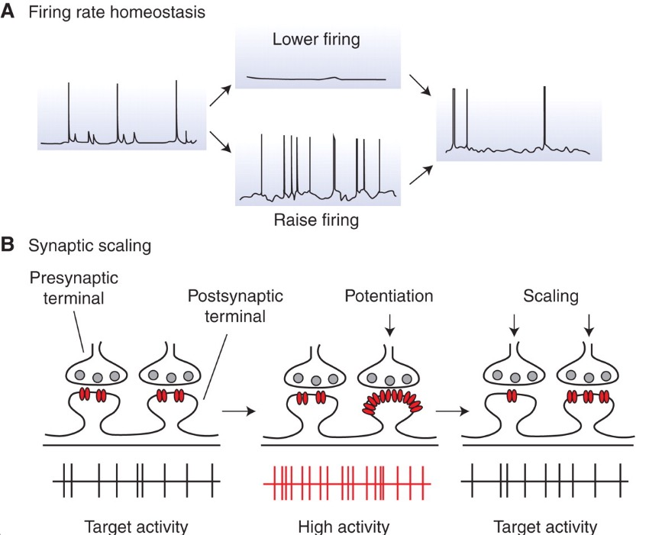

Figure 1. Homeostatic synaptic plasticity. (A) The maintenance of a constant baseline-firing rate given perturbed spikes in either direction using homeostatic regulation of synaptic properties. (B) firing rate homeostasis achieved through synaptic scaling. Given perturbed activity, synaptic scaling produces a proportional reduction or increase in magnitude of synaptic strength to return firing to baseline levels. Because this mechanism scales synaptic strength up or down proportionally, the relative difference in synaptic strengths induced by Hebbian mechanisms is preserved. Recreated from [1].

Carlson et. al. proposed in [2] a biologically plausible mathematical description of a homeostatic synaptic scaling mechanism that prevents runaway synaptic dynamics, in this replication study, a computational model is implemented to examine the synapses simulated in the network and the firing behavior of the neuron.

Methods
The ramp simulation examines the stability of the synapses in the network with and without homeostatic scaling. The multiplicatively synaptic scaling implemented in this experiment should preserve relative weight differences between synapses located on the same neuron.
The STDP update rule used in the computational model is shown in (1).
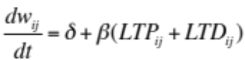 (1)
The change in synaptic strength, or weight, is described by a bias term added to the product of learning rate and the sum of LTP and LTD. The magnitudes of the STDP potentiation and depression terms were calculated using the standard nearest neighbor STDP implementation, which relates STDP to Bienenstock-Cooper-Munro (BCM) (LTP/LTD) by only considering nearest neighbor, in temporal time, to the postsynaptic pairings to contribute to plasticity. The BCM implementation of LTP/LTD uses a sliding threshold to stabilize network activity and promote competition between synapses. The synaptic weight change here is additive, because the it is not proportional to the current weight value as in the multiplicative update rule. The weight changes were updated every time step (1 ms) but the weights were modified once every second.
The proposed homeostatic synaptic plasticity model modifies the STDP update rule as shown in (2).

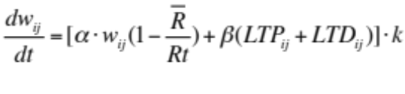 (2)
Here, the bias is replaced by a term that takes into account the product of the homeostatic scaling factor, the synaptic weight, and the proportion of the average firing rate of the postsynaptic neuron, j, and the target firing rate. If the average firing rate is below the target rate, then the weight will increase, conversely, when the averaged firing rate is higher than the target, the weight will decrease and become negative. The alpha term dictates how pronounced this positive or negative weight change is. The entire sum is multiplied by another term k, which is the stability term that dampens oscillations in the weight updates and speeds up learning. K is defined in (3) as:

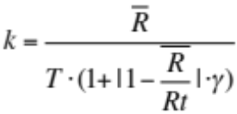 (3)

Here, we use gamma as a tuning factor and T is the time scale over which the firing rate of the postsynaptic neuron was averaged. The STDP and homeostasis parameters used in the ramp test are found in Table 1.
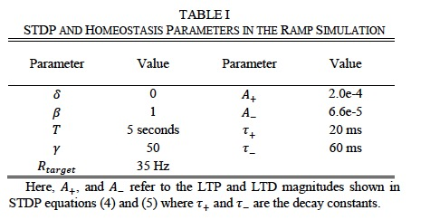
Table 1. The STDP and homeostasis parameters for the ramp simulations. Two sets of STDP update rules were used: equation 3 and equations 4 and 5. Recreated from [2].

Ramp Simulation Network Configuration
The computational model used a spiking neural network with conductance based, Izhikevich-type spiking neurons [32] and were implemented in MATLAB. Excitatory Izhikevich neurons were regular spiking(RS) neurons. The network configuration consisted of 100 Poisson spiking neurons, each with a STDP-enabled plastic synaptic connection to a single RS output neuron. Each Poisson neuron had a firing rate that ranged from 0.2 Hz to 20 Hz, in ascending order as shown in Figure 2. The initial synaptic weights, S, were chosen from a uniform distribution between 0.01 and 0.03. Two different network configurations were run for 1000 simulation seconds and both the synaptic weights and firing rates were monitord. The first network configuration did not include homeostasis and used plasticity update rule (1) while the second network configuration included homeostasis and used plasticity update rule (2). When homeostasis was enabled, the target firing rate of the output neuron was 35 Hz. For clarification, the psuedo code of the proposed implementation is provided in Figure 3, to illustrate the STDP and homeostasis update algorithm.
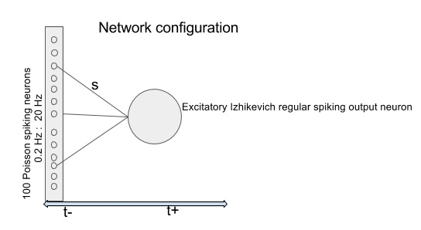
Figure 2. Ramp simulation network configuration. The spiking network consists of one RS exc. Izhikevich output neuron receiving input spikes from 100 Poisson neurons. There are a total of s1..s100 synapses connected to the output neuron, each firing at a different rate starting from 0.2 Hz up to 20 Hz. We are interested in the weight change of these synapses and firing rate of the neuron over the duration of the simulation (1000 simulation seconds).
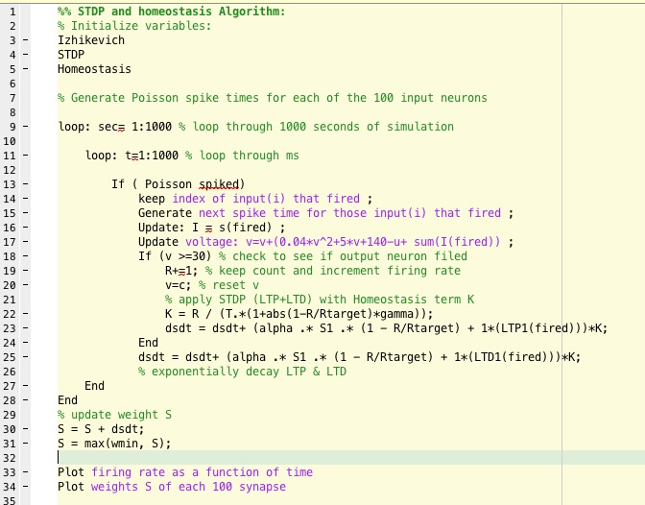
Figure 3. STDP and homeostasis update algorithm. In this pseudocode, the update logic illustrates how the weights are changed and subsequently modified according to the running average of firing rate of the output neuron.

Results
In order to evaluate the current implementation of a spiking newtork with STDP and homeostasis, a comparison to the results from Carlson et. al. [2] is made and evaluated. The published results from [2] are shown below in Figures 4 and 5 and details of their results are discussed in section A. The replication results are shown in Figure 6, and dicsussed in section B.

Ramp Simulation Carlson et al.
The [2] results for the ramp simulation are shown in Figs. 4 and 5. In Figure 4, the synaptic strength of each synapse is shown as a funmction of the Poisson spiking neuron ID at simulatin time t=1000 seconds. For networks with homeostatic synaptic scaling (blue x’s), the synaptic weights roughly track the firing rates. For networks without homeostatic synaptic scaling (red points), the synaptic weights saturate completely, showing runaway potentiation. Note that at the beginning of the ramp test simulation without homeostasis, even the synapse experiencing the lowest firing rate saturates. Figure 5 shows the firing rate of the output neuron versus time with homeostasis enabled(blue line) and without homeostasis enabled (red line). The output firing rate stays near its target rate of 35 Hz with homeostasis but reaches 55 Hz in the case where hoemostasis is excluded. This simple simulation shows that the homeosatasis update rule can stabilize both synaptic dynamics and firing rates while at the same time allowing STDP learning via balanced STDP in the ramp simulation with carefully chosen STDP paremters.

Ramp Simulation replicated implementation

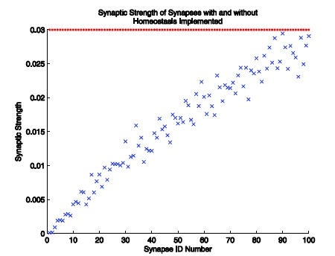Figure 4. Plot of synaptic strength vs. synapse ID number at simulation time t=1000 seconds. The blue x’s represent synapses that underwent STDP learning with homeostatic synaptic scaling enable while the red points represent synapses that underwent STDP learning withouth homeostatic synaptic scaling. Published results from Carlson et. al. [2].
……………………..……………………..……………………..……………………..……………………..……………………..……………………..……………………..……………………..……………………..……………………..……………………..……………………..……………………..……………………..……………………..……………………..……………………..……………………..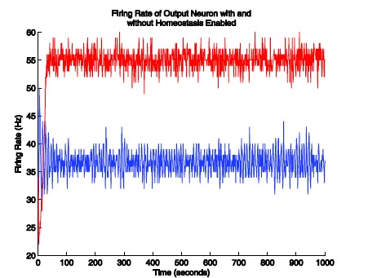
Figure 5. Plot of the output neuron firing rate as a funciton of simulation time for STDP learning with (blue line) and without (red line) homeostatic synaptic scaling. Published results from Carlson et. al. [2].

Poisson neuron spike rates with lower weights for neurons with lower firing rates and higher weights for neurons with higher

Discussion and Conclusion
After the text edit has been completed, the paper is ready for the template. Duplicate the template file by using the Save As command, and use the naming convention prescribed by your conference for the name of your paper. In this newly created file, highlight all of the contents and import your prepared text file. You are now ready to style your paper; use the scroll down window on the left of the MS Word Formatting toolbar.

References

- G. Turrigiano, “Homeostatic Synaptic Plasticity: Local and Global Mechanisms for Stabilizing Neuronal Function,” Cold Spring Harb. PErspect. Biol., vol. 4, no. 1, Jan. 2012.
- K. Carlson, M. Richert, N. Dutt, and J. Krichmar, “Biologically plausible models of homeostasis and STDP: stability and learning in spiking neural networks,” Proceedings of International Joint Conference on Neural Networks, Dallas, Texas, Aug 2013.

