**Assignment(1)**

**Class:BBA-I(Sem-I)**

**Subject: Business Economics-I**

**Topics:**Economics,Difference between micro and macro economics,difference between implicit and explicit cost

**Submitted To:**

Anjali Gupta

Prof.of Management Department

**Ques1:Define Economics?Difference between micro and macro economics?**

**Ans.** Economics is a social science. Economists study the ways people allocate resources, on both a collective and individual level, to be produced, distributed, and consumed. A crucial economic principle is that humans have unlimited wants, but we live in a world with limited resources to fulfill those wants. As a result, efficiency and productivity are highly important in economic thinking since productivity and efficiency when it comes to resources that can improve human living standards.The field of economics is vast. There are whole sloughs of economic theories, indicators, and systems to consider depending on your area of interest. Try making lists of all the various systems, indicators, and theories you can think of in economics

**MACRO VS. MICRO**

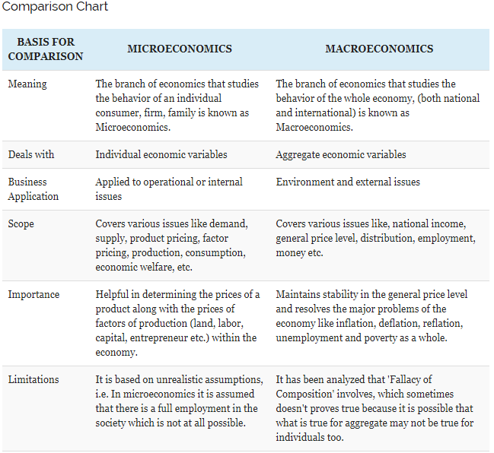

**Ques2:Difference between implicit cost and explicit cost?**

**Ans.**