**Assignment(2)**

**Class:BCAI(Sem-I)**

**Subject:Fundamentals of information Technology**

**Topics:**Number System and types of Number System,Networ Types

**Submitted To:**

Silky Bansal

Prof.of Comp.Sci.Department

**Ques1:What is number system? Types of Number Systems?**

**Ans**.A number system is defined as a system of writing to express numbers. It is the mathematical notation for representing numbers of a given set by using digits or other symbols in a consistent manner. It provides a unique representation of every number and represents the arithmetic and algebraic structure of the figures. It also allows us to operate arithmetic operations like addition, subtraction, multiplication and division.

The value of any digit in a number can be determined by:

* The digit
* Its position in the number
* The base of the number system

Before discussing the different types of number system examples, first, let us discuss what is a number?

What is a Number?

A number is a mathematical value used for counting or measuring or labelling objects. Numbers are used to performing arithmetic calculations.  Examples of numbers are natural numbers, whole numbers, rational and irrational numbers, etc. 0 is also a number that represents a null value.

A number has many other variations such as even and odd numbers, prime and composite numbers. Even and odd terms are used when a number is divisible by 2 or not, whereas prime and composite differentiate between the numbers that have only two factors and more than two factors, respectively.

In a number system, these numbers are used as digits. 0 and 1 are the most common digits in the number system, that are used to represent binary numbers. On the other hand, 0 to 9 digits are also used for other number systems. Let us learn here the types of number systems.

**Types of Number Systems**

There are various types of number systems in mathematics. The four most common number system types are:

1. Decimal number system (Base- 10)
2. Binary number system (Base- 2)
3. Octal number system (Base-8)
4. Hexadecimal number system (Base- 16)

Now, let us discuss the different types of number systems with examples.

**Decimal Number System (Base 10 Number System)**

The decimal number system has a base of 10 because it uses ten digits from 0 to 9. In the decimal number system, the positions successive to the left of the decimal point represent units, tens, hundreds, thousands and so on. This system is expressed in [decimal numbers](https://byjus.com/maths/decimals/). Every position shows a particular power of the base (10).

**Example of Decimal Number System:**

The decimal number 1457 consists of the digit 7 in the units position, 5 in the tens place, 4 in the hundreds position, and 1 in the thousands place whose value can be written as:

(1×103) + (4×102) + (5×101) + (7×100)

(1×1000) + (4×100) + (5×10) + (7×1)

1000 + 400 + 50 + 7

1457

**Binary Number System (Base 2 Number System)**

The base 2 number system is also known as the [Binary number system](https://byjus.com/maths/binary-number-system/) wherein, only two binary digits exist, i.e., 0 and 1. Specifically, the usual base-2 is a radix of 2. The figures described under this system are known as binary numbers which are the combination of 0 and 1. For example, 110101 is a binary number.

We can convert any system into binary and vice versa.

**Example**

Write (14)10 as a binary number.

**Solution:**

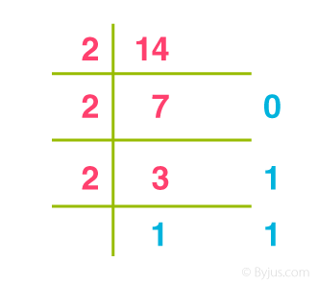

Base 2 Number System Example

∴ (14)10 = 11102

**Octal Number System (Base 8 Number System)**

In the [octal number system](https://byjus.com/maths/octal-number-system/), the base is 8 and it uses numbers from 0 to 7 to represent numbers. Octal numbers are commonly used in computer applications. Converting an octal number to decimal is the same as decimal conversion and is explained below using an example.

**Example: Convert 2158 into decimal.**

**Solution:**

2158 = 2 × 82 + 1 × 81 + 5 × 80

= 2 × 64 + 1 × 8 + 5 × 1

= 128 + 8 + 5

= 14110

**Hexadecimal Number System (Base 16 Number System)**

In the hexadecimal system, numbers are written or represented with base 16. In the hexadecimal system, the numbers are first represented just like in the decimal system, i.e. from 0 to 9. Then, the numbers are represented using the alphabet from A to F. The below-given table shows the representation of numbers in the [hexadecimal number system](https://byjus.com/maths/hexadecimal-number-system/).

|  |  |  |  |  |  |  |  |  |  |  |  |  |  |  |  |  |
| --- | --- | --- | --- | --- | --- | --- | --- | --- | --- | --- | --- | --- | --- | --- | --- | --- |
| **Hexadecimal** | **0** | **1** | **2** | **3** | **4** | **5** | **6** | **7** | **8** | **9** | **A** | **B** | **C** | **D** | **E** | **F** |
| **Decimal** | **0** | **1** | **2** | **3** | **4** | **5** | **6** | **7** | **8** | **9** | **10** | **11** | **12** | **13** | **14** | **15** |

**Number System Chart**

In the number system chart, the base values and the digits of different number systems can be found. Below is the chart of the numeral system.

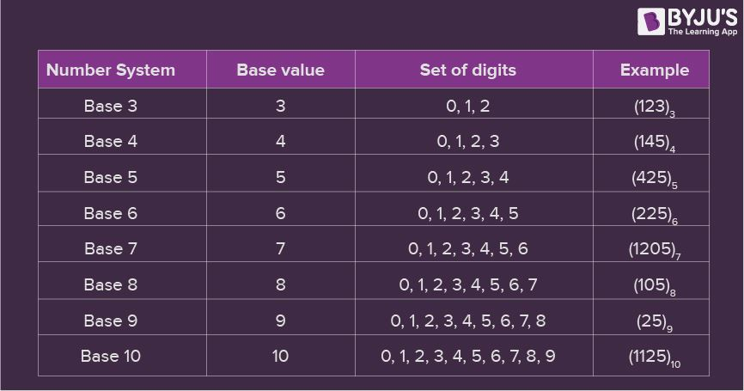

Number System Chart

**Number System Conversion**

Numbers can be represented in any of the number system categories like binary, decimal, hexadecimal, etc. Also, any number which is represented in any of the number system types can be easily converted to another. Check the detailed lesson on the [conversions of number systems](https://byjus.com/maths/number-system-conversion/) to learn how to convert numbers in decimal to binary and vice versa, hexadecimal to binary and vice versa, and octal to binary and vice versa using various examples.

With the help of the different conversion procedures explained above, now let us discuss in brief about the conversion of one number system to the other number system by taking a random number.

Assume the number 349. Thus, the number 349 in different number systems is as follows:

The number 349 in the binary number system is 101011101

The number 349 in the decimal number system is 349.

The number 349 in the octal number system is 535.

The number 349 in the hexadecimal number system is 15D

**Ques2:Explain the types of network?**

**Ans.** Computer Network Types

A computer network is a group of computers linked to each other that enables the computer to communicate with another computer and share their resources, data, and applications.

A computer network can be categorized by their size. A **computer network** is mainly of **four types**:

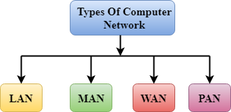

* LAN(Local Area Network)
* PAN(Personal Area Network)
* MAN(Metropolitan Area Network)
* WAN(Wide Area Network)

LAN(Local Area Network)

* Local Area Network is a group of computers connected to each other in a small area such as building, office.
* LAN is used for connecting two or more personal computers through a communication medium such as twisted pair, coaxial cable, etc.
* It is less costly as it is built with inexpensive hardware such as hubs, network adapters, and ethernet cables.
* The data is transferred at an extremely faster rate in Local Area Network.
* Local Area Network provides higher security.

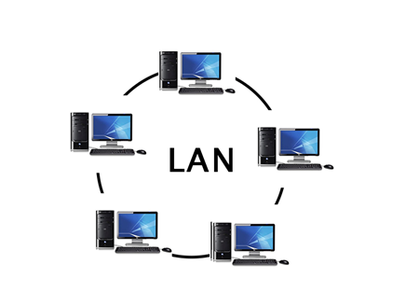

PAN(Personal Area Network)

* Personal Area Network is a network arranged within an individual person, typically within a range of 10 meters.
* Personal Area Network is used for connecting the computer devices of personal use is known as Personal Area Network.
* **Thomas Zimmerman** was the first research scientist to bring the idea of the Personal Area Network.
* Personal Area Network covers an area of **30 feet**.
* Personal computer devices that are used to develop the personal area network are the laptop, mobile phones, media player and play stations.

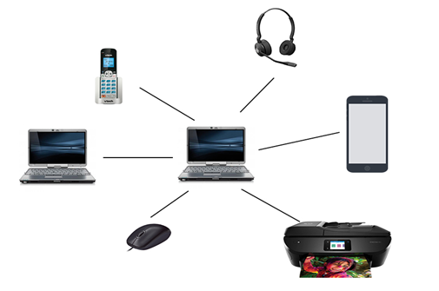

**There are two types of Personal Area Network:**

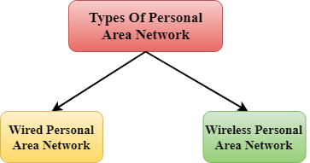

* Wired Personal Area Network
* Wireless Personal Area Network

**Wireless Personal Area Network:** Wireless Personal Area Network is developed by simply using wireless technologies such as WiFi, Bluetooth. It is a low range network.

**Wired Personal Area Network:** Wired Personal Area Network is created by using the USB.

Examples Of Personal Area Network:

* **Body Area Network:** Body Area Network is a network that moves with a person. **For example**, a mobile network moves with a person. Suppose a person establishes a network connection and then creates a connection with another device to share the information.
* **Offline Network:** An offline network can be created inside the home, so it is also known as a **home network**. A home network is designed to integrate the devices such as printers, computer, television but they are not connected to the internet.
* **Small Home Office:** It is used to connect a variety of devices to the internet and to a corporate network using a VPN

MAN(Metropolitan Area Network)

* A metropolitan area network is a network that covers a larger geographic area by interconnecting a different LAN to form a larger network.
* Government agencies use MAN to connect to the citizens and private industries.
* In MAN, various LANs are connected to each other through a telephone exchange line.
* The most widely used protocols in MAN are RS-232, Frame Relay, ATM, ISDN, OC-3, ADSL, etc.
* It has a higher range than Local Area Network(LAN).

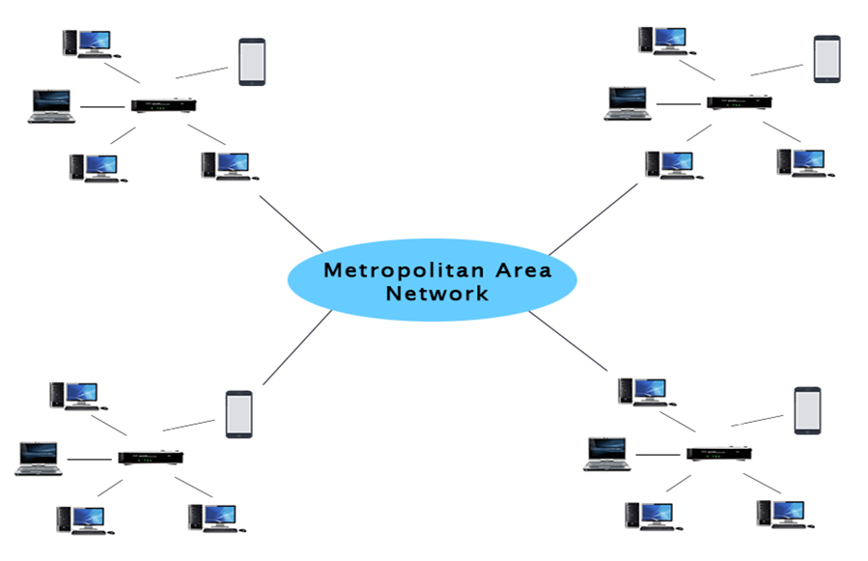

Uses Of Metropolitan Area Network:

* MAN is used in communication between the banks in a city.
* It can be used in an Airline Reservation.
* It can be used in a college within a city.
* It can also be used for communication in the military.

WAN(Wide Area Network)

* A Wide Area Network is a network that extends over a large geographical area such as states or countries.
* A Wide Area Network is quite bigger network than the LAN.
* A Wide Area Network is not limited to a single location, but it spans over a large geographical area through a telephone line, fibre optic cable or satellite links.
* The internet is one of the biggest WAN in the world.
* A Wide Area Network is widely used in the field of Business, government, and education.

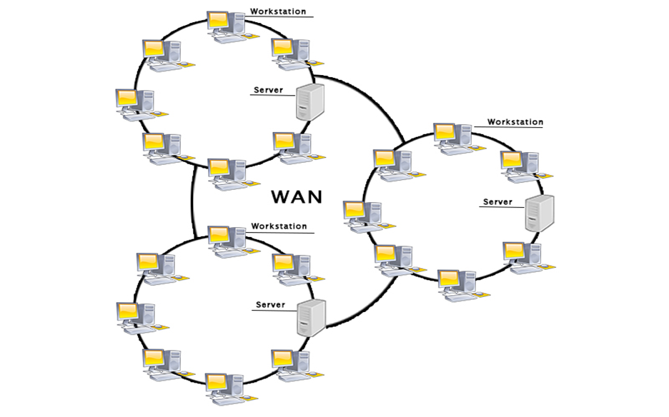

Examples Of Wide Area Network:

* **Mobile Broadband:** A 4G network is widely used across a region or country.
* **Last mile:** A telecom company is used to provide the internet services to the customers in hundreds of cities by connecting their home with fiber.

**Private network:** A bank provides a private network that connects the 44 offices. This network is made by using the telephone leased line provided by the telecom company.