**Assignment(1)**

**ClassPGDCA-I(Sem-I)**

**Subject: Windows Operating System and Office Automation**

**Topics:**MS-WORD and Features,MS-Excel and its Features

**Submitted To:**

Rajveer Singh

Prof.of Comp.Sci.Department

**Ques1:Introduction to MS-WORD and its Features?**

**Ans. What is MS Word?**

Used to make professional-quality documents, letters, reports, etc., MS Word is a word processor developed by Microsoft. It has advanced features which allow you to format and edit your files and documents in the best possible way.

**Where to find MS Word on your personal computer?**

Follow these simple steps to open MS Word on your personal computer:

Start → All Programs → MS Office → MS Word.

**What are the uses of MS Word?**

MS Word enables users to do write-ups, create documents, resumes, contracts, etc. This is one of the most commonly used programs under the Office suite.

**How to create an MS Word document?**

To create an MS Word doc, follow the steps mentioned above to open Microsoft Word. Then once the program is open, click on “File” followed by “New”. This opens a new doc where something new can be created.

Since it is used by people of all age groups, in schools, in colleges and for official purposes, having proper knowledge of Microsoft Word is a must. The preview of the MS Doc file once it is opened is given below:

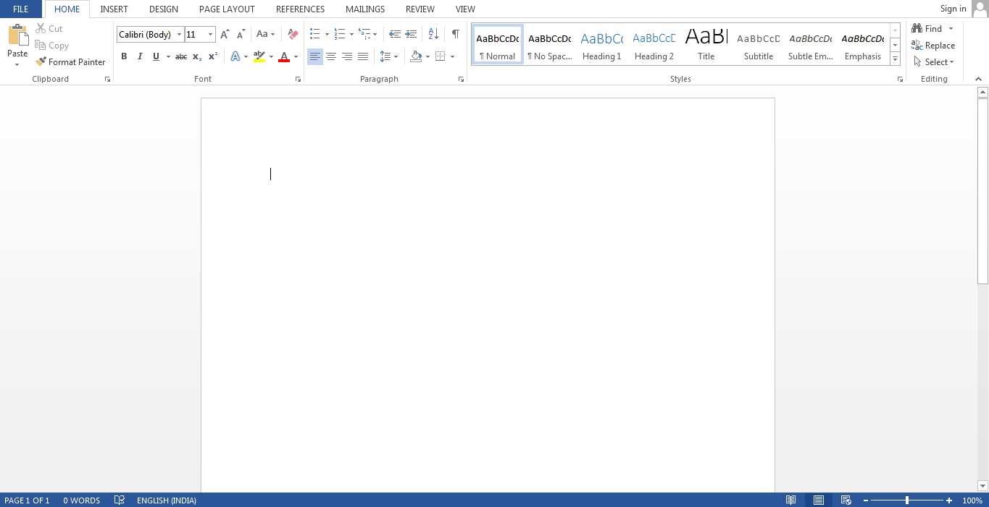

Also, from a competitive exam perspective, one must be well aware of this topic. To get the list of all major [Government exams](https://byjus.com/govt-exams/) conducted in the country, aspirants can visit the linked article.

For a better understanding of how MS Word works and the features that are included in it, you can refer to the video given below and analyse its functioning easily.

Features of MS Word

Now let us read more about the features and components of an MS Word doc file in detail.

The image given below shows the different elements and categories which are available in MS Word doc:

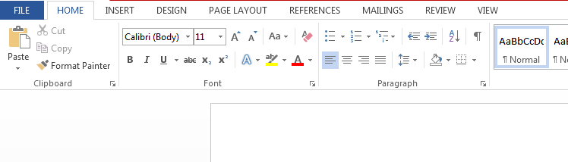

* **Home**

This has options like font colour, font size, font style, alignment, bullets, line spacing, etc. All the basic elements which one may need to edit their document is available under the Home option.

* **Insert**

Tables, shapes, images, charts, graphs, header, footer, page number, etc. can all be entered in the document. They are included in the “Insert” category.

* **Design**

The template or the design in which you want your document to be created can be selected under the Design tab. Choosing an appropriate tab will enhance the appearance of your document.

* **Page Layout**

Under the Page Layout tab comes options like margins, orientation, columns, lines, indentation, spacing, etc.

* **References**

This tab is the most useful for those who are creating a thesis or writing books or lengthy documents. Options like citation, footnote, table of contents, caption, bibliography, etc. can be found under this tab.

* **Review**

Spell check, grammar, Thesaurus, word count, language, translation, comments, etc. can all be tracked under the review tab. This acts as an advantage for those who get their documents reviewed on MS Word.

Apart from all the above-mentioned features, the page can be set in different views and layouts, which can be added and optimised using the View tab on the Word document. Margins and scales are also available for the benefit of the users.

When compared with [MS PowerPoint](https://byjus.com/govt-exams/microsoft-powerpoint/), MS Word is more of reading while PPT is more of visual and graphical representation of data.

To know more about [Microsoft Windows](https://byjus.com/govt-exams/microsoft-windows/), visit the linked article.

Uses of MS Word

Given below are the different fields in which MS Word is used and simplifies the work of an individual:

* **In Education:** It is considered as one of the simplest tools which can be used by both teachers and students. Creating notes is easier using MS Word as they can be made more interactive by adding shapes and images. It is also convenient to make assignments on MS Word and submitting them online
* **In Workplace:** Submitting letters, bills, creating reports, letterheads, sample documents, can all easily be done using MS Word
* **Creating & Updating Resume:** One of the best tools to create your resumes and is easy to edit and make changes in it as per your experience
* **For Authors:** Since separate options are available for bibliography, table of contents, etc., it is the best tool which can be used by authors for writing books and adjusting it as per the layout and alignment of your choice

Also, creating a Doc file and converting it into PDF is a more suitable option, so it is highly recommended.

**Ques2: Introduction to MS-Excel and its Features?**

**Ans. What is MS Excel?**

MS Excel is a spreadsheet program where one can record data in the form of tables. It is easy to analyse data in an Excel spreadsheet. The image given below represents how an Excel spreadsheet looks like:

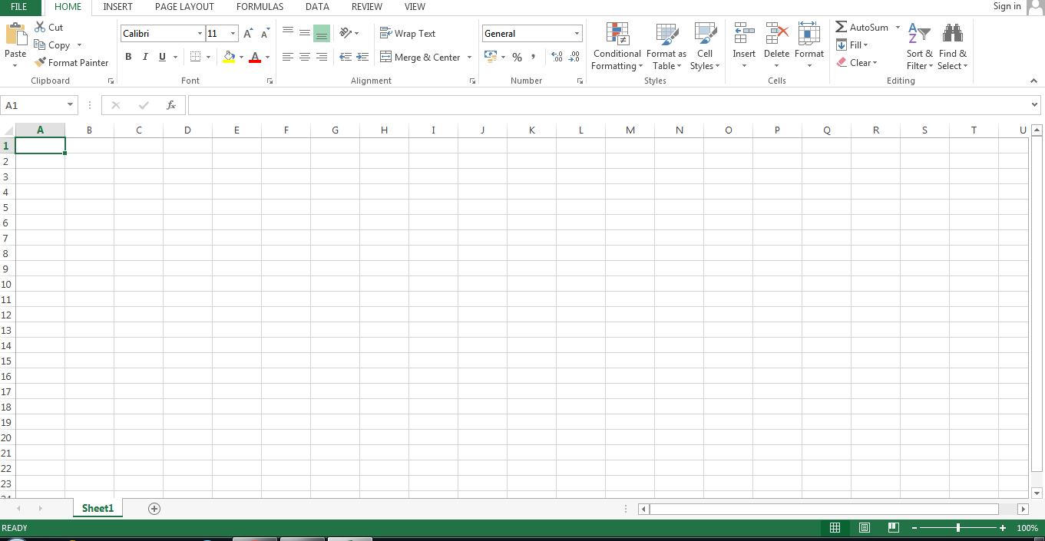

**How to open MS Excel?**

To open MS Excel on your computer, follow the steps given below:

* Click on Start
* Then All Programs
* Next step is to click on MS Office
* Then finally, choose the MS-Excel option

Alternatively, you can also click on the Start button and type MS Excel in the search option available.

**What is a cell?**

A spreadsheet is in the form of a table comprising rows and columns. The rectangular box at the intersection point between rows and columns forms a cell. Given below is an image of a cell: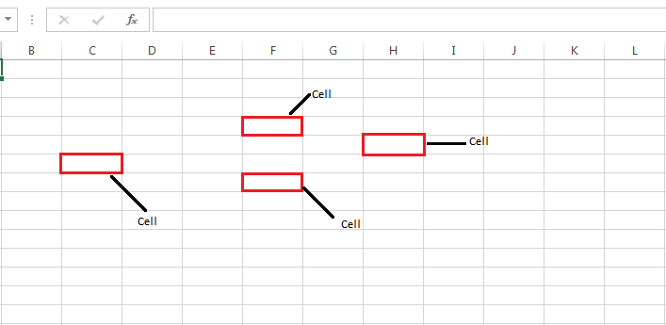

**What is Cell Address?**

The cell address is the name by which is cell can be addressed. For example, if row 7 is interested in column G, then the cell address is G7.

Features of MS Excel

Various editing and formatting can be done on an Excel spreadsheet. Discussed below are the various features of MS Excel.

The image below shows the composition of features in MS Excel:

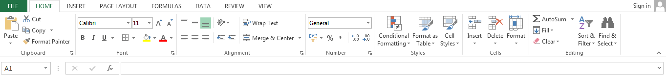

* **Home**
  + Comprises options like font size, font styles, font colour, background colour, alignment, formatting options and styles, insertion and deletion of cells and editing options
* **Insert**
  + Comprises options like table format and style, inserting images and figures, adding graphs, charts and sparklines, header and footer option, equation and symbols
* **Page Layout**
  + Themes, orientation and page setup options are available under the page layout option
* **Formulas**
  + Since tables with a large amount of data can be created in MS excel, under this feature, you can add formulas to your table and get quicker solutions
* **Data**
  + Adding external data (from the web), filtering options and data tools are available under this category
* **Review**
  + Proofreading can be done for an excel sheet (like spell check) in the review category and a reader can add comments in this part
* **View**
  + Different views in which we want the spreadsheet to be displayed can be edited here. Options to zoom in and out and pane arrangement are available under this category

For those willing to learn more about MS Excel, can refer to the video given below and understand every small aspect of this program in detail.

Benefits of Using MS Excel

MS Excel is widely used for various purposes because the data is easy to save, and information can be added and removed without any discomfort and less hard work.

Given below are a few important benefits of using MS Excel:

* **Easy To Store Data:** Since there is no limit to the amount of information that can be saved in a spreadsheet, MS Excel is widely used to save data or to analyse data. Filtering information in Excel is easy and convenient.
* **Easy To Recover Data:** If the information is written on a piece of paper, finding it may take longer, however, this is not the case with excel spreadsheets. Finding and recovering data is easy.
* **Application of Mathematical Formulas:** Doing calculations has become easier and less time-taking with the formulas option in MS excel
* **More Secure:** These spreadsheets can be password secured in a laptop or personal computer and the probability of losing them is way lesser in comparison to data written in registers or piece of paper.
* **Data at One Place:** Earlier, data was to be kept in different files and registers when the paperwork was done. Now, this has become convenient as more than one worksheet can be added in a single MS Excel file.
* **Neater and Clearer Visibility of Information:** When the data is saved in the form of a table, analysing it becomes easier. Thus, information is a spreadsheet that is more readable and understandable.