**Assignment(1)**

**Class:BCA-III(Sem-V)**

**Subject:System Software**

**Topics:**System Software and types of system software,difference between linker and loader

**Submitted To:**

Ekta Garg

Prof.of Comp.Sci.Department

**Ques1:Definition of System Software and types of system software?**

**Ans.**System software is a program that is architected to execute and process hardware and application [**software development**](https://openxcell.com/software-development/) simultaneously. Therefore, we can say that it is an interface between hardware and application software. Operating System is an example of system software. Operating System manages all the other programs on a computer or mobile device.

System Software is used to manage and run mobile and computer systems. It runs in the background and maintains the essential functions of the device. Due to system software, higher-level application software can perform their tasks efficiently. As system software runs at the primary level in your computer and mobile, it is called low-level software. It provides a platform for application software to run on the top and interact with users.

Examples of system software are Compiler, Operating System, Debugger, etc.

**Features of System Software**

System Software is given inbuilt in the devices by the manufacturers. The features of system software are:

**Fast in Speed**

System Software is made to be as fast as possible to provide an effective platform for higher-level software.

**Hard to Manipulate**

System Software is hard to manipulate as they do not directly interact with users and are written in a more complex programming language.

**Written in Low-Level Language**

System Software is written in low-level language so the CPU and other hardware can understand it.

**Close to the System**

It is directly connected to the hardware and enables them to run.

**Small in Size**

The size of software is petite compared to all other applications.

**Difficult to Design**

Designing software is a complicated task as they are written in a lower-level language.

**Types of System Software**

All the essential functions of computers are managed by system software. They also manage disk operating systems, utility software, file management, and operating systems.

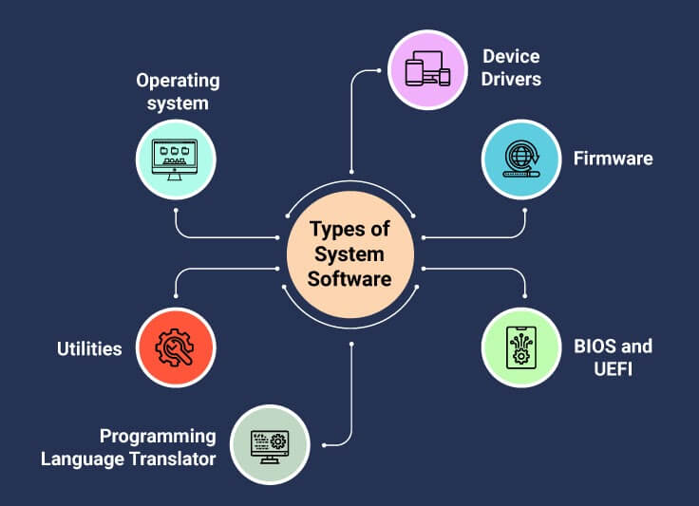

**Operating system**

An operating system is system software that provides a platform between computer hardware, application software, and end-users. It is pre-installed on devices and allows them to be identified and then function. OS is the first thing to be loaded when a system is started.

**Device Drivers**

A Device Driver is system software that operates or controls a particular device attached to a computer. It is the [**device drivers**](https://en.wikipedia.org/wiki/Device_driver) who make it possible for all the external devices to perform their tasks. Most of the hardware comes with pre-installed drivers in it. However, if the device is new to the system, then the user may have to download the drivers.

**Firmware**

Firmware is an operational software stored in a flash, ROM, EPROM for the OS to identify it. The [**firmware**](https://en.wikipedia.org/wiki/Firmware) provides instructions on how the device should be operated. Unlike other software, firmware can not be manipulated, changed, or deleted by the end-users. They remain on the device.

**BIOS and UEFI**

BIOS (Basic Input/Output System) or the new UEFI (Unified Extended Firmware Software) gets the computer system started when we turn it on. [**BIOS**](https://whatis.techtarget.com/definition/BIOS-basic-input-output-system) also manages the flow of information between operating systems and the attached devices.

**Programming Language Translator**

These are the intermediate system software through which programmers convert the high-level language programming code to machine-level language code. Assembler, Interpreter, and Compiler are the popular language translators. They are usually designed by the computer manufacturer and are deliver inbuilt with the system.

**Utilities**

Utilities are the type of system software that is present between user and application software. These are the programs designed to configure, analyze, optimize and maintain tasks of the computer. Their task varies from disk fragmentation to data security.

**Ques2:Differences between Linker and Loader?**

**Ans.**

| **LINKER** | **LOADER** |
| --- | --- |
| The main function of Linker is to generate executable files. | Whereas main objective of Loader is to load executable files to main memory. |
| The linker takes input of object code generated by compiler/assembler. | And the loader takes input of executable files generated by linker. |
| Linking can be defined as process of combining various pieces of codes and source code to obtain executable code. | Loading can be defined as process of loading executable codes to main memory for further execution. |
| Linkers are of 2 types: Linkage Editor and Dynamic Linker. | Loaders are of 4 types: Absolute, Relocating, Direct Linking, Bootstrap. |
| Another use of linker is to combine all object modules. | It helps in allocating the address to executable codes/files. |
| Linker is also responsible for arranging objects in program’s address space. | Loader is also responsible for adjusting references which are used within the program. |