BDA400 Assignment-2 Technical Analysis using R
Student: Pooja Kalia
Repository: college- cdi\ Technical- Analysis
Assignment folder: Assignment-2
This report documents the preliminary setup and analysis for the three stocks AAPL, MSFT and GOOGL. R and R studio were used to install the required packages, read the portfolio, document historical prices, calculate summary statistics and display charts.
- GitHub repository and assignment folder
the technical analysis repository was created on GitHub and an assessment 2 folder was added to this work.

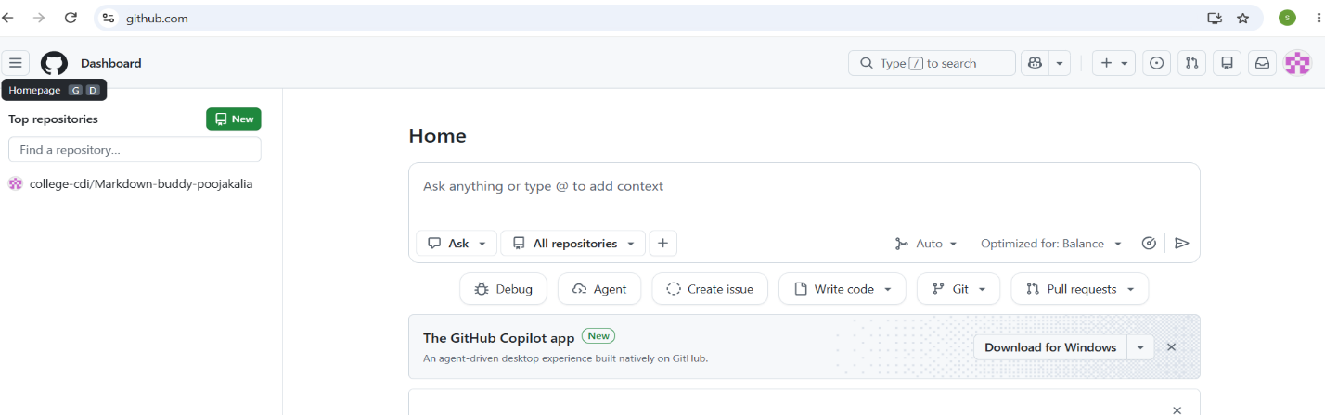

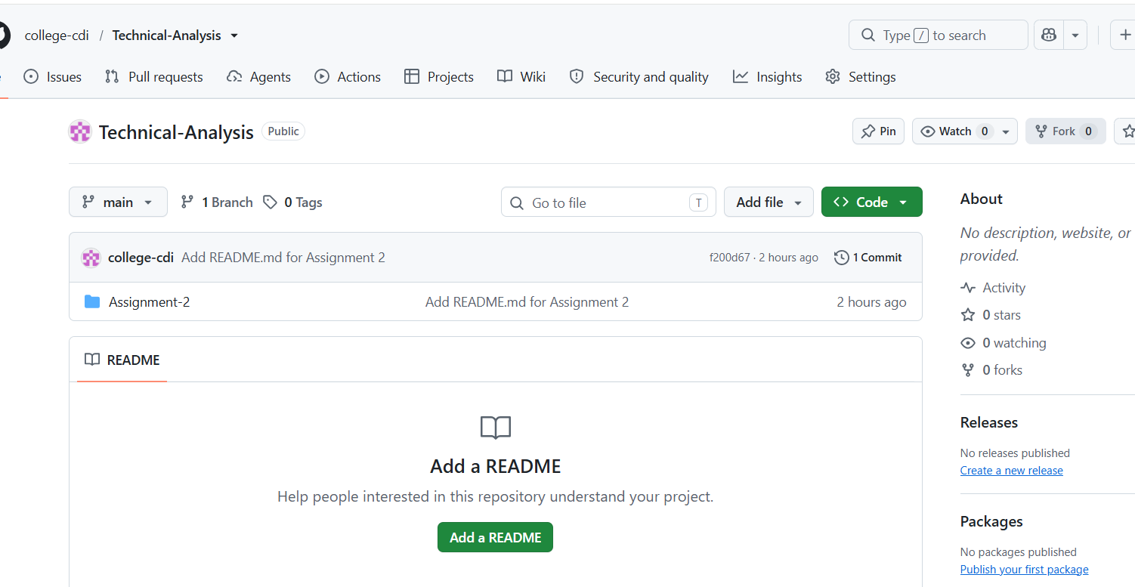

- R and RStudio setup
R studio opened with R available in its console. This confirms that the analysis environments were ready for package installation and script execution.
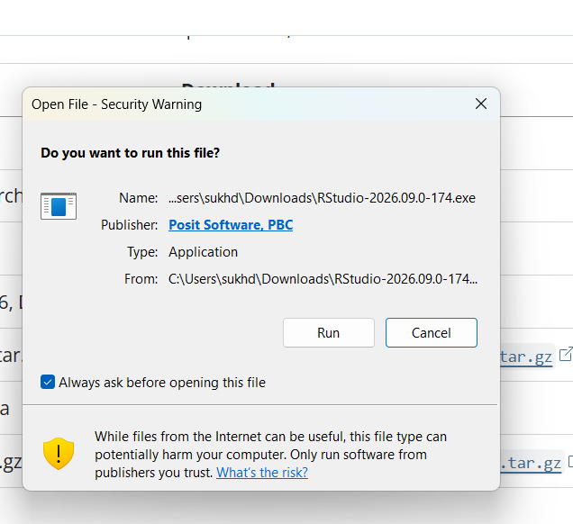

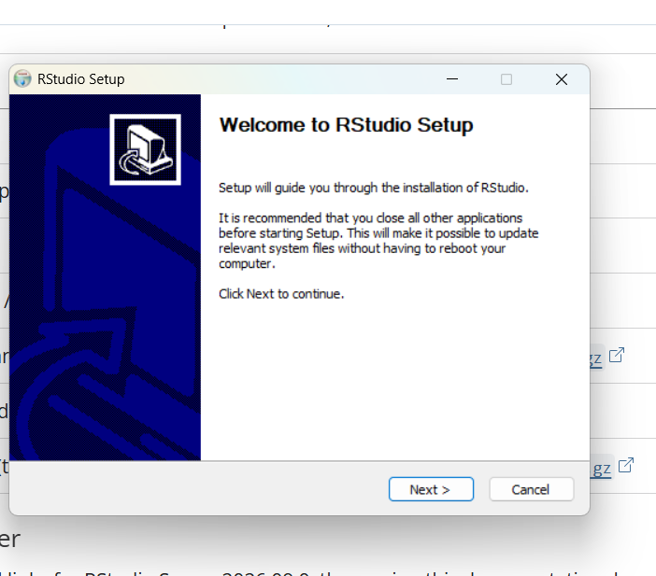
- Packages for Technical Analysis
The quant mod and TTR packages were installed using install.packages[c {“ quantmod”, TTR }}. Both libraries were then loaded successfully. They Rtools notice appeared during installation, But the binary packages installed and loaded.
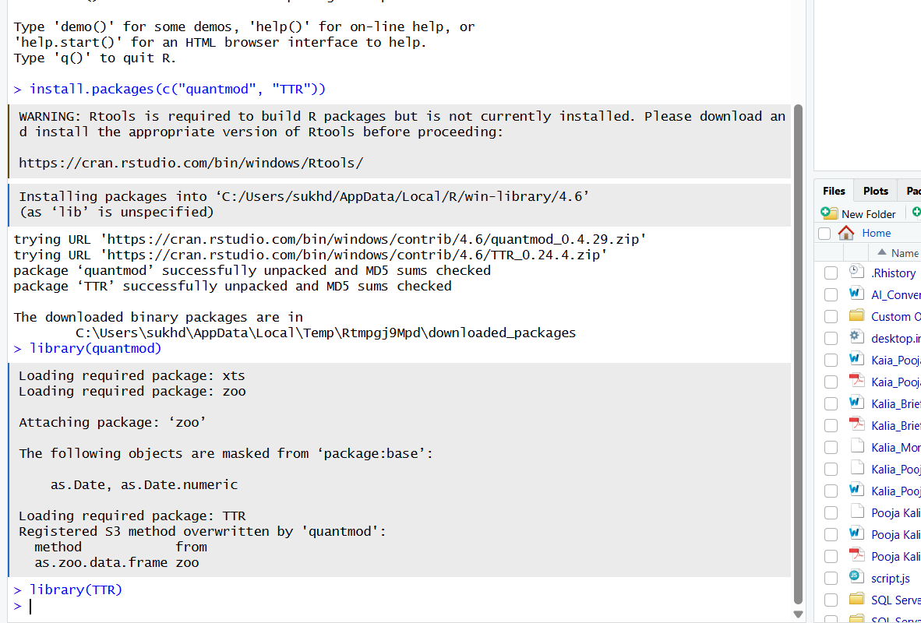

- Portfolio configuration
The portfolio.txt file contains one symbol per line: AAPL, MSFT and GOOGL. It was saved in the same local assessment 2 directory as the R script.
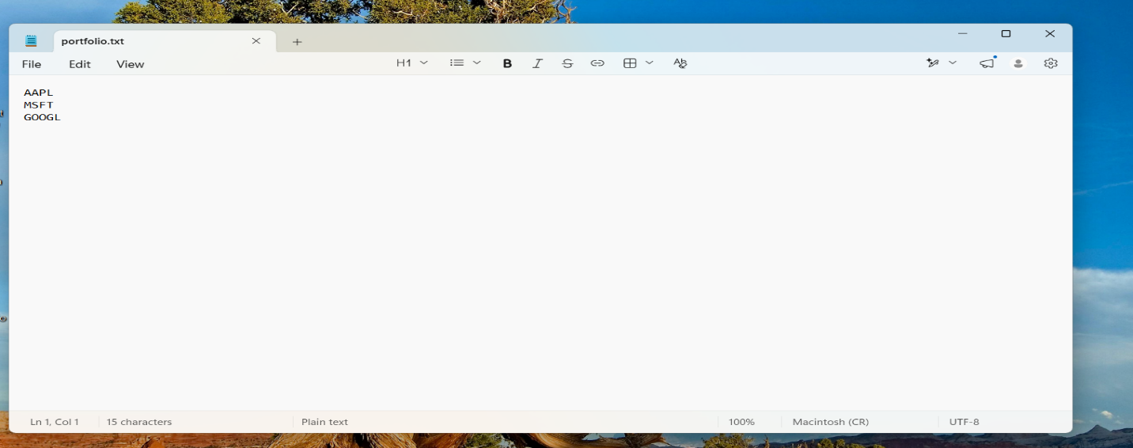

- Importing stock data
The load_stock_data function reads portfolio. txt with read lines and obtain historical Yahoo financial data for each symbol that quantmod get symbols. The result is stored as a named list called stocks. The RStudio environment shows 3 stock objects.
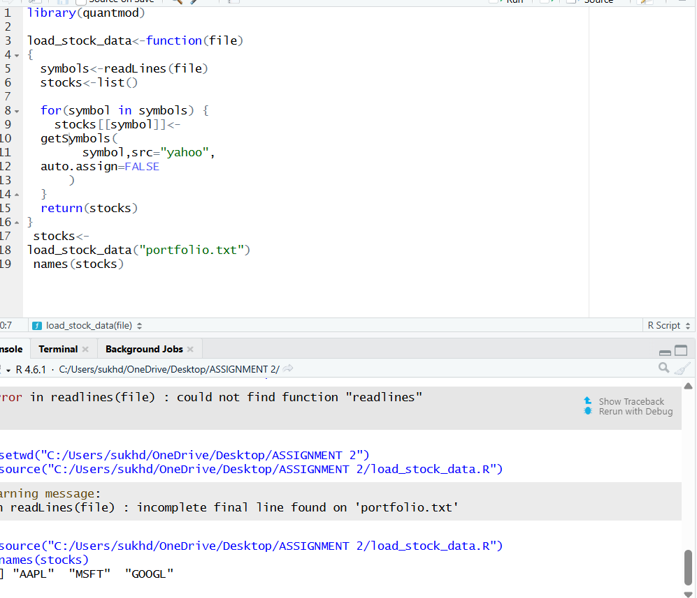

- Basic statistics
For each stock, calculate_statistics extracts the closing-price column and compute it means , median and standard deviation while omitting missing values. Lapply stores the three results in a named list, stock_statistics, with a small data frame for each symbol.
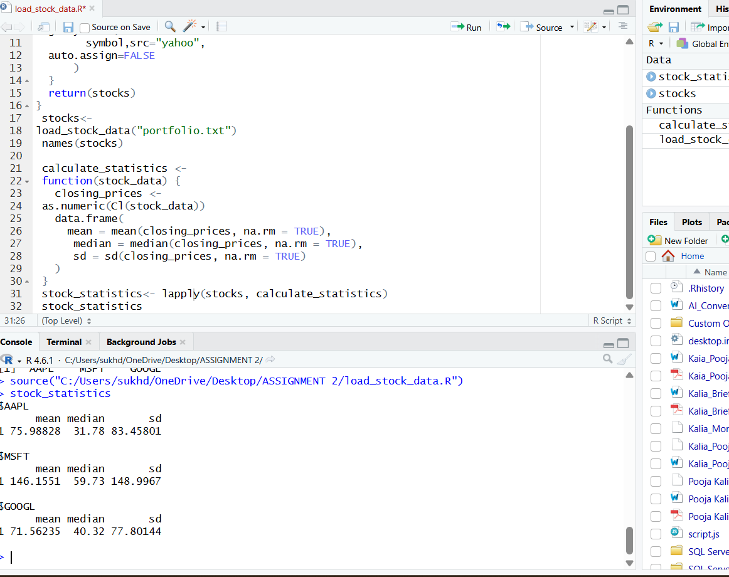

- Stock tables and visualization
The display stock function prints the first six rows of a stock data table and draws its price and volume chart. The image below shows the function running for each portfolio symbol.

