

Department of Computer Engineering
A Mini Project Report (PDL-II)
“LexOS”

“AI-Powered Legal Intelligence Platform for Indian Citizens” Satisfied SDG 16: Peace, Justice and Strong Institutions
SUBMITTED TO THE DEPARTMENT OF COMPUTER ENGINEERING AISSMS IOIT
T. Y. B.Tech Engineering
SUBMITTED BY

Student Roll No | Student Name
B-27 | Soham Pandit
B-14 | Parth Mahale



2026-27

CERTIFICATE
This is to certify that the project report
“LexOS: AI-Powered Legal Intelligence Platform for Indian Citizens”
Submitted by

Student Roll No | Student Name
B-27 | Soham Pandit
B-14 | Parth Mahale

are bonafide students of this institute and the work has been carried out by them under the supervision of Dr. V. S. Bhende and it is approved for the partial fulfillment of the Department of Computer Engineering AISSMS IOIT.

Dr. V. S. Bhende  Guide,  Department of Computer Engineering | Dr. K. S. Wagh  Head of Department  Department of Computer Engineering

Place : Pune Date :

ABSTRACT
Most citizens in India find the law difficult to approach. Basic rights during a police stop or an arrest are not widely known, lawyers can be expensive for a first enquiry, and ordinary tasks such as writing a complaint, checking a rental or employment agreement or preparing an affidavit need legal language that most people do not use. Information is spread across acts, government portals and helplines, and important documents such as pollution certificates, licences and passports expire without the owner noticing.
LexOS is a web-based legal intelligence platform for Indian citizens, built with React and Vite for the user interface, Node.js with Express for the server, MongoDB for storage and token-based (JWT) authentication. It combines an AI legal consultation assistant (AI Counsel), QuickComplaint for drafting formal complaint letters, ForgeScan for finding red flags in legal documents, LexDraft for generating agreements, notices and affidavits, ThreatRadar for tracking document expiry dates, ShieldMode for an offline guide to rights during police interactions, LegalInheritance for a family legal-health checklist, and LexConnect for helplines and legal aid, together with acts and rules, templates and legal alerts.
This report presents the problem, the system design with flow chart, algorithms and UML diagrams, the implementation of the application screens, and the testing carried out. The user interface of all modules is implemented and deployed on Vercel, and the screens were checked by manual functional testing; automated tests and formal load testing are listed as future work.
Keywords: legal assistant, access to justice, artificial intelligence, document analysis, complaint drafting, React, Node.js, MongoDB.

INDEX

Sr No. | Chapter No. | Title of Chapter | Page No.
1 | 1 | ABSTRACT | 1
2 | 2 | INTRODUCTION | 3
 | 2.1 | Background information on chosen topic | 3
 | 2.2 | Scope of the Project | 3
3 | 3 | SYSTEM DESIGN | 5
 | 3.1 | Flow Chart | 5
 | 3.2 | Algorithm | 6
 | 3.3 | System Architecture and UML Diagrams | 10
4 | 4 | IMPLEMENTATION | 20
 | 4.1 | Description of Development Environment | 20
 | 4.2 | Tools and Technologies Used | 21
 | 4.3 | Screenshots of the application | 22
5 | 5 | TESTING AND VALIDATION | 27
 | 5.1 | Validation of Data Integrity and Accuracy | 27
 | 5.2 | Performance Evaluation | 28
6 | 6 | CONCLUSION | 29
 | 6.1 | Summary of the Project Achievements | 29
 | 6.2 | Key Learning | 29
 | 6.3 | Future Scope | 30
7 | 7 | REFERENCES | 31

INTRODUCTION
  - Background information on chosen topic
Access to justice depends on awareness. A person who does not know that an arrested person must be told the grounds of arrest and may consult a lawyer, or that a consumer can complain about a defective product, is less able to use those rights. The Constitution of India guarantees protection of life and personal liberty and safeguards against arbitrary arrest, and laws such as the Consumer Protection Act, 2019 give citizens routes for redress. In practice, the cost of consultation, the complexity of legal language and the scattering of information make these protections hard to use, especially for first-time users.
Everyday legal paperwork adds to the difficulty. Rental agreements, employment contracts, loan papers and affidavits often contain clauses that the signer does not fully understand, and documents such as pollution-under-control certificates, driving licences and passports have expiry dates that are easy to miss. Families also leave basic documentation gaps, such as a missing will or an outdated nominee in a bank account, insurance policy or provident fund, which later cause disputes under laws such as the Indian Succession Act, 1925 and the Transfer of Property Act.
Large language models can explain legal text in plain language, draft letters from a short description and highlight risky clauses in a document. Used carefully, with clear limits and with local information that does not depend on an AI model, they can act as a first point of guidance for a citizen. Such a tool does not replace an advocate; it helps the person understand the situation, prepare a first draft and decide when to approach a professional or a free legal-aid service.
LexOS is developed in this context. It uses React and Vite for the interactive web interface, Node.js and Express for the server, MongoDB for storage and JSON Web Tokens for authentication, and it brings the legal tools a citizen commonly needs into one dashboard.
  - Scope of the Project
The scope of LexOS covers the following modules for registered users:
    - User registration and sign-in with a personal dashboard that shows the available modules, the user’s plan, notifications, recent activity and legal alerts.
    - AI Counsel / LexCounsel: an AI assistant that answers legal questions in plain language, available from the dashboard panel and as a structured consultation.
    - QuickComplaint: drafts a formal complaint letter from the user’s name, address, date and a description of the situation.

    - ForgeScan: accepts a PDF or TXT file, or pasted text, and reports red flags, suspicious clauses, missing sections and legal violations.
    - LexDraft: generates rent agreements, legal notices, affidavits, powers of attorney, NOC letters, offer letters, freelance agreements and vehicle sale agreements.
    - ThreatRadar: tracks document expiry dates (for example PUC and passport) with an Expired or days-left status, and can add a document by scanning it.
    - ShieldMode: shows the user’s rights in five situations (traffic stop, stopped on street, being arrested, home search or raid, called to a police station), cached locally so that it works without internet.
    - LegalInheritance: a family legal-health checklist for the user and the spouse, with the related law, priority and percentage completion.
    - LexConnect, Acts & Rules, Templates and Legal Alerts: emergency helplines, legal-aid categories, reference content and alert notifications.
The system does not replace a qualified advocate, does not file complaints or cases with a court or authority on the user’s behalf, and does not guarantee the legal accuracy of AI-generated text, which the user should verify before relying on it. Court integration, lawyer booking, automatic notifications and multi-language support are listed as future enhancements in Chapter 6.

SYSTEM DESIGN
  - Flow Chart
Figure 3.1 shows the overall flow of the system. After signing in, the user opens the dashboard and selects a module. The AI modules (AI Counsel, QuickComplaint, ForgeScan and LexDraft) validate the input, send a request to the AI service and format the response. The tracking modules (ThreatRadar and LegalInheritance) save the user’s items and compute the expiry status or the completion percentage. The reference modules (ShieldMode, LexConnect, Acts & Rules and Alerts) load stored content, and ShieldMode content is cached locally so that it also works offline. Every action is recorded as recent activity and the result is displayed to the user.
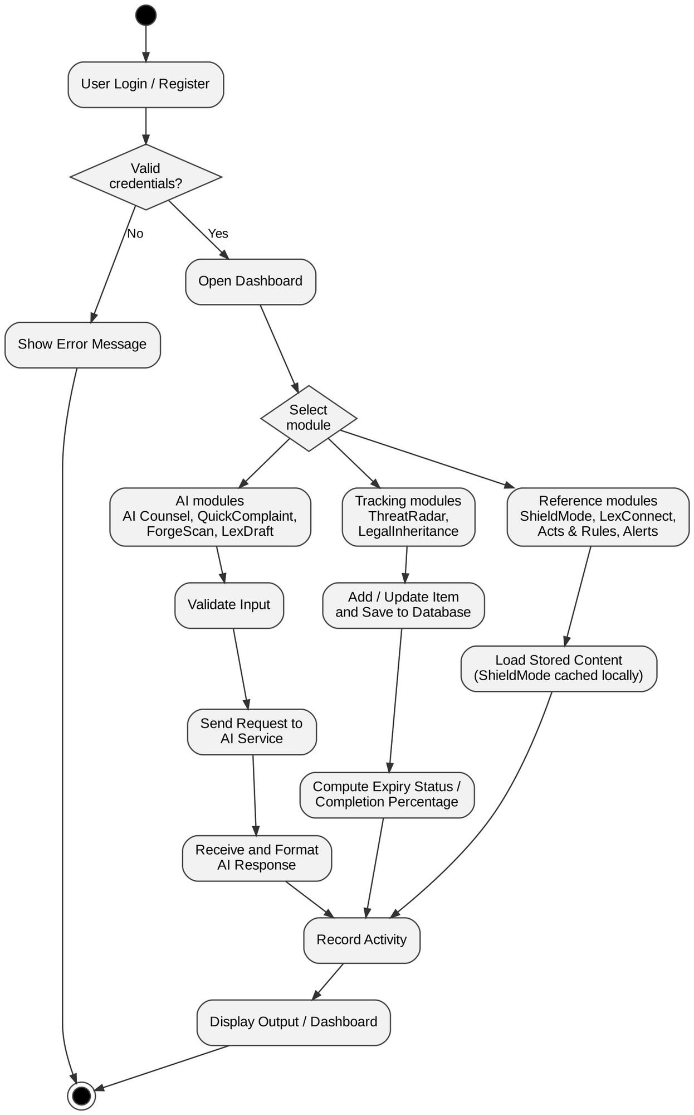
Figure 3.1: Overall system flow of LexOS

  - Algorithm

Algorithm 1: Registration and User Authentication
    - Start
    - User enters full name, email address and password on the registration screen
    - Check that all fields are filled and the email format is valid
    - If the email already exists → display error message; else hash the password and store the user
    - User enters email and password on the sign-in screen
    - Compare the password with the stored hash
    - If valid → create a signed token (JWT) and open the dashboard
    - Else → display an error message
    - End

Algorithm 2: AI Legal Consultation (AI Counsel)
- Start
- User types a legal question or selects a suggested question in the AI panel
- Verify the user’s token; check that the question is not empty
- Build a prompt that asks for a plain-language answer based on Indian law, with a note to consult an advocate
- Send the prompt to the AI service and wait for the reply
- If the reply is received → display it in the chat and record it as recent activity
- Else → display a message asking the user to try again
- End

Algorithm 3: QuickComplaint Generation
- Start
- User enters full name, address, date (default: today) and a description of the situation
- Check that the name, address and description are not empty
- Build a prompt asking for a formal complaint letter with the relevant legal sections
- Send the prompt to the AI service
- Display the generated letter in the “Generated Letter” panel and save it with the activity record
- End

Algorithm 4: ForgeScan Document Risk Analysis
- Start
- User chooses “Upload File” (PDF or TXT) or “Paste Text”
- Check that a supported file or non-empty text is provided
- Extract the text from the document
- Send the text to the AI service with instructions to find red flags, suspicious clauses, missing sections and legal violations
- Display the risk analysis in the “Risk Analysis” panel and save the report
- End

Algorithm 5: LexDraft Document Generation
- Start
- User selects a document type (rent agreement, legal notice, affidavit, power of attorney, NOC letter, offer letter, freelance agreement or vehicle sale agreement)
- User enters the details required for that document type
- Check that the required details are present
- Send the document type and details to the AI service
- Display the generated document for review and download or copying
- End

Algorithm 6: ThreatRadar Document Expiry Tracking
- Start
- User adds a document manually (type, title, expiry date) or scans a document to extract these details
- Save the document for the signed-in user
- For each document calculate days left = expiry date − today
- If days left is less than zero → mark the document Expired; else show “N days left”
- Draw the progress bar according to the time remaining and display all documents as cards
- On delete → remove the document and refresh the list
- End

Algorithm 7: LegalInheritance Completion
- Start
- Load the checklist items for the user and for the spouse (each item has a title, related law and priority)
- User ticks or unticks an item; save the change
- Completion % = ticked items ÷ total items × 100, calculated separately for the user and the spouse
- List all unticked high-priority items under “High Priority Gaps”
- Show the status message and the progress bar (red when critical gaps remain)
- End

Algorithm 8: ShieldMode Rights Display
- Start
- Display the five scenarios: Traffic Stop, Stopped on Street, Being Arrested, Home Search / Raid and Called to Police Station
- User taps a scenario
- Read the rights sections of that scenario from the content cached in the browser
- Display the rights immediately, without calling the server, so that it works without internet
- End

  - System Architecture and UML Diagrams
This section describes the architecture of LexOS using standard UML diagrams. The diagrams follow the structure of the project: a React and Vite frontend, a Node.js and Express backend that uses bcryptjs, jsonwebtoken and Mongoose, and a MongoDB database. The AI features call an external large language model (LLM) service from the server.

Architecture Diagram
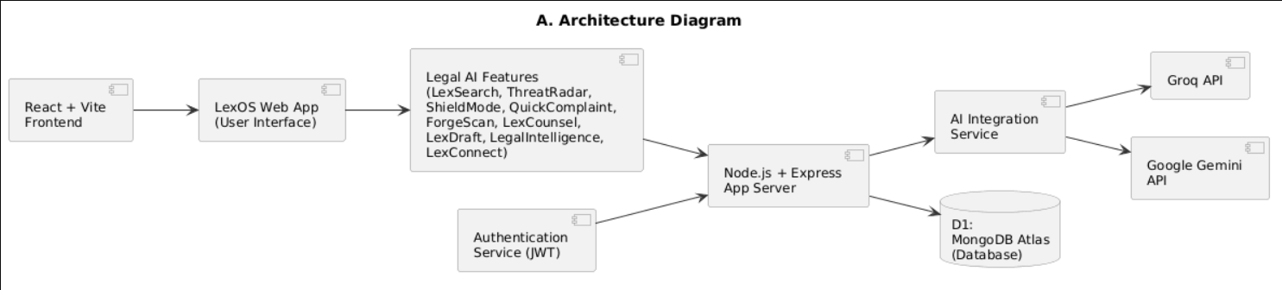

Use Case Diagram
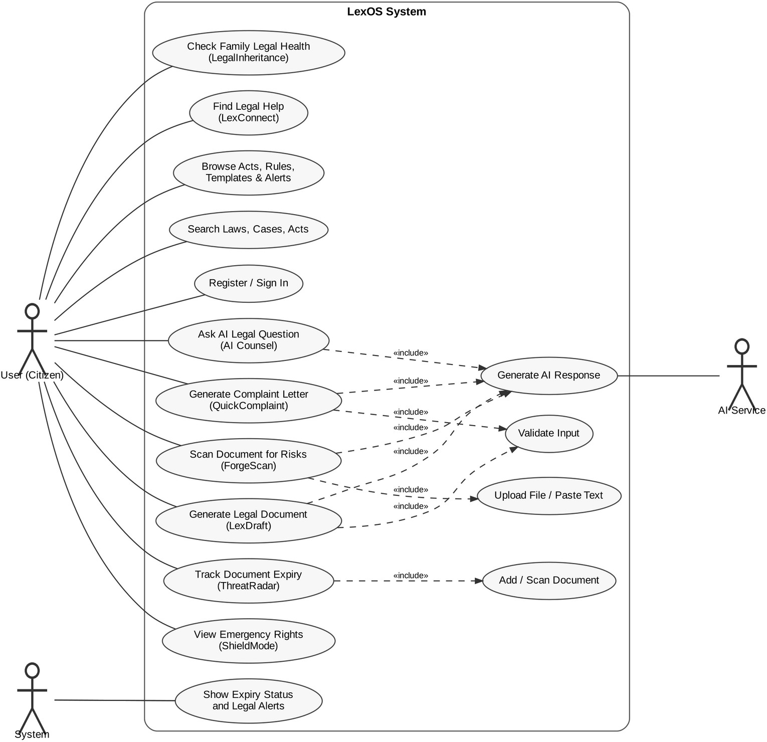

Class Diagrams
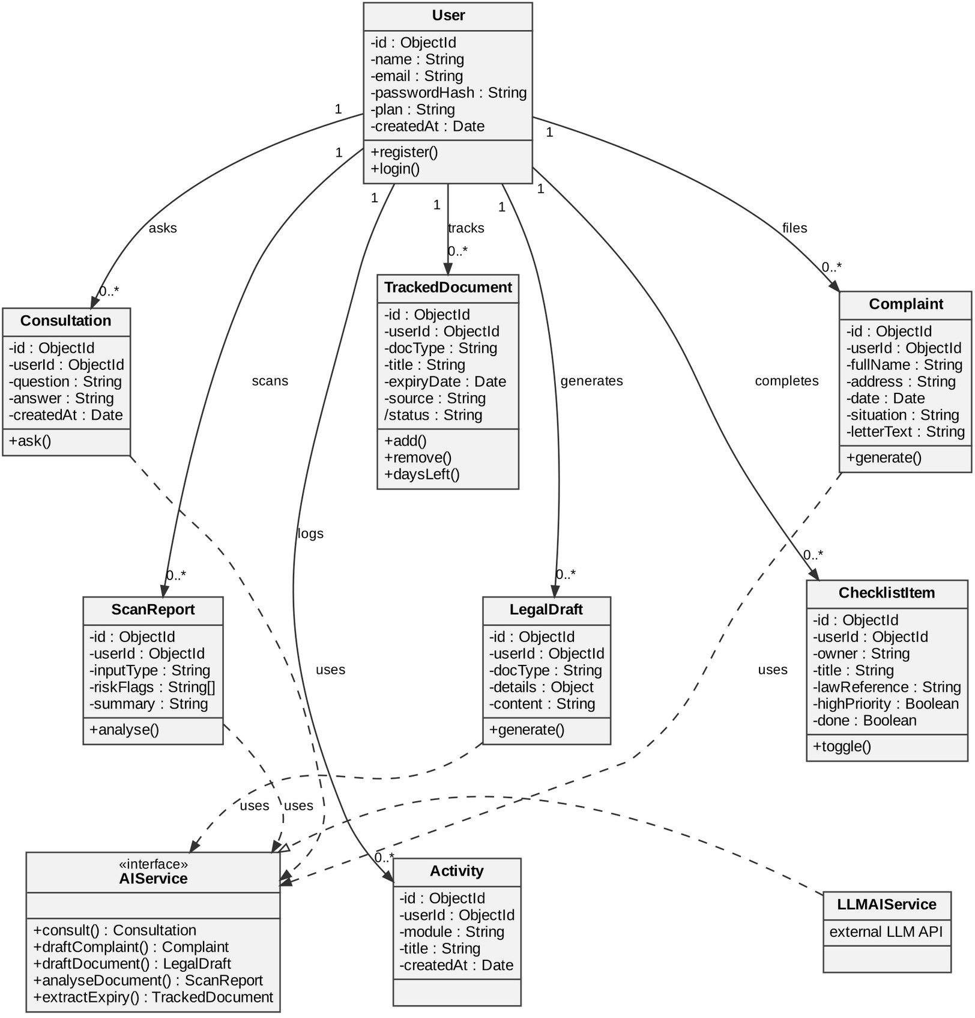

Entity-Relationship Diagram
The entities are stored as MongoDB collections, one set of records per user, linked through the user’s identifier.

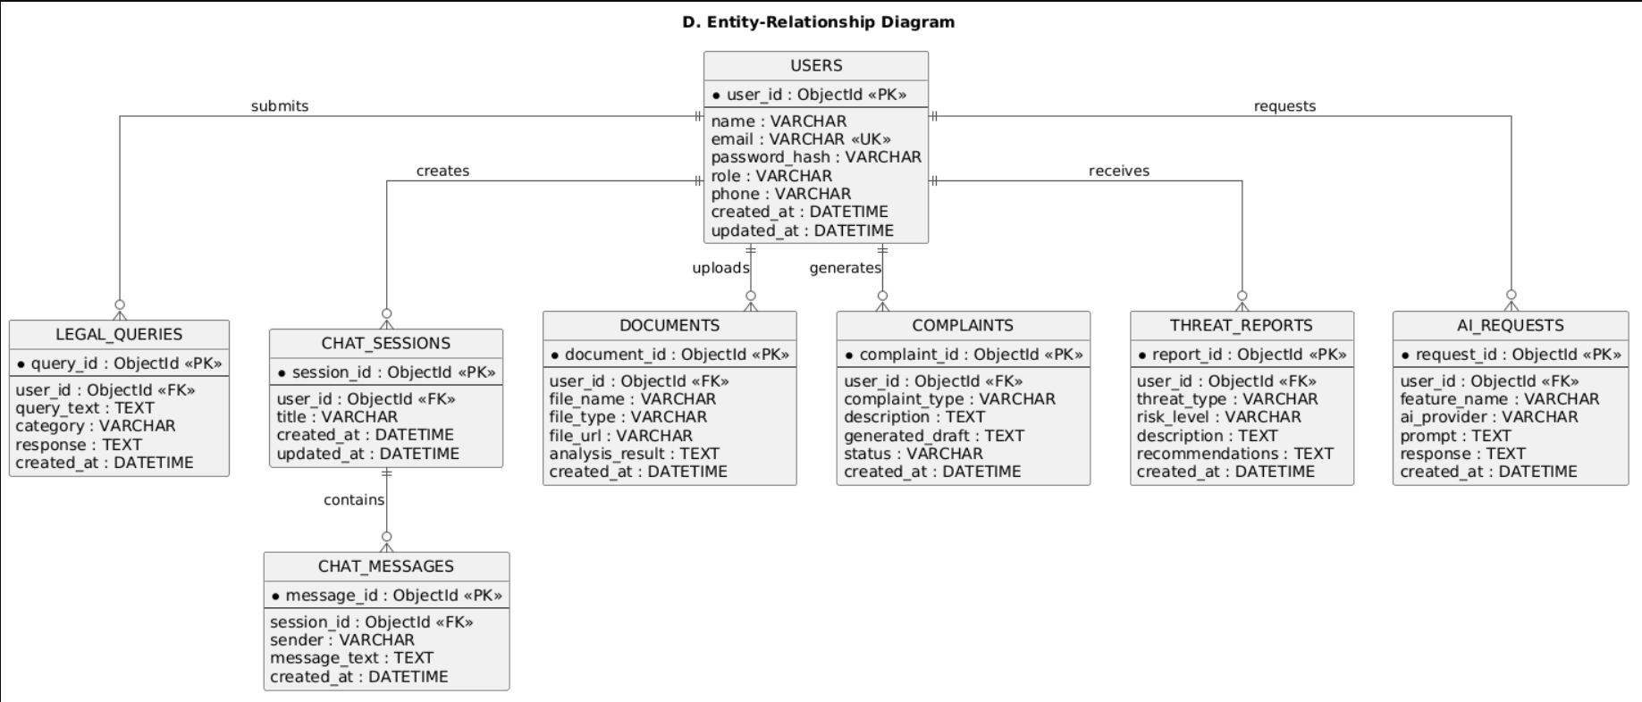

Sequence Diagrams
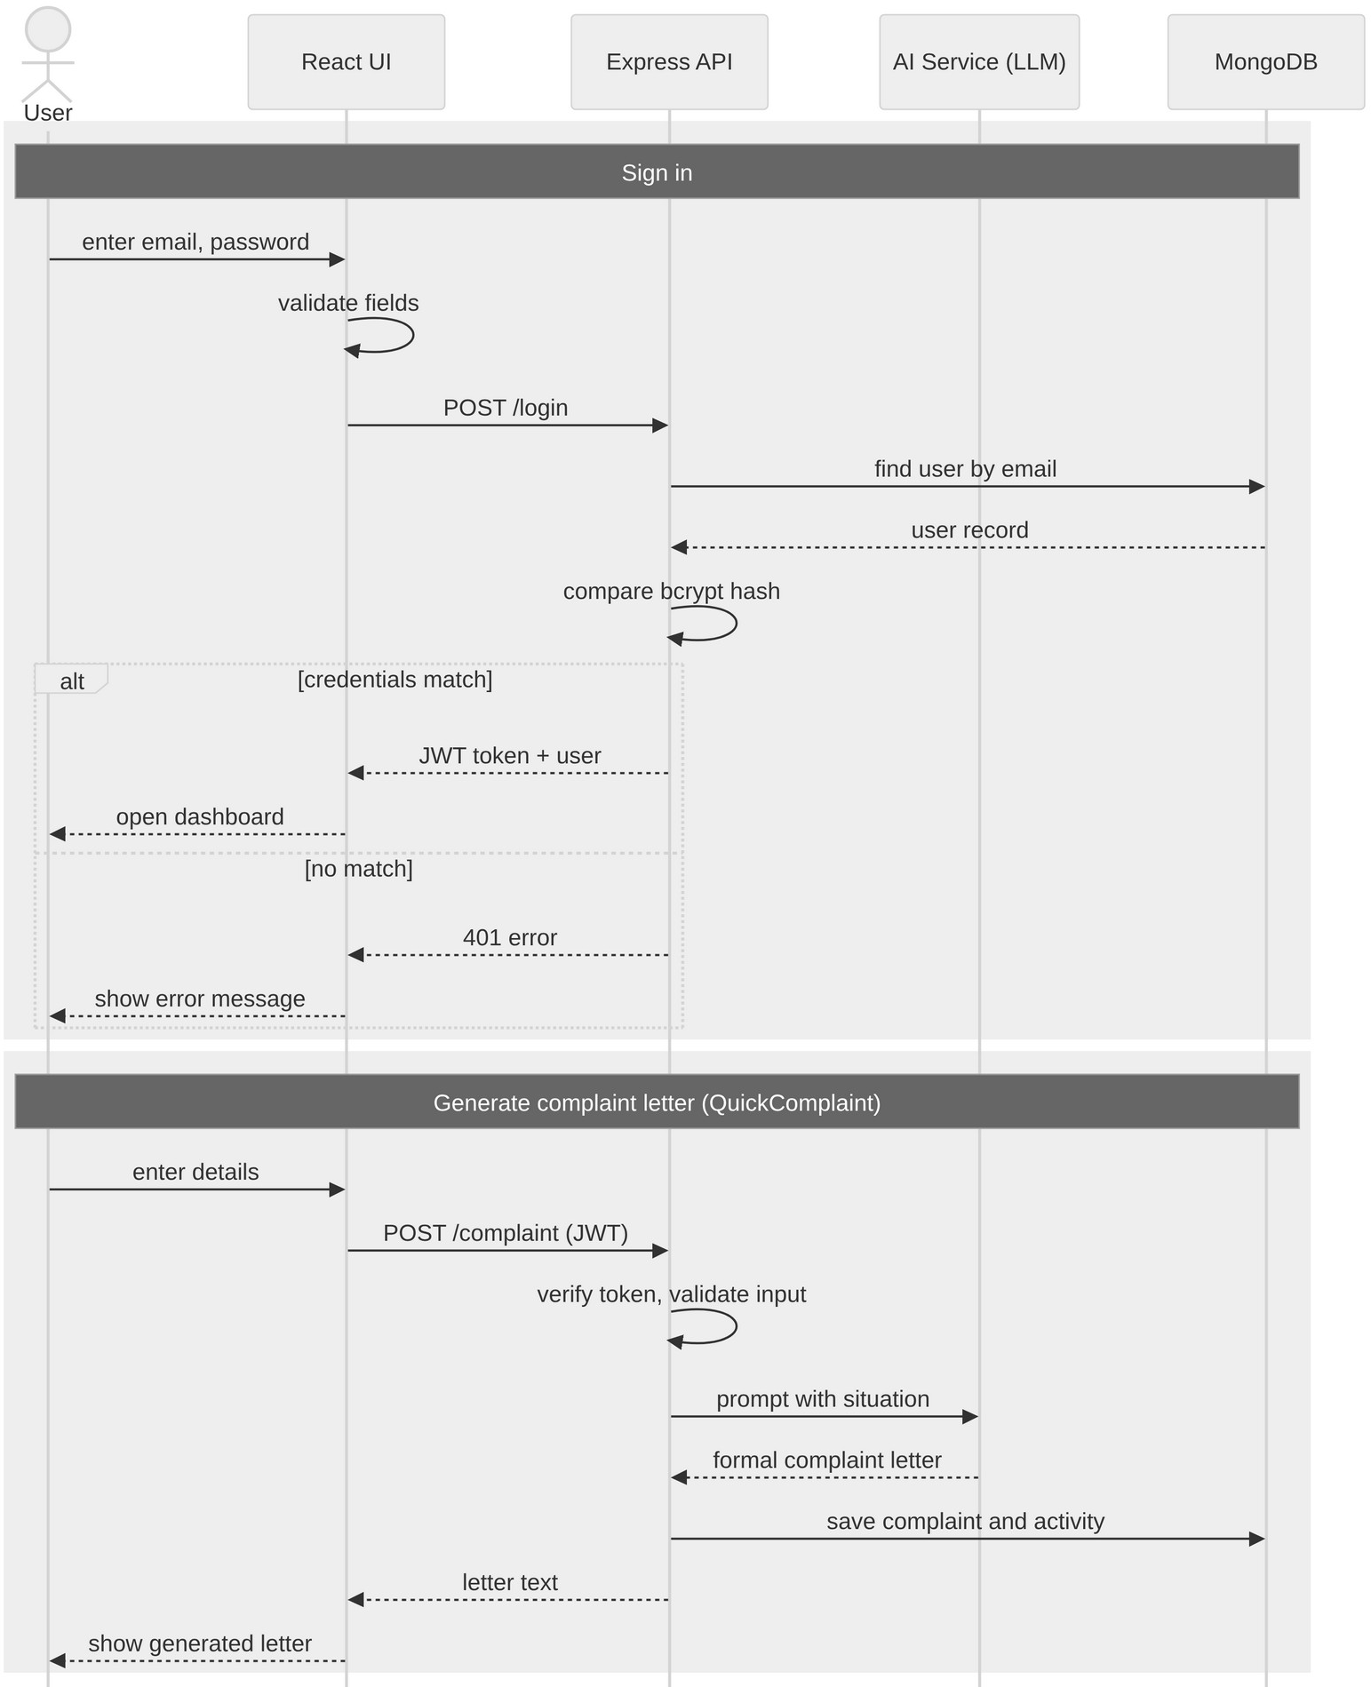

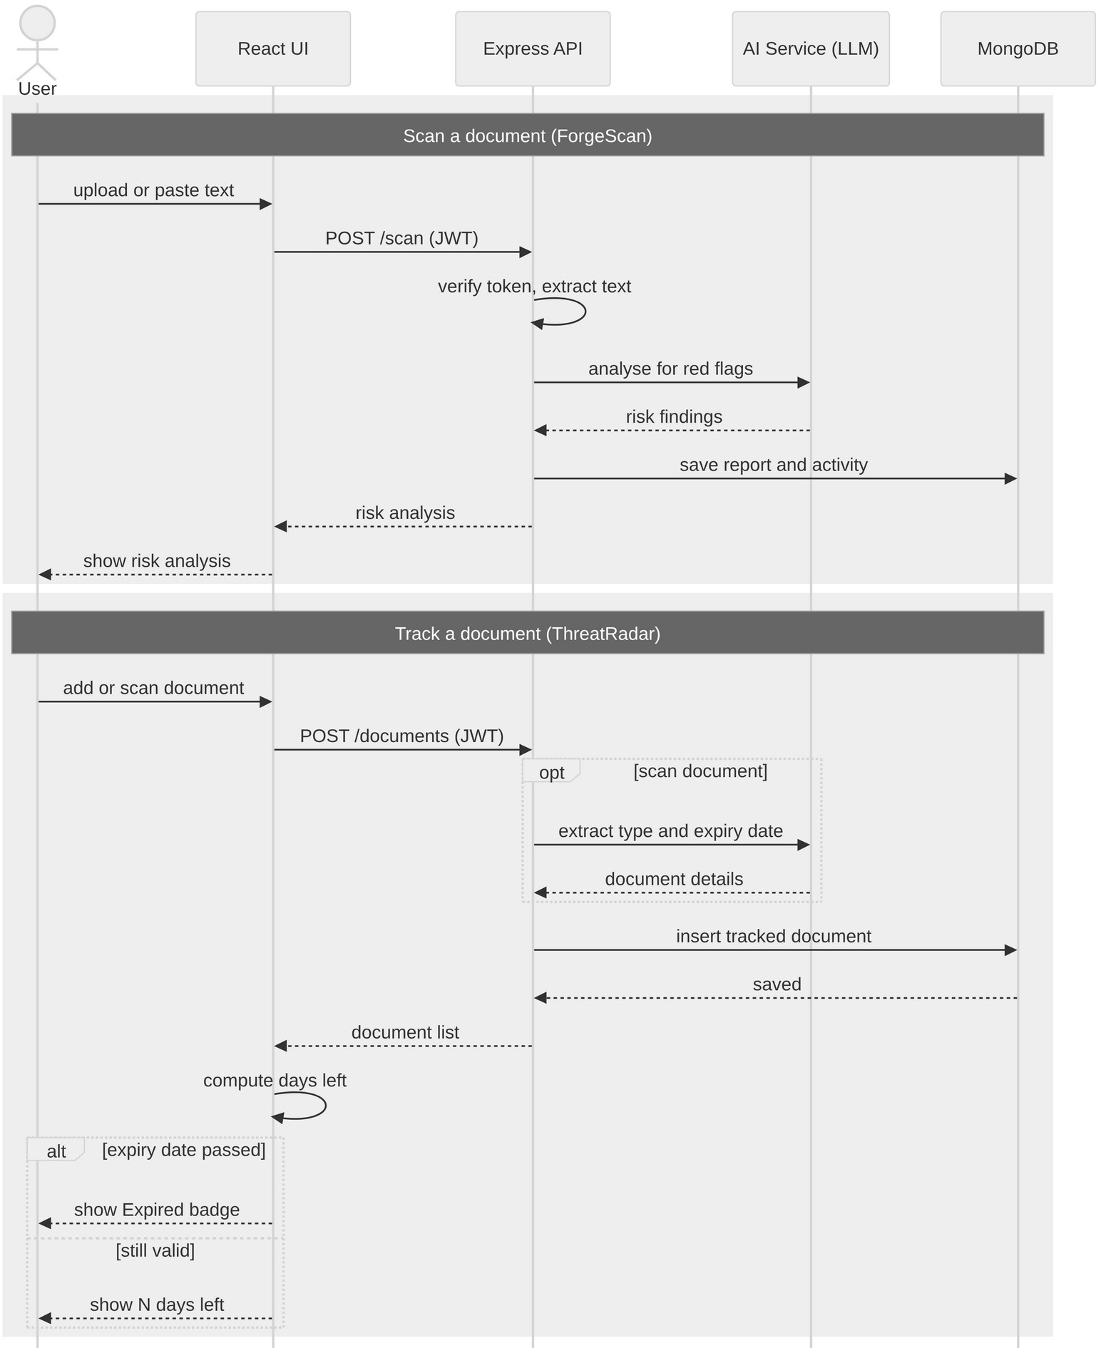

Collaboration Diagram
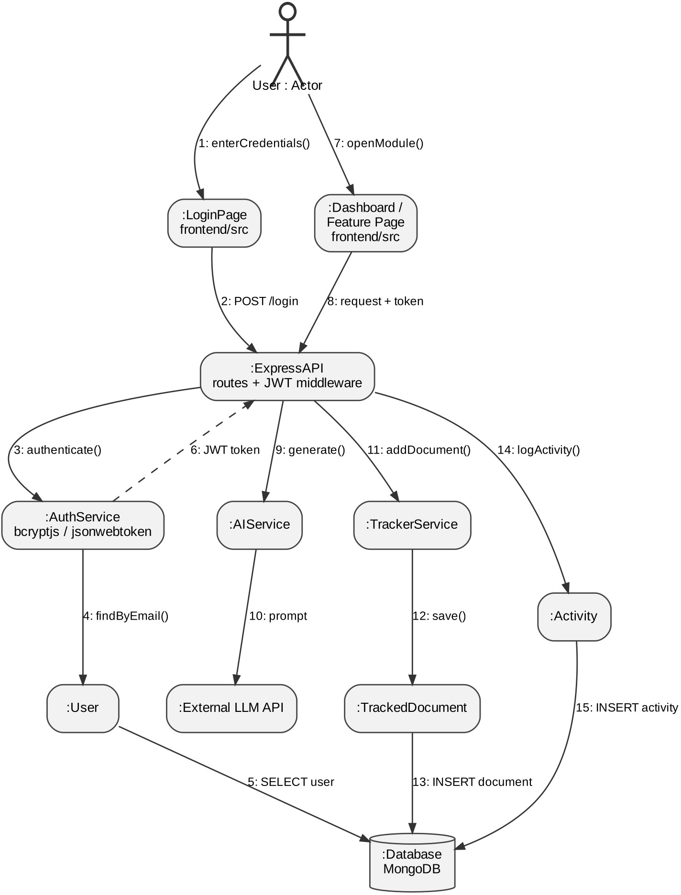

Activity Diagram

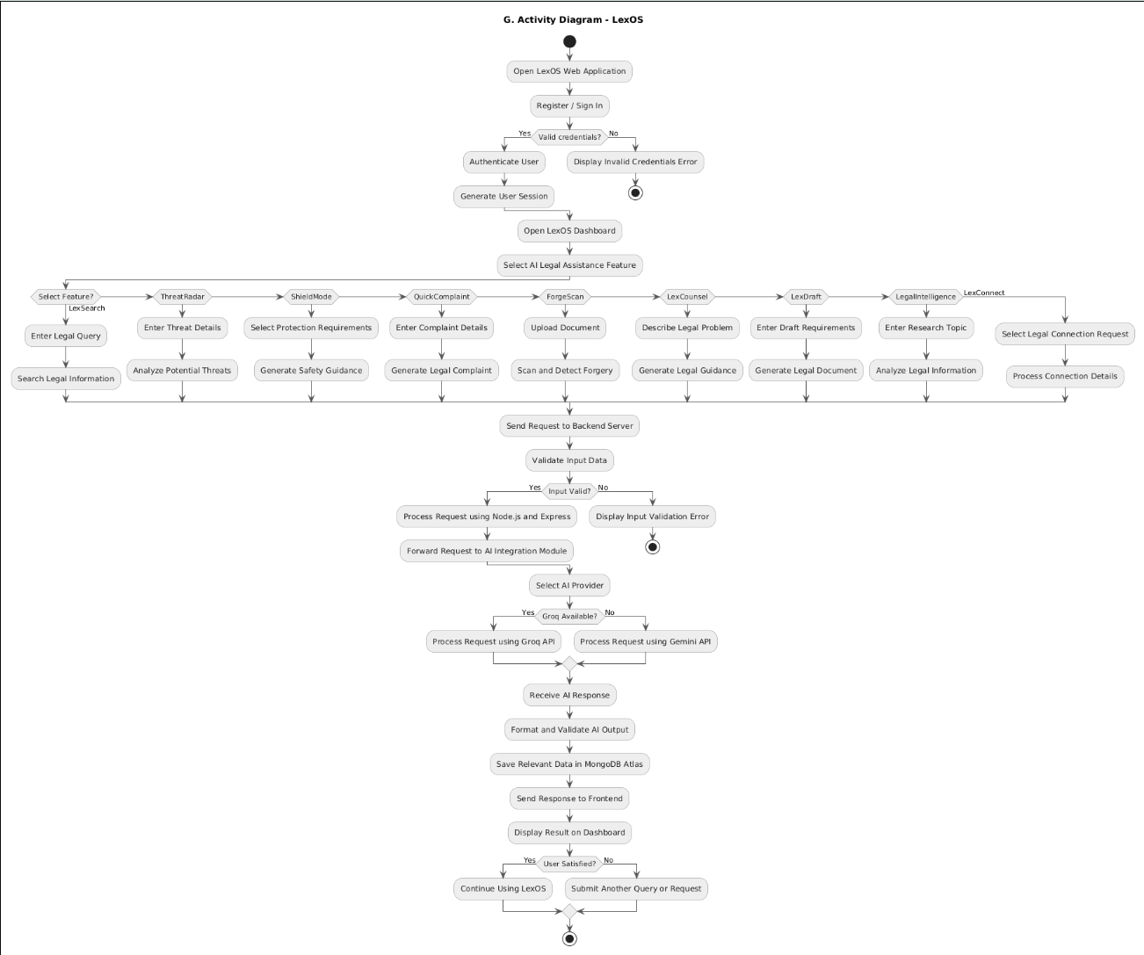

Component Diagram
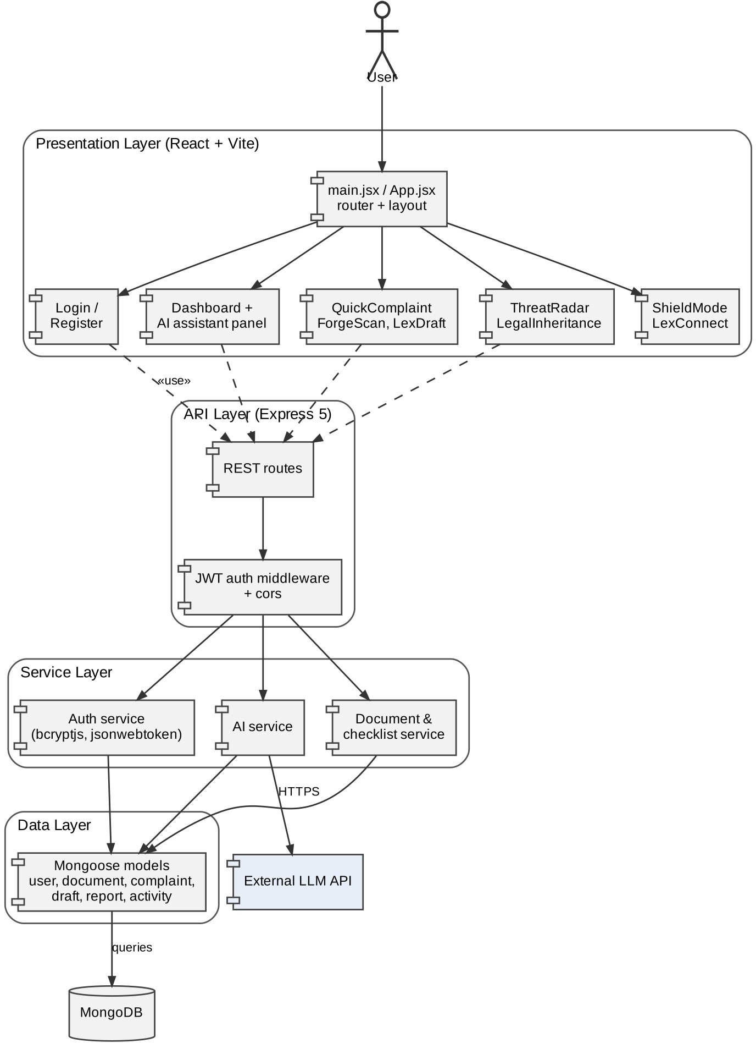

Deployment Diagrams
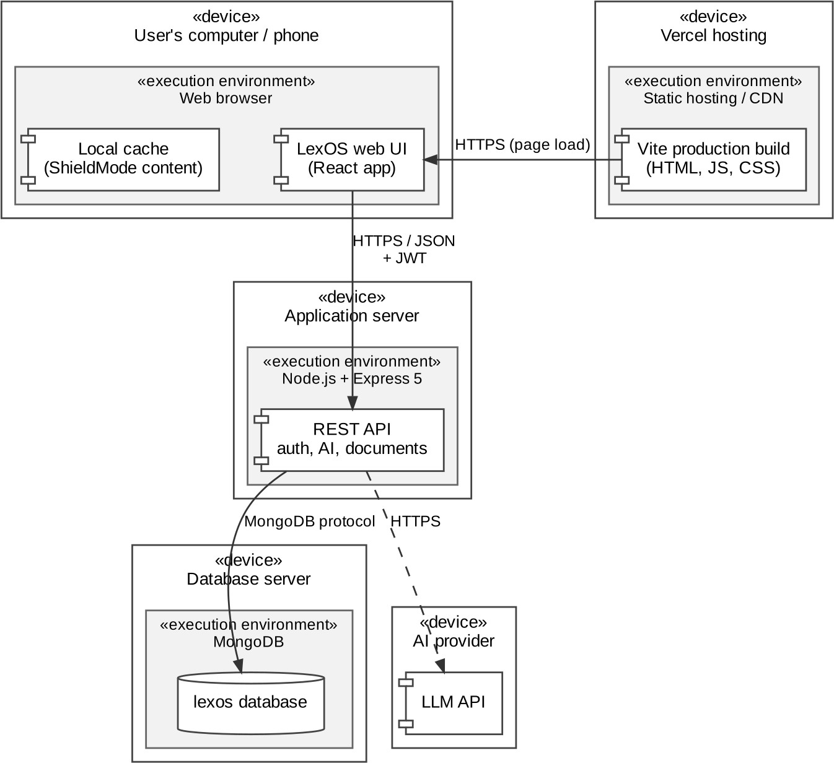

IMPLEMENTATION
  - Description of Development Environment
LexOS is developed in JavaScript with a separate frontend and backend so that the user interface and the server logic can be built independently. The user interface is a single-page application built with React and bundled with Vite, which gives fast development builds and an optimised production bundle. The backend runs on Node.js with the Express framework and exposes a REST API; passwords are protected with bcryptjs, sessions are handled with JSON Web Tokens (jsonwebtoken), cross-origin requests are managed with cors, and settings such as keys and connection strings are kept in environment variables loaded with dotenv. Data is stored in MongoDB and accessed through the Mongoose library. The frontend is deployed on Vercel.
ESLint is used to keep the frontend code consistent. The automated test script of the backend has not yet been written; testing so far has been done manually on the running application (Chapter 5). Table 4.1 lists the project structure and the responsibility of each folder.

Folder / file | Purpose
frontend/src/ | React source code: application entry (main.jsx), root component (App.jsx), global and component styles (index.css, App.css) and images
frontend/public/ | Static files served as they are, such as the icon sprite and favicon
frontend/index.html, vite.config.js | HTML entry page and Vite build configuration
frontend/package.json | Frontend dependencies (react, react-dom) and scripts for dev, build, lint and preview
backend/ | Node.js and Express server: REST API, authentication (bcryptjs, jsonwebtoken), database access through Mongoose, configuration through dotenv and cors
backend/package.json | Backend dependencies (express, mongoose, bcryptjs, jsonwebtoken, cors, dotenv)
Table 4.1: Project structure
The interface is organised as a dashboard with a left navigation menu (Dashboard, AI Counsel, QuickComplaint, Documents, Acts & Rules, Templates, Legal Alerts, LexConnect and Settings), a central area for the selected module and a right-hand panel with the AI assistant, recent activity and legal alerts. A dark theme with gold accents is used throughout, and each feature opens on its own screen with a Back button.

  - Tools and Technologies Used

Frontend Technologies
    - JavaScript (JSX): Core programming language of the user interface.
    - React 19: Library used to build the component-based, interactive single-page application.
    - Vite: Build tool and development server used to bundle the frontend.
    - HTML5 & CSS3: Page structure and the custom dark theme, cards, badges and progress bars.
    - ESLint: Linting of the frontend code.

Backend Technologies
- Node.js: Runtime environment for the server.
- Express 5: Web framework used to build the REST API.
- bcryptjs: Hashing of passwords before they are stored.
- jsonwebtoken: Creation and verification of JWT tokens for signed-in users.
- cors and dotenv: Cross-origin access control and environment-based configuration.
- External large language model (LLM) API: Used from the server for consultation, complaint drafting, document analysis and document generation.

Database
- MongoDB: Document database used to store users, tracked documents, complaints, generated drafts, scan reports, checklist items and recent activity.
- Mongoose: Object-data-mapping library used to define the models and validate the data.

Deployment and Development Tools
- Vercel: Hosting and deployment of the web application.
- npm: Package management for the frontend and backend.
- Web browser developer tools: Manual testing and checking of the screens.

  - Screenshots of the application
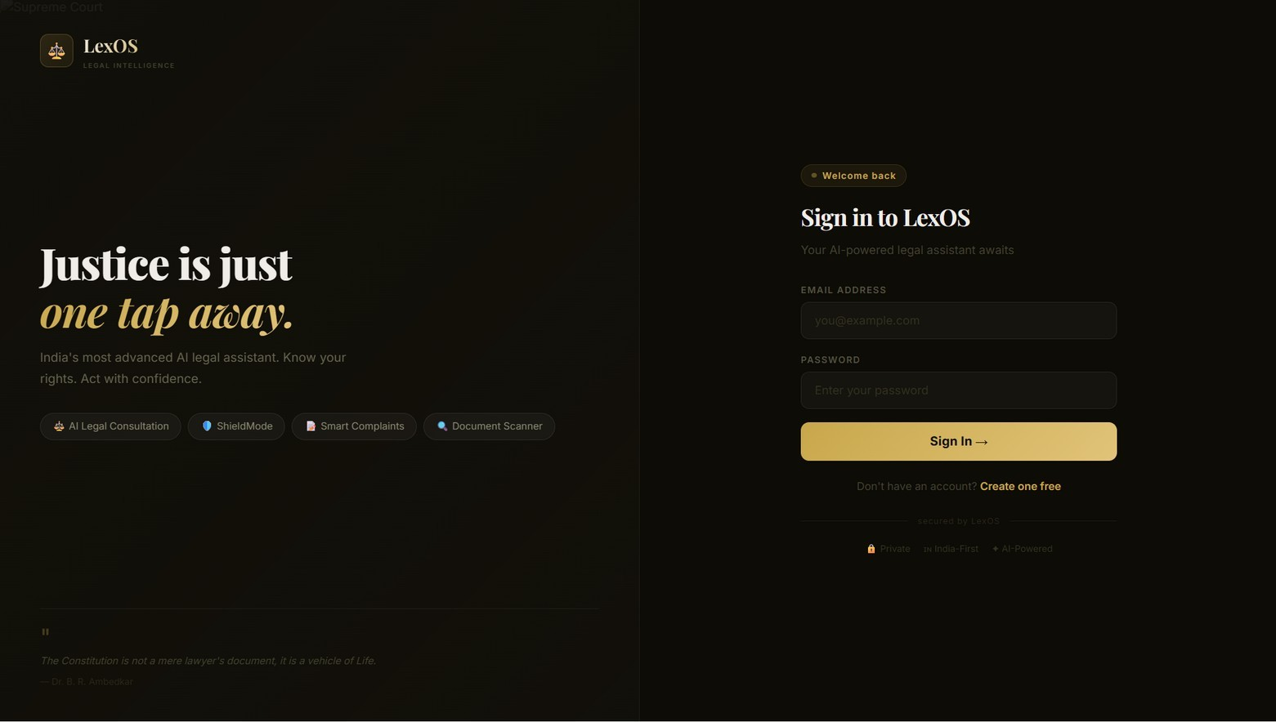
Figure 4.1: Sign-in screen
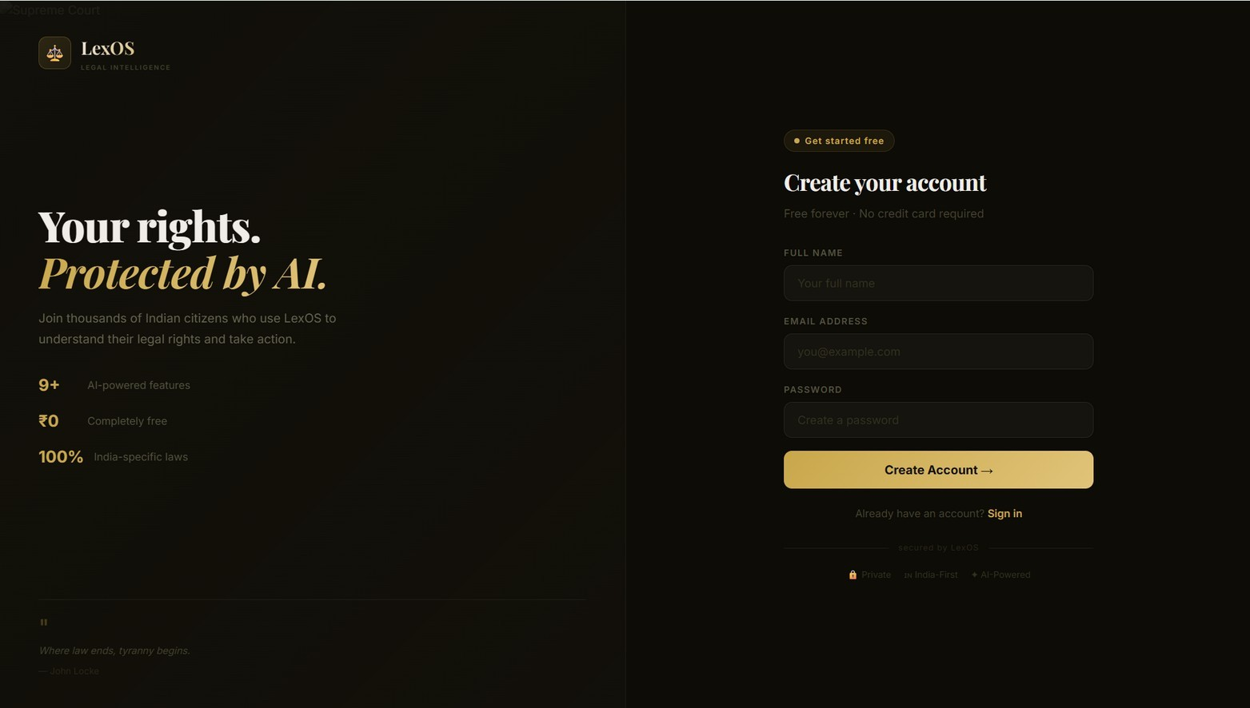
Figure 4.2: Registration screen

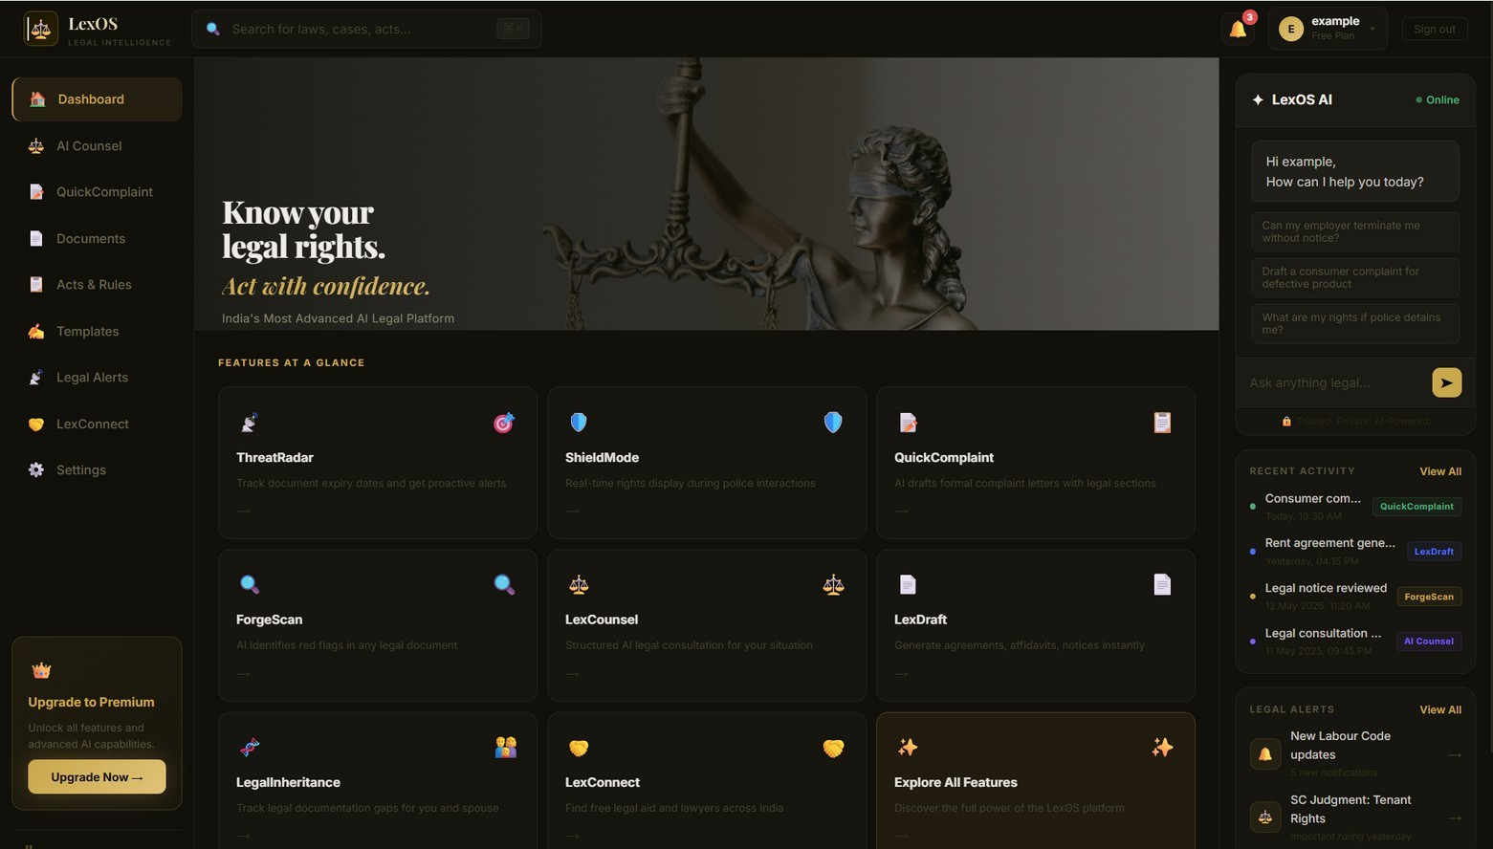
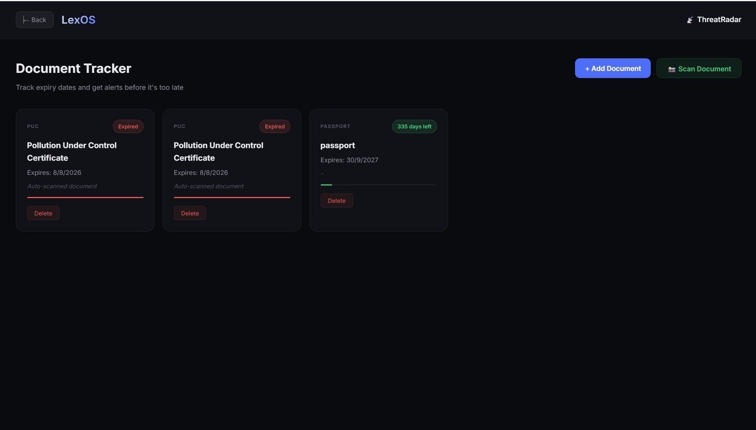
Figure 4.3: Dashboard with feature cards, AI assistant panel, recent activity and legal alerts

Figure 4.4: ThreatRadar document tracker with expiry status

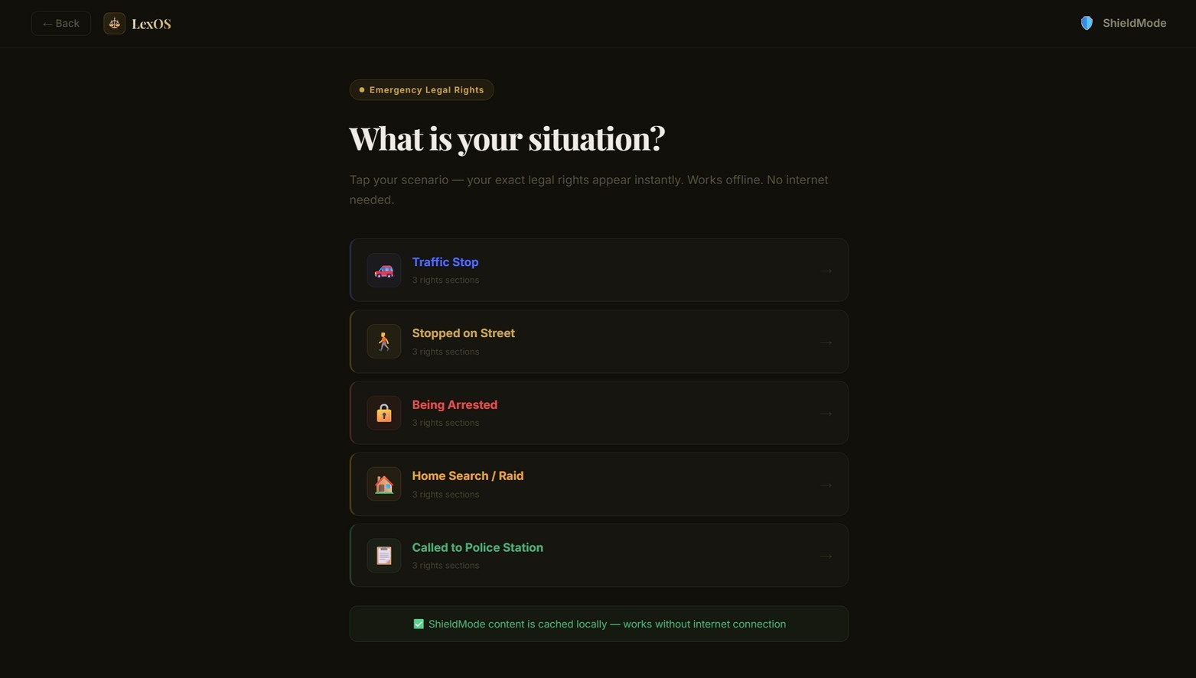
Figure 4.5: ShieldMode emergency rights scenarios (works offline)
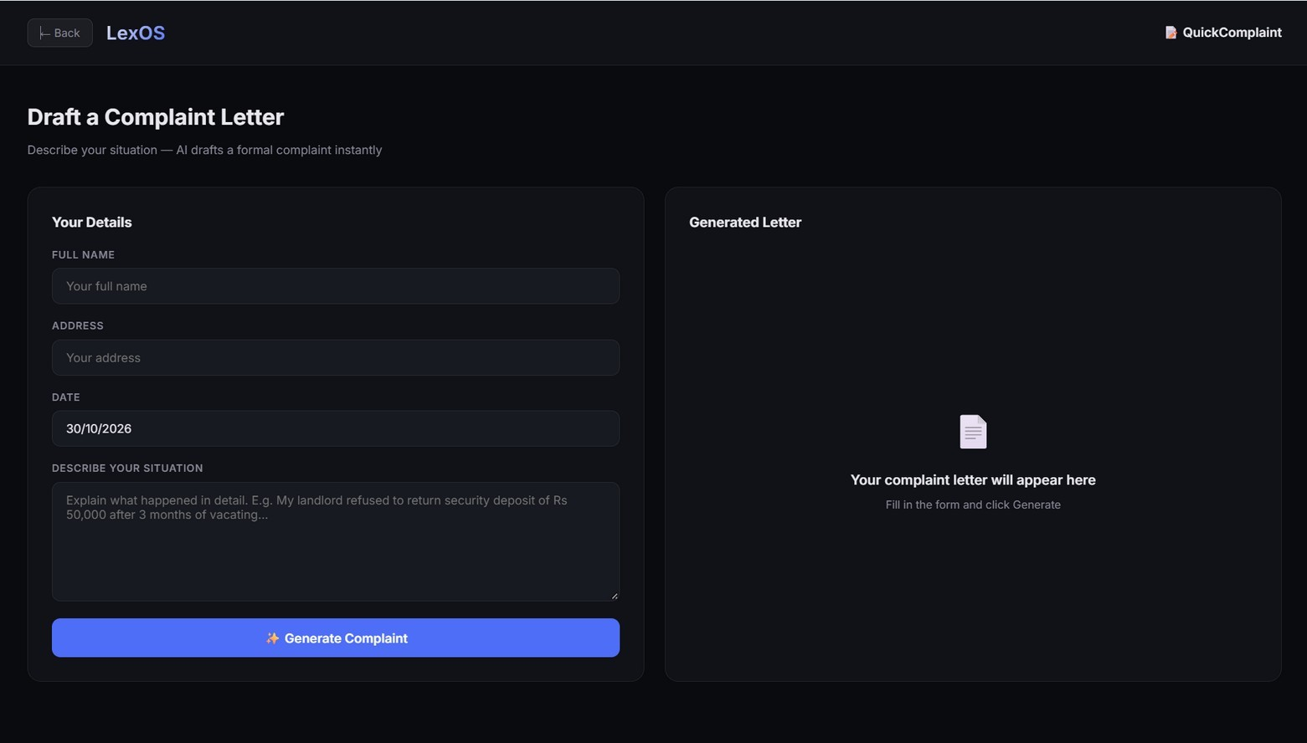
Figure 4.6: QuickComplaint form and generated letter panel

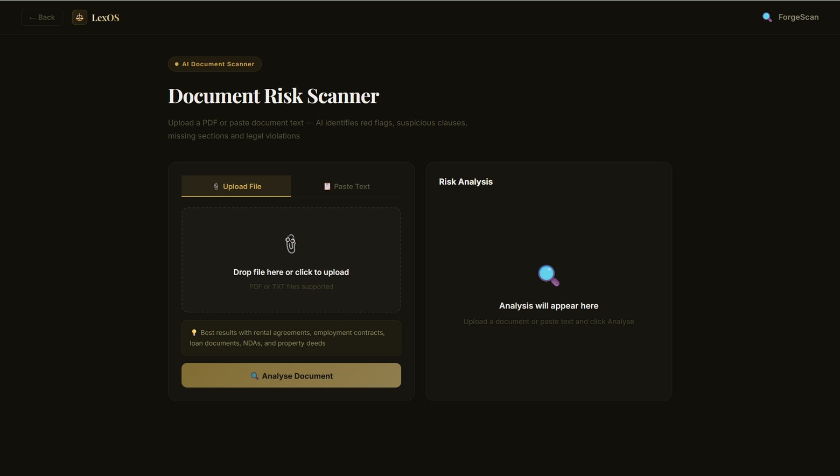
Figure 4.7: ForgeScan document risk scanner (upload file or paste text)
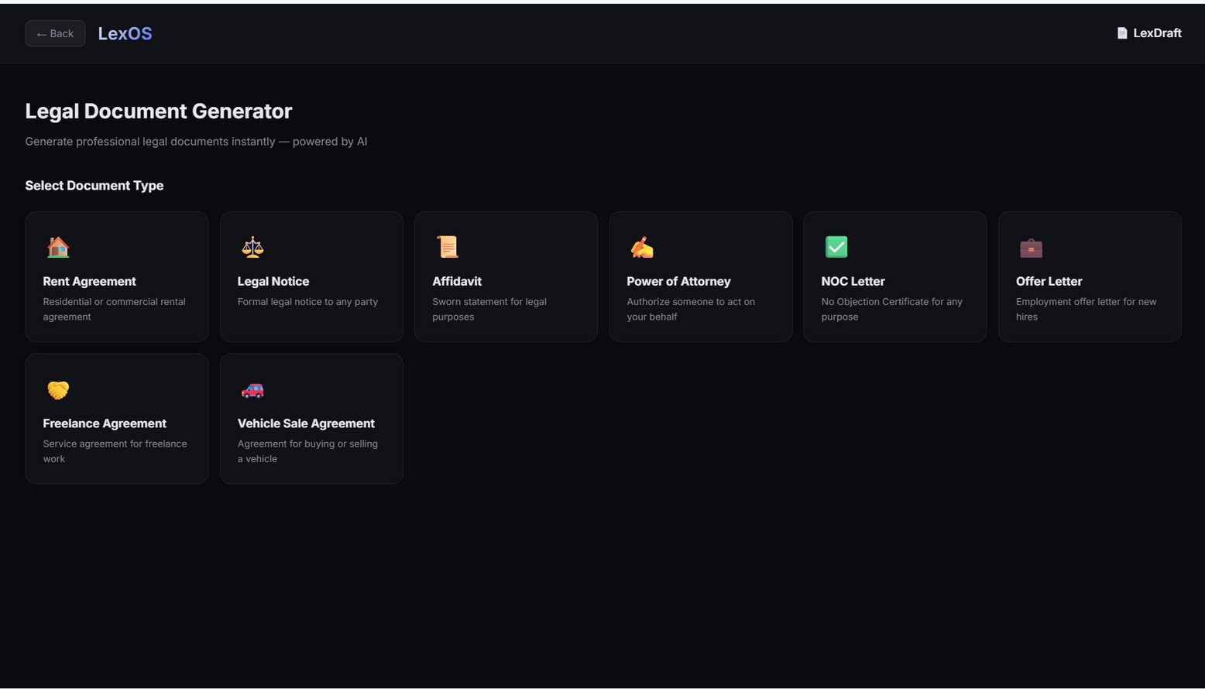
Figure 4.8: LexDraft legal document generator

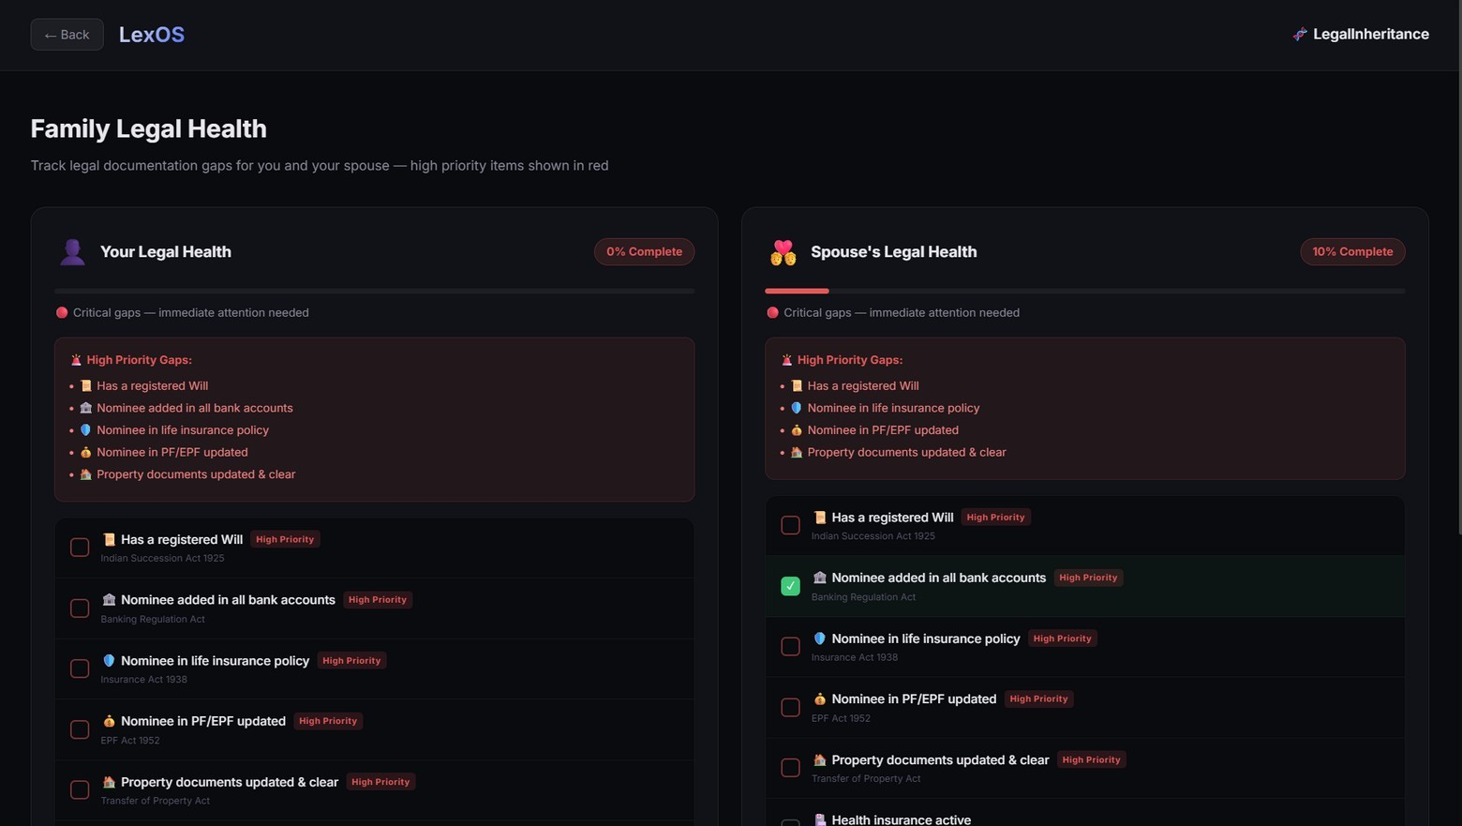
Figure 4.9: LegalInheritance family legal-health checklist
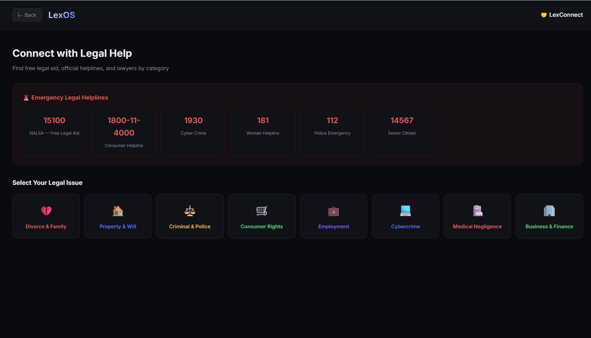
Figure 4.10: LexConnect helplines and legal-aid categories

TESTING AND VALIDATION
  - Validation of Data Integrity and Accuracy
LexOS applies the following mechanisms so that the information shown to the user stays accurate and the user’s data stays protected:
    - Required-field validation: Sign-in, registration and the complaint form need their fields to be filled before a request is made.
    - Secure credentials: Passwords are stored as bcrypt hashes and never as plain text, and access to a user’s data needs a valid signed token.
    - Per-user data: Tracked documents, complaints, drafts, scan reports, checklist items and activity are stored against the user’s identifier, so each user sees only their own records.
    - Calculated status: The Expired or “N days left” status in ThreatRadar and the percentage in LegalInheritance are calculated from the stored dates and ticked items, so they cannot be typed in wrongly.
    - Input restrictions: ForgeScan accepts only PDF or TXT files or pasted text, and the complaint date is pre-filled with the current date.
    - Offline reference content: ShieldMode content is cached in the browser, so the rights shown do not depend on a network call.
    - Priority highlighting: High-priority legal gaps are shown in red with the related law, so that critical items are not missed.
    - AI output verification: AI-generated text is presented as guidance, and the user is advised to verify it or consult an advocate.
The test cases in Table 5.1 were carried out manually on the deployed application. Each test checks that the screen is displayed with the expected content; the results shown were observed in the screens in Section 4.3.

Test case | Expected result | Result
Sign-in and registration screens display | Forms and fields are shown correctly, with links to switch between them | Pass
Sign in with a registered account | The dashboard opens with the user’s name and plan | Pass
Dashboard displays the modules | Feature cards, AI assistant panel, recent activity and legal alerts are shown | Pass
ThreatRadar lists documents | Each document shows its type, expiry date and an Expired or days-left badge | Pass
ShieldMode scenarios | Five situations are listed, each with three rights sections, and the offline note is shown | Pass
QuickComplaint form | Name, address, date (today) and situation fields and the Generate button are shown | Pass

Test case | Expected result | Result
ForgeScan input options | Upload File and Paste Text tabs, supported file types and the Analyse button are shown | Pass
LexDraft document types | Eight document types are shown for selection | Pass
LegalInheritance checklist | Separate checklists for the user and spouse with percentage complete and high-priority gaps | Pass
LexConnect | Six emergency helplines and eight legal-issue categories are shown | Pass
Table 5.1: Test cases and results
These tests check the screens and their content. Automated tests for the API and a systematic review of the quality of AI-generated answers are planned as future work.
  - Performance Evaluation
The performance of the application was evaluated informally on the deployed application, based on responsiveness, efficiency and behaviour on a desktop browser.
    - Screen responsiveness: The application is a single-page app, so moving between the dashboard and the modules does not reload the page and the screens open immediately.
    - Optimised bundle: Vite produces a minified production bundle that is served from Vercel’s hosting network.
    - Offline reference: ShieldMode shows its rights content from the local cache without any network request.
    - AI response time: The time to generate a consultation, complaint, draft or scan depends on the external AI service and the length of the input; a loading state is shown while the request is processed.
    - Credential handling cost: Password hashing is deliberately slow to resist guessing, yet sign-in completes without a noticeable delay.
    - Scalability considerations: Tokens are stateless, so the API can be scaled across several instances, and the fields used for lookup (user identifier, email and expiry date) are intended to be indexed in MongoDB.
Formal load testing has not yet been carried out and is planned. Within the scope of the testing done, the platform shows responsive and reliable behaviour.

CONCLUSION
      - Summary of the Project Achievements
LexOS provides a working, deployed platform that puts the legal tools a citizen commonly needs into one dashboard. The interface of every module has been implemented and demonstrated, and the project achieves the following:
        - Users can register and sign in securely and use a personal dashboard with their plan, notifications, recent activity and legal alerts.
        - An AI assistant answers legal questions in plain language from the dashboard panel and the consultation module.
        - QuickComplaint drafts a formal complaint letter from a short description of the problem.
        - ForgeScan analyses an uploaded or pasted document and reports red flags and missing clauses.
        - LexDraft generates eight types of commonly used legal documents.
        - ThreatRadar tracks document expiry dates and clearly shows Expired or days-left status.
        - ShieldMode shows rights during police interactions and works offline, and LexConnect lists emergency helplines and legal-aid categories.
        - LegalInheritance highlights high-priority documentation gaps for the user and the spouse with a completion percentage.
Overall, the project demonstrates a practical digital solution that helps citizens understand their rights, prepare legal documents and avoid legal problems before they occur.
      - Key Learning
        - Designed and built a multi-screen single-page web application with React and Vite.
        - Learned to build a REST API with Node.js and Express and to structure a separate frontend and backend.
        - Understood token-based authentication with JSON Web Tokens and secure password storage with bcrypt hashing.
        - Gained experience in modelling application data as MongoDB collections with Mongoose.
        - Learned how to use a large language model from a server for drafting and analysis, and how to write prompts that give useful, bounded answers.
        - Understood the limits of AI in legal work and the importance of clear disclaimers and of local reference content that does not depend on AI.

        - Designed a consistent dark interface with cards, badges and progress bars that make the status of a document or checklist clear at a glance.
        - Learned to deploy a web application on Vercel and to manage configuration through environment variables.
        - Learned how to read legal sources and turn them into practical guidance, such as rights in common police situations.
        - Improved problem-solving, documentation and presentation skills through iterative development.
      - Future Scope
        - Automated unit and API tests, and a formal review of the accuracy of AI-generated legal answers.
        - Grounding of AI answers in the text of acts and judgments through retrieval, with citations to the sections used.
        - Email, SMS or push notifications for approaching document expiry dates and new legal alerts.
        - Support for regional languages, voice input and voice output for wider reach.
        - Searchable database of acts, rules and landmark judgments with plain-language summaries.
        - Booking of consultations with verified lawyers and legal-aid clinics through LexConnect.
        - Digital signing and e-stamping support for the documents generated in LexDraft.
        - Case tracking with court status, hearing dates and reminders.
        - Secure document vault with encrypted storage for the user’s important papers.
        - A mobile application or progressive web app with fully offline access to ShieldMode.

REFERENCES
- Government of India. (1950). The Constitution of India. Ministry of Law and Justice, New Delhi.
- Government of India. (1987). The Legal Services Authorities Act, 1987. Ministry of Law and Justice, New Delhi.
- Government of India. (2019). The Consumer Protection Act, 2019. Ministry of Law and Justice, New Delhi.
- Government of India. (1925). The Indian Succession Act, 1925. Ministry of Law and Justice, New Delhi.
- Meta Platforms, Inc. (2024). React documentation. Retrieved from https://react.dev/
- Vite. (2024). Vite guide. Retrieved from https://vite.dev/guide/
- OpenJS Foundation. (2024). Node.js documentation. Retrieved from https://nodejs.org/en/docs
- Express. (2024). Express documentation. Retrieved from https://expressjs.com/
- MongoDB, Inc. (2024). MongoDB manual. Retrieved from https://www.mongodb.com/docs/manual/
- Mongoose. (2024). Mongoose documentation. Retrieved from https://mongoosejs.com/docs/
- Jones, M., Bradley, J., & Sakimura, N. (2015). JSON Web Token (JWT) (RFC 7519). IETF.
- Vercel Inc. (2024). Vercel documentation. Retrieved from https://vercel.com/docs
- Pressman, R. S., & Maxim, B. R. (2019). Software engineering: A practitioner’s approach (9th ed.). McGraw-Hill.

