Hotel Management System (A database project)

By

Kara Lena Summer

Manmeet Singh Bains

Shashi Bala Lnu

Prince Gyamfi

An assignment submitted in partial fulfillment of the requirement for ANA 650

Database Design for Analytics

National University

Professor Eugene Roytman

October 27, 2018

**Logical ERD**

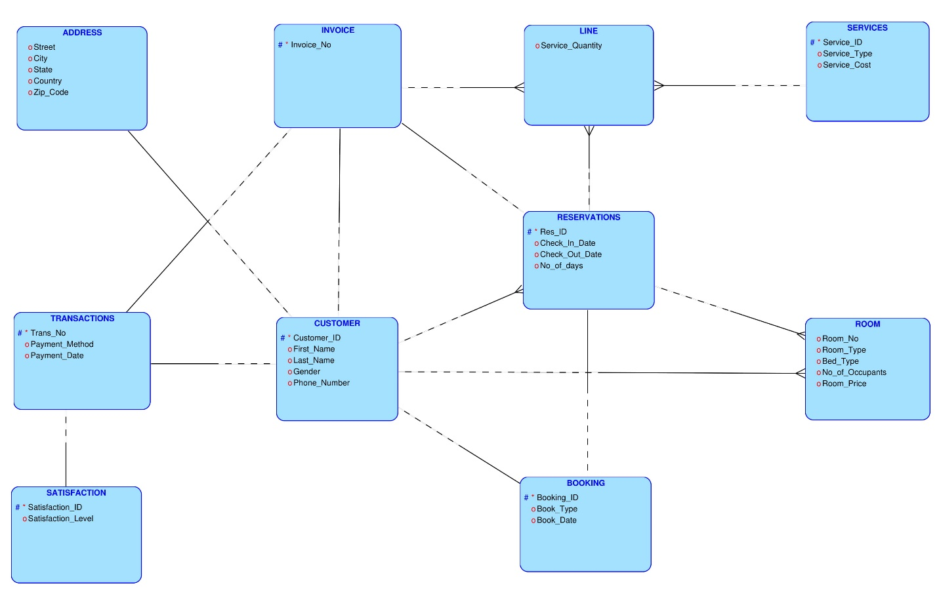

**Relational ERD**

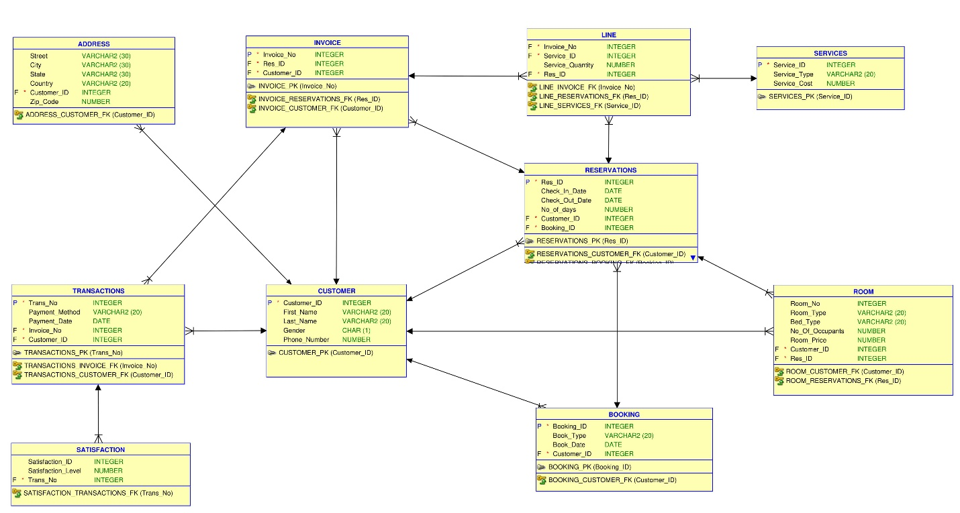

SQL CODING:

(

ALTER SESSION SET NLS_DATE_FORMAT = 'MM/DD/YYYY';

CREATE TABLE customer (

customer_id number NOT NULL primary key,

first_name VARCHAR2(20),

last_name VARCHAR2(20),

Gender VARCHAR2(20),

phone_number NUMBER

);

INSERT INTO customer VALUES ('21225','Bryson','smithson','M','2233234');

INSERT INTO customer VALUES ('21226','Mani','Bains','M','2233235');

INSERT INTO customer VALUES ('21227','Kara','lena','F','2233236');

INSERT INTO customer VALUES ('21228','Shashi','Lnu','F','2233237');

INSERT INTO customer VALUES ('21229','Prince','Sr','M','2233238');

INSERT INTO customer VALUES ('21230','john','kell','M','2233239');

INSERT INTO customer VALUES ('21231','harry','Peter','M','2233240');

INSERT INTO customer VALUES ('21232','Ramesh','Kumar','M','2233241');

INSERT INTO customer VALUES ('21233','David','Cooper','M','2233242');

INSERT INTO customer VALUES ('21234','Steve','Duck','M','2233243');

INSERT INTO customer VALUES ('21235','Henry','Persic','M','2233244');

INSERT INTO customer VALUES ('21236','deepak','Kumar','M','2233245');

INSERT INTO customer VALUES ('21237','Mary','elizabeth','F','2233246');

INSERT INTO customer VALUES ('21238','Betty','ELls','F','2233247');

INSERT INTO customer VALUES ('21239','Kelly','Kender','F','2233248');

INSERT INTO customer VALUES ('21240','Joshua','Second','M','2233249');

INSERT INTO customer VALUES ('21241','Mary','Jane','M','2233250');

INSERT INTO customer VALUES ('21242','Harry','Timon','M','2233251');

INSERT INTO customer VALUES ('21243','Ronald','Wayne','M','2233252');

INSERT INTO customer VALUES ('21244','Kelly','Brooke','F','2233253');

INSERT INTO customer VALUES ('21245','Steven','David','M','2233254');

INSERT INTO customer VALUES ('21246','Philip','Jones','M','2233255');

INSERT INTO customer VALUES ('21247','Michael','Sensom','M','2233256');

INSERT INTO customer VALUES ('21248','Rubin','Lembo','M','2233257');

INSERT INTO customer VALUES ('21249','Kirsten','Lira','F','2233258');

INSERT INTO customer VALUES ('21250','Alysa','Voutur','F','2233259');

INSERT INTO customer VALUES ('21251','Rufus','Blystone','M','2233260');

INSERT INTO customer VALUES ('21252','Steven','Byrnes','M','2233261');

INSERT INTO customer VALUES ('21253','Florrie','Ronald','F','2233262');

INSERT INTO customer VALUES ('21254','Jeania','Giorgio','F','2233263');

INSERT INTO customer VALUES ('21255','Paola','lahey','F','2233264');

INSERT INTO customer VALUES ('21256','Ashley','Garnett','F','2233265');

INSERT INTO customer VALUES ('21257','Russell','Knick','M','2233266');

INSERT INTO customer VALUES ('21258','Phil','Grantham','M','2233267');

INSERT INTO customer VALUES ('21259','Gloria','Knell','F','2233268');

INSERT INTO customer VALUES ('21260','Bernie','blunt','M','2233269');

INSERT INTO customer VALUES ('21261','Kareen','Willet','M','2233270');

INSERT INTO customer VALUES ('21262','Rod','Fernece','M','2233271');

INSERT INTO customer VALUES ('21263','Clasey ','Speidel','F','2233272');

INSERT INTO customer VALUES ('21264','Werner','Nail','M','2233273');

INSERT INTO customer VALUES ('21265','Glady','Ballerini','F','2233274');

INSERT INTO customer VALUES ('21266','Jarvis','Mong','M','2233275');

INSERT INTO customer VALUES ('21267','Kareen','Willet','F','2233276');

INSERT INTO customer VALUES ('21268','Julius','Wooster','M','2233277');

INSERT INTO customer VALUES ('21269','Paul','Craner','M','2233278');

INSERT INTO customer VALUES ('21270','Theresa','Then','F','2233279');

INSERT INTO customer VALUES ('21271','Martina ','Ruis','F','2233280');

INSERT INTO customer VALUES ('21272','Danielle ','Markwell','F','2233281');

INSERT INTO customer VALUES ('21273','Adan ','Tingler','M','2233282');

INSERT INTO customer VALUES ('21274','Jerry ','Keltz','M','2233283');

select * from customer;

CREATE TABLE Booking (

Booking_id INTEGER NOT NULL primary key,

Book_type VARCHAR2(20),

Book_date VARCHAR2(20),

Customer_id number ,

FOREIGN key(customer_id) references customer

);

INSERT INTO Booking VALUES ('31311','Third_Party','01/01/2018','21225');

INSERT INTO Booking VALUES ('31312','Direct','01/01/2018','21226');

INSERT INTO Booking VALUES ('31313','Direct','01/03/2018','21227');

INSERT INTO Booking VALUES ('31314','Third_Party','01/08/2018','21228');

INSERT INTO Booking VALUES ('31315','Third_Party','01/10/2018','21229');

INSERT INTO Booking VALUES ('31316','Direct','01/15/2018','21230');

INSERT INTO Booking VALUES ('31317','Direct','01/17/2018','21231');

INSERT INTO Booking VALUES ('31318','Third_Party','01/20/2018','21232');

INSERT INTO Booking VALUES ('31319','Direct','01/22/2018','21233');

INSERT INTO Booking VALUES ('31320','Third_Party','01/30/2018','21234');

INSERT INTO Booking VALUES ('31321','Direct','02/08/2018','21235');

INSERT INTO Booking VALUES ('31322','Third_Party','02/15/2018','21236');

INSERT INTO Booking VALUES ('31323','Third_Party','02/17/2018','21237');

INSERT INTO Booking VALUES ('31324','Direct','02/20/2018','21238');

INSERT INTO Booking VALUES ('31325','Third_Party','02/25/2018','21239');

INSERT INTO Booking VALUES ('31326','Third_Party','03/10/2018','21240');

INSERT INTO Booking VALUES ('31327','Direct','03/18/2018','21241');

INSERT INTO Booking VALUES ('31328','Direct','03/30/2018','21242');

INSERT INTO Booking VALUES ('31329','Third_Party','04/07/2018','21243');

INSERT INTO Booking VALUES ('31330','Third_Party','04/10/2018','21244');

INSERT INTO Booking VALUES ('31331','Third_Party','04/17/2018','21245');

INSERT INTO Booking VALUES ('31332','Direct','04/20/2018','21246');

INSERT INTO Booking VALUES ('31333','Third_Party','04/29/2018','21247');

INSERT INTO Booking VALUES ('31334','Direct','05/10/2018','21248');

INSERT INTO Booking VALUES ('31335','Third_Party','05/30/2018','21249');

INSERT INTO Booking VALUES ('31336','Direct','06/10/2018','21250');

INSERT INTO Booking VALUES ('31337','Direct','06/16/2018','21252');

INSERT INTO Booking VALUES ('31338','Third_Party','06/28/2018','21253');

INSERT INTO Booking VALUES ('31339','Third_Party','07/11/2018','21254');

INSERT INTO Booking VALUES ('31340','Direct','07/15/2018','21255');

INSERT INTO Booking VALUES ('31341','Third_Party','07/20/2018','21256');

INSERT INTO Booking VALUES ('31342','Direct','07/22/2018','21257');

INSERT INTO Booking VALUES ('31343','Direct','07/25/2018','21258');

INSERT INTO Booking VALUES ('31344','Third_Party','07/27/2018','21259');

INSERT INTO Booking VALUES ('31345','Direct','07/29/2018','21260');

INSERT INTO Booking VALUES ('31346','Third_Party','08/01/2018','21261');

INSERT INTO Booking VALUES ('31347','Third_Party','08/05/2018','21262');

INSERT INTO Booking VALUES ('31348','Third_Party','08/10/2018','21263');

INSERT INTO Booking VALUES ('31349','Direct','08/12/2018','21264');

INSERT INTO Booking VALUES ('31350','Third_Party','08/14/2018','21265');

INSERT INTO Booking VALUES ('31351','Third_Party','08/16/2018','21266');

INSERT INTO Booking VALUES ('31352','Direct','08/26/2018','21267');

INSERT INTO Booking VALUES ('31353','Third_Party','09/05/2018','21268');

INSERT INTO Booking VALUES ('31354','Direct','09/09/2018','21269');

INSERT INTO Booking VALUES ('31355','Third_Party','09/13/2018','21270');

INSERT INTO Booking VALUES ('31356','Third_Party','09/17/2018','21271');

INSERT INTO Booking VALUES ('31357','Third_Party','09/20/2018','21272');

INSERT INTO Booking VALUES ('31358','Direct','09/23/2018','21273');

INSERT INTO Booking VALUES ('31359','Third_Party','09/27/2018','21274');

INSERT INTO Booking VALUES ('31360','Direct','09/29/2018','21251');

select * from booking;

CREATE TABLE Reservation (

Res_id number NOT NULL primary key,

check_in_date Date,

check_out_date Date,

No_of_days number,

Customer_id number ,

Booking_id INTEGER,

FOREIGN key(customer_id) references customer,

FOREIGN key(booking_id) references booking

);

INSERT INTO Reservation VALUES ('1001','01/03/2018','01/05/2018','2','21225','31311');

INSERT INTO Reservation VALUES ('1002','01/01/2018','01/02/2018','1','21226','31312');

INSERT INTO Reservation VALUES ('1003','01/03/2018','01/05/2018','2','21227','31313');

INSERT INTO Reservation VALUES ('1004','01/09/2018','01/12/2018','3','21228','31314');

INSERT INTO Reservation VALUES ('1005','01/11/2018','01/12/2018','1','21229','31315');

INSERT INTO Reservation VALUES ('1006','01/15/2018','01/16/2018','1','21230','31316');

INSERT INTO Reservation VALUES ('1007','01/17/2018','01/18/2018','1','21231','31317');

INSERT INTO Reservation VALUES ('1008','01/20/2018','01/22/2018','2','21232','31318');

INSERT INTO Reservation VALUES ('1009','01/22/2018','01/23/2018','1','21233','31319');

INSERT INTO Reservation VALUES ('1010','01/30/2018','01/31/2018','1','21234','31320');

INSERT INTO Reservation VALUES ('1011','02/08/2018','02/09/2018','1','21235','31321');

INSERT INTO Reservation VALUES ('1012','02/15/2018','02/17/2018','2','21236','31322');

INSERT INTO Reservation VALUES ('1013','02/17/2018','02/18/2018','1','21237','31323');

INSERT INTO Reservation VALUES ('1014','02/20/2018','02/21/2018','1','21238','31324');

INSERT INTO Reservation VALUES ('1015','02/25/2018','02/26/2018','1','21239','31325');

INSERT INTO Reservation VALUES ('1016','03/10/2018','03/11/2018','1','21240','31326');

INSERT INTO Reservation VALUES ('1017','03/18/2018','03/20/2018','2','21241','31327');

INSERT INTO Reservation VALUES ('1018','03/30/2018','03/31/2018','1','21242','31328');

INSERT INTO Reservation VALUES ('1019','04/07/2018','04/08/2018','1','21243','31329');

INSERT INTO Reservation VALUES ('1020','04/10/2018','04/11/2018','1','21244','31330');

INSERT INTO Reservation VALUES ('1021','04/17/2018','04/18/2018','1','21245','31331');

INSERT INTO Reservation VALUES ('1022','04/20/2018','04/22/2018','2','21246','31332');

INSERT INTO Reservation VALUES ('1023','04/29/2018','04/30/2018','1','21247','31333');

INSERT INTO Reservation VALUES ('1024','05/10/2018','05/11/2018','1','21248','31334');

INSERT INTO Reservation VALUES ('1025','05/30/2018','05/31/2018','1','21249','31335');

INSERT INTO Reservation VALUES ('1026','06/10/2018','06/12/2018','2','21250','31336');

INSERT INTO Reservation VALUES ('1027','06/16/2018','05/17/2018','1','21252','31337');

INSERT INTO Reservation VALUES ('1028','06/29/2018','06/30/2018','1','21253','31338');

INSERT INTO Reservation VALUES ('1029','07/13/2018','07/14/2018','1','21254','31339');

INSERT INTO Reservation VALUES ('1030','07/15/2018','07/16/2018','1','21255','31340');

INSERT INTO Reservation VALUES ('1031','07/20/2018','07/23/2018','3','21256','31341');

INSERT INTO Reservation VALUES ('1032','07/22/2018','07/23/2018','1','21257','31342');

INSERT INTO Reservation VALUES ('1033','07/25/2018','07/26/2018','1','21258','31343');

INSERT INTO Reservation VALUES ('1034','07/27/2018','07/29/2018','2','21259','31344');

INSERT INTO Reservation VALUES ('1035','07/29/2018','07/30/2018','1','21260','31345');

INSERT INTO Reservation VALUES ('1036','08/03/2018','08/05/2018','2','21261','31346');

INSERT INTO Reservation VALUES ('1037','08/05/2018','08/06/2018','1','21262','31347');

INSERT INTO Reservation VALUES '1038','08/10/2018','08/11/2018','1','21263','31348');

INSERT INTO Reservation VALUES ('1039','08/12/2018','08/14/2018','2','21264','31349');

INSERT INTO Reservation VALUES ('1040','08/14/2018','08/16/2018','2','21265','31350');

INSERT INTO Reservation VALUES ('1041','08/16/2018','08/17/2018','1','21266','31351');

INSERT INTO Reservation VALUES ('1042','08/26/2018','08/28/2018','2','21267','31352');

INSERT INTO Reservation VALUES ('1043','09/05/2018','09/07/2018','2','21268','31353');

INSERT INTO Reservation VALUES ('1044','09/09/2018','09/12/2018','3','21269','31354');

INSERT INTO Reservation VALUES ('1045','09/13/2018','09/15/2018','2','21270','31355');

INSERT INTO Reservation VALUES ('1046','09/17/2018','09/18/2018','1','21271','31356');

INSERT INTO Reservation VALUES ('1047','09/20/2018','09/22/2018','2','21272','31357');

INSERT INTO Reservation VALUES ('1048','09/23/2018','09/25/2018','2','21273','31358');

INSERT INTO Reservation VALUES ('1049','09/27/2018','09/29/2018','2','21274','31359');

INSERT INTO Reservation VALUES ('1050','09/29/2018','09/30/2018','1','21251','31360');

select * from reservation;

select check_out_date, customer_id from reservation;

CREATE TABLE Room (

Room_no INTEGER NOT NULL ,

Room_type varchar(20),

Bed_type varchar(20),

No_of_occupants number,

Room_price number,

Customer_id number ,

res_id number,

FOREIGN key(customer_id) references Customer,

FOREIGN key(res_id) references Reservation

);

INSERT INTO Room VALUES ('101','Standard','Queen','1','80','21225','1001');

INSERT INTO Room VALUES ('504','President','King','2','190','21226','1002');

INSERT INTO Room VALUES ('402','Executive','Queen','2','130','21227','1003');

INSERT INTO Room VALUES ('404','Executive','Queen','1','110','21228','1004');

INSERT INTO Room VALUES ('408','Executive','Queen','2','110','21229','1005');

INSERT INTO Room VALUES ('401','Executive','Queen','2','130','21230','1006');

INSERT INTO Room VALUES ('409','Executive','Queen','2','130','21231','1007');

INSERT INTO Room VALUES ('402','Executive','Queen','2','110','21232','1008');

INSERT INTO Room VALUES ('504','President','King','2','190','21233','1009');

INSERT INTO Room VALUES ('103','Standard','Queen','1','80','21234','1010');

INSERT INTO Room VALUES ('108','Standard','Queen','1','100','21235','1011');

INSERT INTO Room VALUES ('406','Executive','Queen','2','110','21236','1012');

INSERT INTO Room VALUES ('402','Executive','Queen','2','110','21237','1013');

INSERT INTO Room VALUES ('206','Executive','Queen','2','130','21238','1014');

INSERT INTO Room VALUES ('104','Standard','Queen','2','80','21239','1015');

INSERT INTO Room VALUES ('508','President','King','1','180','21240','1016');

INSERT INTO Room VALUES ('401','Executive','Queen','1','130','21241','1017');

INSERT INTO Room VALUES ('406','Executive','Queen','2','130','21242','1018');

INSERT INTO Room VALUES ('202','Standard','Queen','1','80','21243','1019');

INSERT INTO Room VALUES ('102','Standard','Queen','2','80','21244','1020');

INSERT INTO Room VALUES ('410','Executive','Queen','1','110','21245','1021');

INSERT INTO Room VALUES ('412','Executive','Queen','1','130','21246','1022');

INSERT INTO Room VALUES ('502','President','king','2','180','21247','1023');

INSERT INTO Room VALUES ('506','President','King','2','190','21248','1024');

INSERT INTO Room VALUES ('408','Executive','Queen','2','110','21249','1025');

INSERT INTO Room VALUES ('404','Executive','Queen','1','130','21250','1026');

INSERT INTO Room VALUES ('405','Executive','Queen','1','130','21252','1027');

INSERT INTO Room VALUES ('203','Standard','Queen','2','80','21253','1028');

INSERT INTO Room VALUES ('201','Standard','Queen','2','80','21254','1029');

INSERT INTO Room VALUES ('412','Executive','Queen','2','130','21255','1030');

INSERT INTO Room VALUES ('403','Executive','Queen','1','110','21256','1031');

INSERT INTO Room VALUES ('407','Executive','Queen','1','130','21257','1032');

INSERT INTO Room VALUES ('501','President','King','1','190','21258','1033');

INSERT INTO Room VALUES ('506','President','King','2','180','21259','1034');

INSERT INTO Room VALUES ('111','Standard','Queen','2','100','21260','1035');

INSERT INTO Room VALUES ('117','Standard','Queen','2','80','21261','1036');

INSERT INTO Room VALUES ('105','Standard','Queen','1','80','21262','1037');

INSERT INTO Room VALUES ('405','Executive','Queen','2','110','21263','1038');

INSERT INTO Room VALUES ('406','Executive','Queen','2','130','21264','1039');

INSERT INTO Room VALUES ('404','Executive','Queen','2','110','21265','1040');

INSERT INTO Room VALUES ('506','President','King','1','180','21266','1041');

INSERT INTO Room VALUES ('407','Executive','Queen','2','130','21267','1042');

INSERT INTO Room VALUES ('408','Executive','Queen','1','110','21268','1043');

INSERT INTO Room VALUES ('204','Standard','Queen','2','100','21269','1044');

INSERT INTO Room VALUES ('104','Standard','Queen','1','80','21270','1045');

INSERT INTO Room VALUES ('101','Standard','Queen','2','80','21271','1046');

INSERT INTO Room VALUES ('406','Executive','Queen','2','110','21272','1047');

INSERT INTO Room VALUES ('402','Executive','Queen','2','130','21273','1048');

INSERT INTO Room VALUES ('407','Executive','Queen','2','110','21274','1049');

INSERT INTO Room VALUES ('502','President','King','2','190','21251','1050');

Select * from room;

CREATE TABLE Address (

Street varchar(30),

City varchar(30),

State varchar(30),

Country varchar(20),

Customer_id number ,

Zip_code number,

FOREIGN key(customer_id) references Customer

);

INSERT INTO Address VALUES ('22 Oak Street','San Diego','CA','US','21225','92123');

INSERT INTO Address VALUES ('22 Jump Street','Los Angeles','CA','US','21226','91123');

INSERT INTO Address VALUES ('31 Hill Avenue','San Francisco','CA','US','21227','95126');

INSERT INTO Address VALUES ('44 Areo drive','Phonenix','AZ','US','21228','92123');

INSERT INTO Address VALUES ('29 What Street','San Diego','CA','US','21229','92123');

INSERT INTO Address VALUES ('550 Upas Street','New York','NY','US','21230','92123');

INSERT INTO Address VALUES ('123 Summer Lane','Birmingham','AL','US','21231','91123');

INSERT INTO Address VALUES ('4513 Pineville Road','Chicago','IL','US','21232','95126');

INSERT INTO Address VALUES ('987 Bubbly Lane','Baltimore','MD','US','21233','92133');

INSERT INTO Address VALUES ('555 Elwood Way','Los Angeles','CA','US','21234','92134');

INSERT INTO Address VALUES ('2102 Laurelhurst Drive','Eugene','OR','US','21235','92123');

INSERT INTO Address VALUES ('560 Capitol Way','Seattle','WA','US','21236','91123');

INSERT INTO Address VALUES ('3404 Castro Boulevard','San Francisco','CA','US','21237','95126');

INSERT INTO Address VALUES ('989 Lolipop Lane','Portland','OR','US','21238','92123');

INSERT INTO Address VALUES ('2990 Collwood Boulevard','Albany','NY','US','21239','92123');

INSERT INTO Address VALUES ('7890 Popcorn Lane','Albuquerque','NM','US','21240','92123');

INSERT INTO Address VALUES ('40 Dane Lane','Junction City','OR','US','21241','91123');

INSERT INTO Address VALUES ('3340 Havana Way','Jacksonville','NC','US','21242','95126');

INSERT INTO Address VALUES ('575 Bratwurst Boulevard','Baltimore','MD','US','21243','92133');

INSERT INTO Address VALUES ('6956 Wunderland Way','Los Angeles','CA','US','21244','92134');

INSERT INTO Address VALUES ('7799 Billabong Way','San Diego','CA','US','21245','92123');

INSERT INTO Address VALUES ('6546 Angelou Lane','Los Angeles','CA','US','21246','91123');

INSERT INTO Address VALUES ('8866 Hayward Drive','San Francisco','CA','US','21247','95126');

INSERT INTO Address VALUES ('330 West Lewis Street','Phonenix','AZ','US','21248','92123');

INSERT INTO Address VALUES ('700 Candid Court','San Diego','CA','US','21249','92123');

INSERT INTO Address VALUES ('370 Singh Way','New York','NY','US','21250','92123');

INSERT INTO Address VALUES ('776 Lyons Way','Birmingham','AL','US','21251','91123');

INSERT INTO Address VALUES ('660 Main Street','Chicago','IL','US','21252','95126');

INSERT INTO Address VALUES ('4609 West Elm Street','Baltimore','MD','US','21253','92133');

INSERT INTO Address VALUES ('3484 Northgate Way','Los Angeles','CA','US','21254','92134');

INSERT INTO Address VALUES ('2020 Alderwood Drive','Eugene','OR','US','21255','92123');

INSERT INTO Address VALUES ('1149 Spring Street','Seattle','WA','US','21256','91153');

INSERT INTO Address VALUES ('10 Martin Luther King Blvd','San Francisco','CA','US','21257','95126');

INSERT INTO Address VALUES ('375 Junebug Lane','Portland','OR','US','21258','92123');

INSERT INTO Address VALUES ('5523 Westbrook Boulevard','Albany','NY','US','21259','92123');

INSERT INTO Address VALUES ('1301 King Street','Albuquerque','NM','US','21260','92123');

INSERT INTO Address VALUES ('4409 Lulubilly Lane','Junction City','OR','US','21261','91123');

INSERT INTO Address VALUES ('4653 Windy Way','Jacksonville','NC','US','21262','95126');

INSERT INTO Address VALUES ('83 Walter Street','Baltimore','MD','US','21263','92133');

INSERT INTO Address VALUES ('14295 Maynard Street','Los Angeles','CA','US','21264','92134');

INSERT INTO Address VALUES ('2360 East Irwin Way','Eugene','OR','US','21265','92123');

INSERT INTO Address VALUES ('2137 Rocket Court','Seattle','WA','US','21266','91153');

INSERT INTO Address VALUES ('1992 India Street','San Francisco','CA','US','21267','95126');

INSERT INTO Address VALUES ('1983 Gresham Blvd','Portland','OR','US','21268','92123');

INSERT INTO Address VALUES ('888 Luna Lane','Albany','NY','US','21269','92123');

INSERT INTO Address VALUES ('239 Tristan Way','Albuquerque','NM','US','21270','92123');

INSERT INTO Address VALUES ('444 Brighton Lane','Junction City','OR','US','21271','91123');

INSERT INTO Address VALUES ('519 First Avenue','Jacksonville','NC','US','21262','9576');

INSERT INTO Address VALUES ('1083 Bazar Boulevard','Baltimore','MD','US','21263','92173');

INSERT INTO Address VALUES ('13 Jattan Wali Gali','Los Angeles','CA','US','21274','92134');

select * from address;

create TABLE Invoice (

Invoice_No INTEGER NOT NULL primary key,

Res_id integer,

customer_id number,

FOREIGN key(res_id) references reservation,

FOREIGN key(customer_id) references Customer

);

INSERT INTO Invoice VALUES ('2121','1001','21225');

INSERT INTO Invoice VALUES ('2122','1002','21226');

INSERT INTO Invoice VALUES ('2123','1003','21227');

INSERT INTO Invoice VALUES ('2124','1004','21228');

INSERT INTO Invoice VALUES ('2125','1005','21229');

INSERT INTO Invoice VALUES ('2121','1001','21225');

INSERT INTO Invoice VALUES ('2122','1002','21226');

INSERT INTO Invoice VALUES ('2123','1003','21227');

INSERT INTO Invoice VALUES ('2124','1004','21228');

INSERT INTO Invoice VALUES ('2125','1005','21229');

INSERT INTO Invoice VALUES ('2126','1006','21230');

INSERT INTO Invoice VALUES ('2127','1007','21231');

INSERT INTO Invoice VALUES ('2128','1008','21232');

INSERT INTO Invoice VALUES ('2129','1009','21233');

INSERT INTO Invoice VALUES ('2130','1010','21234');

INSERT INTO Invoice VALUES ('2131','1011','21235');

INSERT INTO Invoice VALUES ('2132','1012','21236');

INSERT INTO Invoice VALUES ('2133','1013','21237');

INSERT INTO Invoice VALUES ('2134','1014','21238');

INSERT INTO Invoice VALUES ('2135','1015','21239');

INSERT INTO Invoice VALUES ('2136','1016','21240');

INSERT INTO Invoice VALUES ('2137','1017','21241');

INSERT INTO Invoice VALUES ('2138','1018','21242');

INSERT INTO Invoice VALUES ('2139','1019','21243');

INSERT INTO Invoice VALUES ('2140','1020','21244');

INSERT INTO Invoice VALUES ('2141','1021','21245');

INSERT INTO Invoice VALUES ('2142','1022','21246');

INSERT INTO Invoice VALUES ('2143','1023','21247');

INSERT INTO Invoice VALUES ('2144','1024','21248');

INSERT INTO Invoice VALUES ('2145','1025','21249');

INSERT INTO Invoice VALUES ('2146','1026','21250');

INSERT INTO Invoice VALUES ('2147','1027','21251');

INSERT INTO Invoice VALUES ('2148','1028','21252');

INSERT INTO Invoice VALUES ('2149','1029','21253');

INSERT INTO Invoice VALUES ('2150','1030','21254');

INSERT INTO Invoice VALUES ('2151','1031','21255');

INSERT INTO Invoice VALUES ('2152','1032','21256');

INSERT INTO Invoice VALUES ('2153','1033','21257');

INSERT INTO Invoice VALUES ('2154','1034','21258');

INSERT INTO Invoice VALUES ('2155','1035','21259');

INSERT INTO Invoice VALUES ('2156','1036','21260');

INSERT INTO Invoice VALUES ('2157','1037','21261');

INSERT INTO Invoice VALUES ('2158','1038','21262');

INSERT INTO Invoice VALUES ('2159','1039','21263');

INSERT INTO Invoice VALUES ('2160','1040','21264');

INSERT INTO Invoice VALUES ('2161','1041','21265');

INSERT INTO Invoice VALUES ('2162','1042','21266');

INSERT INTO Invoice VALUES ('2163','1043','21267');

INSERT INTO Invoice VALUES ('2164','1044','21268');

INSERT INTO Invoice VALUES ('2165','1045','21269');

INSERT INTO Invoice VALUES ('2166','1046','21270');

INSERT INTO Invoice VALUES ('2167','1047','21271');

INSERT INTO Invoice VALUES ('2168','1048','21272');

INSERT INTO Invoice VALUES ('2169','1049','21273');

INSERT INTO Invoice VALUES ('2170','1050','21274');

select * from invoice;

CREATE TABLE Line (

Invoice_No INTEGER ,

Service_id integer,

Service_quantityy number,

res_id number,

FOREIGN key(Service_id ) references services ,

FOREIGN key(Invoice_No) references invoice ,

FOREIGN key(res_id ) references reservation

);

INSERT INTO line VALUES ('2121','55201','1','1001');

INSERT INTO line VALUES ('2122','55205','2','1002');

INSERT INTO line VALUES ('2123','55202','1','1003');

INSERT INTO line VALUES ('2124','55203','1','1004');

INSERT INTO line VALUES ('2125','55204','1','1005');

INSERT INTO line VALUES ('2126','55201','1','1006');

INSERT INTO line VALUES ('2127','55205','2','1007');

INSERT INTO line VALUES ('2128','55202','1','1008');

INSERT INTO line VALUES ('2129','55203','1','1009');

INSERT INTO line VALUES ('2130','55205','1','1010');

INSERT INTO line VALUES ('2131','55203','1','1011');

INSERT INTO line VALUES ('2132','55204','1','1012');

INSERT INTO line VALUES ('2133','55203','1','1013');

INSERT INTO line VALUES ('2134','55204','1','1014');

INSERT INTO line VALUES ('2135','55202','1','1015');

INSERT INTO line VALUES ('2136','55204','1','1016');

INSERT INTO line VALUES ('2137','55201','1','1017');

INSERT INTO line VALUES ('2138','55204','1','1018');

INSERT INTO line VALUES ('2139','55201','1','1019');

INSERT INTO line VALUES ('2140','55204','1','1020');

INSERT INTO line VALUES ('2141','55202','1','1021');

INSERT INTO line VALUES ('2142','55204','1','1022');

INSERT INTO line VALUES ('2143','55203','1','1023');

INSERT INTO line VALUES ('2144','55205','1','1024');

INSERT INTO line VALUES ('2145','55204','1','1025');

INSERT INTO line VALUES ('2146','55204','1','1026');

INSERT INTO line VALUES ('2147','55204','1','1027');

INSERT INTO line VALUES ('2148','55203','1','1028');

INSERT INTO line VALUES ('2149','55204','1','1029');

INSERT INTO line VALUES ('2150','55202','1','1030');

INSERT INTO line VALUES ('2151','55201','1','1031');

INSERT INTO line VALUES ('2152','55204','1','1032');

INSERT INTO line VALUES ('2153','55205','1','1033');

INSERT INTO line VALUES ('2154','55204','1','1034');

INSERT INTO line VALUES ('2155','55205','1','1035');

INSERT INTO line VALUES ('2156','55204','1','1036');

INSERT INTO line VALUES ('2157','55203','1','1037');

INSERT INTO line VALUES ('2158','55204','1','1038');

INSERT INTO line VALUES ('2159','55202','1','1039');

INSERT INTO line VALUES ('2160','55202','1','1040');

INSERT INTO line VALUES ('2161','55201','1','1041');

INSERT INTO line VALUES ('2162','55201','1','1042');

INSERT INTO line VALUES ('2163','55203','1','1043');

INSERT INTO line VALUES ('2164','55204','1','1044');

INSERT INTO line VALUES ('2165','55205','1','1045');

INSERT INTO line VALUES ('2166','55202','1','1046');

INSERT INTO line VALUES ('2167','55204','1','1047');

INSERT INTO line VALUES ('2168','55204','1','1048');

INSERT INTO line VALUES ('2169','55203','1','1049');

INSERT INTO line VALUES ('2170','55203','1','1050');

select * from line;

CREATE TABLE Services (

Service_id INTEGER NOT NULL primary key,

Service_type varchar(20),

Service_cost number

);

INSERT INTO services VALUES ('55201','spa','60');

INSERT INTO services VALUES ('55202','Laundary','30');

INSERT INTO services VALUES ('55203','Breakfast','30');

INSERT INTO services VALUES ('55204','Lunch','40');

INSERT INTO services VALUES ('55205','Dinner','60');

select * from services;

CREATE TABLE transactions (

Trans_No number NOT NULL primary key,

Payment_Method varchar(20),

Payment_Date date,

Invoice_no integer,

Customer_id number,

FOREIGN key(invoice_no) references Invoice,

FOREIGN key(customer_id) references Customer

);

INSERT INTO transactions VALUES ('222444','cash','01/05/2018','2121','21225');

INSERT INTO transactions VALUES ('222445','credit_card','01/02/2018','2122','21226');

INSERT INTO transactions VALUES ('222446','Debit_card','01/05/2018','2123','21227');

INSERT INTO transactions VALUES ('222447','credit_card','01/12/2018','2124','21228');

INSERT INTO transactions VALUES ('222449','cash','01/12/2018','2125','21229');

INSERT INTO transactions VALUES ('222450','Debit_card','01/16/2018','2126','21230');

INSERT INTO transactions VALUES ('222451','cash','01/18/2018','2127','21231');

INSERT INTO transactions VALUES ('222452','cash','01/22/2018','2128','21232');

INSERT INTO transactions VALUES ('222453','cash','01/23/2018','2129','21233');

INSERT INTO transactions VALUES ('222454','credit_card','01/31/2018','2130','21234');

INSERT INTO transactions VALUES ('222455','credit_card','02/09/2018','2131','21235');

INSERT INTO transactions VALUES ('222456','credit_card','02/17/2018','2132','21236');

INSERT INTO transactions VALUES ('222457','cash','02/18/2018','2133','21237');

INSERT INTO transactions VALUES ('222458','credit_card','02/21/2018','2134','21238');

INSERT INTO transactions VALUES ('222459','credit_card','02/26/2018','2135','21239');

INSERT INTO transactions VALUES ('222460','cash','03/11/2018','2136','21240');

INSERT INTO transactions VALUES ('222461','credit_card','03/20/2018','2137','21241');

INSERT INTO transactions VALUES ('222462','credit_card','03/31/2018','2138','21242');

INSERT INTO transactions VALUES ('222463','cash','04/08/2018','2139','21243');

INSERT INTO transactions VALUES ('222464','cash','04/11/2018','2140','21244');

INSERT INTO transactions VALUES ('222465','cash','04/18/2018','2141','21245');

INSERT INTO transactions VALUES ('222466','credit_card','04/22/2018','2142','21246');

INSERT INTO transactions VALUES ('222467','Debit_card','04/30/2018','2143','21247');

INSERT INTO transactions VALUES ('222468','credit_card','05/11/2018','2144','21248');

INSERT INTO transactions VALUES ('222469','credit_card','05/31/2018','2145','21249');

INSERT INTO transactions VALUES ('222470','cash','06/12/2018','2146','21250');

INSERT INTO transactions VALUES ('222471','credit_card','09/30/2018','2147','21251');

INSERT INTO transactions VALUES ('222472','credit_card','06/17/2018','2148','21252');

INSERT INTO transactions VALUES ('222473','cash','06/30/2018','2149','21253');

INSERT INTO transactions VALUES ('222474','credit_card','07/14/2018','2150','21254');

INSERT INTO transactions VALUES ('222475','cash','07/16/2018','2151','21255');

INSERT INTO transactions VALUES ('222476','cash','07/23/2018','2152','21256');

INSERT INTO transactions VALUES ('222477','credit_card','07/23/2018','2153','21257');

INSERT INTO transactions VALUES ('222478','cash','07/26/2018','2154','21258');

INSERT INTO transactions VALUES ('222479','cash','07/29/2018','2155','21259');

INSERT INTO transactions VALUES ('222480','credit_card','07/30/2018','2156','21260');

INSERT INTO transactions VALUES ('222481','cash','08/05/2018','2157','21261');

INSERT INTO transactions VALUES ('222482','credit_card','08/06/2018','2158','21262');

INSERT INTO transactions VALUES ('222483','cash','08/11/2018','2159','21263');

INSERT INTO transactions VALUES ('222484','credit_card','08/14/2018','2160','21264');

INSERT INTO transactions VALUES ('222485','credit_card','08/16/2018','2161','21265');

INSERT INTO transactions VALUES ('222486','cash','08/17/2018','2162','21266');

INSERT INTO transactions VALUES ('222487','credit_card','08/28/2018','2163','21267');

INSERT INTO transactions VALUES ('222488','cash','09/07/2018','2164','21268');

INSERT INTO transactions VALUES ('222489','Debit_card','09/12/2018','2165','21269');

INSERT INTO transactions VALUES ('222490','cash','09/15/2018','2166','21270');

INSERT INTO transactions VALUES ('222491','credit_card','09/18/2018','2167','21271');

INSERT INTO transactions VALUES ('222492','Debit_card','09/22/2018','2168','21272');

INSERT INTO transactions VALUES ('222493','cash','09/25/2018','2169','21273');

INSERT INTO transactions VALUES ('222494','credit_card','09/29/2018','2170','21274');

select * from transactions;

CREATE TABLE Satisfaction (

Satisfaction_ID INTEGER,

Satisfaction_level number,

Trans_no number,

FOREIGN key(Trans_no) references Transactions

);

INSERT INTO Satisfaction VALUES ('001','4','222444');

INSERT INTO Satisfaction VALUES ('002','5','222445');

INSERT INTO Satisfaction VALUES ('003','3','222446');

INSERT INTO Satisfaction VALUES ('004','2','222447');

INSERT INTO Satisfaction VALUES ('006','3','222449');

INSERT INTO Satisfaction VALUES ('007','2','222450');

INSERT INTO Satisfaction VALUES ('008','1','222451');

INSERT INTO Satisfaction VALUES ('009','2','222452');

INSERT INTO Satisfaction VALUES ('010','3','222453');

INSERT INTO Satisfaction VALUES ('011','4','222454');

INSERT INTO Satisfaction VALUES ('012','3','222455');

INSERT INTO Satisfaction VALUES ('013','3','222456');

INSERT INTO Satisfaction VALUES ('014','2','222457');

INSERT INTO Satisfaction VALUES ('015','2','222458');

INSERT INTO Satisfaction VALUES ('016','1','222459');

INSERT INTO Satisfaction VALUES ('017','3','222460');

INSERT INTO Satisfaction VALUES ('018','3','222461');

INSERT INTO Satisfaction VALUES ('019','4','222462');

INSERT INTO Satisfaction VALUES ('020','3','222463');

INSERT INTO Satisfaction VALUES ('021','4','222464');

INSERT INTO Satisfaction VALUES ('022','4','222465');

INSERT INTO Satisfaction VALUES ('023','3','222466');

INSERT INTO Satisfaction VALUES ('024','4','222467');

INSERT INTO Satisfaction VALUES ('025','4','222468');

INSERT INTO Satisfaction VALUES ('026','3','222469');

INSERT INTO Satisfaction VALUES ('027','4','222470');

INSERT INTO Satisfaction VALUES ('028','5','222471');

INSERT INTO Satisfaction VALUES ('029','5','222472');

INSERT INTO Satisfaction VALUES ('030','4','222473');

INSERT INTO Satisfaction VALUES ('031','5','222474');

INSERT INTO Satisfaction VALUES ('032','4','222475');

INSERT INTO Satisfaction VALUES ('033','5','222476');

INSERT INTO Satisfaction VALUES ('034','4','222477');

INSERT INTO Satisfaction VALUES ('035','5','222478');

INSERT INTO Satisfaction VALUES ('036','5','222479');

INSERT INTO Satisfaction VALUES ('037','5','222480');

INSERT INTO Satisfaction VALUES ('038','4','222481');

INSERT INTO Satisfaction VALUES ('039','5','222482');

INSERT INTO Satisfaction VALUES ('040','4','222483');

INSERT INTO Satisfaction VALUES ('041','5','222484');

INSERT INTO Satisfaction VALUES ('042','5','222485');

INSERT INTO Satisfaction VALUES ('043','4','222486');

INSERT INTO Satisfaction VALUES ('044','5','222487');

INSERT INTO Satisfaction VALUES ('045','5','222488');

INSERT INTO Satisfaction VALUES ('046','5','222489');

INSERT INTO Satisfaction VALUES ('047','4','222490');

INSERT INTO Satisfaction VALUES ('048','5','222491');

INSERT INTO Satisfaction VALUES ('049','5','222492');

INSERT INTO Satisfaction VALUES ('050','4','222493');

INSERT INTO Satisfaction VALUES ('005','4','222494');

select * from satisfaction;

1.Query 1: Retrieve the number of customers per month.

select count(customer_id)No_of_Customers, to_char(check_in_date, 'MM')Month

from reservation group by to_char(check_in_date, 'MM')

order by to_char(check_in_date, 'MM')asc;

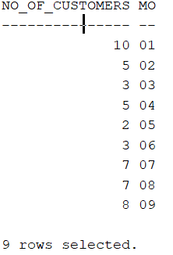

Our query produced the above table. Next we took this information and applied it to Tableau in order to create a visualized format. The bar chart below is the graphical translation of our query.

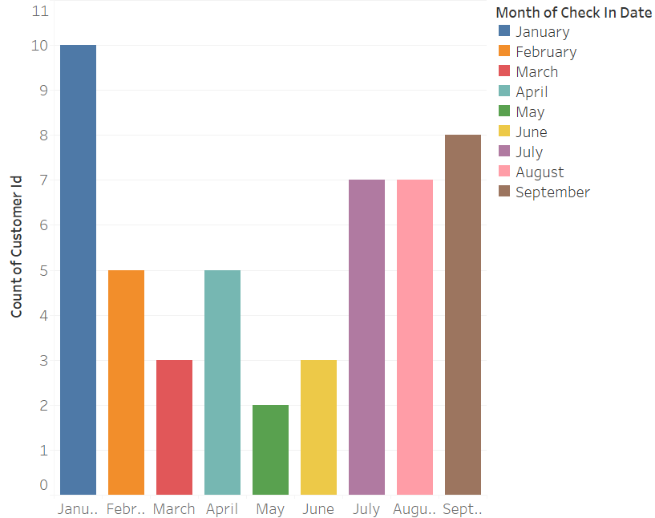

As you can see from the chart above, during the nine-month period of January through September, the month of January incurred the most business, or had the highest number of guests staying at the hotel. The next busiest months were September, followed by July and August. The lowest number of guests staying in the hotel occurred in the month of May, followed closely by March and June.

2.Query 2: Retrieve the Total Hotel sales per month.

select sum(r.room_price*rs.no_of_days + s.service_cost*l.service_quantityy)Total_Sales,

to_char(t.payment_date,'MM')MM,sum (r.room_price*rs.no_of_days)Total_Room_chargess,

sum(s.service_cost*l.service_quantityy)Total_Services_Charges

from room r, reservation rs,services s, line l,invoice i,transactions t

where r.res_id=rs.res_id and s.service_id=l.service_id and l.invoice_no=i.invoice_no

and rs.res_id=i.res_id and t.invoice_no=i.invoice_no

group by to_char(payment_date, 'MM')

order by to_char(payment_date, 'MM')asc;

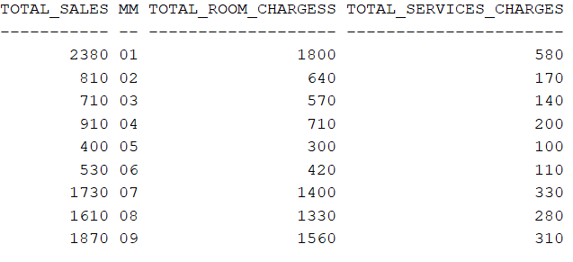

Our query produced the above table, which shows the total sales by month as well as a differentiation between total room charges and total services charged. We took this information and ran it through Tableau to create a visualized format. The bar chart below is the graphical translation of our query.

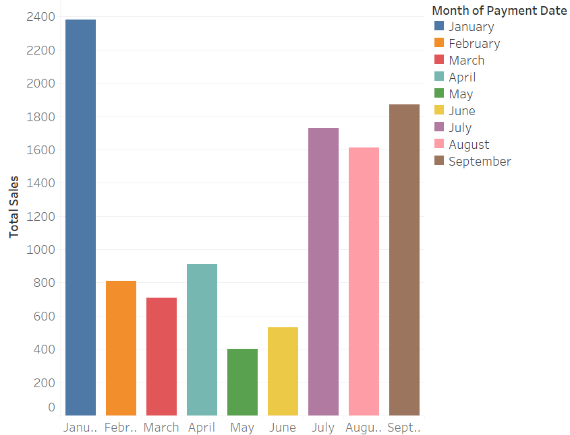

As you can see from the chart above, during the nine-month period of January through September, the month of January incurred the most business and had the highest number of guests. We can deduce that it makes sense to have the highest total sales on the month with the highest number of guests. The next highest total sales occurred in the months of September, followed by July and August. As the lowest number of guests stayed at the hotel in May, it also makes sense that May had the lowest total sales for the observed period.

3.Query 3: Retrieve Average Satisfaction rating per month.

select avg(sf.satisfaction_level), to_char(t.payment_date,'MM')MM from transactions t,

satisfaction sf where sf.trans_id=t.transaction_id

group by to_char(payment_date, 'MM')

order by to_char(payment_date, 'MM')asc;

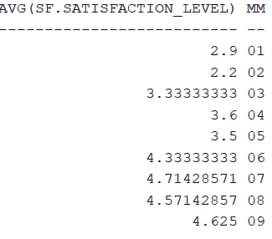

The above table was produced by our query to retrieve the average satisfaction rating per month between 1 and 5, with 1 being not at all satisfied and 5 being an excellent satisfaction rating. By analyzing the table, we can see that the highest average satisfaction level occurred in July.

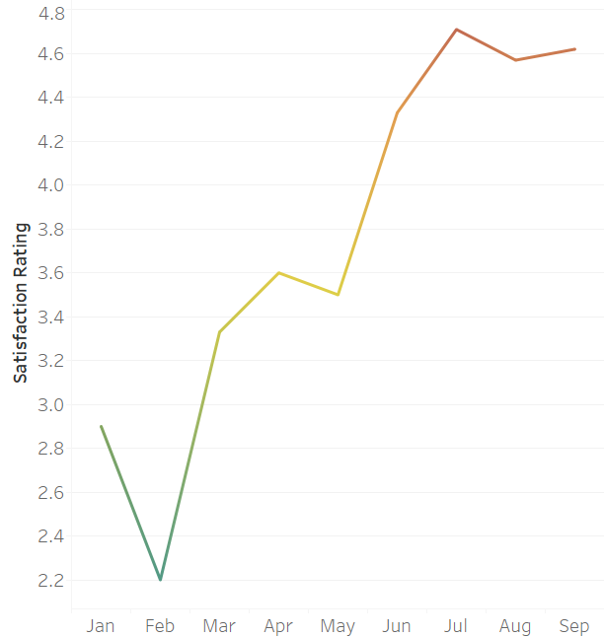

The above line chart shows that during the nine-month period of January through September, the highest satisfaction rating occurred in July. As opposed to the query table, graphically visualizing this information in Tableau allows us to see that there was an overall positive linear rise in customer satisfaction rating. The highest ratings were between the months of June through September.