Project
  - Deadline: Monday 09/08/2026 @ 23:59
[Total Mark is 20]

Introduction to Database
CS350
Instructions:
- You must submit two separate copies (one Word file and one PDF file) using the Assignment Template on Blackboard via the allocated folder. These files must not be in compressed format.
- It is your responsibility to check and make sure that you have uploaded both the correct files.
- Zero mark will be given if you try to bypass the SafeAssign (e.g. misspell words, remove spaces between words, hide characters, use different character sets, convert text into image or languages other than English or any kind of manipulation).
- Email submission will not be accepted.
- You are advised to make your work clear and well-presented. This includes filling your information on the cover page.
- You must use this template, failing which will result in zero mark.
- You MUST show all your work, and text must not be converted into an image, unless specified otherwise by the question.
- Late submission will result in ZERO mark.
- The work should be your own, copying from students or other resources will result in ZERO mark.
- Use Times New Roman font for all your answers.
Student Details: CRN: 50242
Name: Joud Abu Nameh  Name: Shahad Hazazy  Name: Jumanah Alfaeem  Name: Layan Alshehri |  | ID: s230010266  ID: s220042807  ID: s240030046  ID: s240017869

Project Instructions
- You can work on this project as a group (minimum 3 and maximum 4 students). Each group member must submit the project individually with all group member names mentioned on the cover page.
- This project worth 20 marks and will be distributed as in the following:
  - Database Design. (6 marks)
  - Database Implementation. (6 marks)
  - SQL Operations. (6 marks)
  - Project Reflection. (2 marks)
- Each leader in the group must submit one report about their chosen Project via the Blackboard (Email submission will not be accepted and will be awarded ZERO marks) containing the following:
- Task 1 : database design
- Task 2: database implementation
- All requested queries/results
- Screenshots from MySQL (or any other software you use) of all the tables after population and query results.
- Reflection (300–500 words) describing the team's experience, challenges, design decisions, and AI usage (if applicable).
- Submit one SQL file containing the complete database implementation, including database creation, tables, data insertion, required queries, VIEW, and TRIGGER.
- Submit a GitHub (or GitLab) repository containing the complete project with regular commits and meaningful commit messages.
- Submit a progress report describing the completed work, key decisions, challenges, future plan, and contribution of each group member.
- Include links to the live report document, GitHub/GitLab repository, and Google Colab notebook (if applicable) in the Project Artifacts section of the final report.
- You are advised to make your work clear and well presented; marks may be reduced for poor presentation. This includes filling in your information on the cover page.
- You MUST show all your work, and text must not be converted into an image unless specified otherwise by the question.
- Late submission will result in ZERO marks being awarded.
- The work should be your own. Copying from students or other resources, including AI software, will result in ZERO marks.

Project Description
Design and Implementation of a Smart Clinic Database System
Learning Outcome(s):

CLO1, CLO2, CLO3, CLO4, CLO5

A private clinic currently manages its patient information manually, making it difficult to organize appointments, treatments, and payments. The clinic has decided to develop a database system to improve data organization and retrieval.
Your team is required to design, implement, and test a complete relational database using the concepts learned throughout this course. The project should demonstrate your understanding of database design, ER/EER modeling, relational mapping, SQL implementation, and advanced SQL queries. The project must be completed using MySQL.

Task 1 – Database Design (6 Marks)
- Design a complete database for the clinic that includes at least six entities such as Patients, Doctors, Appointments, Treatments, Medicines, Payments, or any other appropriate entities.
- A complete ER/EER diagram.
- Primary and foreign keys.
- Appropriate relationships with cardinality.
- At least one specialization/generalization (EER feature).
- Any assumptions made during the design process.

The Smart Clinic Database System is designed for a private clinic that currently manages patient information manually. The proposed database organizes information related to patients, doctors, departments, appointments, treatments, medicines, prescriptions, and payments. The system is designed to improve data organization, reduce unnecessary data redundancy, and make information easier to store and retrieve.
The database was designed using relational database principles. Primary keys are used to uniquely identify records, while foreign keys are used to connect related entities. The design was first developed as an ER/EER model and was then mapped into a relational schema before being implemented using MySQL.

Entity | Purpose
Patients | Stores information about clinic patients.
Doctors | Stores information about doctors and their specialties.
Departments | Stores the clinic's departments and their locations.
Appointments | Records appointments between patients and doctors.
Treatments | Stores information about medicines available in the clinic.
Medicines | Stores information about medicines available in the clinic.
Prescriptions | Connects patients and doctors with prescribed medicines.
Payments | Records payments made by patients.

Smart Clinic Database ER/EER Diagram
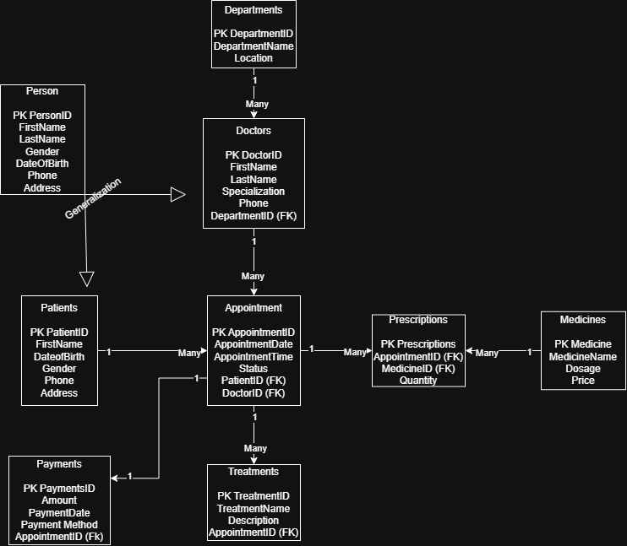Departments(DepartmentID, DepartmentName, Location)
Doctors(DoctorID, FirstName, LastName, Specialty, DepartmentID)
Patients(PatientID, FirstName, LastName, Gender, DateOfBirth, Phone)
Appointments(AppointmentID, PatientID, DoctorID, AppointmentDate, AppointmentTime, Status)
Treatments(TreatmentID, PatientID, DoctorID, TreatmentDate, Description, Cost)
Medicines(MedicineID, MedicineName, Manufacturer, Price)
Prescriptions(PrescriptionID, PatientID, DoctorID, MedicineID, PrescriptionDate, Dosage)
Payments(PaymentID, PatientID, PaymentDate, Amount, PaymentMethod)
Each entity was assigned a primary key to uniquely identify its records. Foreign keys were used where entities needed to reference records in other tables.
Table | Primary Key | Foreign Keys
Departments | DepartmentID | -
Doctors | DoctorID | DepartmentID
Patients | PatientID | -
Appointments | AppointmentID | -  PatientID, DoctorID
Medicines | MedicineID | -
Prescriptions | PrescriptionID | PatientID, DoctorID, MedicineID
Treatments | TreatmentID | PatientID, DoctorID
Payments | PaymentID | PatientID

The relationships between the entities were designed according to the clinic's workflow. A department can have multiple doctors, while each doctor is assigned to a department. Patients can have multiple appointments, and doctors can have multiple appointments. Patients and doctors can also be associated with multiple treatments. Prescriptions connect patients, doctors, and medicines, while payments are associated with patients.

Relationship | Cardinality
Department → Doctor | 1:M
Patient → Appointment | 1:M
Doctor → Appointment | 1:M
Patient → Treatment | 1:M
Doctor → Treatment | 1:M
Patient → Prescription | 1:M
Doctor → Prescription | 1:M
Medicine → Prescription | 1:M
Patient → Payment | 1:M

A generalization/specialization feature was included in the EER model to satisfy the EER design requirement. The model represents common characteristics at the higher-level entity while allowing specialized entities to represent more specific roles. This structure demonstrates how entities with shared characteristics can be modeled without unnecessary duplication.

Design assumptions:
1. Each patient is identified by a unique PatientID.
2. Each doctor belongs to one department, while a department can contain multiple doctors.
3. A patient can have multiple appointments with doctors.
4. Each appointment is associated with one patient and one doctor.
5. A patient may receive multiple treatments during their clinic visits.
6. A prescription can associate a patient, doctor, and medicine.
7. A patient can make multiple payments.
8. Medicine information is stored separately from prescriptions to reduce unnecessary duplication.

Task 2 – Database Implementation (6 Marks)
Complete the following tasks using MySQL. Include screenshots of both your SQL code and the corresponding output (results) for each task:
- Create the database and all required tables.
- Use appropriate data types and constraints (PRIMARY KEY, FOREIGN KEY, NOT NULL, UNIQUE, etc.).
- Insert at least 5 records into each main table.

The Smart Clinic database was implemented using MySQL Workbench. The database was created using the name SmartClinic and was then selected for the creation of the required tables.

Creating the SmartClinic database in MySQL Workbench.
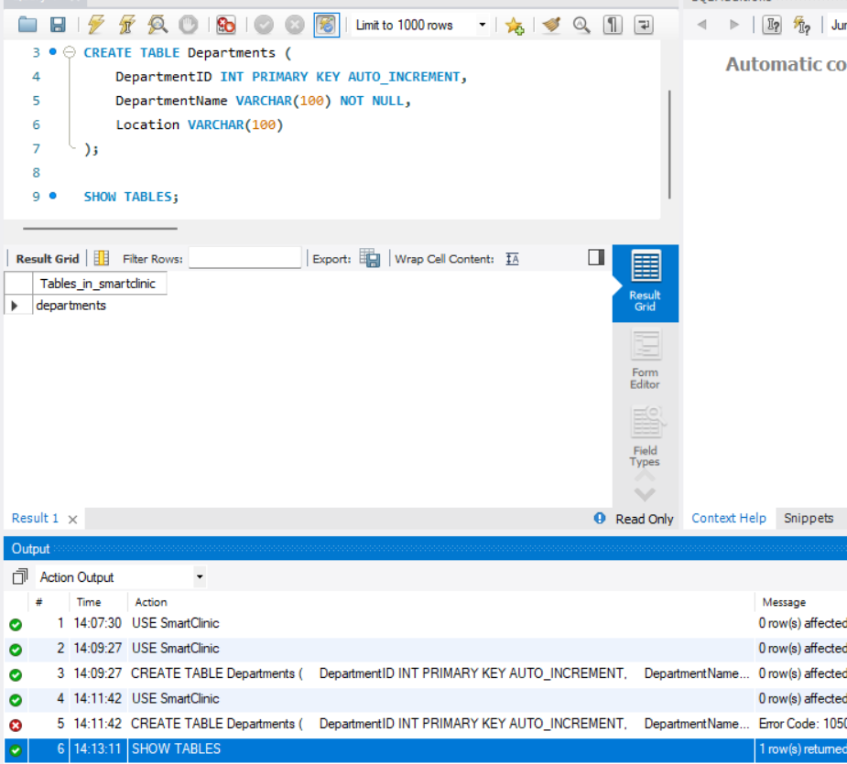
Eight tables were implemented to represent the main entities in the Smart Clinic system. Each table was created with appropriate attributes, data types, primary keys, and foreign keys where relationships were required.
Table | Main Key | Main Purpose
Departments | DepartmentsID | Stores clinic departments
Doctors | DoctorsID | Stores doctor information
Patients | PatientsID | Stores patient information
Appointments | AppointmentsID | Stores patient appointments
Medicines | MedicinesID | Stores medicine information
Prescriptions | PrescriptionsID | Stores prescriptions
Treatments | TreatmentsID | Stores treatments
Payments | PaymentID | Stores patient payments
Appropriate constraints were applied during implementation to maintain data integrity. Primary keys uniquely identify records, foreign keys maintain relationships between related tables, NOT NULL prevents required fields from being left empty, UNIQUE prevents duplicate values where appropriate, and AUTO_INCREMENT automatically generates unique identification numbers.

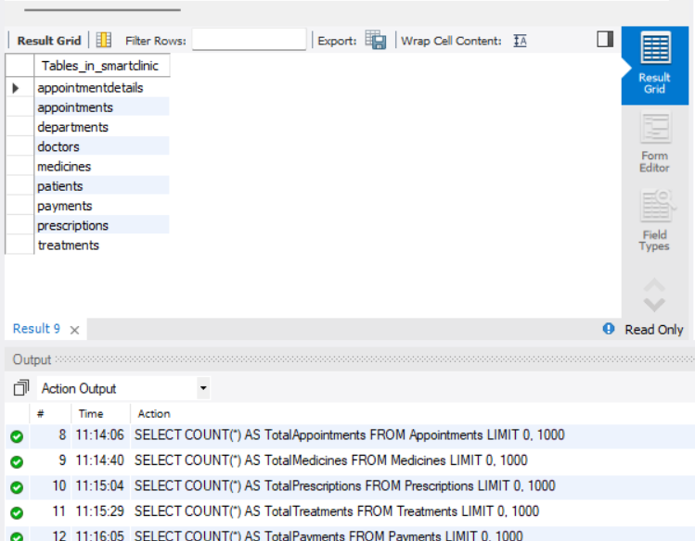
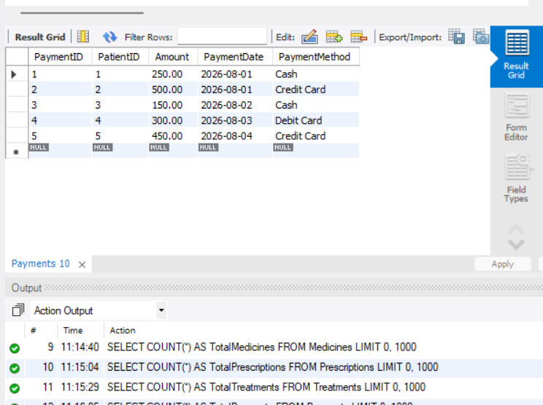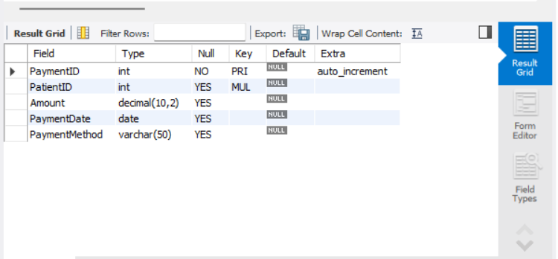Each of the eight main tables was populated with at least five records using realistic sample data. The inserted data was reviewed using SELECT statements to verify that the records were successfully stored and that the relationships between related tables could be used during later SQL operations.

Appropriate data types and integrity constraints were used throughout the implementation. Primary keys were used to uniquely identify records, while foreign keys were used to maintain relationships between related tables. NOT NULL and UNIQUE constraints were applied where appropriate, and AUTO_INCREMENT was used for the identification fields.

The database contains eight main tables, and each table was populated with at least five records. The implemented primary keys, foreign keys, and other constraints were tested in MySQL Workbench to verify the integrity of the database structure.

Task 3 – SQL Operations (6 Marks)
Complete the following tasks using MySQL. For each task, include screenshots of both your SQL code and the corresponding output (results), along with a brief description (one to two sentences) explaining the purpose of the query and the information it is intended to retrieve.
- Write SELECT statements.
- Write JOIN queries.
- Write nested queries.
- Use aggregate functions with GROUP BY.
- Write UPDATE and DELETE statements.
- Create one VIEW.
- Create one TRIGGER.

- 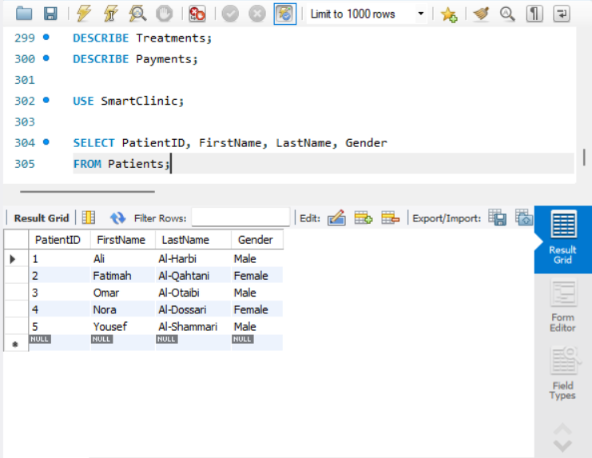This query retrieves basic patient information from the Patients table. It displays the patient's ID, first name, last name, and gender.

- 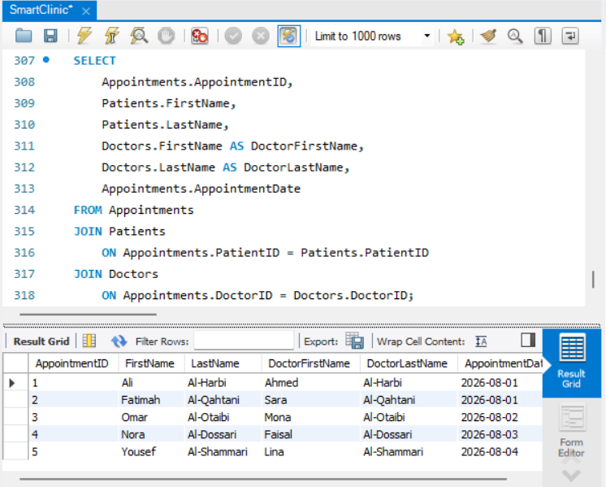This query combines information from the Appointments, Patients, and Doctors tables. It shows which patient has an appointment with which doctor and the date of the appointment.
- 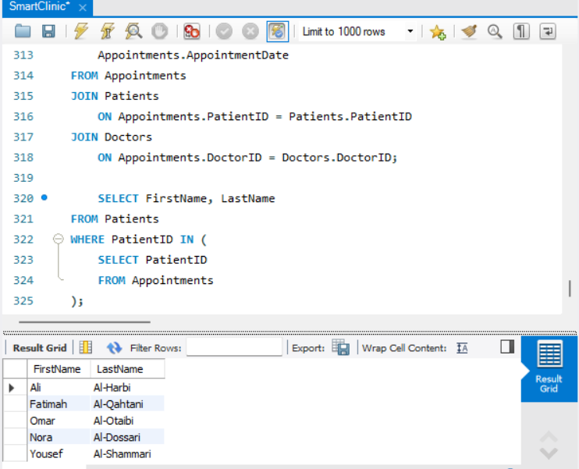This nested query identifies patients who have at least one appointment. The inner query retrieves PatientIDs from the Appointments table, and the outer query retrieves the corresponding patient names.
- 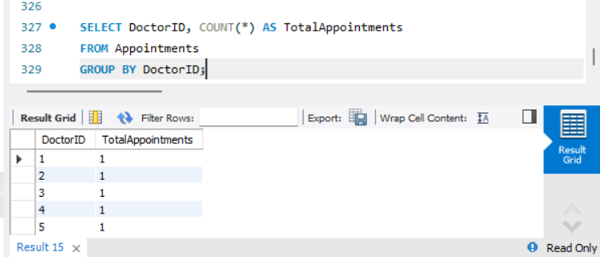This query counts the number of appointments associated with each doctor. The GROUP BY clause groups the appointments according to DoctorID.
- 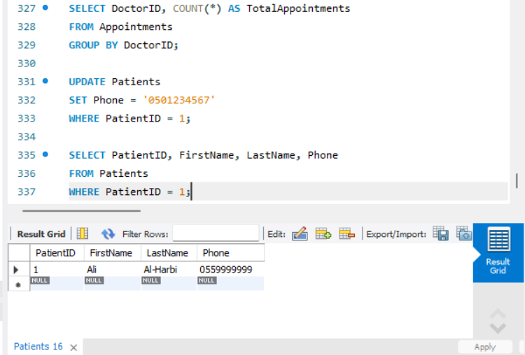This query updates the phone number of a specific patient. The SELECT statement is then used to verify that the change was successfully applied.
- 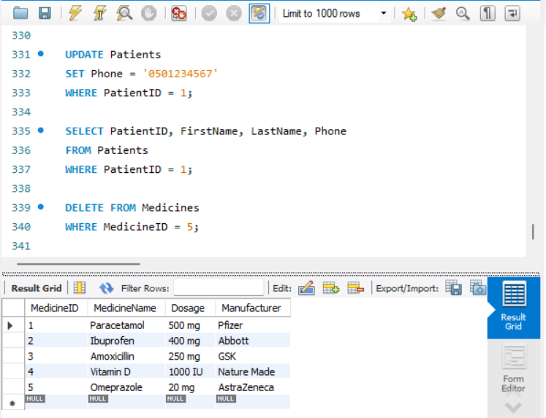This query demonstrates how a specific medicine record can be deleted from the database. The SELECT statement verifies that the selected record has been removed.

- 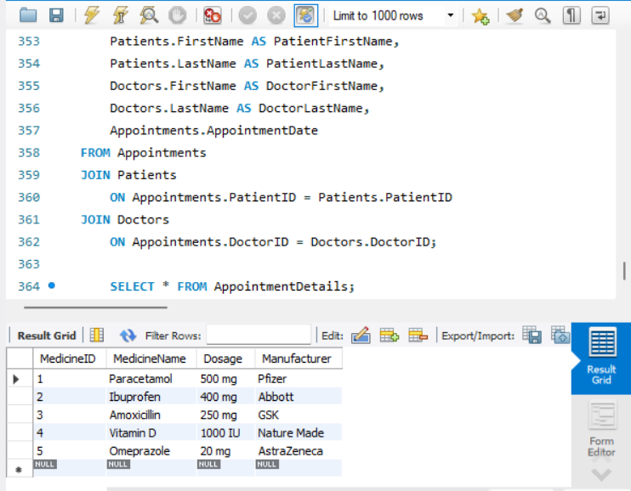This view combines appointment information with the related patient and doctor information. It provides a convenient way to retrieve appointment details without repeatedly writing the same JOIN statements.
- 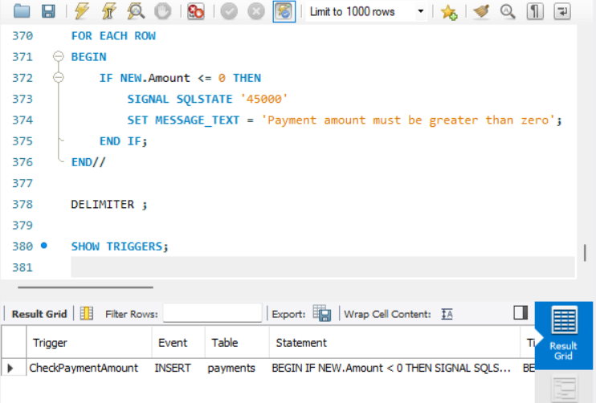This trigger prevents invalid payment amounts from being inserted into the Payments table. It checks the payment amount before insertion and generates an error if the amount is zero or negative.

Verification:
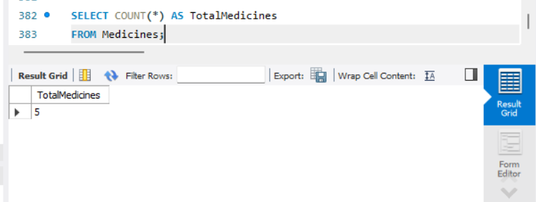

Task 4 – Reflection (2 Marks)
Write a 300–500-word reflection on your experience while completing this project by
answering the following questions. Your responses should be clear, concise, and
supported with specific examples from your own work.
- Describe one specific challenge or obstacle you encountered during this project and explain in detail how you identified and resolved it.
- Explain why you chose your specific approach/method/model over at least one alternative you considered, and what tradeoffs informed that decision.
- If you used any AI tools during this project (e.g., ChatGPT, Claude, Copilot), disclose which tool(s), for what specific purpose (e.g., debugging, grammar checking, brainstorming), and how you verified or modified the output.
- What would you do differently if you were to redo this project with more time or resources?
Working on the Smart Clinic Database System gave our team a better understanding of how database concepts are applied in a complete project. One of the main challenges we faced was deciding how the different entities should be connected, especially appointments, treatments, prescriptions, medicines, and payments. At first, some possible relationships could have created unnecessary duplication or made the database more complicated. We resolved this by reviewing the clinic's workflow, discussing the purpose of each entity, and checking the relationships against normalization principles. We then revised the ER/EER diagram before completing the MySQL implementation.
We chose to complete the database design before implementing all of the tables in MySQL. Another option would have been to create the tables immediately and change them whenever a problem was discovered. Although that approach might have been faster at the beginning, it could have caused more changes and inconsistencies later. Finalizing the ER/EER diagram, keys, relationships, and relational structure first took more planning, but it gave us a clearer structure to follow during implementation.
During the project, we used Chat2DB as an AI assistant for specific tasks such as understanding SQL syntax, troubleshooting errors, clarifying database concepts, and improving some of the wording in the documentation. We also used AI assistance while preparing and reviewing some SQL operations. We did not rely on the generated responses without checking them. SQL statements were tested in MySQL Workbench, and the results were compared with our database design and project requirements. We modified suggestions whenever necessary to make sure they matched our Smart Clinic database.
If we had more time and resources, we would improve the project by adding more realistic sample data and performing more extensive testing with different situations. We would also spend more time refining the database design and documentation before the final submission. Overall, completing the project helped us understand the connection between ER/EER modeling, relational database design, SQL implementation, and database testing.

Deliverables
- Project Report (PDF) – System description, ER/EER diagram, relational schema, SQL code, screenshots, and reflection.
- SQL Script (.sql) – Complete SQL implementation of the project.
- GitHub Repository – Repository link with the complete project and commit history.
- Mid-Project Progress Report – Summary of progress, challenges, decisions, and team contributions.
- Project Artifacts
  - Live report document (with edit history): [link]
  - GitHub/GitLab repository (with commit history): [link]
  - Google Colab notebook (if applicable): [link]

Our mid report was written in Google Docs.
Github Link: https://github.com/collegejoud/Smart-Clinic-Database-System
GoogleDocs Document (mid report part only): https://docs.google.com/document/d/1-KvSMAmOdsbiTNgIgf6G0Ne-RzVRgdeuzVCXc06--10/edit?usp=drivesdk

