1. Write a program of class addition of two numbers by using void method and without void method.

import java.util.Scanner;

public class AdditionProgram {
public static void main(String[] args) {
Scanner scanner = new Scanner(System.in);

System.out.print("Enter the first number: ");
double num1 = scanner.nextDouble();

System.out.print("Enter the second number: ");
double num2 = scanner.nextDouble();

// Call method with void
addNumbersWithVoid(num1, num2);

// Call method without void
double sum = addNumbersWithoutVoid(num1, num2);
System.out.println("Sum of the numbers (without void method): " + sum);
}

// Void method for addition
public static void addNumbersWithVoid(double a, double b) {
double sum = a + b;
System.out.println("Sum of the numbers (void method): " + sum);
}

// Method that returns the sum
public static double addNumbersWithoutVoid(double a, double b) {
return a + b;
}
}

Output

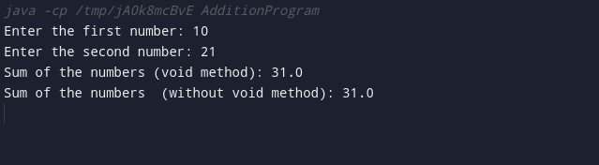

2. Write a program of ‘This’ keyword can be used to refer current class instance variable and Method.

public class ThisKeywordExample {
// Instance variable
private int number;

// Constructor
public ThisKeywordExample(int number) {
// Using 'this' to refer to the instance variable
this.number = number;
}

// Method using 'this' to refer to instance method
public void displayNumber() {
System.out.println("Number from instance variable: " + this.number);
this.performCalculation(); // Calling another method using 'this'
}

// Another method
private void performCalculation() {
System.out.println("Performing calculation using the number: " + this.number);
}

public static void main(String[] args) {
// Creating an instance of the class
ThisKeywordExample example = new ThisKeywordExample(42);

// Calling the method using 'this'
example.displayNumber();
}
}

Output :

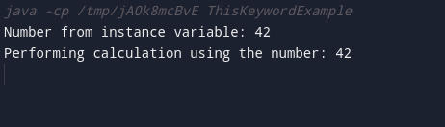

3. Create a Package package1 having one class A contains msg method. Create second package mypack with class B, call msg method of A class in the second package.

A.java (in package1):

package package1;

public class A {
public void msg() {
System.out.println("Hello from class A!");
}
}

B.java (in mypack):

package mypack;
import package1.A; // Importing class A from package1

public class B {
public static void main(String[] args) {
// Creating an instance of class A
A aObject = new A();

// Calling the msg method from class A
aObject.msg();
}
}

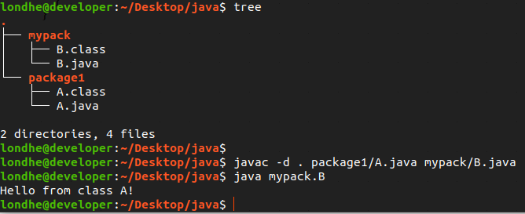
Output :

4. Write a Java program of create Interface GHI having print method which extends another Interface XYZ having a show method . (create Interface extends another Interface program ).

// Interface XYZ
interface XYZ {
void show();
}

// Interface GHI extending XYZ
interface GHI extends XYZ {
void print();
}

// Class implementing GHI
class MyClass implements GHI {
@Override
public void show() {
System.out.println("Show method from interface XYZ");
}

@Override
public void print() {
System.out.println("Print method from interface GHI");
}
}

// Main class
class InterfaceExample {
public static void main(String[] args) {
// Creating an instance of MyClass
MyClass obj = new MyClass();

// Calling methods from interfaces
obj.show();
System.out.println("");
obj.print();
}
}

Output :

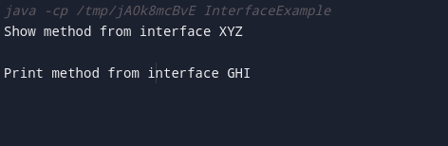

5. Create Constructor with accepting two numbers and perform any two types of constructor.

public class Calculator {
private double result;

// Constructor for addition
public Calculator(double num1, double num2, String operation) {
if ("add".equalsIgnoreCase(operation)) {
this.result = num1 + num2;
} else {
System.out.println("Invalid operation. Defaulting to addition.");
this.result = num1 + num2;
}
}

// Constructor for multiplication
public Calculator(double num1, double num2, boolean multiply) {
if (multiply) {
this.result = num1 * num2;
} else {
System.out.println("Invalid operation. Defaulting to multiplication.");
this.result = num1 * num2;
}
}

public double getResult() {
return result;
}

public static void main(String[] args) {
// Constructor with addition operation
Calculator addCalculator = new Calculator(10.5, 5.2, "add");
System.out.println("Result of addition: " + addCalculator.getResult());

// Constructor with multiplication operation
Calculator multiplyCalculator = new Calculator(7.0, 3.0, true);
System.out.println("Result of multiplication: " + multiplyCalculator.getResult());
}
}

Output :

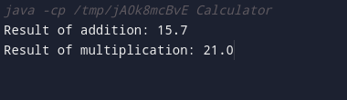

6. Write a Java program to test any one Build in exception and one user defined exception.

// User-defined exception
class CustomException extends Exception {
public CustomException(String message) {
super(message);
}
}

class ExceptionExample {
// Method to test built-in exception
public static void testBuiltInException() {
try {
int[] numbers = {1, 2, 3};
// Trying to access an index that is out of bounds
int value = numbers[5];
System.out.println("Value: " + value); // This line will not be reached
} catch (ArrayIndexOutOfBoundsException e) {
System.out.println("Built-in Exception: " + e.getMessage());
}
}

// Method to test user-defined exception
public static void testUserDefinedException() {
try {
throw new CustomException("This is a user-defined exception.");
} catch (CustomException e) {
System.out.println("User-defined Exception: " + e.getMessage());
}
}

public static void main(String[] args) {
// Test the built-in exception
System.out.println("Testing Built-In Exception:");
testBuiltInException();

// Test the user-defined exception
System.out.println("\nTesting User-Defined Exception:");
testUserDefinedException();
}
}

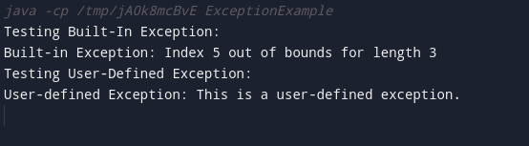
Output :

7. Write a program to create dmart class with accepting values of product id,name,rate and quantity and calculate payable amt with discount If amt 5000 3000 =20 %, 3000-2000 =15%, 2000-1000=10% , Otherwise no discount.

import java.util.Scanner;

class Dmart {
private int productId;
private String productName;
private double rate;
private int quantity;

// Constructor to initialize values
public Dmart(int productId, String productName, double rate, int quantity) {
this.productId = productId;
this.productName = productName;
this.rate = rate;
this.quantity = quantity;
}

// Method to calculate payable amount with discount
public double calculatePayableAmount() {
double totalAmount = rate * quantity;
double discountRate = 0.0;

// Apply discount based on totalAmount
if (totalAmount >= 5000) {
discountRate = 0.20;
} else if (totalAmount >= 3000) {
discountRate = 0.15;
} else if (totalAmount >= 2000) {
discountRate = 0.10;
}

double discount = totalAmount * discountRate;
double payableAmount = totalAmount - discount;

return payableAmount;
}

public static void main(String[] args) {
Scanner scanner = new Scanner(System.in);

System.out.print("Enter Product ID: ");
int productId = scanner.nextInt();

System.out.print("Enter Product Name: ");
String productName = scanner.next();

System.out.print("Enter Rate: ");
double rate = scanner.nextDouble();

System.out.print("Enter Quantity: ");
int quantity = scanner.nextInt();

// Create an instance of Dmart
Dmart dmart = new Dmart(productId, productName, rate, quantity);

// Calculate and display payable amount with discount
double payableAmount = dmart.calculatePayableAmount();
System.out.println("Payable Amount with Discount: " + payableAmount);
}
}

Output :

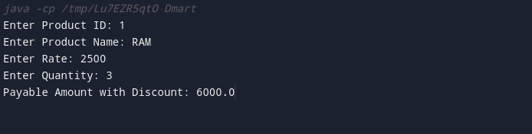

8. Write any one example of Multilevel inheritance in JAVA.

Example-1.java

// Base class
class Vehicle {
void start() {
System.out.println("Vehicle is starting.");
}
}

// Derived class inheriting from Vehicle
class Car extends Vehicle {
void drive() {
System.out.println("Car is driving.");
}
}

// Another class inheriting from Car (Multilevel Inheritance)
class SportsCar extends Car {
void accelerate() {
System.out.println("SportsCar is accelerating.");
}
}

// Main class to test multilevel inheritance
class MultilevelInheritanceExample1 {
public static void main(String[] args) {
// Create an instance of the SportsCar class
SportsCar mySportsCar = new SportsCar();

// Access methods from different levels of inheritance
mySportsCar.start(); // Method from Vehicle class
mySportsCar.drive(); // Method from Car class
mySportsCar.accelerate(); // Method from SportsCar class
}
}

Output :
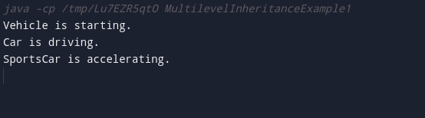
Example-2.java

// Base class
class Shape {
void draw() {
System.out.println("Drawing a shape.");
}
}

// Derived class inheriting from Shape
class Circle extends Shape {
void drawCircle() {
System.out.println("Drawing a circle.");
}
}

// Another class inheriting from Circle (Multilevel Inheritance)
class ColoredCircle extends Circle {
void setColor(String color) {
System.out.println("Setting color to: " + color);
}
}

// Main class to test multilevel inheritance
class MultilevelInheritanceExample2 {
public static void main(String[] args) {
// Create an instance of the ColoredCircle class
ColoredCircle myColoredCircle = new ColoredCircle();

// Access methods from different levels of inheritance
myColoredCircle.draw(); // Method from Shape class
myColoredCircle.drawCircle(); // Method from Circle class
myColoredCircle.setColor("Red"); // Method from ColoredCircle class
}
}

Output :

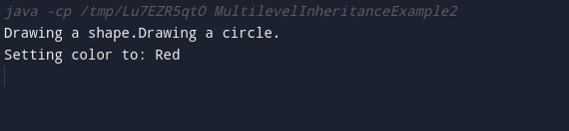

9. WAP of static, abstract class keyword in JAVA.

// Abstract class with abstract and non-abstract methods
abstract class Shape {
// Abstract method (to be implemented by subclasses)
abstract double calculateArea();
// Non-abstract method
void display() {
System.out.println("This is a shape.");
}
// Static method
static void staticMethod() {
System.out.println("This is a static method in the Shape class.");
}
}
// Concrete subclass implementing the abstract class
class Circle extends Shape {
double radius;

Circle(double radius) {
this.radius = radius;
}
// Implementation of abstract method from the superclass
@Override
double calculateArea() {
return Math.PI * radius * radius;
}
}

// Main class to test static and abstract class
class StaticAbstractClassExample {
public static void main(String[] args) {
// Accessing static method without creating an instance
Shape.staticMethod();

// Creating an instance of the Circle class
Circle circle = new Circle(5.0);

// Calling methods from the abstract class
circle.display(); // Non-abstract method
double area = circle.calculateArea(); // Abstract method
System.out.println("Area of the circle: " + area);
}
}
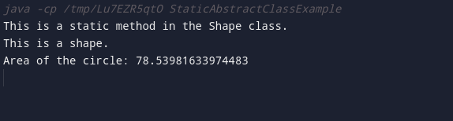
Output :

10. Calculate area of Circle, triangle and Square using Method Overloading.

class AreaCalculator {

// Method to calculate the area of a circle
public static double calculateArea(double radius) {
return Math.PI * radius * radius;
}

// Method to calculate the area of a triangle
public static double calculateArea(double base, double height) {
return 0.5 * base * height;
}

// Method to calculate the area of a square
public static double calculateArea(int sideLength) {
return sideLength * sideLength;
}

public static void main(String[] args) {
// Calculate and display the area of a circle
double circleArea = calculateArea(5.0);
System.out.println("Area of Circle: " + circleArea);

// Calculate and display the area of a triangle
double triangleArea = calculateArea(4.0, 7.0);
System.out.println("Area of Triangle: " + triangleArea);

// Calculate and display the area of a square
double squareArea = calculateArea(5);
System.out.println("Area of Square: " + squareArea);
}
}

Output :

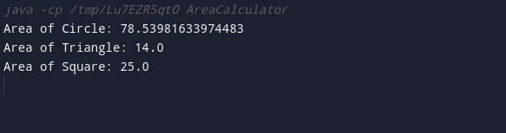

11. Create student information form using Java AWT components (Accept Rollno, Student Name, Address, Mob no) with Save, Update and delete components.

import java.awt.*;
import java.awt.event.ActionEvent;
import java.awt.event.ActionListener;

public class StudentInformationForm extends Frame {
private Label lblRollNo, lblName, lblAddress, lblMobNo;
private TextField tfRollNo, tfName, tfAddress, tfMobNo;
private Button btnSave, btnUpdate, btnDelete;

public StudentInformationForm() {
setTitle("Student Information Form");
setSize(400, 300);
setLayout(new GridLayout(5, 2));
setLocationRelativeTo(null); // Center the frame
setResizable(false);

// Labels
lblRollNo = new Label("Roll No:");
lblName = new Label("Student Name:");
lblAddress = new Label("Address:");
lblMobNo = new Label("Mobile No:");

// TextFields
tfRollNo = new TextField();
tfName = new TextField();
tfAddress = new TextField();
tfMobNo = new TextField();

// Buttons
btnSave = new Button("Save");
btnUpdate = new Button("Update");
btnDelete = new Button("Delete");

// Adding components to the frame
add(lblRollNo);
add(tfRollNo); add(lblName);
add(tfName);
add(lblAddress);
add(tfAddress);
add(lblMobNo);
add(tfMobNo);
add(btnSave);
add(btnUpdate);
add(btnDelete);

// Button actions
btnSave.addActionListener(new ActionListener() {
@Override
public void actionPerformed(ActionEvent e) {
saveStudentInformation();
}
});

btnUpdate.addActionListener(new ActionListener() {
@Override
public void actionPerformed(ActionEvent e) {
updateStudentInformation();
}
});

btnDelete.addActionListener(new ActionListener() {
@Override
public void actionPerformed(ActionEvent e) {
deleteStudentInformation();
}
});

// Closing the window
addWindowListener(new java.awt.event.WindowAdapter() {
public void windowClosing(java.awt.event.WindowEvent windowEvent) {
System.exit(0);
}
});

setVisible(true);
}

private void saveStudentInformation() {
// Implement the logic for saving student information
System.out.println("Save button clicked.");
}

private void updateStudentInformation() {
// Implement the logic for updating student information
System.out.println("Update button clicked.");
}

private void deleteStudentInformation() {
// Implement the logic for deleting student information
System.out.println("Delete button clicked.");
}

public static void main(String[] args) {
new StudentInformationForm();
}
}

Output :

12. Create SBI Bank customer information form using Java Swing components

import javax.swing.*;
import java.awt.*;
import java.awt.event.ActionEvent;
import java.awt.event.ActionListener;

public class SbiBankCustomerForm extends JFrame {

private JTextField tfAccountNumber, tfCustomerName, tfBalance;
private JButton btnSave, btnUpdate, btnDelete;

public SbiBankCustomerForm() {
setTitle("SBI Bank Customer Information Form");
setSize(400, 300);
setLocationRelativeTo(null);
setDefaultCloseOperation(JFrame.EXIT_ON_CLOSE);

initializeComponents();

setLayout(new GridLayout(4, 2));
add(new JLabel("Account Number:"));
add(tfAccountNumber);
add(new JLabel("Customer Name:"));
add(tfCustomerName);
add(new JLabel("Balance:"));
add(tfBalance);
add(btnSave);
add(btnUpdate);
add(btnDelete);

addActionListeners();

setVisible(true);
}

private void initializeComponents() {
tfAccountNumber = new JTextField();
tfCustomerName = new JTextField();
tfBalance = new JTextField();
btnSave = new JButton("Save");
btnUpdate = new JButton("Update");
btnDelete = new JButton("Delete");
}

private void addActionListeners() {
btnSave.addActionListener(new ActionListener() {
@Override
public void actionPerformed(ActionEvent e) {
saveCustomerInformation();
}
});

btnUpdate.addActionListener(new ActionListener() {
@Override
public void actionPerformed(ActionEvent e) {
updateCustomerInformation();
}
});

btnDelete.addActionListener(new ActionListener() {
@Override
public void actionPerformed(ActionEvent e) {
deleteCustomerInformation();
}
});
}

private void saveCustomerInformation() {
// Implement the logic for saving customer information
String accountNumber = tfAccountNumber.getText();
String customerName = tfCustomerName.getText();
String balance = tfBalance.getText();

// Perform necessary operations with the collected information (e.g., save to a database)
System.out.println("Saving customer information - Account Number: " + accountNumber +
", Customer Name: " + customerName + ", Balance: " + balance);
}

private void updateCustomerInformation() {
// Implement the logic for updating customer information
String accountNumber = tfAccountNumber.getText();
String customerName = tfCustomerName.getText();
String balance = tfBalance.getText();

// Perform necessary operations with the collected information (e.g., update in a database)
System.out.println("Updating customer information - Account Number: " + accountNumber +
", Customer Name: " + customerName + ", Balance: " + balance);
}

private void deleteCustomerInformation() {
// Implement the logic for deleting customer information
String accountNumber = tfAccountNumber.getText();

// Perform necessary operations with the collected information (e.g., delete from a database)
System.out.println("Deleting customer information - Account Number: " + accountNumber);
}

public static void main(String[] args) {
SwingUtilities.invokeLater(() -> new SbiBankCustomerForm());
}
}

Output :

13. Write program of any two Layout Managers JAVA.

import javax.swing.*;
import java.awt.*;

public class LayoutManagerExample extends JFrame {

public LayoutManagerExample() {
// Set the layout manager for the JFrame
setLayout(new FlowLayout()); // FlowLayout

// Creating buttons for FlowLayout
JButton button1 = new JButton("Button 1");
JButton button2 = new JButton("Button 2");
JButton button3 = new JButton("Button 3");

// Adding buttons to the JFrame
add(button1);
add(button2);
add(button3);

// Creating buttons for GridLayout
JButton button4 = new JButton("Button 4");
JButton button5 = new JButton("Button 5");
JButton button6 = new JButton("Button 6");

// Creating a panel with GridLayout
JPanel gridPanel = new JPanel(new GridLayout(2, 2)); // 2 rows, 2 columns

// Adding buttons to the GridLayout panel
gridPanel.add(button4);
gridPanel.add(button5);
gridPanel.add(button6);

// Adding the GridLayout panel to the JFrame
add(gridPanel);

// Set JFrame properties
setTitle("Layout Manager Example");
setSize(300, 200);
setDefaultCloseOperation(JFrame.EXIT_ON_CLOSE);
setLocationRelativeTo(null); // Center the frame
setVisible(true);
}

public static void main(String[] args) {
// Create an instance of the LayoutManagerExample class
SwingUtilities.invokeLater(() -> new LayoutManagerExample());
}
}

Output :

