NANNAPANENI VENKAT RAO
College of Engineering & Technology
(Approved by AICTE and affiliated to JNTU, Kakinada)
A PROJECT REPORT ON INDUSTRIAL TRAINING AT
TECHIN IT PROCESS PRIVAVTE LIMITED, HYDERABAD

Submitted in partial fulfillment of the requirements for the award of

DIPLOMA IN
COMPUTER SCIENCE ENGINEERING

Submitted By
Name:
Pin no:- 23255-CM-0
Academic Year 2025-2026

DEPARTMENT OF COMPUTER SCIENCE ENGINEERING

ADITYA COLLEGE OF ENGINEERING & TECHNOLOGY

(POLYTECHNIC -255)

SURAMPALEM. 533 437 (2025-2026)

ADITYA COLLEGE OF ENGINEERING &TECHNOLOGY (POLYTECHNIC -255)

SURAMPALEM
DEPARTMENT OF COMMUNICATION & COMPUTER NETWORKING



CERTIFICATE

This is to certify that the project work entitled “____________________________________” is the Bonafide
work of PIN No. __________________________________________, Mr./Miss __________________________________________of Final Year DCCN Branch, along with his/her batch mates, submitted in partial fulfillment ofthe requirements for the award of Diploma in Communication & Computer Networking of the State
Board of Technical Education & Training, A.P., Hyderabad, during the academic year 2025–2026.

Training Supervisor Training Mentor HOD

External Signature

ACKNOWLEDGEMENT

We wish to express our deep gratitude to our honorable principal Sri. S.T.V.S. KUMAR for providing us necessary department facilities in completion of our project.
We would like to express our sincere gratitude to SRI NUKALA MANOJ Head of the department of Computer science Engineering, Surampalam for permitting us to do Industrial training at TECHIN-IT, Hyderabad and for his/her encouragement, guidance and valuable suggestions which are utmost importance in successful completion of the industrial training.
We express our deep sense of gratitude and heartful thanks to Sri. Srinivasa Rao M.D, TECHIN IT PROCESS PRIVATE LIMITED
Lastly, we convey our profound thanks to all the employees working at LLP, TECHIN IT PROCESS PRIVATE LIMITED Hyderabad.

Thanking you all.

- V. JOHN

ABSTRACT

"Techin IT Process Private Limited is a company incorporated under the companies Act 2013. Techin IT process governs many constraints in the arena of education and employment With the aspect of providing qualified service to the clients and students, the company mainly focusses on 1. Admission process 2. Internships 3. Industrial trainings 4.campus trainings 5.Campus placements 6. Professional courses training and placements 7. Career Guidance 8. Educational loan process 9. Payroll services 10. HR Consulting 11.Contractual Staffing 12. Recruitment process 13. Training and Development"

Techin IT process private limited is a company that provides the courses such as java, core java, .net, python, python full stack, java full stack, AWS, power BI, azure, data structure, big data, tally, business accounts, GST, SAP (FICO, MM) HRM, HR payroll management, software IT development, advance IT software training.

It provides services like software development, web designing, app development, digital marketing, payroll process, recruitment, campus recruitment. This company has been found in compliance with requirements of quality management system ISO 9001:2015.

EPARTMENT OF COMPUTERSCIENCE& ENGINEERING

INDEX

S.NO | CONTENTS | PAGE NO.
1 | INTRODUCTION TO PYTHON | 1
2 | KEY CONCEPTS | 8
3 | CONTROL STATEMENTS | 17
4 | FUNCTIONS | 24
5 | FILES AND DATA STRUCTURES | 27
6 | STRUCTURED QUERY LANGUAGE | 32
7 | SQL DATA BASE | 39
8 | HTML | 41
9 | CSS | 42
10 | DJANGO | 44
11 | FLASK | 45
12 | CONCLUSION | 46
13 | HANDS ON PROJECT | 47

INTRODUCTION TO PYTHON

INTRODUCTION
    - Python is a simple, general purpose, high level, and object-oriented programming language.
    - Python is a interpreted scripting language.
    - Python is a trending programming language to develop various applications.
    - As of 2022, Python continues to be one of the most popular programming languages worldwide, used extensively in Web development, data science, machine learning, artificial intelligence, science computing, automation, and more.
    - The Python Software Foundation (PSF) oversees Python’s development and promotes
its adoption and growth.

HISTORY
    - Invented in Netherlands early by Guido Van Rossum.
    - Python was conceived in late 1980’s and its implementation was started in December 1989.
    - Guido van Rossum is fan of ‘Monty Python Firing Circus,’ this is a famous TV show in Netherlands.
    - Maned after Monty Python.
    - Open sourced in the year 2012.
    - Its vibrant community and thriving ecosystem ensure that Python remains relevant and continues to evolve to meet the needs of developers and industries alike.

FEATURES
    - Easy-to-learn – Python has few keywords, simple structures, and a clearly defined syntax. This allows the student to pick up the language quickly.
    - Easy-to-read – Python code is more clearly defined and visible to eyes.
    - Easy-to-maintain – Python’s source code is fairly easy-to-maintain.
    - A broad standard library – Python’s bulk pf the library is very portable and cross- platform compatible on UNIX, Windows, and Macintosh.

1
    - Interactive Mode – Python has support for an interactive mode which allows interactive testing and debugging of snippets of code.
    - Portable – Python can run on a widely variety of hardware platforms and has the same interface on all platforms.
    - Extendable – It can add low-level modules to the Python interpreter. These modules enable programmers to add to or customize their tools to be more efficient.
    - Databases – Python provides interfaces to all major commercial databases.
    - GUI Programming – Python supports GUI applications that can be created and ported to many system calls, libraries, and windows systems, such as Windows MFC, Macintosh, and the X Window system of Unix.
    - Scalable – Python provides a better structure and support for large programs than shell
scripting.

APPLICATIONS

Web Development
      - Django – A high-level Python web framework that enables rapid development and clean, pragmatic design.
      - Flask – A lightweight web framework that provides the essentials for building web applications without the complexity of a full-stack framework.
      - Pyramids – A flexible and minimalist web framework for building small to large- scale web applications.

Data Science and Analytics
      - NumPy – A library for numerical computing that provides support for large, multi- dimensional arrays and matrices.
      - Pandas – A library for data manipulation and analysis, offering data structures and functions to efficiently work with structured data.
      - Matplotlib – A plotting library for creating ststic, interactive, and animated visualizations in Python.
      - Scikit-learn – A machine learning library that provides simple and efficient tools for data mining and analysis.

2

Machine Learning and Artificial Intelligence
      - TensorFlow – An open-source machine learning framework developed by Google for building and training machine learning modules.
      - PyTorch – An open-source deep learning framework developed by Facebook’s AI Research lab for building neural networks.
      - Keras – A high-level neural networks API built on top of Tensor-Flow and Theano, providing a user-friendly interface for building deep learning models.

Scientific Computing
      - SciPy – A library for scientific computing that builds on top of NumPy and provides a collection of algorithms and functions for optimization, integration, interpolation, and more.
      - SymPy – A library for symbolic mathematics that allows for symbolic computation,
including algebraic manipulation, calculus, and solving equations.

Desktop GUI Applications
      - Tkinter – The standard GUI toolkit for Python, included with most Python installations, providing a simple and easy-to-use interface for building desktop applications.
      - PyQt – A set of Python bindings for the Qt application framework, enabling the
development of cross-platform desktop applications with rich graphical interfaces.

Game Development
      - Pygame – A set of Python modules designed for writing video games, providing functionality for handling graphics, sound, and user input.

Scripting and Automation
      - Python is commonly used for writing scripts and automating tasks, such as system administration, file manipulation, web scraping, and data processing.

IOT (Internet of Things) and Embedded Systems
      - Python is increasingly being used for IOT development due to its simplicity and versatility, enabling developers to build applications for IO devices and embedded systems.

3

INSTALLATION OF PYTHON
    - Download: Get the Python installer from the official website.

    - Run Installer: Execute the installer file.

    - Customize (Optional): Adjust installation options if needed.

    - Add to PATH: Check the option to add Python to system PATH.

    - Complete Installation: Follow the prompts to finish installation.

    - Verify: Check Python installation using ‘python – version’ in CMD.

    - Start Using: Access Python via command line with ‘python,’ or create and run Python scripts.
    - Fig 1 showing the official website of python.

    - Download Python Installer --- https://www.python.org/.
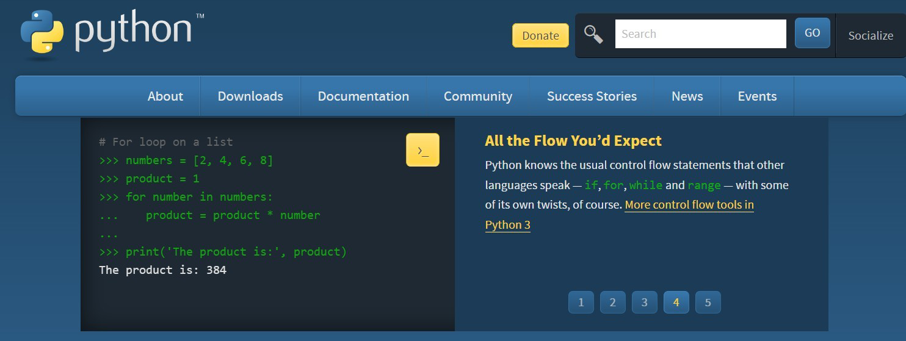

Fig 1. Official website Python

4

REQUIREMENTS OF PYTHON

The hardware and software requirement for Python development and execution are relatively minimal, making it accessible across a wide range of devices and platforms.

HARDWARE REQUIREMENT

    - CENTRAL PROCEESING UNIT (CPU)
      - Python itself is not particularly resource-intensive and it can run on a wide range of CPUs, from low-power devices to high-performance servers.

MEMORY (RAM)
      - The amount of RAM required depends on the complexity of Python applications and the size of datasheets that working with. For basics development and execution, even system with few gigabytes of RAM should suffice.

STORAGE SPACE
      - Python’s core installation does not require much disk space. However, the disk space needed may vary depending on the size of the project and the dependencies/libraries that install. A few gigabytes of storage space should be more than enough for most Python projects.

(a) (b)
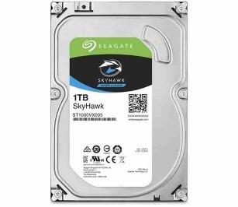
(c)

Fig 2. Hardware Requirements of Python (a) i3 processor (b) RAM (c) Storage.

5

SOFTWARE REQUIREMENT

Operating System
      - Python is compatible with various operating systems, including Windows, Macintosh, Linux distributions (e.g., Ubuntu, Debian, CentOS).
      - Python code written on one operating system can typically run on other without modification, thanks to Python’s cross-platform compatibility.

Python Interpreter
      - You need a Python interpreter to run Python code. You can download and install the official Python interpreter from the Python Software Foundation's website: Python Downloads.

Integrated Development Environment (IDE)
      - While not strictly required, using an IDE or text editor can greatly enhance your Python development experience. Some popular choices include: PyCharm, Visual Studio Code (with Python extension), Sublime Text, Atom, Vim, Emacs are shown in Fig 3.

Package Manager
      - Python's package manager, pip, comes bundled with Python installations starting from Python 3.4.

Optional: Virtual Environments
      - While not mandatory, using virtual environments (‘virtualenv’ or ‘venv’) is considered a best practice for managing dependencies. You can create virtual environments to isolate your Python projects and their dependencies, ensuring consistency and avoiding conflicts between different projects.

Optional: Dependency Management Tools
      - Depending on your project's requirements, you may need additional tools for managing dependencies, such as:
      - requirements.txt files for specifying project dependencies.

Python's minimal hardware and software requirements contribute to its popularity and accessibility, allowing developers to write and run Python code on a wide range of devices and platforms with ease.

6
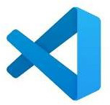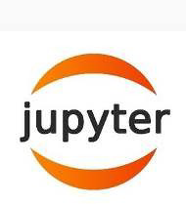


IDE (Integrated Development Environment)

Fig 3. Various IDEs for Python development.

UNDERSTANDING THE EXECUTION OF PYTHON
The execution of the Python program involves two steps:
- Compilation
- Interpreter

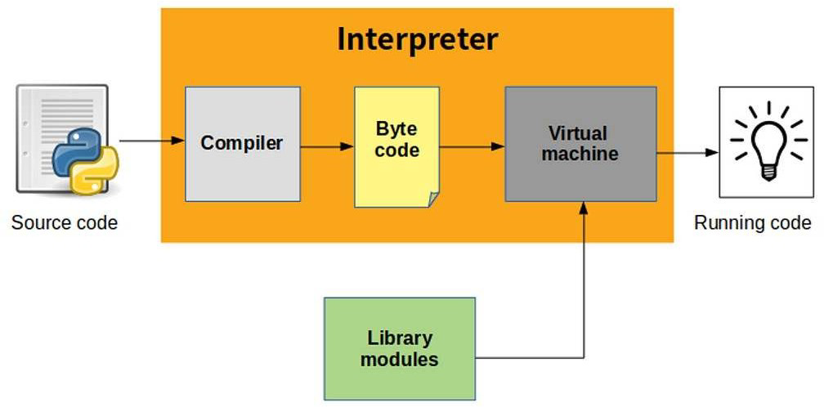

Fig 4. Execution of Python Program.

7

KEY CONCEPTS

LITERAL CONSTANTS
- It is called a literal because it is literal – use its value literally.
- The number 2 always represents itself and nothing else – it is a constant because its value cannot be changed.
- 7,3,9,’A’ and ‘Hello’ all are literals constants.
- Hence, all these are referred to as literal constants.

There are two types of literal constants

- Numbers
- Strings

NUMBERS

  - There can be use of four type of numbers in python program.
  - Integers - 5,1000, 520,250, etc.,
  - Long integers – 535633629843L
  - Floating points – 3.23, 91.5E-2 (E notation indicates power of 10 91.5*10^-2)
  - Complex numbers – a+bi form -3+7i

  - Commas are never used in numeric literals 10,20,30,40 are not allowed in python.
  - There is no limit to size of an integer.
  - Floating point numbers do not have limited range and limited precision.
  - Range – 10^-308 to 10^308
  - Precision – 10to 17 digits.

ISSUES WITH FLOATING POINT

  - Arithmetic overflow problem – 2.7e00+4.3e200 result would be inf.
  - Arithmetic underflow problem – 3.0e-400/5.0e200 result 0.0
  - Loss of precision – 1/3=0.33333333333 where 3 is repeated infinitely.

8

STRING

  - Using Single Quotes – ‘Hello’
  - Using Double Quotes – “Hello”
  - Using Triple Quotes – Multiline strings
  - ‘’’Good morning, everyone, “Welcome to the world of ‘Python’,” Happy Reading””

ESCAPE SEQUENCES

  - Some characters like (“, \) cannot be directly specified in a string.
  - Example – print (‘What your name?’)

Syntax error – Invalid Syntax

print (‘What\’s your name?’): correct

\n = New line, \t = Tab space, \b = Back space.

VARIABLES & IDENTIFIERS

- Variables are reserved memory, locations that stores values.
- To be identified easily every variable is given a name.
- Variables are examples of identifiers.
- Identifiers are names given to variables, functions, class etc.,

RULES FOR NAMING IDENTIFIERS

Starts with Alphabets or Underscore.
- These are case sensitive.
- No special characters are allowed except underscore.
- Digits (0-9), letters, _ are only allowed.

9

DATA TYPES
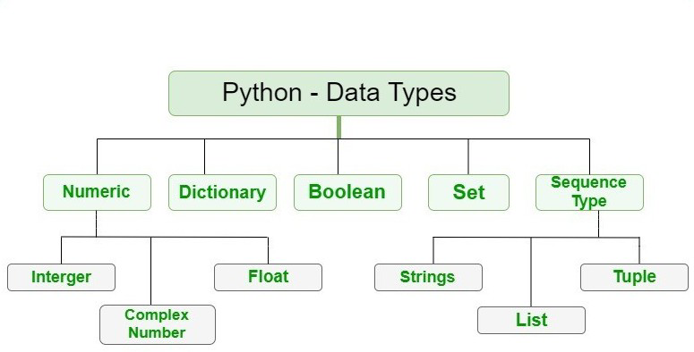
    - Variables can hold values of different types are called datatypes.Based on datatype of a variable interpreter reserves memory.

Fig 5. Python Datatypes

NUMBER SYSTEM (Numeric Datatypes)

PREFIX | INTERPRETATION | BASE
0b (Zero + lowercase letter ‘b’)  0B (Zero + uppercase letter ‘B’) | Binary | 2
0o (Zero + lowercase letter ‘o’)  0O (Zero + uppercase letter ‘O’) | Octal | 8
0x (Zero + lowercase letter ‘x’)  0X (Zero + uppercase letter ‘X’) | Hexadecimal | 16

COMPLEX DATATYPES
- Representation is a+bj
- Example – a=2+3j

Type () – This function is used to determine the type of an object as in Figure 6. It returns the type of the object as a class object.

10
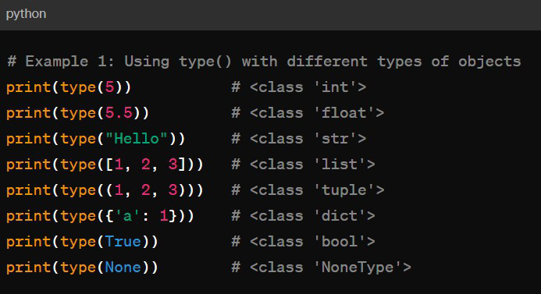

Fig 6. Type () function in Python

BOOLEAN
- The Boolean data type is either True or False.
- In Python, Boolean variables are defined by the True and False keywords.

COLLECTIONS

Collections refers to data structures that are used to store and manage collections of data. These collections provide various functions and are designed to suit different needs. Collections in python are basically container data types, namely lists, sets, tuples, dictionary. Here an introduction to collections in Python along with some commonly used types:

LISTS

- List are ordered collections of items.
- List are created using square brackets ‘[]’.
- Example: ‘my list = [1, 2, 3, 4, 5, 6]’

11

TUPLES

- Tuples are similar to lists but are immutable, meaning their content cannot be changed after creation.
- Tuples are created using parentheses ‘()’.
- Example: ‘my tuples = (1, 2, 3, 4, 5, 6)’

SETS

- Sets are unordered collections of unique elements.
- They are mutable, but their elements must be immutable.
- Sets are created using curly braces ‘{}’ or the ‘set()’ function.
- Example: ‘my_set = {1, 2, 3, 4, 5, 6}’

DICTIONARIES

- Dictionaries are collection of key-value pairs.
- They are unordered, mutable, and can contain any data types as values.
- Dictionaries are created using curly braces ‘{}’ with key-value pairs separated by colons :
- Examples: ‘my_dict = {‘name’: ‘John’, ‘age’: ‘24’, ‘city’: ‘New York’}’

OPERATIONS
In Python, operators are special symbols or keywords that are used to perform operations on operands. Here is an overview of the different types of operators in Python:

ARITHMETIC OPERATORS

Arithmetic operators are used to perform mathematical operations as in Figure 7.

    - Addition: ‘+’
    - Subtraction: ‘-’
    - Multiplication: ‘*’
    - Division: ‘/’
    - Floor Division: ‘//’ (returns the integer part of the division)
    - Modulus: ‘%’ (returns the remainder of the division)

12
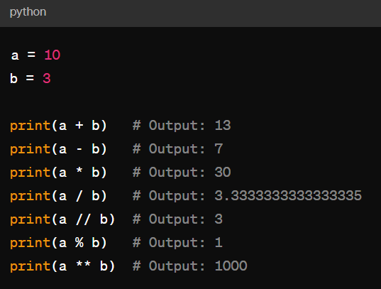

Fig 7. Arithmetic Operators in Python.

COMPARISON OPERATIONS
Comparison operators are used to compare the values of two operands as shown in Figure 8.
    - Equal to: ‘==’
    - Not equal to: ‘! =’
    - Greater than: ‘>’
    - Less than: ‘<’
    - Greater than or equal to: ‘>=’
    - Less than or equal to: ‘<=’
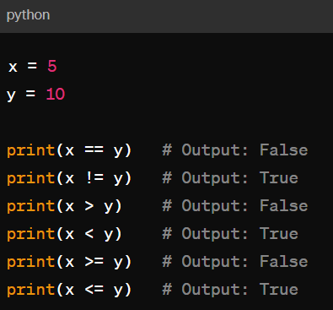
Fig 8. Comparison Operators in Python.

13

LOGICAL OPERATORS
Logical operators are used to combine conditional statements as in Figure 10.
    - Logical AND – ‘and’
    - Logical OR – ‘or’
    - Logical NOT – ‘not’

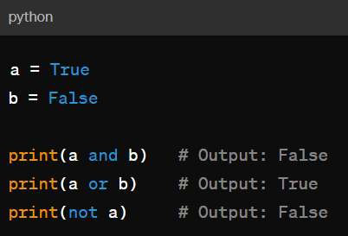
Fig 9. Logical Operators in Python.

ASSIGNMENT OPERATORS
Assignment operators are used to assign values to variables as in Figure 11.
    - Assignment: ‘=’
    - Addition assignment: ‘+=’
    - Subtraction assignment: ‘ -=’
    - Multiplication assignment: ‘*=’
    - Division assignment: ‘/=’
    - Modulus assignment: ‘%=’
    - Floor division assignment: ‘//=’
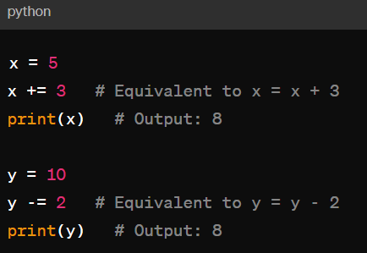
Fig 10. Assignment Operators in Python.

14

BITWISE OPERATION
Bitwise operators are used to perform bitwise operations on integers as in Figure 12.
- Bitwise AND: ‘&’
- Bitwise OR: ‘|’
- Bitwise XOR: ‘^’
- Bitwise NOT: ‘ ~’
- Left shift: ‘<<’
- Right shift: ‘>>’

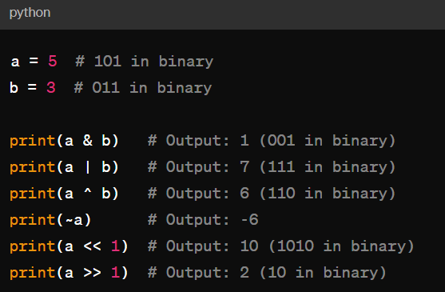
Fig 11. Bitwise Operators in Python.

TYPE CASTING VS TYPE COERCION

Type casting and type coercion are both mechanisms used in programming language to convert data from one type to another, but they differ in their approaches and implications.
- Explicit conversion of a value from one datatype to another is called type casting.
- Implicit conversion of datatypes during compilation or runtime is called Type Coercion.

15

TYPE CONVERSION
Type conversion, also known as type casting, is the process of converting a value from one data type to another. In Python, it can perform type conversion using built-in functions or constructors. Here are some common type conversion functions:
- Int(x): Converts x to integer
- Float(x): Converts x to float
- Str(x): Converts x to string.
- Tuple(x): Converts x to tuple.
- List(x): Converts x to list.
- Set(x): Converts x to set
- Ord(x) : Converts ASCII value of characters x
- Oct(x) : Converts x to octal.
- Hex(x): Converts x to hexadecimal.
- Chr(x): Converts ASCII code to characters.

16

CONTROL STATEMENTS

In Python, control statements are used to control the flow of execution in a program based on certain conditions. They allow to make decisions, execute code repeatedly, and handle exceptions. Three fundamental methods of control flow:
- Sequential
- Selection (execution only a selected set of stmts)
- Iteration (execute a set of statements repeatedly)

SELECTION / CONDITIONAL BRANCHING

  - These statements usually jump from one part of code to another depending on whether a particular condition is satisfied or not.
  - Conditional statements execute sequentially when there is no condition around the statements.
If: An if statement is a programming condition that, if proved true, perform a function, or displays information. The flow chart for if statement is shown in Figure 13.

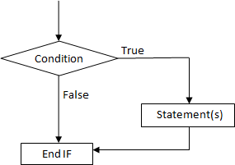

Fig 13. Flowchart for if statement in Python.

17

SAMPLE PROGRAM

Program to increment a number if positive
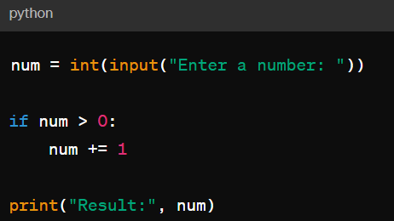
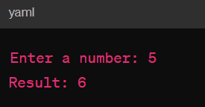
If you input a positive number like 5, the program will increment it by 1, resulting in 6 as the output. If you input a number that is not positive, such as 0 or a negative number, the program will not increment it, and the output will be the same as the input number.
Nested if: Nested if statements mean an if statement inside another is statement. The flow chart for if statement is shown in Figure 14.
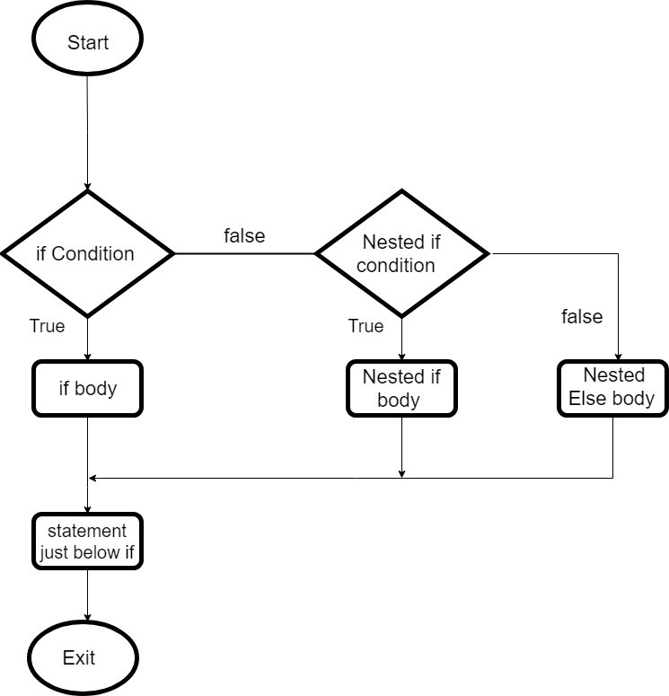

Fig 14. Flowchart for nested if statement in Python.

18

SAMPLE PROGRAM

Program to print the given year is leap year or not
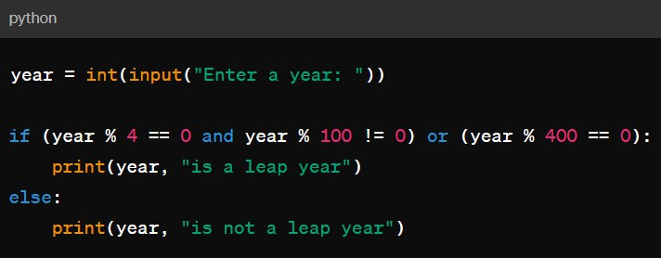
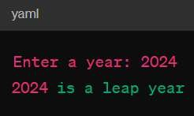

If the input the year 2024, the program will determine that it is a leap year and print "2024 is a leap year".
If-else: The if-else statement evaluates test expression and will execute the body of if only when the test condition is True. If the condition is False, the body of else is executed. Indentation is used to separate the blocks.
If-Elif-else: The if-Elif-else statements is used to conditionally execute a statement or a block of statements. Conditions can be true or false, execute one thing when the condition is true, something else when the condition is false.

ITERATIVE STATEMENTS

- WHILE LOOP
In the while loop, test expression is checked first. The body of the loop is entered only if the test expression evaluates to True. After one iteration, the test expression is checked again. This process continues until the test expression evaluates to False. The flow chart of while loop is in the figure 15.
19
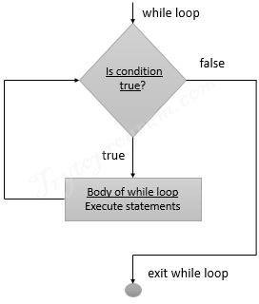

Fig 15. Flowchart for while loop in Python.

PYTHON BREAK STATEMENTS

The break statements terminate the loop containing it. Control of the program flow to the statements immediately after the body of the loop. If the break statements is inside a nested loop (loop inside another loop), the break statement will terminate the innermost loop.

Example – Usage break in a while loop
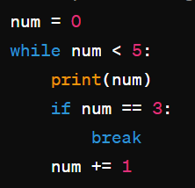
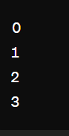

20

In this example, the while loop continues as long as num is less than 5. Inside the loop, num is printed, and then it is checked whether num is equal to 3. If the condition is true, the break statement is executed, and the loop terminates

PYTHON CONTINUE STATEMENT

The continue statement is used to skip the rest of the code inside a loop for the current iteration only. Loop does not terminate but continues on with the next iteration.

Example – Using continue in a while loop
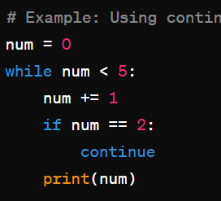
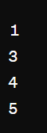

In this example, the while loop continues as long as Num is less than 5. Inside the loop, Num is incremented by 1. Then, it is checked whether Num is equal to 2. If the condition is
true, the continue statement is executed, and the loop skips the remaining code block for that iteration. Otherwise, the value of Num is printed.

FOR LOOP
For loop is usually known as determinate or definite loop because the programmer knows exactly how many times the loop will repeat. The number of times loop has to be executed can be determined mathematically checking logic of the loop. The flow chart of for loop is shown in figure 16.

Syntax
For loop_control_var in sequence: Statement 1
Statement 2

21
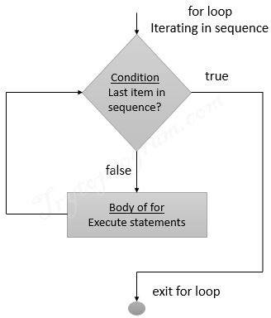

Fig 16. Flowchart for loop in Python.

SAMPLE PROGRAM

- Program using for loop to check whether the number is even or odd
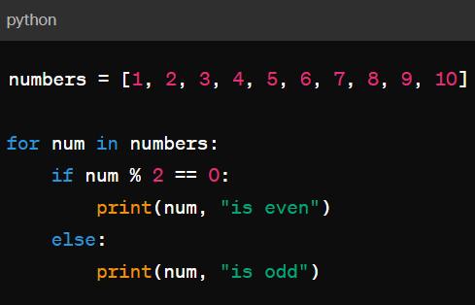
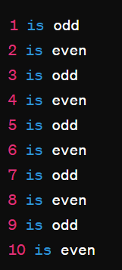

Each number from 1 to 10 is printed along with whether it is odd or even. Odd numbers have a remainder of 1 when divided by 2, while even numbers have a remainder of 0.

22

NESTED LOOPS

Nested loops in Python refer to using one or more loops inside another loop. This allows you to iterate over a sequence of elements or perform a certain operation multiple times, with one loop contained within another loop.
The basic syntax for a nested loop in Python is as follows:

for outer_loop_variable in outer sequence:

# Code block for Outer loop

for inner_loop_variable in inner sequence:

# Code block for inner loop

Nested loops are commonly used when dealing with multi-dimensional data structures, such as lists of lists or matrices, or when you need to perform a repetitive task that involves multiple levels of iteration.

Example – Simple example of a nested loop to print a pattern

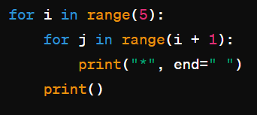
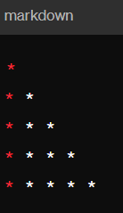
In this example, the outer loop (for i in range (5)) iterates over the rows, and the inner loop which (for j in range (i + 1)) iterates over the columns for each row. This results in a pattern where the number of asterisks increases with each row.

23

FUNCTIONS

INTRODUCTION

- A function is a block of organized and reusable program code that performs a simple, specific, and well-defined task.
- Func (1) is called to perform a well-defined task. As soon as Func (1) is called, the program control is passed to first statement in function. All the statements in function are executed and program control is passed to function following the one that called the function.

FUNCTION CALLING ANOTHER FUNCTION

- Func (1) calls function named Func (2). Therefore Func (1) is known as calling function.
- Func (2) is known as function.

NOTE: Func (1) calls as many functions as it wants.

NEED FOR FUNCTIONS
    - Dividing the program into separate functions facilitates each function to be written and tested separately.
    - Understanding, coding and testing multiple separate functions are far easier than the doing same for one huge function.
    - If a big program is done without functions, then there will be a large line of codes and maintaining it is a big mess.
    - All libraries in python contains predefined and pre-tested functions which the programmer can use them directly.
    - When a big program is broken into smaller functions different programmers working on that project can divide the workload.
    - Code reuse is one of the most prominent reasons to use the functions.

24

BUILT-IN MATH FUNCTIONS

Python provides a built-in math module that contains a variety of mathematical functions for performing common mathematical operations. Here are some of the most used math functions available in Python:
- abs(x): Returns the absolute value of x.
- pow (x, y) or x ** y: Returns x raised to the power of y.
- sqrt(x): Returns the square root of x.
- exp(x): Returns the exponential value of x (e^x).
- log(x): Returns the natural logarithm of x (base e).
- log10(x): Returns the base-10 logarithm of x.
- sin(x), cos(x), tan(x): Returns the trigonometric sine, cosine, and tangent of x, respectively. The input x is in radians.
- asin(x), acos(x), atan(x): Returns the inverse trigonometric sine, cosine, and tangent of x, respectively. The result is in radians.
- degrees(x): Converts angle x from radians to degrees.
- radians(x): Converts angle x from degrees to radians.
- ceil(x): Returns the smallest integer greater than or equal to x (i.e., the ceiling of x).
- floor(x): Returns the largest integer less than or equal to x (i.e., the floor of x).

- round(x): Returns x rounded to the nearest integer.
- gcd (x, y): Returns the greatest common divisor of two integers x and y.
- hypot (x, y): Returns the Euclidean norm, sqrt (xx + yy).

FUNCTION ASPECTS
    - The inputs that function takes are called as arguments or parameters.
    - When a called function returns some results to calling function it is said to return result.
    - The calling function may or may not pass parameters.
    - Function Declaration is a declaration statement that identifies a function with its name, list of arguments, and type of data it returns.
    - Function Definition consists of a function header that identifiers the function, followed by body of function containing executable code for that function.

25

FUNCTION DEFINITION

      - Function blocks begin with the keyword def followed by the function name and parentheses ().
      - Any input parameters or arguments should be placed within these parentheses ().
      - The first statement of a function can be an optional statement – the documentation string of the function or docstring.

FUNCTION CALL

        - The function call statement invokes the function.
        - When a function is invoked the program control jumps to called functions to execute statements that are part of a function.
        - Once called function is executed the program control passes back to calling function.
        - Function name ().

26

FILES AND DATA STRUCTURES

INTRODUCTION
- File is a collection of data stored on a secondary storage device like hard disk.
- If working in a large software application where they process many data, then it cannot expect those data to be stored in a variable as the variables are volatile in nature.
- Hence when it handles such situations, the role of files will come into the picture.
- As files are non-volatile in nature, the data will be stored permanently in a second device like Hard Disk and using python it can handle the files in applications.

TYPES OF FILES

There are two types of files in Python. They are:

- Binary file
- Text file

BINARY FILE

Most of the files that visible in personal computer system are called binary files.

  - Document Files - .pdf, .doc, .xls etc.
  - Image Files - .png, .jpg, .gif, .bmp etc.
  - Video Files - .mp4, .3gp, .mkv, .avi etc
  - Audio Files - .mp3, .wav, .mka, .aac etc
  - Database Files - .mdb, .accde, .frm, .sqlite etc
  - Archive Files - .zip, .rar, .iso, .7z etc
  - Executable Files - .exe, .dll, .class etc

All binary files follow a specific format. It can open some binary files in the normal text editor but it cannot read the content present inside the file. That is because all the binary files will be encoded in the binary format, which can be understood only by a computer or machine.
For handling such binary files it can need a specific type of software to open it.

27

For Example – it needs Microsoft word software to open .doc binary files. Likewise, it need a .pdf reader software to open .pdf binary files and it need a photo editor software to read the image files and so on.

TEXT FILE

Text files do not have any specific encoding and it can be opened in normal text editor itself.

  - Web Standards – html, XML, CSS, Java etc
  - Source Code – C, apps, Js, Py, Java etc
  - Documents – txt, tex, RTF etc
  - Tabular Data – scv, tsv etc
  - Configuration – ini, cfg, reg etc

PYTHON FILE HANDLING OPERATION

Most importantly there are four types of operations that handled by Python on files:

OPENING A FILE

    - Python has an in-built function called open () to open a file.
    - The open method returns a file object which is used to access the write, read and other in- built methods.

SYNTAX

    - File object = open(File_name, mode)
    - File_name is the name of the file or the location of the file that want to open.

MODE

- The file in the open function syntax will tell Python as what operation that what to do on a file.
- ‘r’ – Read Mode: Read mode is used only to read data from the file.
- ‘w’ – Write Mode: This mode is used when it want to write data into a file or modify it. Remember write mode overwrites the data present in the file.
- ‘s’ – Append Mode: Append mode is used to append data to the file. Remember data will be appended at the end of the file pointer.

28

- ‘r+’ – Read or Write Mode : This mode is used when it want to write or read the data from the same file.
- ‘w+’ – Read or Write Mode : When a file is opened in this mode. If the file has not been created new file will be created if created it is overwritten.
- ‘a+’ – Append or Read Mode : This mode is used when it want to read data from the file or append the data into the same file.

BINARY MODE

- ‘wb’ – Open a file for write only mode in the binary format.
- ‘rb’ – Open a file for the read -only mode in the binary format.
- ‘ab’ – Open a file for appending only mode in the binary format.
- ‘rb+’- Open a file for read and write only mode in the binary format.
- ‘ab’ - Open a file for appending and read only mode in the binary format.

READ A FILE

    - There are three ways in which we can read the files in python
    - Read([n])
    - Readline([n])
    - Readlines ()

Here, n is the number of bytes to be read. Program to read specific line from a file lineno=int(input(“enter a number”)) fp=open(“hello.txt”,”r”)
cufrentline=1 for line in fp:
if(currentline==lineno): print(line)
break.

29

PYTHON CLOSE A FILE:
    - In order to close a file, we must first open a file. In python, we have an in built method called close() to close the file which is opened.
    - Whenever you open a file, it is important to close it, especially, with write method. Because if we don’t call the close function after the write method then whatever data we have written to a file will not be saved in to the file.

Example

My_file= open(“C:/Documents/Pythhon/test.txt”, “r”) Print(my_file.read())
My_file.close()

WRITE A FILE:

    - In order to write data into a file, we must open the file in the write mode.
    - We need to be very careful while writing data in to the file as it overwrites the content present inside the file that you were writing, and all previous data will be erased.
    - We have two methods for writing data into a file as shown below.
    - Write(string)
    - Writelines(list)

Write() my_file=open(“C:/Documents/Python/test.txt”, “w”) my_file.write(“Hello World/n”)
my_file. Write(“Hello Python”)

Writelines()

- Fruits=[“Apple/n”, “Orange/n”, “Grapes/n”, “Watermelon”]
- My_file=open(“C:/Documents/Python/test.txt”, “w”)
- My_file. Writelines(fruits)
- My_ file. Close()

30

PYTHON APPEND TO FILE:
My_file=open(“C:/Documents/Python/test.txt”, “a+”) My_file.write(“Strawberry”)
The above code appends the string ‘strawberry’ at the end of the ‘test.txt’file.

APPENDING A LIST OF DATA:

Fruits=[“ /n Banana”, “/n Avacado”, “/nFigs”, “/n Mango”] My_file=open(“C:/Documents/Python/test.txt”, “w”) My_file. Writelines(fruits)
The above code appends a list of data into a “test.txt” file.

FILE OBJECT ATTRIBUTES

ATTRIBUTES | DESCRIPTION
Name | Return name of file
Mode | Return mode of file
Encoding | Return encoding format of file
Closed | Return true if file closed else return false

31

6. STRUCTURED QUERY LANGUAGE

6.1 INTRODUCTION

SQL, or Structured Query Language, is a powerful programming language used for managing and manipulating relational databases. It provides a standardized way to interact with databases, allowing users to perform tasks such as querying data, updating records, and defining database structures. Originally developed in the 1970s by IBM, SQL has since become the de facto standard language for relational database management systems (RDBMS), including popular systems such as MySQL, PostgreSQL, Microsoft SQL Server, Oracle Database, and SQLite, among others.

KEY ASPECTS

    - Data Querying: SQL allows users to retrieve data from databases using queries. Queries can range from simple requests for specific records to complex operations involving multiple tables and conditions.
    - Data Manipulation: SQL provides commands for inserting, updating, and deleting data
within a database. This allows users to modify existing records or add new ones as needed.
    - Database Definition: SQL includes commands for defining and managing database
structures such as tables, indexes, views, and stored procedures. These structures help organize and optimize data storage and access.
    - Data Control: SQL offers mechanisms for controlling access to databases and managing
user permissions. This ensures that only authorized users can view or modify sensitive data.
    - Data Integrity: SQL supports the enforcement of data integrity constraints such as
primary keys, foreign keys, and unique constraints. These constraints help maintain the consistency and reliability of data within a database.
    - Transaction Control: SQL provides features for managing database transactions,
allowing users to group multiple database operations into atomic units of work. This ensures that either all operations within a transaction are completed successfully or none of them are, maintaining data consistency.

32

IMPORTANCE OF SQL

- Business Insights: Data can provide valuable insights into customer behaviour, market trends, and operational efficiency, helping businesses optimize their strategies.
- Predictive Analysis: By analyzing historical data, organizations can make predictions about future trends and outcomes, aiding in planning and risk management.
- Personalization: Data allows businesses to personalize products, services, and marketing efforts to better meet the needs and preferences of individual customers.
- Performance Monitoring: Monitoring key performance indicators (KPIs) through data analysis helps organizations track progress towards goals and identify areas for improvement.

TYPES OF DATA
- Structured Data: This type of data has a predefined data model or is organized in a tabular format with a clear schema, making it easy to query and analyze. Examples include data in relational databases or spreadsheets.
- Unstructured Data: Unstructured data lacks a predefined data model and is not organized in a structured manner. Examples include text documents, images, audio files, and videos. Analysing unstructured data often requires specialized tools and techniques such as natural language processing (NLP) or computer vision.
- Semi-Structured Data: Semi-structured data falls somewhere between structured and
unstructured data. It may have a flexible schema or tags that provide some structure, but it does not fit neatly into a relational database. Examples include JSON, XML, and log files.
- Transactional Data: Transactional data records specific events or transactions, typically in a structured format. Examples include sales transactions, financial transactions, and log entries.
- Temporal Data: Temporal data includes information related to time, such as timestamps
or time-series data. It is commonly used in applications where the temporal aspect is important, such as IoT (Internet of Things) devices, financial markets, and weather forecasting.

DATA TYPES
In SQL, data types define the type of data that can be stored in a column of a table or used as variables within SQL statements. Different database management systems (DBMS) may support slightly different sets of data types, but there are common types found across most SQL implementations.
Here is an overview of common data types and their categories:

NUMERIC DATA TYPE

  - INTEGER/INT: Stores whole numbers, typically within a specified range.
  - SMALLINT: Like INTEGER but with a smaller range.
  - BIGINT: Like INTEGER but with a larger range.
  - DECIMAL/NUMERIC: Stores fixed-point numbers with exact precision.
  - FLOAT/REAL: Stores approximate numeric values with floating-point precision.
  - DOUBLE PRECISION: Like FLOAT but with double precision.

CHARACTER STRING DATA TYPES:

  - CHAR(n): Fixed-length character strings with a specified length 'n'.
  - VARCHAR(n): Variable-length character strings with a maximum length 'n'.
  - TEXT: Variable-length character strings with no specified maximum length (often used for large text data).

BINARY DATA TYPES:

  - BINARY(n): Fixed-length binary strings with a specified length 'n'.
  - VARBINARY(n): Variable-length binary strings with a maximum length 'n'.
  - BLOB: Variable-length binary strings with no specified maximum length (often used for large binary data).

DATE AND TIME DATA TYPES:

  - DATE: Stores date values in the format YYYY-MM-DD.
  - TIME: Stores time values in the format HH:MM: SS.
  - DATETIME/TIMESTAMP: Stores both date and time values.
  - INTERVAL: Represents a time interval.

BOOLEAN DATA TYPE:
  - BOOLEAN/BOOL: Stores true or false values.

6) ENUMERATION DATA TYPES:

. ENUM: Represents a set of predefined values.

INSTALLATION OF SQL

- Download MySQL Installer: Visit the MySQL website and download the MySQL Installer for your operating system (Windows, macOS, Linux).
- Run Installer: Locate the downloaded installer file and double-click it to run the installer.
- Choose Installation Type: Select your preferred installation type (e.g., "Developer Default" for standard development setup) and click "Next".
- Configure MySQL Server: Set the root password for MySQL Server and choose a port number for MySQL to listen on.
- Complete Installation: Wait for the installer to finish installing components and configuring MySQL Server.
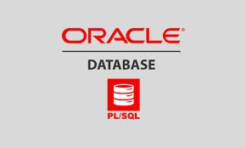

Fig 17. Run SQL through Oracle

CREATION OF TABLES, DATABASE, INSERTING VALUES

Creating Table – Syntax

CREATE TABLE table name(column name datatype);

EXAMPLE

CREATE TABLE Student (Student id int, Student name varchar2(30), Student_DOB date, Student_age int):

Inserting values into the table – syntax

INSERT INTO table name VALUES (value1,value2. );

EXAMPLE

INSERT INTO Student values (1,’Rahul’, ’31-AUG-1998’, 24);

SELECT, WHERE, PROJECTION AND SELECTION

- SELECT – The SELECT statement in SQL is used to retrieve data from table in a database.
Syntax - SELECT column1, column2,...FROM table name;

Example - SELECT first_name, last_name, salary FROM employees:

- WHERE - The WHERE clause is used to filter rows based on a specified condition. It allows you to retrieve only the rows that meet the specified criteria
Syntax - SELECT column1,column2,. name where conditions

Example - select” from employees where employee_ name=’sahana’;

- PROJECTION - a query retrieves specific columns from a table

Example - select employee_ name from employees

- SELECTION - a selection query filters rows from a table based on specific conditions

Example - select’ employees where employee _ name = ‘sahana’;

CASE SENSITIVITY
- SQL command (e.g., SELECT, INSERT) are not case – sensitive.
- SQL keywords (e.g., SELECT, FROM, WHERE) are not case – sensitive.
- Data is not case-sensitive. For example, ‘Hello’ and ‘hello’ are considered as equivalent values.
- Column names are not case-sensitive.
- Table names are not case-sensitive.

OPERATORS

SQL operators are used to perform operations on data in SQL queries. These are the basic syntax patterns for using common SQL operators in queries. Keep in mind that the exact syntax may vary slightly depending on the SQL dialect or database management system you're using.
Here is a summary of some common SQL operators:

ARITHMETIC OPERATORS:

• + (Addition): Adds two values.
- - (Subtraction): Subtracts one value from another.
- (Multiplication): Multiplies two values.
- / (Division): Divides one value by another.
- % (Modulo): Returns the remainder of a division operation.

COMPARISON OPERATORS:

• = (Equal to): Tests if two values are equal.
- or != (Not equal to): Tests if two values are not equal.
- < (Less than): Tests if one value is less than another.
- (Greater than): Tests if one value is greater than another.
- <= (Less than or equal to): Tests if one value is less than or equal to another.
- >= (Greater than or equal to): Tests if one value is greater than or equal to another.

LOGICAL OPERATORS:

- AND: Returns true if all conditions separated by AND are true.
- OR: Returns true if any condition separated by OR is true.
- NOT: Negates the result of a condition.

CONCATENATION OPERATOR:

- || (Double Pipe): Concatenates two or more strings.

PATTERN MATCHING OPERATORS (USED WITH LIKE):

- %: Matches any sequence of characters (zero or more).
- _ (Underscore): Matches any single character.
- [ ]: Matches any single character within the specified range or set.
- [^ ]: Matches any single character not within the specified range or set.

IN OPERATOR:

- Checks if a value matches any value in a list of specified values.

BETWEEN OPERATOR:

- Checks if a value is within a range of values.

IS NULL OPERATOR:

- Checks if a value is NULL.

IS NOT NULL OPERATOR:

- Checks if a value is not NULL.

7.SQL DATA BASE

SQL (Structured Query Language) databases are a cornerstone of modern data storage, retrieval, and management systems. They are designed to efficiently handle structured data and have been the go-to solution for relational data management for decades. If you need to describe SQL databases for your report, here are the key points you might want to cover:

Overview of SQL Databases

SQL databases use a structured approach to organize data into tables, which consist of rows and columns. This tabular structure allows for easy querying, indexing, and relationships among data. The relational model, proposed by Edgar F. Codd in 1970, underpins the design of SQL databases, emphasizing the use of keys and relationships to maintain data integrity.
Key Characteristics of SQL Databases
- Relational Structure: Data is stored in tables, with each table representing a specific entity. Relationships among tables are established using primary keys (unique identifiers for each row) and foreign keys (references to primary keys in other tables).
- SQL Language: SQL is the standard language for interacting with relational databases. It provides commands for querying, updating, and managing data, such as SELECT, INSERT, UPDATE, and DELETE.
- Data Integrity and Constraints: SQL databases enforce data integrity through constraints like primary keys, foreign keys, unique constraints, and check constraints. These rules ensure that the data remains consistent and reliable.
- ACID Properties: SQL databases adhere to ACID properties—Atomicity, Consistency, Isolation, and Durability. These properties ensure that transactions are processed reliably, even in the event of system failures or concurrent access.
- Normalization: SQL databases use normalization to minimize data redundancy and avoid data anomalies. This process involves decomposing complex tables into simpler ones to maintain consistency and reduce duplication.
Common SQL Database Systems
Several SQL database systems are widely used across different industries. Some of the most popular ones include:
- MySQL: An open-source SQL database known for its speed, reliability, and ease of use. It's commonly used for web applications and small to medium-sized businesses.
- PostgreSQL: An open-source, feature-rich SQL database that supports advanced features like complex queries, triggers, and stored procedures. It's favored for enterprise-level applications.
- Microsoft SQL Server: A robust SQL database system from Microsoft, popular in enterprise environments and with deep integration into the Microsoft ecosystem.
- Oracle Database: A powerful and highly scalable SQL database known for its advanced features and support for large-scale enterprise applications. Use Cases for SQL Databases SQL databases are used in a variety of scenarios, including:
- Enterprise Applications: Managing complex business processes, customer data, and internal operations.
- E-commerce Platforms: Handling product information, customer orders, and inventory.

- Financial Systems: Storing and processing financial transactions, ensuring data integrity and compliance.
- Healthcare Systems: Managing patient records and medical data, with strict data privacy and security requirements.
- Consistency and Reliability: ACID properties ensure consistent and reliable data transactions.
- Rich Querying Capabilities: SQL allows complex queries, joins, and data aggregations.
- Strong Data Integrity: Constraints and normalization help maintain data integrity.
- Scalability: SQL databases can scale to handle large volumes of data and high transaction loads.

8. HTML

HTML is an acronym which stands for Hyper Text Markup Language which is used for
creating web pages and web applications. Tim Berners-Lee is known as the father of HTML. The first available description of HTML was a document called "HTML Tags" proposed by Tim in late 1991. The latest version of HTML is HTML5.

Hyper Text: Hypertext simply means "Text within Text." A text has a link within it, is a hypertext.
Whenever you click on a link which brings you to a new webpage, you have clicked on a hypertext.
Hypertext is a way to link two or more web pages (HTML documents) with each other.

Markup language: A markup language is a computer language that is used to apply layout and formatting conventions to a text document. Markup language makes text more interactive and dynamic. It can turn text into images, tables, links, etc.

Web Page: A web page is a document which is commonly written in HTML and translated by a web browser. A web page can be identified by entering an URL. A Web page can be of the static or dynamic type. With the help of HTML only, we can create static web pages.

Hence, HTML is a markup language which is used for creating attractive web pages with the help of styling, and which looks in a nice format on a web browser. An HTML document is made of many HTML tags and each HTML tag contains different content. Features of HTML
- It is a very easy and simple language. It can be easily understood and modified.
- It is very easy to make an effective presentation with HTML because it has a lot of formatting tags.
- It is a markup language, so it provides a flexible way to design web pages along with the text. <!DOCTYPE>: It defines the document type or it instruct the browser about the version of HTML.
- <html>: This tag informs the browser that it is an HTML document. Text between html tag describes the web document. It is a container for all other elements of HTML except<!DOCTYPE>
- <head>: It should be the first element inside the <html> element, which contains the metadata (information about the document). It must be closed before the body tag opens.
- <title >: As its name suggested, it is used to add title of that HTML page which appears at the top of the browser window. It must be placed inside the head tag and should close immediately. (Optional)
- <body>: Text between body tag describes the body content of the page that is visible to the end user. This tag contains the main content of the HTML document.
- <h1>: Text between <h1>tag describes the first level heading of the webpage.
- <p>: Text between <p>tag describes the paragraph of the webpage.
- <frame>tag: HTML<frame> tag define the particular area within an HTML file where another HTML web page can be displayed

9.CSS (Cascading Style Sheets)

CSS is a stylesheet language used to control the appearance and layout of web pages. It allows developers to separate content (HTML) from design, making websites more attractive, responsive, and easy to maintain. With CSS, you can style multiple web pages at once, ensuring consistency across a website.

1. Basic Syntax
selector {
property: value;
}
Example:
p {
color: blue;
font-size: 16px;
}
CSS rules are applied by selecting HTML elements and assigning styles to them.

2. Types of CSS
- Inline CSS – Applied directly inside HTML elements (used for quick changes)
- Internal CSS – Defined within <style> tag in the HTML file
- External CSS – Stored in a separate .css file (recommended for large projects)

3. Selectors
Selectors help target HTML elements:
- Element → p, h1
- Class →. className
- ID → #idName
- Group → h1, p
- Universal → *

4. Colors & Background
color: red;
background-color: yellow;
background-image: url("img.jpg");
CSS supports color names, HEX, RGB, and HSL values for better design flexibility.
5. Text & Fonts
font-size: 16px;
font-family: Arial;
font-weight: bold;
text-align: center;
text-decoration: underline;
Typography plays a major role in improving readability and user experience.

6. Box Model
Every element follows the box model:
Content → Padding → Border → Margin
margin: 10px;
padding: 10px;
border: 1px solid black;

Understanding this helps in spacing and layout design.

7. Display & Position
display: block | inline | flex | grid;
position: static | relative | absolute | fixed;
These properties control how elements are arranged on the page.

8. Flexbox
display: flex;
justify-content: center;
align-items: center;
Flexbox is used for one-dimensional layouts (row or column alignment).

9. Grid
display: grid;
grid-template-columns: auto auto auto;
Grid is useful for creating complex two-dimensional layouts.

10. Common CSS Shortcuts
- Margin/Padding shorthand:
margin: 10px 20px;
padding: 5px 10px 15px 20px;
- Border shorthand:
border: 1px solid black;
- Background shorthand:
background: red url("img.jpg") no-repeat center;
- Font shorthand:
font: italic bold 16px Arial;
Shorthand properties reduce code length and improve readability.

11. Pseudo Classes
a: hover { color: red; }
input: focus {border: blue;}
They define special states of elements like hover, focus, etc.

12. Units
- px – fixed size
- % – relative size
- em, rem – scalable units
- vh, vw – viewport-based

13. Important Tips
- Prefer external CSS for scalability
- Use classes for reusability
- Keep styles organized and clean
- Use Flexbox and Grid for responsive design
- Follow consistent naming conventions

14. Developer Shortcuts (VS Code)
- ! + Enter → HTML boilerplate
- Ctrl + / → comment
- Alt + Shift + ↓ → duplicate line
- Ctrl + Space → auto-suggestions
- Shift + Alt + F → format code
Django Framework
- Django is a high-level Python web framework that enables developers to build secure, scalable, and feature-rich web applications quickly. It follows the Model-View-Template (MVT) architecture, which helps in organizing code efficiently by separating data handling, business logic, and user interface. Django is widely preferred for large-scale applications because it provides many built-in tools that reduce development time and effort.
- One of the most important aspects of Django is its “batteries-included” approach. It comes with a built-in admin panel, authentication system, and Object Relational Mapping (ORM), which allows developers to interact with databases using Python instead of SQL. For example, a simple model can be created as:
from django.db import models
class Student(models.Model):
name = models.CharField(max_length=100)
- This automatically creates a database table without writing SQL queries. Django also provides strong security features that protect applications from threats like SQL injection and cross-site scripting.
- Creating a simple view in Django is very easy. For instance:
from django.http import HttpResponse

def home(request):
return HttpResponse("Hello, Django!")
- This shows how quickly a webpage response can be generated. Django also has a powerful URL routing system:
from django.urls import path
from . import views
urlpatterns = [
path('', views.home),
]
- Although Django may feel complex for beginners due to its structured approach, it becomes very efficient for handling large projects.
- In conclusion, Django is best suited for developing complex and large-scale web applications where security, scalability, and rapid development are important.

Flask Framework

Flask is a lightweight and flexible Python web framework designed for simplicity and ease of use. It is known as a micro framework because it provides only the essential tools required to build web applications, allowing developers to add extra features when needed.
Flask does not follow a strict project structure, which gives developers full freedom to design applications. This flexibility makes it ideal for beginners and small projects. A basic Flask application can be created with just a few lines of code:
from flask import Flask

app = Flask(__name__)

@app.route('/')
def home():
return "Hello, Flask!"

app.run()
This simple example shows how easily a web server can be started and a webpage displayed. Flask also supports dynamic URLs:
@app.route('/user/<name>')
def user(name):
return f"Hello, {name}"
- Flask allows developers to extend functionality using extensions for databases, authentication, and forms. However, unlike Django, these features must be added manually, which can increase effort in large applications.
- Even though Flask is lightweight, it includes a built-in development server and debugger, making testing easier and faster.
- In conclusion, Flask is best suited for small to medium applications, prototypes, and learning purposes due to its simplicity, flexibility, and ease of use.

WEATHER FORECASTING APPLICATION USING PYTHON
INTRODUCTION
The Weather Forecasting Application is an advanced real-time weather monitoring and forecasting system developed using Python, Streamlit, PyOWM API, and Matplotlib. The application provides accurate weather details and future forecasts for any city through an interactive and user-friendly web interface.
The system helps users monitor temperature, humidity, pressure, visibility, wind speed, cloud coverage, sunrise and sunset timings, and upcoming weather alerts. The application also provides graphical representation of weather trends using bar graphs and line graphs.
OBJECTIVES OF THE PROJECT
1. To provide real-time weather updates.
2. To display future weather forecasts.
3. To visualize weather data graphically.
4. To generate weather alerts for dangerous conditions.
5. To develop an interactive web-based application.
6. To demonstrate practical implementation of Python concepts.
TECHNOLOGIES USED
• Python – Core programming language.
• Streamlit – User interface development.
• PyOWM API – Live weather data retrieval.
• Matplotlib – Data visualization and graph plotting.
• Datetime Module – Date and time handling.
WORKING OF THE PROJECT
STEP 1 – USER INPUT
The user enters the city name, selects the temperature unit, and chooses a graph type.
STEP 2 – API COMMUNICATION
The application communicates with the OpenWeatherMap API using PyOWM and retrieves weather information.
STEP 3 – DATA PROCESSING
The system processes weather information such as minimum and maximum temperatures, humidity, and visibility.
STEP 4 – DATA VISUALIZATION
The processed data is represented using graphs and charts.
STEP 5 – ALERT GENERATION
The application checks for rain, fog, storms, hurricanes, tornadoes, and snowfall alerts.
MODULE DESCRIPTION
1. CURRENT WEATHER MODULE
Displays current temperature, humidity, pressure, wind speed, and weather conditions.
2. TEMPERATURE FORECAST MODULE
Provides 5-day minimum and maximum temperature forecasts.
3. GRAPH MODULE
Displays bar graphs and line graphs for weather analysis.
4. HUMIDITY MODULE
Displays humidity trends for upcoming days.
5. SUNRISE AND SUNSET MODULE
Shows sunrise and sunset timings.
6. WEATHER ALERT MODULE
Provides alerts regarding upcoming weather conditions.
FEATURES OF THE PROJECT
• Real-time weather forecasting
• Interactive web interface
• Multiple graph representations
• Humidity forecasting
• Weather alert system
• Sunrise and sunset tracking
• Error handling and exception management
ADVANTAGES OF THE PROJECT
• Easy to use
• Fast weather updates
• Attractive graphical representation
• Real-time weather monitoring
• Supports multiple cities worldwide
FUTURE ENHANCEMENTS
• GPS-based weather detection
• Mobile application support
• Voice assistant integration
• AI-based weather prediction
• Multi-language support
• Dark mode interface
SOURCE CODE: from datetime import datetime
import pyowm
import streamlit as st
from matplotlib import dates
from matplotlib import pyplot as plt

# Use streamlit secrets to fetch the secret ApiKey.
api_key = st.secrets["API_KEY"]

sign = u"\N{DEGREE SIGN}"
owm = pyowm.OWM(api_key)
mgr = owm.weather_manager()

st.title("Weather Forecaster")
st.write("## *Made by Akash with* :heart:")
st.write("##")

st.write("### Enter the city name, choose a Temperature unit and a graph type from the bottom:")

location = st.text_input("Name of The City :", "")
units = st.selectbox("Select Temperature Unit: ", ('celsius', 'fahrenheit'))
graph = st.selectbox("Select Graph Type:", ('Bar Graph', 'Line Graph'))

if units == 'celsius':
degree = 'C'
else:
degree = 'F'

def get_temperature():
""" Get the max and min temepature for the next 5 days using API call."""
forecaster = mgr.forecast_at_place(location, '3h')
forecast = forecaster.forecast

days = []
dates = []
temp_min = []
temp_max = []
for weather in forecast:
day = datetime.utcfromtimestamp(weather.reference_time())
date = day.date()
if date not in dates:
dates.append(date)
temp_min.append(None)
temp_max.append(None)
days.append(date)
temp = weather.temperature(unit=units)['temp']
if not temp_min[-1] or temp < temp_min[-1]:
temp_min[-1] = temp
if not temp_max[-1] or temp > temp_max[-1]:
temp_max[-1] = temp
return (days, temp_min, temp_max)

def init_plot():
""" Initialize the plot and label x and y axis."""
plt.style.use('ggplot')
plt.figure('PyOWM Weather')
plt.xlabel('Day')
plt.ylabel(f'Temperature({sign}{degree})')
plt.title("Weekly Forecast")
#plt.tick_params(axis='both')

def plot_temperature():
""" Plot the bar graph of final min and max temperature of the week."""
days, temp_min, temp_max = get_temperature()
days = dates.date2num(days)
bar_x = plt.bar(days-0.25, temp_min, width=0.5, color='#42bff4', label='Min')
bar_y = plt.bar(days+0.25, temp_max, width=0.5, color='#ff5349', label='Max')
plt.legend(fontsize='x-small')
return (bar_x, bar_y)

def label_xaxis():
""" Label the date in the format 'mm/dd' on the x label."""
days, temp_min, temp_max = get_temperature()
days = dates.date2num(days)
plt.xticks(days)
axes = plt.gca()
xaxis_format = dates.DateFormatter('%m/%d')
axes.xaxis.set_major_formatter(xaxis_format)

def show_max_temp_on_barchart():
""" Show max and min temp on the bar plot."""
bar_x, bar_y = plot_temperature()
axes = plt.gca()
y_axis_max = axes.get_ylim()[1]
label_offset = y_axis_max * 0.1
for bar_chart in [bar_x, bar_y]:
for index, bar in enumerate(bar_chart):
bar_height = bar.get_height()
xpos = bar.get_x() + bar.get_width() / 2.0
ypos = bar_height - label_offset
label_text = f"{int(bar_height)}{sign}"
plt.text(xpos, ypos, label_text, ha='center', va='bottom', color='white')

def plot_line_graph_temp():
""" Plot the line graph of final min and max temperature of the week."""

st.write("_____________________________________")
st.title("5 Day Min and Max Temperature")
init_plot()
days, temp_min, temp_max = get_temperature()
days = dates.date2num(days)
plt.xticks(days)
axes = plt.gca()
xaxis_format = dates.DateFormatter('%m/%d')
axes.xaxis.set_major_formatter(xaxis_format)
plt.plot(days, temp_min, label='Min', color='#42bff4', marker='o')
plt.plot(days, temp_max, label='Max', color='#ff5349', marker='o')
plt.legend(fontsize='x-small')
st.set_option('deprecation.showPyplotGlobalUse', False)
st.pyplot(plt.show())

def weather_forcast():
""" Show the current weather forecast."""

obs = mgr.weather_at_place(location)
weather = obs.weather
icon = weather.weather_icon_url(size='4x')

temp = weather.temperature(unit=units)['temp']
temp_felt = weather.temperature(unit=units)['feels_like']
st.image(icon, caption= (weather.detailed_status).title())
st.markdown(f"## 🌡️ Temperature: **{round(temp)}{sign}{degree}**")
st.write(f"### Feels Like: {round(temp_felt)}{sign}{degree}")

cloud = weather.clouds
st.write(f"### ☁️ Clouds Coverage: {cloud}%")

wind = weather.wind()['speed']
st.write(f"### 💨 Wind Speed: {wind}m/s")

humidity = weather.humidity
st.write(f"### 💧 Humidity: {humidity}%")

pressure = weather.pressure['press']
st.write(f"### ⏲️ Pressure: {pressure}mBar")

visibility = weather.visibility(unit='kilometers')
st.write(f"### 🛣️ Visibility: {visibility}km")

def upcoming_weather_alert():
""" Shows the upcoming weather alerts."""

forecaster = mgr.forecast_at_place(location, '3h')
flag = 0
st.write("_____________________________________")
st.title("Upcoming Weather Alerts")
if forecaster.will_have_clouds():
st.write("### - Cloud Alert ⛅")
flag += 1
if forecaster.will_have_rain():
st.write("### - Rain Alert 🌧️")
flag += 1
if forecaster.will_have_snow():
st.write("### - Snow Alert ❄️")
flag += 1
if forecaster.will_have_hurricane():
st.write("### - Hurricane Alert 🌀")
flag += 1
if forecaster.will_have_tornado():
st.write("### - Tornado Alert 🌪️")
flag += 1
if forecaster.will_have_fog():
st.write("### - Fog Alert 🌫️")
flag += 1
if forecaster.will_have_storm():
st.write("### - Storm Alert 🌩️")
flag += 1
if flag == 0:
st.write("### No Upcoming Alerts!")

def sunrise_sunset():
""" Show the sunrise and sunset time."""
st.write("_____________________________________")
st.title("Sunrise and Sunset")
obs = mgr.weather_at_place(location)
weather = obs.weather

sunrise_unix = datetime.utcfromtimestamp(int(weather.sunrise_time()))
sunrise_date = sunrise_unix.date()
sunrise_time = sunrise_unix.time()

sunset_unix = datetime.utcfromtimestamp(int(weather.sunset_time()))
sunset_date = sunset_unix.date()
sunset_time = sunset_unix.time()

st.write(f"#### Sunrise Date: {sunrise_date}")
st.write(f"### --Sunrise Time: {sunrise_time}")
st.write(f"#### Sunset Date: {sunset_date}")
st.write(f"### --Sunset Time: {sunset_time}")

def get_humidity():
""" Get the humidity data of 5 days using API call."""
days = []
dates = []
humidity_max = []
forecaster = mgr.forecast_at_place(location, '3h')
forecast = forecaster.forecast

for weather in forecast:
day = datetime.utcfromtimestamp(weather.reference_time())
date = day.date()
if date not in dates:
dates.append(date)
humidity_max.append(None)
days.append(date)

humidity = weather.humidity
if not humidity_max[-1] or humidity > humidity_max[-1]:
humidity_max[-1] = humidity

return(days, humidity_max)

def plot_humidity():
""" Plot the 5 days humidity graph."""
days, humidity = get_humidity()
st.write("_____________________________________")
st.title("Humidity Index of 5 days")

plt.style.use('ggplot')
plt.figure('PyOWM Weather')
plt.xlabel('Day')
plt.ylabel('Humidity (%)')
plt.title('Humidity Forecast')

days = dates.date2num(days)
plt.xticks(days)
axes = plt.gca()
xaxis_format = dates.DateFormatter('%m/%d')
axes.xaxis.set_major_formatter(xaxis_format)

bar = plt.bar(days, humidity, color='#42bff4')
return bar

def show_max_humidity_on_bar():
""" Display the maximum humidity on the top of the graph."""
bar_max = plot_humidity()
axes = plt.gca()
y_max = axes.get_ylim()[1]
label_offset = y_max * 0.1
for bar_chart in [bar_max]:
for index, bar in enumerate(bar_chart):
height = bar.get_height()
xpos = bar.get_x() + bar.get_width() / 2.0
ypos = height - label_offset
label_text = f"{str(height)}%"
plt.text(xpos, ypos, label_text, ha='center', va='bottom', color='white')

def plot_humidity_graph():
show_max_humidity_on_bar()
st.pyplot(plt.show())

def plot_bar_graph_temp():
st.write("_____________________________________")
st.title("5 Day Min and Max Temperature")
init_plot()
plot_temperature()
label_xaxis()
show_max_temp_on_barchart()

if __name__ == '__main__':
if st.button('Submit'):
if location == '':
st.warning('Provide a city name!!')
else:
try:
weather_forcast()
if graph == 'Bar Graph':
plot_bar_graph_temp()
st.pyplot(plt.show())
elif graph == 'Line Graph':
plot_line_graph_temp()

upcoming_weather_alert()
sunrise_sunset()
plot_humidity_graph()
except:
error1 = NameError("Location Not Found!!\nTo make search more precise\
put the city's name, comma, 2-letter country code. Like this one- (city, XY)")
#error2 = SystemError("Server Down.....!\nPlease Try Again Later..")
st.exception(error1)

OUTPUT SCREENSHOTS: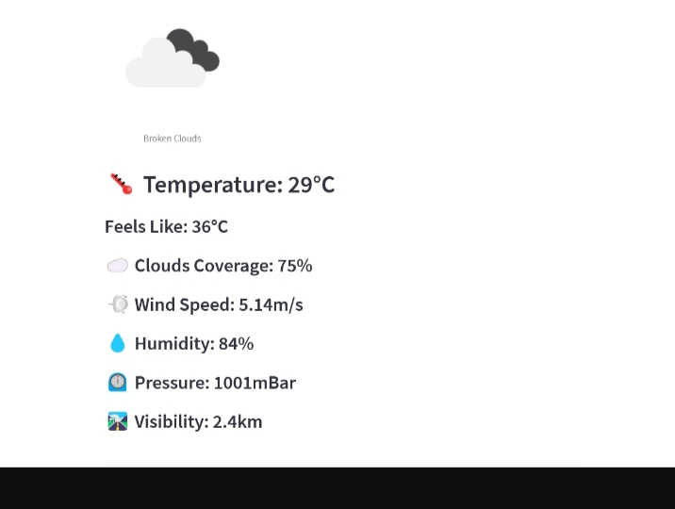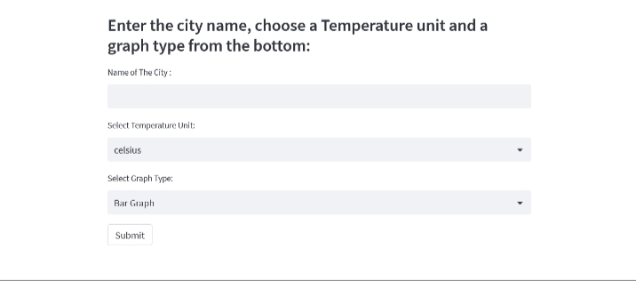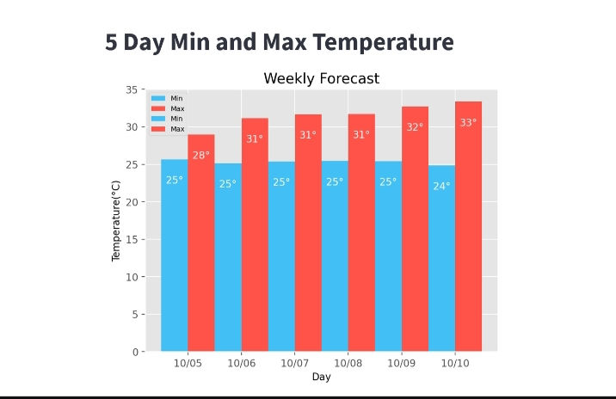
CONCLUSION
The Weather Forecasting Application successfully demonstrates the implementation of Python programming, API integration, Streamlit development, and graphical data visualization. The project provides accurate and user-friendly weather forecasting services and improves practical understanding of modern web application development.

10.CONCLUSION

Python full stack development offers a comprehensive approach to building web applications using Python for both frontend and backend development. Here is a concise conclusion highlighting its key aspects:
- Python's versatility and simplicity make it an excellent choice for full stack development. With Python, developers can use the same language across the entire stack, from frontend to backend, reducing complexity and streamlining development.
- For frontend development, Python frameworks like Django and Flask offer powerful tools for building robust web applications. These frameworks provide features such as routing, templating, form handling, and authentication, allowing developers to create dynamic and interactive user interfaces.
- On the backend, Python's extensive ecosystem of libraries and frameworks, combined with its ease of integration with databases and other services, enables developers to build scalable and efficient server-side applications.
- Then, you move on to databases. You learn about SQL, which is a language used to communicate with databases, and you explore different types of databases like Oracle and MySQL.
- Understanding databases is crucial because most web applications need to store and retrieve data. Next, you venture into web development.
- Here, you learn about the languages used for creating the visual part of websites: HTML for structure, CSS for styling, and JavaScript for adding interactivity. Additionally, you delve into backend frameworks like Flask and Django, which help you build the server-side of web applications.
- Throughout the internship, you also explore more advanced topics such as object-oriented programming concepts like inheritance, polymorphism, and encapsulation.
- These concepts are important for writing clean, efficient, and organized code. By the end of the internship, you're equipped with the skills to build your own web applications from scratch.
- You understand how to connect the frontend and backend of a website, manage databases, and apply best practices in software development.
- You understand the importance of collaboration and communication in a development team, and you become familiar with methodologies like Agile, which help teams work efficiently together.
- Overall, the Python Full Stack Development internship provides a comprehensive learning
Overall, Python full stack development offers a cohesive and efficient approach to building modern web applications, leveraging Python's strengths in simplicity, versatility, and extensive ecosystem of libraries and frameworks. As a result, Python remains a popular and widely-used technology stack for developers seeking to build robust and scalable web applications.

