CA SELENIUM AUTOMATIOIN 727721EUIT002-ABINAYA.S

TASK 1

1. Verify that the user can add a product to the cart by clicking on the "Add to Cart" button on the product page.

package com.selenium.test1.selenium1;

import org.openqa.selenium.By;

import org.openqa.selenium.WebDriver;

import org.openqa.selenium.chrome.ChromeDriver;

import org.openqa.selenium.chrome.ChromeOptions;

import io.github.bonigarcia.wdm.WebDriverManager;

public class TASK1 {

public static void main( String[] args ) throws InterruptedException

{

WebDriverManager.*chromedriver*().setup();

ChromeOptions co=new ChromeOptions();

co.addArguments("--remote-allow-origins=*");

WebDriver driver=new ChromeDriver(co);

driver.get("https://www.amazon.in/");

driver.manage().window().maximize();

String actualTitle=driver.getTitle();

System.***out***.println("Page title is : " + driver.getTitle());

String expectedTitle = "Online Shopping site in India: Shop Online for Mobiles, Books, Watches, Shoes and More - Amazon.in";

if(actualTitle.equalsIgnoreCase(expectedTitle))

System.***out***.println("Title Matched");

else

System.***out***.println("Title didn't match");

driver.get("https://www.amazon.in/Amazon-Brand-Tealight-Candles-Unscented/dp/B0744P71Y9/ref=sr_1_1?pd_rd_r=c06ef2b7-59da-457e-aa77-aaf7ebd414a2&pd_rd_w=kVt55&pd_rd_wg=vANIH&pf_rd_p=4901d125-0f33-48fa-87d3-a07efd7793cd&pf_rd_r=VSEXK1W6N5BTXD0J3B0H&qid=1681290806&refinements=p_n_format_browse-bin%3A19560799031&s=kitchen&sr=1-1");

driver.findElement(By.*id*("add-to-cart-button")).submit();

String t=driver.getTitle();

System.***out***.println("Added to cart");

}

}

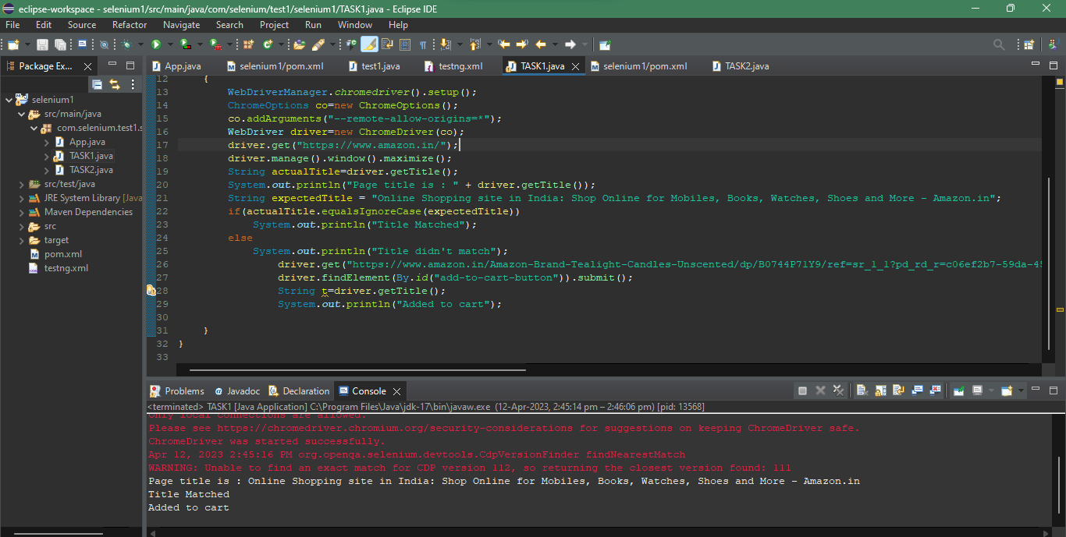

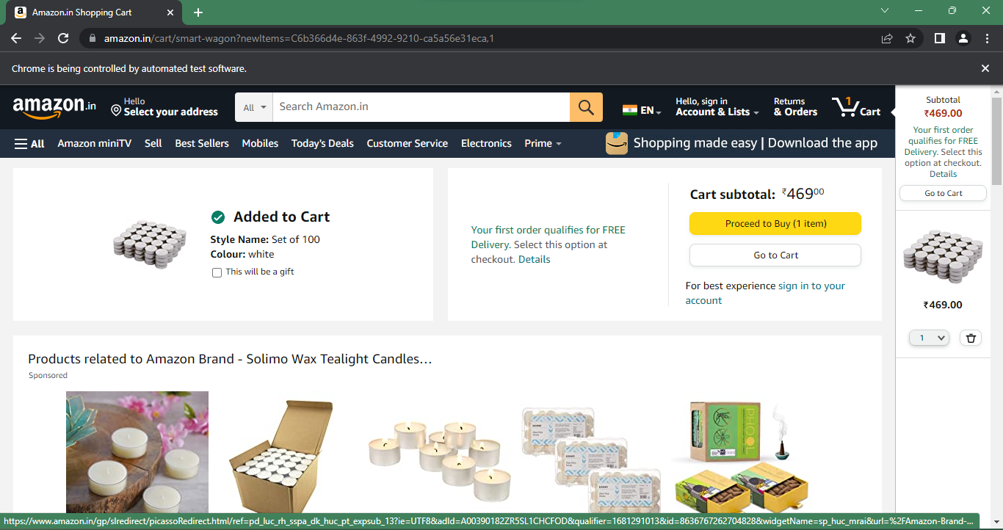

2. Verify that the user can remove a product from the cart by clicking on the "Remove" button next to the product.

package com.selenium.test1.selenium1;

import org.openqa.selenium.By;

import org.openqa.selenium.WebDriver;

import org.openqa.selenium.chrome.ChromeDriver;

import org.openqa.selenium.chrome.ChromeOptions;

import io.github.bonigarcia.wdm.WebDriverManager;

public class TASK_1_2 {

public static void main(String[] args) {

// **TODO** Auto-generated method stub

WebDriverManager.chromedriver().setup();

ChromeOptions co = new ChromeOptions();

co.addArguments("--remote-allow-origins=*");

WebDriver driver = new ChromeDriver(co);

driver.manage().window().maximize();

driver.get("https://www.amazon.in/DR-VAKU-Adapter-Charger-Black/dp/B09KN43PW1/ref=sr_1_1_sspa?crid=3GMJKRSPW2K0J&keywords=iphone+charger&qid=1681291277&sprefix=ip+hone+c%2Caps%2C432&sr=8-1-spons&sp_csd=d2lkZ2V0TmFtZT1zcF9hdGY&psc=1");

driver.findElement(By.id("add-to-cart-button")).submit();

String t = driver.getTitle();

System.out.println(t);

// Click on Cart Icon

driver.findElement(By.id("nav-cart-count-container")).click();

// Verify Item is in Cart

String cartTitle = driver.getTitle();

if (cartTitle.equals("Amazon.in Shopping Cart")) {

System.out.println("Item is in the Cart");

// Click on "Delete" button to remove the item from cart

driver.findElement(By.cssSelector("[value='Delete']")).click();

// Verify if the item has been removed from the cart

String emptyCartTitle = driver.getTitle();

if (emptyCartTitle.equals("Amazon.in Shopping Cart")) {

System.out.println("Item is NOT removed from the Cart");

} else {

System.out.println("Item is removed from the Cart");

}

} else {

System.out.println("Item is NOT in the Cart");

}

    }

}

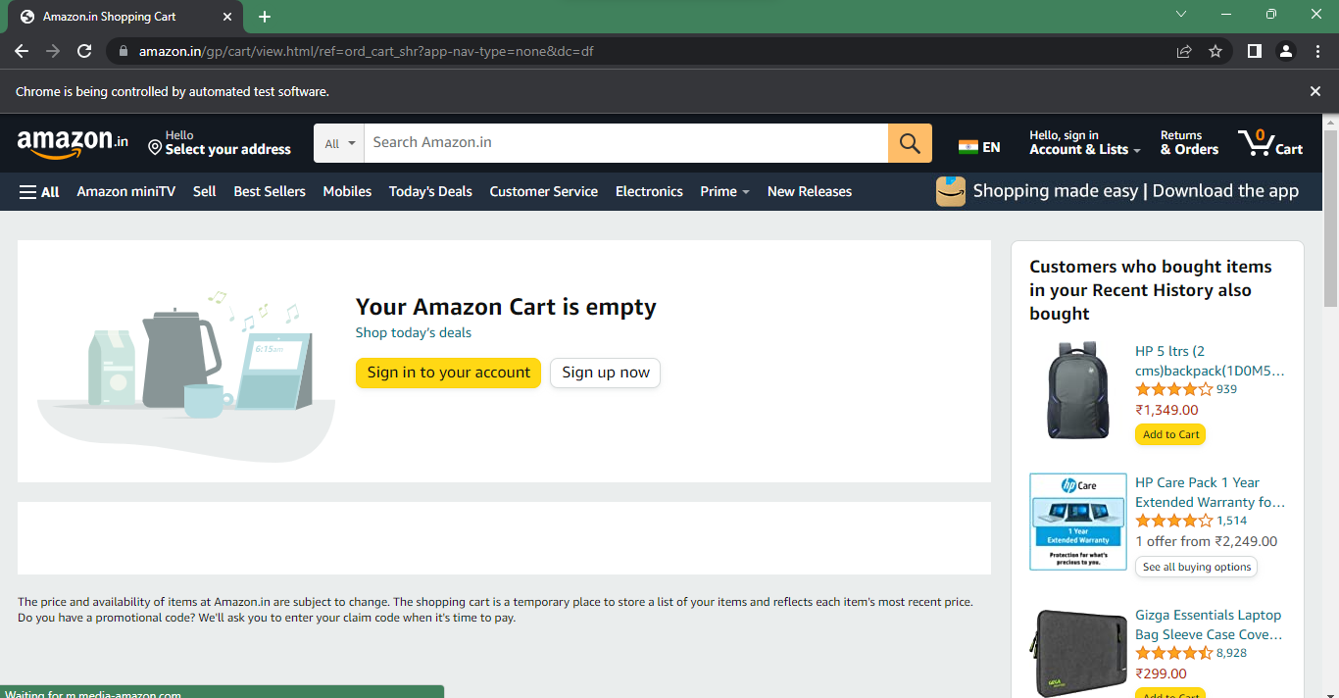

3. Verify that the user can update the quantity of a product in the cart by changing the quantity and clicking on the "Update" button.

package com.selenium.test1.selenium1;

import java.util.List;

import org.openqa.selenium.By;

import org.openqa.selenium.JavascriptExecutor;

import org.openqa.selenium.WebDriver;

import org.openqa.selenium.WebElement;

import org.openqa.selenium.chrome.ChromeDriver;

import org.openqa.selenium.chrome.ChromeOptions;

import org.openqa.selenium.edge.EdgeDriver;

import org.openqa.selenium.interactions.Actions;

import org.openqa.selenium.support.ui.Select;

import dev.failsafe.internal.util.Assert;

import io.github.bonigarcia.wdm.WebDriverManager;

public class TASK_1_3 {

public static void main( String[] args ) throws InterruptedException

{

WebDriverManager.chromedriver().setup();

ChromeOptions co=new ChromeOptions();

co.addArguments("--remote-allow-origins=*");

WebDriver driver=new ChromeDriver(co);

driver.manage().window().maximize();

driver.get("https://www.amazon.in/Anne-Diamond-Analog-Womens-Watch-AK3686BKGB/dp/B0968Q7L3M/ref=sr_1_1_sspa?crid=293FS4VHUVN6K&keywords=watches&qid=1681287782&sprefix=watches%2Caps%2C323&sr=8-1-spons&sp_csd=d2lkZ2V0TmFtZT1zcF9hdGY&psc=1");

driver.findElement(By.id("add-to-cart-button")).submit();

String t=driver.getTitle();

System.out.println(t);

String cart=driver.findElement(By.xpath("//*[@id=\"NATC_SMART_WAGON_CONF_MSG_SUCCESS\"]/span")).getText();

if(cart.equals("Added to cart"));

System.out.println("1. Verified that Product added to cart ");

driver.navigate().back();

WebElement sort1=driver.findElement(By.xpath("//*[@id=\"quantity\"]"));

sort1.click();

Select select=new Select(sort1);

select.selectByIndex(1);

String drop=driver.findElement(By.xpath("//*[@id=\"quantity\"]")).getText();

if(drop.equals("2"));

System.out.println("3. Verified that Product is updated to cart ");

    }

}

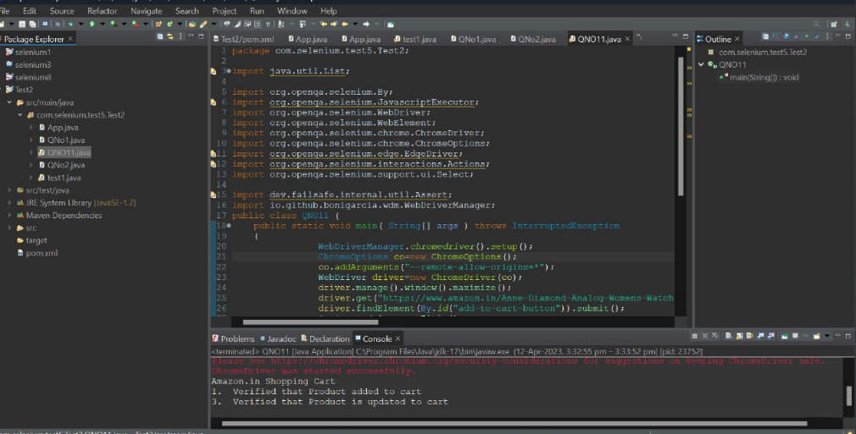

4. Verify that the user can proceed to the checkout page by clicking on the "Checkout" button on the cart page.

5. Verify that the checkout process is working as expected and calculates the total cost accurately.

TASK 2

1. Verify that the user can search any product on website and the corresponding search product details needs to be displayed

package com.selenium.test1.selenium1;

import org.openqa.selenium.By;

import org.openqa.selenium.Keys;

import org.openqa.selenium.WebDriver;

import org.openqa.selenium.WebElement;

import org.openqa.selenium.chrome.ChromeDriver;

import org.openqa.selenium.chrome.ChromeOptions;

import io.github.bonigarcia.wdm.WebDriverManager;

public class TASK_2_1 {

public static void main( String[] args ) throws InterruptedException

{

WebDriverManager.*chromedriver*().setup();

ChromeOptions co=new ChromeOptions();

co.addArguments("--remote-allow-origins=*");

WebDriver driver=new ChromeDriver(co);

driver.get("https://www.amazon.in/");

driver.manage().window().maximize();

String actualTitle=driver.getTitle();

System.***out***.println("Page title is : " + driver.getTitle());

String expectedTitle = "Online Shopping site in India: Shop Online for Mobiles, Books, Watches, Shoes and More - Amazon.in";

if(actualTitle.equalsIgnoreCase(expectedTitle))

System.***out***.println("Title Matched");

else

System.***out***.println("Title didn't match");

WebElement txt1=driver.findElement(By.*id*("twotabsearchtextbox"));

txt1.sendKeys("LAPTOP");

driver.findElement(By.*id*("twotabsearchtextbox")).sendKeys(*Keys*.***ENTER***);

}

}

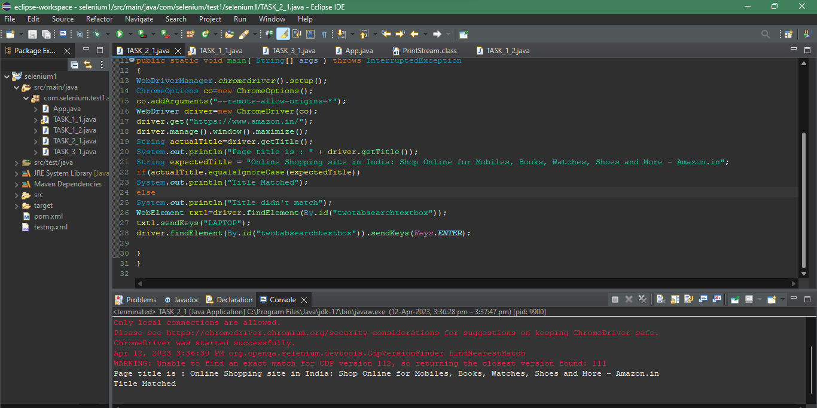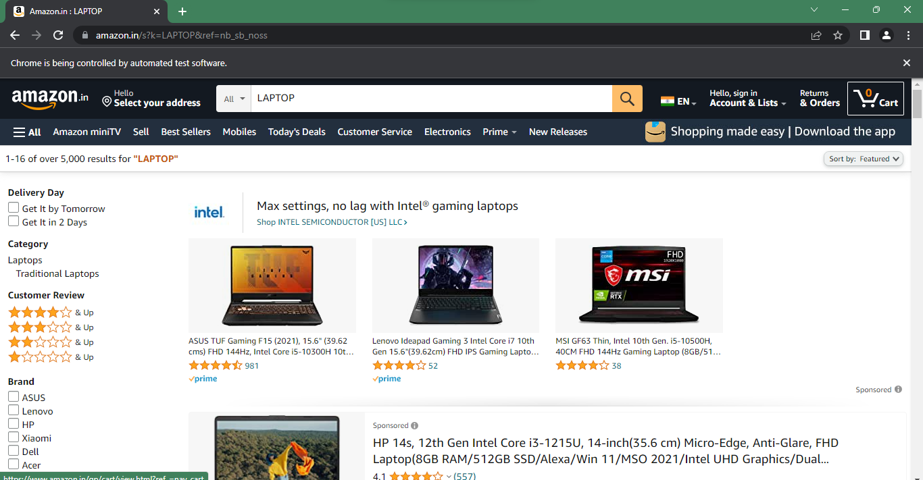

1. Print minimum 5 Names of the products displayed on the webpage

package com.selenium.test1.selenium1;

import java.util.List;

import org.openqa.selenium.By;

import org.openqa.selenium.JavascriptExecutor;

import org.openqa.selenium.WebDriver;

import org.openqa.selenium.WebElement;

import org.openqa.selenium.chrome.ChromeDriver;

import org.openqa.selenium.chrome.ChromeOptions;

import io.github.bonigarcia.wdm.WebDriverManager;

public class TASK_2_2 {

public static void main(String args[]) {

WebDriverManager.chromedriver().setup();

ChromeOptions co=new ChromeOptions();

co.addArguments("--remote-allow-origins=*");

WebDriver driver=new ChromeDriver(co);

driver.get("https://www.amazon.in/deal/2c2d3a50/?_encoding=UTF8&showVariations=true&_ref=dlx_gate_sd_dcl_tlt_2c2d3a50_dt&pd_rd_w=YgMyt&content-id=amzn1.sym.a532052b-26f3-4811-a261-3b35ffa57237&pf_rd_p=a532052b-26f3-4811-a261-3b35ffa57237&pf_rd_r=SWJFXC5PAM03PF4G0AWT&pd_rd_wg=6zviy&pd_rd_r=1f436e7b-ab36-4c27-9e50-8f8c69db422a&ref_=pd_gw_unk");

driver.manage().window().maximize();

JavascriptExecutor js=(JavascriptExecutor) driver;

js.executeScript("window.scrollBy(0,1000)","");

String title = driver.getTitle();

System.out.println(title);

String title2="Budget Laptops under INR 45000; Mega Electronic Days";

//title2=driver.getTitle();

if(title2.equals(title)) {

System.out.println("It is corret page title");

}

List<WebElement> li=driver.findElements(By.xpath("//*[@id=\"octopus-dlp-asin-stream\"]/ul/li[3]/span/div/div[2]/div[1]/a"]"));"

for(WebElement link:li) {

System.out.println(link.getText());

}

driver.navigate().back();

driver.navigate().forward();

driver.navigate().refresh();

driver.quit();

}

}

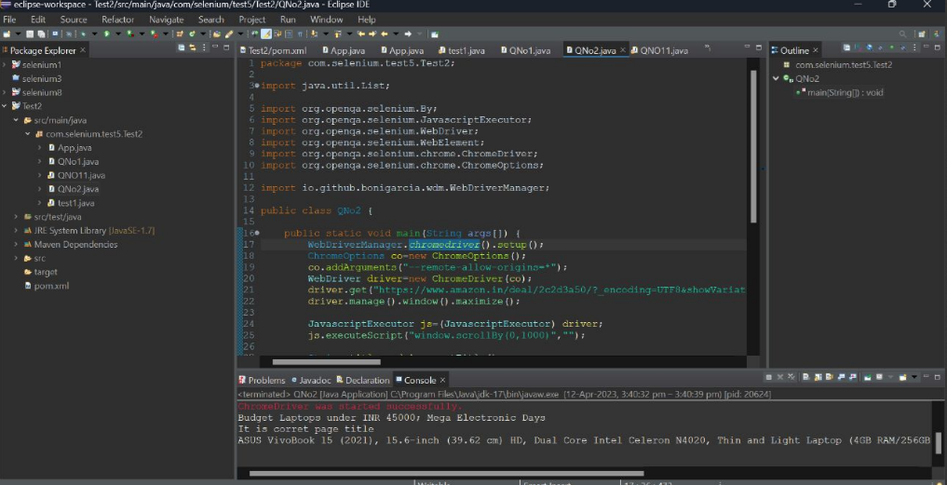

1. Verify that the user can filter the search results by category, price, and other parameters.

package com.selenium.test1.selenium1;

import java.util.List;

import org.openqa.selenium.By;

import org.openqa.selenium.WebDriver;

import org.openqa.selenium.WebElement;

import org.openqa.selenium.chrome.ChromeDriver;

import org.openqa.selenium.chrome.ChromeOptions;

import io.github.bonigarcia.wdm.WebDriverManager;

public class TASK_2_3 {

public static void main( String[] args ) throws InterruptedException

{

WebDriverManager.*chromedriver*().setup();

ChromeOptions co=new ChromeOptions();

co.addArguments("--remote-allow-origins=*");

WebDriver driver=new ChromeDriver(co);

driver.get("https://www.amazon.in/");

driver.manage().window().maximize();

String actualTitle=driver.getTitle();

System.***out***.println("Page title is : " + driver.getTitle());

String expectedTitle = "Online Shopping site in India: Shop Online for Mobiles, Books, Watches, Shoes and More - Amazon.in";

if(actualTitle.equalsIgnoreCase(expectedTitle))

System.***out***.println("Title Matched");

else

System.***out***.println("Title didn't match");

driver.findElement(By.*id*("a-autoid-0-announce")).click();

List<WebElement>li=driver.findElements(By.*xpath*("//*[@id=\"octopus-dlp-asin-stream\"]/ul/li[2]/span/div/div[2]/div[1]/a"));

for(WebElement link:li) {

System.***out***.println(link.getText());

}

System.***out***.println("User is able to filter by search");

System.***out***.println("Testing Ended");

driver.findElement(By.*id*("a-autoid-0-announce")).click();

List<WebElement>li=driver.findElements(By.*xpath*("//*[@id=\"octopus-dlp-asin-stream\"]/ul/li[2]/span/div/div[2]/div[1]/a"));

for(WebElement link:li) {

System.***out***.println(link.getText());

}

System.***out***.println("User is able to filter by search");

System.***out***.println("Testing Ended");

}

}

TASK 3

package com.selenium.test1.selenium1;

import java.util.List;

import org.openqa.selenium.By;

import org.openqa.selenium.JavascriptExecutor;

import org.openqa.selenium.Keys;

import org.openqa.selenium.WebDriver;

import org.openqa.selenium.WebElement;

import org.openqa.selenium.chrome.ChromeDriver;

import org.openqa.selenium.chrome.ChromeOptions;

import org.openqa.selenium.support.ui.Select;

import io.github.bonigarcia.wdm.WebDriverManager;

/**

* Hello world!

*

*/

public class TASK_3

{

public static void main( String[] args ) throws InterruptedException

{

WebDriverManager.*chromedriver*().setup();

ChromeOptions co = new ChromeOptions();

co.addArguments("--remote-allow-origins=*");

WebDriver driver=new ChromeDriver(co);

driver.get("https://www.amazon.in/ref=nav_logo");

driver.manage().window().maximize();

String title=driver.getTitle();

System.***out***.println(title);

if(title.equals("Online Shopping site in India: Shop Online for Mobiles, Books, Watches, Shoes and More - Amazon.in")) {

System.***out***.println("Verified title of the page");

}else {

System.***out***.println("Title not matched");

}

driver.findElement(By.*id*("nav-link-accountList")).click();

driver.findElement(By.*id*("ap_email")).sendKeys("ALCY@gmail.com");

driver.findElement(By.*id*("ap_email")).sendKeys(*Keys*.***ENTER***);

driver.findElement(By.*id*("ap_password")).sendKeys("DENCY52+");

driver.findElement(By.*id*("ap_password")).sendKeys(*Keys*.***ENTER***);

Thread.*sleep*(2000);

String name=driver.findElement(By.*id*("nav-link-accountList-nav-line-1")).getText();

if(name.equals("Hello, Feviliya")) {

System.***out***.println("Successfully, signed in");

}else {

System.***out***.println("Sign in failed");

}

System.***out***.println("Testing Ended");

driver.quit();

}

}

