CODING CONTEST 1 727721EUIT002 ABINAYA.S

TASK 1

i)

**package** com.selenium.project1.selenium1;

**import** org.openqa.selenium.By;

**import** org.openqa.selenium.WebDriver;

**import** org.openqa.selenium.WebElement;

**import** org.openqa.selenium.chrome.ChromeDriver;

**import** org.openqa.selenium.chrome.ChromeOptions;

**import** io.github.bonigarcia.wdm.WebDriverManager;

**public** **class** CCQ1 {

**public** **static** **void** main(String[] args) {

WebDriverManager.*chromedriver*().setup();

WebDriver driver;

ChromeOptions co = **new** ChromeOptions();

co.addArguments("--remote-allow-origins=*");

driver=**new** ChromeDriver(co);

driver.get("https://www.saucedemo.com/");

driver.manage().window().maximize();

WebElement uname=driver.findElement(By.*id*("user-name"));

uname.sendKeys("standard_user");

WebElement pword=driver.findElement(By.*id*("password"));

pword.sendKeys("secret_sauce");

WebElement login=driver.findElement(By.*xpath*("//*[@id=\"login-button\"]"));

driver.findElement(By.*name*("login-button")).click();

WebElement cli=driver.findElement(By.*xpath*("//*[@id=\"add-to-cart-sauce-labs-backpack\"]"));

cli.click();

}

}

OUTPUT:

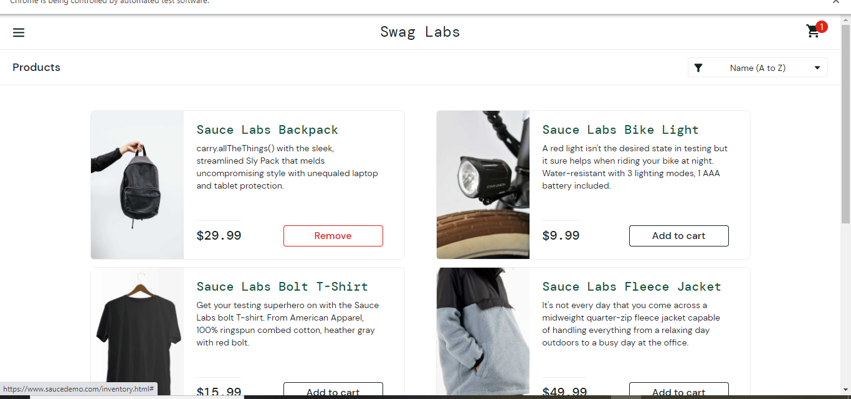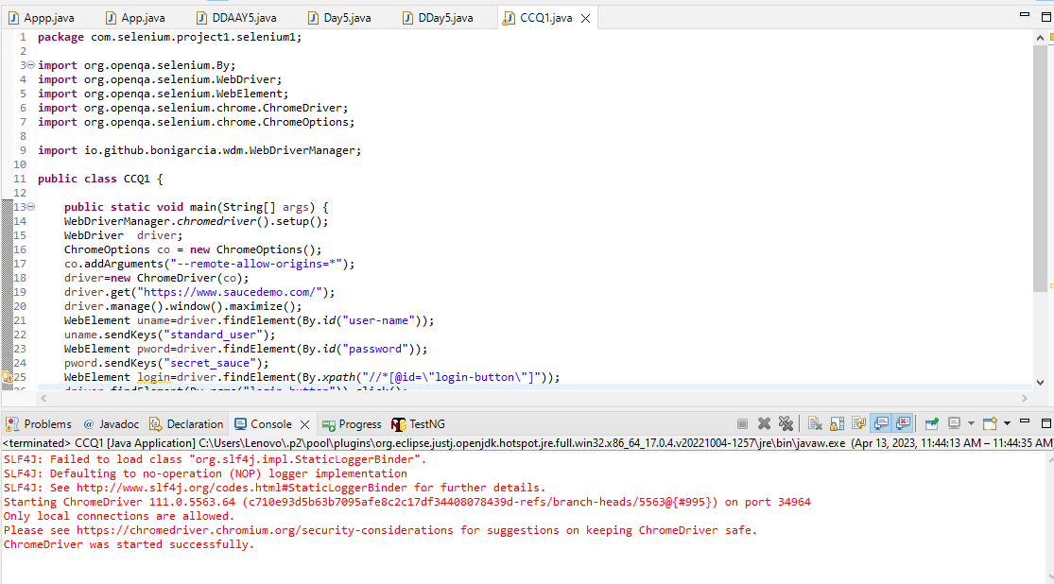

ii)

**package** com.selenium.project1.selenium1;

**import** org.openqa.selenium.By;

**import** org.openqa.selenium.WebDriver;

**import** org.openqa.selenium.WebElement;

**import** org.openqa.selenium.chrome.ChromeDriver;

**import** org.openqa.selenium.chrome.ChromeOptions;

**import** org.testng.Assert;

**import** io.github.bonigarcia.wdm.WebDriverManager;

**public** **class** CCQ1 {

**public** **static** **void** main(String[] args) {

WebDriverManager.*chromedriver*().setup();

WebDriver driver;

ChromeOptions co = **new** ChromeOptions();

co.addArguments("--remote-allow-origins=*");

driver=**new** ChromeDriver(co);

driver.get("https://www.saucedemo.com/");

driver.manage().window().maximize();

WebElement uname=driver.findElement(By.*id*("user-name"));

uname.sendKeys("standard_user");

WebElement pword=driver.findElement(By.*id*("password"));

pword.sendKeys("secret_sauce");

WebElement login=driver.findElement(By.*xpath*("//*[@id=\"login-button\"]"));

driver.findElement(By.*name*("login-button")).click();

WebElement cli=driver.findElement(By.*xpath*("//*[@id=\"add-to-cart-sauce-labs-backpack\"]"));

cli.click();

WebElement clic=driver.findElement(By.*xpath*("//*[@id=\"shopping_cart_container\"]/a"));

clic.click();

String nm=driver.findElement(By.*xpath*("//*[@id=\"item_4_title_link\"]/div")).getText();

System.***out***.print(nm);

String Check="Sauce Labs Backpack";

**if**(Check.equals(nm)) {

System.***out***.println("Can view the product in the cart");

}

}

}

OUTPUT:

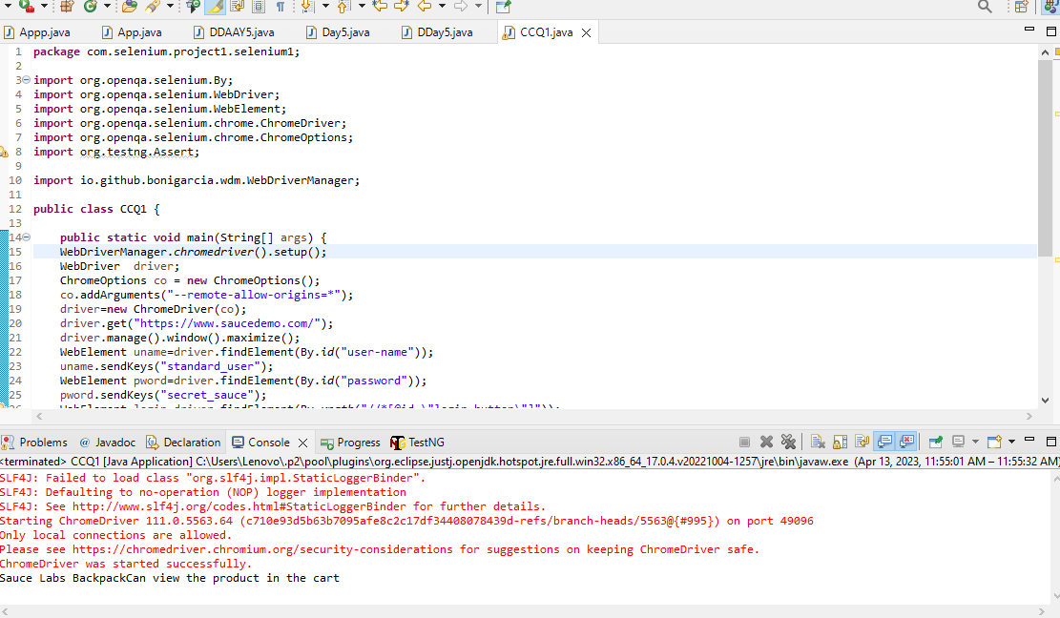

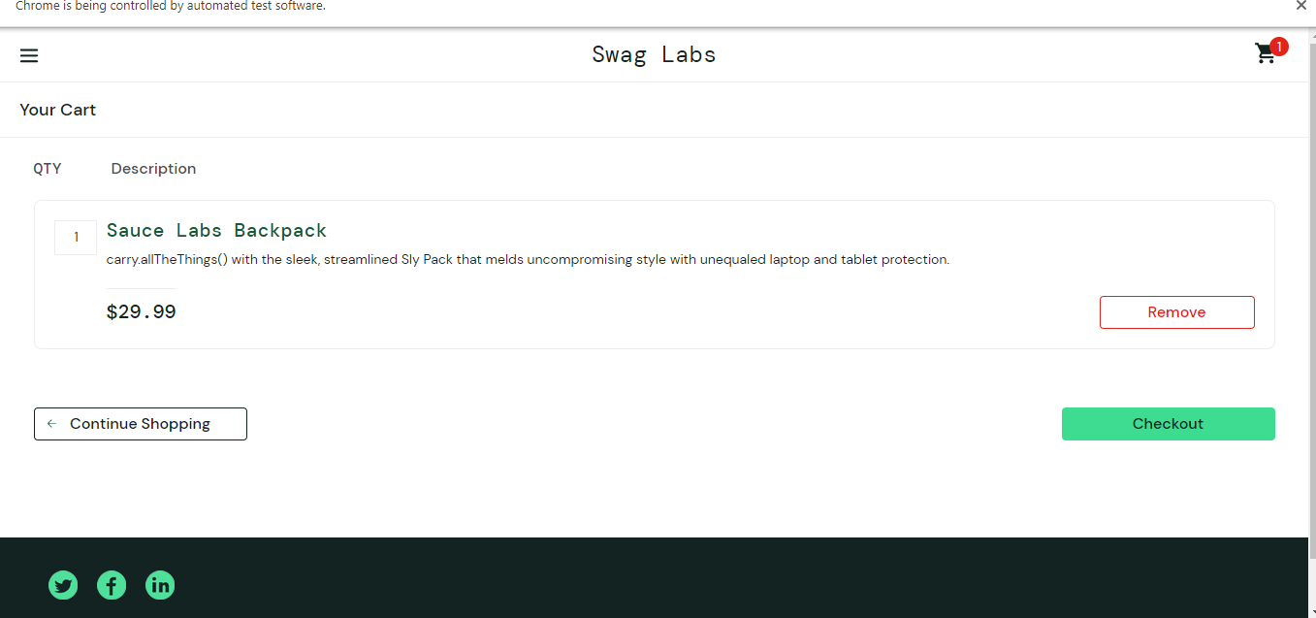

Iii)

**package** com.selenium.project1.selenium1;

**import** org.openqa.selenium.By;

**import** org.openqa.selenium.WebDriver;

**import** org.openqa.selenium.WebElement;

**import** org.openqa.selenium.chrome.ChromeDriver;

**import** org.openqa.selenium.chrome.ChromeOptions;

**import** org.testng.Assert;

**import** io.github.bonigarcia.wdm.WebDriverManager;

**public** **class** CCQ1 {

**public** **static** **void** main(String[] args) {

WebDriverManager.*chromedriver*().setup();

WebDriver driver;

ChromeOptions co = **new** ChromeOptions();

co.addArguments("--remote-allow-origins=*");

driver=**new** ChromeDriver(co);

driver.get("https://www.saucedemo.com/");

driver.manage().window().maximize();

WebElement uname=driver.findElement(By.*id*("user-name"));

uname.sendKeys("standard_user");

WebElement pword=driver.findElement(By.*id*("password"));

pword.sendKeys("secret_sauce");

WebElement login=driver.findElement(By.*xpath*("//*[@id=\"login-button\"]"));

driver.findElement(By.*name*("login-button")).click();

WebElement cli=driver.findElement(By.*xpath*("//*[@id=\"add-to-cart-sauce-labs-backpack\"]"));

cli.click();

WebElement clic=driver.findElement(By.*xpath*("//*[@id=\"shopping_cart_container\"]/a"));

clic.click();

String nm=driver.findElement(By.*xpath*("//*[@id=\"item_4_title_link\"]/div")).getText();

System.***out***.print(nm);

String Check="Sauce Labs Backpack";

**if**(Check.equals(nm)) {

System.***out***.println("Can view the product in the cart");

}

WebElement clc=driver.findElement(By.*xpath*("//*[@id=\"checkout\"]"));

clc.click();

System.***out***.println("Yes the information is displayed");

}

}

OUTPUT

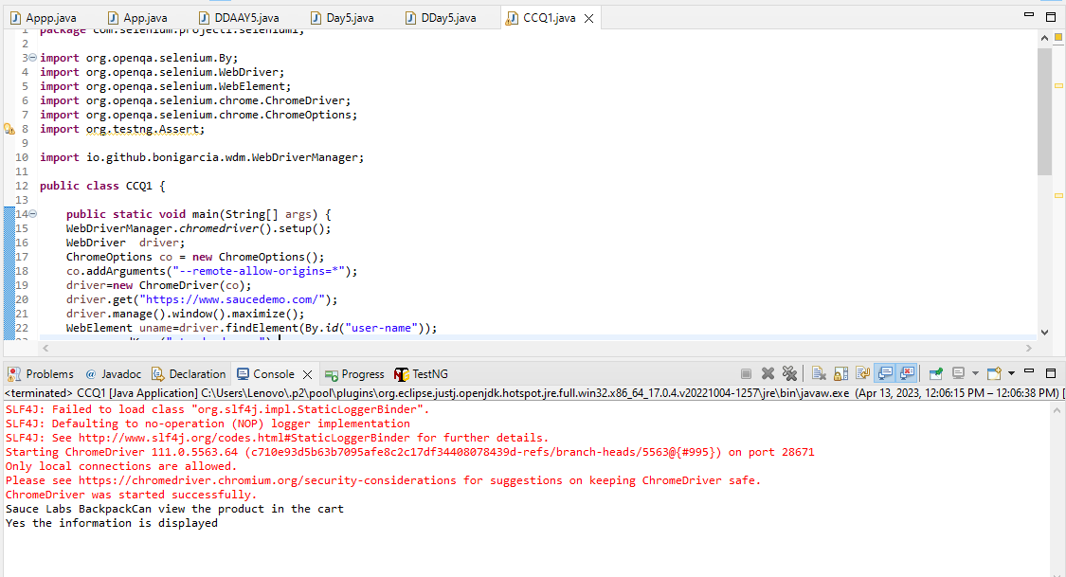

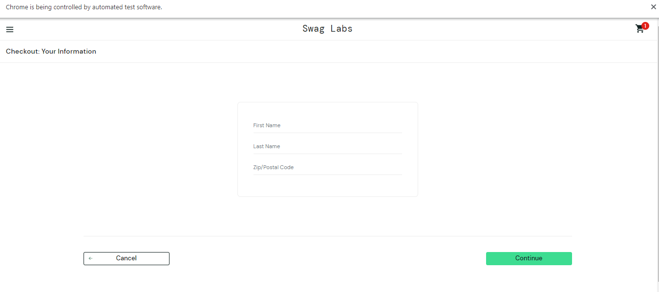

iv)

**package** com.selenium.project1.selenium1;

**import** org.openqa.selenium.By;

**import** org.openqa.selenium.WebDriver;

**import** org.openqa.selenium.WebElement;

**import** org.openqa.selenium.chrome.ChromeDriver;

**import** org.openqa.selenium.chrome.ChromeOptions;

**import** org.testng.Assert;

**import** io.github.bonigarcia.wdm.WebDriverManager;

**public** **class** CCQ1 {

**public** **static** **void** main(String[] args) {

WebDriverManager.*chromedriver*().setup();

WebDriver driver;

ChromeOptions co = **new** ChromeOptions();

co.addArguments("--remote-allow-origins=*");

driver=**new** ChromeDriver(co);

driver.get("https://www.saucedemo.com/");

driver.manage().window().maximize();

WebElement uname=driver.findElement(By.*id*("user-name"));

uname.sendKeys("standard_user");

WebElement pword=driver.findElement(By.*id*("password"));

pword.sendKeys("secret_sauce");

WebElement login=driver.findElement(By.*xpath*("//*[@id=\"login-button\"]"));

driver.findElement(By.*name*("login-button")).click();

WebElement cli=driver.findElement(By.*xpath*("//*[@id=\"add-to-cart-sauce-labs-backpack\"]"));

cli.click();

WebElement clic=driver.findElement(By.*xpath*("//*[@id=\"shopping_cart_container\"]/a"));

clic.click();

String nm=driver.findElement(By.*xpath*("//*[@id=\"item_4_title_link\"]/div")).getText();

System.***out***.print(nm);

String Check="Sauce Labs Backpack";

**if**(Check.equals(nm)) {

System.***out***.println("Can view the product in the cart");

}

WebElement clc=driver.findElement(By.*xpath*("//*[@id=\"checkout\"]"));

clc.click();

System.***out***.println("Yes the information is displayed");

WebElement fname=driver.findElement(By.*id*("first-name"));

fname.sendKeys("abi");

WebElement last=driver.findElement(By.*id*("last-name"));

last.sendKeys("S");

WebElement code=driver.findElement(By.*id*("postal-code"));

code.sendKeys("123");

WebElement cic=driver.findElement(By.*xpath*("//*[@id=\"continue\"]"));

cic.click();

}

}

OUTPUT:

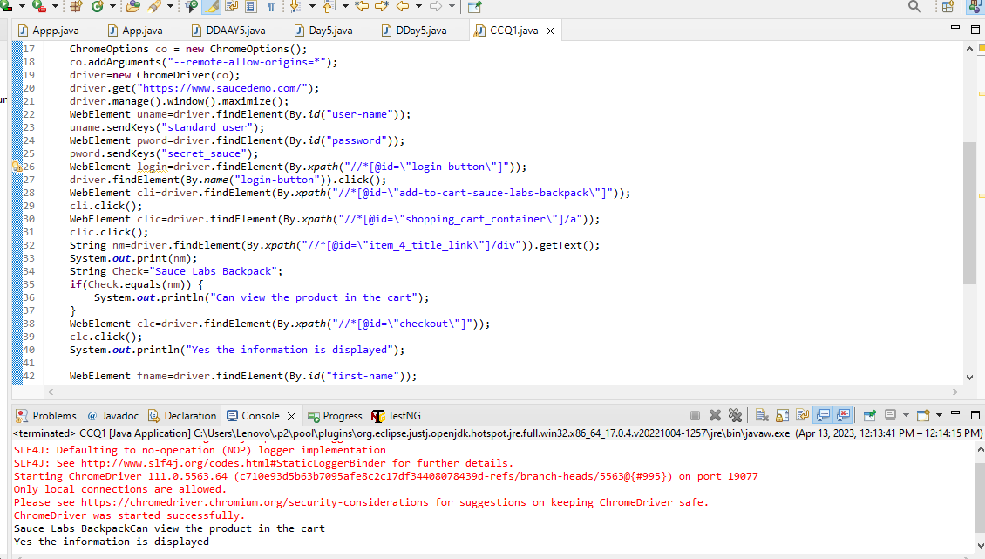

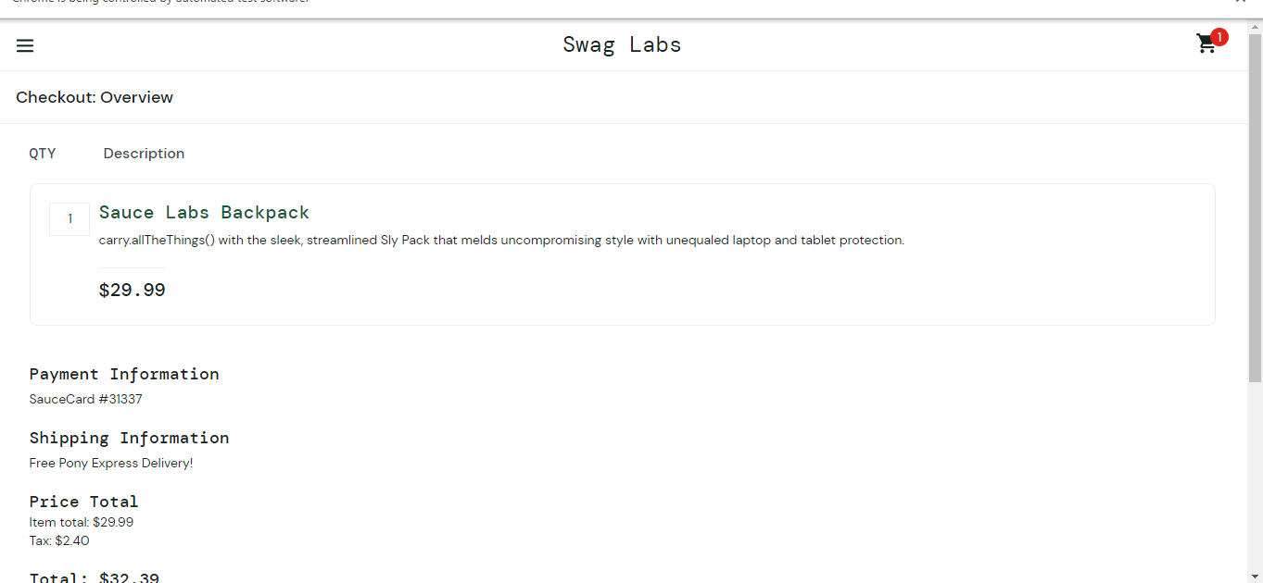

V)

**package** com.selenium.project1.selenium1;

**import** org.openqa.selenium.By;

**import** org.openqa.selenium.WebDriver;

**import** org.openqa.selenium.WebElement;

**import** org.openqa.selenium.chrome.ChromeDriver;

**import** org.openqa.selenium.chrome.ChromeOptions;

**import** org.testng.Assert;

**import** io.github.bonigarcia.wdm.WebDriverManager;

**public** **class** CCQ1 {

**public** **static** **void** main(String[] args) {

WebDriverManager.*chromedriver*().setup();

WebDriver driver;

ChromeOptions co = **new** ChromeOptions();

co.addArguments("--remote-allow-origins=*");

driver=**new** ChromeDriver(co);

driver.get("https://www.saucedemo.com/");

driver.manage().window().maximize();

WebElement uname=driver.findElement(By.*id*("user-name"));

uname.sendKeys("standard_user");

WebElement pword=driver.findElement(By.*id*("password"));

pword.sendKeys("secret_sauce");

WebElement login=driver.findElement(By.*xpath*("//*[@id=\"login-button\"]"));

driver.findElement(By.*name*("login-button")).click();

WebElement cli=driver.findElement(By.*xpath*("//*[@id=\"add-to-cart-sauce-labs-backpack\"]"));

cli.click();

WebElement clic=driver.findElement(By.*xpath*("//*[@id=\"shopping_cart_container\"]/a"));

clic.click();

String nm=driver.findElement(By.*xpath*("//*[@id=\"item_4_title_link\"]/div")).getText();

System.***out***.print(nm);

String Check="Sauce Labs Backpack";

**if**(Check.equals(nm)) {

System.***out***.println("Can view the product in the cart");

}

WebElement clc=driver.findElement(By.*xpath*("//*[@id=\"checkout\"]"));

clc.click();

System.***out***.println("Yes the information is displayed");

WebElement fname=driver.findElement(By.*id*("first-name"));

fname.sendKeys("abi");

WebElement last=driver.findElement(By.*id*("last-name"));

last.sendKeys("S");

WebElement code=driver.findElement(By.*id*("postal-code"));

code.sendKeys("123");

WebElement cic=driver.findElement(By.*xpath*("//*[@id=\"continue\"]"));

cic.click();

WebElement prints=driver.findElement(By.*className*("inventory_item_name"));

System.***out***.println("ProductName: "+prints.getText());

WebElement print1=driver.findElement(By.*xpath*("//*[@id=\"checkout_summary_container\"]/div/div[2]/div[8]"));

System.***out***.println(print1.getText());

}

}

OUTPUT:

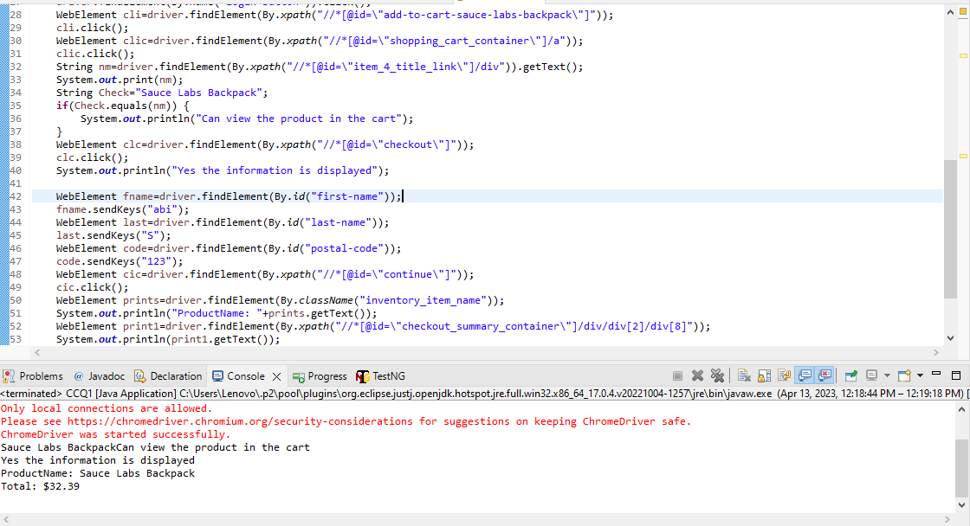

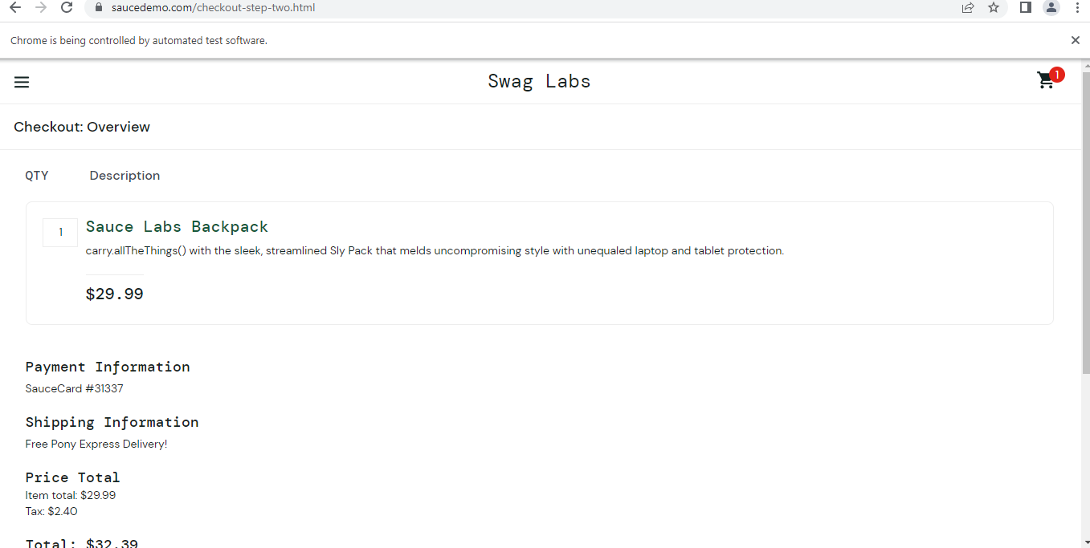

VI)

**package** com.selenium.project1.selenium1;

**import** org.openqa.selenium.By;

**import** org.openqa.selenium.WebDriver;

**import** org.openqa.selenium.WebElement;

**import** org.openqa.selenium.chrome.ChromeDriver;

**import** org.openqa.selenium.chrome.ChromeOptions;

**import** org.testng.Assert;

**import** io.github.bonigarcia.wdm.WebDriverManager;

**public** **class** CCQ1 {

**public** **static** **void** main(String[] args) {

WebDriverManager.*chromedriver*().setup();

WebDriver driver;

ChromeOptions co = **new** ChromeOptions();

co.addArguments("--remote-allow-origins=*");

driver=**new** ChromeDriver(co);

driver.get("https://www.saucedemo.com/");

driver.manage().window().maximize();

WebElement uname=driver.findElement(By.*id*("user-name"));

uname.sendKeys("standard_user");

WebElement pword=driver.findElement(By.*id*("password"));

pword.sendKeys("secret_sauce");

WebElement login=driver.findElement(By.*xpath*("//*[@id=\"login-button\"]"));

driver.findElement(By.*name*("login-button")).click();

WebElement cli=driver.findElement(By.*xpath*("//*[@id=\"add-to-cart-sauce-labs-backpack\"]"));

cli.click();

WebElement clic=driver.findElement(By.*xpath*("//*[@id=\"shopping_cart_container\"]/a"));

clic.click();

String nm=driver.findElement(By.*xpath*("//*[@id=\"item_4_title_link\"]/div")).getText();

System.***out***.print(nm);

String Check="Sauce Labs Backpack";

**if**(Check.equals(nm)) {

System.***out***.println("Can view the product in the cart");

}

WebElement clc=driver.findElement(By.*xpath*("//*[@id=\"checkout\"]"));

clc.click();

System.***out***.println("Yes the information is displayed");

WebElement fname=driver.findElement(By.*id*("first-name"));

fname.sendKeys("abi");

WebElement last=driver.findElement(By.*id*("last-name"));

last.sendKeys("S");

WebElement code=driver.findElement(By.*id*("postal-code"));

code.sendKeys("123");

WebElement cic=driver.findElement(By.*xpath*("//*[@id=\"continue\"]"));

cic.click();

WebElement prints=driver.findElement(By.*className*("inventory_item_name"));

System.***out***.println("ProductName: "+prints.getText());

WebElement print1=driver.findElement(By.*xpath*("//*[@id=\"checkout_summary_container\"]/div/div[2]/div[8]"));

System.***out***.println(print1.getText());

String tit=driver.getTitle();

String tit1="Swag Labs";

**if**(tit1.equals(tit))

System.***out***.println("Correct title");

}

}

OUTPUT:

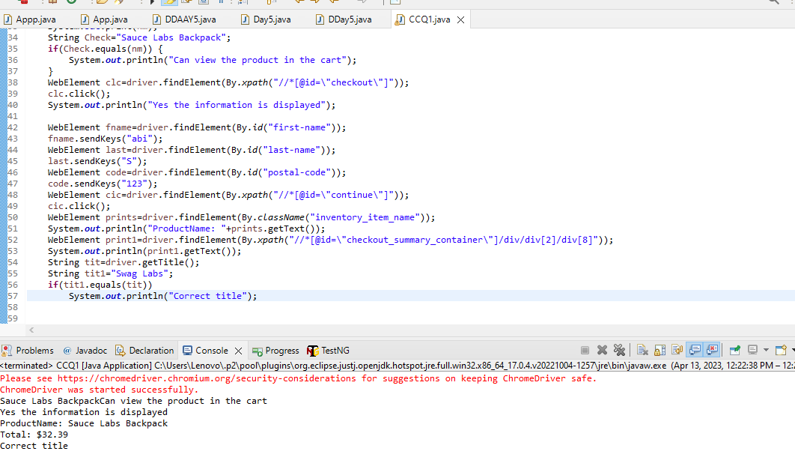

VII)

**package** com.selenium.project1.selenium1;

**import** org.openqa.selenium.By;

**import** org.openqa.selenium.WebDriver;

**import** org.openqa.selenium.WebElement;

**import** org.openqa.selenium.chrome.ChromeDriver;

**import** org.openqa.selenium.chrome.ChromeOptions;

**import** org.testng.Assert;

**import** io.github.bonigarcia.wdm.WebDriverManager;

**public** **class** CCQ1 {

**public** **static** **void** main(String[] args) {

WebDriverManager.*chromedriver*().setup();

WebDriver driver;

ChromeOptions co = **new** ChromeOptions();

co.addArguments("--remote-allow-origins=*");

driver=**new** ChromeDriver(co);

driver.get("https://www.saucedemo.com/");

driver.manage().window().maximize();

WebElement uname=driver.findElement(By.*id*("user-name"));

uname.sendKeys("standard_user");

WebElement pword=driver.findElement(By.*id*("password"));

pword.sendKeys("secret_sauce");

WebElement login=driver.findElement(By.*xpath*("//*[@id=\"login-button\"]"));

driver.findElement(By.*name*("login-button")).click();

WebElement cli=driver.findElement(By.*xpath*("//*[@id=\"add-to-cart-sauce-labs-backpack\"]"));

cli.click();

WebElement clic=driver.findElement(By.*xpath*("//*[@id=\"shopping_cart_container\"]/a"));

clic.click();

String nm=driver.findElement(By.*xpath*("//*[@id=\"item_4_title_link\"]/div")).getText();

System.***out***.print(nm);

String Check="Sauce Labs Backpack";

**if**(Check.equals(nm)) {

System.***out***.println("Can view the product in the cart");

}

WebElement clc=driver.findElement(By.*xpath*("//*[@id=\"checkout\"]"));

clc.click();

System.***out***.println("Yes the information is displayed");

WebElement fname=driver.findElement(By.*id*("first-name"));

fname.sendKeys("abi");

WebElement last=driver.findElement(By.*id*("last-name"));

last.sendKeys("S");

WebElement code=driver.findElement(By.*id*("postal-code"));

code.sendKeys("123");

WebElement cic=driver.findElement(By.*xpath*("//*[@id=\"continue\"]"));

cic.click();

WebElement prints=driver.findElement(By.*className*("inventory_item_name"));

System.***out***.println("ProductName: "+prints.getText());

WebElement print1=driver.findElement(By.*xpath*("//*[@id=\"checkout_summary_container\"]/div/div[2]/div[8]"));

System.***out***.println(print1.getText());

String tit=driver.getTitle();

String tit1="Swag Labs";

**if**(tit1.equals(tit))

System.***out***.println("Correct title");

String url1="https://www.saucedemo.com/checkout-step-two.html";

String url2="";

url2=driver.getCurrentUrl();

**if**(url1.equals(url2))

System.***out***.println("Correct url");

}

}

}

OUTPUT:

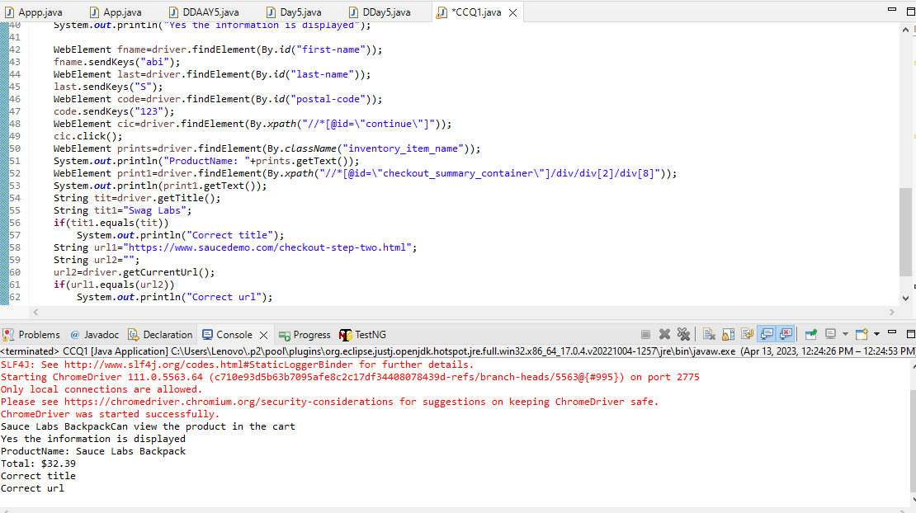

Task 2.1

package com.selenium.test1.selenium1;

import org.openqa.selenium.By;

import org.openqa.selenium.WebDriver;

import org.openqa.selenium.WebElement;

import org.openqa.selenium.chrome.ChromeDriver;

import org.openqa.selenium.chrome.ChromeOptions;

import org.openqa.selenium.support.ui.Select;

import io.github.bonigarcia.wdm.WebDriverManager;

public class QUE2_1 {

public static void main( String[] args ) throws InterruptedException

{

WebDriverManager.chromedriver().setup();

ChromeOptions co=new ChromeOptions();

co.addArguments("--remote-allow-origins=*");

WebDriver driver=new ChromeDriver(co);

driver.get("https://www.saucedemo.com/");

driver.manage().window().maximize();

driver.findElement(By.name("user-name")).sendKeys("standard_user");

driver.findElement(By.name("password")).sendKeys("secret_sauce");

driver.findElement(By.id("login-button")).click();

WebElement sort1=driver.findElement(By.className("product_sort_container"));

sort1.click();

System.out.println("A-Z is applicable");

Select select=new Select(sort1);

select.selectByIndex(1);

System.out.println("Z-A is applicable");

}

}

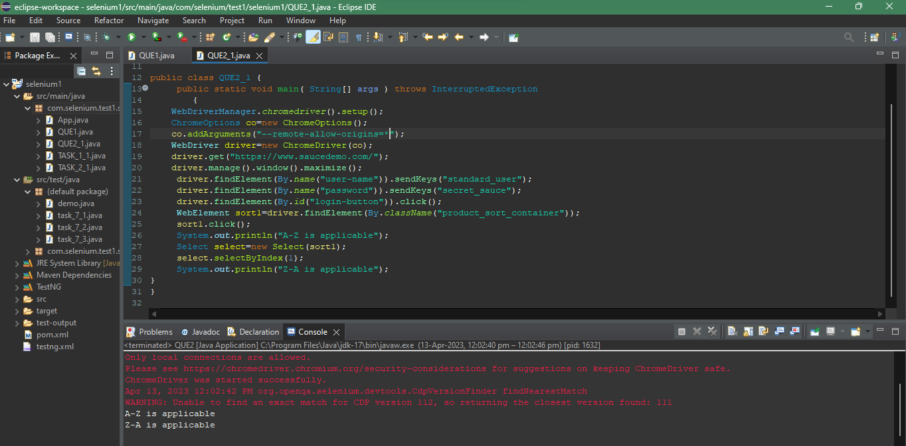

Task 2.2

package com.selenium.test1.selenium1;

import org.openqa.selenium.By;

import org.openqa.selenium.WebDriver;

import org.openqa.selenium.WebElement;

import org.openqa.selenium.chrome.ChromeDriver;

import org.openqa.selenium.chrome.ChromeOptions;

import org.openqa.selenium.support.ui.Select;

import io.github.bonigarcia.wdm.WebDriverManager;

public class QUE2_2 {

public static void main( String[] args ) throws InterruptedException

{

WebDriverManager.chromedriver().setup();

ChromeOptions co=new ChromeOptions();

co.addArguments("--remote-allow-origins=*");

WebDriver driver=new ChromeDriver(co);

driver.get("https://www.saucedemo.com/");

driver.manage().window().maximize();

driver.findElement(By.name("user-name")).sendKeys("standard_user");

driver.findElement(By.name("password")).sendKeys("secret_sauce");

driver.findElement(By.id("login-button")).click();

WebElement sort1=driver.findElement(By.className("product_sort_container"));

sort1.click();

Select select=new Select(sort1);

select.selectByIndex(0);

String fpo=driver.findElement(By.className("inventory_item_name")).getText();

System.out.println(fpo);

select.selectByIndex(1);

String fp1=driver.findElement(By.className("inventory_item_name")).getText();

System.out.println(fp1);

}

}

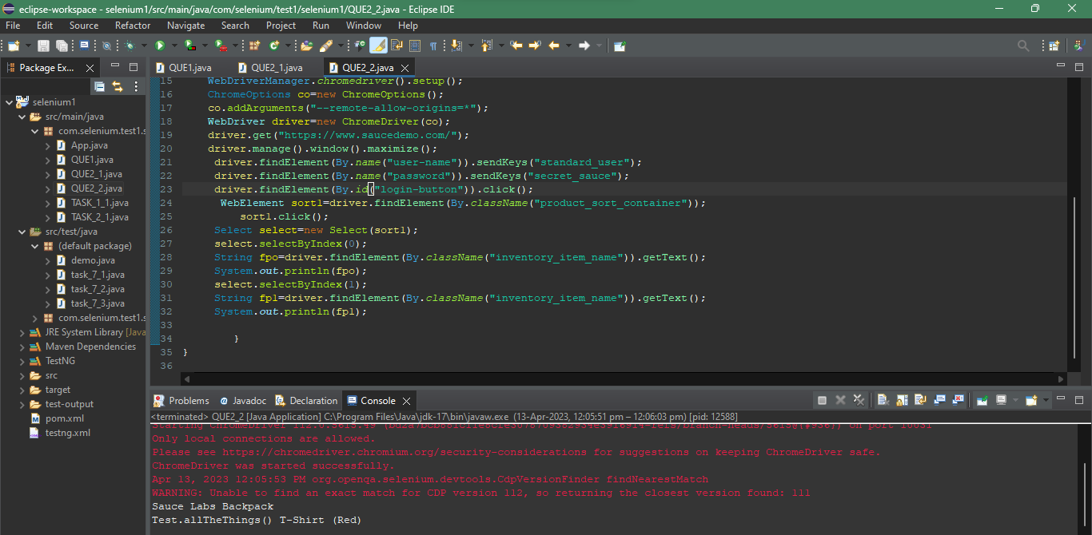

Task 2.3

package com.selenium.test1.selenium1;

import org.openqa.selenium.By;

import org.openqa.selenium.WebDriver;

import org.openqa.selenium.WebElement;

import org.openqa.selenium.chrome.ChromeDriver;

import org.openqa.selenium.chrome.ChromeOptions;

import org.openqa.selenium.support.ui.Select;

import io.github.bonigarcia.wdm.WebDriverManager;

public class QUE2_3 {

public static void main( String[] args ) throws InterruptedException

{

WebDriverManager.chromedriver().setup();

ChromeOptions co=new ChromeOptions();

co.addArguments("--remote-allow-origins=*");

WebDriver driver=new ChromeDriver(co);

driver.get("https://www.saucedemo.com/");

driver.manage().window().maximize();

driver.findElement(By.name("user-name")).sendKeys("standard_user");

driver.findElement(By.name("password")).sendKeys("secret_sauce");

driver.findElement(By.id("login-button")).click();

WebElement sort1=driver.findElement(By.className("product_sort_container"));

sort1.click();

Select select=new Select(sort1);

select.selectByIndex(2);

System.out.println("LOW-HIGH is applicable");

WebElement sort2=driver.findElement(By.className("product_sort_container"));

sort2.click();

Select select1=new Select(sort2);

select1.selectByIndex(3);

System.out.println("HIGH-LOW is applicable");

}

}

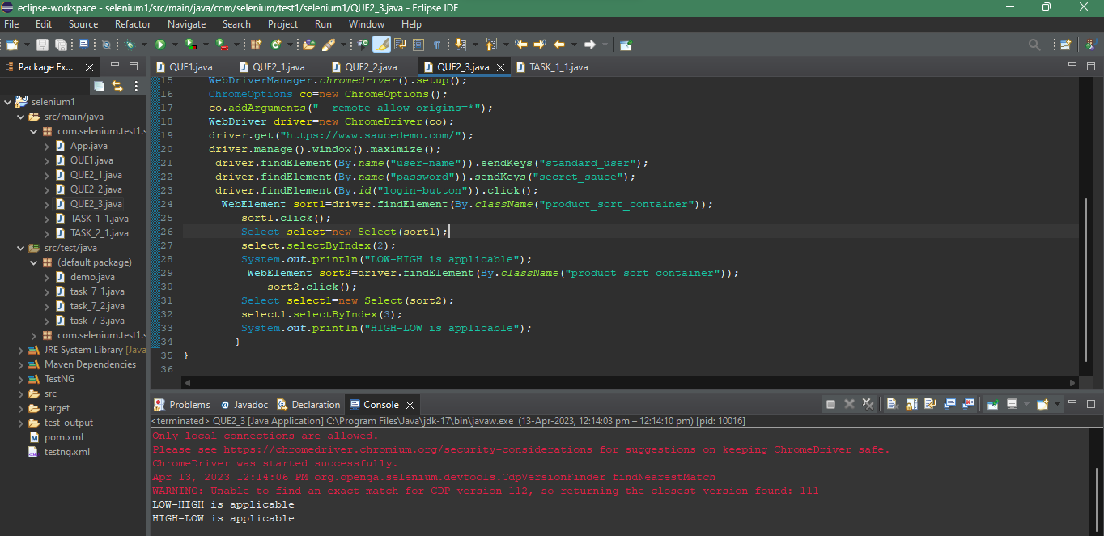

Task 2.4

package com.selenium.test1.selenium1;

import org.openqa.selenium.By;

import org.openqa.selenium.WebDriver;

import org.openqa.selenium.WebElement;

import org.openqa.selenium.chrome.ChromeDriver;

import org.openqa.selenium.chrome.ChromeOptions;

import org.openqa.selenium.support.ui.Select;

import io.github.bonigarcia.wdm.WebDriverManager;

public class QUE2_4 {

public static void main( String[] args ) throws InterruptedException

{

WebDriverManager.chromedriver().setup();

ChromeOptions co=new ChromeOptions();

co.addArguments("--remote-allow-origins=*");

WebDriver driver=new ChromeDriver(co);

driver.get("https://www.saucedemo.com/");

driver.manage().window().maximize();

driver.findElement(By.name("user-name")).sendKeys("standard_user");

driver.findElement(By.name("password")).sendKeys("secret_sauce");

driver.findElement(By.id("login-button")).click();

WebElement sort1=driver.findElement(By.className("product_sort_container"));

sort1.click();

Select select=new Select(sort1);

select.selectByIndex(2);

String d1=driver.findElement(By.className("inventory_item_name")).getText();

System.out.println(d1);

WebElement sort2=driver.findElement(By.className("product_sort_container"));

sort2.click();

Select select1=new Select(sort2);

select1.selectByIndex(3);

String d2=driver.findElement(By.className("inventory_item_name")).getText();

System.out.println(d2);

}

}

