Table of Contents
Info 2
Set param: 4
Read Param: 7
Refresh 12
Stop recording 14
Data download 15
Disconnect 19
Connect 20

Info
Host command for capture:
cat /sys/kernel/debug/usb/usbmon/1u

lsusb info
Bus 001 Device 011: ID 10c4:82cd Cygnal Integrated Products, Inc.
Device Descriptor:
bLength 18
bDescriptorType 1
bcdUSB 1.10
bDeviceClass 0 (Defined at Interface level)
bDeviceSubClass 0
bDeviceProtocol 0
bMaxPacketSize0 64
idVendor 0x10c4 Cygnal Integrated Products, Inc.
idProduct 0x82cd
bcdDevice 0.00
iManufacturer 1 SLAB
iProduct 2 HT2000
iSerial 0
bNumConfigurations 1
Configuration Descriptor:
bLength 9
bDescriptorType 2
wTotalLength 41
bNumInterfaces 1
bConfigurationValue 1
iConfiguration 0
bmAttributes 0x80
(Bus Powered)
MaxPower 64mA
Interface Descriptor:
bLength 9
bDescriptorType 4
bInterfaceNumber 0
bAlternateSetting 0
bNumEndpoints 2
bInterfaceClass 3 Human Interface Device
bInterfaceSubClass 0 No Subclass
bInterfaceProtocol 0 None
iInterface 0
Warning: Descriptor too short
HID Device Descriptor:
bLength 9
bDescriptorType 33
bcdHID 1.01
bCountryCode 0 Not supported
bNumDescriptors 2
bDescriptorType 34 Report
wDescriptorLength 128
bDescriptorType 214 (null)
wDescriptorLength 15834
Report Descriptors:
** UNAVAILABLE **
Endpoint Descriptor:
bLength 7
bDescriptorType 5
bEndpointAddress 0x81 EP 1 IN
bmAttributes 3
Transfer Type Interrupt
Synch Type None
Usage Type Data
wMaxPacketSize 0x0040 1x 64 bytes
bInterval 10
Endpoint Descriptor:
bLength 7
bDescriptorType 5
bEndpointAddress 0x01 EP 1 OUT
bmAttributes 3
Transfer Type Interrupt
Synch Type None
Usage Type Data
wMaxPacketSize 0x0040 1x 64 bytes
bInterval 10
Device Status: 0x0000
(Bus Powered)

Set param:
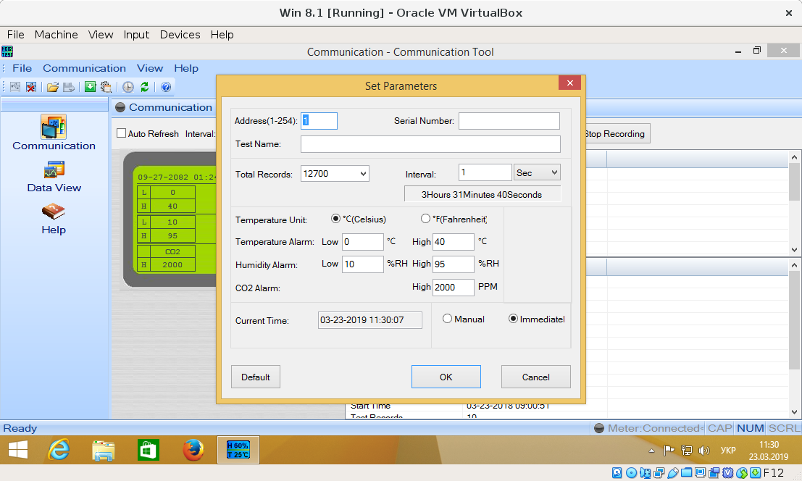
ffff92c147628b40 2318059230 S Io:1:011:1 -115:8 61 = 02000100 00000000 00000000 00000000 00000000 00000000 00000000 00000000
ffff92c147628b40 2318063356 C Io:1:011:1 0:8 61 >
ffff92c1470f93c0 2318063570 S Io:1:011:1 -115:8 61 = 02010320 006403b6 005c95fc a10123a6 b45a0000 000007d0 00000000 00000020
ffff92c1470f93c0 2318071361 C Io:1:011:1 0:8 61 >

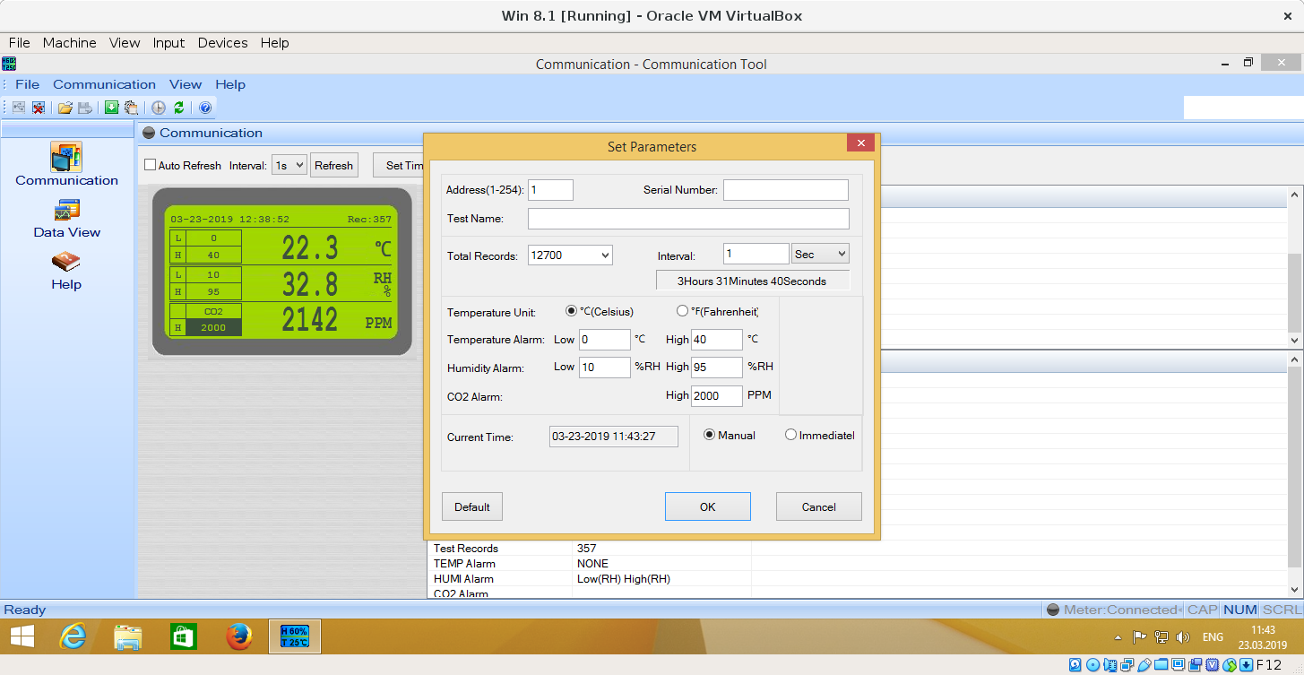
ffff92bf6c219540 3115374475 S Io:1:011:1 -115:8 61 = 02000100 00000000 00000000 00000000 00000000 00000000 00000000 00000000
ffff92bf6c219540 3115376109 C Io:1:011:1 0:8 61 >
ffff92bf6c219540 3115376304 S Io:1:011:1 -115:8 61 = 02010320 006403b6 005c95ff c000a1fc 955c0000 000007d0 00000000 00000020
ffff92bf6c219540 3115384102 C Io:1:011:1 0:8 61 >

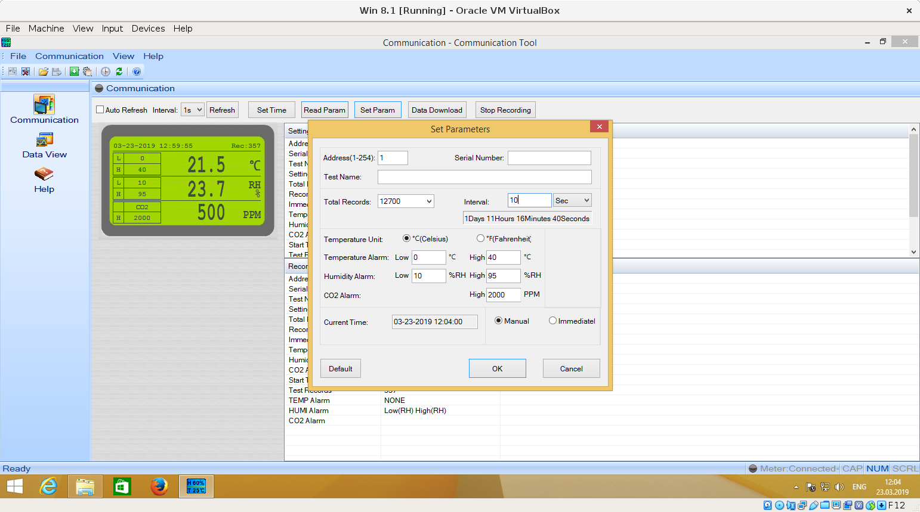
ffff92c1474f36c0 261655206 S Io:1:011:1 -115:8 61 = 02000100 00000000 00000000 00000000 00000000 00000000 00000000 00000000
ffff92c1474f36c0 261656750 C Io:1:011:1 0:8 61 >
ffff92bf77bcbe40 261656875 S Io:1:011:1 -115:8 61 = 02010320 006403b6 005c9604 9900c0ff 955c0000 000007d0 00000000 00000020
ffff92bf77bcbe40 261664731 C Io:1:011:1 0:8 61 >

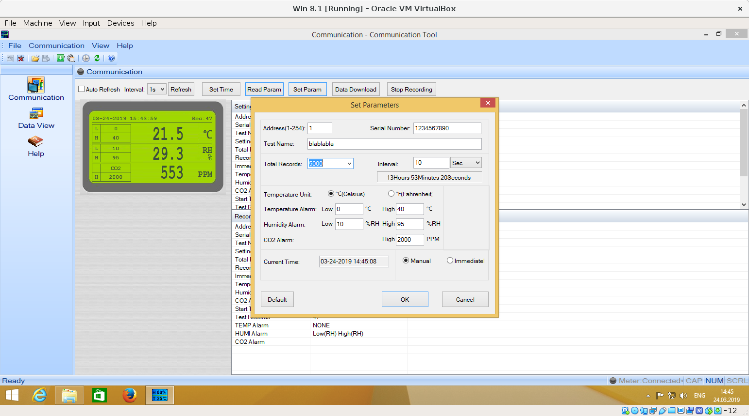

ffff951d87c1bf00 2202889345 S Io:1:005:1 -115:8 61 = 02000131 32333435 36373839 3062006c 00610062 006c0061 0062006c 00610000
ffff951d87c1bf00 2202893871 C Io:1:005:1 0:8 61 >
ffff951c21bfa780 2202894110 S Io:1:005:1 -115:8 61 = 02010320 006403b6 005c977c 4a009904 965c0000 000007d0 00000000 00000020
ffff951c21bfa780 2202901869 C Io:1:005:1 0:8 61 >

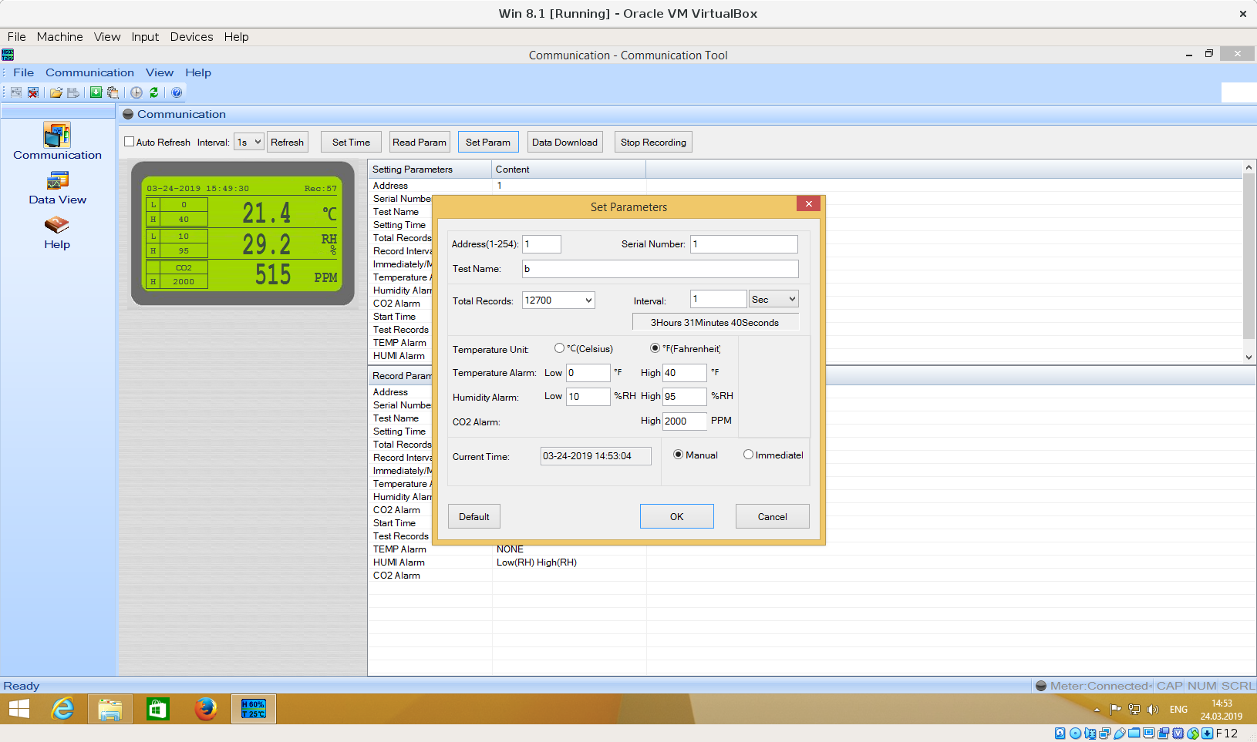
ffff951bc924a6c0 2577567374 S Io:1:005:1 -115:8 61 = 02000131 00333435 36373839 30620000 00610062 006c0061 0062006c 00610000
ffff951bc924a6c0 2577574136 C Io:1:005:1 0:8 61 >
ffff951c22582d80 2577574374 S Io:1:005:1 -115:8 61 = 020101bc 006403b6 005c977d d4004a7c 975c0000 000007d0 00000000 00000020
ffff951c22582d80 2577582134 C Io:1:005:1 0:8 61 >

Read Param:
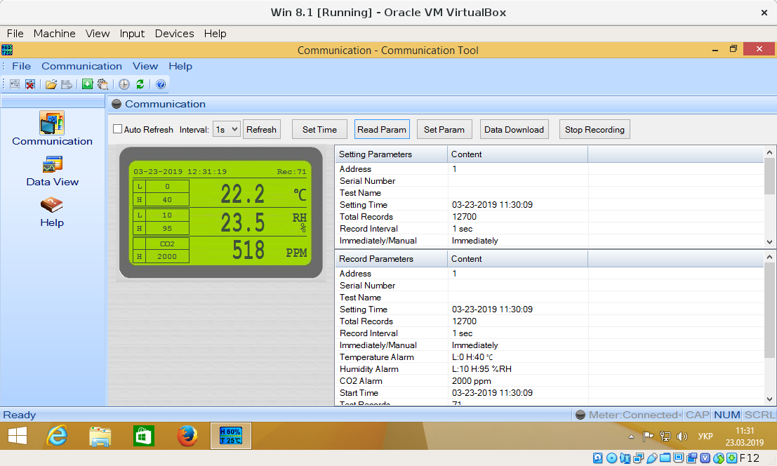
ffff92c146f57a80 2388371372 S Ci:1:011:0 s a1 01 0105 0000 003d 61 <
ffff92c146f57a80 2388371847 C Ci:1:011:0 0 32 = 055c9627 17004702 6e00eb01 90032000 6403b6b0 0301bd12 02060000 07d0059d
ffff92c12352dc00 2388373106 S Ci:1:011:0 s a1 01 0106 0000 003d 61 <
ffff92c12352dc00 2388374161 C Ci:1:011:0 0 61 = 06000100 00000000 00000000 00000000 00000000 00000000 00000000 00000000
ffff92c12a2fc6c0 2388374253 S Ci:1:011:0 s a1 01 0106 0000 003d 61 <
ffff92c12a2fc6c0 2388375113 C Ci:1:011:0 0 61 = 06010320 006403b6 005c95fc a1015c95 fca10000 000007d0 00000000 00000002
ffff92c14b3386c0 2388375829 S Ci:1:011:0 s a1 01 0107 0000 003d 61 <
ffff92c14b3386c0 2388376906 C Ci:1:011:0 0 61 = 07000100 00000000 00000000 00000000 00000000 00000000 00000000 00000000
ffff92c146f57e40 2388377086 S Ci:1:011:0 s a1 01 0107 0000 003d 61 <
ffff92c146f57e40 2388377944 C Ci:1:011:0 0 61 = 07010320 006403b6 005c95fc a1015c95 fca10047 000007d0 00000000 00000002

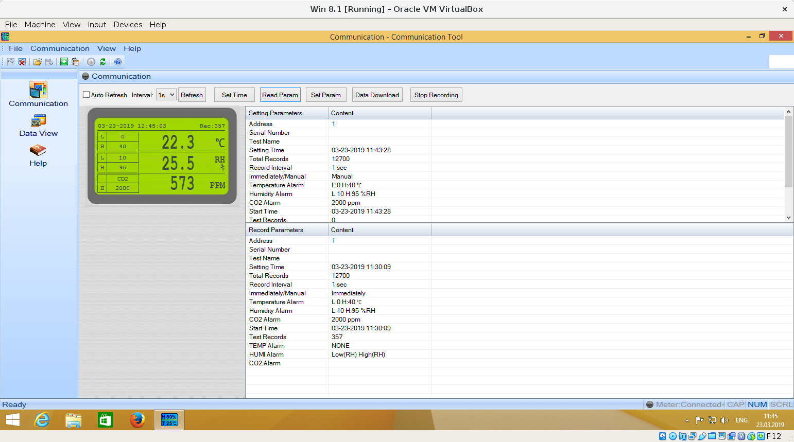
ffff92bf81b83300 3210500049 S Ci:1:011:0 s a1 01 0105 0000 003d 61 <
ffff92bf81b83300 3210500517 C Ci:1:011:0 0 32 = 055c962a 4f016502 6f00ff01 90032000 6403b6b0 0300ee02 023d0000 07d0026e
ffff92c147235a80 3210502389 S Ci:1:011:0 s a1 01 0106 0000 003d 61 <
ffff92c147235a80 3210503460 C Ci:1:011:0 0 61 = 06000100 00000000 00000000 00000000 00000000 00000000 00000000 00000000
ffff92c148b176c0 3210503578 S Ci:1:011:0 s a1 01 0106 0000 003d 61 <
ffff92c148b176c0 3210504455 C Ci:1:011:0 0 61 = 06010320 006403b6 005c95ff c0005c95 ffc00000 000007d0 00000000 00000002
ffff92c1482193c0 3210505293 S Ci:1:011:0 s a1 01 0107 0000 003d 61 <
ffff92c1482193c0 3210506372 C Ci:1:011:0 0 61 = 07000100 00000000 00000000 00000000 00000000 00000000 00000000 00000000
ffff92c148a7cc00 3210506603 S Ci:1:011:0 s a1 01 0107 0000 003d 61 <
ffff92c148a7cc00 3210507457 C Ci:1:011:0 0 61 = 07010320 006403b6 005c95fc a1015c95 fca10165 000007d0 00000000 00000002

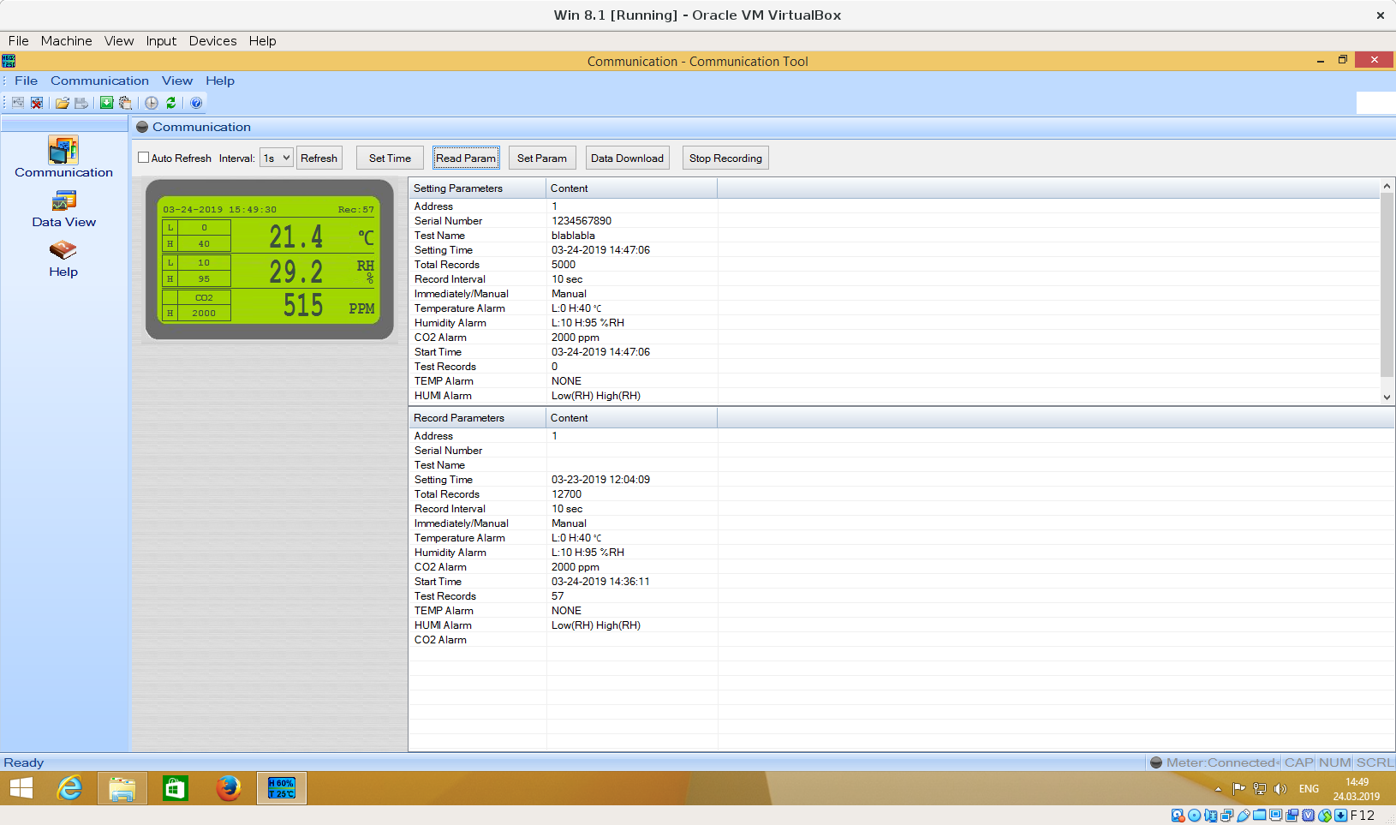

ffff951c7cd7cd80 2347176989 S Ci:1:005:0 s a1 01 0105 0000 003d 61 <
ffff951c7cd7cd80 2347177462 C Ci:1:005:0 0 32 = 055c97a7 0a003902 66012401 90032000 6403b6b0 0300046f 02030000 07d0fe22
ffff951b801dff00 2347178639 S Ci:1:005:0 s a1 01 0106 0000 003d 61 <
ffff951b801dff00 2347179708 C Ci:1:005:0 0 61 = 06000131 32333435 36373839 3062006c 00610062 006c0061 0062006c 00610000
ffff951c7cd7ccc0 2347179938 S Ci:1:005:0 s a1 01 0106 0000 003d 61 <
ffff951c7cd7ccc0 2347180783 C Ci:1:005:0 0 61 = 06010320 006403b6 005c977c 4a005c97 7c4a0000 000007d0 00000000 00000002
ffff951cd2f04780 2347181596 S Ci:1:005:0 s a1 01 0107 0000 003d 61 <
ffff951cd2f04780 2347182666 C Ci:1:005:0 0 61 = 07000100 00000000 00000000 00000000 00000000 00000000 00000000 00000000
ffff951c7cd7ccc0 2347182835 S Ci:1:005:0 s a1 01 0107 0000 003d 61 <
ffff951c7cd7ccc0 2347183699 C Ci:1:005:0 0 61 = 07010320 006403b6 005c9604 99005c97 79bb0039 000007d0 00000000 00000002

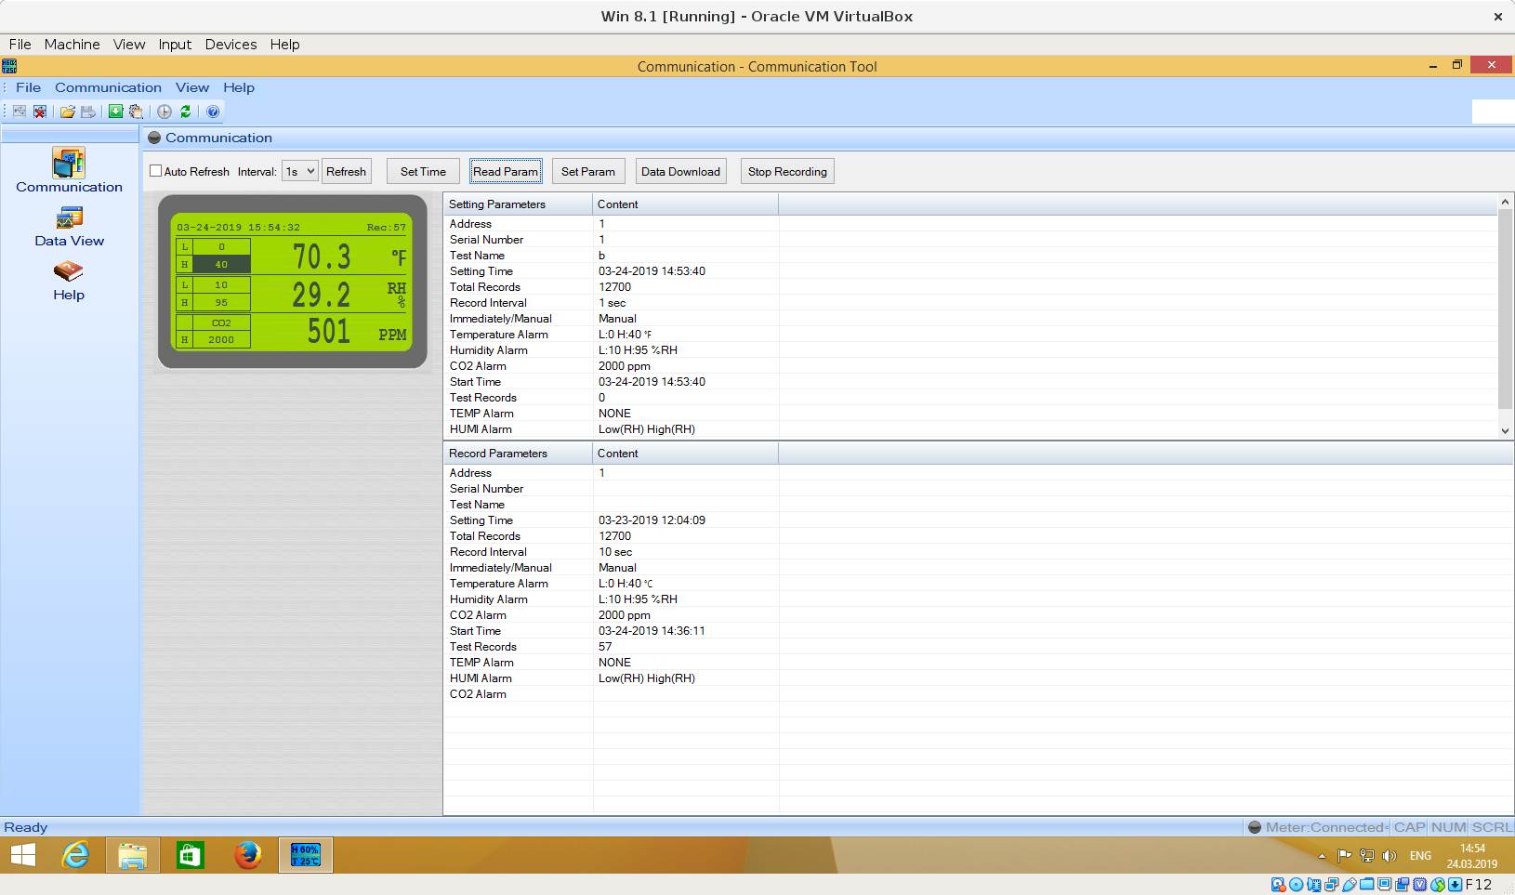

ffff951cd2f049c0 2629647451 S Ci:1:005:0 s a1 01 0105 0000 003d 61 <
ffff951cd2f049c0 2629647917 C Ci:1:005:0 0 32 = 055c97a8 38003902 65012400 de01bc00 6403b6b1 030007d0 01f50000 07d00002
ffff951ad2d6f9c0 2629649223 S Ci:1:005:0 s a1 01 0106 0000 003d 61 <
ffff951ad2d6f9c0 2629650301 C Ci:1:005:0 0 61 = 06000131 00333435 36373839 30620000 00610062 006c0061 0062006c 00610000
ffff951d8801bd80 2629650473 S Ci:1:005:0 s a1 01 0106 0000 003d 61 <
ffff951d8801bd80 2629651339 C Ci:1:005:0 0 61 = 060101bc 006403b6 005c977d d4005c97 7dd40000 000007d0 00000000 00000002
ffff951ad2d6f900 2629652130 S Ci:1:005:0 s a1 01 0107 0000 003d 61 <
ffff951ad2d6f900 2629653215 C Ci:1:005:0 0 61 = 07000100 00000000 00000000 00000000 00000000 00000000 00000000 00000000
ffff951d85b9cc00 2629653410 S Ci:1:005:0 s a1 01 0107 0000 003d 61 <
ffff951d85b9cc00 2629654270 C Ci:1:005:0 0 61 = 07010320 006403b6 005c9604 99005c97 79bb0039 000007d0 00000000 00000002

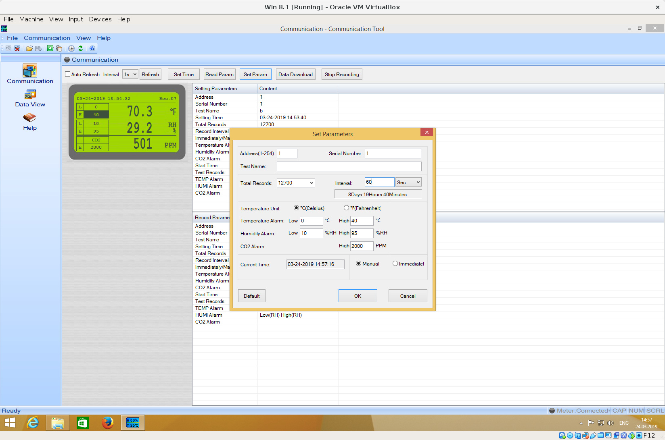

ffff951b8b6250c0 2798066211 S Io:1:005:1 -115:8 61 = 02000131 00333435 36373839 30000000 00610062 006c0061 0062006c 00610000
ffff951b8b6250c0 2798070308 C Io:1:005:1 0:8 61 >
ffff951a962a5840 2798070498 S Io:1:005:1 -115:8 61 = 02010320 006403b6 005c977e b100d47d 975c0000 000007d0 00000000 00000020
ffff951a962a5840 2798078311 C Io:1:005:1 0:8 61 >

Refresh

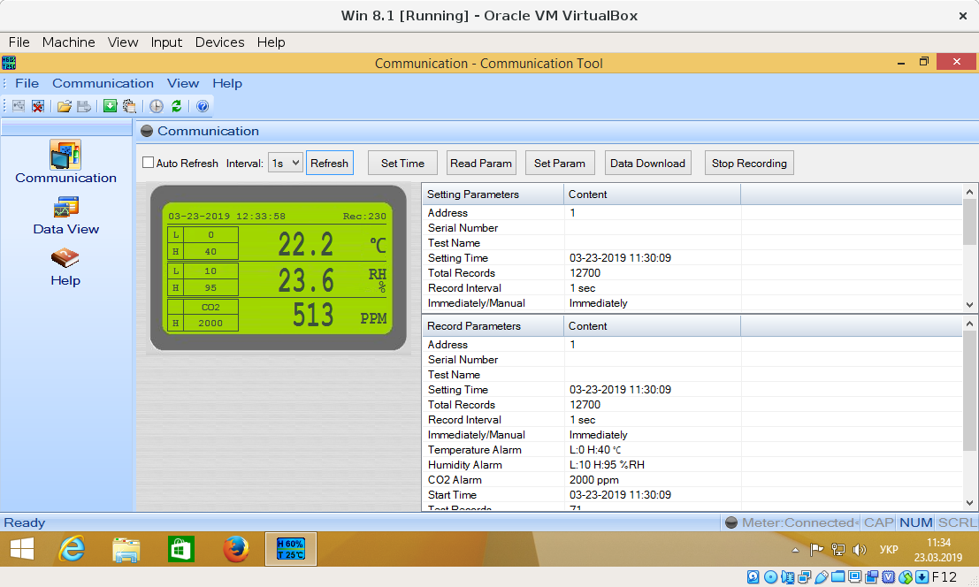
ffff92bf81afaa80 2547016213 S Ci:1:011:0 s a1 01 0105 0000 003d 61 <
ffff92bf81afaa80 2547016674 C Ci:1:011:0 0 32 = 055c9627 b600e602 6e00ec01 90032000 6403b6b0 030107d0 02010000 07d00002

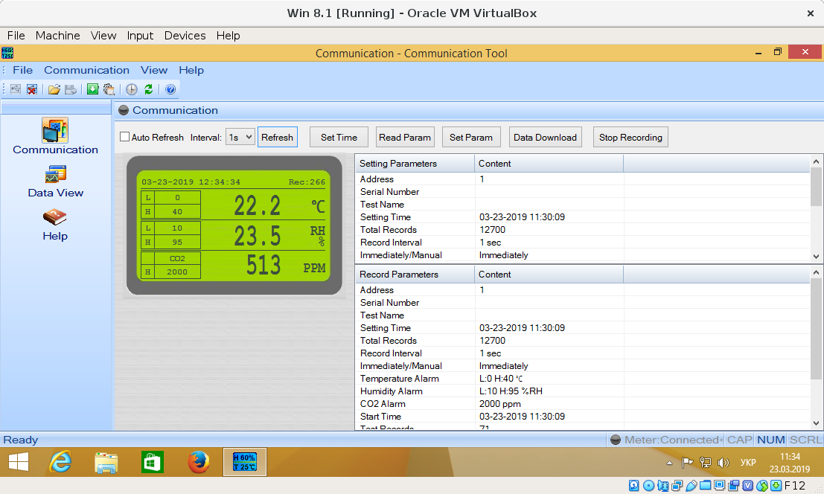
ffff92bf81983a80 2582605884 S Ci:1:011:0 s a1 01 0105 0000 003d 61 <
ffff92bf81983a80 2582606370 C Ci:1:011:0 0 32 = 055c9627 da010a02 6e00eb01 90032000 6403b6b0 030107d0 02010000 07d00002

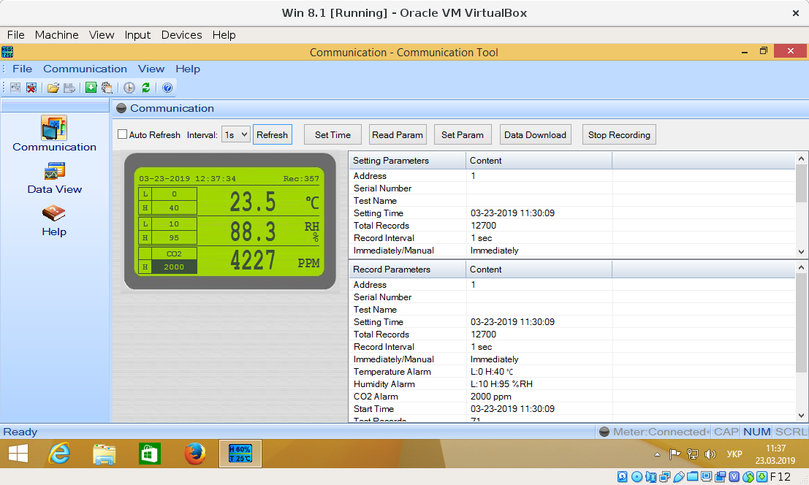
ffff92bf81948f00 2763421158 S Ci:1:011:0 s a1 01 0105 0000 003d 61 <
ffff92bf81948f00 2763421641 C Ci:1:011:0 0 32 = 055c9628 8e016502 7b037301 90032000 6403b6b0 030007d0 10830000 07d00003

Stop recording

ffff92c146f57240 2671399848 S Ci:1:011:0 s a1 01 0105 0000 003d 61 <
ffff92c146f57240 2671400341 C Ci:1:011:0 0 32 = 055c9628 32016202 6e00ee01 90032000 6403b6b0 030107d0 020d0000 07d00002
ffff92c148219900 2674321648 S Io:1:011:1 -115:8 2 = 0300
ffff92c148219900 2674327648 C Io:1:011:1 0:8 2 >
ffff92bf779b1540 2674327857 S Ci:1:011:0 s a1 01 0107 0000 003d 61 <
ffff92bf779b1540 2674329079 C Ci:1:011:0 0 61 = 07000100 00000000 00000000 00000000 00000000 00000000 00000000 00000000
ffff92bf779b1b40 2674329241 S Ci:1:011:0 s a1 01 0107 0000 003d 61 <
ffff92bf779b1b40 2674330101 C Ci:1:011:0 0 61 = 07010320 006403b6 005c95fc a1015c95 fca10165 000007d0 00000000 00000003

Data download

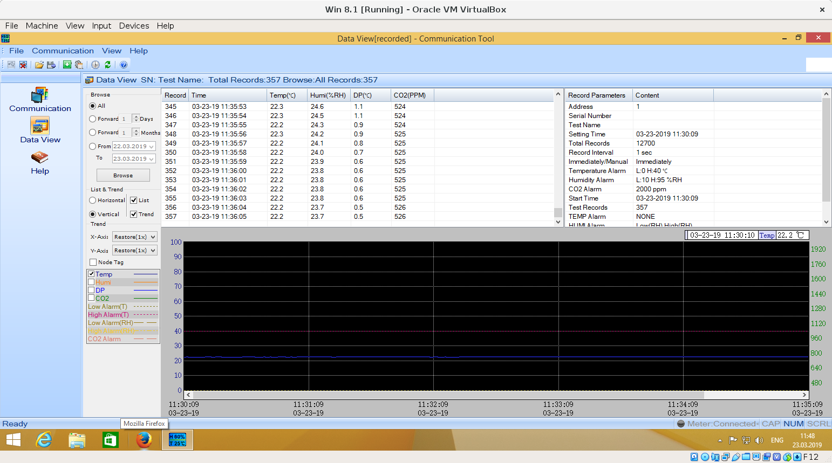

ffff92c12a2fc480 2841135729 S Ci:1:011:0 s a1 01 0105 0000 003d 61 <
ffff92c12a2fc480 2841136182 C Ci:1:011:0 0 32 = 055c9628 dc016502 6f014801 90032000 6403b6b0 030007d0 085e0000 07d00003
ffff92c12a2fca80 2844742221 S Io:1:011:1 -115:8 2 = 0300
ffff92c12a2fca80 2844743869 C Io:1:011:1 0:8 2 >
ffff92bf84620f00 2844744115 S Ci:1:011:0 s a1 01 0107 0000 003d 61 <
ffff92bf84620f00 2844745320 C Ci:1:011:0 0 61 = 07000100 00000000 00000000 00000000 00000000 00000000 00000000 00000000
ffff92bf779b1f00 2844745509 S Ci:1:011:0 s a1 01 0107 0000 003d 61 <
ffff92bf779b1f00 2844746367 C Ci:1:011:0 0 61 = 07010320 006403b6 005c95fc a1015c95 fca10165 000007d0 00000000 00000003
ffff92c1476286c0 2844866776 S Io:1:011:1 -115:8 3 = 040000
ffff92c1476286c0 2844871871 C Io:1:011:1 0:8 3 >
ffff92c14b0abcc0 2844872088 S Ci:1:011:0 s a1 01 0108 0000 003d 61 <
ffff92c14b0abcc0 2844892218 C Ci:1:011:0 0 61 = 086ded02 04026eec 0204026e ec020402 6dec0204 026eec02 04026dec 0205026d
ffff92c149013b40 2845006439 S Io:1:011:1 -115:8 3 = 040001
ffff92c149013b40 2845007848 C Io:1:011:1 0:8 3 >
ffff92c149013b40 2845008055 S Ci:1:011:0 s a1 01 0108 0000 003d 61 <
ffff92c149013b40 2845028218 C Ci:1:011:0 0 61 = 086eec02 05026eec 0205026d ec020502 6eec0205 026eec02 05026eeb 0205026e
ffff92c147a2dc00 2845131612 S Io:1:011:1 -115:8 3 = 040002
ffff92c147a2dc00 2845135857 C Io:1:011:1 0:8 3 >
ffff92bf779b16c0 2845136019 S Ci:1:011:0 s a1 01 0108 0000 003d 61 <
ffff92bf779b16c0 2845156518 C Ci:1:011:0 0 61 = 086dea02 05026dea 0206026d ea020602 6dea0206 026eea02 06026eea 0205026e
ffff92c1490136c0 2845271821 S Io:1:011:1 -115:8 3 = 040003
ffff92c1490136c0 2845279870 C Io:1:011:1 0:8 3 >
ffff92bf779b16c0 2845280093 S Ci:1:011:0 s a1 01 0108 0000 003d 61 <
ffff92bf779b16c0 2845300269 C Ci:1:011:0 0 61 = 086eeb02 05026deb 0206026e eb020602 6eeb0206 026deb02 06026eec 0205026e
ffff92c14b0abcc0 2845412655 S Io:1:011:1 -115:8 3 = 040004
ffff92c14b0abcc0 2845415870 C Io:1:011:1 0:8 3 >
ffff92c1476286c0 2845416092 S Ci:1:011:0 s a1 01 0108 0000 003d 61 <
ffff92c1476286c0 2845436497 C Ci:1:011:0 0 61 = 086eec02 05026eec 0205026d ec020502 6eec0205 026eed02 05026ded 0205026e
ffff92c1490136c0 2845537233 S Io:1:011:1 -115:8 3 = 040005
ffff92c1490136c0 2845543871 C Io:1:011:1 0:8 3 >
ffff92bf779b19c0 2845544051 S Ci:1:011:0 s a1 01 0108 0000 003d 61 <
ffff92bf779b19c0 2845564271 C Ci:1:011:0 0 61 = 086eed02 05026eed 0205026e ec020502 6eec0205 026eec02 05026eec 0206026e
ffff92bf779b19c0 2845677954 S Io:1:011:1 -115:8 3 = 040006
ffff92bf779b19c0 2845679870 C Io:1:011:1 0:8 3 >
ffff92bf77b26780 2845680079 S Ci:1:011:0 s a1 01 0108 0000 003d 61 <
ffff92bf77b26780 2845700541 C Ci:1:011:0 0 61 = 086deb02 06026eec 0206026e eb020602 6eeb0206 026eeb02 06026eeb 0206026e
ffff92c148219b40 2845803442 S Io:1:011:1 -115:8 3 = 040007
ffff92c148219b40 2845807874 C Io:1:011:1 0:8 3 >
ffff92bf779b1d80 2845808094 S Ci:1:011:0 s a1 01 0108 0000 003d 61 <
ffff92bf779b1d80 2845828267 C Ci:1:011:0 0 61 = 086eec02 07026eec 0207026e ec020702 6eec0207 026eec02 07026eec 0208026e
ffff92c148219b40 2845943565 S Io:1:011:1 -115:8 3 = 040008
ffff92c148219b40 2845943847 C Io:1:011:1 0:8 3 >
ffff92c148219b40 2845944055 S Ci:1:011:0 s a1 01 0108 0000 003d 61 <
ffff92c148219b40 2845964418 C Ci:1:011:0 0 61 = 086eec02 09026eeb 0209026e ec020902 6eec0209 026eec02 09026eec 0209026e
ffff92c148b17600 2846068717 S Io:1:011:1 -115:8 3 = 040009
ffff92c148b17600 2846071871 C Io:1:011:1 0:8 3 >
ffff92bf77b263c0 2846072041 S Ci:1:011:0 s a1 01 0108 0000 003d 61 <
ffff92bf77b263c0 2846092318 C Ci:1:011:0 0 61 = 086eec02 09026eec 020a026e ec020a02 6eec020a 026eec02 0a026eec 020b026e
ffff92bf77b263c0 2846194122 S Io:1:011:1 -115:8 3 = 04000a
ffff92bf77b263c0 2846199858 C Io:1:011:1 0:8 3 >
ffff92c147a2d600 2846200042 S Ci:1:011:0 s a1 01 0108 0000 003d 61 <
ffff92c147a2d600 2846220419 C Ci:1:011:0 0 61 = 086eeb02 0a026eeb 020a026e eb020a02 6deb020a 026dea02 0a026eea 020a026e
ffff92bf77b26f00 2846334464 S Io:1:011:1 -115:8 3 = 04000b
ffff92bf77b26f00 2846335871 C Io:1:011:1 0:8 3 >
ffff92c147a2d000 2846336064 S Ci:1:011:0 s a1 01 0108 0000 003d 61 <
ffff92c147a2d000 2846356269 C Ci:1:011:0 0 61 = 086eec02 0a026eec 0209026e eb020902 6eec0209 026eec02 09026eeb 0209026e
ffff92c147a2d000 2846459441 S Io:1:011:1 -115:8 3 = 04000c
ffff92c147a2d000 2846463858 C Io:1:011:1 0:8 3 >
ffff92c12a3c3b40 2846464080 S Ci:1:011:0 s a1 01 0108 0000 003d 61 <
ffff92c12a3c3b40 2846484417 C Ci:1:011:0 0 61 = 086eec02 08026eec 0208026e ec020702 6eeb0207 026eec02 07026eec 0207026e
ffff92bf779b19c0 2846600430 S Io:1:011:1 -115:8 3 = 04000d
ffff92bf779b19c0 2846607848 C Io:1:011:1 0:8 3 >
ffff92c148219b40 2846608036 S Ci:1:011:0 s a1 01 0108 0000 003d 61 <
ffff92c148219b40 2846628346 C Ci:1:011:0 0 61 = 086eec02 06026eec 0206026e ec020602 6eec0206 026eec02 06026eec 0206026e
ffff92c12a3c3b40 2846740578 S Io:1:011:1 -115:8 3 = 04000e
ffff92c12a3c3b40 2846743882 C Io:1:011:1 0:8 3 >
ffff92c147a2d000 2846744068 S Ci:1:011:0 s a1 01 0108 0000 003d 61 <
ffff92c147a2d000 2846764398 C Ci:1:011:0 0 61 = 086eec02 05026eec 0205026e ed020402 6eec0204 026eed02 04026eec 0204026e
ffff92c12a3c33c0 2846865766 S Io:1:011:1 -115:8 3 = 04000f
ffff92c12a3c33c0 2846871872 C Io:1:011:1 0:8 3 >
ffff92c147a2d000 2846872061 S Ci:1:011:0 s a1 01 0108 0000 003d 61 <
ffff92c147a2d000 2846892220 C Ci:1:011:0 0 61 = 086eec02 04026eed 0204026e ed020402 6eed0204 026eec02 04026eed 0204026e
ffff92c14834a6c0 2847006023 S Io:1:011:1 -115:8 3 = 040010
ffff92c14834a6c0 2847007849 C Io:1:011:1 0:8 3 >
ffff92c123508180 2847008076 S Ci:1:011:0 s a1 01 0108 0000 003d 61 <
ffff92c123508180 2847028394 C Ci:1:011:0 0 61 = 086eed02 03026eec 0203026e ec020302 6eec0203 026eec02 03026eec 0203026e
ffff92c147a2d600 2847131389 S Io:1:011:1 -115:8 3 = 040011
ffff92c147a2d600 2847135872 C Io:1:011:1 0:8 3 >
ffff92c14834a6c0 2847136094 S Ci:1:011:0 s a1 01 0108 0000 003d 61 <
ffff92c14834a6c0 2847156271 C Ci:1:011:0 0 61 = 086eec02 01026eec 0201026e ec020102 6eec0201 026eec02 01026eec 0201026e
ffff92c123517780 2847272350 S Io:1:011:1 -115:8 3 = 040012
ffff92c123517780 2847279873 C Io:1:011:1 0:8 3 >
ffff92c123517240 2847280094 S Ci:1:011:0 s a1 01 0108 0000 003d 61 <
ffff92c123517240 2847300398 C Ci:1:011:0 0 61 = 086eec02 01026eec 0201026e ec020102 6eec0201 026eec02 01026eec 0201026e
ffff92c147a2d000 2847412517 S Io:1:011:1 -115:8 3 = 040013
ffff92c147a2d000 2847415874 C Io:1:011:1 0:8 3 >
ffff92c0b47b7240 2847416086 S Ci:1:011:0 s a1 01 0108 0000 003d 61 <
ffff92c0b47b7240 2847436272 C Ci:1:011:0 0 61 = 086eec02 01026eec 0201026e ec020102 6eec0201 026eed02 01026eec 0201026e
ffff92c0b47b7c00 2847537789 S Io:1:011:1 -115:8 3 = 040014
ffff92c0b47b7c00 2847543878 C Io:1:011:1 0:8 3 >
ffff92c12a3c3b40 2847544079 S Ci:1:011:0 s a1 01 0108 0000 003d 61 <
ffff92c12a3c3b40 2847564297 C Ci:1:011:0 0 61 = 086eec02 01026eeb 0201026e ea020102 6eeb0201 026eea02 01026eea 0201026e
ffff92c1474f36c0 2847678019 S Io:1:011:1 -115:8 3 = 040015
ffff92c1474f36c0 2847679876 C Io:1:011:1 0:8 3 >
ffff92c147a2d000 2847680129 S Ci:1:011:0 s a1 01 0108 0000 003d 61 <
ffff92c147a2d000 2847700295 C Ci:1:011:0 0 61 = 086eea02 00026eea 0200026e ea020102 6eeb0201 026eeb02 01026eeb 0201026e
ffff92bf7794c0c0 2847803324 S Io:1:011:1 -115:8 3 = 040016
ffff92bf7794c0c0 2847807865 C Io:1:011:1 0:8 3 >
ffff92c146cee840 2847808071 S Ci:1:011:0 s a1 01 0108 0000 003d 61 <
ffff92c146cee840 2847828320 C Ci:1:011:0 0 61 = 086eeb02 01026eeb 0201026e eb020202 6eec0202 026eec02 02026eec 0202026e
ffff92bf77b263c0 2847944213 S Io:1:011:1 -115:8 3 = 040017
ffff92bf77b263c0 2847951874 C Io:1:011:1 0:8 3 >
ffff92c1235173c0 2847952075 S Ci:1:011:0 s a1 01 0108 0000 003d 61 <
ffff92c1235173c0 2847972296 C Ci:1:011:0 0 61 = 086eec02 04026eec 0204026e ec020402 6eed0204 026eec02 04026eed 0204026e
ffff92bf7794c480 2848084237 S Io:1:011:1 -115:8 3 = 040018
ffff92bf7794c480 2848087859 C Io:1:011:1 0:8 3 >
ffff92bf7794cd80 2848088020 S Ci:1:011:0 s a1 01 0108 0000 003d 61 <
ffff92bf7794cd80 2848108346 C Ci:1:011:0 0 61 = 086eed02 07026fed 0207026e ed020702 6eed0207 026eed02 07026eed 0207026e
ffff92c0b47b7240 2848225080 S Io:1:011:1 -115:8 3 = 040019
ffff92c0b47b7240 2848231874 C Io:1:011:1 0:8 3 >
ffff92c0b47b7c00 2848232049 S Ci:1:011:0 s a1 01 0108 0000 003d 61 <
ffff92c0b47b7c00 2848252339 C Ci:1:011:0 0 61 = 086eed02 08026eed 0208026e ed020802 6fed0208 026eed02 08026eed 0208026e
ffff92c0b47b7c00 2848366019 S Io:1:011:1 -115:8 3 = 04001a
ffff92c0b47b7c00 2848367873 C Io:1:011:1 0:8 3 >
ffff92c0b47b7c00 2848368032 S Ci:1:011:0 s a1 01 0108 0000 003d 61 <
ffff92c0b47b7c00 2848388322 C Ci:1:011:0 0 61 = 086eec02 09026eed 0209026e ed020902 6eec0209 026fec02 09026eec 0209026e
ffff92c098cb4e40 2848490661 S Io:1:011:1 -115:8 3 = 04001b
ffff92c098cb4e40 2848495849 C Io:1:011:1 0:8 3 >
ffff92c147235a80 2848496033 S Ci:1:011:0 s a1 01 0108 0000 003d 61 <
ffff92c147235a80 2848516574 C Ci:1:011:0 0 61 = 086eeb02 09026fed 0209026f f1020902 6ff80209 026f0312 09026e0c 1209026f
ffff92c147628180 2848631447 S Io:1:011:1 -115:8 3 = 04001c
ffff92c147628180 2848631874 C Io:1:011:1 0:8 3 >
ffff92c146496000 2848632106 S Ci:1:011:0 s a1 01 0108 0000 003d 61 <
ffff92c146496000 2848652328 C Ci:1:011:0 0 61 = 086e0312 0a026f01 120a026e ff020a02 6ffd020b 026efc02 0b026ffa 020b026f
ffff92c14bc2e180 2848755960 S Io:1:011:1 -115:8 3 = 04001d
ffff92c14bc2e180 2848759851 C Io:1:011:1 0:8 3 >
ffff92c14bc2e180 2848760017 S Ci:1:011:0 s a1 01 0108 0000 003d 61 <
ffff92c14bc2e180 2848780522 C Ci:1:011:0 0 61 = 086ef102 0d026ef0 020d026e ef020d02 6eee020d 026eee02 0d026eee 020d026e
ffff92c129858600 2853019879 C Ii:1:008:2 0:1 16 = 09000000 00000004 00000000 00000000

Disconnect

ffff92c098cb4b40 4023022264 C Ii:1:011:1 -2:8 0

Connect

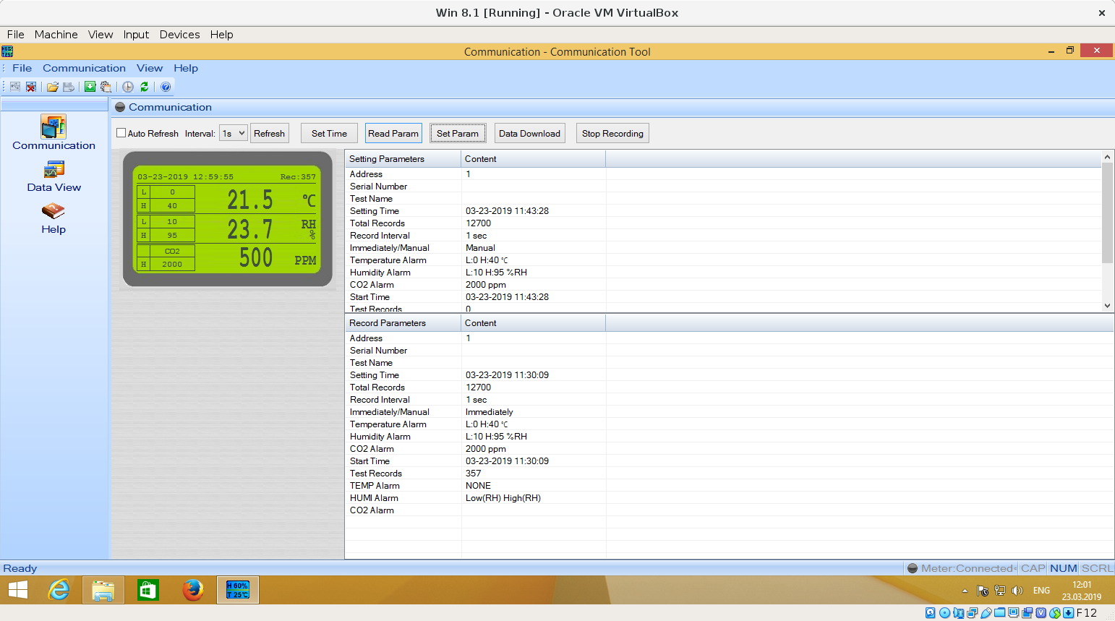

ffff92c0b47b7e40 6370755 S Co:1:011:0 s 21 0a 0000 0000 0000 0
ffff92c0b47b7e40 6370888 C Co:1:011:0 0 0
ffff92c0b47b7e40 6371036 S Ii:1:011:1 -115:8 61 <
ffff92c0b47b7780 6371183 S Ci:1:011:0 s 80 06 0302 0409 0202 514 <
ffff92c0b47b7780 6371466 C Ci:1:011:0 0 14 = 0e034800 54003200 30003000 3000
ffff92c146246600 6678573 S Ci:1:011:0 s a1 01 0105 0000 003d 61 <
ffff92c146246600 6679046 C Ci:1:011:0 0 32 = 055c962d cb016502 6700ed01 90032000 6403b6b0 030007d0 01f40000 07d00002
ffff92c0b47b7780 6680252 S Ci:1:011:0 s a1 01 0106 0000 003d 61 <
ffff92c0b47b7780 6681302 C Ci:1:011:0 0 61 = 06000100 00000000 00000000 00000000 00000000 00000000 00000000 00000000
ffff92c146246600 6681465 S Ci:1:011:0 s a1 01 0106 0000 003d 61 <
ffff92c146246600 6682321 C Ci:1:011:0 0 61 = 06010320 006403b6 005c95ff c0005c95 ffc00000 000007d0 00000000 00000002
ffff92c0b47b70c0 6682847 S Ci:1:011:0 s a1 01 0107 0000 003d 61 <
ffff92c0b47b70c0 6683896 C Ci:1:011:0 0 61 = 07000100 00000000 00000000 00000000 00000000 00000000 00000000 00000000
ffff92c0b47b7780 6684095 S Ci:1:011:0 s a1 01 0107 0000 003d 61 <
ffff92c0b47b7780 6684946 C Ci:1:011:0 0 61 = 07010320 006403b6 005c95fc a1015c95 fca10165 000007d0 00000000 00000002

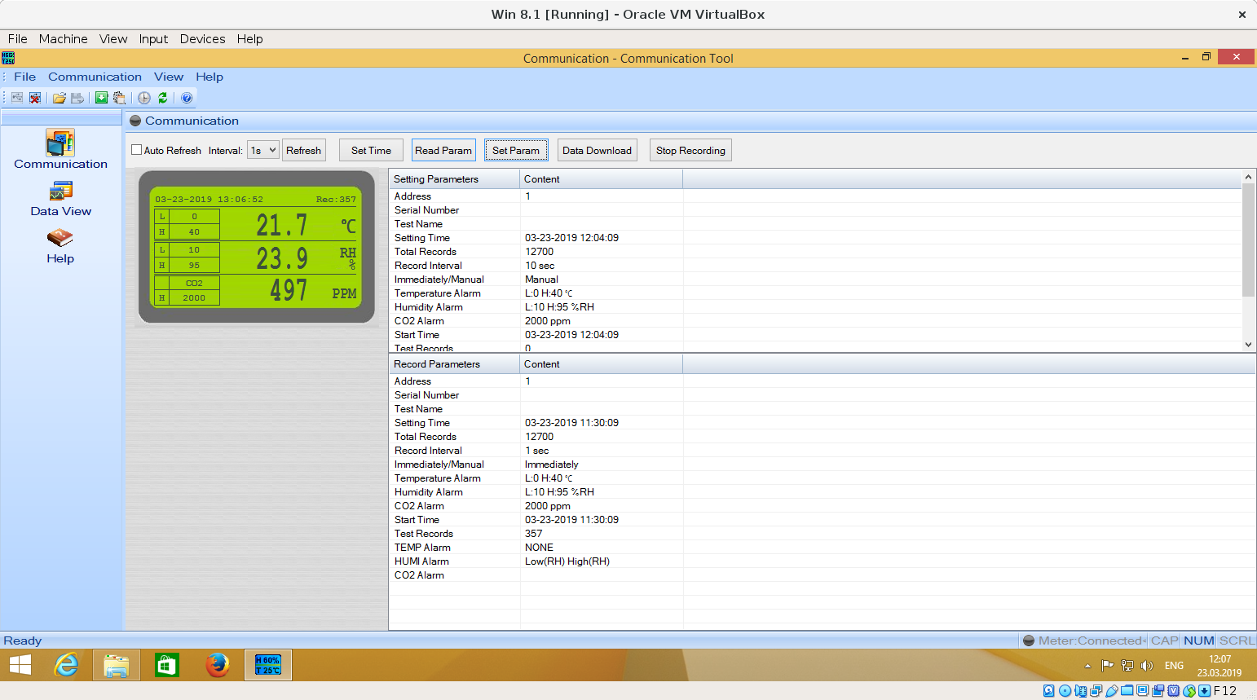
ffff92bf77b26f00 424428190 S Co:1:011:0 s 21 0a 0000 0000 0000 0
ffff92bf77b26f00 424428360 C Co:1:011:0 0 0
ffff92c148b17a80 424428626 S Ii:1:011:1 -115:8 61 <
ffff92c1474f3b40 424428751 S Ci:1:011:0 s 80 06 0302 0409 0202 514 <
ffff92c1474f3b40 424429060 C Ci:1:011:0 0 14 = 0e034800 54003200 30003000 3000
ffff92c123517300 424740455 S Ci:1:011:0 s a1 01 0105 0000 003d 61 <
ffff92c123517300 424740945 C Ci:1:011:0 0 32 = 055c962f 6c016502 6900ef01 90032000 6403b6b0 030007d0 01f10000 07d00002
ffff92c148b17f00 424742010 S Ci:1:011:0 s a1 01 0106 0000 003d 61 <
ffff92c148b17f00 424743098 C Ci:1:011:0 0 61 = 06000100 00000000 00000000 00000000 00000000 00000000 00000000 00000000
ffff92c123517900 424743310 S Ci:1:011:0 s a1 01 0106 0000 003d 61 <
ffff92c123517900 424744174 C Ci:1:011:0 0 61 = 06010320 006403b6 005c9604 99005c96 04990000 000007d0 00000000 00000002
ffff92c123517180 424745028 S Ci:1:011:0 s a1 01 0107 0000 003d 61 <
ffff92c123517180 424746121 C Ci:1:011:0 0 61 = 07000100 00000000 00000000 00000000 00000000 00000000 00000000 00000000
ffff92c123517240 424746436 S Ci:1:011:0 s a1 01 0107 0000 003d 61 <
ffff92c123517240 424747281 C Ci:1:011:0 0 61 = 07010320 006403b6 005c95fc a1015c95 fca10165 000007d0 00000000 00000002

