## Curriculum Vitae (CV) Form

| D | D | M | M | Y | Y | Y | Y |
| --- | --- | --- | --- | --- | --- | --- | --- |
| 0 | 4 | 0 | 9 | 2 | 0 | 2 | 4 |

Date of Completing this Form

Full Name: TRAN QUOC DANG

Citizenship: VIETNAM

QUOC-DANG TRAN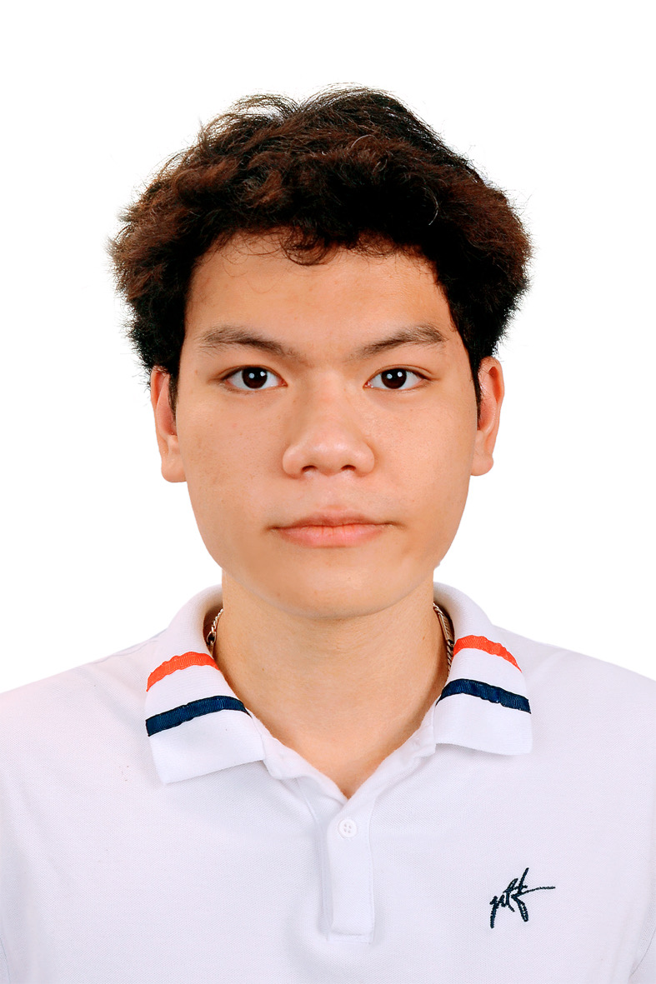

quocdangtran.work@gmail.com | (+84) 332 192 968

DOB: 04/12/2002

Gender: Male

Nationality: Vietnamese

Address: Room 201, Y3 Building, Alley 135 Nui Truc Street, Kim Ma Ward, Ba Dinh District, Hanoi, Vietnam

*"Dream big, work hard, stay focused, and surround yourself with good people."*

**EDUCATION**

**International School - Vietnam National University Hanoi, Vietnam**

*Bachelor of Informatics and Computer Engineering* Oct 2020 - Aug 2024

*Graduation Classification: Good*

**Xa La High School - Ha Dong, Hanoi, Vietnam** Aug 2017 - Sep 2020

*Graduation Classification: Excellent*

**THESIS PROJECT**

**Financial Performance Analysis & AI-Based Stock Price Prediction**Mar 2024 - Jun 2024

*Data Analyst*

*Grade: 8.7/10*

* Conducted comprehensive financial analysis of Sabeco, a leading beverage manufacturer in Vietnam.
* Developed predictive models using advanced machine learning techniques.
* Evaluated model performance using metrics.
* Provided insights into the financial health and stock price trends of Sabeco, highlighting the impact of state policies on its performance.

**WORK EXPERIENCE**

**United Nations PRME Global Students**  Aug 2024 - present

*Ambassador Programme Taskforce Member*

* Promoted responsible management education internationally.
* Developed strategies for sustainable business curricula.
* Represented the PRME initiative in various global forums and discussions, advocating for educational reforms in line with the UN's Sustainable Development Goals.
* Worked on partnerships with academic institutions to promote the integration of PRME principles into educational programs.

**Viettel IDC** Mar 2023 - Sep 2023

*Data Engineer | Internship*

* Utilized Python automation tools for data initialization
* Cleaned and filtered data for warehouse integration.

**ISTECH - International School Club of Computer Science and Technology** Nov 2020 - present *Data Science Operations Team Member*

* Analyze data and create predictive models for club projects
* Participate in Data Science hackathons hosted by Kaggle,,Shopee, etc.
* Trained 15+ members in Data Science and Data Engineering concepts and tools.

**ISTECH - International School Club of Computer Science and Technology** Nov 2021 - Feb 2022

*IoT Operations Team Lead*

* Train other members about loT basic skills.
* Developed the backend to integrate with middleware.

**IScholar International School Club of Student Scientific - Research**

*Head of Communication* Nov 2022 - Oct 2023

* Applied data cleaning skills to improve the organization's database, removing obsolete content and ensuring data accuracy.
* Led the communication branch, overseeing the creation and dissemination of promotional materials, social media content, and event announcements.

**PROJECTS**

**People Search Engine**Jan 2024 - present

*Back-end Developer, Data Engineer*

* Developed a secure RESTful API with Django.
* Implemented user management, authentication, and search features in PostgreSQL.
* Utilized Swagger to streamline API documentation and testing, ensuring effective collaboration with the frontend team.
* Automated data scraping from various sources.

**Audiobook Generator**Jun 2024 - present

*Developer*

* Created an audiobook generator using Google Cloud Text-to-Speech.
* Implemented both a user interface (UI) using Flask and a command-line interface (CLI) for system interaction.
* Developed commands for generating audio from PDFs and HTML URLs, and for checking the status of generated audio operations.

**RESEARCH**

**Design an Automatic Attendance System based on Face Recognition** Oct 2022 - Apr 2023

*Team Leader*

* Led the development of an automatic attendance system utilizing facial recognition technology to enhance the efficiency of attendance tracking in educational institutions.
* Implemented a facial recognition algorithm using Python and OpenCV, ensuring accurate real-time attendance recording.
* Conducted system testing and evaluation, improving accuracy and reducing manual workload for teachers.

**Predictive Modeling for Student Performance in Education** Oct 2023 - May 2024

*Team Leader*

* Developed a predictive model to forecast student outcomes based on data mining techniques.
* Analyzed key factors such as parental education and test preparation to determine their impact on student performance.

### EXTRACURRICULAR ACTIVITIES

**Temasek Foundation SCALE 2024, Singapore**Feb 2024 - Mar 2024

*Representative*

* Represented Vietnam National University - International School at the event, showcasing the school’s commitment to regional integration and innovation.
* Participated in a student exchange program promoting leadership, community development, and cross-cultural skills within Southeast Asia.
* Collaborated with international peers on projects addressing regional challenges, fostering leadership and teamwork.

**ASEAN University Network AELP 2023, Singapore**Jun 2023

*Delegate/Representative*

* Represented Vietnam National University in a week-long program hosted by Nanyang Technological University and National University of Singapore.
* Engaged in experiential learning activities and cultural exchanges with ASEAN students, developing cross-cultural communication and collaboration skills.
* Awarded a $300 scholarship for exemplary representation and participation in the program.

**Overseas Immersion Programme (OIP)**Mar 2023 & Sep 2023

*Representative*

* Co-organized a 2-week immersive program for students from Ngee Ann Polytechnic, Singapore, and International School - VNU, Hanoi.
* Facilitated student participation in cultural visits, academic workshops, industry tours, and social events, fostering cross-cultural understanding and collaboration.

**CERTIFICATES**

**Certifications & Training**: Agile Project Management - Issued by Agilearn Vietnam, Google Data Analytics Specialization - Issued by Coursera

**SKILLS**

**Languages:** Vietnamese (native), English (full professional proficiency - B2 CEFR), French (elementary proficiency), Russian (elementary proficiency)

**Technical Skills:** Python, Linux, Data Engineering, Data Analytics.

**Soft Skills:** Teamwork, Leadership, Communication, Problem-Solving.

**AWARDS & HONORS**

**Honors:** "Excellent Student" title (academic years 2020-2021), “Outstanding achievements in the Youth Union and Student Union activities” title (academic years 2021-2022 & 2022-2023).

**Awards:** Top 10 in Cybersecurity track - JunctionX Hackathon Vietnam 2023, Titled #638 per 24.479 entries - WiDS 2021 Datathon.

**REFERENCES**

**Name:** Manh-Hung Ha

**Position:** Lecturer at the Faculty of Applied Sciences at the International School, Head of Financial Technology & Digital Business Program; Group Leader of Cognitive Machine Intelligent, Vietnam National University, Hanoi; Visiting Professor at KL University, India

**Email:** hunghm@vnu.edu.vn