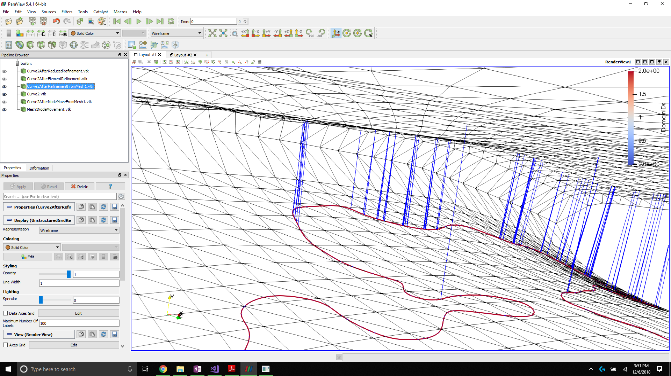

This figure shows curve 2 in the intersection curve list. The first curve is having no problems identifying the correct surface elements to project against. However, curve 2 (shown here) is misidentifying the surface elements to project on. The issue is coming from using the K-D tree search to find the 8 closest element for certain intersection curve segments. Instead of locating the elements that the segment lies nearly in-plane with, the search returns the elements that lie on the other side of the tow surface. I’m not really sure what the issue is. I have tried multiple rewrites to the surround code without any improvement for this curve.