**AFRL Research Collaboration Program**

**Contract FA8650-13-C-5800**

**Effect of Constituents and Microstructure on Energy Dissipation Mechanisms During Damage Growth**

**University: Texas A&M University**

**REPORT COVERS PERIOD: 10-1-16 THRU 12-30-16**

1. **PROJECT TEAM MEMBERS**
2. **LEAD UNIVERSITY POC:** John Whitcomb, 979-845-4006, jdw@tamu.edu
3. **PROJECT TEAM MEMBERS:** John Whitcomb,Keith Ballard, Collin Blake
4. **AFRL TECHNICAL POC:** Craig Przybyla
5. **TECHNICAL DISCUSSION**
6. **CURRENT WORK**This quarter we worked on studying the dependency of damage growth on cohesive zone meshes.

**Background**

With the increasingly widespread use of fiber/matrix composites, the accurate prediction of the progression of damage and final failure is an important topic for researchers. Consequently, researchers have proposed numerous computational models to predict progressive damage within a multiscale framework. At the microscale, where fibers and matrix are modelled discretely, some popular approaches to model damage include the use of continuum damage elements, which models the effect of a damage parameter on the response of a material, cohesive elements placed along a predetermined potential crack path, which models the discrete crack explicitly, a plasticity model for matrix damage combined with cohesive zone elements for interfacial debonding, and mesh independent methods, which allow the crack to grow along an arbitrary path.

With all of these methods, very little of the literature compares the results of these methods, and no work compares the different methods using the same meshes and material properties. To confidently predict the progression of damage at the fiber matrix scale, the differences between the available models and their agreement with experimental results should be understood.

**Approach**

This work compares the progression of damage using a continuum damage model and cohesive zone model. Both of these models have been used extensively in previous research. Continuum damage offers the benefits of allowing damage to occur anywhere, easier mesh generation, and better numerical stability. However, continuum damage does not directly model discrete cracks or fiber/matrix debonding. The use of cohesive elements alleviates this shortcoming, but the analyses have mesh dependency and much worse numerical stability.

During this quarter, the focal problem was an infinite hexagonal array of fibers subjected to uniaxial loads. Because of periodic boundary conditions, only one fiber was modeled. The study examined the dependence of damage propagation on structured quadrilateral and unstructured triangular cohesive zone meshes. Uniaxial, horizontal load was applied. The refinement for the mesh for the structured matrix is defined radially and circumferentially and was increased by factors of 2 in each direction, resulting in overall increased element numbers of 4x. The unstructured meshes were parameterized by the number nodes along each hexagonal edge to match the structured meshes. These unstructured meshes were also randomly seeded to generate similarly refined meshes that were different geometrically. Figure 1 shows the same section of a mesh that has the same refinement but is seeded differently.

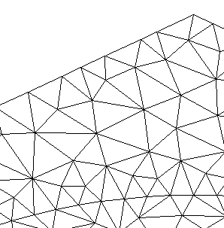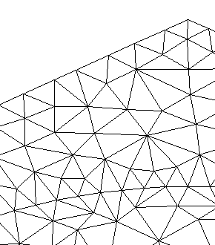

Figure 1: Same Refinement, Different Seeded Section of Unstructured Mesh

Figure 2 shows typical meshes. The fiber region of theses models are assumed to not damage and therefore are treated as fully elastic. Therefore, the refinement of the fiber is not as crucial as long as the stress gradients can be accounted for at the fiber-matrix boundary. Both meshes have a similar number of elements in the matrix that are similar in area and size. This allows for the same relative refinement but different geometry and element type. These meshes were used to determine the dependence of damage growth on mesh geometry specifically. Models for each refinement were subjected to the same loading with the same properties, including cohesive zone properties that simulate more brittle behavior. The strength and energy dissipated were determined for each analysis and analyzed for convergence and disparities.

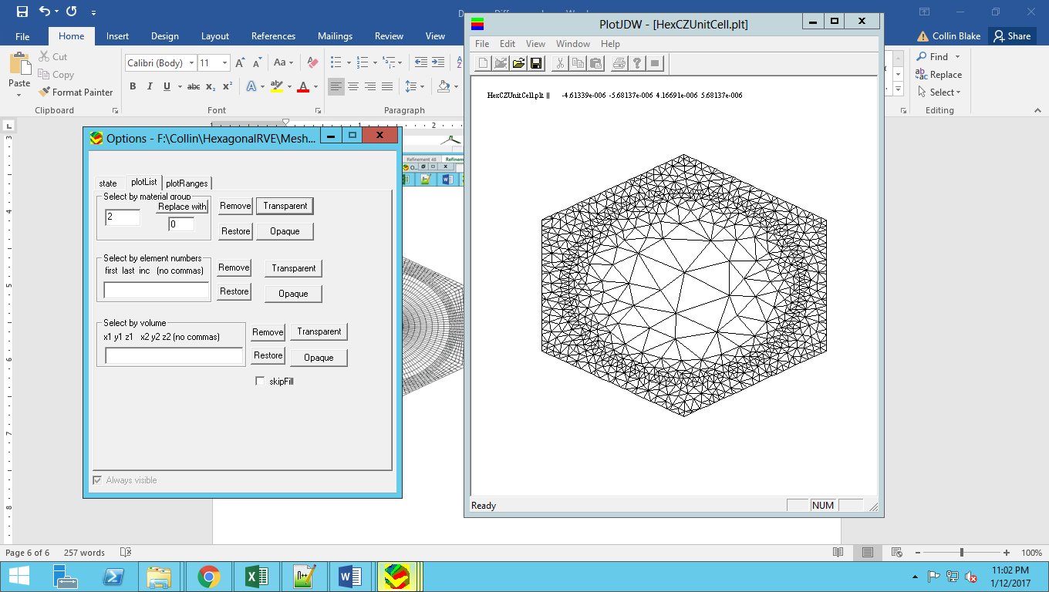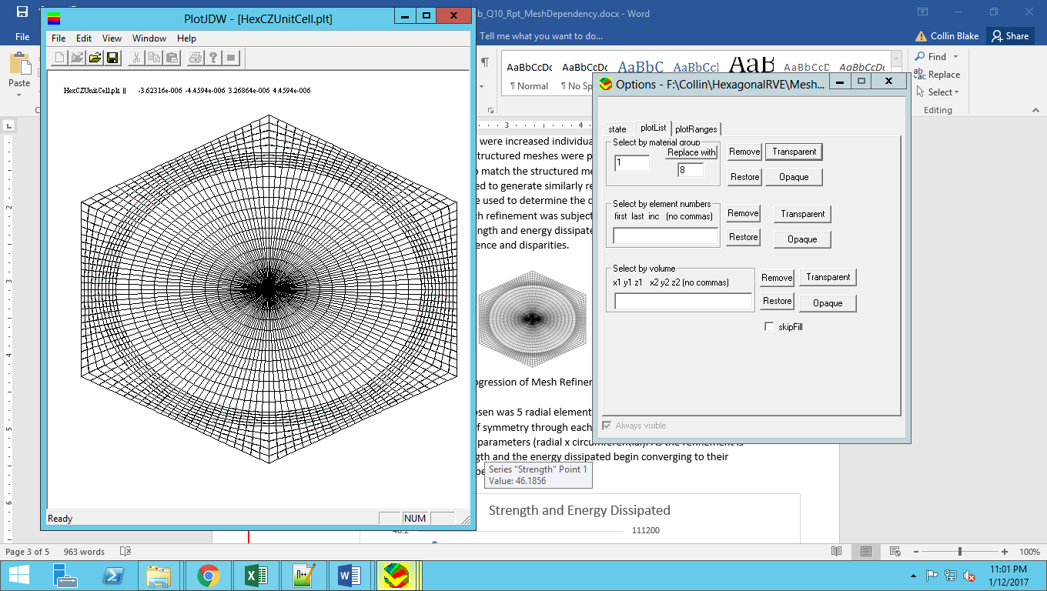

After the initial analysis, we found that there were inconsistencies in the strength predictions. We adjusted the load step increment from 0.1% strain per load step to 0.008% strain per load step. This reduced the differences between the strengths for the randomized unstructured meshes. However, there was still a large difference between the structured meshes and unstructured meshes in terms of strengths and energy dissipated, which we calculated by finding the area underneath the stress strain curve up to the peak stress. We assume that the failure is brittle and that the model could not hold any stress after the peak load. This differences were most prominent at high level of refinements. Figure 3 shows the stress-strain curves at the highest refined mesh (96 nodes along an edge).

Figure 3: Stress-Strain Curve at Refinement 96 for all Meshes

These curves show that the structured mesh has significantly more ductile behavior than the unstructured mesh using the same material properties. This forced us to look into the damage patterns produced initially at the peak stress. The patterns found are shown in Figure 4. For the structured mesh, there was no damage right at the fiber/matrix interface. For the unstructures mesh, the most intense damage still occurred a short distance from the interface, but there was also damage between the fiber and the location of the intense damage.

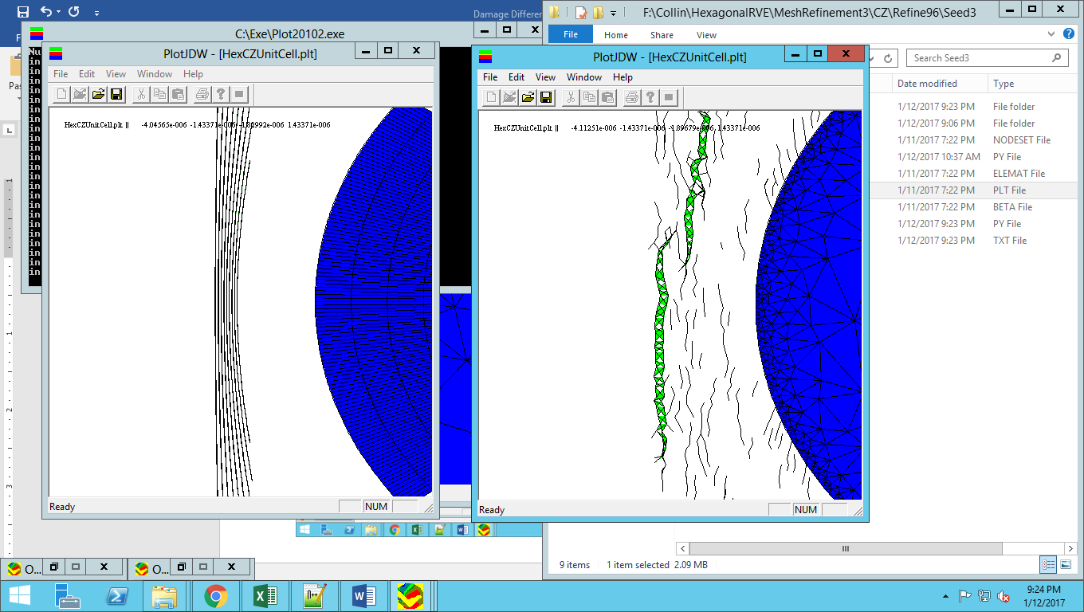

Figure 4: Damage Propagation at Equal Load Step, Structured (Left) and Unstructured (right)



Figure 4 shows noticeably different damage patterns for the same amount of strain. The lines and green areas outside the fiber are the damaged cohesive zones between the elements. In Figure 4, the undamaged matrix elements have been hidden to better show these damaged areas. While the damage is relatively in the same area, the damage patterns are different. The structured mesh damage pattern shows parallel but unconnected cracks. The unstructured mesh shows one large crack with multiple, partially connected matrix cracks, which we believe is more realistic. This leads us to believe that the arrangement of elements may have a larger effect on the models than originally anticipated. It appears that the structured mesh with quadrilateral elements is not allowing a similar pattern of damage that is allowed by triangular elements of the unstructured mesh. It is unclear at this point if the element shape is the source of the differences, or if the element type contributes to this discrepancy as well, and further study of this behavior is needed for a definitive conclusion.

1. **CONCLUSIONS/ANALYSIS TO DATE**

The cohesive zone model was found to have a dependence on the mesh being used for the analysis. We found that higher refined meshes have a larger discrepancy between the two types of meshes studied, which was surprising. We believe that the element shape could be playing a major role in the propagation of damage.

**WORK FORECAST AND PLANS**Collin Blake is planning to be at AFRL as an intern this summer. This will be an ideal opportunity for continued collaboration.   
  
The work described above is of a fundamental nature. There is much yet to be done. In fact, more than could possibly be completed during the term of this contract. Hence, the focus has been on raising distinct questions and trying to answer those questions. We have made progress, but we now believe that it is time to re-focus our work.



One reason is that as an undergraduate, Collin Blake has operated in a much more dependent mode than I wish for him to do starting in January. In January, he will begin his Master’s program at TAMU. It is my understanding that the internship that he spent at AFRL played a big part in his decision to go to graduate school, so this recruiting success can be attributed both to this project and the interactions during his internship. Since Keith Ballard is aggressively studying progressive damage prediction as a PhD under NDSEG support, there is great danger that Collin could slip into too much of a “technician” role, which is fine for undergraduates, but not for graduate students.

I have discussed this issue with our POC Craig Przybla and have identified a new area that is potentially of high interest to AFRL and AFOSR: “Analysis of Advanced Materials with Tailored Complex Architecture”. This would include fabrication techniques such as textile composites, tow steering, 3D printing with tows, materials with vasculature, and embedded sensors. Although we have experience that is highly applicable, there are distinct research questions that Collin can address that allow both significant independent research and an opportunity to take advantage of the suite of analysis tools we have developed on various projects.

The proposed plan is for Collin to work initially on two tasks:

1) A literature survey to establish the state of the art in modeling of this class of material systems. The literature survey will assure that we focus our efforts on the most important unsolved issues that are also of greatest interest to AFRL.

2) An assessment of the current state of the art in mesh generation capability. The Achilles heel of the extremely powerful finite element method is the ability to generate meshes for the complex geometries of interest. Fortunately, the capabilities have been improving and we need to assess the current limits.